Testing Duet Boards

Adrian Bowyer

RepRapPro Ltd

Items you will need

You will need to install the Arduino Development Environment Arduino 1.5 BETA. This is available from:

http://arduino.cc/en/Main/Software.

It should install in C:\Program files\arduino-1.5.4

You will also need (if you don't have it already) a copy of the Google Chrome browser. This is available from:

https://www.google.com/intl/en_uk/chrome/browser/.

Finally you will need a micro SD card with some files loaded on it (see below) and a copy of the test firmware. These are available from:

https://github.com/reprappro/RepRapFirmware/archive/duet.zip

Unzip the file in a folder of your choice. Let's suppose it is in C:\DuetTest. It will appear in that folder as C:\DuetTest\RepRapFirmware-duet.

Preparing a test

There are three sub-folders in the folder C:\DuetTest\RepRapFirmware-duet\SD-image called gcodes, sys, and www. Copy those folders and their contents into the root folder of the micro SD card. The same micro SD card can be used for any number of tests, so this only needs to be done once.

Plug the Duet to be tested into your computer using the USB interface. It will get logic power from the USB and some LEDs should light. Check which USB port on your computer the Duet is using. It will probably be something like COM5: .

Open a Command Prompt window (MSDOS command window).

Press the Duet's MCU ERASE button, then press its RESET button.

Type (or copy and paste) the following command:

C:\> C:\Program files\arduino-1.5.4\hardware\tools\bossac --port=COM5 -U true -e -w -v -b C:\DuetTest\RepRapFirmware-duet\Release\RepRapFirmware.bin -R

This should load the firmware into the Duet's program memory.

Unplug the USB lead to power down the Duet.

Put the micro SD card in the Duet.

Connect the Duet to the 12v supply (don't switch it on yet), the test stepper motors, the test fan, the test hot-end and the test heated bed. Plug an RJ45 (Ethernet) cable into the Duet to connect it to your network. Plug the USB cable back into the Duet end but not the computer end.

Running a test

Run the Arduino IDE program.

Plug the USB cable into the computer. The LEDs should light again.

In the Arduino IDE program, go to Tools->Board and select Arduino Due (Native USB port).

Then go to Tools->Port and select the USB port you had before.

Then go to Tools->SerialMonitor. It will open a window. At the bottom make sure Newline is selected as the line ending.

Turn on the 12v power.

In the top bar of the Arduino Serial Monitor window type

M105

and click the Send button. This asks the Duet for its temperatures. It should reply something like:

T:19.1 B:14.6

These should be about room temperature, but won't be very accurate – the Duet is designed for best accuracy at its operating temperatures.

Open the Google Chrome browser and type the IP address 10.10.1.100 in the address bar at the top. You should get a page like this:

The password is “reprap” (without the quotes).

Select the Print page:

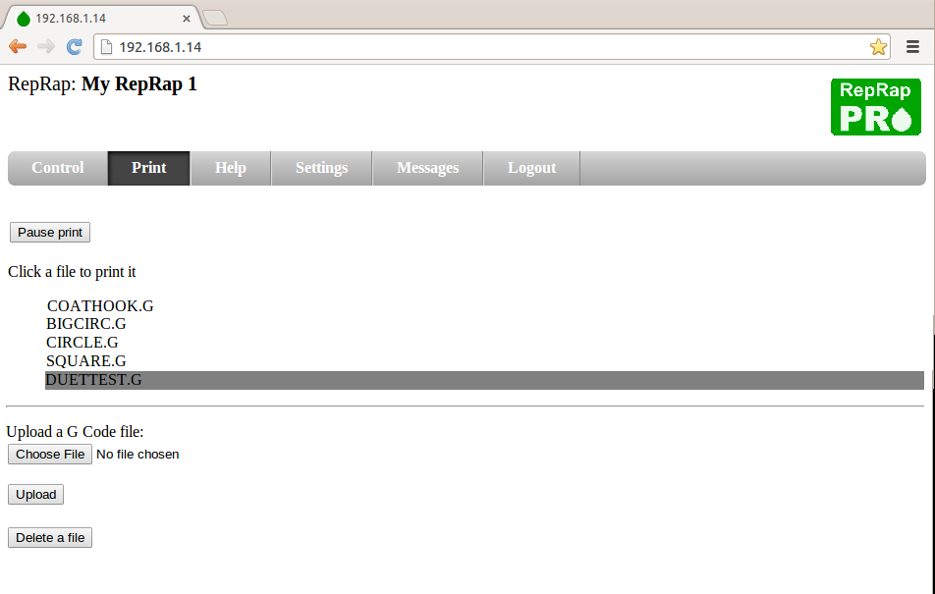
And click on DUETTEST.G.

The motors should spin forwards and backwards, X, then Y, then Z, then the extruder motor. The fan should then turn on, then off, and the heaters should come on and start to rise in temperature.

In the Arduino window you should see the G Codes in the test file as it runs, which will look something like like:

file: M111 S1
file: G21
file: G90
file: M83
file: M906 X800 Y800 Z800 E800
file: T0
file: G1 X50 F500
file: G1 X0
file: G4 P500
file: G1 Y50 F500
file: G1 Y0
file: G4 P500
file: G1 Z20 F200
file: G1 Z0
file: G4 P500
file: G1 E20 F200
file: G1 E-20
file: G4 P500
file: M106 S255
file: G4 P500
file: M106 S0
file: G4 P500
file: M105
T:18.0 B:14.6
file: G10 P0 S100
file: T0
file: M140 S100
file: G4 P5000
file: M105
T:17.1 B:15.0
file: G4 P5000
file: M105
T:17.5 B:15.4
file: G4 P5000
file: M105
T:27.2 B:16.1
file: G4 P5000
file: M105
T:31.7 B:16.5
file: G4 P5000
file: M105
T:45.0 B:17.6
file: G4 P5000
file: M105
T:50.2 B:18.4
file: G4 P5000
file: M105
T:67.1 B:18.4
file: G4 P5000
file: M105
T:70.4 B:19.4
file: G4 P5000
file: M105
T:78.7 B:19.8
file: G4 P5000
file: M105
T:85.9 B:20.5
file: G4 P5000
file: M105
T:90.9 B:20.8
file: G4 P5000
file: M105
T:96.2 B:21.1
file: M0

The lines at the end are reporting the rising temperatures at 5000ms intervals. The extruder should warm up much quicker than the bed, but both should rise in temperature.

The final line (M0) should shut down all the motors and heaters.

Switch off the 12v power, then unplug the USB and the ethernet cable. Disconnect the Duet from the test motors and heaters. The test is now complete.

