2.程序源代码

admin.h

#pragma once

#include<iostream>

#include<string>

#include <vector>

#include <fstream>

#include <iomanip>

using namespace std;

class admin {

private:

string name;

string password;

public:

admin(string a, string b)

{

name = a;

password = b;

}

void useradd();//用户添加

void usermodify();//;用户修改

void userdelete();//用户删除

void useroutput();//用户查看

};

city.h

#pragma once

#pragma once

#include<iostream>

#include<string>

#include <vector>

#include <fstream>

#include <iomanip>

using namespace std;

class city {

public:

string name;

string phonenum;

vector<float> max;

vector<float> min;

vector<float> aver;

vector<float> capacity;//降雨量

float predictedtemperature;

float foresee();//气温预测

};

user.h

#pragma once

#include <iostream>

#include <vector>

#include <fstream>

#include <iomanip>

#include"city.h"

using namespace std;

class user {

public:

string name;//用户名

string cityname;//城市名

string phone;//手机号

string password;//密码

void cityadd();//城市添加

void citymodify();//城市修改

void citydelete();//城市删除

void cityoutput();//打印功能：以表格形式打印用户全部城市信息。

void usersave();//信息（用户）保存

void readFrom(const char filename[]);//信息读取

vector <city> usercity;

friend istream& operator>>(istream&, user&);

user(string name1, string password1,string phone1, string cityname1) {

name1 = name;

password1 = password;

phone1 = phone;

cityname1 = cityname;

}

};

admin.cpp

#include"admin.h"

#include"user.h"

#include <fstream>

#include"city.h"

vector<user> users;

void a1() {

user new1("123", "123", "110", "长沙");

user new2("456", "456", "120", "武汉");

user new3("789", "789", "130", "上海");

users.push_back(new1);

users.push_back(new2);

users.push_back(new3);

}

void admin::useradd() {

user newuser("0","0","0","0");

cout << "请输入新用户的姓名" << endl;

cin >> newuser.name;

cout << "请输入新用户的密码" << endl;

cin >> newuser.password;

cout << "请输入新用户的手机号" << endl;

cin >> newuser.phone;

cout << "请输入新用户的城市信息" << endl;

cin >> newuser.cityname;

ofstream write;

write.open("name.txt", ios::app);

if (!write) {

cerr << "open error!" << endl;

exit(1);

}

write << newuser.name << " " << newuser.password;

write << "\n";

users.push_back(newuser);

cout << "已输入该用户" << endl;

write.close();

fflush(stdin);

getchar();

}

void admin::usermodify() {

string a;

int i = 0;

int n;

bool b = false;

cout << "请输入你要修改的用户：" << endl;

cin >> a;

for (;;i++) {

if (a == users[i].name) {

n = i;

b = true;

break;

}

}

if (!b ) {

cout << "没有找到所要修改的用户：" << endl;

}

else {

cout << "请输入用户的新姓名" << endl;

cin >> users[n].name;

cout << "请输入用户的新密码" << endl;

cin >> users[n].password;

cout << "请输入用户的新手机号" << endl;

cin >> users[n].phone;

cout << "请输入用户的新城市信息" << endl;

cin >> users[n].cityname;

cout << "已输入该用户，按任意键继续" << endl;

fflush(stdin);

getchar();

}

}

void admin::userdelete() {

string a;

cout << "请输入你要删除的用户名" << endl;

cin >> a;

int n,i;

bool b = false;

for (i=0;; i++) {

if (a == users[i].name) {

n = i;

b = true;

break;

}

}

if (!b) {

cout << "没有找到所要修改的用户" << endl;

}

else {

cout << "你却要删除该用户数据吗(Y/N)?" << endl;

char c;

cin >> c;

if (c == 'Y' || c == 'y') {

users.erase(users.begin() + n);

cout << "删除完毕";

}

else if (c == 'N' || c == 'n')

cout << "删除取消";

fflush(stdin);

getchar();

}

}

void admin::useroutput() {

int n;

size_t i;

string b;

bool j = false;

cout << "请输入你要查看信息的用户名";

cin >> b;

for (i = 0; i < users.size(); i++) {

if (b == users[i].name) {

n = i;

j = true;

break;

}

}

if (!j) {

cout << "未找到该用户" << endl;

return;

}

else {

cout << "用户名：" << endl << users[n].name << endl;

cout << "密码：" << endl << users[n].password << endl;

cout << "城市名：" << endl << users[n].cityname << endl;

cout << "手机号：" << endl << users[n].phone << endl;

users[n].cityoutput();

cout << "查看完成" << endl;

fflush(stdin);

getchar();

}

}

city.cpp

#include"city.h"

float city::foresee() {

float t1 = 0, t2 = 0, t3 = 0, t4 = 0, a, b;

for (size_t i = 0; i < aver.size(); i++)

{

t1 += i * i;

t2 += i;

t3 += i * aver[i];

t4 += aver[i];

}

a = (t3 * aver.size() - t2 * t4) / (t1 * aver.size() - t2 * t2);

b = (t1 * t4 - t2 * t3) / (t1 * aver.size() - t2 * t2);

predictedtemperature = a * aver.size() + b;

cout << "预测明天的平均气温为:" << predictedtemperature << endl;

cout << "按任意键继续" << endl;

return predictedtemperature;

fflush(stdin);

getchar();

}

user.cpp

#include"user.h"

#include"city.h"

extern vector<float> max;

extern vector<float> min;

extern vector<float> aver;

extern vector<float> capacity;//降雨量

void user::cityadd() {

city newcity;

int i;

float a;

cout << "请输入电话区号:" << endl;

cin >> newcity.phonenum;

cout << "请输入城市名称:"<<endl;

cin >> newcity.name;

cout << "请输入近三十天最低气温:";

for (i = 0; i < 30; i++) {

cin >> a;

newcity.min.push_back(a);

}

cout << "请输入近三十天平均气温:";

for (i = 0; i < 30; i++) {

cin >> a;

newcity.aver.push_back(a);

}

cout << "请输入近三十天最高气温:";

for (i = 0; i < 30; i++) {

cin >> a;

newcity.max.push_back(a);

}

cout << "请输入近三十天降水量:";

for (i = 0; i < 30; i++) {

cin >> a;

newcity.capacity.push_back(a);

}

usercity.push_back(newcity);

cout << "输入完毕" << endl << "按任意键继续";

fflush(stdin);

getchar();

}

void user::citymodify() {

string b;

int n = 0;

size_t i;

float a;

cout << "请输入你要修改的城市名称或者电话区号";

cin >> b;

bool j = false;

for (i = 0; i < usercity.size(); i++) {

if (b == usercity[i].name || b == usercity[i].phonenum) {

n = i;

j = true;

break;

}

}

if (!j) {

cout << "未找到该城市" << endl;

cout << endl << "按任意键继续";

return;

}

else

{

cout << "请输入城市名称:" << endl;

cin >> usercity[n].name;

cout << "请输入电话区号:";

cin >> usercity[n].phonenum;

cout << "请输入近三十天城市天气最低气温:";

for (i = 0; i < 30; i++) {

cin >> a;

usercity[n].min.push_back(a);

}

cout << "请输入近三十天城市天气平均气温:";

for (i = 0; i < 30; i++) {

cin >> a;

usercity[n].aver.push_back(a);

}

cout << "请输入近三十天城市天气最高气温:";

for (i = 0; i < 30; i++) {

cin >> a;

usercity[n].max.push_back(a);

}

cout << "请输入近三十天城市降水量:";

for (i = 0; i < 30; i++) {

cin >> a;

usercity[n].capacity.push_back(a);

}

cout << "修改完毕" << endl << "按任意键继续";

fflush(stdin);

getchar();

}

}

void user::citydelete() {

string b;

int n = 0;

size_t i;

char a;

cout << "请输入你要删除的城市名称或者电话区号";

cin >> b;

bool j = false;

for (i = 0; i < usercity.size(); i++) {

if (b == usercity[i].name || b == usercity[i].phonenum) {

n = i;

j = true;

break;

}

}

if (!j) {

cout << "未找到该城市" << endl;

return;

}

else {

cout << "你却要删除该城市数据吗(Y/N)?" << endl;

cin >> a;

if (a == 'Y' || a == 'y') {

usercity.erase(usercity.begin() + n);

cout << "删除完毕";

}

else if (a == 'N' || a == 'n')

cout << "删除取消";

fflush(stdin);

getchar();

}

}

void user::cityoutput() {

size_t i, j;

for (i = 0; i < usercity.size(); i++) {

cout << "--------------------------------------------" << endl;

cout << "|" << setw(9) << usercity[i].name << "|" << setw(9) << usercity[i].phonenum << "|" << endl;

cout << "--------------------------------------------" << endl;

cout << endl << "|" << "近三十天最低气温" << endl;

for (j = 0; j < 30; j++) {

cout << setw(4) << usercity[i].min[j] << " ";

}

cout << endl << "|" << "近三十天平均气温" << endl;

for (j = 0; j < 30; j++) {

cout << setw(4) << usercity[i].aver[j] << " ";

}

cout << endl << "|" << "近三十天最高气温" << endl;

for (j = 0; j < 30; j++) {

cout << setw(4) << usercity[i].max[j] << " ";

}

cout << endl << "|" << "近三十天降水量" << endl;

for (j = 0; j < 30; j++) {

cout << setw(4) << usercity[i].capacity[j] << " ";

}

cout << endl << "|" << "预测平均气温" << endl;

cout << usercity[i].predictedtemperature;

}

cout << endl << "按任意键继续" << endl;

fflush(stdin);

getchar();

}

void user::usersave() {

size_t i, j;

ofstream write;

write.open("userdata.txt", ios::app);

if (!write) {

cerr << "open error!" << endl;

exit(1);

}

write << name << " " << password << " " << cityname << " " << phone << " ";

write << "\n";

write.close();

write.open("citydata.txt", ios::app);

if (!write) {

cerr << "open error!" << endl;

exit(1);

}

write << name << " " << password << " " << cityname << " " << phone << " ";

for (i = 0; i < usercity.size(); i++) {

for (j = 0; j < usercity.size(); j++) {

write << usercity[i].name << " " << usercity[i].phonenum << " ";

}

}

for (i = 0; i < usercity.size(); i++) {

for (j = 0; j < 30; j++) {

write << usercity[i].min[j] << " ";

}

}

for (i = 0; i < usercity.size(); i++) {

for (j = 0; j < 30; j++) {

write << usercity[i].aver[j] << " ";

}

}

for (i = 0; i < usercity.size(); i++) {

for (j = 0; j < 30; j++) {

write << usercity[i].max[j] << " ";

}

}

for (i = 0; i < usercity.size(); i++) {

for (j = 0; j < 30; j++) {

write << usercity[i].capacity[j] << " ";

}

}

write << "\n";

write.close();

write.open("name.txt", ios::app);

if (!write) {

cerr << "open error!" << endl;

exit(1);

}

write << name<<" "<<password;

write << "\n";

write.close();

write.open("password.txt", ios::app);

if (!write) {

cerr << "open error!" << endl;

exit(1);

}

write << password ;

write << "\n";

write.close();

cout << "已保存，按任意键继续" << endl;

fflush(stdin);

getchar();

}

void user::readFrom(const char filename[])

{

ifstream inFile;

inFile.open(filename);

inFile >> name >>password ;

inFile.close();

}

istream& operator>>(istream& input, user& s)

{

cout << "输入用户数据：" << endl;

cout << "用户名：";

input >> s.name;

cout << "密码：";

input >> s.password;

return input;

}

main.cpp

#include"admin.h"

#include"user.h"

#include"city.h"

#include <iostream>

#include <vector>

#include <fstream>

#include <istream>

#include <iomanip>

#include<sstream>//使用string流

using namespace std;

admin ope("admin", "admin");

extern vector<user> users;

extern vector<city> usercity;

void _admin();

void userl(int a);

int userlogin1(vector<user> users);

int main()

{

int b;

void userlogin();

void _admin();

void userl(int);

void a1();

void colormenu();

A: cout << " 天气管理与预测系统" << endl;

cout << " ---------------------------------------------" << endl;

cout << " | |" << endl;

cout << " | 1.管理员登录 |" << endl;

cout << " | 2.用户登录 |" << endl;

cout << " | 3.更换皮肤 |" << endl;

cout << " | 0.退出系统 |" << endl;

cout << " | |" << endl;

cout << " ---------------------------------------------" << endl;

cout << "请输入您想要执行的指令:" << endl;

cin >> b;

switch (b) {

case 1: {

userlogin();

}

case 2:

{ int c;

c = userlogin1(users);

if (c = 0) { goto A; }

else userl(c);

}

case 3: colormenu();

goto A;

break;

default:

exit(0);

}

return 0;

}

void userlogin()

{

string a, b;

int n=0;

size_t i;

cout << "请输入用户名" << endl;

cin >> a;

cout << "请输入密码" << endl;

cin >> b;

if (a == "admin" && b == "admin") {

_admin();

}

}

void _admin()

{

int a;

cout << "管理员登陆" << endl;

A: cout << endl;

cout << " -----------------------------------------------------------------------" << endl;

cout << " | 1.用户添加 |" << endl;

cout << " | 2.用户修改 |" << endl;

cout << " | 3.用户删除 |" << endl;

cout << " | 4.用户查看 |" << endl;

cout << " | 0.返回上一级 |" << endl;

cout << " -----------------------------------------------------------------------" << endl;

cout << "请输入您想要执行的指令:";

cin >> a;

switch (a) {

case 0:

main();

case 1:

ope.useradd();

goto A;

case 2:

ope.usermodify();

goto A;

case 3:

ope.userdelete();

goto A;

case 4:

ope.useroutput();

goto A;

default:

cout << "请核对后重新输入指令~";

goto A;

}

}

int userlogin1(vector<user> users)

{

string a, b;

int n = 0;

size_t i;

C: cout << "请输入用户名" << endl;

cin >> a;

cout << "请输入密码" << endl;

cin >> b;

bool j = false;

for (i = 0; i < 3; i++) {

if ((a == users[i].name && b == users[i].password)) {

n = i;

j = true;

break;

}

if ((a != users[i].name && b == users[i].password) ) {

cout << "未找到该用户" << endl;

cout << endl << "请重新输入" << endl;

goto C;

}

if ((a == users[i].name && b != users[i].password)) {

cout << "密码错误" << endl;

cout << endl << "请重新输入" << endl;

goto C;

}

}

return n;

}

void userl(int a)

{

int ins;

cout << "用户登陆" << endl;

B: cout << endl;

cout << " -----------------------------------------------------------------------------------" << endl;

cout << " | 1.城市添加 |" << endl;

cout << " | 2.城市修改 |" << endl;

cout << " | 3.城市删除 |" << endl;

cout << " | 4.天气预测 |" << endl;

cout << " | 5.打印功能 |" << endl;

cout << " | 6.信息保存 |" << endl;

cout << " | 0.返回上一级 |" << endl;

cout << " -----------------------------------------------------------------------------------" << endl;

cout << "请输入您想要执行的指令:";

cin >> ins;

switch (ins) {

case 0:

main();

case 1:

users[a].cityadd();

goto B;

case 2:

users[a].citymodify();

goto B;

case 3:

users[a].citydelete();

goto B;

case 4:

{

string b;

int n = 0;

size_t i = 0;

bool j = false;

D: cout << "请输入你要预测的城市名称或电话区号";

cin >> b;

for (i = 0; i < users[a].name.size(); i++) {

if (b == users[a].usercity[i].name || b == users[a].usercity[i].phonenum) {

n = i;

j = true;

break;

}

}

if (!j) {

cout << "未找到该城市" << endl;

cout << endl << "请重新输入" << endl;

goto D;

}

else {

users[a].usercity[n].predictedtemperature = users[a].usercity[n].foresee();

goto B;

}

}

case 5:

users[a].cityoutput();

goto B;

case 6:

users[a].usersave();

goto B;

default:

cout << "请核对后重新输入指令~";

goto B;

}

}

void colormenu()

{

string key;

int m;

cout << "\n\n";

cout << "\t|———请选择一下您的主题颜色—|\n";

cout << "\t|--------1.蓝底黑字------------|\n";

cout << "\t|--------2.蓝底青字------------|\n";

cout << "\t|--------3.黑底黄字------------|\n";

cout << "\t|--------4.绿底红字------------|\n";

cout << "\t|--------5.白底紫字------------|\n";

cout << "\t|--------6.白底黑字------------|\n";

cout << "\t|———————————————|\n";

cout << "\n请输入你喜欢的颜色1~6:\n";

m = 1;

cin >> key;

if (key.length() == 1)

switch (key[0])

{

case '1':

system("color 10");

break;

case '2':

system("color 1a");

break;

case '3':

system("color 06");

break;

case '4':

system("color 24");

break;

case '5':

system("color 75");

break;

case '6':

system("color 70");

break;

default:

printf("输入错误!\n");

break;

}

else

cout << "输入错误！" << endl;

}

四、调试运行结果并显示输入数据和输出结果

主菜单

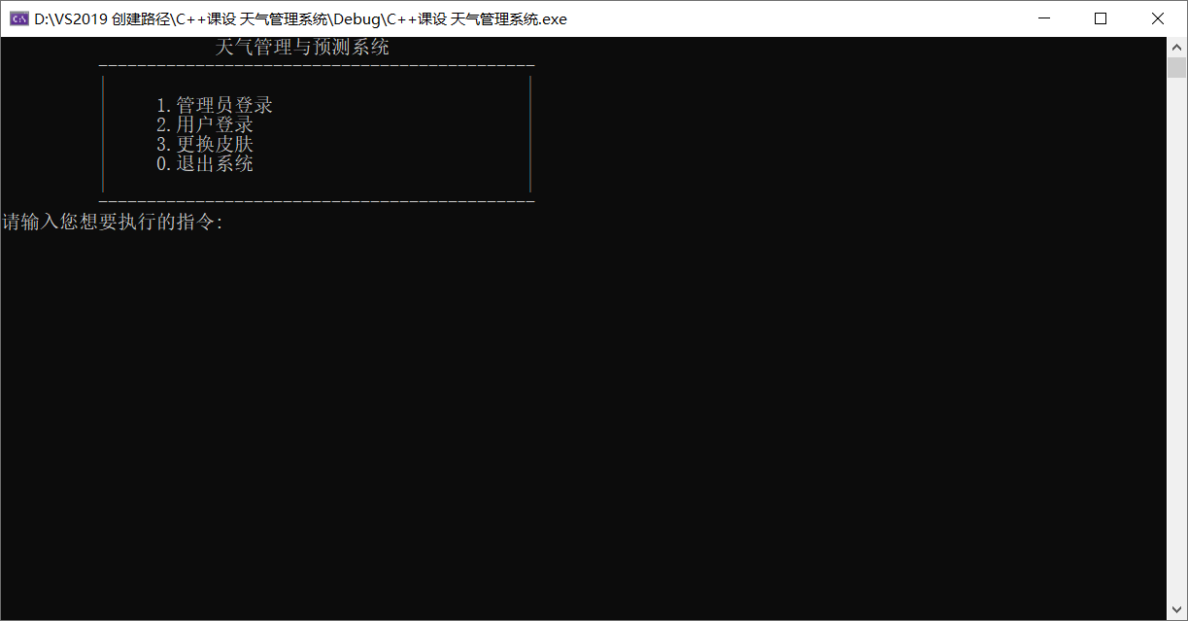

管理员登录

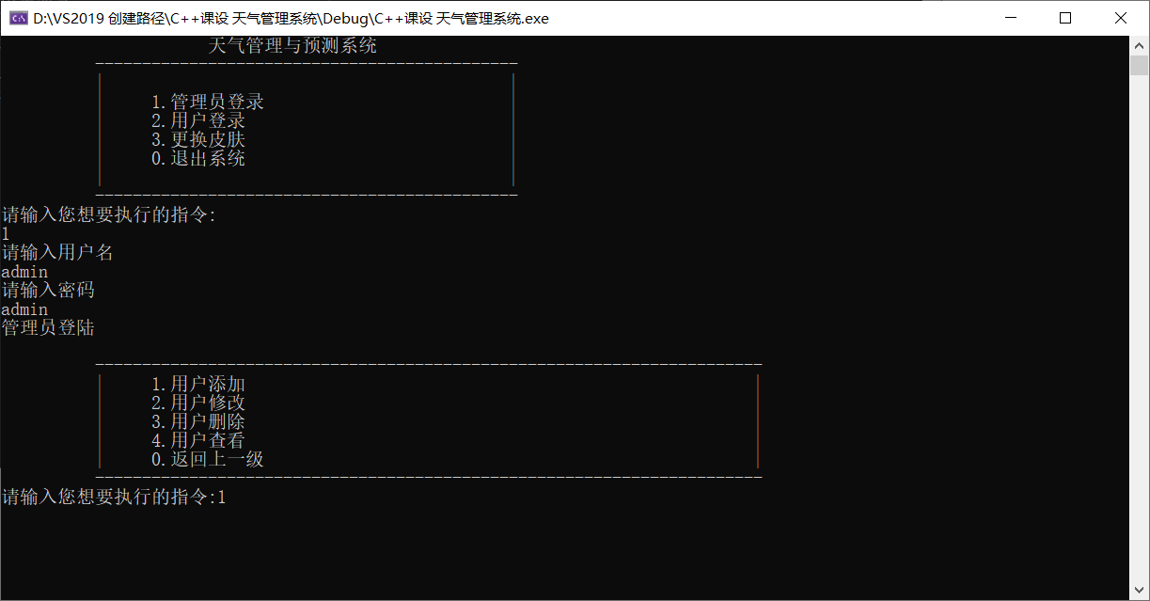

添加用户

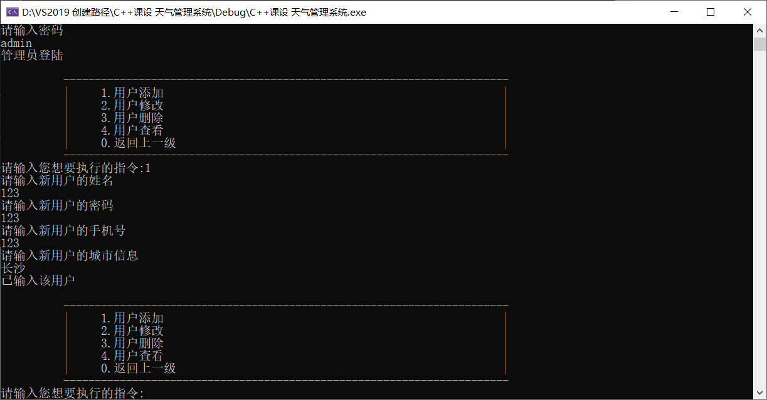

修改用户

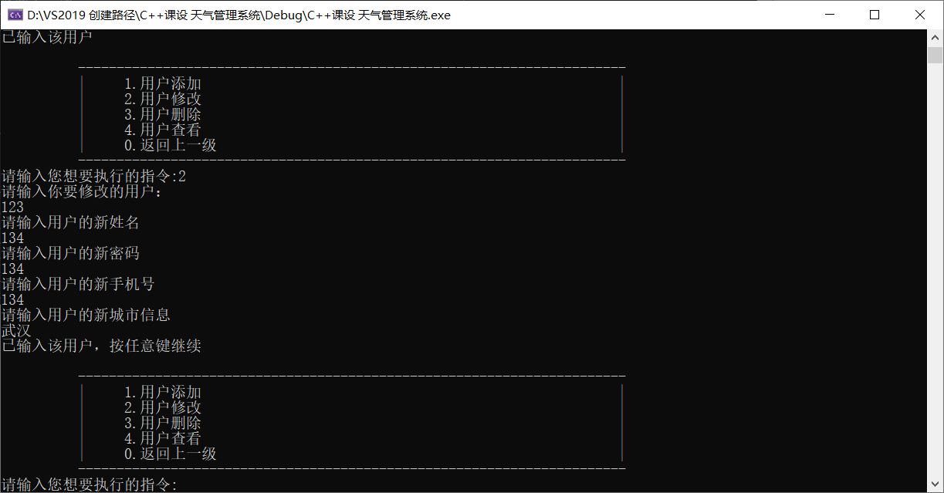

用户查看

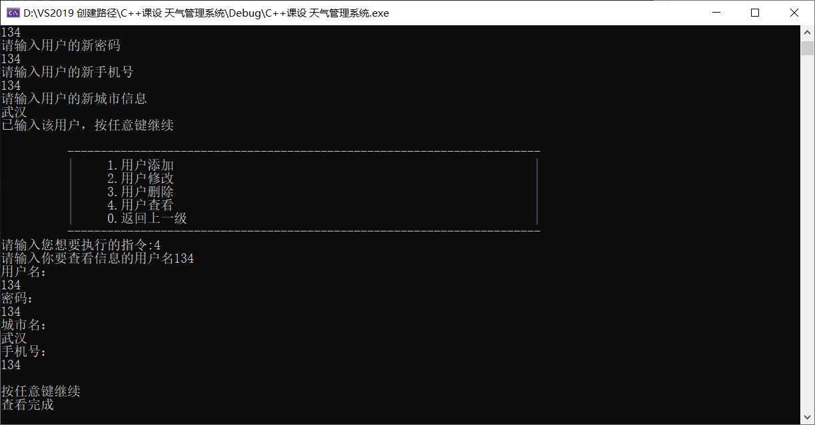

用户登录

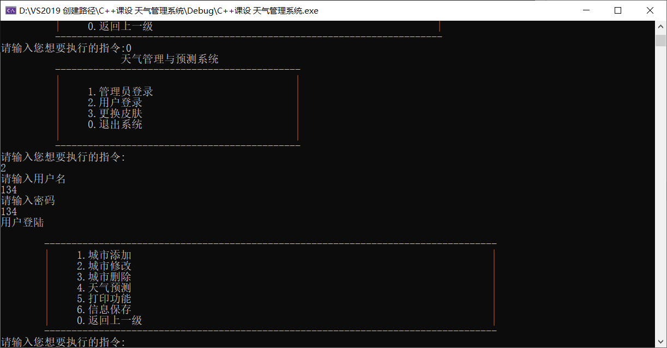

城市添加

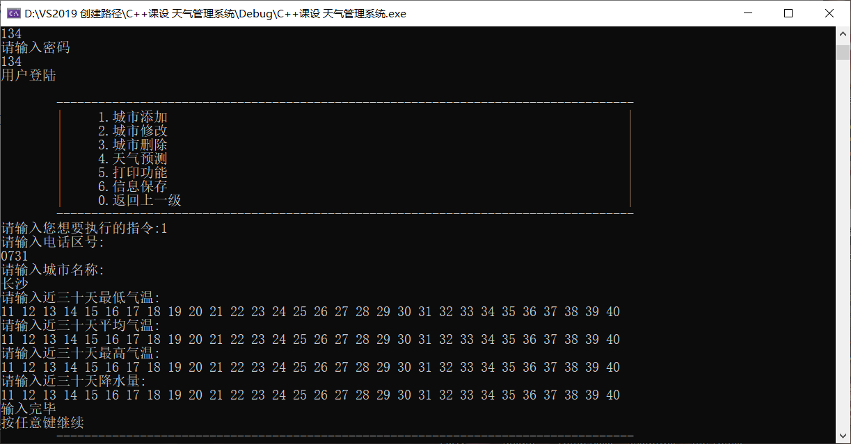

城市修改

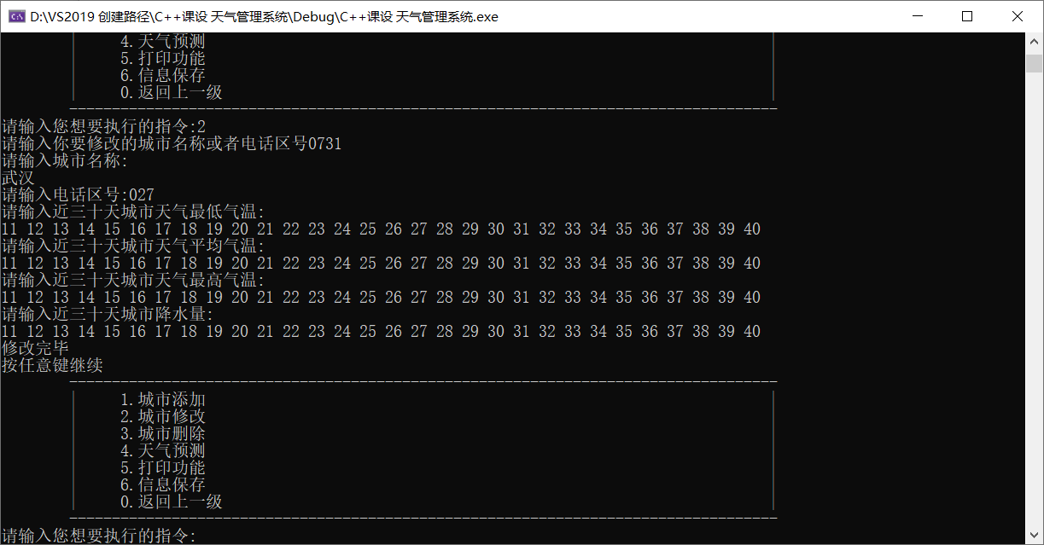

天气预测

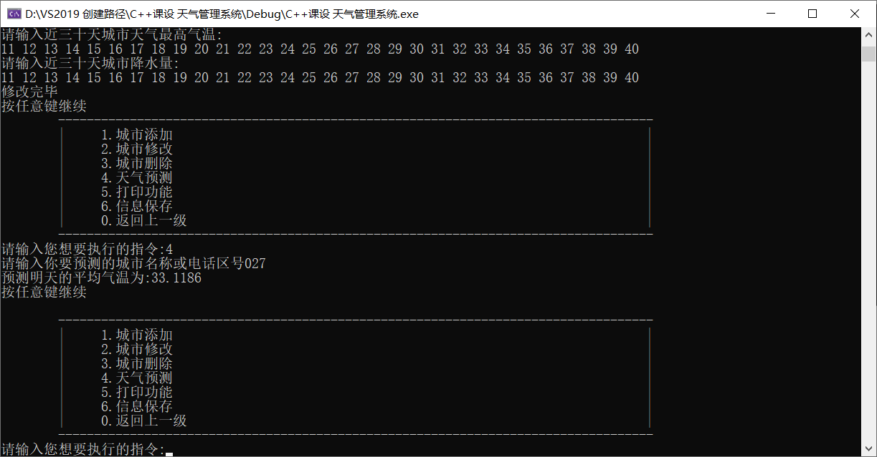

打印功能

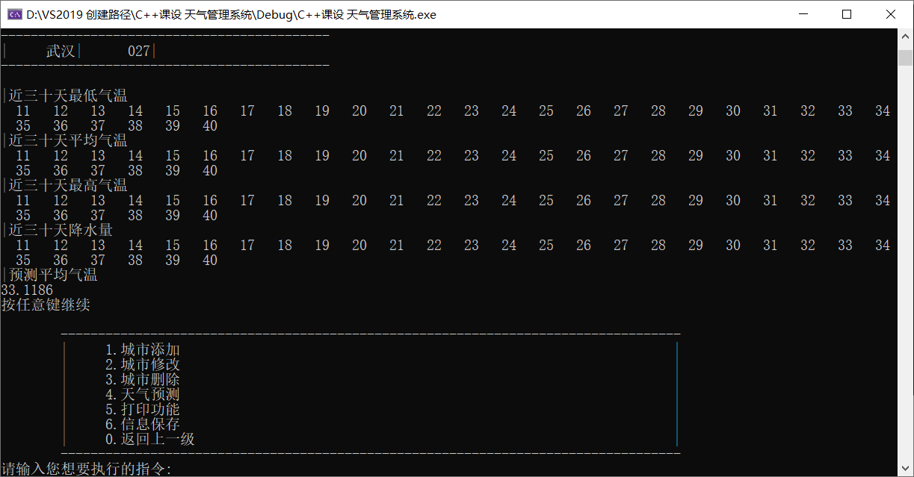

城市删除

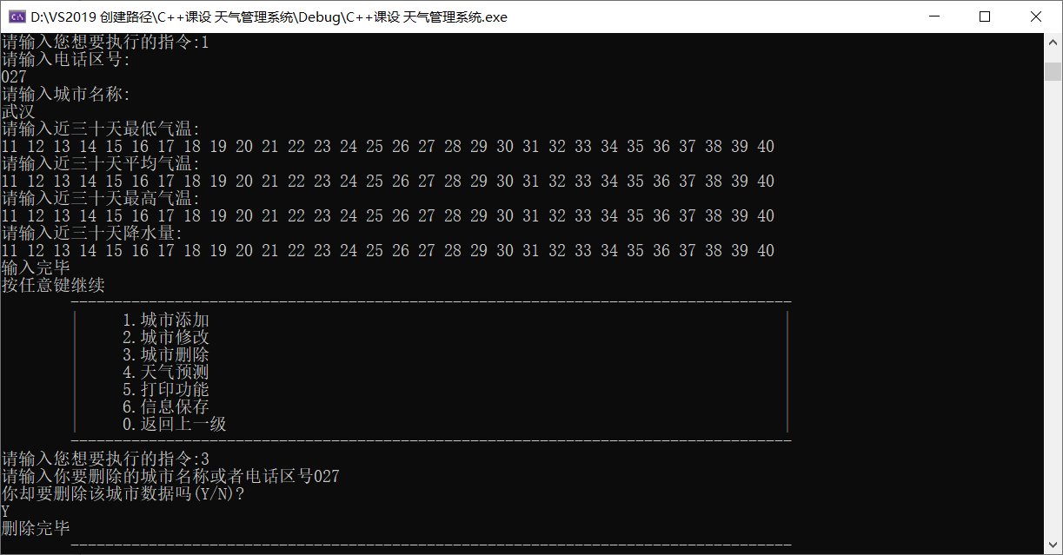

信息保存（已又输入长沙的城市信息）

