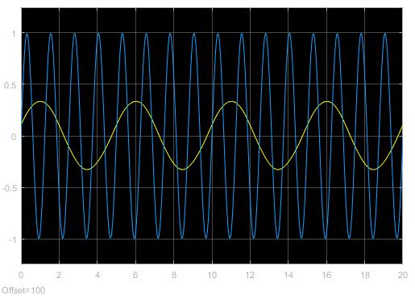

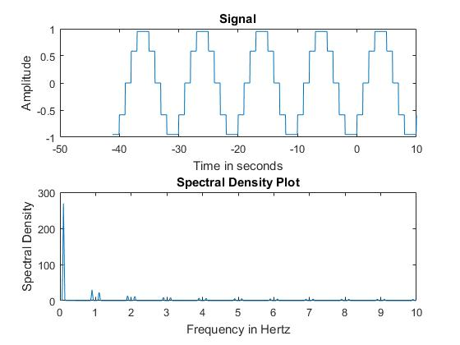

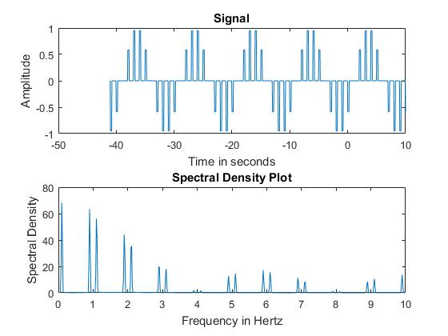

Section 6

music = audioread('music.au');

%sound(music);

sig1 = music(1:2:end);

%sound(sig1)

LPF = fir1(20,1/2);

y = conv(music,LPF);

sig2 = y(1:2:end);

sound(sig2)