ECE 438 Lab, division 1

Lab 09, Speech Processing

Shijia Shu, [50%]_ _ _ _ _ _ _

Junyan Shi, [50%]_ _ _ _ _ _ _

April 14 , 2016

Section 2.2

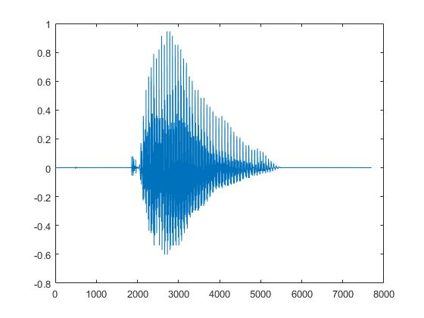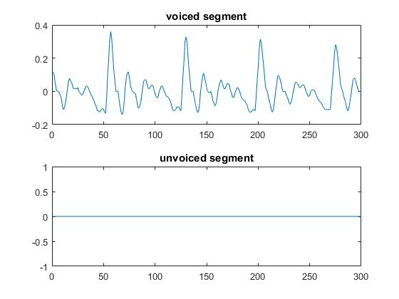

1. Pitch period = 8 ms

Speaker is male

1. For voiced segment, P = 0.0087, # zeros = 13

For unvoiced segment, P = 0, # zeros = 0

function [y] = zero_cross(x)

%ZERO_CROSS Summary of this function goes here

% Detailed explanation goes here

y = 0;

for i = 1:length(x)-1

if (x(i)*x(i+1)<0)

y = y + 1;

end

end

end

Section 3.1

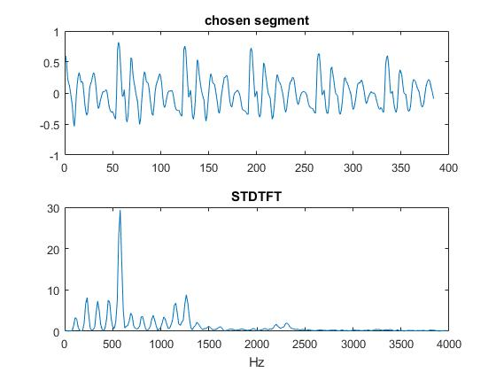

F1 = 550 Hz, F2 = 1300 Hz

function [A] = Specgm(x,L,overlap,N)

%SPECGM Summary of this function goes here

% Detailed explanation goes here

A = zeros(N,ceil(2*length(x)/L));

inds = 1;

inde = L;

cnt = 1;

while(inde < length(x))

X = DFTwin(x(inds:inde)',L,1,N);

A(:,cnt) = X ;

cnt = cnt + 1;

inds = inde - overlap + 1;

inde = inds + L - 1;

end

A = A(1:N/2+1,1:cnt-2);

end

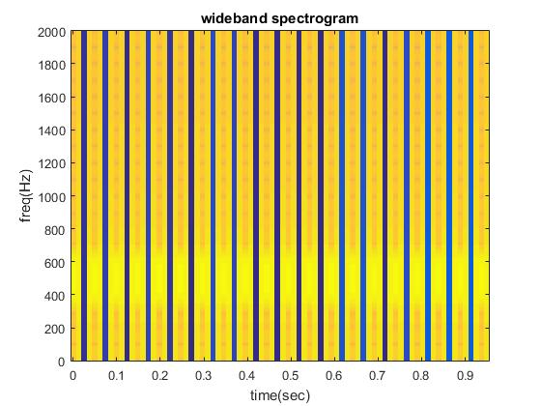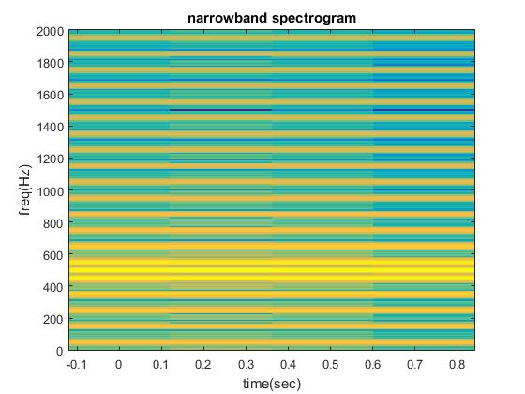

Section 3.3

