ECE 438 Lab, division 1
Lab 06 (week 08): Discrete Fourier Transform
and Fast Fourier Transform Algorithm (2)

Shijia Shu, [50%]_ _ _ _ _ _ _
Junyan Shi, [50%]_ _ _ _ _ _ _

March 10, 2016

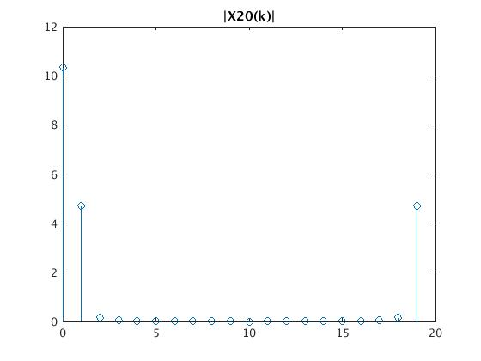
2.1

function [X,w] = DTFTsamples(x)
%DTFTSAMPLES Summary of this function goes here
% Detailed explanation goes here
N = length(x);
X = DFTsum(x);
k = 0:N-1;
w = 2*pi*k/N;
w(w>=pi) = w(w>=pi)-2*pi;
X = fftshift(X);
w = fftshift(w);
end

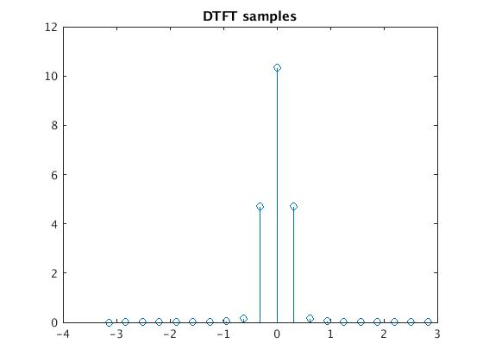

2.2

DT samples for N=5 and N=200

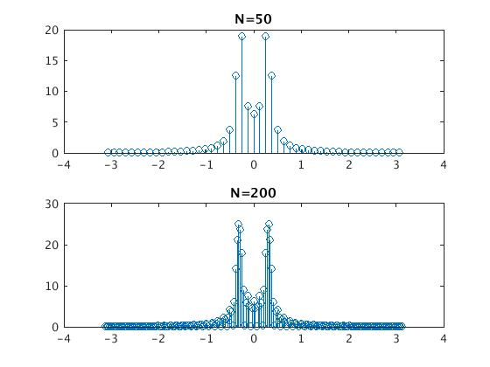

3.1
function X = dcDFT(x)
%DCDFT Summary of this function goes here
% Detailed explanation goes here
N = length(x);
X = zeros(1,N);
x0 = x(1:2:N);
x1 = x(2:2:N);
X0 = DFTsum(x0);
X1 = DFTsum(x1);

for k = 1:N/2
X(k) = X0(k) + exp(-i*2*pi*(k-1)/N) * X1(k);
X(k+N/2) = X0(k) - exp(-i*2*pi*(k-1)/N) * X1(k);

end

3.2

1.

function X = FFT2(x)
%FFT2 Summary of this function goes here
% Detailed explanation goes here
X = zeros(1,2);
X(1) = x(1) + x(2);
X(2) = x(1) - x(2);

end

function X = FFT4(x)
%FFT4 Summary of this function goes here
% Detailed explanation goes here
N =4;
X = zeros(1,N);
x0 = x(1:2:N);
x1 = x(2:2:N);
X0 = FFT2(x0);
X1 = FFT2(x1);

for k = 1:N/2
X(k) = X0(k) + exp(-i*2*pi*(k-1)/N) * X1(k);
X(k+N/2) = X0(k) - exp(-i*2*pi*(k-1)/N) * X1(k);

end

function X = FFT8(x)
%FFT8 Summary of this function goes here
% Detailed explanation goes here
N = 8;
X = zeros(1,N);
x0 = x(1:2:N);
x1 = x(2:2:N);
X0 = FFT4(x0);
X1 = FFT4(x1);

for k = 1:N/2
X(k) = X0(k) + exp(-i*2*pi*(k-1)/N) * X1(k);
X(k+N/2) = X0(k) - exp(-i*2*pi*(k-1)/N) * X1(k);

end

2.

N = 8;
n = 0:N-1;
x = ((n>=0)-(n>N));
X = FFT8(x)

X =

1 1 1 1 1 1 1 1

3.

function X = fft_stage(x)
%FFT_STAGE Summary of this function goes here
% Detailed explanation goes here
N = length(x);
X = zeros(1,N);
if (N == 2)
X(1) = x(1) + x(2);
X(2) = x(1) - x(2);
else
x0 = x(1:2:N);
x1 = x(2:2:N);
X0 = fft_stage(x0);
X1 = fft_stage(x1);
for k = 1:N/2
X(k) = X0(k) + exp(-i*2*pi*(k-1)/N) * X1(k);
X(k+N/2) = X0(k) - exp(-i*2*pi*(k-1)/N) * X1(k);
end

end

