ECE 438 Lab, division 1
Lab 07 (week 11): Discrete-Time Random Process (Week 2)

Shijia Shu, [50%]_ _ _ _ _ _ _
Junyan Shi, [50%]_ _ _ _ _ _ _

March 30, 2016

Section 1.2
1

2
because pxz is the theoretical correlation coefficient, while pxz' is just an estimation using the samples. They are not exactly equal, but close enough.

3
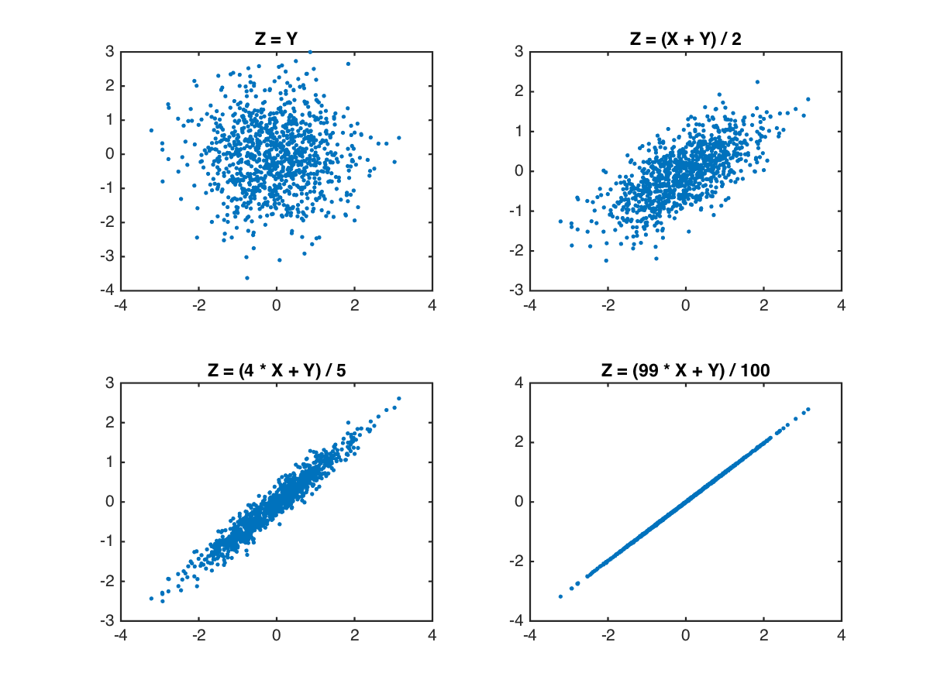
4
The greater the pxz is, the plots is more close to the line: Z=X;
The smaller the pxz is, which means X and Z are less correlated, so the plot looks like a bunch of random dots.

Section 2
2.2
1)
2)
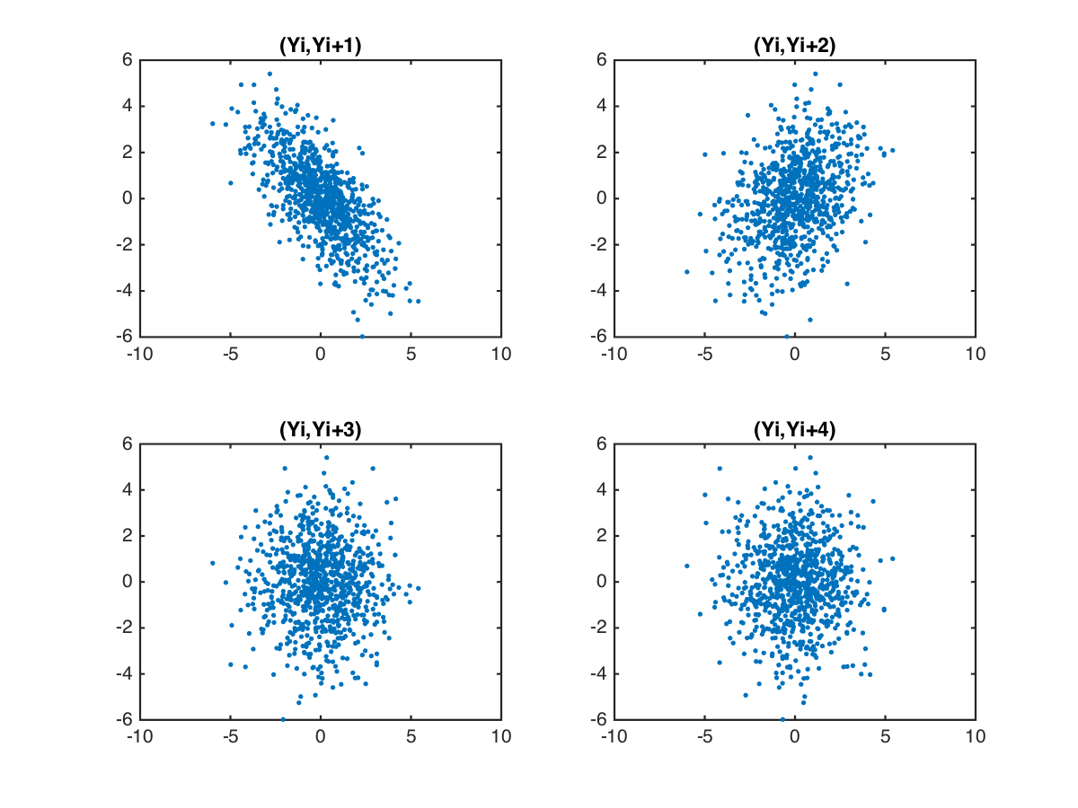

3) 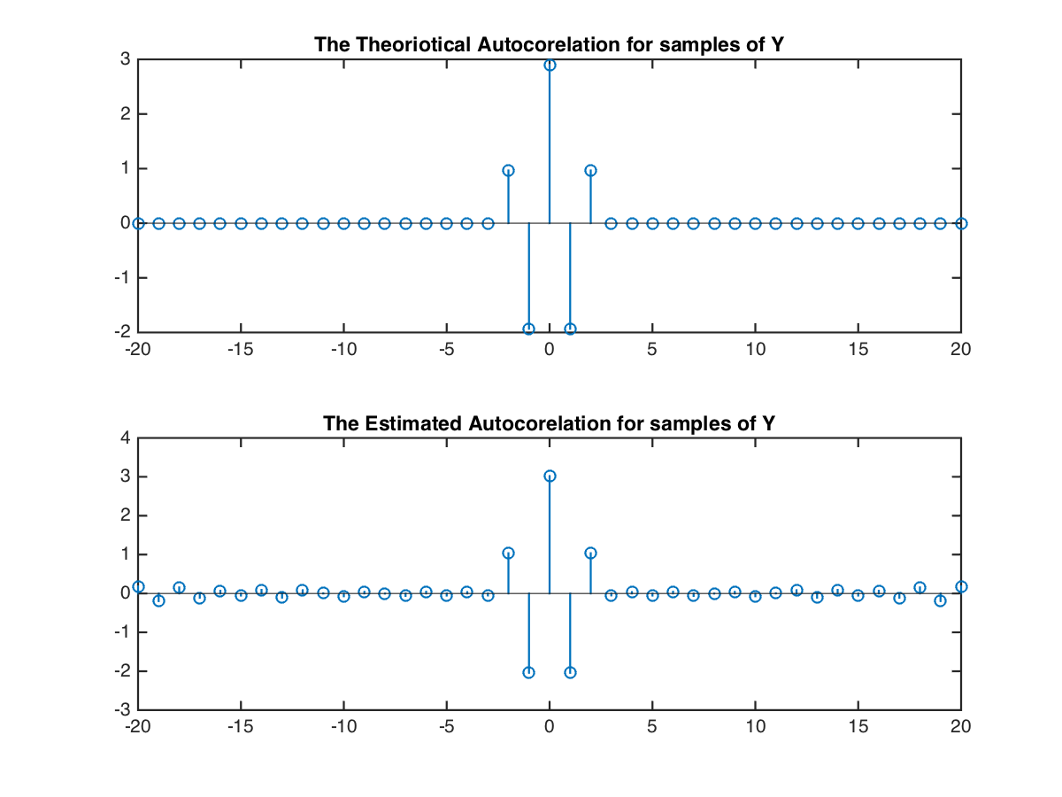
The equation (13) do produce a reasonable approximation of true auto correlation.
For both cases, when m = 0, ryy and ryy’ both reach their maximum.

4)
%2.2
N = 1000;
X = randn(1,N);
n = 1:1000;
Y = zeros(1,N);
Y(3:1000) = X(3:N) - X(2:N-1) + X(1:N-2);
figure (2)
subplot(2,2,1)
plot(Y(1:900),Y(2:901),'.')
title('(Yi,Yi+1)')
subplot(2,2,2)
plot(Y(1:900),Y(3:902),'.')
title('(Yi,Yi+2)')
subplot(2,2,3)
plot(Y(1:900),Y(4:903),'.')
title('(Yi,Yi+3)')
subplot(2,2,4)
plot(Y(1:900),Y(5:904),'.')
title('(Yi,Yi+4)')
saveas(gcf,'2.png')
%%
%Estimate sample autocorrelation
N = 1000;
X = randn(1,N);
Y = zeros(1,N);
Y(3:N) = X(3:N) - X(2:N-1) + X(1:N-2);
m = -20:20;
h1 = (m==0) - (m==1) + (m==2);
h2 = (m==0) - (m==-1) + (m==-2);
rxx = var(X).*(m == 0);
ryy_theory = conv(conv(h1,h2),rxx);

ryy_estimate = zeros(1,2*21-1);

part1 = 0;

for i = 1: (2*21 - 1)
for n = 1 : (N - abs(m(i)))
part1 = part1 + Y(n) * Y(n+abs(m(i)));
end
ryy_estimate(i) = 1 / (N - abs(m(i))) * part1;
part1 = 0;
end
h1 = (m==0) - (m==1) + (m==2);
h2 = (m==0) - (m==-1) + (m==-2);
rxx = var(X).*(m == 0);
ryy_theory = conv(conv(h1,h2),rxx);
figure (3)
subplot(2,1,1)
stem(m,ryy_theory(41:81))
title('The Theoriotical Autocorelation for samples of Y')
subplot(2,1,2)
stem(m,ryy_estimate)
title('The Estimated Autocorelation for samples of Y')
Section 3
3.2
Part1
1)
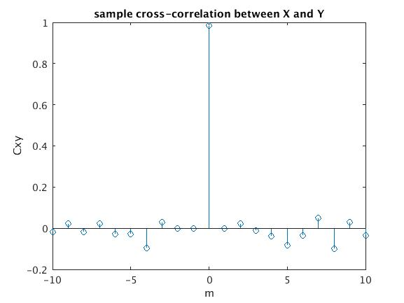

2)
When m =0, the largest cross-correlation occurs. Because there is no delay between two random variables.
3)
No.
It's not necessary that Cxy(m) = Cxy(-m)
4)
function [C] = CorR(X,Y,m)
%CORR Summary of this function goes here
% Detailed explanation goes here
N = length(X);
if (m >= 0 & m <= N-1)
C = 1/(N-m)*X(1:N-m)*Y(1+m:N)';
elseif (m >= 1-N & m <0)
C = 1/(N-abs(m))*X(abs(m)+1:N)*Y(1:N+m)';

end

Part 2
1)
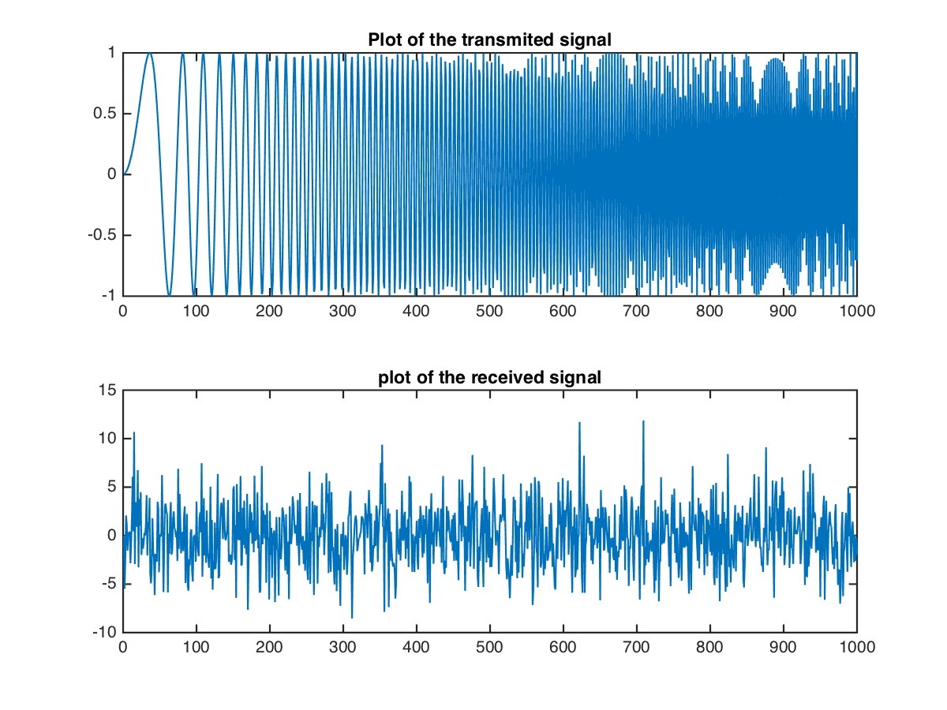
It is hard to estimate the delay by inspection.

2)
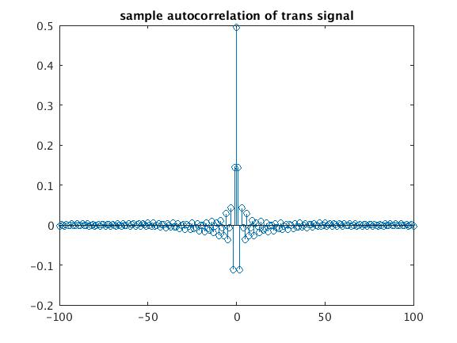

3)
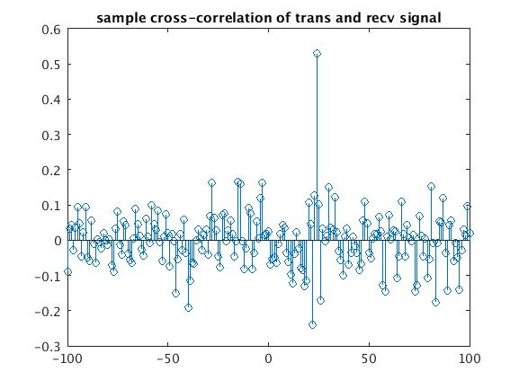
4)
D = the value of m when Cxy(m) is max:

D = find(cxy==max(cxy)) - 100
D =

25

