Feasibility Model Design

F2019 – Edit this document into a deliverable.

|  |  |  |  |
| --- | --- | --- | --- |
| Lab Section: | 5 | Group: | 4 |

# System-Level Design

Our ECE 298 projects start with a conceptual architecture, like the block diagram in Figure 1a). Specific example in Figure 1b). **Replace this figure with a high-level block diagram of your system.**

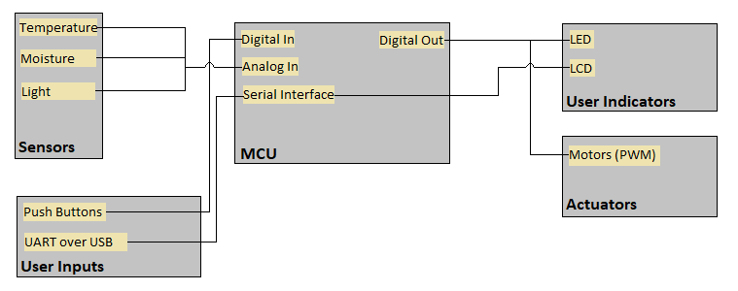

## Project Design Requirements

In PD 21 you learned about engineering requirements. they fall into three major categories, as follows:

1. **Functional requirements** are quantities that specify the performance of a design. They are related to the functions of the design, identified as answers to the question, "What does it do?" For example, a functional requirement for a coffee maker may specify the time required to brew a pot of coffee, a DC power supply may specify its maximum voltage, and a vehicle alarm system may specify how much noise it makes when it is set off
2. **Non-functional requirements** specify characteristics of the design that are not performance based. Theses are typically features or qualities that are desirable to the client. For example, ease of use, ease of manufacturing, and use of recycled materials.
3. **Constraint requirements** place limits on the design space, and often reflect budget or other project limitations. For example, cost, weight, and noise.

The basic form of most of these requirements is the same: a short description, followed by a relationship (equals, less than, or greater than) and a value.

**State three to five major Functional Requirements that your project must meet to successfully solve your problem statement.**

1. Must determine temperature
2. Must determine soil moisture
3. Must distinguish daytime vs nighttime
4. Must be able to drive motors based on sensor input
5. Must be able to accept threshold conditions for activation of motors over UART/USB from a computer

## Project Sensors and User Inputs

* List the types of sensors and user inputs you may require (light, sound, temperature, magnetic field).
* For each sensor and user input, list how you will connect it to the MCU, including additional interface components, if needed.

1. Temperature sensors (2-5V)
   1. Connect using ADC to analog input
2. Light sensor
   1. Photoresistor so implemented as a voltage splitter circuit
   2. Connect using ADC to analog input
3. Moisture sensor (2-5V)
   1. Operation voltage is 2-5V and output is analog so no voltage stepping needed
   2. Might require and op amp to amplify the signal
   3. Connect using ADC to analog input
4. Push Buttons
   1. Connect directly to GPIO

## Project Actuators and Indicators

* List the types of actuators and indicators you may require (e.g. light, sound, mechanical motion)
* For each actuator and indicator, list how you will connect it to the MCU, including additional interface components, if needed.

1. Motors
   1. Motor needs external high-power 5V source (due to current surges)
2. LEDS
   1. Connect to GPIO

## Project MCU Peripherals

* List the resources inside the MCU that could be used to implement your project (e.g. ADC, timers, interrupts, GPIO functions).
* List parameters that the software running on the MCU might require.

1. MCU Resources
   1. GPIO (LEDs, Push Buttons)
   2. Interrupts (Push Buttons)
   3. PWM (Motor Actuators)
   4. ADC (Sensors)
2. Software Parameters
   1. Threshold Conditions for activation of the motors
   2. Push button input to toggle between the two zones

## Project Testing Methodology

* For each sensor, user input, actuator, indicator, and MCU peripheral listed above, state how you will verify that each one is functioning as expected (a table may be helpful)
* State how you will validate that each Project Design Requirement has been met

|  |  |
| --- | --- |
| **Part** | **Methodology** |
| Light sensor | Set up voltage divider and read voltage drop using a resistor (while varying light intensity) |
| Temperature sensor | Read temperature in area with known temperature. Test analog output voltage with multimeter |
| Moisture sensor | Test in dry vs wet soil and measure analog output with multimeter |
| Motors | Send pwm signal to motor using function generator and monitor output |
| LEDs | Use 3v3 rail and resistor on board to test functionality |
| Must determine temperature | Use the serial port to determine whether valid readings and interpretations are being received from the analog input of the MCU from the temperature sensor |
| Must determine soil moisture | Use the serial port to determine whether valid readings and interpretations are being received from the analog input of the MCU from the moisture sensor. Try with very dry and very wet soil |
| distinguish daytime vs nighttime | Use the serial port to determine whether valid readings and interpretations are being received from the analog input of the MCU from the light sensor. |
| Must be able to drive motors based on sensor input | Connect and test sensors. Once sensors are validated, use sensor readings to drive motors. Test motor output using extreme conditions (complete light vs complete dark, very wet vs very dry, very cold vs very hot). Can alternatively validate, by printing motor PWM values to consol upon changes in environment conditions. |
| Must be able to accept  threshold conditions for activation of motors over UART/USB from a computer | Complete transfer over USB/UART and then print variable values to console. |

# Feasibility Model Diagram and Software Flowchart (High-Level)

A simplified example is shown in Figure 2 and Figure 3. **Replace these figures with high-level block diagrams of your system.**

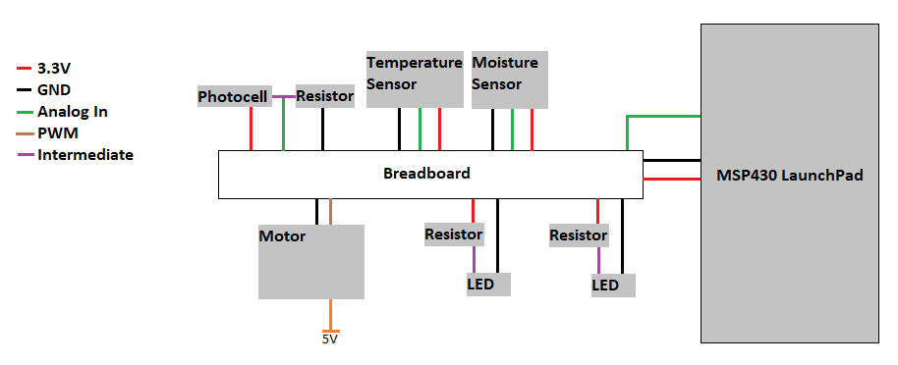

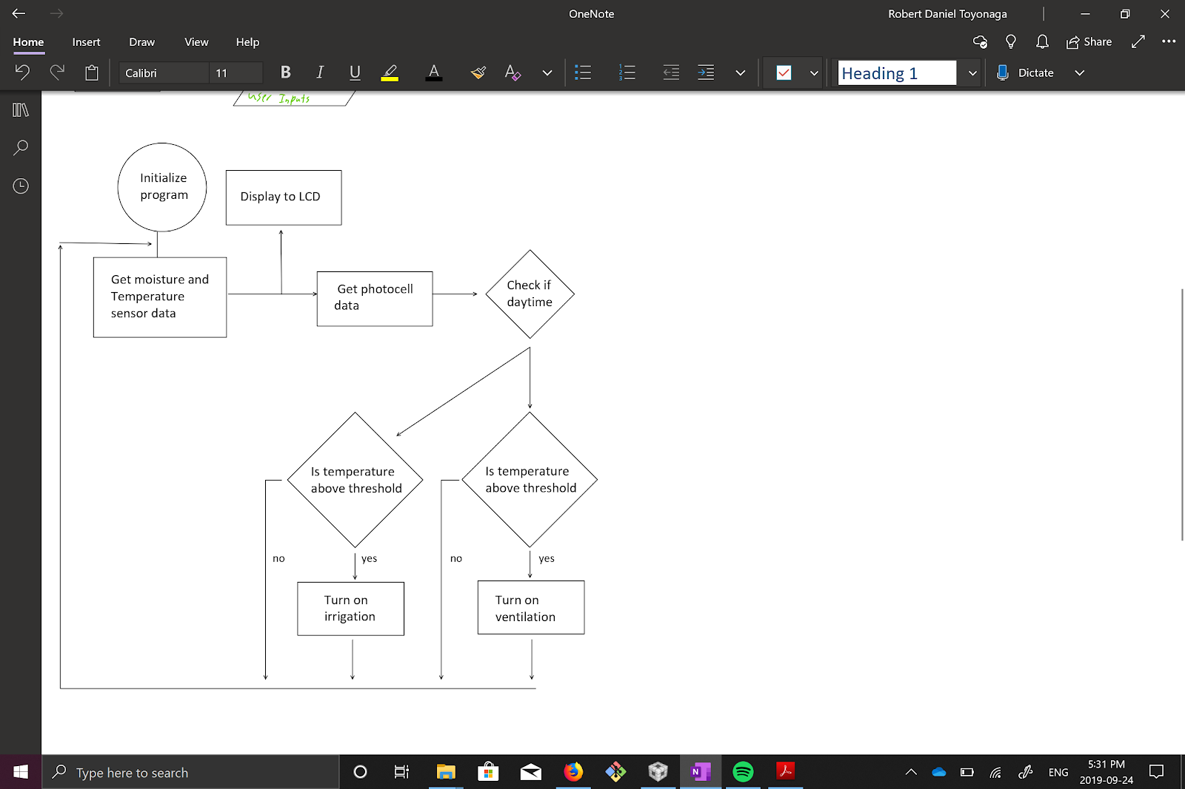

## Initial Bill of Materials

* List what modules and components (including quantities) are needed from the ECE 298 Parts spreadsheet for your Feasibility Model Design

|  |  |  |  |  |  |
| --- | --- | --- | --- | --- | --- |
| **ECE-298 F2019 MODULES and COMPONENTS ORDER LIST** | | | | | |
| LAB SESSION NUMBER: 5 | | TEAM NUMBER: 4 | | | Order #: 1 |
| **PART NAME** | **Distributor Part No** | **ECE 398 DipTrace Part** | **RIGIDWARE SKU** | **RIGIDWARE PRICE (without TAX)** | **QUANTITY** |
| MODULE - Digital Signal Voltage Level Converter | Sparkfun BOB-12009 |  | 4923899 | $4.70 | 1 |
| MODULE - Micro Servo Motor | Amazon Distributed Micro Servo |  | 4916769 | $3.50 | 2 |
| MODULE - Soil Moisture Sensor | Robotshop RB-WAV-58 |  | 4923915 | $4.55 | 1 |
| COMPONENT - Temperature Sensor - Analog | Digikey TMP36GT9Z-ND Temperature Sensor | UPART36 | 4916009 | $2.00 | 3 |
| COMPONENT - Ambient Light Sensor (LDR) | Sparkfun SEN-09088 | UPART5528 | 4916063 | $2.15 | 3 |
| COMPONENT - GREEN LED - Clear (5mm) | Digikey 1497-1002-ND | QPARTG5C34 | 4916358 | $0.40 | 2 |
| COMPONENT - BLUE LED - Clear (3mm) | Digikey 1497-1003-ND | QPARTB3C1 | 4916367 | $0.40 | 2 |
|  |  |  |  | **30.30** |  |