Production Model Design Report

F2019 – ECE 298

|  |  |  |  |
| --- | --- | --- | --- |
| Lab Section: | 5 | Group: | 4 |

# Team Members

|  |  |  |
| --- | --- | --- |
| # | Name | Role |
| 1 | Robert Toyonaga | Software design for ADC and zone monitoring; layout; testing of pcb |
| 2 | Zain Denno | High-level design; Part research for multiplexing and voltage level shifting; Schematic entry for motor multiplexing and voltage level shifting; Software design for UART and motor logic. |

# Design Overview

## Problem Statement

For people without a green thumb, growing plants can sometimes be a daunting task. It can be difficult to know how much water a plant needs, or even determine if the growing environment is too hot/cold. Design a solution to this problem that automates the irrigation and ventilation of two growing zones. The solution should be able to activate fans, LEDs, and sprinkler actuators depending on changing growing conditions.

## Design Scope

This project solves the problem by implementing a centralized unit for monitoring two growing zones. The system also automatically activates irrigation and ventilation by constantly monitoring the conditions in the zones. The solution consists of a simple display and one button that can be used to monitor the state of each of the zones, connected to a computer that can be used to change the thresholds for irrigation/ventilation activation.

It was assumed that the user will have knowledge of the ideal growing conditions for each of the zones. As well as that they would be able to push a button and use a computer.

## Project Design Requirements

[Paste the requirements that you developed and modified from your Feasibility Model Design document.]

1. Must determine temperature of each growing zone and display them on LCD
2. Must determine soil moisture of each growing zone and display them on LCD
3. Must distinguish daytime vs nighttime using a photoresist
4. Must be able to drive motors based on the above inputs
5. Must be able to accept threshold conditions for activation of motors over UART/USB from a computer

## System-Level Design (High-Level)

## 

## Completed Prototype

## 

## 

Device and its display

Sensor bundle to be used in a growing zone

## Preliminary Production Design Changes

* More robust wiring for sensor bundle
* Move 5V barrel jack to make LCD more easily viewable
* Improves calibration of sensors
* More intuitive UI, including a static LCD display (instead of scrolling)
* Make board power independent of USB port (would including adding an LDO or step down)

# Member 1 Production Details

Robert Toyonaga – ID# 20663611

## Cables and Connectors

Cables and connectors are what parts of a system need in order to communicate with each other. Cables allow for the flow of data and power to different parts of the system, and connectors are the interface that allow for incoming/outgoing resources. Often it is important to choose appropriate cables to maintain integrity of data signals or to carry large currents. For example, larger gauge wire (AWG) is required for the longevity of larger current applications and high-quality cables are required to maintain high internet speeds. Choice of appropriate connector is also an important design decision. For example, through-hole connectors often provide more mechanical reliability, while surface-mount connectors have a smaller footprint (desirable in some applications). Choice of connector can also allow or prevent compatibility with certain cables (USB-A vs USB-C).

Since my group’s greenhouse monitoring system project involves many sensors and servo motors (5 4 wired sensors and 4 wired motors), it is important to seriously consider cables and connectors. Currently, our system employs through-hole connectors that do not have mating housings. The absence of mating housings can make it confusing when attempting to correctly insert wires into the female connectors (which individual wire goes where?). For the average consumer, correctly wiring the sensors and actuators might be a challenge. This issue could be addressed by inserting the wires from sensors and motors into housings and choosing appropriate connectors. Mating connectors and housings would eliminate the guess work that might be associated with the average consumer attempting to set up the system by themselves.

In terms of next steps, new connectors and mating housings should be chosen. The JST XH series connectors and housings might be of interest because of their ubiquity in common household electronics and small footprint. These new connectors should replace the servo motor and sensor connectors on board. Additionally, the wires in the sensor cable harness should be crimped into the JST XH series housings. This will make the presentation of the system much cleaner and more intuitive for an end user.

## RoHS/Environmental Safety

RoHS stands for restriction of hazardous substances. Products are said to be RoHS compliant and will be certified if they contain less than the amount of hazardous substances than outlined in the RoHS guidelines [1]. Environmental safety is important because hazardous materials that are often used in electronics can pollute the environment and harm workers that make such electronic products. Companies with environmentally friendly images also become more appealing to consumers.

Environmental safety and RoHS compliance is very relevant to our project. Our project centres around growing plants and will be in direct physical contact with the natural environment. As such, it is especially important that our project be RoHS compliant and environmentally friendly. Currently, our project is not RoHS compliant because leaded solder was used to create electrical connections on the PCB. In the field, this lead could contaminate the soil that our system is monitoring. This could have serious environmental consequences.

When this project goes into production, lead free solder should be used to create electrical connections and all components used should be RoHS compliant. This means that the solder joints used to connect components to the PCB should be made with lead free solder. The new connectors that are to be chosen should also be checked for RoHS compliancy. It might be especially important to ensure that no part of the sensor bundle (which contacts soil) be a risk to the environment.

# Member 2 Production Details

Zain Denno – ID# 20654316

## Mechanical Enclosure

Mechanical enclosure describes the packaging of a device or part of a system. Mechanical enclosures house the electronics of a device, protecting them from environmental factors outside the designer’s control. Enclosures can also be used to create an aesthetically appealing product, more attractive to the average consumer. It is important to carefully select materials that can best shield the electronics and are appropriate for the intended use case. For example, if a device is to be used in aviation, where there are higher levels of electromagnetic noise, one should consider materials that would appropriately shield the electronics and prevent noise and glitching.

Regarding our product, it would be safe to assume that the sensor bundle would be placed in soil that would be regularly irrigated. As such, one should consider materials that would not corrode under extended exposure to such environment. The central monitoring unit (which contains arguably the most important component in the microcontroller) could be placed in any number of conditions depending on the consumer. The unpredictability of conditions that may interfere with the working of the system presents a challenge in that the mechanical enclosure must sufficiently account for all variables.

As mentioned above, when it comes to the sensor bundle, it is important to select a relatively inert material for enclosure, as the bundle will experience prolonged exposure to moisture. Poly(methyl methacrylate), otherwise known as acrylic, is an inert material that is also lightweight, shatter-resistant, widely available, and relatively easy to machine. When it comes to the central unit, the enclosure could be designed such that it only exposes the LCD screen and a push button, with a USB port for connecting to a computer. For easy use, the unit would ideally be wall-mounted, with wires for the sensors being routed through the back, such that they are out of view, creating a more visually appealing product. Material choice should be thoroughly researched to account for a variety of environmental conditions.

## Cost Analysis at Volume

As a product moves into large-scale production, one must take into consideration the accumulation of costs as the number of devices being produced increases. This would also have to include the costs of equipment to streamline the manufacturing/assembly process, operators for said equipment, costs of maintaining the equipment and the facility of assembly, as well as countless other factors required for at-scale manufacturing of devices. For a product to be successful, it is essential to find a price margin that would account for all the manufacturing costs, as well as profit. For example, if a device costs $100 in parts, and $200 in additional costs, it should be sold at a minimum of $300.

When taking our product to production, we must ensure that we break even on the cost of production, at the very minimum. Ideally, one would hope that a product will result in profit that will allow a company to further develop their product, or design new products. Considering parts, fabrication, and assembly procedure there is a fair amount of improvements that can be made to cut down costs and allow for a more streamlined manufacturing process.

As with most things, purchasing parts in bulk allows for decreases in costs per unit. PCB fabrication should be completed in large quantity orders by one manufacturer, as this would greatly cut down costs. Soldering parts onto the PCB can be made cheaper, faster, and more consistent by using automated pick-and-place equipment. The assembly of sensor bundles can be made very simple by employing braiding machines. Employing automated processes reduces the cost of skilled labour required during manufacturing and would allow the company to either market at a lower price or gain more in profit.

# References

|  |  |
| --- | --- |
| [1] | RoHS, "RoHS Guide," RoHS Guide, 3 12 2020. [Online]. Available: https://rohsguide.com/. [Accessed 3 12 2020]. |
|  |

# Appendix – Detailed Design

*[Include design documentation here. The idea is for this document to be a fully detailed snapshot of the prototype. Include the four tables from your Template for Prototype Design document, schematics, layouts, code or a link to a repository, mechanical drawings, etc. I put a Section Break before this part, so you can put the pages landscape if that works better and it won’t affect those pages up front.]*

# Necessary Changes and Notes

**Table 1:** Changes that had to be made to get your Feasibility Model working as expected

Table 1: Necessary Design Changes

|  |  |  |
| --- | --- | --- |
| # | Change | Reason/Notes |
| 1 | Use a multiplexer (reversed) to select motors to drive with PWM | We do not have enough PWM pins to drive all of our motors using separate lines. |
| 2 | Use a DC barrel jack adapter for 5V input | Need external 5V input to drive motors. Required to use a wall socket for power instead of a power supply. |
|  |  |  |

**Table 2:** Lessons Learned

Table 2: Important Notes

|  |  |
| --- | --- |
| # | Note |
| 1 | Always read the datasheet thoroughly. We had difficulty getting the small servo motors to move in the direction desired. It was later discovered that we were setting the duty cycle to incorrect values and that the correct values were listed at the very bottom of the datasheet. |
| 2 | It is important to figure out what pins need to be used to each task. It is a good idea to keep a spread sheet or a diagram of pins currently assigned to perform tasks. This is a good way to ensure that there are no conflicts where a single pin was desired to have multiple functions. |
|  |  |

# Signal Specifications

Table 3: Hardware Signal Test Plan

|  |  |  |  |  |  |
| --- | --- | --- | --- | --- | --- |
| Signal (TP*) | Property | Required Software Mode | Min | Nominal | Max |
| PWM Out (X) | Voltage | Motor on | 0 V |  | 3.3 V |
|  | Period | Motor on |  | 20 ms |  |
|  | Duty Cycle | Motor on | 5 % |  | 10 % |
| LS_out (X) | Voltage | Analog sensor test mode | 0V |  | 3V3 |
| TMP36_out1 (X) | Voltage | Analog sensor test mode | 0.2V | 0.8V | 1.4V |
| TMP36_out2 (X) | Voltage | Analog sensor test mode | 0.2V | 0.8V | 1.4V |
| MS_out1 (X) | Voltage | Analog sensor test mode | 2.3 V |  | 2.9V |
| MS_out2 (X) | Voltage | Analog sensor test mode | 2.3 V |  | 2.9V |
| MX_enable (X) | Voltage | Motor On | 0V |  | 5V |

*Indicates Test Point Required

# Signal Mapping

Table 4: Hardware Signal Connectivity

|  |  |  |  |
| --- | --- | --- | --- |
| Signal | MSP430FR4133 Pin | LaunchPad J1/J2 Pin | Prototype Connection |
| PWM Out | P1.7 (PWM) | J2 pin 2 | U 14 pin 3 (mux) |
| TMP36_out1 | P1.4(A4) | J1 pin 9 | U2 pin2 |
| TMP36_out2 | P1.5 (A5) | J2 pin 10 | U3 pin2 |
| MS_out1 | P1.3(A3) | J2 pin 8 | J3 pin 4 |
| MS_out2 | P1.6(A6) | J2 pin 3 | J4 pin 4 |
| MX_enable | P2.5 | J1 pin1 | U14 pin 6 |
| Mux_i0 | P8.2 | J1 pin 9 | U14 pin 11 |
| Mux_i1 | P8.3 | J1 pin 10 | U14 pin 10 |
| LS out | P8.1 (A9) | J1 pin 2 | U1 pin 2 |

# Code and Design Files

These can be found at https://github.com/DuhBrain/ECE-298

# Schematic

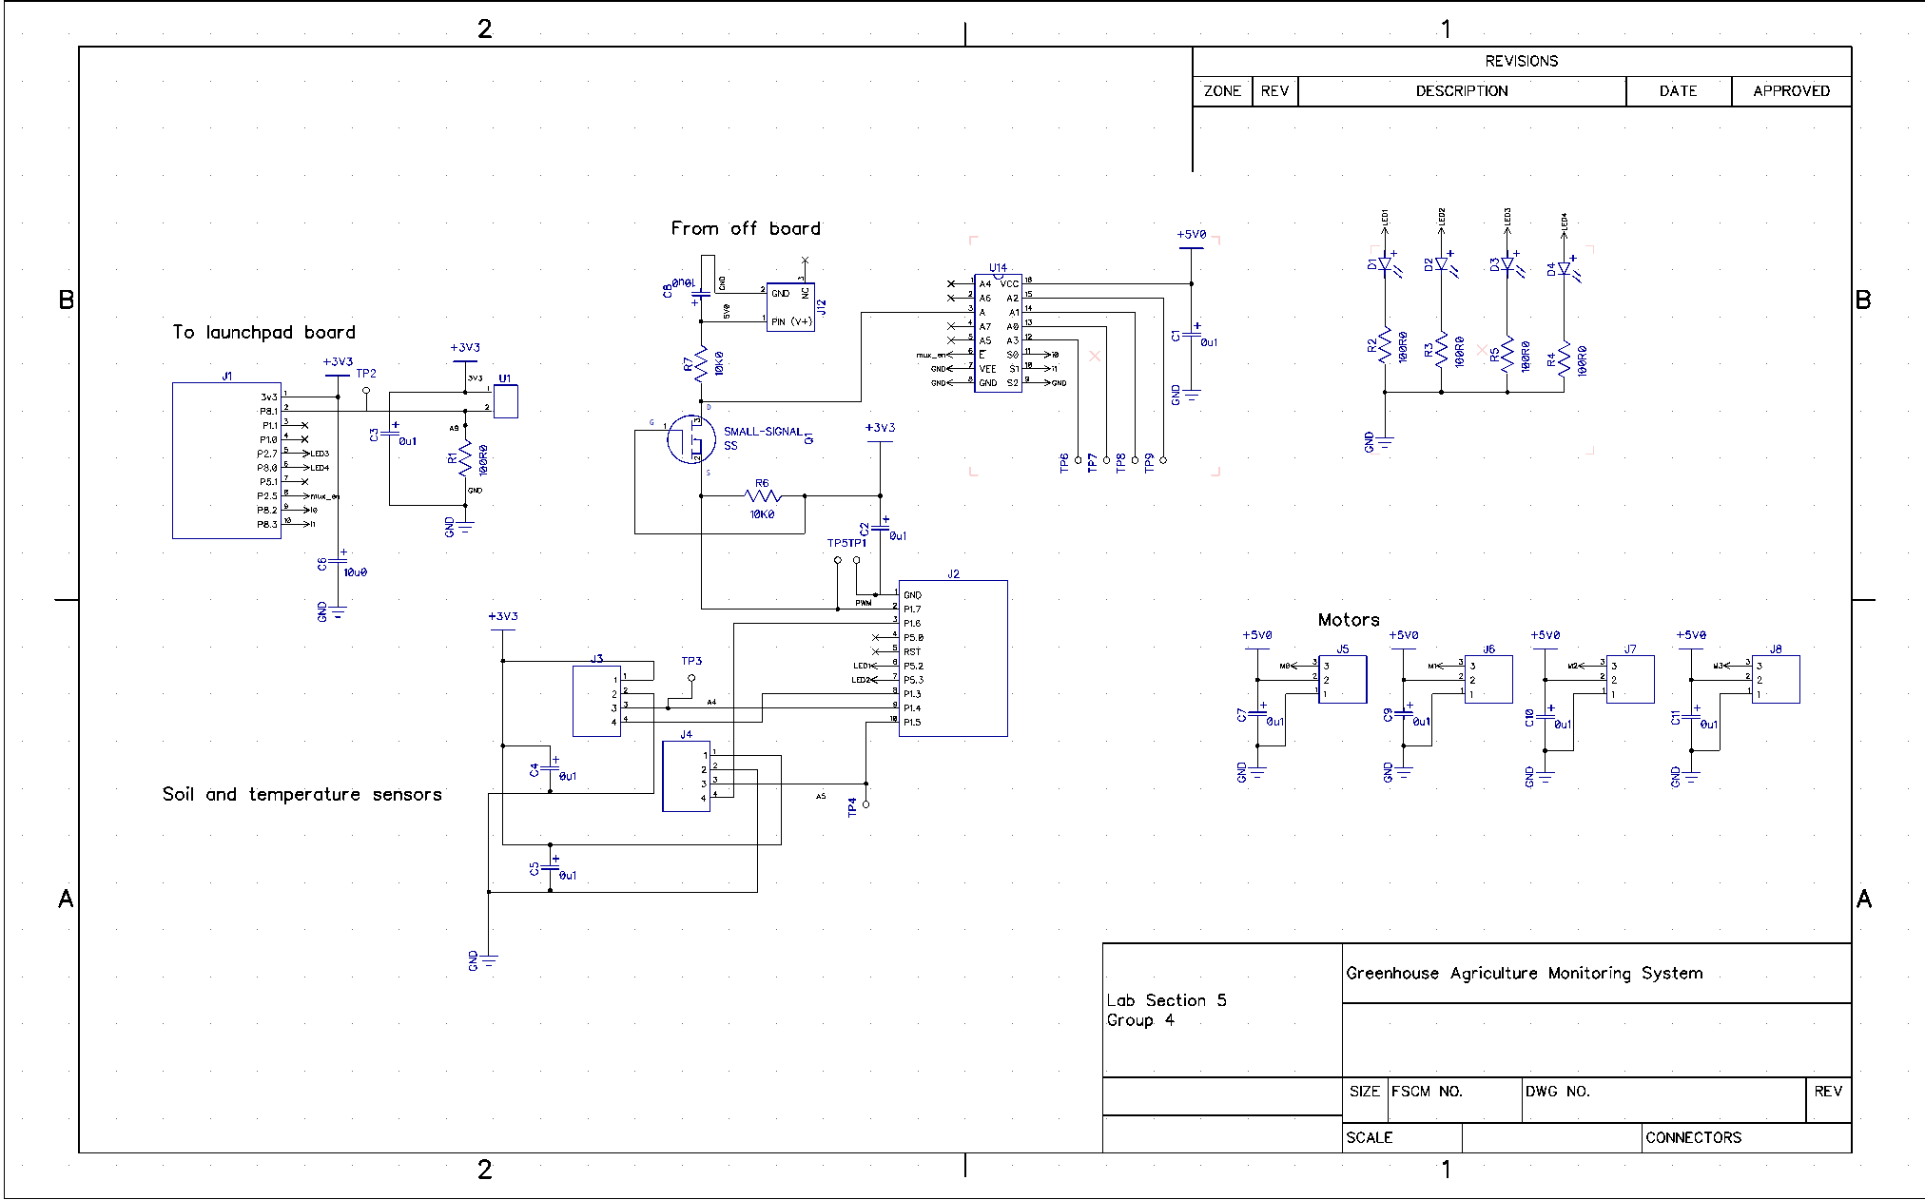

# PCB Preview

This is just a brief preview of the layout. CAD files can be found at: https://github.com/DuhBrain/ECE-298

