**Lab Assignment – 2**

**Name : Archit Bagad**

**Div : AI&DS (A)**

**Roll no : 25**

**Batch : 3**

**Prn : 12311951**

**Assignment : To Establish the LAN,WAN and configuration of the Networking Devices in CISCO Packet Tracer.**

**1.WAN Network**

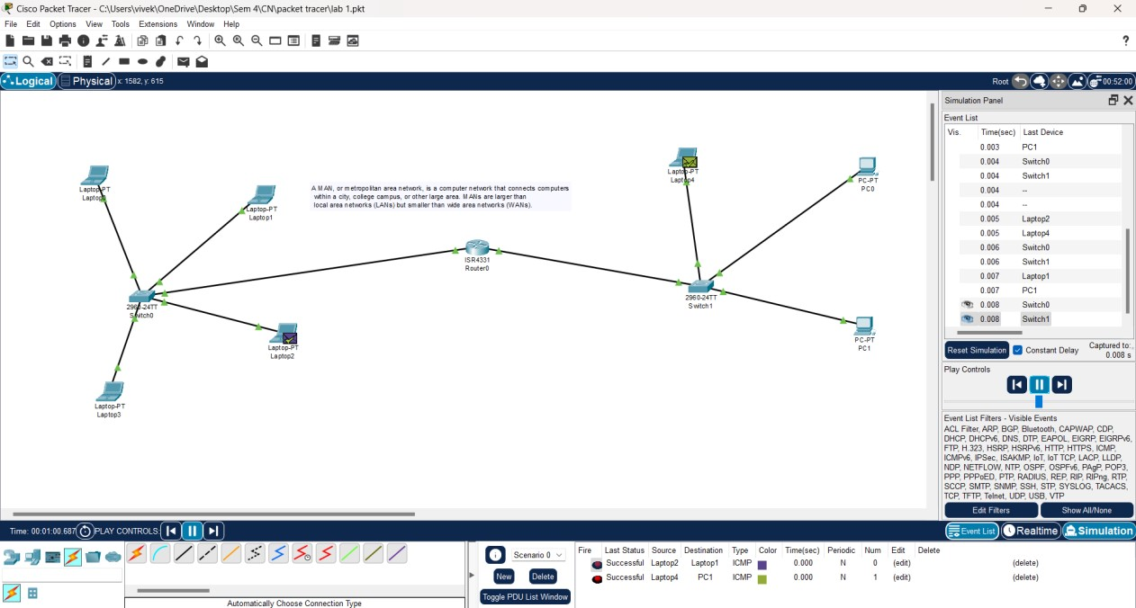

2. Bus Topology :

