Bansilal Ramnath Agarwal Charitable Trust’s

**Vishwakarma Institute of Technology, Pune**

(*An Autonomous Institute of Savitribai Phule Pune University*)



**Department of Artificial Intelligence and Data Science**

|  |  |
| --- | --- |
| **Class/ Division** | SY-AIDS-A |
| **Name** | Archit Bagad |
| **Roll No.** | 25 |
| **GR No** | 12311951 |
| **Batch** | 03 |
| **Subject** | Computer Network |

**Assignment 6**

**Write a program to simulate**

1. **Go back N  Sliding Window Protocol in peer to peer mode :**

* **Code :**

import java.util.Random;

class GoBackN {

private static final int WINDOW_SIZE = 4;

private static final int TOTAL_FRAMES = 10;

private static final Random rand = new Random();

public static void main(String[] args) {

int base = 0;

int nextSeqNum = 0;

while (base < TOTAL_FRAMES) {

System.out.println("\nSender Window: [" + base + " - " + Math.min(base + WINDOW_SIZE - 1, TOTAL_FRAMES - 1) + "]");

for (int i = base; i < base + WINDOW_SIZE && i < TOTAL_FRAMES; i++) {

System.out.println("Sending frame: " + i);

}

int lostFrame = rand.nextInt(10) < 3 ? base + rand.nextInt(WINDOW_SIZE) : -1;

for (int i = base; i < base + WINDOW_SIZE && i < TOTAL_FRAMES; i++) {

if (i == lostFrame) {

System.out.println("Frame " + i + " lost!");

break;

} else {

System.out.println("Received frame: " + i);

}

}

if (lostFrame != -1) {

System.out.println("Timeout! Retransmitting from frame " + lostFrame);

base = lostFrame;

} else {

base += WINDOW_SIZE;

}

}

System.out.println("\nAll frames sent successfully!");

}

}

* **Output :**

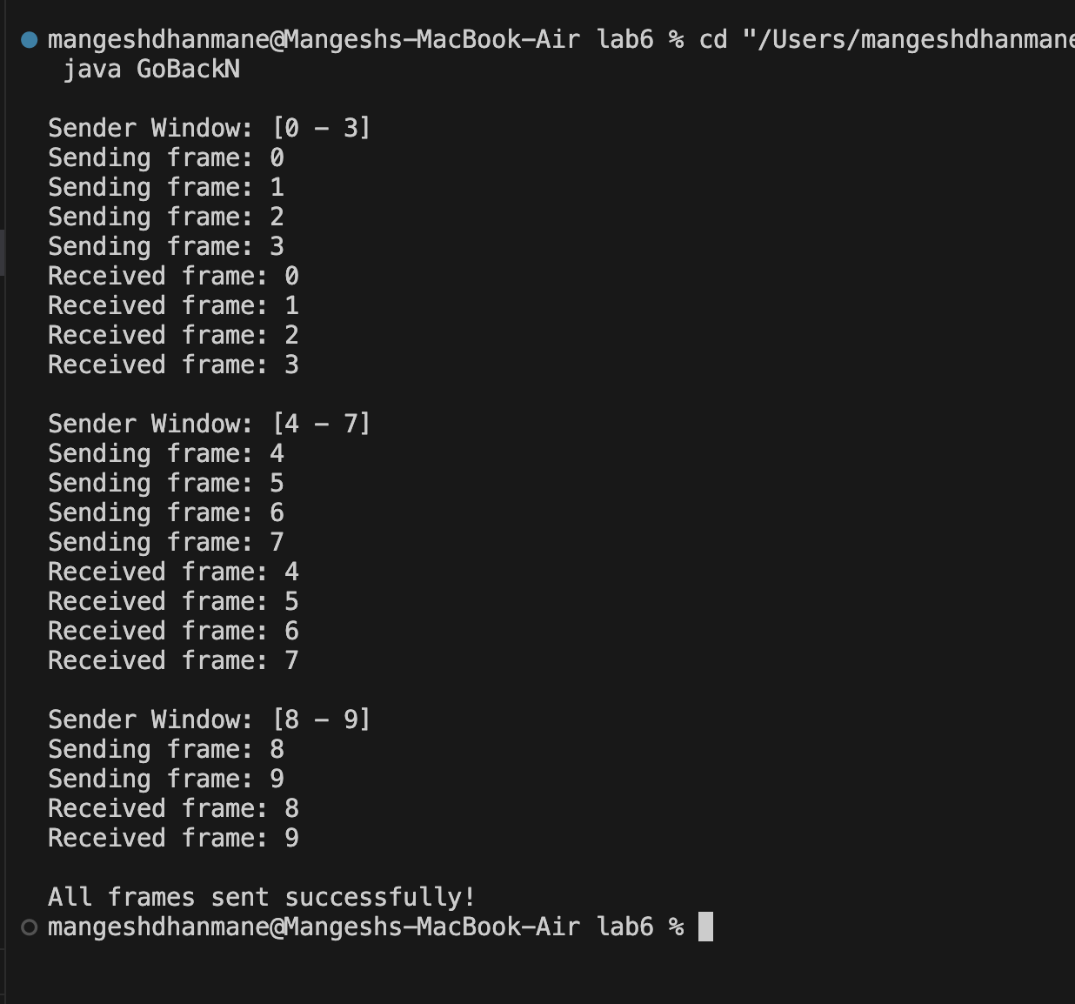

1. **Selective Repeat Sliding Window Protocol in peer to peer mode :**

* **Code :**

import java.util.Random;

class SelectiveRepeat {

private static final int WINDOW_SIZE = 4;

private static final int TOTAL_FRAMES = 10;

private static final Random rand = new Random();

private static boolean[] received = new boolean[TOTAL_FRAMES];

public static void main(String[] args) {

int base = 0;

while (base < TOTAL_FRAMES) {

System.out.println("\nSender Window: [" + base + " - " + Math.min(base + WINDOW_SIZE - 1, TOTAL_FRAMES - 1) + "]");

for (int i = base; i < base + WINDOW_SIZE && i < TOTAL_FRAMES; i++) {

if (!received[i]) {

System.out.println("Sending frame: " + i);

}

}

for (int i = base; i < base + WINDOW_SIZE && i < TOTAL_FRAMES; i++) {

if (!received[i]) {

if (rand.nextInt(10) < 3) {

System.out.println("Frame " + i + " lost!");

} else {

received[i] = true;

System.out.println("Received frame: " + i + " (ACK sent)");

}

}

}

while (base < TOTAL_FRAMES && received[base]) {

base++;

}

}

System.out.println("\nAll frames sent successfully!");

}

}

* **Output :**

