**Bansilal Ramnath Agarwal Charitable Trust’s**



Vishwakarma Institute of Technology,Pune-37

*(An Autonomous Institute of Savitribai Phule Pune University)*

**Department of Artificial Intelligence and Data Science**

|  |  |
| --- | --- |
| **Division** | A |
| **Batch** | 03 |
| **GR-no** | 12311951 |
| **Rollno** | 25 |
| **Name** | Archit Bagad |

# Experiment Number: 09

**Write a program using TCP socket for wired network for following:**

1. **Say Hello to Each other**
2. **File transfer**
3. **Calculator (Arithmetic)**

CODE :-

import socket  
  
def start_server():  
 server = socket.socket(socket.AF_INET, socket.SOCK_STREAM)  
 server.bind(("0.0.0.0", 9999))  
 server.listen(5)  
 print("Server started. Listening on port 9999...")  
  
 while True:  
 client_socket, addr = server.accept()  
 print(f"Connection established with {addr}")  
  
 option = client_socket.recv(1024).decode()  
  
 if option == "1":  
 client_socket.send("Hello, Client!".encode())  
  
 elif option == "2":  
 filename = client_socket.recv(1024).decode()  
 try:  
 with open(filename, "rb") as file:  
 data = file.read()  
 client_socket.sendall(data)  
 except FileNotFoundError:  
 client_socket.send("File not found".encode())  
  
 elif option == "3":  
 expression = client_socket.recv(1024).decode()  
 try:  
 result = str(eval(expression))  
 except:  
 result = "Error"  
 client_socket.send(result.encode())  
  
 client_socket.close()  
  
if __name__ == "__main__":  
 start_server()

Output :-

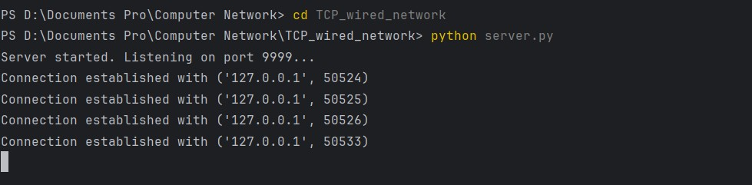

Client.py

import socket  
  
def client():  
 client = socket.socket(socket.AF_INET, socket.SOCK_STREAM)  
 client.connect(("127.0.0.1", 9999))  
  
 print("Choose an option:\n1. Say Hello\n2. File Transfer\n3. Calculator")  
 option = input("Enter option: ")  
 client.send(option.encode())  
  
 if option == "1":  
 print("Server:", client.recv(1024).decode())  
  
 elif option == "2":  
 filename = input("Enter filename to send: ")  
 client.send(filename.encode())  
 data = client.recv(1024)  
 if data.decode() == "File not found":  
 print("File not found on server.")  
 else:  
 with open("received_" + filename, "wb") as file:  
 file.write(data)  
 print("File received successfully.")  
  
 elif option == "3":  
 expression = input("Enter arithmetic expression (e.g., 5+3): ")  
 client.send(expression.encode())  
 print("Result from server:", client.recv(1024).decode())  
  
 client.close()  
  
if __name__ == "__main__":  
 client()

output :   
  
