**Committee Meeting Report** **Sahar Mozaffari**  
Professor: Carole Ober  
GGSB Matriculated 2013 Date: 09/08/16

**Progress since last Committee Meeting - June 16, 2015**

## Awards

* Awarded F31 Ruth L. Kirschstein NRSA
* FASEB MARC Travel Award to ASHG 2015 in Baltimore, MD
* FASEB MARC Travel Award to ASHG 2014 in San Diego, CA
* Genetics and Regulation Training Grant: 2013-2016

## Publications

* Gamazon, E. R., Wheeler, H. E., Shah, K. P., Mozaffari, S. V., Aquino-Michaels, K., Carroll, R. J., et al. (2015). *A gene-based association method for mapping traits using reference transcriptome data.* Nature Genetics, 47(9), 1091–1098. http://doi.org/10.1038/ng.3367

## Presentations

* Genetics of Model Organisms Club April 21, 2016  
  Mozaffari, SV. *Parent of Origin Effects in the Hutterites*
* Complex Trait Mapping Journal Club March 25, 2016  
  Paper: Amin V, Harris RA, Onuchic V, et al. *Epigenomic footprints across 111 reference epigenomes reveal tissue-specific epigenetic regulation of lincRNAs.* Nat Commun. 2015;6:6370.
* Human Genetics Work in Progress January 20, 2016  
  Mozaffari, SV. *Parent of Origin Effects*
* Molecular Biosciences Retreat November 5, 2015  
  Mozaffari SV, DeCara J, Shah S, Herman C, Lang R, Nicolae D, Ober C., *Parent of Origin GWAS with Cardiovascular Disease Associated Traits in the Hutterites.* 2015: Nov 5; Galena, IL.
* ASHGOctober 9, 2015  
  Mozaffari SV, DeCara J, Shah S, Herman C, Lang R, Nicolae D, Ober C., *Parent of Origin GWAS of CVD-Associated Phenotypes in the Hutterites* (Abstract Program #310). Presented at the Annual Meeting of The American Society of Human Genetics; 2015: Oct 9; Baltimore, MD.

## Posters

* Mozaffari SV, Gamazon E, Aquino-Michaels K, Cox NJ, Im HK. *Quantifying Context Specificity of Gene Regulation using Predicted Gene Expression Levels.* Poster presented at the Annual Meeting of The American Society of Human Genetics Conference; 2014: Oct 18-22; San Diego, CA

## Teaching Assistantship Requirements Completed

* MGCB 31400 (BIOS 21236) *Genetic Analysis of Model Organisms*Fall 2014  
  Graduate & Undergraduate Course: Introduction to genetic tools, experiments, and model organisms
* HGEN 47000 *Human Genetics* Fall 2015  
  Graduate Course: Classic and modern approaches to studying cytogenetic, Mendelian, and complex human diseases. Grant proposal writing course.

## Additional Courses

* STAT 24500 *Statistical Theory & Methods II* Winter 2015
* HGEN 46900 *Human Variation & Disease* Spring 2015
* STAT 35500 *Statistical Genetics* Spring 2015
* myChoice Mini-Course: *Effective Writing in the Biological Sciences* Fall 2015
* HGEN 48600 *Fundamentals of Computational Biology: Models & Inference* Winter 2016
* PBHS 31831 *Genetic & Molecular Epidemiology* Spring 2016

## Additional Workshops

* Master R Developer Workshop taught by Hadley Wickham May 2015
* Summer Institute in Statistical Genetics at the University of Washington July 2016

## Extracurricular

* Museum of Science & Industry: Science Connections volunteer Fall 2014-current
* myCHOICE Internship: Institute of Translational Medicine Summer 2015  
  Translate complex research into dynamic science stories. Share translational research stories in weekly newsletter, ITM website, and social media platforms

# Proposal Updates:

I would like to revise my aims to focus on Parent of Origin Effects. There are many different aspects of the project to explore and I would like to take advantage of it. These were my previous aims.

**AIM 1** To identify and characterize parent of origin effects and allele specific effects on gene expression in 430 Hutterites.  
**AIM 2** To investigate association of gene age and eQTLs in endometrial-expressed genes in humans.  
**AIM 3** To characterize the contributions of genetic variants, IBD segments, parent of origin, functional variants, and relatedness among individuals to predict clinical phenotypes.  
The following are my proposed revised aims:

**AIM 1a** To identify and characterize parent of origin effects on quantitative traits in the Hutterites.   
**AIM 1b** To estimate maternal and paternal heritability measures on quantitative traits in the Hutterites.   
**AIM 2a** To identify and characterize parent of origin effects on gene expression in 430 Hutterites.  
**AIM 2b** To identify and characterize parent of origin and allele specific effects on gene expression in 430 Hutterites.  
Previously, I shared results on parent of effects on gene expression where I tested maternally- and paternally- inherited alleles separately with the sum of gene expression. I received feedback to separate the gene expression into reads that map maternally and those that map paternally, and to use these measures for POeQTL.

**Since my Qualifying Exam**

**AIM 1**  
I have ran Parent of Origin GWAS, testing maternally and paternally- inherited alleles separately with 22 different traits. The manhattan plots for the Maternal and Paternal GWAS for LDL are in Figure 1. Table 1 has the phenotypes with significant maternal and paternal allele associations.

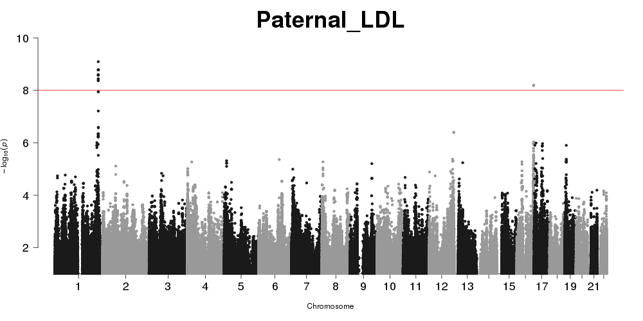 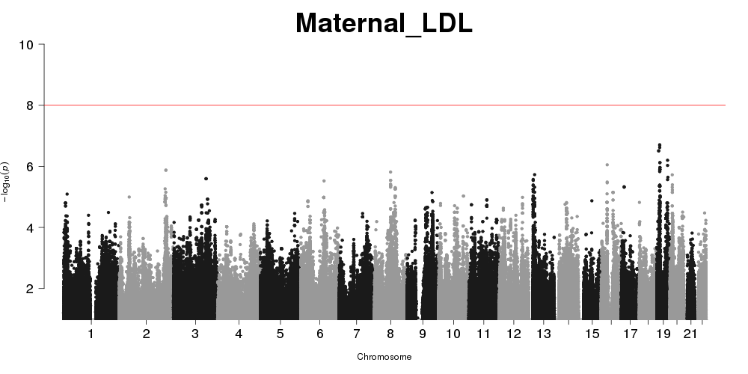

[tab:Signif]Phenotypes with Significant Maternal or Paternal Allele Associations.

|  |  |  |
| --- | --- | --- |
|  | Phenotypes |  |
| Significant Maternal Association | Carotid Intima Media Thickness, FEV1, Trigylcerides |  |
| Significant Paternal Associations | Systolic Blood Pressure, Blood eosinophil count LDL-C |  |
|  | Total cholesterol |  |
| No Significant Parental Associations | Left Atrial Volume Index, Left Ventricular Mass Index, FEV1/FVC, |  |
|  | Bronchial Responsiveness Index, Fraction exhaled nitric oxide |  |
|  | Diastolic Blood Pressure, Lymphocyte Count, Monocyte Count, |  |
|  | Neutrophil Count, IgE, Chitin, YKL40, BMI, Height, HDL-C |  |

I have also ran a new model (equation 1) that tests for difference of parental effects in two of these phenotypes (LDL & BMI), and I am working on running them on the remaining 20 phenotypes. I am working on replicating the interesting findings with BMI in the Framingham cohort.

$$Y=μ+(β_{p}−β_{m})\frac{(X_{p}−X_{m})}{2}+\frac{(β_{p}+β_{m})}{2}X_{mp}+ϵ$$

**AIM 1b**  
With the help of Mark Abney, I have models to test for parent of origin heritability. I have estimated the average maternal and average paternal heritability for each of the 22 traits and I am working on getting a more accurate measure (as opposed to average).  
  
**AIM 2a**  
I have remapped the LCL RNA-seq data using STAR and corrected sample swaps using verifyBamID (fixed 2 samples that were already included, and gained 4 samples). I used WASP to remove mapping bias and mapped reads to the maternal and paternal haplotypes.  
  
For this aim I have methods to detect patterns of parent of origin effects (i.e. imprinting) using maternal and paternal gene expression but not any SNPs (no POeQTL). First I test for asymmetry in maternal and paternal gene expression (normalized total gene expression) with permutations of the data. The second test uses a binomial test to get a Z-score of maternal and paternal expression within each sample (not normalized gene expression). The distribution of the Z-score can be tested against a normal distribution with the Shapiro-Wilk test. The most significant genes from this test have a lot of overlap with known imprinted genes as shown in Table 2 & 3.

**AIM 2b**  
I will test for POeQTLs in this aim testing maternally inherited SNPs with the maternal gene expression and paternally inherited SNPs with paternal expression. I will combine this with POeQTL results from before using the sum of gene expression, especially for genes which we don’t have maternal or paternal expression.

9 Gamazon, E. R., Wheeler, H. E., Shah, K. P., Mozaffari, S. V., Aquino-Michaels, K., Carroll, R. J., et al. (2015). A gene-based association method for mapping traits using reference transcriptome data. Nature Genetics, 47(9), 1091–1098. http://doi.org/10.1038/ng.3367 Cusanovich, D. A., Caliskan, M., Billstrand, C., Michelini, K., Chavarria, C., De Leon, S., et al. (2016). Integrated analyses of gene expression and genetic association studies in a founder population. Human Molecular Genetics, ddw061. http://doi.org/10.1093/hmg/ddw061 Dobin, A., & Gingeras, T. R. (2015). Mapping RNA-seq Reads with STAR. Current Protocols in Bioinformatics. 51, 11.14.1–19. http://doi.org/10.1002/0471250953.bi1114s51 G. Jun, M. Flickinger, K. N. Hetrick, Kurt, J. M. Romm, K. F. Doheny, G. Abecasis, M. Boehnke,and H. M. Kang, (2012) Detecting and Estimating Contamination of Human DNA Samples in Sequencing and Array-Based Genotype Data, AJHG doi:10.1016/j.ajhg.2012.09.004 (volume 91 issue 5 pp.839 - 848) van de Geijn B, McVicker G, Gilad Y, Pritchard JK. (2015) WASP: allele-specific software for robust molecular quantitative trait locus discovery. Nat Meth. 12:1061-1063. doi:10.1038/nmeth.3582.