Long-Term Capital Market Assumptions — 2026 Edition
A proprietary 12-year forward outlook for global asset classes
- As-of date: 18 May 2026
- Base currency: USD
- Horizon: 12 years (midpoint of a 10–15-year window)
- Universe: 24 asset classes spanning global equities, fixed income, and real assets
- Engine: building-block returns + Ledoit-Wolf shrinkage + regime-switching GPU Monte Carlo
- Data: free public sources — Yahoo Finance, FRED, Damodaran (1928+),
Shiller (1871+), Ken French (1990+), Siblis Research, the GPR and EPU
uncertainty indices, central banks
This document is the strategic layer (Step 1) of a three-step allocation
process: (1) LTCMA 10–15-year assumptions → (2) normalize to a 3–5-year
cycle-aware forecast → (3) overlay current macro indicators. Reviewed annually.

1. Executive Summary
After a long US-led bull market, **the starting point for the next decade is one
of extreme valuation dispersion.** The US trades at a CAPE of ~35 and Japan ~29,
while Mexico, Brazil, and China trade at 12–18× earnings. That gap drives four
strategic conclusions:
- **US large-cap equity has the lowest expected return of any equity market
in the universe (~6.6% base case)* — and the highest* sensitivity to the
valuation assumption. A 2.4-percentage-point swing separates the optimistic and
pessimistic scenarios. Owning US equity at today's multiple is, mathematically,
a bet that rich valuations persist.
- **Emerging and Latin American equity offer the highest expected returns
(~8.0–8.8%)* and the smallest* valuation bet — their return is carried by
income and growth, not multiple expansion.
- The richest fixed-income edge is in EM local and USD sovereign debt.
Mexican local government bonds offer ~6.3% in USD at one of the best downside
profiles in the universe; EM USD sovereigns ~6.0%. Both beat US investment-grade
and high-yield credit, which sit at multi-year-tight spreads.
- Bonds still diversify, but less reliably than the pre-2021 era. The
trailing stock/long-Treasury correlation is ~0.00. Gold (0.12 vs US equity)
and the Treasury/commodity pairing (−0.35) now do more genuine diversification
work than nominal bonds alone.
Two cross-checks against the live market sharpen the picture:
- What's priced in (Section 4): the Treasury curve says the market expects
no further rate cuts — short-rate forwards rise, not fall. Inflation
expectations (2.5%) sit right on the LTCMA assumption. Credit is priced for
perfection. The LTCMA's active bets are exactly where it diverges from this.
- News and regime risk (Section 7): geopolitical and policy uncertainty
(GPR, EPU indices) are **elevated, and the market is currently in a "stress"
regime.** Quantified, that history shows stress periods amplify volatility
(1.2–2.2×) and cross-correlations (0.66→0.74) — but, tellingly, did not
reliably depress returns over 2013–2026.
Headline expected returns (USD, 12-year, base case):
 | Point estimate | Simulated 12y median | Volatility
US large-cap equity | 6.6% | 5.7% | 13.6%
EM equity | 8.0% | 6.4% | 18.8%
Brazil / Mexico equity | 8.8% / 8.0% | 4.1% / 5.7% | 32.7% / 22.4%
US Treasury / IG credit | 4.5% – 5.0% | 4.2% – 4.7% | 7.6% – 8.0%
EM USD sovereign / Mexican local govt | 6.0% / 6.3% | 5.5% / 5.7% | 9.9% / 11.3%
Cash (US T-bills) | 3.3% | 3.2% | 3.4%

(Simulated medians sit below point estimates by design — the volatility drag on
compounded returns. See Section 7.)

2. Methodology

2.1 Building-block framework
Every serious capital-market-assumptions publisher — J.P. Morgan, BlackRock,
Vanguard, Northern Trust, GMO, Research Affiliates, AQR — uses the same
building-block skeleton. Expected return is decomposed into observable,
defensible components rather than extrapolated from past performance.
Equities (return expressed directly in USD):
ER = dividend yield + net buyback yield + real EPS growth
+ US inflation + λ × valuation reversion
The relative-PPP assumption lets us anchor on US inflation: a foreign
market's local inflation is, over a long horizon, broadly offset by depreciation
of its currency against the dollar.
Fixed income: ER = starting yield + roll − expected credit loss ± normalization,
where expected credit loss = default rate × (1 − recovery rate).
Currencies: purchasing-power parity + real-interest-rate differential.

2.2 The valuation-reversion dial (λ) — a multi-firm synthesis
Firms agree on the skeleton; they disagree on how hard valuations mean-revert.
This model exposes that choice as one parameter, λ:
λ | Meaning | Closest to the house view of
0.0 | No reversion — today's multiples persist | Momentum / regime views (Bridgewater-style)
0.5 | Partial normalization (base case) | J.P. Morgan, BlackRock, Vanguard, Northern Trust
1.0 | Full reversion to fair value | GMO, Research Affiliates, AQR

Annualized reversion is (fair multiple / current multiple)^(1/H) − 1. The
spread across λ is itself a signal — the "valuation bet" column.
The fair-value anchor is data-driven. Shiller's 150-year series puts the US
CAPE at a 1990+ median of 26.0 — exactly the anchor used here.

2.3 Risk model — shrinkage and long history
Volatility blends a trailing-window estimate with multi-decade history (Shiller
1871+, Ken French 1990+, Damodaran 1928+), plus 25 years of intraday FX history
(FxPro M5 data aggregated to monthly — EURUSD/USDJPY since 2000, USDMXN since
2007). The covariance matrix uses Ledoit-Wolf shrinkage — well-conditioned
and positive semi-definite, a requirement for the simulation engine.

2.4 Priced-in indicators
Markets continuously quote their own expectations. Section 4 extracts them —
the rate path implied by Treasury forwards, inflation from breakevens, risk from
VIX and credit spreads — and contrasts each with the LTCMA. Where they diverge,
the LTCMA is making an explicit, identifiable active bet.

2.5 Quantifying news and market regimes
Discretionary news — a tariff tweet, a Fed-chair change, a strike on Iran —
cannot be turned into a defensible number tweet-by-tweet. The rigorous approach,
and the one used here, is established text-based uncertainty indices:
- GPR — Geopolitical Risk index (Caldara-Iacoviello), built from newspaper
text; spikes on wars and military escalation.
- EPU — Economic Policy Uncertainty (Baker-Bloom-Davis); spikes on
Fed-chair uncertainty, tariff conflict, fiscal standoffs.
These quantify the aggregate of the news flow. They are used to classify
history into calm and stress regimes (Section 7), which then drive the
simulation — so "the news" enters the model as regime probabilities and
regime-specific risk, not as ad-hoc adjustments.

2.6 Regime-switching Monte Carlo engine
A GPU Monte Carlo engine simulates 100,000 monthly multi-asset paths over the
12-year horizon. It is two-regime Markov-switching (calm/stress, calibrated
from the news indices) with Student-t innovations (fat tails), and it
starts in the stress regime to reflect today's elevated-uncertainty reading.
It runs on an NVIDIA RTX 4060 in ~15 seconds and produces full return
distributions — percentiles, probability of loss, and conditional tail loss
(CVaR) — for every asset and portfolio.

2.7 Consensus and historical cross-checks
- Forward consensus: 2026 published LTCMAs put US large-cap equity at 5–7.6%
and US aggregate bonds at 4.1–4.8%. This model's base case sits inside both.
- Historical realized (Damodaran, 1928–2025): US large-cap returned 10.0%
annualized, 10-year Treasuries 4.5%, T-bills 3.4%. The forward US equity number
is deliberately below its history — the starting CAPE (35) is far above the
historical norm.

3. Macro Backdrop & Fundamentals Grid
Market | Policy rate | 10Y nominal | 10Y real* | Inflation | Trend real GDP | Equity valuation | Damodaran ERP
US | ~3.6% | 4.59% | ~1.9% | ~2.7% | ~1.9% | CAPE 34.7 — rich | 4.46%
Mexico | 6.50% | 8.88% | ~4.4% | 4.45% | ~2.0% | P/E 13.0 — cheap | 6.69%
Brazil | 14.50% | ~13.5% | ~9.0% | ~4.5% | ~2.0% | P/E 11.8 — cheap | 7.47%
China | ~3.0% (LPR) | ~1.8% | ~1.3% | ~0.5% | ~4.0% | CAPE 17.7 — cheap | 5.14%
Japan | ~0.75% | 2.52% | ~0.0% | ~2.5% | ~0.7% | CAPE 29.4 — rich | 5.14%
UK | ~3.9% | 4.82% | ~1.8% | ~3.0% | ~1.3% | CAPE 20.2 — fair | 5.01%
France | ~2.0% (ECB) | 3.68% | ~1.9% | ~1.8% | ~1.2% | CAPE ~21 — fair | 5.01%

*Real yield = 10Y nominal − current inflation (approximate).
What the grid says: valuation is bimodal — the US and Japan are expensive,
EM/LatAm and China are cheap, with only the UK and France in between. Real yields
favor Latin America massively (Mexico ~4.4%, Brazil ~9%, vs US ~1.9%). Rate
direction is no longer a tailwind anywhere — carry, not duration, is where the
return is. China is the contrarian case: cheap and still growing ~4%, but
deflation and policy risk are what the discount prices.
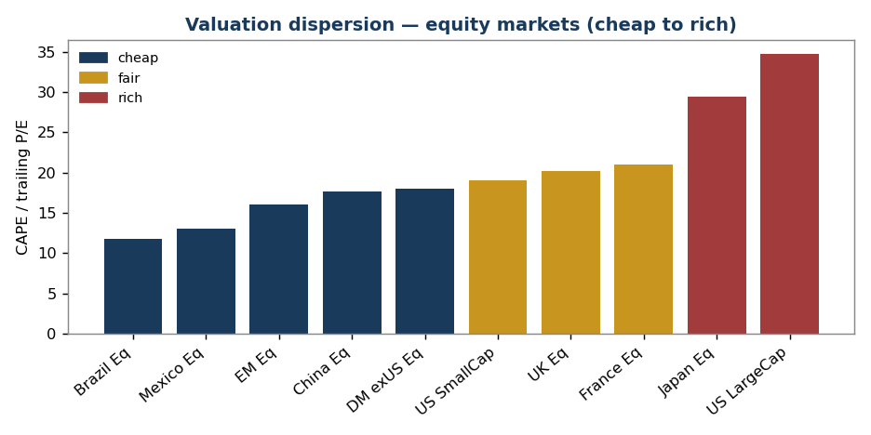
Valuation dispersion across equity markets

4. Priced-In Indicators
A capital-market assumption is only active where it disagrees with what the
market already expects. This section extracts the market's own forecasts.

4.1 Priced-in policy-rate path — the headline
The Treasury curve, read as implied forward rates, reveals the market's expected
path of short rates:
Period | Implied avg short rate
Current fed funds (effective) | 3.63%
Next 12 months (1Y Treasury) | 3.82%
1–2 years forward | 4.36%
2–3 years forward | 4.24%
3–5 years forward | 4.44%
5–10 years forward | ~4.9%

The market is pricing zero further rate cuts. Forward short rates rise, not
fall — the curve says the Fed's easing cycle is over and the next move is as
likely up as down. This matters: despite a steady "central banks are easing"
narrative, anyone positioning for a rate-cut tailwind is fighting the curve. The
LTCMA's cash assumption (3.3%, assuming a drift toward a ~3.0–3.3% neutral rate)
is slightly below what the market prices — a small, deliberate divergence.
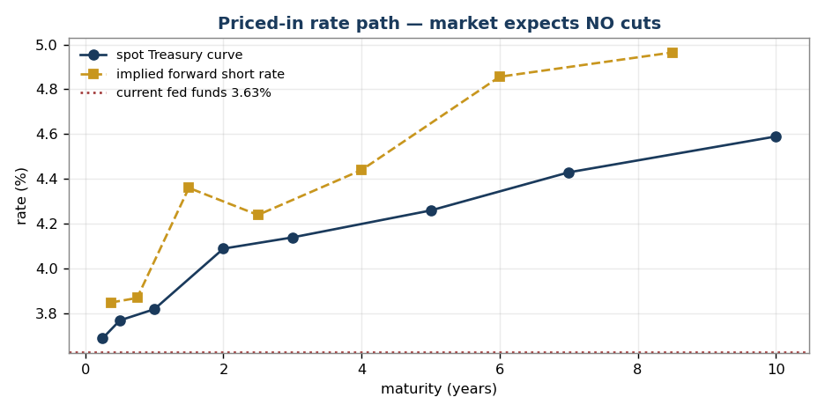
Priced-in rate path: spot Treasury curve vs implied forwards

4.2 Priced-in inflation, risk, and the dashboard
Signal | What the market prices | LTCMA assumption | Read
Rate path | No cuts; 1–2y forward 4.4% | Cash 3.3% | Market more hawkish than the LTCMA's neutral-rate drift
Long-run inflation | 10y breakeven 2.48%, 5y5y forward 2.27% | 2.40% | Aligned — LTCMA sits mid-range
US credit risk | HY OAS 2.80% (~14th percentile — very tight) | HY 5.0%, tight-spread drag applied | Agreement — credit priced for perfection; LTCMA already cautious
Equity volatility | VIX 18.4 (~historical median) | Equity vols 13–33% | Market calm; no near-term stress priced
Recession | Yield curve 10Y–3M +0.93% (positive) | n/a | No recession priced in
Policy uncertainty | EPU 212 (baseline ~100 — elevated) | n/a | Complacency divergence — see below

The complacency divergence. Policy uncertainty (EPU) is elevated at ~212
while equity volatility (VIX) sits near its historical median. The market is
treating heavy policy noise — a Fed-chair transition, tariff conflict, the Gulf
situation — as signal-free. Either the noise resolves benignly (the 2013–2026
pattern) or this gap closes through a volatility spike. The regime engine in
Section 7 is built precisely to price that asymmetry.

5. Expected Returns

5.1 Full table (USD, 12-year)
Asset class | Type | ER λ=0 | ER base (λ=0.5) | ER λ=1 | Volatility
US Large Cap | Equity | 7.8% | 6.6% | 5.4% | 13.6%
US Small Cap | Equity | 6.7% | 6.5% | 6.3% | 19.6%
Mexico Equity | Equity | 7.4% | 8.0% | 8.6% | 22.4%
Brazil Equity | Equity | 8.9% | 8.8% | 8.7% | 32.7%
China Equity | Equity | 8.1% | 7.4% | 6.7% | 23.1%
Japan Equity | Equity | 7.1% | 6.4% | 5.8% | 16.7%
UK Equity | Equity | 8.0% | 7.0% | 6.1% | 16.6%
France Equity | Equity | 7.4% | 7.2% | 7.0% | 17.7%
EM Equity (broad) | Equity | 8.0% | 8.0% | 8.0% | 18.8%
DM ex-US Equity (broad) | Equity | 7.5% | 7.7% | 8.0% | 15.7%
US Cash / T-Bills | Fixed Income | — | 3.3% | — | 3.4%
US Treasury Intermediate | Fixed Income | — | 4.5% | — | 7.6%
US Treasury Long | Fixed Income | — | 4.8% | — | 15.2%
US TIPS | Fixed Income | — | 4.5% | — | 6.2%
US IG Corporate | Fixed Income | — | 5.0% | — | 8.0%
US High Yield | Fixed Income | — | 5.0% | — | 7.9%
EM USD Sovereign | Fixed Income | — | 6.0% | — | 9.9%
EM Local Debt | Fixed Income | — | 4.8% | — | 11.3%
Mexico Govt (local, Mbonos) | Fixed Income | — | 6.3% | — | 11.3%
Global Aggregate ex-US (hedged) | Fixed Income | — | 3.8% | — | 5.9%
US REITs | Real Asset | — | 6.3% | — | 17.6%
Global REITs ex-US | Real Asset | — | 6.4% | — | 16.5%
Commodities (broad) | Real Asset | — | 3.5% | — | 17.2%
Gold | Real Asset | — | 3.3% | — | 18.6%

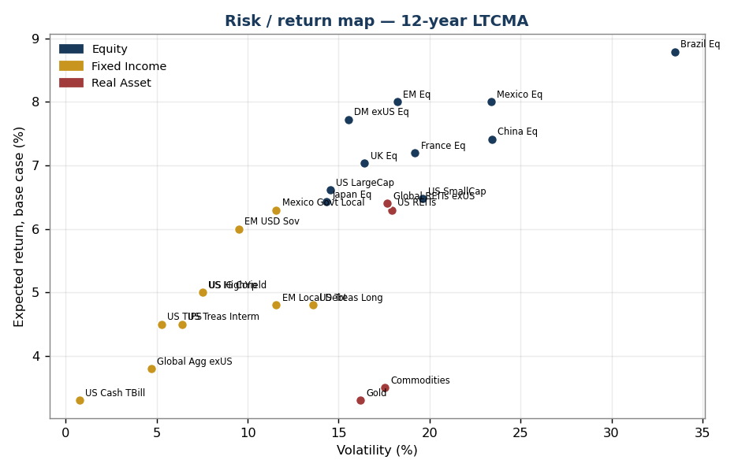
Risk/return map of the 24-asset universe

5.2 Equity building-block decomposition (base case, λ=0.5)
Market | Dividend | Buyback | Real EPS growth | US inflation | Valuation reversion | = ER
US Large Cap | 1.2% | 1.7% | 2.5% | 2.4% | −1.2% | 6.6%
US Small Cap | 1.3% | 0.5% | 2.5% | 2.4% | −0.2% | 6.5%
Mexico | 3.2% | 0.0% | 1.8% | 2.4% | +0.6% | 8.0%
Brazil | 4.5% | 0.0% | 2.0% | 2.4% | −0.1% | 8.8%
China | 2.2% | 0.5% | 3.0% | 2.4% | −0.7% | 7.4%
Japan | 2.2% | 1.0% | 1.5% | 2.4% | −0.7% | 6.4%
UK | 3.8% | 0.5% | 1.3% | 2.4% | −1.0% | 7.0%
France | 3.0% | 0.5% | 1.5% | 2.4% | −0.2% | 7.2%
EM (broad) | 2.8% | 0.0% | 2.8% | 2.4% | 0.0% | 8.0%
DM ex-US (broad) | 3.2% | 0.4% | 1.5% | 2.4% | +0.2% | 7.7%

**US equity's return is built on growth and buybacks fighting a valuation
headwind; EM/LatAm's return is built on income** — a more reliable foundation.
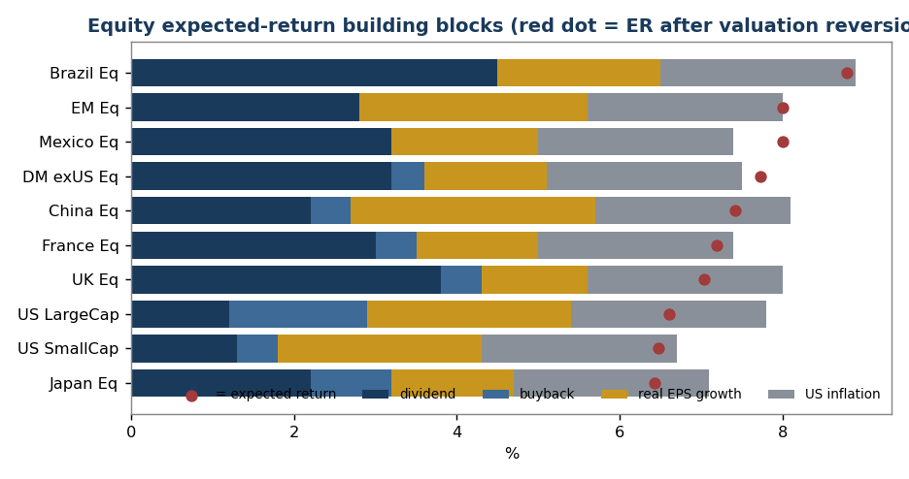
Equity expected-return building blocks

6. Risk — Volatility & Correlation
Volatility blends a trailing window with multi-decade history; the covariance
matrix is Ledoit-Wolf shrunk and positive semi-definite.

6.1 Selected correlation matrix (full-sample)
 | US LC | EM Eq | Mexico | Japan | DM exUS | US Treas Long | US HY | EM USD Sov | Gold | Commod
US Large Cap | 1.00 | 0.71 | 0.61 | 0.69 | 0.83 | −0.01 | 0.79 | 0.66 | 0.12 | 0.41
EM Equity | 0.71 | 1.00 | 0.67 | 0.70 | 0.83 | 0.00 | 0.70 | 0.72 | 0.38 | 0.49
Mexico Equity | 0.61 | 0.67 | 1.00 | 0.58 | 0.73 | −0.04 | 0.66 | 0.65 | 0.27 | 0.44
Japan Equity | 0.69 | 0.70 | 0.58 | 1.00 | 0.83 | 0.03 | 0.61 | 0.58 | 0.13 | 0.31
US Treasury Long | −0.01 | 0.00 | −0.04 | 0.03 | −0.01 | 1.00 | 0.13 | 0.36 | 0.27 | −0.35
US High Yield | 0.79 | 0.70 | 0.66 | 0.61 | 0.78 | 0.13 | 1.00 | 0.81 | 0.27 | 0.45
Gold | 0.12 | 0.38 | 0.27 | 0.13 | 0.26 | 0.27 | 0.27 | 0.37 | 1.00 | 0.22
Commodities | 0.41 | 0.49 | 0.44 | 0.31 | 0.46 | −0.35 | 0.45 | 0.33 | 0.22 | 1.00

6.2 What the risk picture tells us
- Equities are highly correlated (0.6–0.83). Geographic diversification
reduces single-country risk but little systemic drawdown risk.
- Long Treasuries are the cleanest equity diversifier on paper (≈0.00) — but
regime-dependent (Section 7); the average hides post-2021 positive-correlation
episodes.
- Gold is a genuine diversifier (0.12 vs US equity) and earns its place
despite a modest 3.3% return.
- High yield is equity in disguise (0.79 correlation with US equity).
- The Treasury/commodity pair (−0.35) is the strongest natural hedge.
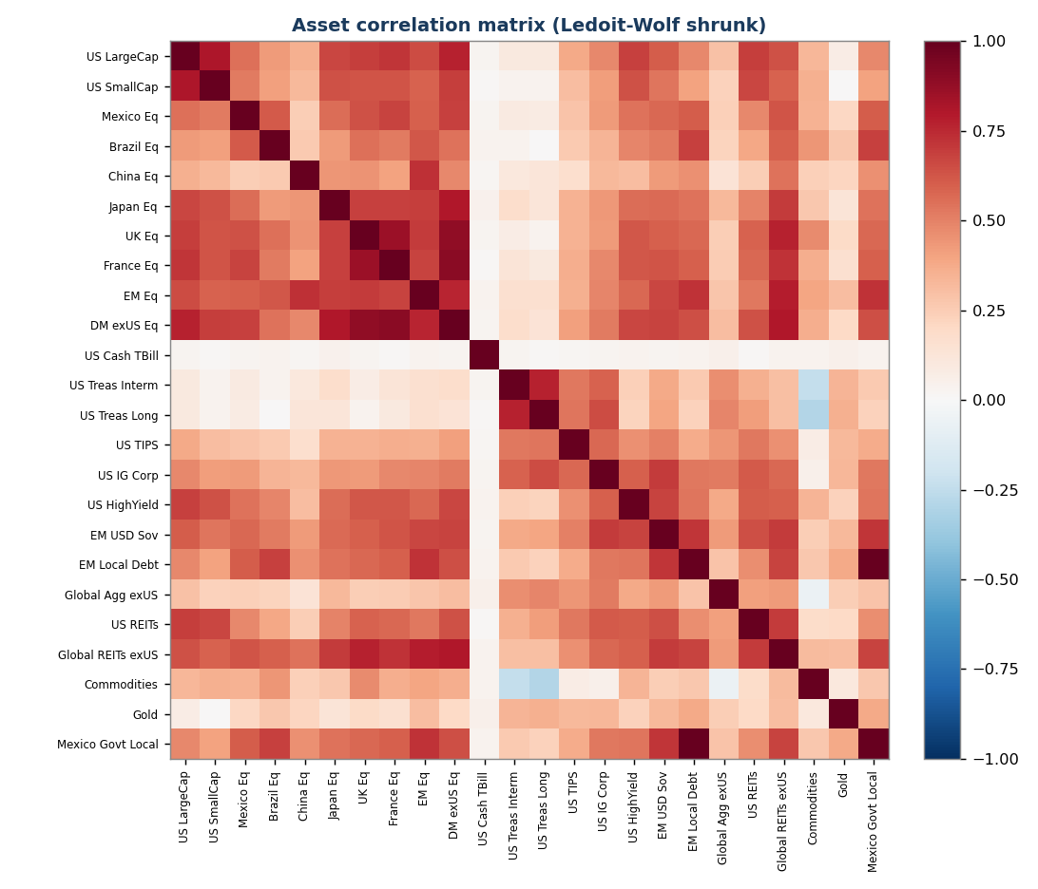
Asset correlation matrix (Ledoit-Wolf shrunk)

7. News, Regimes & Monte Carlo Simulation

7.1 Quantifying the news
Geopolitical and policy events enter the model through two text-based indices
(see 2.5): GPR (geopolitical risk) and EPU (economic policy uncertainty).
Both are currently elevated — GPR ~231 and EPU ~212 against a ~100 baseline,
reflecting the Gulf situation, tariff conflict, and the Fed-chair transition.
History (2013–2026) is classified into calm and stress regimes — a stress
month being one in the top third of a combined GPR+EPU score. **34% of months
were stress months; as of May 2026 the market is in a stress regime.**
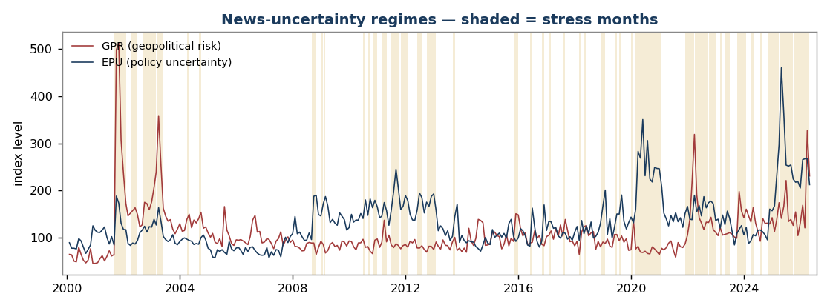
GPR and EPU uncertainty indices with stress months shaded

7.2 What stress regimes do — and don't do
Behavior in stress months | Finding
Volatility | Amplifies 1.2–2.2× (US equity 1.6×, high yield 2.1×, EM sovereign 2.2×; gold least affected at 1.2×)
Correlation | Equity cross-correlation rises 0.66 → 0.74 — diversification weakens just when it is needed
Persistence | Stress regimes last ~5.7 months on average (Markov: stress→stress 0.82)
Returns | No reliable drawdown. Over 2013–2026, news-stress months did not systematically post lower returns — markets repeatedly "climbed the wall of worry"

This last point is the honest, important finding. **Elevated geopolitical and
policy uncertainty is reliably a volatility event, not reliably a return
event.** Accordingly the simulation amplifies risk (volatility, correlation, fat
tails) in the stress regime but does not impose a speculative mean drawdown —
that would overfit a benign 13-year sample. Severe downside is instead captured
two honest ways: through fat tails and regime clustering in the simulation, and
through an explicit deterministic scenario (7.5).
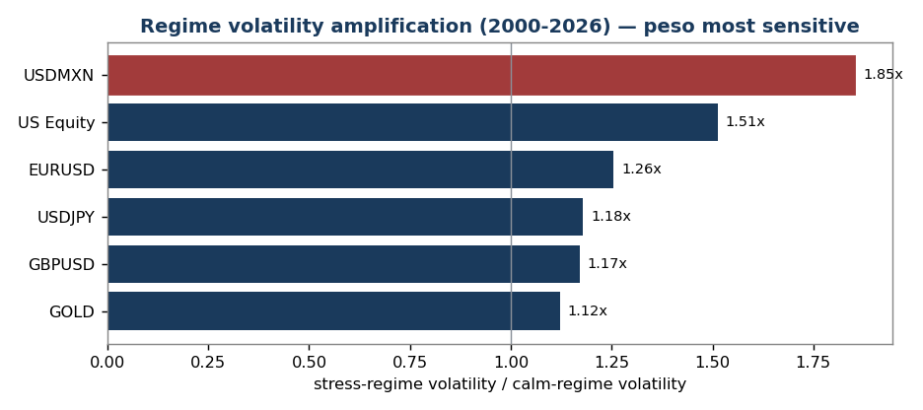
Regime volatility amplification — peso most sensitive

7.3 The simulation engine
100,000 paths, monthly steps over 12 years, two-regime Markov-switching with
Student-t fat tails, starting in the stress regime. The engine ran on the
RTX 4060 in ~15 seconds.

7.4 Simulated 12-year outcomes — portfolios
Portfolio | 5th pct | Median | 95th pct | Mean | CVaR (worst-5% avg) | P(loss) | P(< inflation)
Conservative 30/70 | 1.7% | 5.0% | 8.5% | 5.0% | +0.8% | 1% | 10%
Moderate 60/40 | 1.1% | 5.7% | 10.6% | 5.8% | −0.1% | 2% | 12%
Growth 90/10 | 0.2% | 6.2% | 12.6% | 6.3% | −1.4% | 5% | 15%
Edge-Tilted (moderate risk) | 0.7% | 5.8% | 11.2% | 5.9% | −0.6% | 3% | 14%

CVaR is the average annualized return in the worst 5% of paths — the genuine
tail. The gap between the 5th percentile and CVaR is the fat tail at work: in a
genuinely bad 12-year run, a Growth portfolio compounds at −1.4% per year,
not the −0.2%/yr a normal-distribution model would suggest. Conservative, by
contrast, still eked out a small positive return even in its worst 5%.
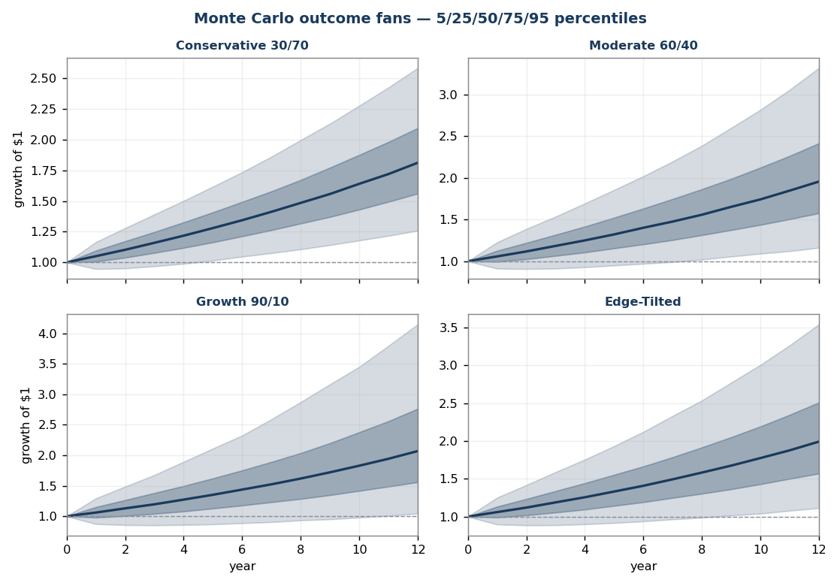
Monte Carlo outcome fans for the four portfolios
Asset-level distributions (data/mc_regime_assets.csv) confirm the earlier
ranking: **Mexican local government bonds (5.7% median, 3.5% chance of a 12-year
loss) and EM USD sovereigns (5.5% median, 2.6% loss probability)** remain the
standout risk-adjusted holdings; **gold and commodities have a >50% chance of
failing to beat inflation** and belong in a portfolio for correlation, not return.

7.5 Deterministic geopolitical-stress scenario
Separately from the simulation, a severe one-year geopolitical shock —
2008/2020-magnitude: global equities −28% to −42%, high yield −14%, EM sovereign
−16%, gold +15%, long Treasuries +12% — produces:
Portfolio | 1-year impact
Conservative 30/70 | −8.8%
Moderate 60/40 | −18.0%
Growth 90/10 | −27.2%
Edge-Tilted (moderate risk) | −20.2%

Note the Edge-Tilted portfolio loses more than the conventional Moderate 60/40
in this scenario (−20.2% vs −18.0%) — its EM and Latin American tilt sells off
harder in a global risk-off. **That is the honest cost of the strategic edge:
higher expected return and higher geopolitical-tail risk.** It should be sized as
a deliberate, risk-budgeted decision.

7.6 Long-history validation (25 years of FX & equity data)
The regime model is calibrated on 2013–2026 ETF data — a window with no global
financial crisis. To test whether that biases the result, the calibration was
re-run on a longer, cleaner dataset: Shiller US equity since 2000 and 25 years of
FxPro intraday FX history (EURUSD/USDJPY from 2000, USDMXN from 2007), which do
include the 2008 GFC, the 2000–02 dot-com bust, and 2020.
Test | 2013–26 window | 2000–26 (incl. crises) | Verdict
Equity stress/calm vol multiple | 1.61× | 1.51× | Stable — model not biased by the benign window
MXN depreciation vs USD | 2.5% assumed | 2.43% realized | Assumption confirmed
Worst equity month | — | Oct 2008 −20%, Mar 2020 −19%, Sep 2001 −11% (GPR spiked to 499) | Regime classifier catches real crises

Two things came out of this. First, the model survives the robustness check —
the regime amplification is a stable ~1.5–1.6× whether or not the GFC is in the
sample, and the Mexican-peso depreciation assumption is confirmed almost exactly
by 18 years of data. Second, a new finding: the **Mexican peso is the most
regime-sensitive asset in the book — USDMXN volatility amplifies 1.85×** in
stress regimes, more than equities (1.5×) or developed-market FX (1.2×). The
peso-heavy Edge-Tilted portfolio therefore concentrates stress risk in the
currency; that is a deliberate, identified exposure, not a hidden one.
Data-quality note: the FxPro index-CFD series (#USNDAQ100 etc.) were found to
have spurious year-boundary jumps in early years and were excluded; only the
clean continuous FX-pair data and Shiller's equity series were used.

8. Strategic-Edge Scan

8.1 Highest expected return (base case)
Brazil 8.8% · Mexico & EM 8.0% · DM ex-US 7.7% · China 7.4% · UK 7.0%

8.2 Best risk-adjusted (return per unit of volatility)
DM ex-US equity 0.28 · EM USD sovereign 0.27 · Mexican local govt bonds 0.27
· EM equity 0.25 · US Large Cap 0.24

8.3 Smallest "valuation bet"
EM equity (0.0pp), Brazil (0.2pp), US Small Cap & France (0.4–0.5pp) barely move
with λ. US Large Cap (2.4pp) and UK (1.9pp) carry the largest valuation risk.

8.4 The five edges this LTCMA identifies
- Sell expensive US beta, buy cheap ex-US beta. US large-cap has the lowest
equity return and the highest valuation risk; DM ex-US and EM offer more
return with less valuation risk. Highest-conviction edge.
- Mexican local government bonds are the standout fixed-income holding.
~6.3% USD return, and the simulation confirms an outstanding downside profile
(3.5% loss probability). The ~4.4% real yield is a thick cushion against MXN
depreciation.
- EM USD sovereign debt over US credit. 6.0% vs 5.0%, similar volatility,
the best inflation-beating odds in the book, and it avoids the tight-spread
compression risk in US IG and HY.
- Use gold and commodities for diversification, not return. With the
stock/bond correlation no longer dependably negative, and gold the least
volatility-amplified asset in stress regimes (1.2×), it is a structural hedge —
but the simulation is blunt that it rarely beats inflation, so size it as one.
- Don't fight the curve on rates. The market prices no cuts; positioning
long duration for an easing tailwind is a bet against what is priced in.
Carry — EM and Mexican local rates — is the better-paid risk.
Contrarian watch-item: China is cheap with decent growth, but deflation and
policy risk are real. A diversified EM allocation, not a standalone overweight.

9. Sample Portfolios
Three conventional risk-ladder portfolios plus an Edge-Tilted variant, each run
through the regime-switching engine (annually rebalanced).
Portfolio | Mean | Median | 5th–95th range | CVaR | Geopolitical scenario | P(< inflation)
Conservative 30/70 | 5.0% | 5.0% | 1.7% – 8.5% | +0.8% | −8.8% | 10%
Moderate 60/40 | 5.8% | 5.7% | 1.1% – 10.6% | −0.1% | −18.0% | 12%
Growth 90/10 | 6.3% | 6.2% | 0.2% – 12.6% | −1.4% | −27.2% | 15%
Edge-Tilted (moderate risk) | 5.9% | 5.8% | 0.7% – 11.2% | −0.6% | −20.2% | 14%

The Edge-Tilted portfolio underweights US large-cap, overweights EM/DM-ex-US
and Japan equity, and replaces much of the bond sleeve with EM USD sovereign
debt, Mexican local government bonds, TIPS, and gold. It delivers a **higher
median than the conventional Moderate 60/40 at a similar central risk profile** —
but, as Section 7.5 shows, it carries more geopolitical-tail risk. The edge is
real and should be taken deliberately, not by accident. Allocations are in
data/mc_regime_portfolios.csv and the scripts.

10. Assumptions, Limitations & Sources

10.1 Key judgment assumptions
- US long-run inflation: 2.4% — confirmed close to the 2.5% the market prices.
- Fair-value valuation anchors: US CAPE 26 (Shiller-confirmed); China 15,
Japan 25, UK 16, France 20, EM 16 remain judgment anchors (no long CAPE history
sourced for these) — the most subjective inputs, exposed via the λ dial.
- Real EPS growth is set below trend GDP for most markets (share dilution);
the US is held near trend (buybacks offset dilution).
- Regime means held equal across calm/stress — the 2013–2026 sample does not
reliably identify a stress mean shift; imposing one would overfit (see 7.2).
- Student-t with ν=6 for fat tails; regime-switching adds tail clustering.

10.2 Limitations
- No paid data. Valuations rely on Yahoo Finance ETF data and Siblis Research
CAPE; ETF distribution yields were hand-adjusted toward true dividend yields.
- ETF proxies, not indices, for current-regime prices; the regional long
history (French) proxies some single-country exposures (France/UK use European
data).
- Mexican local govt bonds have no clean USD price series — return computed
from yield, risk statistics proxied from EM local debt.
- The regime model is primarily calibrated on 2013–2026, but the calibration
has been validated against 25 years of FX/equity history including 2008 and
2020 (Section 7.6); the deterministic scenario (7.5) imports crisis-magnitude
shocks explicitly.
- FX/index data quality: the FxPro intraday FX pairs are clean; the broker's
index-CFD series had year-boundary artifacts and were excluded (see 7.6).
- This is the strategic (Step 1) layer only.

10.3 Data sources
- Prices / returns: Yahoo Finance (yfinance), monthly, dividend-adjusted.
- Yields, curve, spreads, breakevens, VIX, EPU, macro: Federal Reserve (FRED).
- Geopolitical Risk index: Caldara & Iacoviello (matteoiacoviello.com).
- Long history: Damodaran/NYU Stern (1928+), Shiller (1871+), Ken French (1990+).
- Intraday FX: FxPro MetaTrader 5 M5 data (2000+), aggregated to monthly.
- Equity risk premiums: Damodaran 2026. CAPE: Siblis Research (Dec 2025).
- Policy rates / inflation: Banco de México, central bank releases.
- Consensus cross-check: 2026 LTCMAs (Schwab, BlackRock, BNY, Vanguard, Northern
Trust, J.P. Morgan); Horizon Actuarial survey recommended for recalibration.

10.4 Reproducibility
All figures regenerate from the scripts in ~/LTCMA/scripts (WSL, cudf-env):
01–02 data · 03–04 returns/portfolios · 05a–05b long history ·
06 shrinkage risk model · 07 Monte Carlo · 08–09 signals & priced-in ·
10 regimes · 11 regime-switching GPU Monte Carlo · 13–14 FX ingest &
long-history validation · 15 visualizations · 12 Word/PDF rendering.
*Prepared 18 May 2026. Expected returns are forward-looking estimates, not
guarantees; actual outcomes will differ. For internal strategic-allocation use.*

