Lab – 3

1. First i added values

2)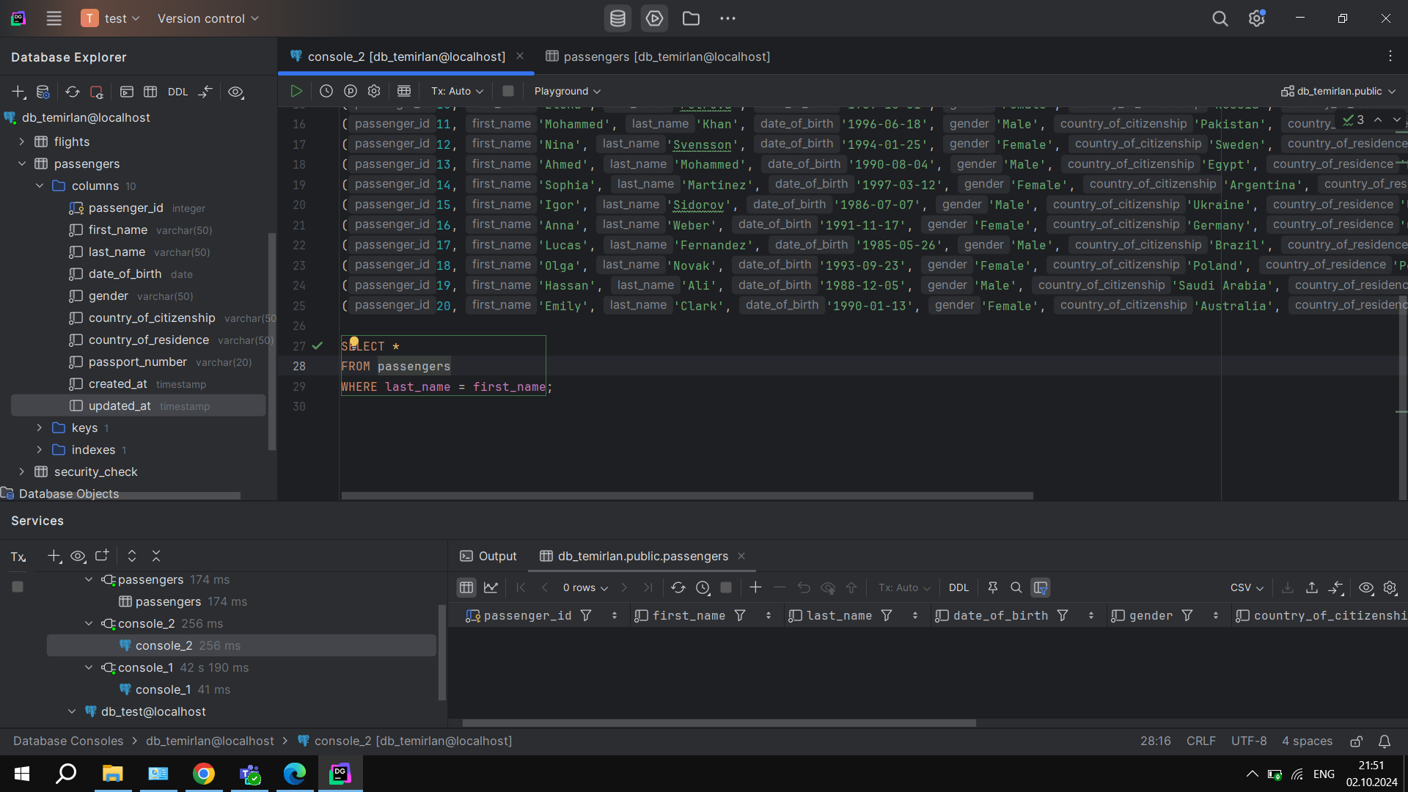Then select all the data of passengers whose last name is same as first name

3)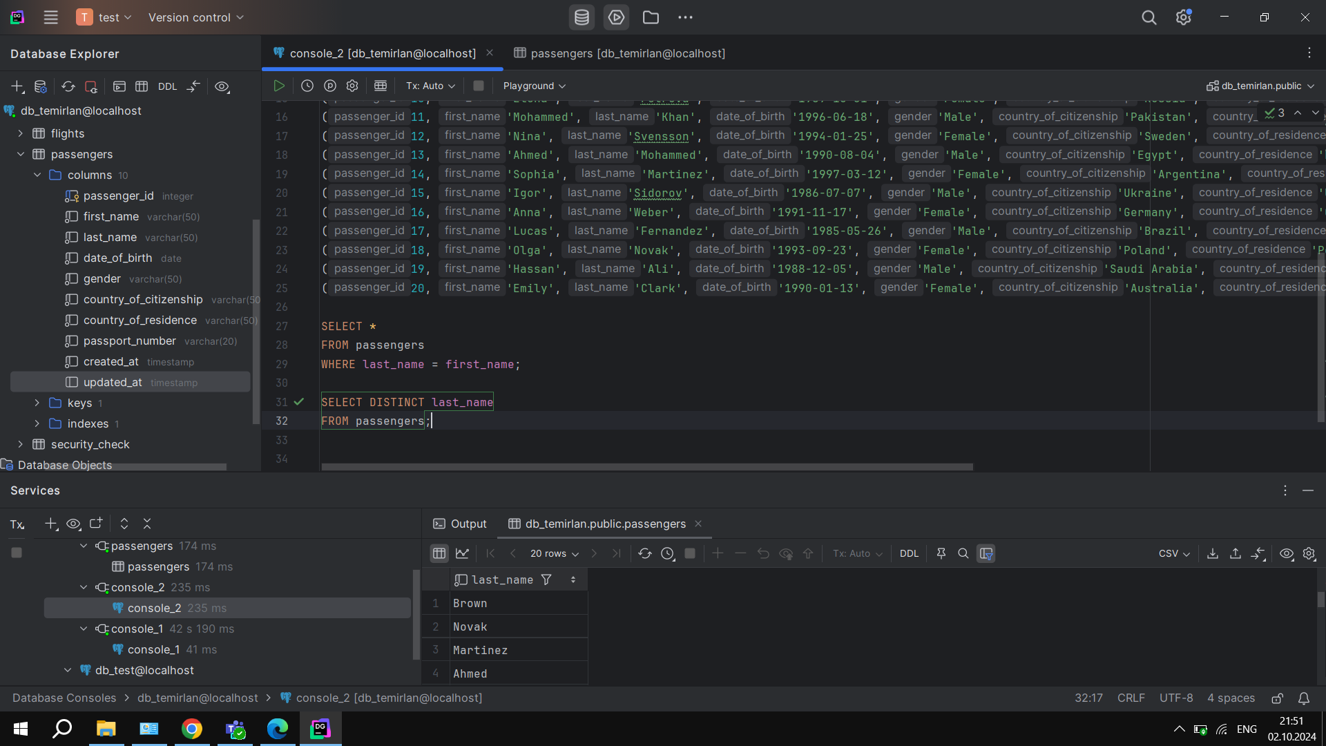Select the last name of all passangers without duplicates.

4)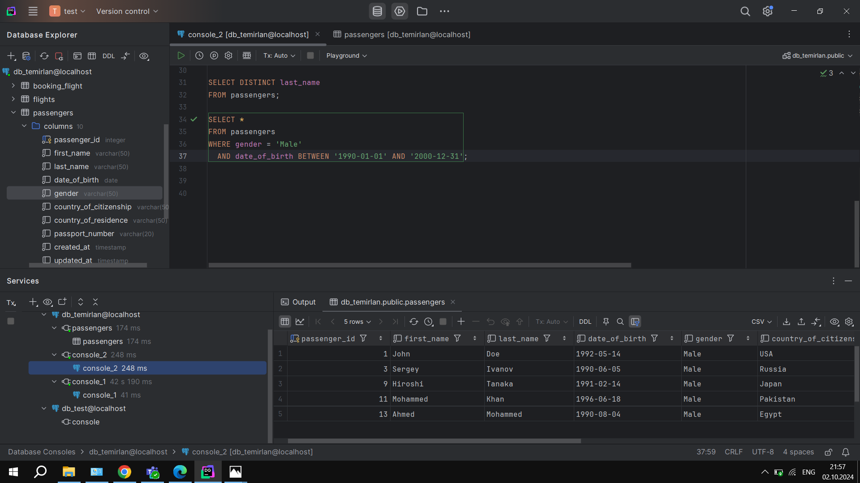Find all male passengers born between 1990 and 2000

5)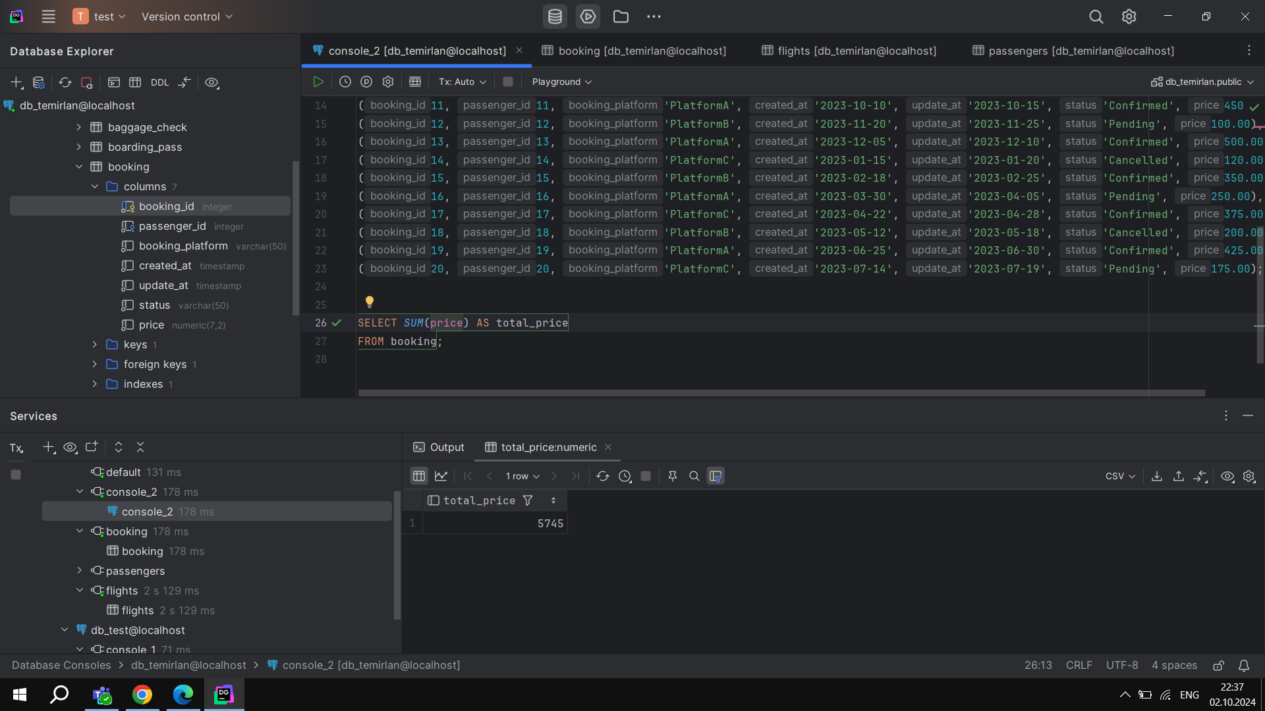Find price of tickets sold for each month in sorted way

6)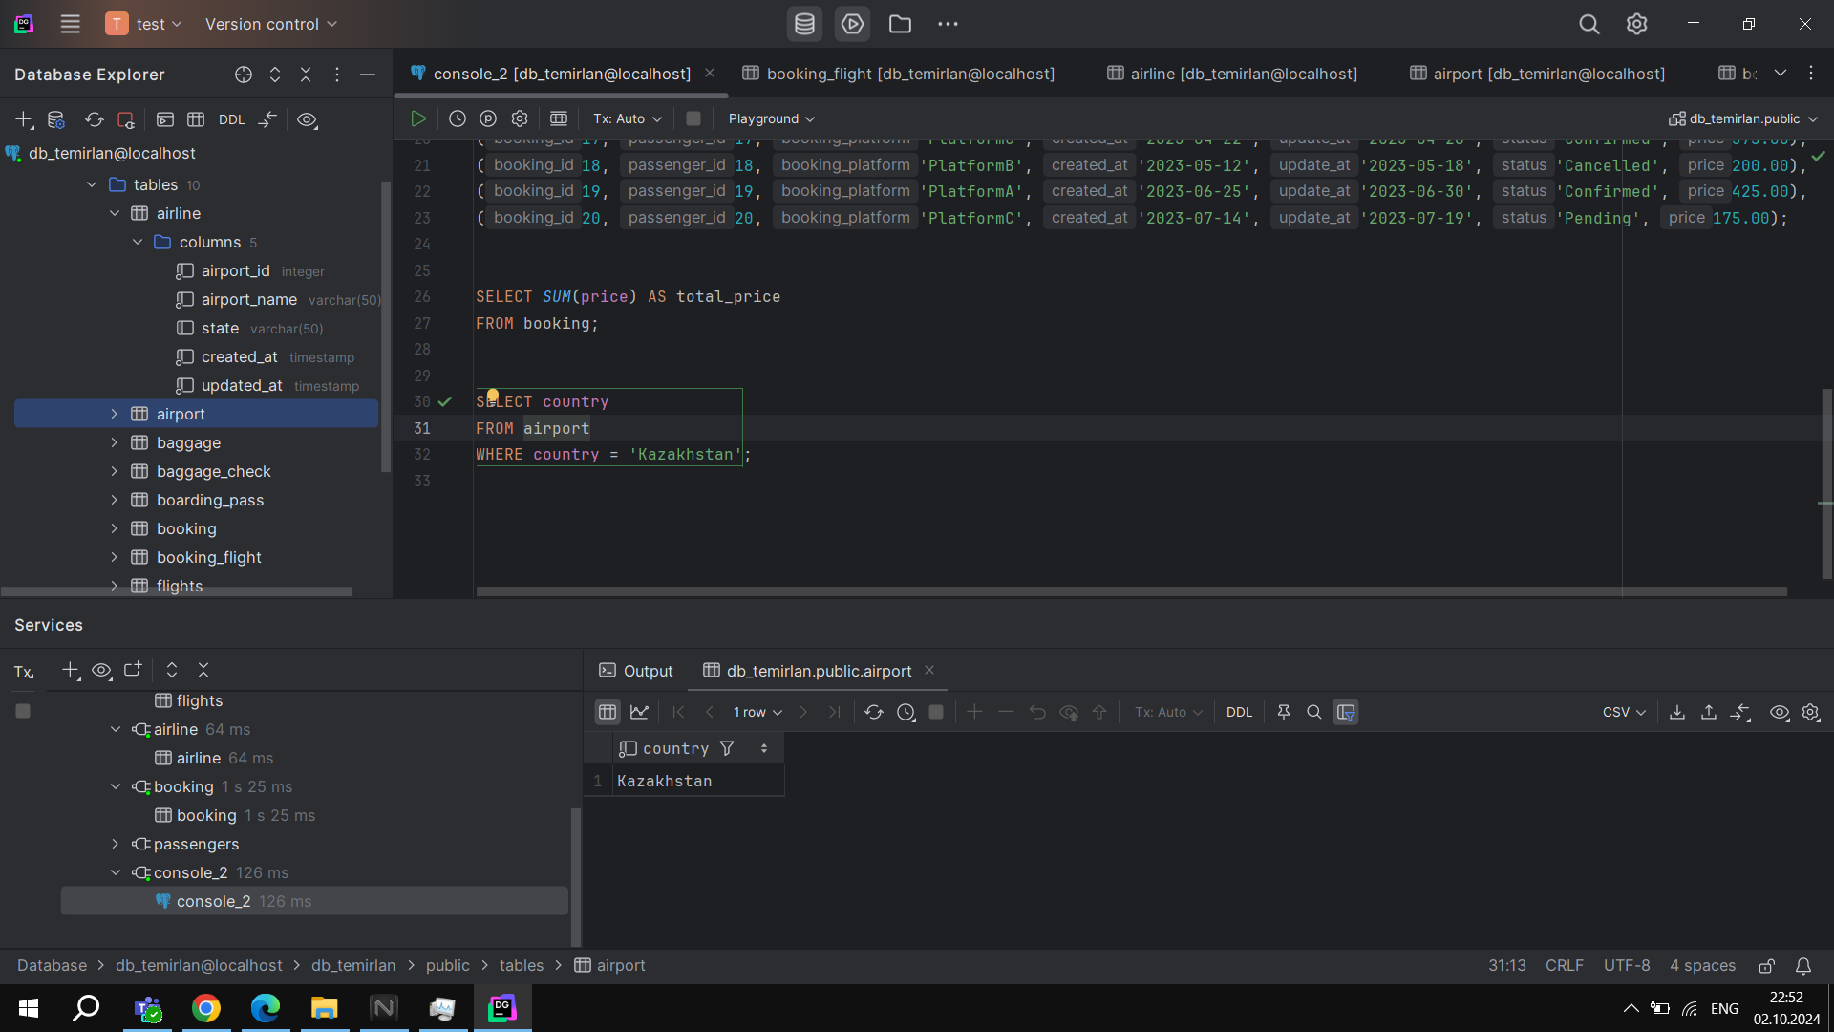Find all airline names based in Kazakhstan

7)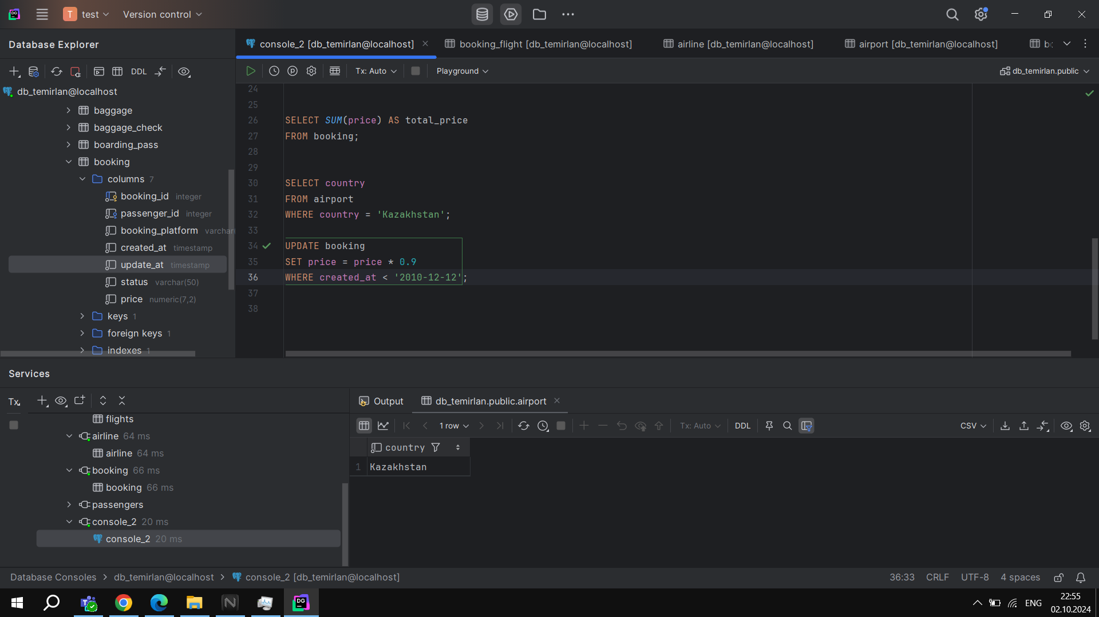Reduce the cost of booking price by 10% created before ’12-12-2010

8)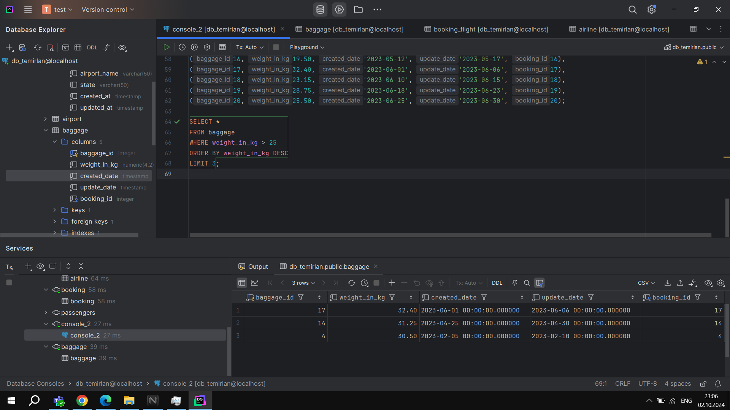Find top3 overweighted baggage with more than 25kg

9)  
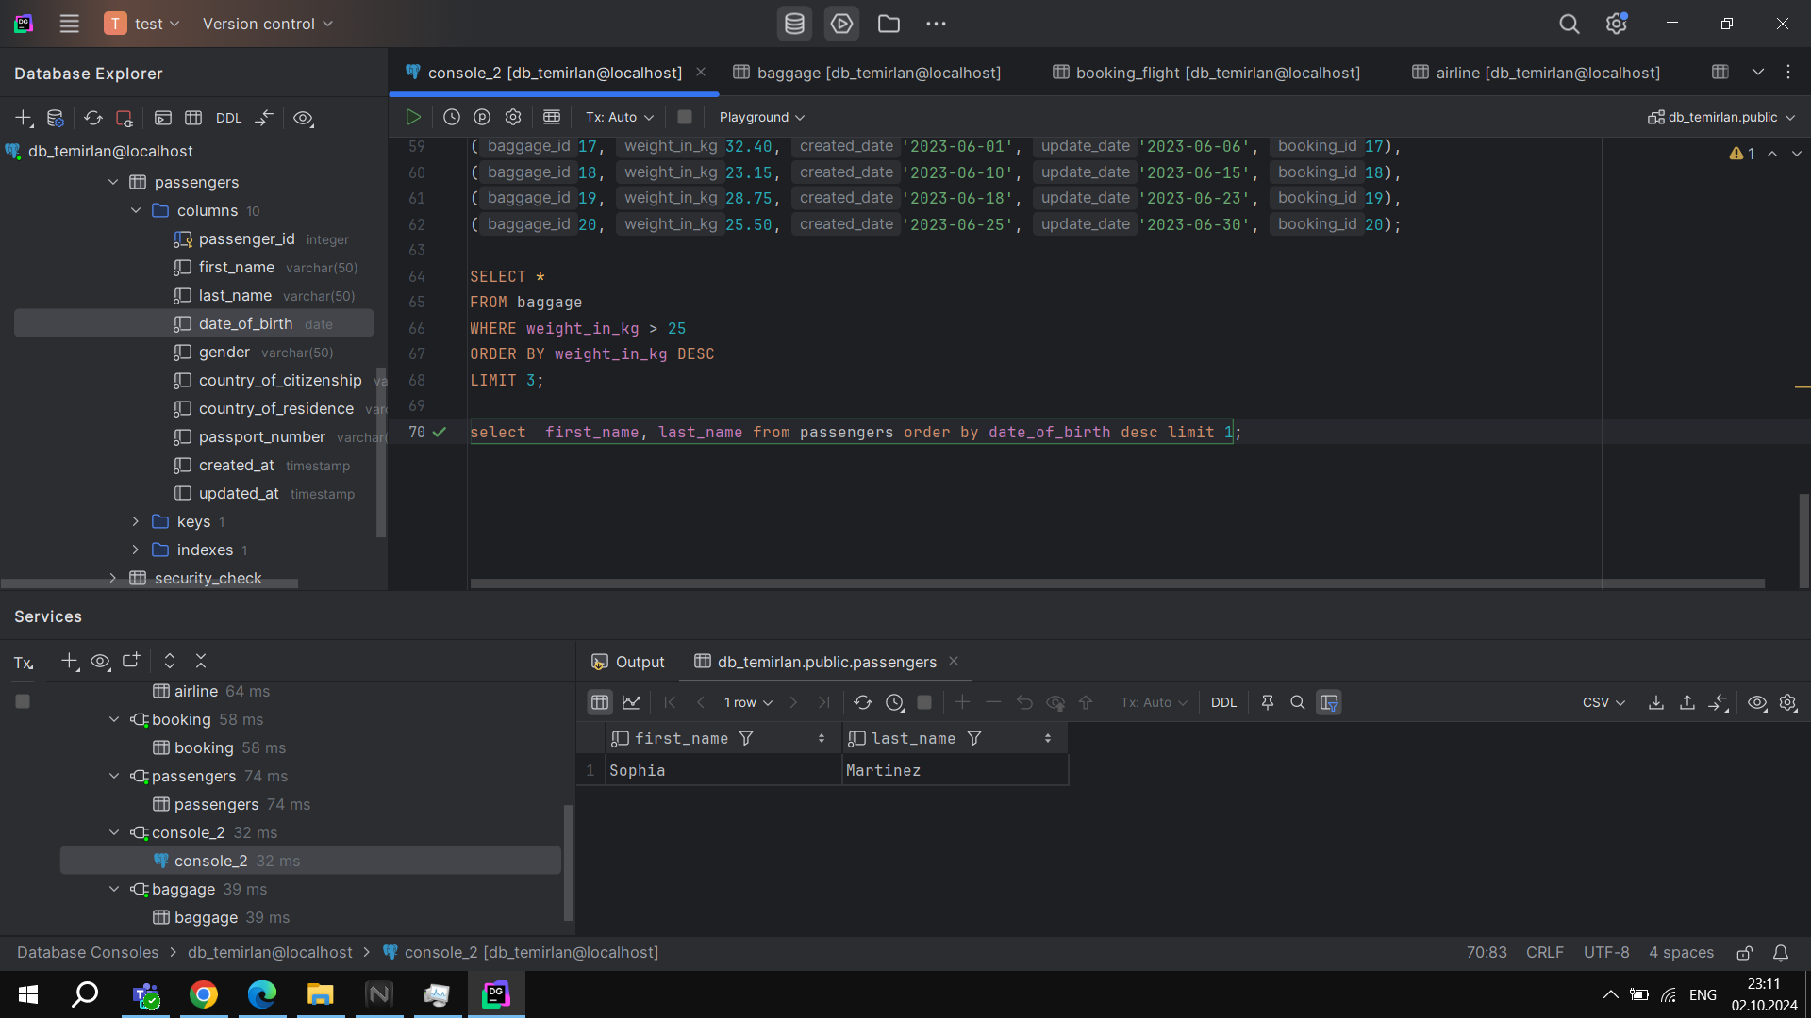Find the youngest passengers’ full name.

10)  
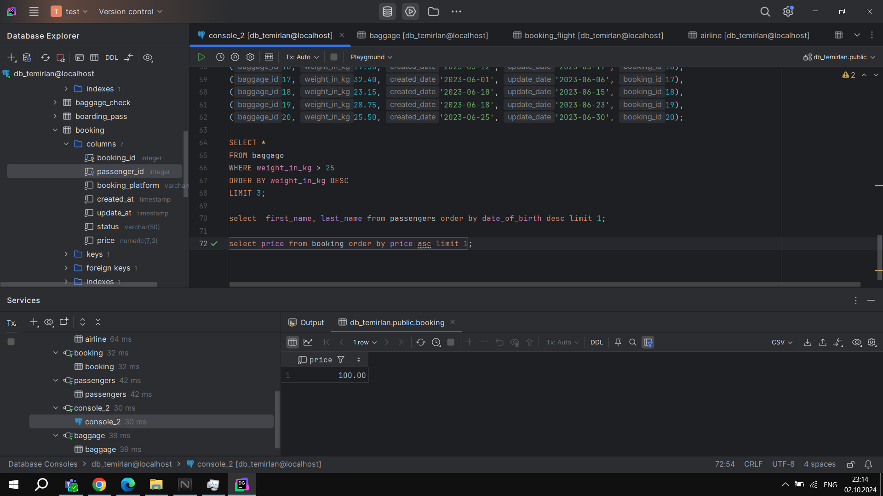10) Find the cheapest booking price in each booking platform.