

Requirement & Design Specification

**Pharmacy & Appointment System (PAS)**

**Version: 1.0**

– Hanoi, Feb 2025 –

# Record of Changes

| **Version** | **Date** | **A* M, D** | **In charge** | **Change Description** |
| --- | --- | --- | --- | --- |
| V1.0 | 9/2/2025 | A | TaiND | Home Page |
|  | 9/2/2025 | A | HieuDM | User Login |
|  | 9/2/2025 | A | HieuDM | User Register |
|  | 9/2/2025 | A | QuangNB | Product List |
|  | 9/2/2025 | A | QuangNB | Product Detail |
|  | 9/2/2025 | A | NamPV | Patient Profile |
|  | 9/2/2025 | A | NamPV | Profile Setting Patient |
|  | 9/2/2025 | A | TaiND | Invoice Detail |
|  | 9/2/2025 | A | TaiND | Invoice List |
|  | 9/2/2025 | A | NguyenND | Appointment Doctor |
|  | 9/2/2025 | A | NguyenND | Patient of Doctor |
|  | 9/2/2025 | A | NguyenND | List Doctor |

*A - Added M - Modified D - Deleted

Table of contents

Record of Changes 2

I. Overview 4

1. System Context 4

2. User Requirements 4

2.1. Actors 4

2.2. Diagrams 5

2.3. Descriptions 6

2.4. Main Workflows 6

3. System Functionalities 7

3.1. Screens Flow 7

3.2. Screen Authorization 8

3.3. Non-UI Functions 8

II. Functional Requirements 9

1. <<Feature Name1>> 9

1.1. <<Screen/Function Name1>> 9

1.2 User Login 9

1.3 … 9

2. System Administration 9

2.1 System Settings 9

2.2 … 10

3. … 10

III. System Design 11

1. Database Design 11

1.1 Database Schema 11

1.2 Table Descriptions 11

2. Code Packages 11

2.1 Package Diagram 12

2.2 Package Descriptions 12

# I. Overview

## 1. System Context

The Pharmacy and Appointment System is designed to streamline the process of purchasing medication and scheduling medical appointments. This system provides a seamless interface for patients, healthcare providers, and pharmacies to interact efficiently. The goal is to improve accessibility, reduce wait times, and enhance overall healthcare management by integrating various entities involved in medical services.

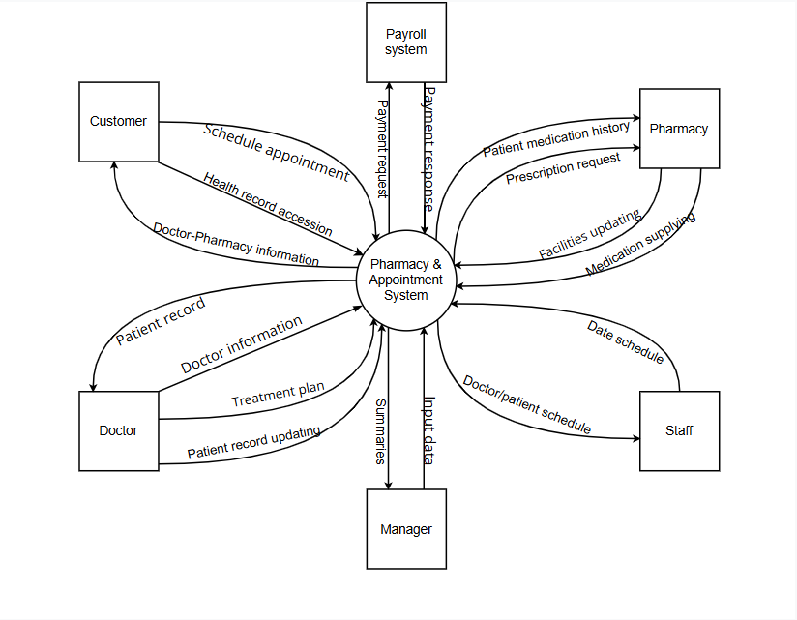

## 

## 2. User Requirements

### 2.1. Actors

| **#** | **Actor** | **Description** |
| --- | --- | --- |
| 1 | Manager | Oversees system operations, generates reports, and manages data input |
| 2 | Customer | Schedules appointments, accesses health records, and interacts with pharmacies for medication purchases |
| 3 | Doctor | Provides patient diagnoses, prescribes medications, and updates patient records |
| 4 | Pharmacy | Processes prescription requests, supplies medications, and updates inventory |
| 5 | Staff | Manages doctor and patient schedules, assists with administrative tasks |
| 6 | Payroll system | Handles payment processing for medication purchases and appointment fees |

### 2.2 Diagrams

#### 2.2.1. UCs for Guest

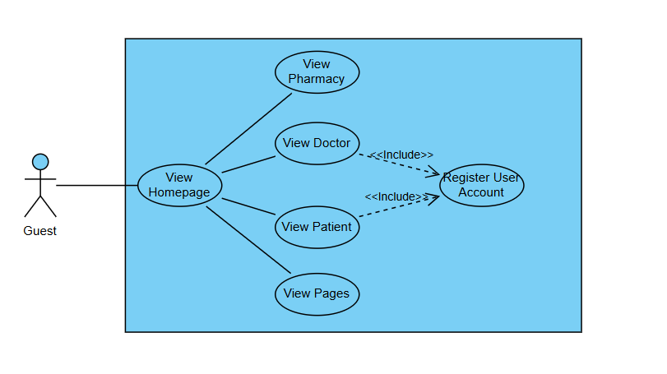

#### 2.2.2 UCs for Customer

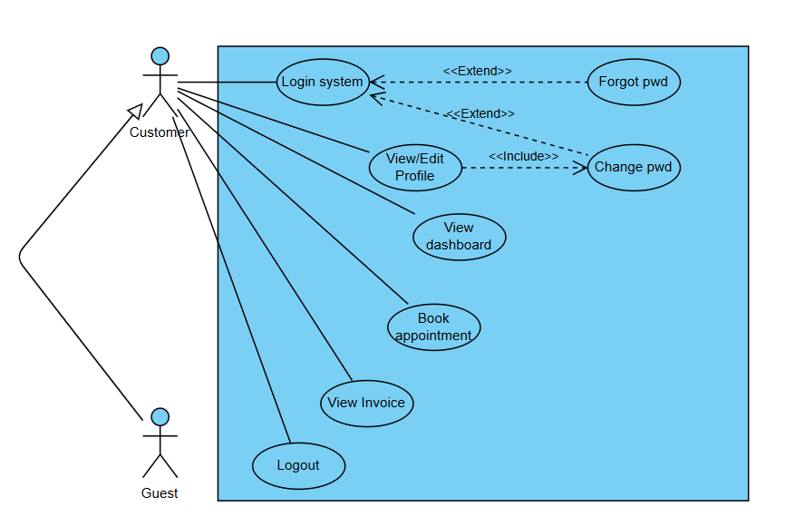

#### 2.2.3. UCs for Doctor

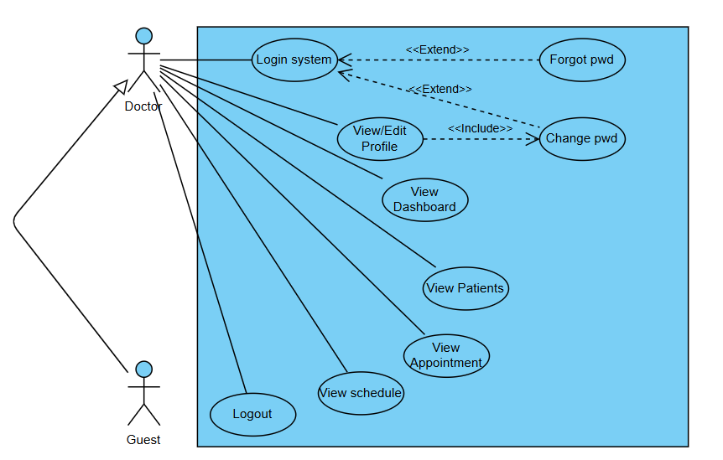

#### 2.2.3. UCs for Manager

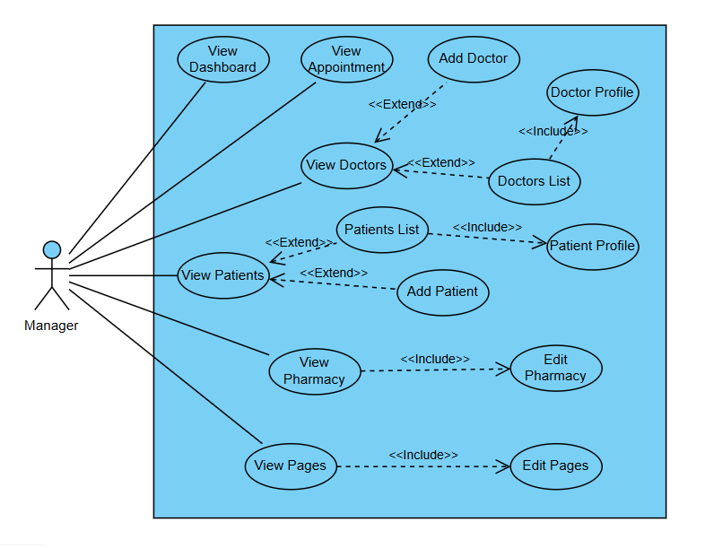

### 2.3. Descriptions

| **ID** | **Use Case** | **Actors** | **Use Case Description** |
| --- | --- | --- | --- |
| 01 | View homepage | All actors | Displays the homepage with general information and navigation options |
| 02 | Login system | All actors | The customer/doctor/manager log in using credentials to access the system |
| 03 | Forgot password | Customer, doctor | Allows a customer/doctor to reset their password if forgotten |
| 04 | View/edit profile | Customer, doctor | The customer/doctor can view and modify personal details |
| 05 | Change password | Customer, doctor | The customers can change their password within the profile settings |
| 06 | View dashboard | All actors | The customer/doctor/manager sees an overview of their activities |
| 07 | Book appointment | Customer | Allows customers to schedule a medical appointment with a doctor |
| 08 | View invoice | Customer | Customers can view their billing details and past payments |
| 09 | View patients | Doctor/manager | The doctor/manager can access patient information |
| 10 | View appointment | Doctor/manager | The doctor/manager can track patient bookings |
| 11 | View schedule | Doctor | Doctors can view their daily or weekly schedule |
| 12 | View doctor list | Manager | Managers can access the list of doctors in the system |
| 13 | Add doctor | Manager | Managers can add new doctors to the system |
| 14 | View patient list | Manager | Managers can see a list of registered patients |
| 15 | Add patient | Manager | Managers can add new patients to the system |
| 16 | Edit pharmacy | Manager | Managers can see details and able to edit information about the pharmacy |
| 17 | Edit pages | Manager | Managers can see details and able to edit information about the pages |
| 18 | Logout system | All actors | Allows all actors to securely log out of the system |

### (!)2.4 Main Workflows

*[Provide main workflows (business processes) using the swim-lane diagram(s) like sample below]*

#### 2.4.1. Order Processing

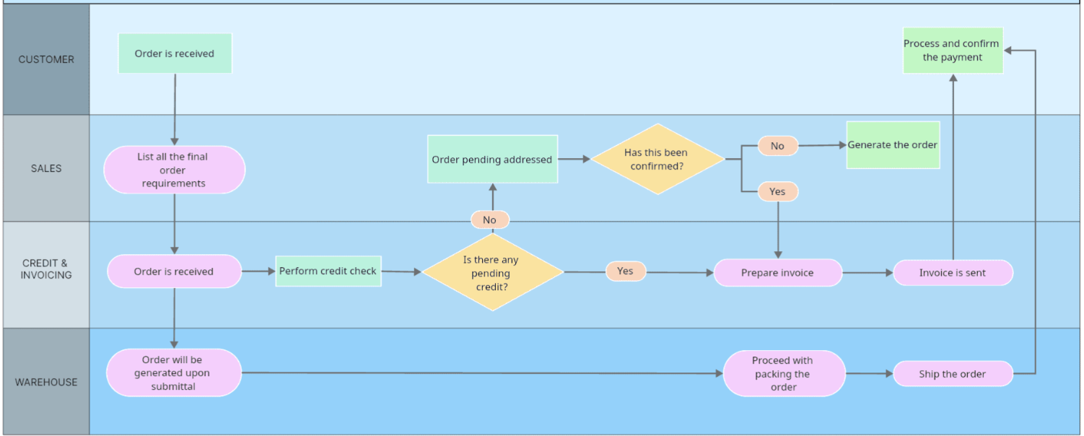

#### 2.4.2. Customer Support

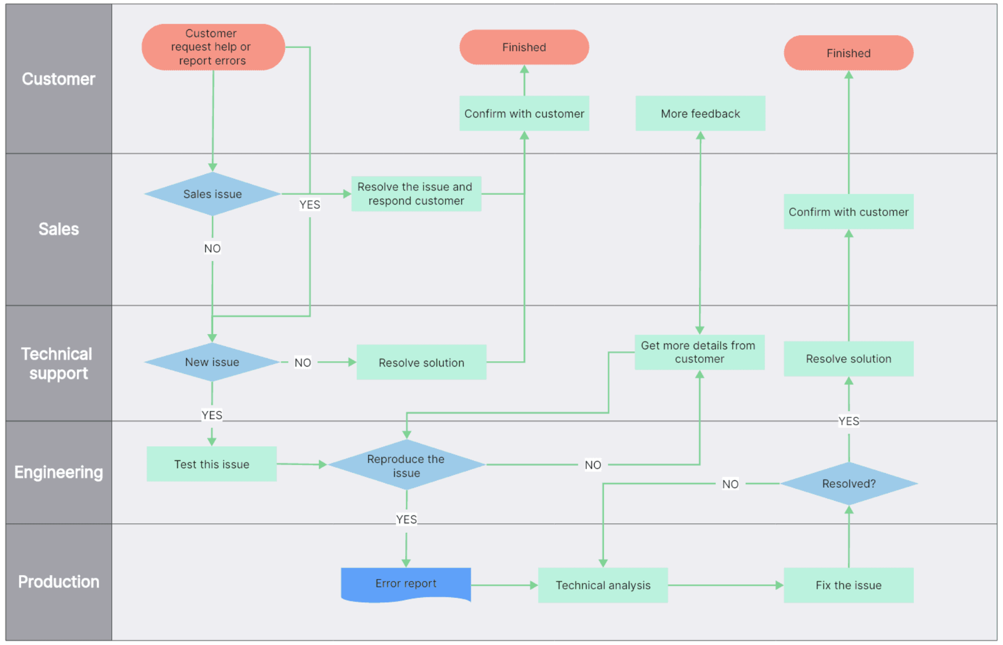

## 3. System Functionalities

### 

### 3.1 Screens Flow

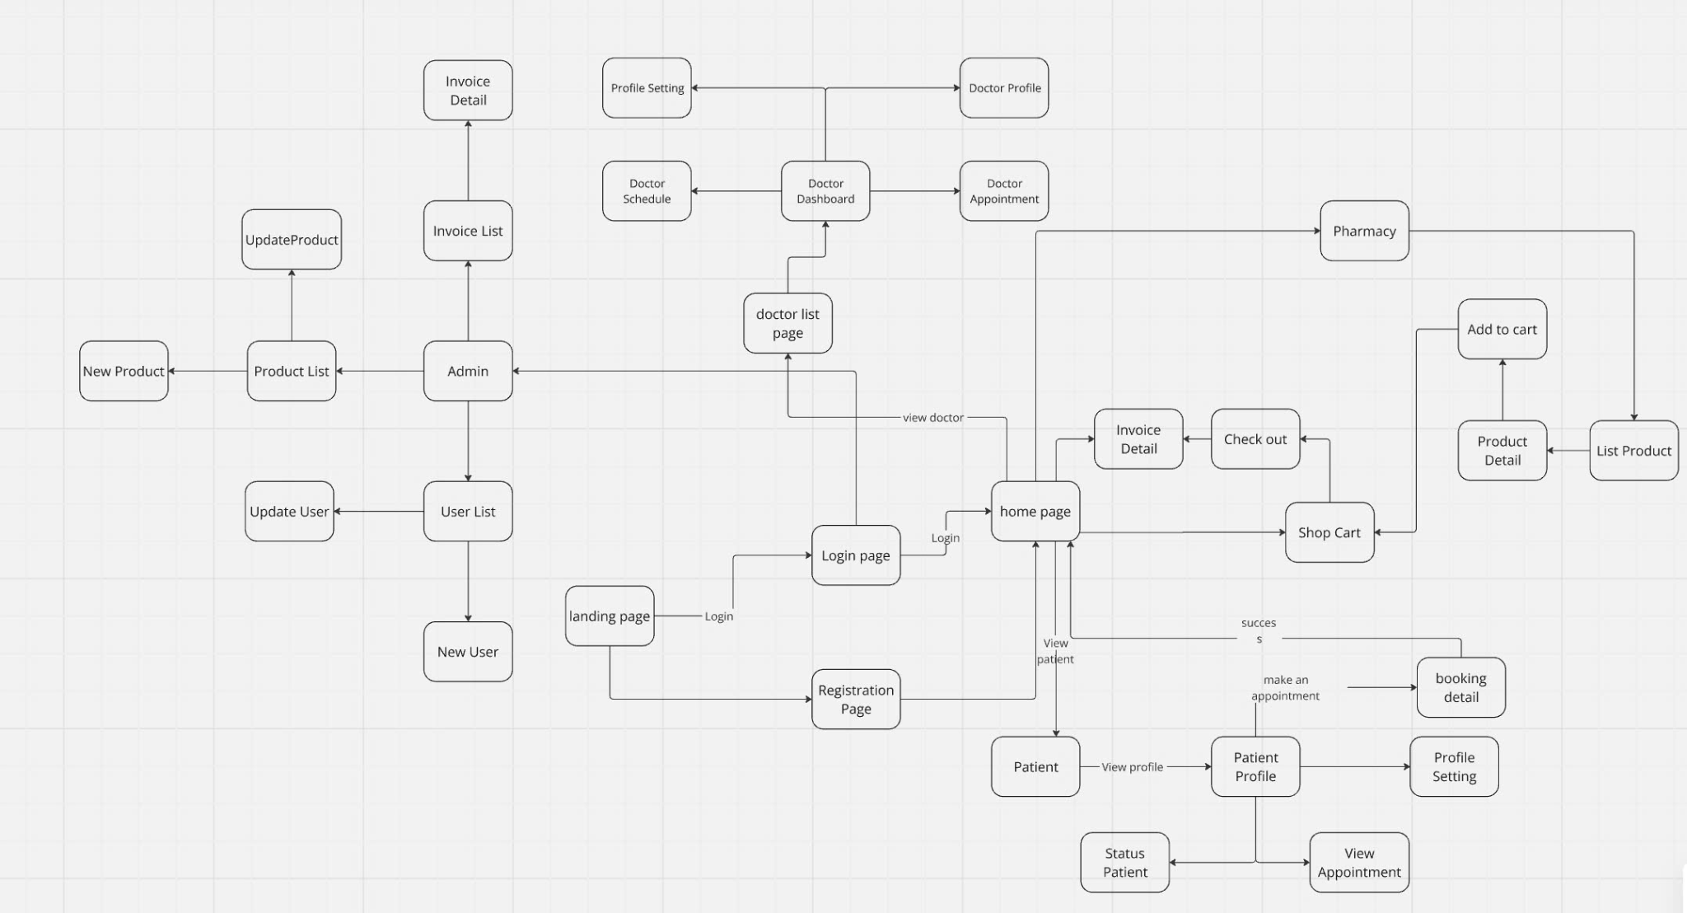

### 

### 3.2 Screen Authorization

| **Screen** | **Customer** | **Doctor** | **Manager** |
| --- | --- | --- | --- |
| **Landing page** | X | X | X |
| **User management** |  |  |  |
| Query All Data |  | X | X |
| Query Own Data | X | X |  |
| Add New Data | X | X | X |
| Update All Data |  |  | X |
| Update Own Data | X | X |  |
| Delete Data |  |  | X |
| **Appointment** |  |  |  |
| View Appointments | X | X | X |
| Book Appointment | X |  |  |
| Approve Appointment |  | X |  |
| Cancel Appointment | X | X | X |
| **Pharmacy** |  |  |  |
| View Prescriptions | X |  |  |
| Order Medicine | X |  |  |
| Approve Order |  | X |  |
| Edit/Update Pharmacy |  |  | X |

### (!)3.3 Non-UI Functions

*[Provide the descriptions for the non-screen system functions, i.e batch/cron job, service, API, etc.]*

| **#** | **Feature** | **System Function** | **Description** |
| --- | --- | --- | --- |
| 1 | <<Feature Name>> | <<Function Name1>> | <<Function Name1 Description>> |
| 2 | … |  |  |

# II. Functional Requirements

*[Provide descriptions about the system’s functions/screens. The functions/screens are grouped by the system features, and even sub-features if needed. For the screens, you need to provide the screen layouts (mock-up screens) and relevant specifications if needed]*

## 1. <<Feature Name1>>

### 1.1 <<Screen/Function Name1>>

*[Screen/Function description: what are purposes of the screen, how is the screen called, etc.]*

*[Screen layout(s)]*

*[Screen specifications: field initializations, the showing/hiding of some fields, business rules, normal flow, alternative flow, etc.]*

### 1.2 User Login

This screen allows user to be authenticated to the system screens/functionalities.

The main login screen is shown to the user in one of below cases:

* He/she clicks the Login link in the pages’ header
* He/she clicks the Login link in the User Register screen
* He/she is accessing one of the authenticated page while not logging-in yet

| ***S1_User Login screen*** | ***S2_Select account to login (with Google)*** |
| --- | --- |
|  |  |

*[Specifications for the two screens…]*

### 1.3 …

## 2. System Administration

### 2.1 System Settings

#### 2.1.1 Setting List

After clicking the System Configurations link on the NavBar (sider) menu, this page is shown.

This is for the administrator to view the list of current system settings. On this page, s/he can also activate or deactivate (change status) of a specific setting.

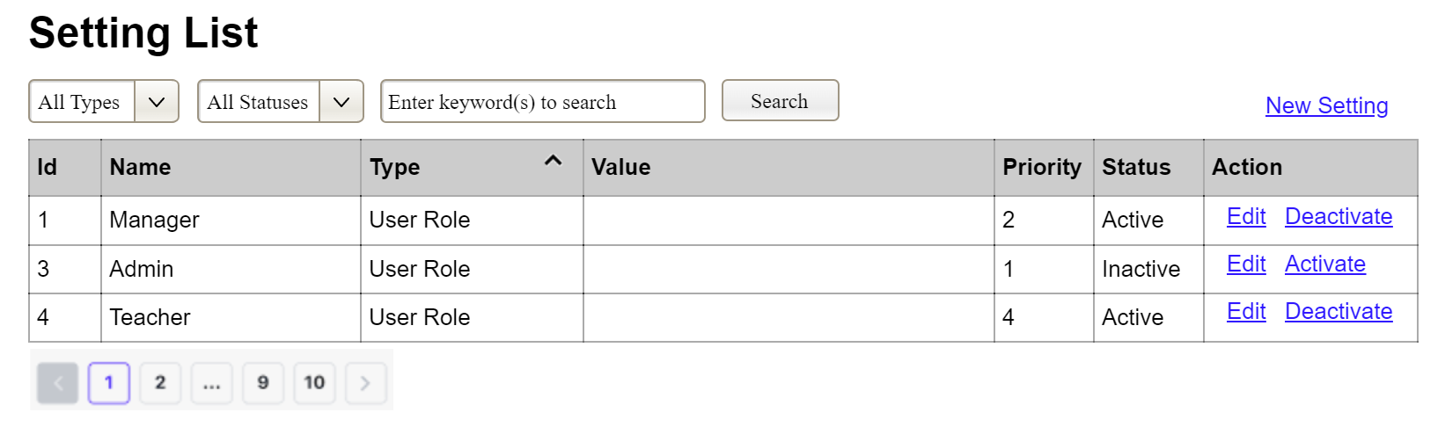

(1) Setting Type:

* Initialized with all the active setting types filled in,
* Allow user to filter the setting list by a specific setting type
* Default value is “All Types”, allowing user to see the settings at all types

(2) Setting Status:

* Initialized with two values Active and Inactive filled in
* Allow user to filter the setting list by a specific status (Active or Inactive)
* Default value is “All Types”, allowing user to see the settings at all statuses

(3) The change-status action is Activate or Deactivate depending on the current status of the relevant setting (Inactive or Active, respectively). The user needs to confirm the status changing via a modal confirmation message before getting that done.

…

#### 2.1.2 Setting Details

This page is shown after the user click the New Setting link or the Edit link in the Setting List page

This is for the administrator to add new or view/update an existing system setting

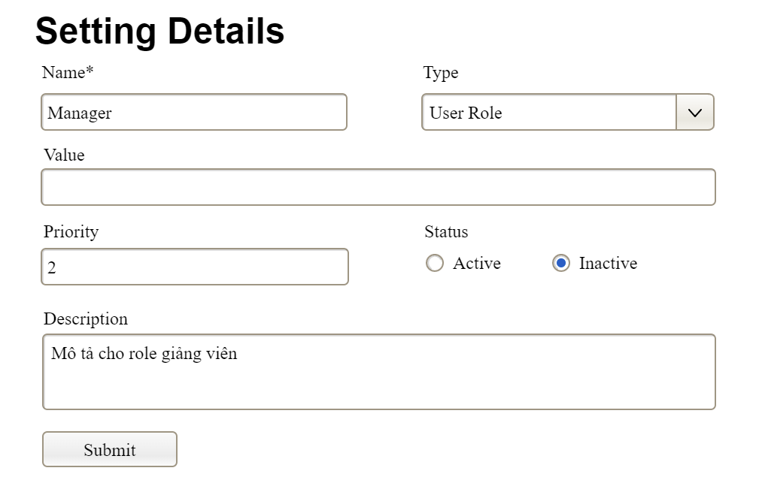

…

### 2.2 …

## 3. …

# III. System Design

## 1. Database Design

### 1.1 Database Schema

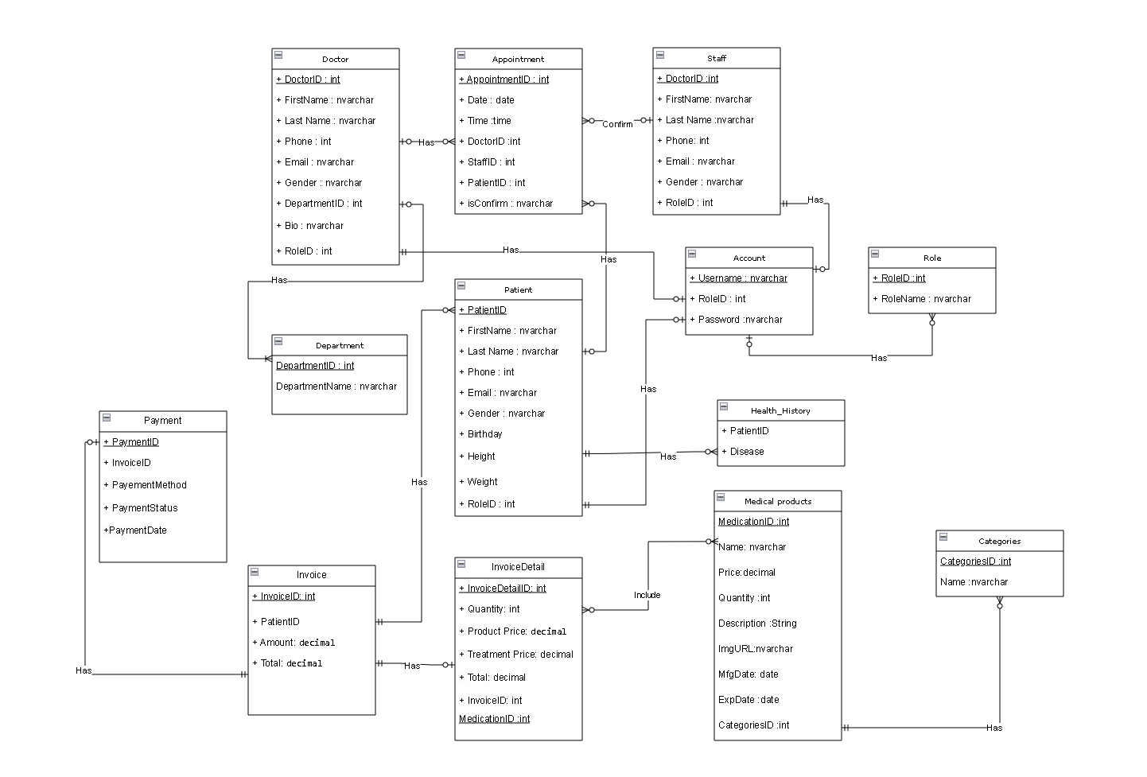

### 1.2 Table Descriptions

| **No** | **Table** | **Description** |
| --- | --- | --- |
| *01* | *<Table name>* | *<Description of the table>*  *- Primary keys: <<list of primary key fields>>*  *- Foreign keys: <<list of foreign key fields>>*  *- Unique keys:<<list of unique field or unique field set>>* |
| *02* | *<Table name2>* | *…* |

## 2. Code Packages

*[Provide the package diagram for the system (or sub systems) and package description similar to sample diagram and using description table format below]*

### 2.1 Package Diagram

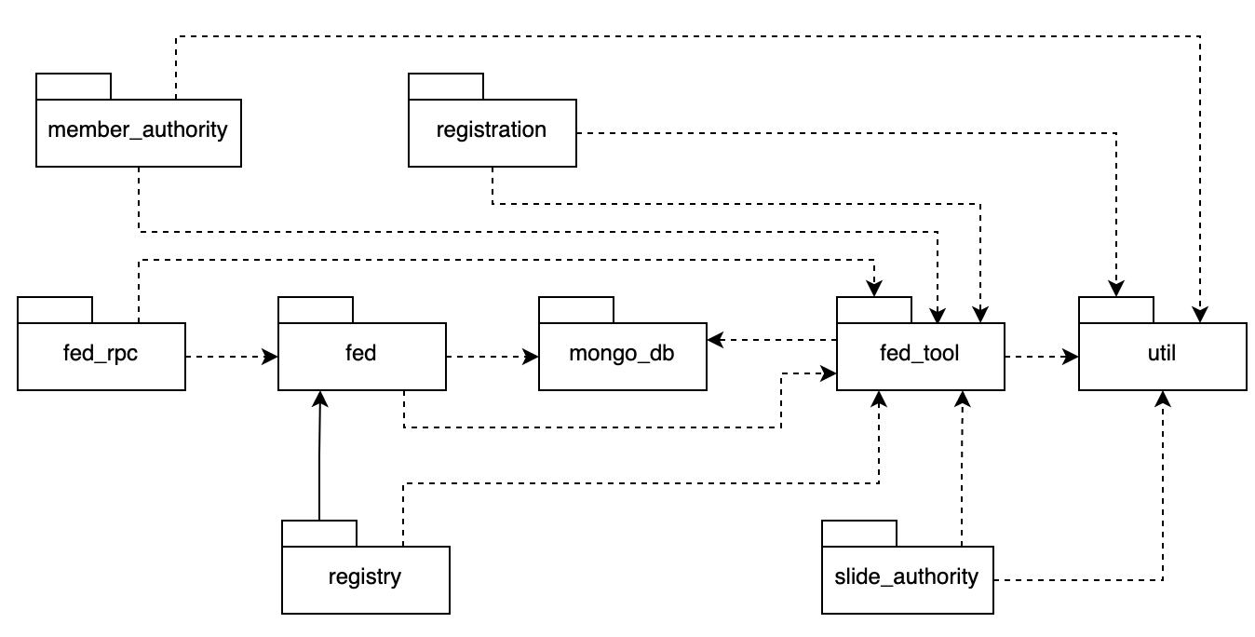

### 2.2 Package Descriptions

| **No** | **Package** | **Description** |
| --- | --- | --- |
| *01* | *member_authority* | *<Description of the package: purpose, contents,..>* |
| *02* | *registration* | *<Description of the package: purpose, contents,..>* |
| *03* | *…* |  |