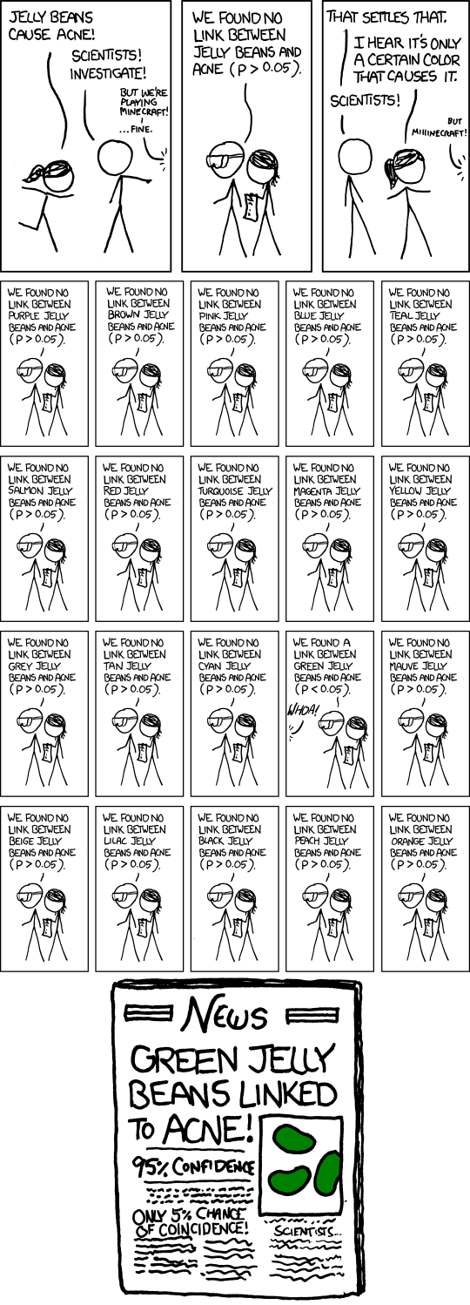

**STA 108: Applied Statistical Methods:**

Regression Analysis

Prof. Erin Melcon

Project II

Topic I Dataset: “transform1.csv”

Topic II Dataset: “athlete.csv”

DUKE LETRAN

https://xkcd.com/882/