Manuscript Draft: Methods and Results
PAD Major Lower-Extremity Amputation and Non-Home Discharge: External Validation of the Iannuzzi 2020 Score, the Subramaniam mFI-5, and the Kraiss 2022 sVQI-FS
Date: 2026-08-03

1. Methods

1.1. Data source
This analysis used patient-level data mapped to the Observational Medical Outcomes Partnership Common Data Model (OMOP CDM; CDM version: 5.4; vocabulary release: v5.0 27-AUG-25). The study window spanned January 01, 2017 to December 31, 2025. Full data source metadata are reported in Supplemental Table S1; the analytic implementation and its portability to other OMOP CDM v5 sources are described under Implementation and code deployment, below.

1.2. Target and outcome cohort definitions
The target cohort comprised adults aged 18 years or older who underwent an inpatient major lower-extremity amputation. The index event was defined by six OMOP procedure concept ancestors and all descendants via the concept_ancestor table: above-knee amputation (concept 4195136), amputation through tibia and fibula / below-knee (concept 4338257), through-knee amputation (concept 4143795), hip disarticulation (concept 4242396), ankle disarticulation (concept 4264289), and hemipelvectomy (concept 36675618). At least one of the following indications was required to be documented on or before the index date: peripheral arterial disease (SNOMED 399957001 and descendants), diabetes mellitus (SNOMED 73211009 and descendants), or a lower-extremity wound (ulcers, open wounds, gangrene, soft-tissue infection, osteomyelitis, or diabetic foot). These eligibility criteria exclude traumatic, burn, and oncologic amputations. Patients were required to have at least 1 day(s) of prior observation before the index date (a minimal requirement that accommodates emergency presentations). All patients were enrolled from inpatient visits (OMOP visit_concept_id 9201) only.
The outcome was non-home discharge (NHD) at the end of the index hospitalization, defined as any unambiguously non-home discharge destination. Discharge destination was ascertained from visit_occurrence.discharged_to_concept_id using a dynamic vocabulary query resolved at runtime. Non-home destinations include skilled nursing facility (SNF), inpatient rehabilitation facility (IRF), long-term acute care (LTAC), hospice, and other institutional care. Hospice is classified as a single non-home category regardless of setting; a known limitation is that this does not distinguish home hospice (UB-04 NUBC code 50) from facility-based hospice (code 51), which the Iannuzzi 2020 score's own NHD definition (rehabilitation or SNF only, excluding hospice and LTAC entirely — see Supplemental Table S2) does not need to resolve; this distinction was not implemented because the current synthetic cohort does not generate hospice discharges to validate the split against, and should be addressed before this classification is relied on with a real-data cohort that does include hospice discharges. NHD is a complete-case classification, not an exclusion: every patient in the target cohort is retained in both the NHD rate's numerator and denominator, and is classified as NOT non-home discharge (i.e., presumed home) whenever the destination cannot be confirmed as non-home. Concretely: patients with null, zero, or unresolved discharge_to_concept_id (mapping to 'No matching concept' or equivalent in the local vocabulary) are classified as not-NHD because the true discharge destination could not be confirmed non-home — this is a conservative default that may under-count true NHD events among these patients, and is noted as a limitation. Patients whose UB-04 source code was 'HO' (Home) are classified as home discharges (not-NHD); where the ETL had additionally assigned a conflicting non-home concept_id to these visits, the source code is treated as authoritative. Patients with source code 'AM' (against medical advice) are likewise classified as home discharges (not-NHD). The outcome was attributed to the index hospitalization. The dataset contained 195 patients with at least one qualifying amputation within the study window.

1.3. Implementation and code deployment
The analysis was implemented as an OHDSI Strategus (v1.5.0) study package, so that the same code and cohort definitions can be executed unmodified at any site holding an OMOP CDM v5 instance. Cohort construction, cohort diagnostics, and baseline characterization are delegated to standard HADES modules — CohortGenerator, CohortDiagnostics, and Characterization — invoked from a single declarative analysis specification. Cohorts are specified as OHDSI Circe JSON expressions and are rendered to dialect-specific SQL by CirceR at execution time, so no site-specific SQL editing is required. All schema and table names are supplied at run time; no credentials or institution-specific identifiers are embedded in the analytic code.
Predictor ascertainment is likewise cohort-based rather than expressed as ad hoc queries against the CDM domain tables. Each component of each risk score is resolved to a named cohort definition, and a single mapping table links every published score item to the cohort that operationalizes it, together with that item's point value and its lookback window. Where an equivalent cohort definition already existed in the investigators' shared phenotype library it was reused unchanged; the remainder were authored for this study and are named and versioned for later contribution to that library. Two consequences of this design are reported transparently in the Limitations, because they affect what the scores measure: some reused definitions are broader than the corresponding published score item, and some cannot carry a lookback window.
Three elements fall outside what the Strategus modules can express and are implemented as documented extensions. First, the non-home discharge outcome is derived from visit_occurrence.discharged_to_concept_id, an attribute the Circe cohort-definition schema does not support; it is therefore implemented as hand-authored, parameterized SQL that is applied to the generated cohort table before any analysis reads it, and is protected by an automated check that halts the pipeline if the definition is ever silently replaced. Second, application of the three published scoring rules is performed by a study-specific step, because the Strategus prediction module fits new models rather than applying fixed published weights. Third, three predictors requiring arithmetic on measurement values — body mass index computed from height and weight, and unit normalization of laboratory results — are computed in analytic code rather than as cohort definitions. Every such deviation is recorded in the study repository alongside the definition it applies to.
To verify that moving predictor ascertainment from direct CDM queries to cohort definitions did not change what was measured, both implementations are retained and an automated regression test scores every instrument twice — once by each route — and compares the resulting per-patient predictor values. Predictors whose definitions are semantically identical between the two routes are required to agree exactly; predictors that are expected to differ, because the reused cohort definition cannot carry a lookback window, are quantified rather than suppressed, and the magnitude of each difference is reported. A second automated check confirms that each authored cohort's concept set still matches the concept set recorded for that score component, so that a later revision of a shared definition cannot silently change this study's predictors.

1.4. Risk score evaluation
No published risk score exists for non-home discharge after major lower-extremity amputation. Each instrument evaluated here was derived for a different outcome, a different population, or both: the Iannuzzi 2020 score predicts NHD but was derived in patients undergoing elective lower extremity bypass; the Subramaniam mFI-5 is a general frailty index derived to predict mortality, postoperative complications, and unplanned readmission rather than discharge destination; and the Kraiss 2022 simple VQI Frailty Score (sVQI-FS) was derived to predict 9-month mortality in non-emergent vascular surgery cases. We therefore evaluated whether any of these existing instruments transports to NHD prediction in amputation patients. This is a screening step, undertaken as a benchmark before committing to de novo model development; it is not an external validation of the scores against the outcomes and populations for which they were designed.
Three published integer risk scores were evaluated. The Iannuzzi 2020 NHD integer risk score (range 0–18 points) predicts non-home discharge using age, the sex/race interaction, ambulatory status, tissue loss, anemia, and insulin-dependent diabetes. Its published sex/race term is a four-level interaction (white male 0, white female +1, nonwhite male +2, nonwhite female +3); because those integer weights are exactly additive, we implement them as two independent binary components (female +1, non-White +2), which reproduces the published point totals exactly rather than ignoring the interaction. The Subramaniam 2018 modified Frailty Index — 5-item (mFI-5, range 0–5 points) assigns one point each for diabetes mellitus, COPD, congestive heart failure, hypertension requiring medication, and dependent functional status. The Kraiss 2022 simple VQI Frailty Score (sVQI-FS, implemented here as a 0–10 integer point sum) assigns one point each for hypertension, congestive heart failure, coronary artery disease, peripheral vascular disease, diabetes, COPD, renal impairment, anemia, underweight status, and non-ambulatory status. The eleventh published item — non-home residence — is omitted because it is near-circular with the non-home discharge outcome and has no clean standard concept in this vocabulary build. We evaluate the equally weighted form of the score; the authors' preferred differentially weighted VQI-FS could not be applied because it requires nomogram regression coefficients together with a procedure-specific risk term whose categories (carotid endarterectomy, carotid artery stenting, endovascular and open abdominal aortic aneurysm repair, peripheral vascular intervention, suprainguinal and infrainguinal bypass) do not include major amputation. The implications of both departures are addressed in the Limitations discussion. For each score, covariates were extracted from the OMOP CDM using component-specific lookback windows relative to the index amputation date (Tables 3a–3c). A patient meeting the minimum event threshold for a given component received the full integer point value; those below threshold received zero. Absent records were treated as zero evidence for that component. The source publication does not compute the sVQI-FS when fewer than five frailty domains have available data; because component ascertainment here is based on the presence or absence of coded records rather than on registry fields with an explicit missing state, no equivalent suppression rule was applied and every patient in the cohort received a score.
Six model specifications were evaluated. (1) Iannuzzi 2020 — published lookup: predicted NHD probabilities drawn from the original score-to-risk table without any local refitting. Because the published table's tail is non-monotonic in the sparse high-score cells, the mapping used here is a monotone (isotonic) fit pooling the derivation and validation columns of the source publication's Table III; both raw columns are retained in covariates/risk_lookup.csv for provenance. (2) Iannuzzi 2020 — temporal recalibration: a logistic regression of the total integer score on the observed binary NHD outcome, fitted on the chronologically earlier half of the cohort (training set) and evaluated on the later half (test set). This quantifies the improvement in calibration obtainable by re-anchoring the score's probability scale to the local event rate. (3) mFI-5 — raw score and (4) mFI-5 — temporal recalibration: the same procedure applied to the mFI-5 raw integer score. Because no published NHD probability mapping exists for the mFI-5, recalibration is required to obtain predicted probabilities. (5) sVQI-FS — raw score and (6) sVQI-FS — temporal recalibration: likewise applied to the sVQI-FS raw integer score, for which no published NHD probability mapping exists either. Because logistic recalibration of a single predictor is a strictly monotone transform, the raw-score and recalibrated specifications of a given score share the same discrimination by construction; AUROC and AUPRC are therefore computed once per score and reported in both columns.
Patients were sorted chronologically by index amputation date and divided at the midpoint (floor(n / 2) training rows). Each recalibration logistic regression was fitted exclusively on the training set (earlier half), and every specification that involves local fitting — the recalibrated and raw-score models — was evaluated on the test set (later half) only. This prevents optimistic bias from evaluating a locally fitted model on the data used to fit it, and provides an estimate of prospective performance on future patients from the same source. The Iannuzzi published-lookup specification is the exception: it is a fixed external mapping with no parameters estimated from these data, so restricting it to the test half would discard half the available events without removing any bias. It is therefore evaluated over the full cohort. Table 4 states the evaluation set for every column.
Patients were sorted chronologically by index date and divided into a training set (n = 97; through 2018-10-01) used only to fit the recalibration models and a test set (n = 98; after 2018-10-01) on which the recalibrated and raw-score specifications were evaluated. The same split applies to every score.
Discrimination was summarised using the area under the receiver operating characteristic curve (AUROC) and the area under the precision-recall curve (AUPRC), each with 95% bootstrap percentile confidence intervals (B = 500 resamples). Calibration was assessed using the Brier score, expected calibration error (ECE), calibration intercept, and calibration slope, each with 95% bootstrap percentile CIs. ECE was computed as the probability-weighted mean absolute difference between mean predicted and observed NHD rates across quantile-based bins. Calibration plots compare mean predicted risk versus observed event rate within each bin; the dashed diagonal represents perfect calibration.

1.5. Subgroup analysis and bias assessment
Model calibration was assessed across prespecified patient subgroups to identify populations in which the recalibrated risk scores may systematically over- or underestimate observed non-home discharge risk. Subgroups evaluated included biological sex, race, ethnicity, age group (<65, 65–74, ≥75 years), amputation level (above-knee, below-knee, other), and calendar year of the index procedure. Expected calibration error (ECE) was computed within each subgroup as the weighted mean absolute difference between grouped predicted and observed event rates across quantile-based bins. Uncertainty was quantified using 200 bootstrap resamples (percentile 95% CI). Subgroup levels with fewer than 10 observed NHD events were suppressed to avoid unreliable estimates. Subgroup ECE is computed on the same temporal test partition as the overall ECE reported in Table 4, so the two are directly comparable. Results are presented separately for the Iannuzzi 2020 (Recalibrated) model in Supplemental Table S9 and Supplemental Figure S10; the mFI-5 (Recalibrated) model in Supplemental Table S11 and Supplemental Figure S12; the sVQI-FS (Recalibrated) model in Supplemental Table S13 and Supplemental Figure S14.

2. Results

2.1. Cohort characteristics
The final target cohort included 195 patients, of whom 78 experienced non-home discharge (NHD), corresponding to an observed NHD rate of 40.0%.
Characteristic | Value
Age, median (IQR), years | 63 (57–71)
Sex
Male | 99 (50.8%)
Female | 96 (49.2%)
Race
White | 130 (66.7%)
Black | 60 (30.8%)
Asian | 2 (1.0%)
Ethnicity
Hispanic / Latino | 29 (14.9%)
Not Hispanic / Latino | 166 (85.1%)
Indication (not mutually exclusive)
Peripheral arterial disease (PAD) | 168 (86.2%)
Diabetes mellitus | 183 (93.8%)
Lower-extremity wound / gangrene | 22 (11.3%)
Amputation level
Above-knee (AKA) | 80 (41.0%)
Below-knee (BKA) | 115 (59.0%)
Other | 0 (0.0%)
Outcome
Non-home discharge (NHD) | 78 (40.0%)
Total cohort | 195 (100.0%)
Table 1. Demographics and clinical characteristics of the validation cohort. Values are n (%) unless stated. Age is summarised as median (IQR). Race and ethnicity are derived from OMOP person table concept fields. Indication rows are not mutually exclusive; a patient may have more than one. PAD = peripheral arterial disease (ancestor 317309); diabetes mellitus (ancestor 201820); lower-extremity wound / gangrene (25 SNOMED ancestors — ulcers, open wounds, gangrene, soft-tissue infection, osteomyelitis, diabetic foot). Amputation level is assigned hierarchically: AKA (ancestor 4195136), then BKA (4338257), then Other (through-knee 4143795, hip disarticulation 4242396, ankle disarticulation 4264289, hemipelvectomy 36675618). Amputation level rows are mutually exclusive.

2.2. NHD patient outcomes
Among the 78 patients who experienced non-home discharge (NHD) at the end of the index hospitalization, Table 2 summarises key post-discharge outcomes.
Outcome | Value
Index hospitalization length of stay, median (IQR) | 16 days (IQR: 11–18)
Discharge destination
Skilled Nursing Facility | 53 (67.9%)
Rehabilitation Hospital | 25 (32.1%)
90-day readmission, n (%) | 20 (25.6%)
90-day mortality, n (%) | 1 (1.3%)
Table 2. NHD patient outcomes at the index hospitalization and within 90 days. Denominator is all patients with non-home discharge at the index hospitalization (n = 78). Index hospitalization LOS: length of the inpatient visit (visit_concept_id 9201) containing the index procedure date, calculated as DATEDIFF(DAY, visit_start_date, COALESCE(visit_end_date, visit_start_date)). Discharge destination: destination concept name from visit_occurrence.discharged_to_concept_id joined to the vocabulary concept table; destinations with fewer than 11 patients are suppressed. 90-day readmission: any inpatient visit (visit_concept_id 9201) starting after the index hospitalization's discharge date and within 90 days of that discharge date (anchored on discharge, not admission, so patients with a longer index stay are not given a shorter effective follow-up window). 90-day mortality: any death record on or after the discharge date and within 90 days of it.

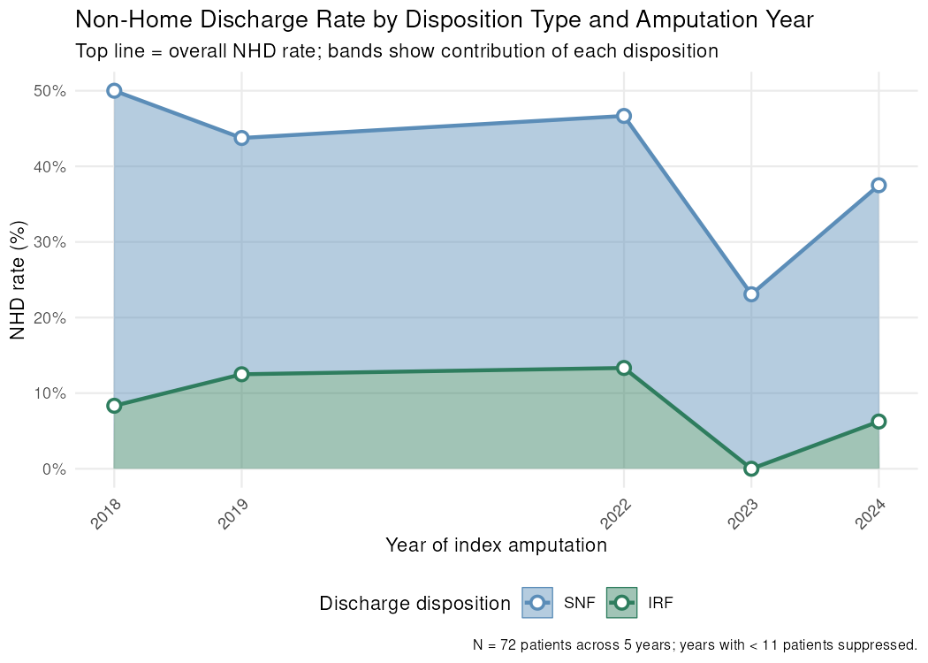
Figure 1. Non-home discharge (NHD) rate by disposition type and amputation year. Non-home discharge (NHD) rate (%) by calendar year of index amputation, stratified by discharge disposition (SNF = Skilled Nursing Facility; IRF = Inpatient Rehabilitation Facility; LTAC = Long-term Acute Care; Hospice; Other NHD). Stacked bands show the cumulative NHD rate by disposition; the top edge of the uppermost band equals the overall NHD rate for that year. Points and lines trace the top edge of each disposition's contribution. Years with fewer than 11 patients are suppressed (small-cell privacy rule, matching Table 2's discharge-destination suppression threshold). Disposition is mapped from UB-04 discharged_to_source_value codes.

2.3. Predictor activation
Component | Points | Definition | OMOP Standard Concept ID(s) | Count | Total | Prevalence %
Dependent functional status (frailty / impaired mobility) | +1 | Partial or total dependence for ADLs, frailty, or impaired mobility | Concept 4086506 (Frailty, SNOMED 248279007) + 4306934 (Impaired mobility, SNOMED 82971005) + descendants [vocab query] | 55 | 195 | 28.2%
Diabetes mellitus (any type) | +1 | Any type of diabetes mellitus | Concept 201820 (Diabetes mellitus, SNOMED 73211009) + descendants [vocab query] | 169 | 195 | 86.7%
Chronic obstructive pulmonary disease | +1 | COPD (current-pneumonia sub-component of mFI-5 omitted — documented limitation in EHR data) | Concept 255573 (COPD, SNOMED 13645005) + descendants [vocab query] | 68 | 195 | 34.9%
Congestive heart failure (within 30 days prior) | +1 | Congestive heart failure within 30 days before the index amputation date | Concept 316139 (Heart failure, SNOMED 84114007) + descendants [vocab query] | 60 | 195 | 30.8%
Hypertension | +1 | Hypertensive disorder (medication requirement not enforced — documented limitation) | Concept 316866 (Hypertensive disorder, SNOMED 38341003) + descendants [vocab query] | 107 | 195 | 54.9%
Table 3a. Subramaniam mFI-5: component definitions and activation summary. The five Subramaniam 2018 mFI-5 components are listed with their point value (each = 1 point, range 0–5), OMOP-based definition, and observed activation rate in the validation cohort. All components use a 10-year lookback window except congestive heart failure (30-day lookback per the original publication). Absent records are treated as true negatives (missing_is_negative = TRUE for all components).

Component | Points | Definition | OMOP Standard Concept ID(s) | Count | Total | Prevalence %
Age 60-69 years at index | +2 | Age 60–69 years at the index amputation date | person.year_of_birth (no OMOP concept ID required) | 64 | 195 | 32.8%
Age 70-79 years at index | +4 | Age 70–79 years at the index amputation date | person.year_of_birth (no OMOP concept ID required) | 66 | 195 | 33.8%
Age 80 or more years at index | +6 | Age ≥80 years at the index amputation date | person.year_of_birth (no OMOP concept ID required) | 0 | 195 | 0%
Female sex | +1 | Female gender recorded in OMOP person table | Concept 8532 (Female) [vocab query] | 96 | 195 | 49.2%
Non-White race | +2 | Non-White race recorded in OMOP person table | Concept 8527 (White) as reference [vocab query]; non-White = race_concept_id ≠ 8527 | 62 | 195 | 31.8%
Ambulatory deficit (use of any ambulatory device) | +3 | Use of any ambulatory assistive device (cane, walker, wheelchair, etc.) | 4012645, 437643, 439405, 36714126 + descendants [vocab query] | 71 | 195 | 36.4%
Tissue loss (CLI indication — wound ulcer or gangrene) | +3 | Critical limb ischaemia indication: wound, ulcer, or gangrene | 4029926, 4291464 + descendants [vocab query]; see catalog entry tissue_loss | 98 | 195 | 50.3%
Anemia (Hgb less than 10 g/dL) | +2 | Pre-operative anemia: hemoglobin < 10 g/dL | 3000963 (LOINC 718-7, Hgb) [vocab query]; see covariate_concepts.csv :: anemia | 60 | 195 | 30.8%
Insulin-dependent diabetes mellitus | +2 | Insulin use as proxy for insulin-dependent diabetes mellitus | 21600713 (ATC: Insulins and analogues) + descendants [vocab query] | 89 | 195 | 45.6%
Table 3b. Iannuzzi 2020 NHD score: component definitions and activation summary. The nine components of the Iannuzzi 2020 non-home discharge integer risk score are listed with point values (range 0–18), OMOP-based definitions, and observed activation rates in the validation cohort. For the anemia component (Hgb < 10 g/dL), absent measurement records are treated as unknown (missing_is_negative = FALSE). All other components treat absent records as true negatives.

Component | Points | Definition | OMOP Standard Concept ID(s) | Count | Total | Prevalence %
Hypertension | +1 | Hypertensive disorder | Concept 316866 (Hypertensive disorder, SNOMED 38341003) + descendants [vocab query] | 107 | 195 | 54.9%
Congestive heart failure | +1 | Congestive heart failure | Concept 316139 (Heart failure, SNOMED 84114007) + descendants [vocab query] | 111 | 195 | 56.9%
Coronary artery disease | +1 | Coronary artery disease | Concept 4185932 (Coronary arteriosclerosis) + descendants [vocab query] | 39 | 195 | 20%
Peripheral vascular disease | +1 | Peripheral arterial occlusive disease (diagnosis proxy; paper uses ABI <0.7 or prior arterial intervention/amputation) | Concept 317309 (Peripheral arterial occlusive disease, SNOMED 399957001) + descendants [vocab query] | 168 | 195 | 86.2%
Diabetes mellitus (any type) | +1 | Any type of diabetes mellitus | Concept 201820 (Diabetes mellitus, SNOMED 73211009) + descendants [vocab query] | 169 | 195 | 86.7%
Chronic obstructive pulmonary disease | +1 | COPD | Concept 255573 (COPD, SNOMED 13645005) + descendants [vocab query] | 68 | 195 | 34.9%
Renal impairment (creatinine > 1.8 mg/dL or dialysis) | +1 | Creatinine > 1.8 mg/dL or dialysis, the paper's own lab-value definition (no longer a diagnosis proxy — CORRECTED 2026-07-26 after the prior CKD-diagnosis proxy activated in 224/225 patients, 99.6%, due to an over-broad concept-ancestor expansion) | Concept 3016723 (Creatinine [Mass/volume] in Serum or Plasma, LOINC) thresholded at >1.8 mg/dL, OR Concepts 4146536 (Renal dialysis) / 4032243 (Dialysis procedure) [vocab query] | 89 | 195 | 45.6%
Anemia (sex-specific Hgb threshold: <13 g/dL M / <12 g/dL F) | +1 | Hgb < 13 g/dL (male) / < 12 g/dL (female), the paper's own sex-specific lab threshold (no longer a diagnosis proxy — CORRECTED 2026-07-26 after the prior anemia-diagnosis proxy activated in only 3/225 patients, 1.3%, under-capturing relative to the lab threshold) | Concept 3000963 (Hemoglobin [Mass/volume] in Blood, LOINC 718-7) — the same measurement Iannuzzi's single-threshold anemia component uses [vocab query] | 131 | 195 | 67.2%
Underweight (BMI < 18.5) | +1 | BMI < 18.5, the paper's own cut-point (direct measurement preferred; weight/height fallback) | Concepts 3038553, 36304833 (BMI direct); 3025315, 3013762, 3011054, 3026600 (weight); 3036277, 3023540, 3015514 (height) [vocab query] | 15 | 195 | 7.7%
Non-ambulatory / impaired ambulation status | +1 | Impaired ambulation, walking aid use, or gait abnormality | Concepts 4012645, 437643, 439405, 36714126 (Observation/Clinical Finding) + 4085915 (Provision of long cane, Procedure) + 4044714 (Using wheelchair, Observation) + 4240470 (Wheelchair, Device) [vocab query]; see phenotype_library/catalog.yaml :: ambulatory_deficit for per-concept domain notes | 71 | 195 | 36.4%
Table 3c. Kraiss 2022 sVQI-FS: component definitions and activation summary. Ten of the eleven Kraiss 2022 simple VQI Frailty Score components are listed with their point value (each = 1 point, range 0–10 as implemented here; non-home residence is omitted, see covariates/covariates_vqifs.csv header), OMOP-based definition, and observed activation rate in the validation cohort. All components use a 10-year lookback window. Renal impairment (serum creatinine > 1.8 mg/dL or dialysis) and anemia (hemoglobin < 13 g/dL in males, < 12 g/dL in females) apply the source publication's own laboratory thresholds rather than diagnosis proxies; underweight uses a direct BMI < 18.5 measurement threshold. Peripheral vascular disease remains a diagnosis-based proxy rather than the paper's ankle-brachial index < 0.7 or prior arterial intervention definition. Absent records are treated as true negatives (missing_is_negative = TRUE) for all components except underweight and anemia, where an unmeasured BMI or hemoglobin value is treated as unknown rather than a true negative.

2.4. Model performance
Metric | Iannuzzi 2020  (Lookup, 95% CI) | Iannuzzi 2020  (Recalibrated, 95% CI) | mFI-5  (Raw score, 95% CI) | mFI-5  (Recalibrated, 95% CI) | sVQI-FS  (Raw score, 95% CI) | sVQI-FS  (Recalibrated, 95% CI)
AUROC | 0.539 (0.460–0.614) | 0.472 (0.349–0.600) | 0.540 (0.415–0.659) | 0.540 (0.415–0.659) | 0.479 (0.361–0.613) | 0.479 (0.361–0.613)
AUPRC | 0.440 (0.346–0.559) | 0.305 (0.206–0.454) | 0.352 (0.246–0.503) | 0.352 (0.246–0.503) | 0.358 (0.237–0.508) | 0.358 (0.237–0.508)
Brier score | 0.261 (0.232–0.291) | 0.241 (0.223–0.257) | N/A | 0.241 (0.233–0.248) | N/A | 0.240 (0.230–0.250)
Expected calibration error | 0.163 (0.122–0.236) | 0.134 (0.107–0.247) | N/A | 0.128 (0.081–0.229) | N/A | 0.141 (0.082–0.242)
Calibration intercept | -0.042 (-0.329–0.315) | -0.417 (-0.853–0.031) | N/A | -0.537 (-0.980–-0.122) | N/A | -0.508 (-0.958–-0.106)
Calibration slope | 0.194 (-0.106–0.531) | -0.330 (-1.873–1.339) | N/A | -0.969 (-7.025–4.334) | N/A | -0.484 (-3.979–3.164)
Table 4. Model performance: discrimination and calibration metrics for Iannuzzi 2020 (published lookup), Subramaniam mFI-5 (raw integer score), and Kraiss 2022 sVQI-FS (raw integer score). Six model specifications are compared. Iannuzzi 2020 (Lookup): predicted probabilities drawn from a refitted score-to-risk lookup (monotone isotonic fit, resolving the non-monotonic inversion in the published Table III). Iannuzzi 2020 (Recalibrated): logistic regression of the total Iannuzzi integer score on the observed NHD outcome, fitted on the chronologically earlier half of the cohort (training set) and evaluated on the later half (test set). mFI-5 (Raw score): discrimination from the raw integer score (0–5) only; no published NHD probability mapping exists so calibration metrics are N/A. mFI-5 (Recalibrated): logistic recalibration of the mFI-5 raw score on the same temporal training split as above; all four metrics reported on the test set. sVQI-FS (Raw score): discrimination from the raw integer score only; no published NHD probability mapping exists so calibration metrics are N/A. sVQI-FS (Recalibrated): logistic recalibration of the sVQI-FS raw score on the same temporal training split as above; all four metrics reported on the test set. Iannuzzi 2020: metrics reported on the test set (n = 98; after 2018-10-01). mFI-5: metrics reported on the test set (n = 98; after 2018-10-01). sVQI-FS: metrics reported on the test set (n = 98; after 2018-10-01). N/A = metric not applicable for this specification. 95% CI = 95% bootstrap percentile confidence interval (B = 500 resamples). — indicates CI not available.

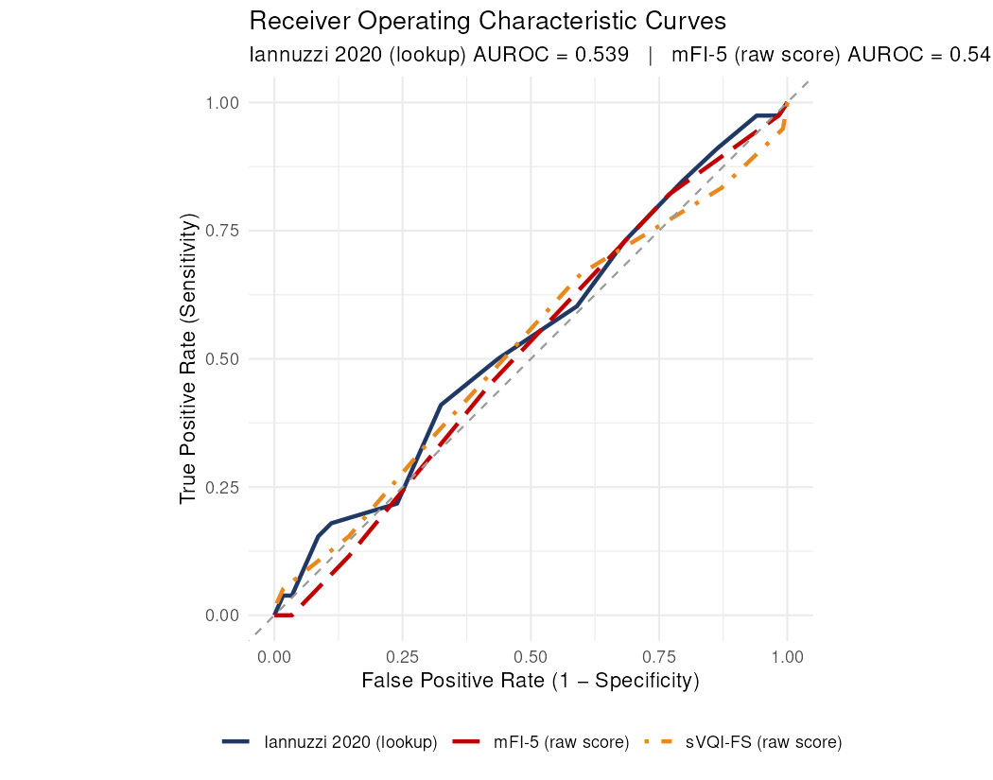
Figure 2. Receiver operating characteristic (ROC) curves. ROC curves for the Iannuzzi 2020 NHD score (published lookup, blue solid), the Subramaniam mFI-5 (raw integer score 0–5, red dashed), and the Kraiss 2022 sVQI-FS (raw integer score, orange dot-dash) predicting non-home discharge. For mFI-5 and sVQI-FS, the raw score is normalised to [0, 1] for curve plotting. AUROC with 95% bootstrap percentile CI (B = 500 resamples).

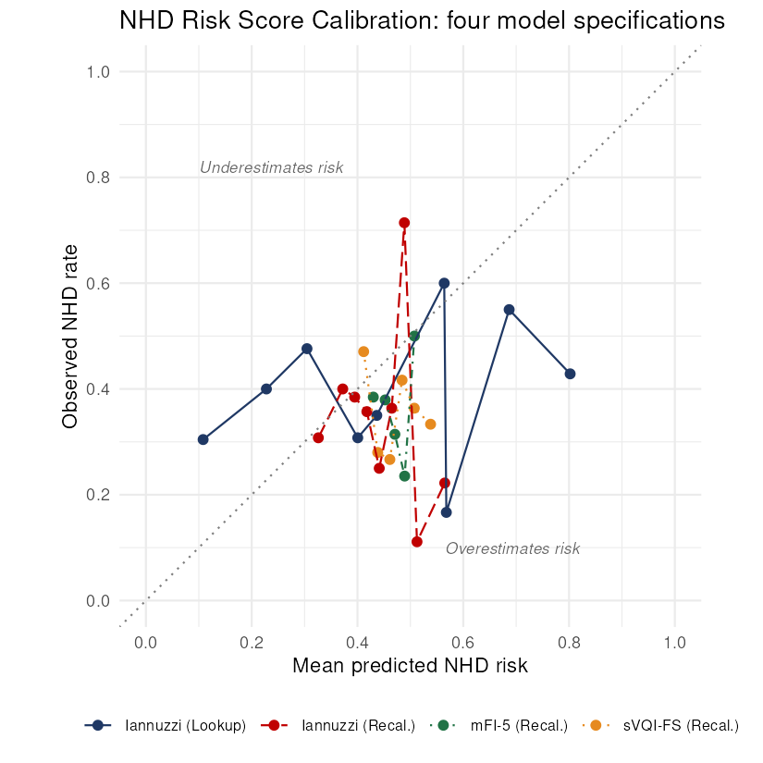
Figure 3. NHD risk score calibration — four model specifications. Calibration curves for four NHD risk score specifications. Blue solid line: Iannuzzi 2020 refitted score-to-risk lookup (monotone isotonic). Red dashed line: Iannuzzi 2020 temporal recalibration — logistic regression of the total integer score fitted on the chronologically earlier half of the cohort and evaluated on the later half. Green dot-dash line: mFI-5 temporal recalibration — same split applied to the mFI-5 score. Orange dotted line: Kraiss 2022 sVQI-FS temporal recalibration — same split applied to the sVQI-FS score. Mean predicted NHD risk (x-axis) vs. observed NHD rate (y-axis) by quantile bin. Dotted diagonal = perfect calibration.

2.5. Risk tier analysis
Risk Tier | N | NHD Events | Observed NHD Rate (%)
Iannuzzi 2020 (Lookup, full cohort)
Low (<30%) | 58 | 21 | 36.2%
Intermediate (30–70%) | 130 | 54 | 41.5%
High (>70%) | 7 | 3 | 42.9%
Iannuzzi 2020 (Recalibrated, test set)
Low (<30%) | 3 | 1 | 33.3%
Intermediate (30–70%) | 95 | 32 | 33.7%
High (>70%) | 0 | 0 | N/A
mFI-5 (Recalibrated, test set)
Low (<30%) | 0 | 0 | N/A
Intermediate (30–70%) | 98 | 33 | 33.7%
High (>70%) | 0 | 0 | N/A
sVQI-FS (Recalibrated, test set)
Low (<30%) | 0 | 0 | N/A
Intermediate (30–70%) | 98 | 33 | 33.7%
High (>70%) | 0 | 0 | N/A
Iannuzzi 2020 published score strata (full cohort)
Low (score 0–4) | 36 | 12 | 33.3% (published 10.1%)
Moderate (score 5–9) | 114 | 49 | 43% (published 36.7%)
High (score ≥10) | 45 | 17 | 37.8% (published 66.1%)
Table 5. Risk tier classification by model specification. Patients are stratified into three tiers based on each model's predicted NHD risk: Low (<30%), Intermediate (30–70%), and High (>70%); a final section instead uses the Iannuzzi 2020 publication's own raw-score strata. The observed NHD rate within each tier provides a direct assessment of clinical utility. five specifications are shown in separate sections: Iannuzzi 2020 (Lookup, full cohort); Iannuzzi 2020 (Recalibrated, test set); mFI-5 (Recalibrated, test set); sVQI-FS (Recalibrated, test set); Iannuzzi 2020 published score strata (full cohort). EVALUATION SET: recalibrated specifications are restricted to the temporal test partition, matching Table 4, because the training half was used to fit their recalibration. The published lookup and the published score strata involve no fitting and are therefore reported over the full cohort. N = number of patients assigned to that tier by the corresponding model. NHD Events = number with non-home discharge. Observed NHD Rate = NHD Events / N. Predicted risk thresholds: Low <30%, Intermediate 30–70%, High >70%. Iannuzzi published score strata: Low 0–4, Moderate 5–9, High ≥10, with the publication's own observed rates (10.1% / 36.7% / 66.1%) shown in parentheses for direct comparison. Note that logistic recalibration of a weakly discriminating integer score compresses the predicted probability range toward the cohort base rate; when this places every patient in a single probability tier, that is a substantive finding about the score's limited spread, not a computational artefact.

2.6. Decision curve analysis
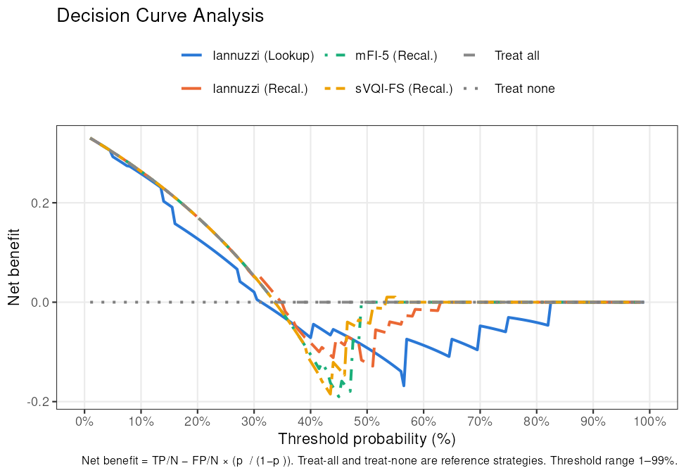
Figure 4. Decision curve analysis. Decision curve analysis for every NHD risk prediction model specification available in this run (Iannuzzi lookup and recalibrated; mFI-5 and sVQI-FS recalibrated, when their pipelines were run), evaluated on the temporal test partition so that all curves compare net benefit across the same patients. Net benefit is plotted across threshold probabilities from 1% to 99%. Model curves are compared with the 'treat-all' (dashed) and 'treat-none' (zero reference) strategies. Threshold probabilities correspond to the minimum predicted NHD risk at which a clinician would recommend an intervention.

2.7. Subgroup bias assessment — Iannuzzi 2020 (Recalibrated)
Subgroup | Level | N | Events | ECE | 95% CI
Age Group | <65 | 61 | 18 | 0.153 | (0.108–0.271)
Age Group | 65-74 | 28 | 11 | 0.327 | (0.213–0.478)
Sex | Female | 52 | 15 | 0.266 | (0.19–0.403)
Sex | Male | 46 | 18 | 0.106 | (0.081–0.3)
Race | White | 64 | 24 | 0.166 | (0.103–0.293)
Ethnicity | Non-Hispanic | 80 | 28 | 0.168 | (0.113–0.285)
Supplemental Table S9. ECE by subgroup — Iannuzzi 2020 (Recalibrated). Subgroups with fewer than 10 observed NHD events are suppressed. Overall ECE = 0.134. 95% CI = bootstrap percentile interval (B = 200 resamples).

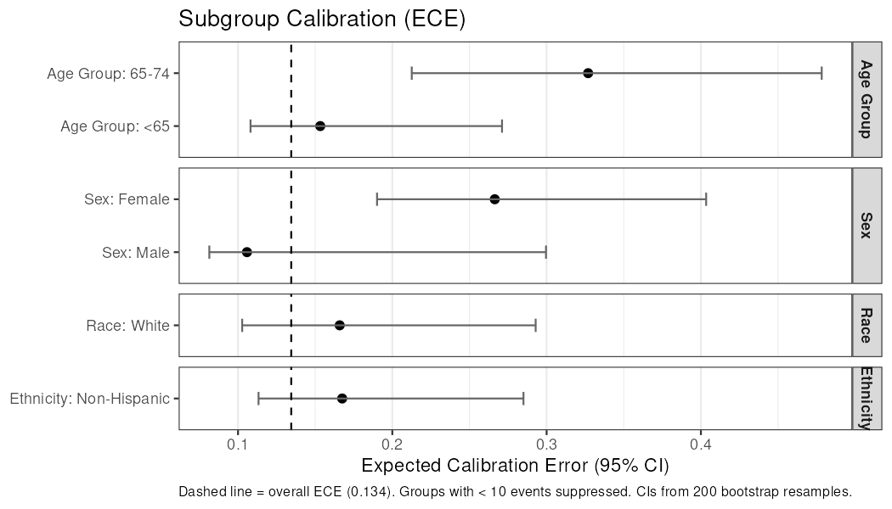
Supplemental Figure S10. Subgroup calibration forest plot — Iannuzzi 2020 (Recalibrated). Expected calibration error (ECE) with 95% bootstrap percentile CIs (B = 200) by subgroup. Dashed vertical line = overall ECE. Subgroups with < 10 NHD events are suppressed.

3. Supplemental Material

CDM source metadata
Field | Value
CDM Source Name | Synthea synthetic health database
Source Abbreviation | Synthea
CDM Holder | OHDSI
Source Release Date | 2026-08-03
CDM Release Date | 2026-08-03
CDM Version | 5.4
Vocabulary Version | v5.0 27-AUG-25
Study Start Date | 2017-01-01
Study End Date | 2025-12-31
Supplemental Table S1. CDM source metadata. Metadata from the cdm_source table of the OMOP CDM instance used for this analysis. CDM Version and Vocabulary Version confirm compliance with OMOP CDM v5.4 and the Athena vocabulary release used during ETL.

Model descriptions
Field | Description
Score name | Iannuzzi 2020 NHD integer risk score
Reference | Iannuzzi JC et al. J Vasc Surg 2020;71:889-95
Derivation cohort | Vascular Study Group of New England (VSGNE), 2003-2017; elective lower extremity bypass (LEB) for peripheral arterial disease (n = 10,145)
Derivation exclusions | Derivation exclusions: urgent or emergent cases; not admitted from home; bedridden; died during index admission.
Outcome definition | Non-home discharge (NHD): discharge to rehabilitation facility or skilled nursing facility (SNF) ONLY. Does NOT include hospice or long-term acute care (LTAC) — narrower than this study's NHD outcome definition, which additionally counts hospice and LTAC as non-home (see Methods 1.2 and the Limitations discussion of this population/outcome mismatch).
Prediction window | Index hospitalisation
Score design | Integer score (0-18 pts) from 9 pre-operative components: age 60-69 (+2), 70-79 (+4), >=80 (+6) [reference: age <60, 0 pts]; sex/race interaction modelled as white female (+1), nonwhite male (+2), nonwhite female (+3) [reference: white male, 0 pts; implemented in this study as two additive binary components, female +1 and non-White +2, which reproduces the published point totals exactly because the interaction's integer weights are exactly additive]; ambulation deficit (+3); tissue loss (+3); anemia (+2); insulin-dependent diabetes (+2).
Score range | 0-18
Original discrimination (C statistic / AUC) | Derivation: 0.77; Validation: 0.78
Score name | Subramaniam 2018 modified Frailty Index - 5-item (mFI-5)
Reference | Subramaniam S et al. J Am Coll Surg 2018;226:173-181.e8
Derivation cohort | ACS NSQIP, 2012 (last NSQIP year all 11 mFI variables were captured, per source); general surgery procedures (not amputation- or PAD-specific)
Outcome definition | Derived and validated to predict MORTALITY, postoperative complications, and unplanned 30-day readmission — NOT non-home discharge. mFI-5 is a general frailty index, not an NHD-specific score; this study repurposes it to test whether frailty burden transports to NHD prediction in this cohort (see the transportability framing in Methods 1.3).
Score design | Modified Frailty Index (5-item, range 0-5): 1 point each for diabetes mellitus (any type), COPD, congestive heart failure (30-day lookback per the original publication), hypertension (medication requirement not enforced in this implementation — a documented proxy limitation), and dependent functional status.
Score range | 0-5
Original discrimination (C statistic / AUC) | Derivation: Not reported for NHD (mFI-5 was not derived to predict NHD)
Score name | Kraiss 2022 simple VQI Frailty Score (sVQI-FS)
Reference | Kraiss LW, Al-Dulaimi R, Allen CM, Mell MW, Arya S, Presson AP, Brooke BS. J Vasc Surg 2022;76:1325-34
Derivation cohort | Vascular Quality Initiative (VQI) — seven registries, 2010-2017; non-emergent vascular surgery cases (not amputation- or PAD-specific) (n = 265,632)
Derivation exclusions | Derivation exclusions: emergent cases.
Outcome definition | Derived and validated to predict 9-MONTH MORTALITY (AUC 0.724) — NOT non-home discharge. Like the mFI-5, this study repurposes the sVQI-FS to test transportability to NHD prediction rather than treating it as an NHD score being externally validated on its own terms.
Score design | The published instrument is a PROPORTION, not an integer count: sVQI-FS = (number of positive frailty items) / (number of items evaluated), over 11 items, and is not computed at all when fewer than five domains have data. This study recasts it as an integer point sum (1 point per positive item) so it is directly comparable with the Iannuzzi and mFI-5 integer scores in this repo, and scores every patient rather than suppressing sparse records. Implemented here as 0-10; the published instrument's 11th item, non-home residence, is omitted — see covariates/covariates_vqifs.csv header. 1 point each for hypertension, congestive heart failure, coronary artery disease, peripheral vascular disease, diabetes mellitus, COPD, renal impairment (creatinine >1.8 mg/dL or dialysis), anemia (sex-specific Hgb threshold), underweight (BMI <18.5), and non-ambulatory status. NOTE: this is the EQUALLY weighted form. The paper states "The term VQI-FS refers to the differentially weighted model. We do not recommend the use of the equally weighted sVQI-FS to estimate 9-month mortality." That differentially weighted 7-item VQI-FS (AUC 0.758) requires nomogram regression coefficients plus a procedure-specific risk term whose categories (CEA, CAS, EVAR, open AAA, PVI, SUPRA, INFRA) do not include major amputation, so it cannot be applied in this cohort. The disavowal is scoped to estimating 9-month mortality, which this study does not do — the raw score is locally recalibrated to NHD instead.
Score range | 0-10 integer as implemented here; the original publication reports a 0-1 proportion (positive items / items evaluated; cohort mean and median 0.3), NOT an integer count.
Original discrimination (C statistic / AUC) | Derivation: AUC 0.724 (9-month mortality, not NHD; equally weighted sVQI-FS. The authors' preferred differentially weighted VQI-FS with procedure-specific risk achieved AUC 0.758 and is not implemented here.)
Supplemental Table S2. Description of integer risk score models evaluated. Derivation details for each score are read from covariates/model_metadata.yaml. None of these instruments was derived to predict non-home discharge after major lower-extremity amputation (see Methods 1.3 for the transportability framing this study uses instead of describing itself as an external validation). The Iannuzzi 2020 score's own outcome definition (rehabilitation or SNF discharge only) is narrower than this study's NHD definition, which additionally counts hospice and LTAC discharges as non-home — see the Limitations discussion. The Iannuzzi 2020 NHD score uses a published lookup table to convert integer score to predicted probability; a temporally recalibrated version is also evaluated. The Subramaniam mFI-5 — derived to predict mortality and postoperative complications, not NHD — is evaluated via temporal logistic recalibration only (no published NHD lookup table exists). The Kraiss 2022 sVQI-FS — derived to predict 9-month mortality, not NHD — is likewise evaluated via temporal logistic recalibration only.

Index procedure CPT codes
No CPT-4/HCPCS-coded procedure records were found for the target cohort at their index amputation date. Index amputations in this dataset are captured using native standard (SNOMED) procedure concepts rather than CPT-4 source codes (see Table 1 and the amputation-level concept IDs cited in its footnote); a CPT-4 crosswalk table is therefore not applicable to this data source and is omitted rather than shown as an uninformative all-zero table.

Discharge destination source codes
NUBC Code | OMOP Concept ID | Concept Name | Classification | Visits (n) | Persons (n)
01 | 581476 | Home Visit | Home | 117 | 117
03 | 8863 | Skilled Nursing Facility | SNF | 53 | 53
62 | 38004285 | Rehabilitation Hospital | IRF | 25 | 25
Supplemental Table S4. UB-04 NUBC discharge disposition codes observed in the validation cohort. All distinct values of visit_occurrence.discharged_to_source_value for the index inpatient visit (visit_concept_id 9201) among target cohort patients, including rows with no source code recorded ('(none / NULL)'). OMOP Concept ID and Concept Name are drawn from discharged_to_concept_id. Classification: Home = confirmed home discharge (not-NHD); SNF/IRF/Hospice/LTAC/Other NHD = confirmed non-home discharge; HO = classified Home (source value treated as authoritative) even when the ETL has assigned a conflicting non-home concept_id; AM = Against Medical Advice, classified as home discharge (not-NHD); Other / Unknown = destination not classifiable from source code or concept ID, also classified not-NHD (presumed home) — a conservative default, not a removal from the analytic denominator; see Methods 1.2. Visits (n) = total index hospitalizations; Persons (n) = distinct patients.

NHD rate by month
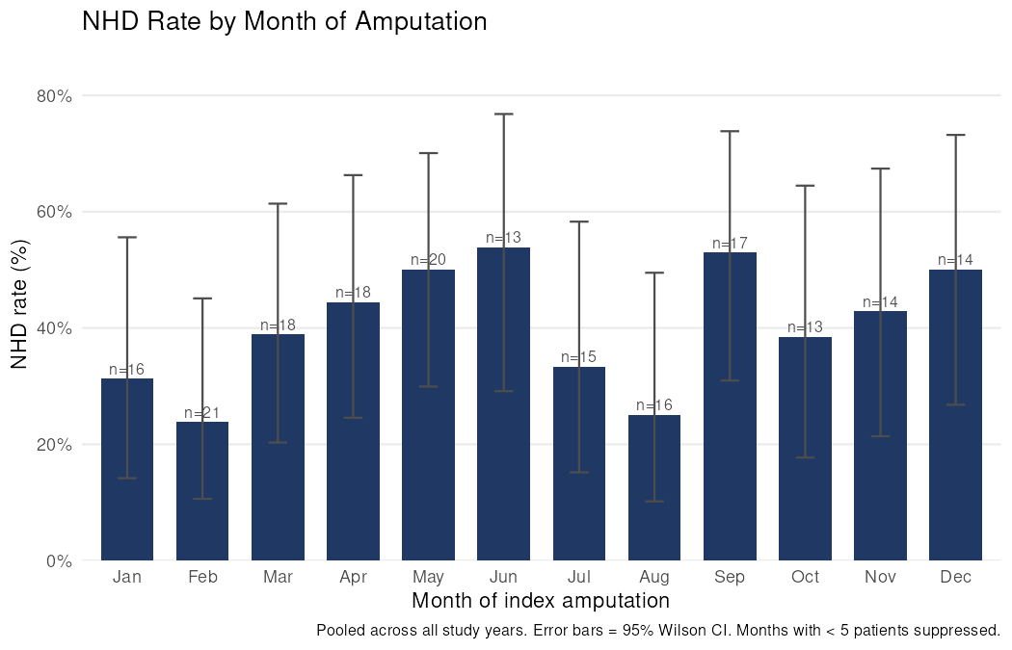
Supplemental Figure S5. Non-home discharge (NHD) rate by calendar month of amputation. Observed non-home discharge rate (%) for each calendar month (January through December), pooled across all study years. Bar height represents the NHD rate; numbers above each bar show the total procedure count for that month. Months with fewer than 5 procedures are suppressed.

Score distribution — Iannuzzi 2020
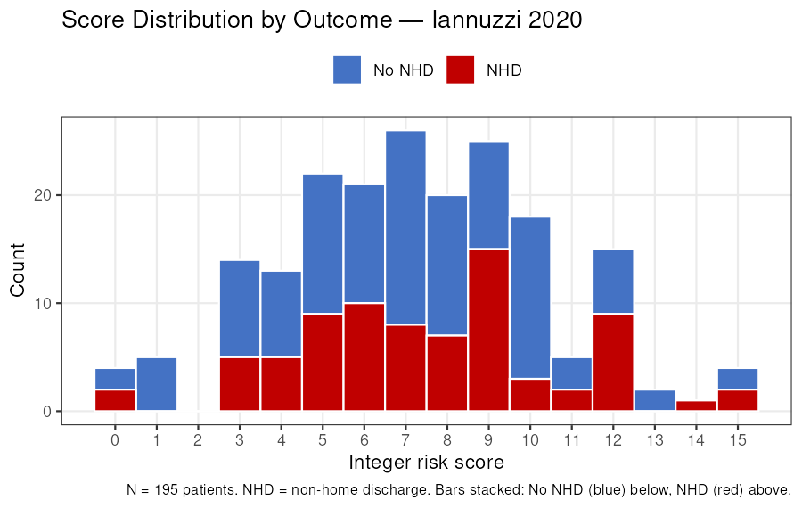
Supplemental Figure S6. Distribution of Iannuzzi 2020 integer risk score by outcome group. Stacked count histogram of Iannuzzi 2020 integer scores. Blue bars = patients without NHD; red bars = patients with NHD. Bars are stacked so the total bar height equals the count of all patients at that score. NHD = non-home discharge.

Score distribution — mFI-5
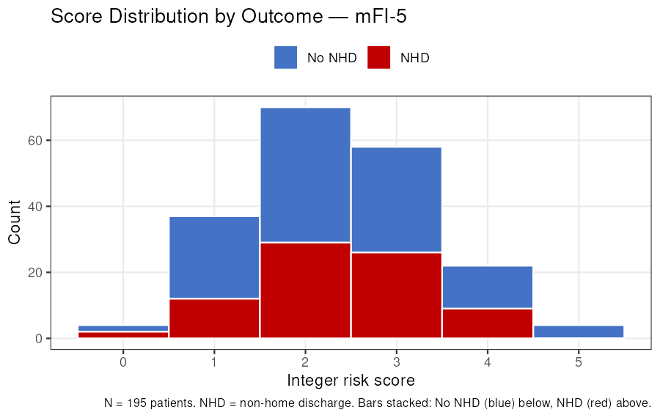
Supplemental Figure S7. Distribution of mFI-5 integer risk score by outcome group. Stacked count histogram of mFI-5 integer scores. Blue bars = patients without NHD; red bars = patients with NHD. Bars are stacked so the total bar height equals the count of all patients at that score. NHD = non-home discharge.

Score distribution — sVQI-FS
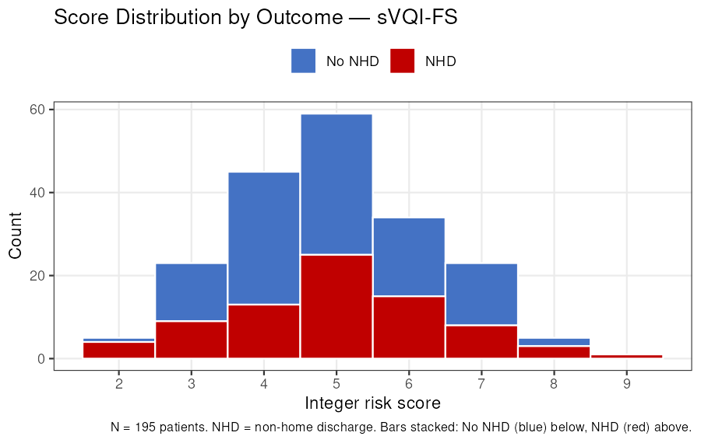
Supplemental Figure S8. Distribution of sVQI-FS integer risk score by outcome group. Stacked count histogram of sVQI-FS integer scores. Blue bars = patients without NHD; red bars = patients with NHD. Bars are stacked so the total bar height equals the count of all patients at that score. NHD = non-home discharge.

