Requirements and Analysis Document for “Roung Out”

Version: alpha 1.0

Date : 24 /03/17

Main author: Alex Nitsche  
Co-author: Adam Grandén

**1. Introduction**

1.1 Background

Our application is a game that we call “Roung Out”, its our modern mix of the two classics “Pong” and “Breakout”. The main *game-loop* is to have two *players*, each controlling a *pad* that is used to bounce a ball in a circular playing area. The ball can hit *bricks* which may contain *power-ups* which is used to make the game more exciting for the *players*. The goal of the game is to gather points. Points are given out when a *player* manages to prevent the opposing *player* to rebound the ball, the ball hits a *brick* or when some specific power-up is collected. Visual and sound feedback for interactions within the game are planned to be implemented.

We think that this mix is needed since we still can add new design, game-elements and complexity to old classics by combining the two games (and add a bit of our own ideas to it). We believe that there is a problem in the *indie-games* genre and that is the abundance of games that simply takes old ideas and put new graphics on top of it instead of trying to innovate and improve on these ideas and we hope that our work will help solving this problem. This game is aimed to children in the age-group 8-12 years with the goal of bringing a moment of joy and happiness to their everyday life. The game is to be used mainly on a desktop environment with the possible transition to a mobile platform.

1.2 Word List  
Please look in the separate document “Word Book” that we have made, it lists all our “custom”-words and their respective meanings.

**2 Requirements**

2.1 User interface Sketches, drawings and explanations of the application user interface (possible navigation).

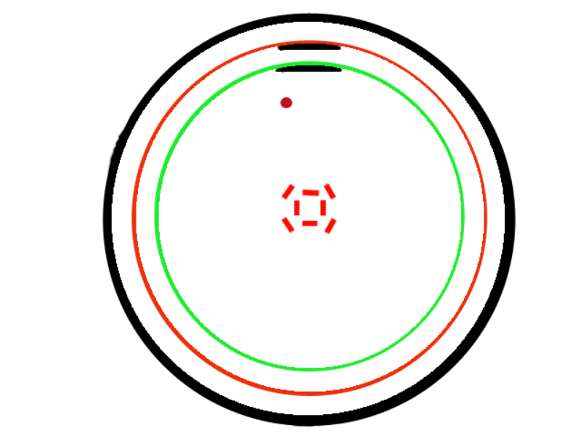

The outer black circle is the wall of the game, if the ball (the red circle) hits the wall it’s reset and points are distributed to the players accordingly. Ther red and green inner circles represent the orbit of the pads (the pads are the black semi-oval shapes), the respective pad is confined to its orbit. When the pad in the green orbit hits the ball, the pads switches orbit, this is also the way we show whose turn it is to hit the ball.

2.2 Functional requirements What will the user be able to do ? **Write a list of use case names (id’s) in the language of the customer**. The specific flows for each use case is recorded below. Specify use cases in priority order.

The users should be able to start and exit from the application (obviously). The users should be able to start a game. A *game-session* should be able to be won by either player, the *game-session* must end at some point. Within a *game-session* a player should be able to control their respective *pad*, they should also be able to use *power-ups* during the game. A player should be able to gather points

*Insert UC’s here*

2.3 Non-functional requirements Any special considerations besides functionality? Usability, reliability, performance, supportability, legal, implementation, … NOTE: Testability mandatory (must have tests)

We want 8/10 users to intuitively be able to start a game and play with minimal instructions on how to play from an experienced user or the game itself. We aim to get 9/10 users to be able to play the game without having any issues with the readability of the game. The application should only be allowed to 1 unaccounted termination (crash) in every 100 uses. The application should pass all of our unit-tests with at least 90% code coverage. No obligatory support to the application post-release is promised, tough there might be optional support post-development.

**3 Use cases**

An UML use case diagram

3.1 Use case listing Use case texts (using the use case template)

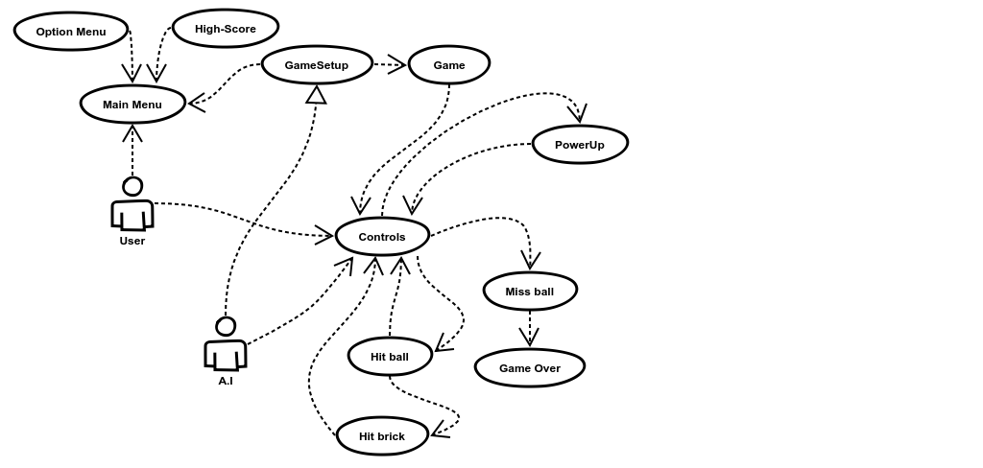

**4 Domain model**

An UML class diagram.

4.1 Class responsibilities Explanation of responsibilities of classes in diagram

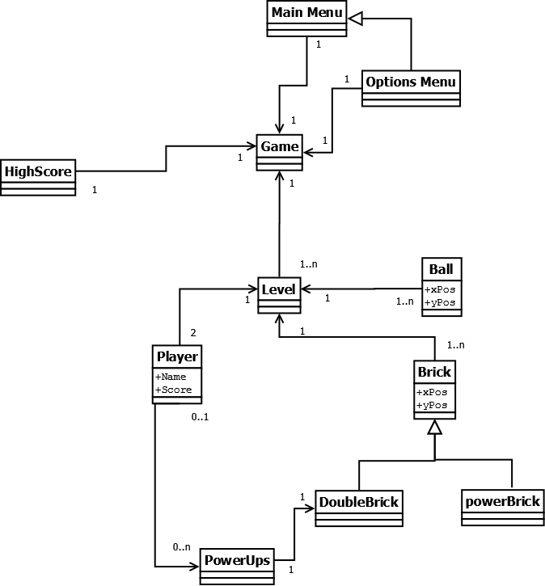

**5 References**