**10.10.100.50**

**SQL Tables**

Database: RGL

Status: N/A

Used Where: N/A

Last Updated: April 29, 2021

Table of Contents

account…………………….……………….…………………………..……… 3

u3………………...……………………………………………………………..… 4

ue………………...…………………………………………..…………………… 5

**TABLE:** account

**SIZE:** 16.0 KiB

**OLDEST RECORD:** N/A

**LAST UPDATED:** N/A

**UPDATED FROM:** N/A

**PROGRAM:** N/A

**ACCESS FROM WHERE:** N/A

**NUMBER OF ROWS:** 0

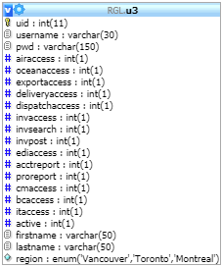**TABLE:** u3

**SIZE:** 9.2 KiB

**OLDEST RECORD:** N/A

**LAST UPDATED:** Jun 03, 2020 at 08:47 PM

**UPDATED FROM:** N/A

**PROGRAM:** N/A

**ACCESS FROM WHERE:** N/A

**NUMBER OF ROWS:** 58

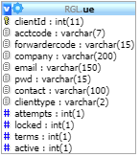**TABLE:** ue

**SIZE:** 46.1 KiB

**OLDEST RECORD:** N/A

**LAST UPDATED:** Jun 03, 2020 at 08:48 PM

**UPDATED FROM:** N/A

**PROGRAM:** N/A

**ACCESS FROM WHERE:** N/A

**NUMBER OF ROWS:** 399