**10.10.100.50**

**SQL Tables**

Database: webrns

Status: N/A

Used Where: N/A

Table of Contents

Across ………………………….…………………………..…………….… 3

air ………………...………………………………………………………..… 4

airinput …………………..………………………………………….…….. 5

cfia ………………………………….………………………………….…….. 6

cfiadetails …………………………………….……………..……………. 7

cfiatemp …………………………………………………..………………. 8

Errors ……………………………………………………………………..… 9

iptocountry……………………………………………………………….. 10

members ………………………………………………………………….. 11

msgfunction…………………………………………………….………… 12

ports………………………………………………………………………….. 13

Productions………………………………………………………..……… 14

rw_app………………………………………………………………………. 15

rw_promo_code ……………………………………………………….. 16

rw_promo_code_redeemed …………………..………………… 17

ServiceOption………………………………………………………....... 18

Status ………………………………………………………..………………. 19

submits…………………………………………………………….……… 20

usererror……………………………………………..……..…………… 21

venderpo……………………………………………………………….… 22

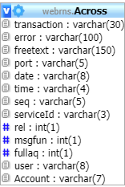**TABLE:** Across

**SIZE:** 11.5 MiB

**OLDEST RECORD:** N/A

**LAST UPDATED:** Feb 10, 2021 at 10:56 AM

**UPDATED FROM:** N/A

**PROGRAM:** N/A

**ACCESS FROM WHERE:** N/A

**NUMBER OF ROWS:** 86,159

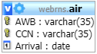**TABLE:** air

**SIZE:** 1.0 KiB

**OLDEST RECORD:** N/A

**LAST UPDATED:** May 14, 2014 at 09:04 PM

**UPDATED FROM:** N/A

**PROGRAM:** N/A

**ACCESS FROM WHERE:** N/A

**NUMBER OF ROWS:** 0

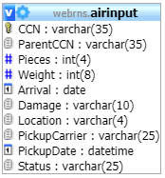**TABLE:** airinput

**SIZE:** 1.0 KiB

**OLDEST RECORD:** N/A

**LAST UPDATED:** May 14, 2014 at 09:04 PM

**UPDATED FROM:** N/A

**PROGRAM:** N/A

**ACCESS FROM WHERE:** N/A

**NUMBER OF ROWS:** 0

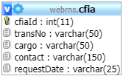**TABLE:** cfia

**SIZE:** 4.7 MiB

**OLDEST RECORD:** N/A

**LAST UPDATED:** Feb 09, 2021 at 03:25 PM

**UPDATED FROM:** N/A

**PROGRAM:** N/A

**ACCESS FROM WHERE:** N/A

**NUMBER OF ROWS:** 54,245

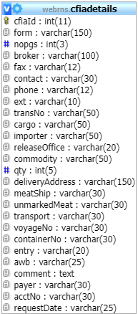**TABLE:** cfiadetails

**SIZE:** 1.0 KiB

**OLDEST RECORD:** N/A

**LAST UPDATED:** May 14, 2014 at 09:04 PM

**UPDATED FROM:** N/A

**PROGRAM:** N/A

**ACCESS FROM WHERE:** N/A

**NUMBER OF ROWS:** 0

**TABLE:** cfiatemp

**SIZE:** 611.1 KiB

**OLDEST RECORD:** N/A

**LAST UPDATED:** Mar 05, 2021 at 02:15 PM

**UPDATED FROM:** N/A

**PROGRAM:** N/A

**ACCESS FROM WHERE:** N/A

**NUMBER OF ROWS:** 31,237

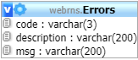**TABLE:** Errors

**SIZE:** 161.4 KiB

**OLDEST RECORD:** N/A

**LAST UPDATED:** May 14, 2014 at 09:02 PM

**UPDATED FROM:** N/A

**PROGRAM:** N/A

**ACCESS FROM WHERE:** N/A

**NUMBER OF ROWS:** 2212

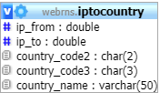**TABLE:** iptocountry

**SIZE:** 3.3 MiB

**OLDEST RECORD:** N/A

**LAST UPDATED:** May 14, 2014 at 09:04 PM

**UPDATED FROM:** N/A

**PROGRAM:** N/A

**ACCESS FROM WHERE:** N/A

**NUMBER OF ROWS:** 91,748

**TABLE:** members

**SIZE:** 1.0 KiB

**OLDEST RECORD:** N/A

**LAST UPDATED:** May 14, 2014 at 09:04 PM

**UPDATED FROM:** N/A

**PROGRAM:** N/A

**ACCESS FROM WHERE:** N/A

**NUMBER OF ROWS:** 0

**TABLE:** msgfunction

**SIZE:** 1.1 KiB

**OLDEST RECORD:** N/A

**LAST UPDATED:** May 14, 2014 at 09:04 PM

**UPDATED FROM:** N/A

**PROGRAM:** N/A

**ACCESS FROM WHERE:** N/A

**NUMBER OF ROWS:** 3

**TABLE:** ports

**SIZE:** 11.2 KiB

**OLDEST RECORD:** N/A

**LAST UPDATED:** May 14, 2014 at 09:04 PM

**UPDATED FROM:** N/A

**PROGRAM:** N/A

**ACCESS FROM WHERE:** N/A

**NUMBER OF ROWS:** 303

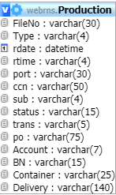**TABLE:** Production

**SIZE:** 2.9 GiB

**OLDEST RECORD:** N/A

**LAST UPDATED:** Apr 20, 2021 at 09:22 AM

**UPDATED FROM:** N/A

**PROGRAM:** N/A

**ACCESS FROM WHERE:** N/A

**NUMBER OF ROWS:** 17,414,792

**TABLE:** rw_app

**SIZE:** 16.0 KiB

**OLDEST RECORD:** N/A

**LAST UPDATED:** N/A

**UPDATED FROM:** N/A

**PROGRAM:** N/A

**ACCESS FROM WHERE:** N/A

**NUMBER OF ROWS:** 1

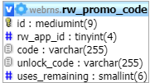**TABLE:** rw_promo_code

**SIZE:** 16.0 KiB

**OLDEST RECORD:** N/A

**LAST UPDATED:** N/A

**UPDATED FROM:** N/A

**PROGRAM:** N/A

**ACCESS FROM WHERE:** N/A

**NUMBER OF ROWS:** 1

**TABLE:** rw_promo_code_redeemed

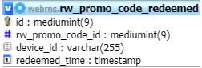**SIZE:** 16.0 KiB

**OLDEST RECORD:** N/A

**LAST UPDATED:** N/A

**UPDATED FROM:** N/A

**PROGRAM:** N/A

**ACCESS FROM WHERE:** N/A

**NUMBER OF ROWS:** 0

**TABLE:** ServiceOption

**SIZE:** 13 KiB

**OLDEST RECORD:** N/A

**LAST UPDATED:** May 14, 2014 at 09:04 PM

**UPDATED FROM:** N/A

**PROGRAM:** N/A

**ACCESS FROM WHERE:** N/A

**NUMBER OF ROWS:** 14

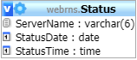**TABLE:** Status

**SIZE:** 1.0 KiB

**OLDEST RECORD:** N/A

**LAST UPDATED:** May 14, 2014 at 09:04 PM

**UPDATED FROM:** N/A

**PROGRAM:** N/A

**ACCESS FROM WHERE:** N/A

**NUMBER OF ROWS:** 1

**TABLE:** submits

**SIZE:** 16.0 KiB

**OLDEST RECORD:** N/A

**LAST UPDATED:** N/A

**UPDATED FROM:** N/A

**PROGRAM:** N/A

**ACCESS FROM WHERE:** N/A

**NUMBER OF ROWS:** 0

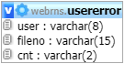**TABLE:** usererror

**SIZE:** 1.0 KiB

**OLDEST RECORD:** N/A

**LAST UPDATED:** May 14, 2014 at 09:04 PM

**UPDATED FROM:** N/A

**PROGRAM:** N/A

**ACCESS FROM WHERE:** N/A

**NUMBER OF ROWS:** 0

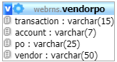**TABLE:** vendorpo

**SIZE:** 0.9 GiB

**OLDEST RECORD:** N/A

**LAST UPDATED:** Jun 03, 2019 at 09:57 PM

**UPDATED FROM:** N/A

**PROGRAM:** N/A

**ACCESS FROM WHERE:** N/A

**NUMBER OF ROWS:** 17,598,753