**10.10.100.50**

**SQL Tables**

Database: wlr

Status: N/A

Used Where: N/A

Last Updated: April 29, 2021

Table of Contents

2012Tariff ………………………….…………………………..……… 4

accounts ………………...…………………………………………..… 5

B3Footer …………………..………………………………………….. 6

B3HI ………………………………….………………………………….. 7

B3Line …………………………………….……………………………. 8

B3Sub …………………………………………………..………………. 9

B3Temp ………………………………………………………………… 10

ccn ……………………………………………………………………….. 11

containers …………………………………………………………….. 12

dhlglobal………………………………………………………………. 13

dhlglobal ……………………………………………………………… 14

dhlglobal2 ……………………………………………………………. 15

download …………………………………………………………….. 16

downloadrecap ……………………………………………………. 17

DutyTemp ………………………………………………………...... 18

ehbl …………………………………………………………………….. 19

headerdese …………………………………………………………. 20

imexlvs………………………………………………………………… 21

InvAddress ……………………………………………………….… 22

Invapc ……………………………………………………….……….. 23

invdetail ……………………………………………………….……. 24

Invheader ……………………………………………….……….… 25

invinfo …………………………………………………………….…. 26

inviparcel …………………………………………………….…..… 27

invmattel ………………………………………………………...… 28

invoice ……………………………………………………….………. 29

loginAttempts ……………………………………………….…… 30

office ……………………………………………………………….… 31

ports………………………………………………………………...… 32

RECAPFooter ……………………………….…………………..… 33

RECAPHI …………………………………………………………….. 34

RECAPLine ………………………………………………………….. 35

RECAPSub …………………………………………………………… 36

RECAPTemp ………………………………………………………… 37

rglfreight ……………………………………………………………… 38

rglfreightclients …………………………………………………… 39

rh_invoice ……………………………………………………………. 40

shipments ……………………………………………………………. 41

test09 ………………………………………………………………….. 42

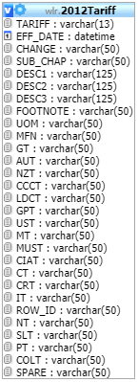**TABLE:** 2012Tariff

**SIZE:** 1.0 KiB

**OLDEST RECORD:** N/A

**LAST UPDATED:** N/A

**UPDATED FROM:** N/A

**PROGRAM:** N/A

**ACCESS FROM WHERE:** N/A

**NUMBER OF ROWS:** 0

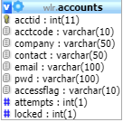**TABLE:** accounts

**SIZE:** 15.2 KiB

**OLDEST RECORD:** N/A

**LAST UPDATED:** Japr 12, 2021 at 09:54 AM

**UPDATED FROM:** N/A

**PROGRAM:** N/A

**ACCESS FROM WHERE:** N/A

**NUMBER OF ROWS:** 65

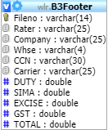**TABLE:** B3Footer

**SIZE:** 405.7 MiB

**OLDEST RECORD:** N/A

**LAST UPDATED:** apr 13, 2021 at 11:30 AM

**UPDATED FROM:** N/A

**PROGRAM:** N/A

**ACCESS FROM WHERE:** N/A

**NUMBER OF ROWS:** 2,821,090

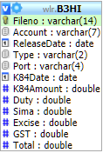**TABLE:** B3HI

**SIZE:** 369.8 MiB

**OLDEST RECORD:** N/A

**LAST UPDATED:** apr 13, 2021 at 11:30 AM

**UPDATED FROM:** N/A

**PROGRAM:** N/A

**ACCESS FROM WHERE:** N/A

**NUMBER OF ROWS:** 2,824,799

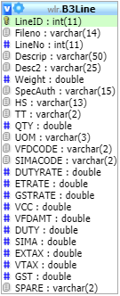**TABLE:** B3Line

**SIZE:** 2.1 GiB

**OLDEST RECORD:** N/A

**LAST UPDATED:** apr 13, 2021 at 11:30 AM

**UPDATED FROM:** N/A

**PROGRAM:** N/A

**ACCESS FROM WHERE:** N/A

**NUMBER OF ROWS:** 12,095,085

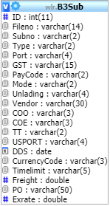**TABLE:** B3Sub

**SIZE:** 740.4 MiB

**OLDEST RECORD:** N/A

**LAST UPDATED:** apr 13, 2021 at 11:30 AM

**UPDATED FROM:** N/A

**PROGRAM:** N/A

**ACCESS FROM WHERE:** N/A

**NUMBER OF ROWS:** 4,823,629

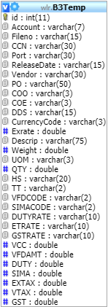**TABLE:** B3Temp

**SIZE:** 16.9 MiB

**OLDEST RECORD:** N/A

**LAST UPDATED:** apr 09, 2021 at 12:08 PM.

**UPDATED FROM:** N/A

**PROGRAM:** N/A

**ACCESS FROM WHERE:** N/A

**NUMBER OF ROWS:** 56,061

**TABLE:** ccn

**SIZE:** 2.1 KiB

**OLDEST RECORD:** N/A

**LAST UPDATED:** May 14, 2014 at 08:53 PM

**UPDATED FROM:** N/A

**PROGRAM:** N/A

**ACCESS FROM WHERE:** N/A

**NUMBER OF ROWS:** 4



**TABLE:** containers

**SIZE:** 1.0 KiB

**OLDEST RECORD:** N/A

**LAST UPDATED:** N/A

**UPDATED FROM:** N/A

**PROGRAM:** N/A

**ACCESS FROM WHERE:** N/A

**NUMBER OF ROWS:** 0

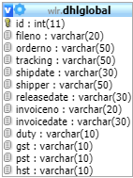**TABLE:** dhlglobal

**SIZE:** 1.6 GiB

**OLDEST RECORD:** N/A

**LAST UPDATED:** apr 12, 2021 at 03:40 PM.

**UPDATED FROM:** N/A

**PROGRAM:** N/A

**ACCESS FROM WHERE:** N/A

**NUMBER OF ROWS:** 12,406,375

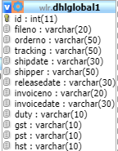**TABLE:** dhlglobal1

**SIZE:** 518.7 MiB

**OLDEST RECORD:** N/A

**LAST UPDATED:** sep 30, 2016 at 02:30 PM.

**UPDATED FROM:** N/A

**PROGRAM:** N/A

**ACCESS FROM WHERE:** N/A

**NUMBER OF ROWS:** 3,717,311

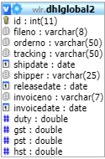**TABLE:** dhlglobal2

**SIZE:** 16.0 KiB

**OLDEST RECORD:** N/A

**LAST UPDATED:** N/A

**UPDATED FROM:** N/A

**PROGRAM:** N/A

**ACCESS FROM WHERE:** N/A

**NUMBER OF ROWS:** 0

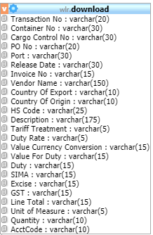

**TABLE:** download

**SIZE:** 1.0 KiB

**OLDEST RECORD:** N/A

**LAST UPDATED:** N/A

**UPDATED FROM:** N/A

**PROGRAM:** N/A

**ACCESS FROM WHERE:** N/A

**NUMBER OF ROWS:** 0

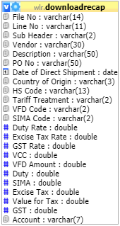

**TABLE:** downloadrecep

**SIZE:** 1.0 KiB

**OLDEST RECORD:** N/A

**LAST UPDATED:** N/A

**UPDATED FROM:** N/A

**PROGRAM:** N/A

**ACCESS FROM WHERE:** N/A

**NUMBER OF ROWS:** 0

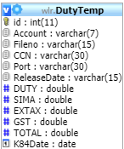**TABLE:** DutyTemp

**SIZE:** 547.9 KiB

**OLDEST RECORD:** N/A

**LAST UPDATED:** Feb 22, 2021 at 03:55 PM

**UPDATED FROM:** N/A

**PROGRAM:** N/A

**ACCESS FROM WHERE:** N/A

**NUMBER OF ROWS:** 3,548

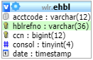**TABLE:** ehbl

**SIZE:** 32.0 KiB

**OLDEST RECORD:** N/A

**LAST UPDATED:** N/A

**UPDATED FROM:** N/A

**PROGRAM:** N/A

**ACCESS FROM WHERE:** N/A

**NUMBER OF ROWS:** 261

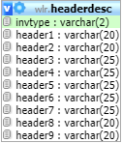**TABLE:** headerdesc

**SIZE:** 1.6 KiB

**OLDEST RECORD:** N/A

**LAST UPDATED:** May 14, 2014 at 08:55 PM

**UPDATED FROM:** N/A

**PROGRAM:** N/A

**ACCESS FROM WHERE:** N/A

**NUMBER OF ROWS:** 10

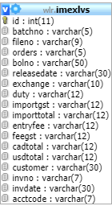**TABLE:** imexlvs

**SIZE:** 2.0 MiB

**OLDEST RECORD:** N/A

**LAST UPDATED:** Jul 08, 2019 at 03:18 PM

**UPDATED FROM:** N/A

**PROGRAM:** N/A

**ACCESS FROM WHERE:** N/A

**NUMBER OF ROWS:** 9,178

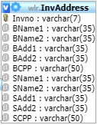**TABLE:** InvAdress

**SIZE:** 2.3 KiB

**OLDEST RECORD:** N/A

**LAST UPDATED:** May 14, 2014 at 08:41 PM

**UPDATED FROM:** N/A

**PROGRAM:** N/A

**ACCESS FROM WHERE:** N/A

**NUMBER OF ROWS:** 3

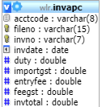**TABLE:** invapc

**SIZE:** 32.0 KiB

**OLDEST RECORD:** N/A

**LAST UPDATED:** N/A

**UPDATED FROM:** N/A

**PROGRAM:** N/A

**ACCESS FROM WHERE:** N/A

**NUMBER OF ROWS:** 0

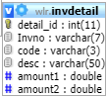**TABLE:** invdetail

**SIZE:** 3.8 KiB

**OLDEST RECORD:** N/A

**LAST UPDATED:** May 14, 2014 at 08:55 PM

**UPDATED FROM:** N/A

**PROGRAM:** N/A

**ACCESS FROM WHERE:** N/A

**NUMBER OF ROWS:** 19

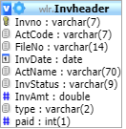**TABLE:** Invheader

**SIZE:** 2.1 KiB

**OLDEST RECORD:** N/A

**LAST UPDATED:** May 14, 2014 at 08:41 PM

**UPDATED FROM:** N/A

**PROGRAM:** N/A

**ACCESS FROM WHERE:** N/A

**NUMBER OF ROWS:** 2

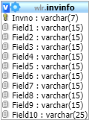**TABLE:** invinfo

**SIZE:** 2.3 KiB

**OLDEST RECORD:** N/A

**LAST UPDATED:** May 14, 2014 at 08:55 PM

**UPDATED FROM:** N/A

**PROGRAM:** N/A

**ACCESS FROM WHERE:** N/A

**NUMBER OF ROWS:** 3

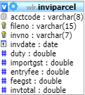**TABLE:** inviparcel

**SIZE:** 1.8 MiB

**OLDEST RECORD:** N/A

**LAST UPDATED:** N/A

**UPDATED FROM:** N/A

**PROGRAM:** N/A

**ACCESS FROM WHERE:** N/A

**NUMBER OF ROWS:** 7,483

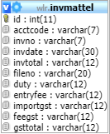**TABLE:** invmattel

**SIZE:** 45.6 KiB

**OLDEST RECORD:** N/A

**LAST UPDATED:** Dec 21, 2016 at 03:04 PM

**UPDATED FROM:** N/A

**PROGRAM:** N/A

**ACCESS FROM WHERE:** N/A

**NUMBER OF ROWS:** 313

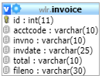**TABLE:** invoice

**SIZE:** 312.6 KiB

**OLDEST RECORD:** N/A

**LAST UPDATED:** Apr 12, 2021 at 03:40 PM.

**UPDATED FROM:** N/A

**PROGRAM:** N/A

**ACCESS FROM WHERE:** N/A

**NUMBER OF ROWS:** 5,158

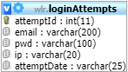**TABLE:** loginAttempts

**SIZE:** 548.6 KiB

**OLDEST RECORD:** N/A

**LAST UPDATED:** Apr 15, 2021 at 06:08 AM

**UPDATED FROM:** N/A

**PROGRAM:** N/A

**ACCESS FROM WHERE:** N/A

**NUMBER OF ROWS:** 3,953

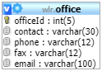**TABLE:** office

**SIZE:** 2.6 KiB

**OLDEST RECORD:** N/A

**LAST UPDATED:** May 14, 2014 at 08:55 PM

**UPDATED FROM:** N/A

**PROGRAM:** N/A

**ACCESS FROM WHERE:** N/A

**NUMBER OF ROWS:** 7

**TABLE:** ports

**SIZE:** 18.1 KiB

**OLDEST RECORD:** N/A

**LAST UPDATED:** May 14, 2014 at 08:55 PM

**UPDATED FROM:** N/A

**PROGRAM:** N/A

**ACCESS FROM WHERE:** N/A

**NUMBER OF ROWS:** 304

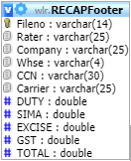**TABLE:** RECAPFooter

**SIZE:** 398.1 MiB

**OLDEST RECORD:** N/A

**LAST UPDATED:** ‘Apr 13, 2021 at 11:30 AM

**UPDATED FROM:** N/A

**PROGRAM:** N/A

**ACCESS FROM WHERE:** N/A

**NUMBER OF ROWS:** 2,817,764

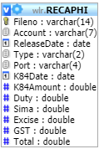**TABLE:** RECAPHI

**SIZE:** 350.6 MiB

**OLDEST RECORD:** N/A

**LAST UPDATED:** ‘Apr 13, 2021 at 11:30 AM

**UPDATED FROM:** N/A

**PROGRAM:** N/A

**ACCESS FROM WHERE:** N/A

**NUMBER OF ROWS:** 2,821,172

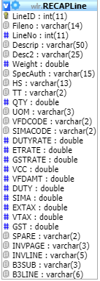**TABLE:** RECAPLine

**SIZE:** 4.5 GiB

**OLDEST RECORD:** N/A

**LAST UPDATED:** ‘Apr 13, 2021 at 11:30 AM

**UPDATED FROM:** N/A

**PROGRAM:** N/A

**ACCESS FROM WHERE:** N/A

**NUMBER OF ROWS:** 27,006,567

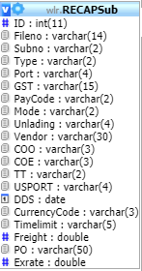**TABLE:** RECAPSub

**SIZE:** 587.5 MiB

**OLDEST RECORD:** N/A

**LAST UPDATED:** ‘Apr 13, 2021 at 11:30 AM

**UPDATED FROM:** N/A

**PROGRAM:** N/A

**ACCESS FROM WHERE:** N/A

**NUMBER OF ROWS:** 4,668,964

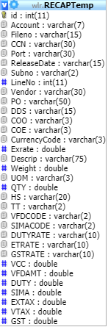**TABLE:** RECAPTemp

**SIZE:** 5.7 MiB

**OLDEST RECORD:** N/A

**LAST UPDATED:** Mar 19, 2021 at 08:47 AM

**UPDATED FROM:** N/A

**PROGRAM:** N/A

**ACCESS FROM WHERE:** N/A

**NUMBER OF ROWS:** 10,525

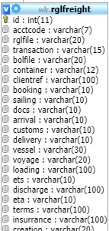**TABLE:** rglfreight

**SIZE:** 8.0 KiB

**OLDEST RECORD:** N/A

**LAST UPDATED:** Dec 31, 2014 at 08:47 AM

**UPDATED FROM:** N/A

**PROGRAM:** N/A

**ACCESS FROM WHERE:** N/A

**NUMBER OF ROWS:** 28

**TABLE:** rglfreightclients

**SIZE:** 3.0 KiB

**OLDEST RECORD:** N/A

**LAST UPDATED:** May 14, 2014 at 08:55 PM

**UPDATED FROM:** N/A

**PROGRAM:** N/A

**ACCESS FROM WHERE:** N/A

**NUMBER OF ROWS:** 1

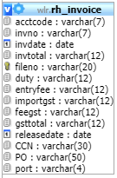**TABLE:** rh_invoice

**SIZE:** 750.1 KiB

**OLDEST RECORD:** N/A

**LAST UPDATED:** ‘Apr 14, 2021 at 06:19 PM.

**UPDATED FROM:** N/A

**PROGRAM:** N/A

**ACCESS FROM WHERE:** N/A

**NUMBER OF ROWS:** 4,438

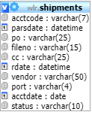**TABLE:** shipments

**SIZE:** 1.0 KiB

**OLDEST RECORD:** N/A

**LAST UPDATED:** N/A

**UPDATED FROM:** N/A

**PROGRAM:** N/A

**ACCESS FROM WHERE:** N/A

**NUMBER OF ROWS:** 0

**TABLE:** test09

**SIZE:** 521.8 KiB

**OLDEST RECORD:** N/A

**LAST UPDATED:** May 14 2014 a 08:55 PM

**UPDATED FROM:** N/A

**PROGRAM:** N/A

**ACCESS FROM WHERE:** N/A

**NUMBER OF ROWS:** 22,222