**10.10.100.50**

**SQL Tables**

Database: _global1

Status:

Used Where:

Last Updated: April 24, 2021

Table of Contents

ruThG1_commentmeta.………….…………………………..……… 3

ruThG1_comments ………………...………………………………..… 4

ruThG1_links …………………..………………………………………….. 5

ruThG1_options ………………………………….….…………….…….. 6

ruThG1_postmeta …………………………………….…………………. 7

ruThG1_posts ……………………………………….……………………… 8

ruThG1_termmeta………………………………………………………… 9

ruThG1_terms………………………………….……………………………. 10

ruThG1_term_relationships……………………..…………………… 11

ruThG1_term_taxonomy………………………..…………………….. 12

ruThG1_usermeta…………………………….………………………...... 13

ruThG1_users……………………………….……………………………….. 14

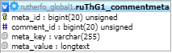**TABLE:** ruThG1_commentmeta

**SIZE:** 48.0 KiB

**OLDEST RECORD:** N/A

**LAST UPDATED:** N/A

**UPDATED FROM:** N/A

**PROGRAM:** N/A

**ACCESS FROM WHERE:** N/A

**NUMBER OF ROWS:** 0

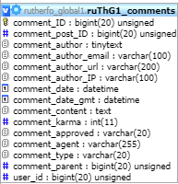**TABLE:** ruThG1_comments

**SIZE:** 96.0 KiB

**OLDEST RECORD:** N/A

**LAST UPDATED:** N/A

**UPDATED FROM:** N/A

**PROGRAM:** N/A

**ACCESS FROM WHERE:** N/A

**NUMBER OF ROWS:** 3

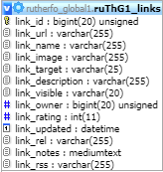**TABLE:** ruThG1_links

**SIZE:** 32.0 KiB

**OLDEST RECORD:** N/A

**LAST UPDATED:** N/A

**UPDATED FROM:** N/A

**PROGRAM:** N/A

**ACCESS FROM WHERE:** N/A

**NUMBER OF ROWS:** 0

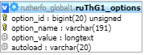**TABLE:** ruThG1_options

**SIZE:** 80.0 KiB

**OLDEST RECORD:** N/A

**LAST UPDATED:** N/A

**UPDATED FROM:** N/A

**PROGRAM:** N/A

**ACCESS FROM WHERE:** N/A

**NUMBER OF ROWS:** 170

**TABLE:** ruThG1_postmeta

**SIZE:** 48.0 KiB

**OLDEST RECORD:** N/A

**LAST UPDATED:** N/A

**UPDATED FROM:** N/A

**PROGRAM:** N/A

**ACCESS FROM WHERE:** N/A

**NUMBER OF ROWS:** 3

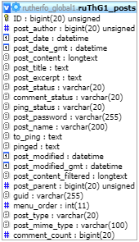**TABLE:** ruThG1_posts

**SIZE:** 80.0 KiB

**OLDEST RECORD:** N/A

**LAST UPDATED:** N/A

**UPDATED FROM:** N/A

**PROGRAM:** N/A

**ACCESS FROM WHERE:** N/A

**NUMBER OF ROWS:** 4

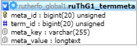**TABLE:** ruThG1_termmeta

**SIZE:** 48.0 KiB

**OLDEST RECORD:** N/A

**LAST UPDATED:** N/A

**UPDATED FROM:** N/A

**PROGRAM:** N/A

**ACCESS FROM WHERE:** N/A

**NUMBER OF ROWS:** 0

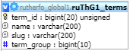**TABLE:** ruThG1_terms

**SIZE:** 48.0 KiB

**OLDEST RECORD:** N/A

**LAST UPDATED:** N/A

**UPDATED FROM:** N/A

**PROGRAM:** N/A

**ACCESS FROM WHERE:** N/A

**NUMBER OF ROWS:** 1

**TABLE:** ruThG1_term_relationships

**SIZE:** 32.0 KiB

**OLDEST RECORD:** N/A

**LAST UPDATED:** N/A

**UPDATED FROM:** N/A

**PROGRAM:** N/A

**ACCESS FROM WHERE:** N/A

**NUMBER OF ROWS:** 1

**TABLE:** ruThG1_term_taxonomy

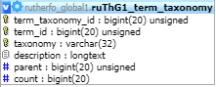**SIZE:** 48.0 KiB

**OLDEST RECORD:** N/A

**LAST UPDATED:** N/A

**UPDATED FROM:** N/A

**PROGRAM:** N/A

**ACCESS FROM WHERE:** N/A

**NUMBER OF ROWS:** 1

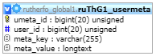**TABLE:** ruThG1_usermeta

**SIZE:** 48.0 KiB

**OLDEST RECORD:** N/A

**LAST UPDATED:** N/A

**UPDATED FROM:** N/A

**PROGRAM:** N/A

**ACCESS FROM WHERE:** N/A

**NUMBER OF ROWS:** 18

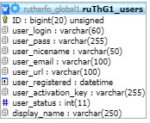**TABLE:** ruThG1_users

**SIZE:** 64.0 KiB

**OLDEST RECORD:** N/A

**LAST UPDATED:** N/A

**UPDATED FROM:** N/A

**PROGRAM:** N/A

**ACCESS FROM WHERE:** N/A

**NUMBER OF ROWS:** 1