**10.10.100.50**

**SQL Tables**

Database: ifw

Status: N/A

Used Where: N/A

Table of Contents

addressadmin………………………….…………………………..……… 7

addressbook………………...…………………………………………..… 8

airbreakdown…………………..………………………………..……….. 9

aircontainer………………………………….…………………………….. 10

airdeliverycalc…………………………………….…..…………………. 11

airexit…………………………………………………..……………………. 12

airlines……………………………………………………………….……… 13

airsplit……………………………………………………………………….. 14

airtranscalc……………………………………………………………….. 15

arrival……………………………………………………………………….. 16

arrivalerror……………………………………………………………….. 17

ar_receipts……………………………………………………………….. 18

bchistory………………………………………………………………….. 19

billingcodes………………………………………………………………. 20

clienthistory………………………………………………………...... 21

clientinv…………………………………………………………..…….. 22

clientship……………………………………………………………….. 23

cmactivate……………………………………………………………… 24

cmchange……………………………………………………….……… 25

cmhistory……………………………………………………….……... 26

container……………………………………………………….………. 27

currentdel……………………………………………….……….……. 29

customermaster…………………………………………..…….…. 30

d4…………………………………………………….…..………………. 31

delivery……………………………………………………….………… 32

delivery2……………………………………………….………………. 33

delivaryareas……………………………………………………….… 34

deliverybilling……………………………………..……………...… 35

deliveryhistory……………………………….…….……………..… 36

deliveryno……………………………….…………………..……..… 37

deliveryverify……………………………….……………………..… 38

dispatch……………………………….…………………..…………… 39

dispatchhistory……………………………….…………………..… 40

dispatchssr………………………………………………………….... 41

dispatchssrhistory………………………………………..……….. 42

drivers…………………………………………………………………… 43

expcoload……………………………………………………………… 44

expconsol……………………………………………………………… 45

export…………………………………………………………………… 46

exportbilling…………………………………………………………. 47

exportdims………………………………………………………..…. 48

exportdims_old…………………………………..……………….. 49

exportdriver………………………….……….……………..……… 50

exportforwarders……………..………………………………..… 51

exportforwarders_old……….………………………………….. 52

exporthistory…………………….………………………………….. 53

exportno…………………………..…….……………………………. 54

exportpics…………………………..………………..………………. 55

exportscreening………………….………………………………… 56

export_old…………………………..……………………………….. 57

exptransferbill………………………..…………………………….. 58

fileairhistory…………………………….……………………………. 59

filehistory………………………………….…………………………… 60

forwarders………………………………….…………………………. 61

invbatch………………………………………….…………………….. 62

invhistory………………………………………………………………. 63

invoice………………………………………………………………..... 64

invoicenumber…………………………………….……………….. 65

invoice_bchistory………………………….………………………. 66

invoice_details…………………….………………………………… 67

invoice_details_bchistory……..…………………………….… 68

invoice_details_history………….…………………….……….. 69

invoice_details_mtlhistory…….……………………………... 70

invoice_dock…………………………..……………………….……. 71

invoice_dockdetails…………………………………….……….… 72

invoice_history……………………………..…………………….…. 73

invoice_mtlhistory………………………….……………….…..… 74

invpaid………………………………………………………………...… 75

loginAttempts……………………………………….……….………. 76

loginDriver……………………………………………………..….…… 77

newacctcode………………………………………………….…….… 78

news…………………………………………………………………....… 79

oceandeliverycalc……………………………….………………..… 80

oceanpics……………………………………………………………….. 81

orderitems……………………………………………………………… 82

orderno………………………………………………………………….. 83

orders…………………………………………………………………….. 84

piggybank……………………………………………………………… 85

prealertbilling……………………………………………………….. 86

producthistory……………………………………………………… 87

products………………………………………………………………. 88

quotenumber………………………………………………………. 89

RNS………………………….…………………………..……………… 90

shipment………………...………………………………………..… 91

shipto…………………..……………………………………….…….. 93

specialrequests………………………………….………….…….. 94

specialreq_details…………………………………….…………. 95

specialreq_verify ……………………………………………..…. 96

taxes………………………………………………………………….… 97

tempinvlines……………………………………………………….. 98

tempquoteslines…………………………………………………. 99

textmsg………………………………………………………………. 100

users…………………………………………………………………… 101

warehouses……………………………………………..…………. 102

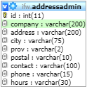**TABLE:** addressadmin

**SIZE:** 17.7 KiB

**OLDEST RECORD:** N/A

**LAST UPDATED:** Mar 23, 2021 at 10:40 AM

**UPDATED FROM:** N/A

**PROGRAM:** N/A

**ACCESS FROM WHERE:** N/A

**NUMBER OF ROWS:** 128

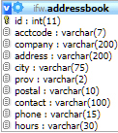**TABLE:** addressbook

**SIZE:** 1.0 MiB

**OLDEST RECORD:** N/A

**LAST UPDATED:** Apr 21, 2021 at 12:20 PM

**UPDATED FROM:** N/A

**PROGRAM:** N/A

**ACCESS FROM WHERE:** N/A

**NUMBER OF ROWS:** 6,302

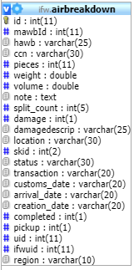**TABLE:** airbreakdown

**SIZE:** 4.4 MiB

**OLDEST RECORD:** N/A

**LAST UPDATED:** Apr 22, 2021 at 02:04 AM

**UPDATED FROM:** N/A

**PROGRAM:** N/A

**ACCESS FROM WHERE:** N/A

**NUMBER OF ROWS:** 20,614

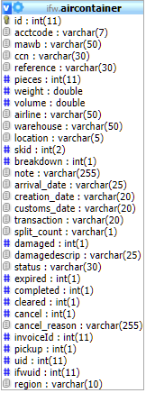**TABLE:** aircontainer

**SIZE:** 11.5 MiB

**OLDEST RECORD:** N/A

**LAST UPDATED:** Apr 22, 2021 at 02:03 PM

**UPDATED FROM:** N/A

**PROGRAM:** N/A

**ACCESS FROM WHERE:** N/A

**NUMBER OF ROWS:** 50,351

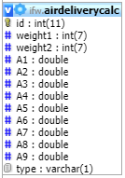**TABLE:** airdeliverycalc

**SIZE:** 3.6 KiB

**OLDEST RECORD:** N/A

**LAST UPDATED:** Mar 20, 2019 at 02:39 PM

**UPDATED FROM:** N/A

**PROGRAM:** N/A

**ACCESS FROM WHERE:** N/A

**NUMBER OF ROWS:** 28

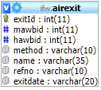**TABLE:** airexit

**SIZE:** 4.5 MiB

**OLDEST RECORD:** N/A

**LAST UPDATED:** Apr 22, 2021 at 02:04 PM

**UPDATED FROM:** N/A

**PROGRAM:** N/A

**ACCESS FROM WHERE:** N/A

**NUMBER OF ROWS:** 62,087

**TABLE:** airlines

**SIZE:** 3.2 KiB

**OLDEST RECORD:** N/A

**LAST UPDATED:** May 14, 2014 at 09:05 PM

**UPDATED FROM:** N/A

**PROGRAM:** N/A

**ACCESS FROM WHERE:** N/A

**NUMBER OF ROWS:** 60

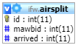**TABLE:** airsplit

**SIZE:** 107.4 KiB

**OLDEST RECORD:** N/A

**LAST UPDATED:** Apr 20, 2021 at 10:25 AM

**UPDATED FROM:** N/A

**PROGRAM:** N/A

**ACCESS FROM WHERE:** N/A

**NUMBER OF ROWS:** 2,634

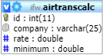**TABLE:** airtranscalc

**SIZE:** 2.4 KiB

**OLDEST RECORD:** N/A

**LAST UPDATED:** May 14, 2014 at 09:05 PM

**UPDATED FROM:** N/A

**PROGRAM:** N/A

**ACCESS FROM WHERE:** N/A

**NUMBER OF ROWS:** 14

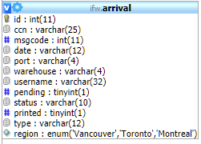**TABLE:** arrival

**SIZE:** 3.5 MiB

**OLDEST RECORD:** N/A

**LAST UPDATED:** N/A

**UPDATED FROM:** N/A

**PROGRAM:** N/A

**ACCESS FROM WHERE:** N/A

**NUMBER OF ROWS:** 44,971

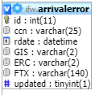**TABLE:** arrivalerror

**SIZE:** 1.5 MiB

**OLDEST RECORD:** N/A

**LAST UPDATED:** N/A

**UPDATED FROM:** N/A

**PROGRAM:** N/A

**ACCESS FROM WHERE:** N/A

**NUMBER OF ROWS:** 27,132

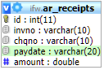**TABLE:** ar_receipts

**SIZE:** 32.0 KiB

**OLDEST RECORD:** N/A

**LAST UPDATED:** N/A

**UPDATED FROM:** N/A

**PROGRAM:** N/A

**ACCESS FROM WHERE:** N/A

**NUMBER OF ROWS:** 0

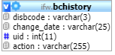 **TABLE:** bchistory

**SIZE:** 1.3 KiB

**OLDEST RECORD:** N/A

**LAST UPDATED:** Jul 21, 2020 at 03:39 PM

**UPDATED FROM:** N/A

**PROGRAM:** N/A

**ACCESS FROM WHERE:** N/A

**NUMBER OF ROWS:** 6

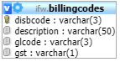**TABLE:** billingcodes

**SIZE:** 4.4 KiB

**OLDEST RECORD:** N/A

**LAST UPDATED:** Jul 21, 2020 at 03:39 PM

**UPDATED FROM:** N/A

**PROGRAM:** N/A

**ACCESS FROM WHERE:** N/A

**NUMBER OF ROWS:** 73

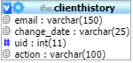**TABLE:** clienthistory

**SIZE:** 1.9 KiB

**OLDEST RECORD:** N/A

**LAST UPDATED:** May 14, 2014 at 09:05 PM

**UPDATED FROM:** N/A

**PROGRAM:** N/A

**ACCESS FROM WHERE:** N/A

**NUMBER OF ROWS:** 16

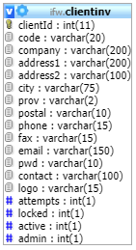**TABLE:** clientinv

**SIZE:** 2.3 KiB

**OLDEST RECORD:** N/A

**LAST UPDATED:** May 14, 2014 at 09:05 PM

**UPDATED FROM:** N/A

**PROGRAM:** N/A

**ACCESS FROM WHERE:** N/A

**NUMBER OF ROWS:** 2

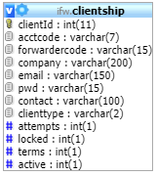**TABLE:** clientship

**SIZE:** 44.5 KiB

**OLDEST RECORD:** N/A

**LAST UPDATED:** Apr 16, 2021 at 02:05 PM

**UPDATED FROM:** N/A

**PROGRAM:** N/A

**ACCESS FROM WHERE:** N/A

**NUMBER OF ROWS:** 2

**TABLE:** cmactivate

**SIZE:** 1.1 KiB

**OLDEST RECORD:** N/A

**LAST UPDATED:** Apr 19, 2021 at 03:29 PM|

**UPDATED FROM:** N/A

**PROGRAM:** N/A

**ACCESS FROM WHERE:** N/A

**NUMBER OF ROWS:** 1

**TABLE:** cmchange

**SIZE:** 5.7 KiB

**OLDEST RECORD:** N/A

**LAST UPDATED:** N/A

**UPDATED FROM:** N/A

**PROGRAM:** N/A

**ACCESS FROM WHERE:** N/A

**NUMBER OF ROWS:** 0

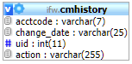 **TABLE:** cmhistory

**SIZE:** 159.1 KiB

**OLDEST RECORD:** N/A

**LAST UPDATED:** Apr 14, 2021 at 01:23 PM

**UPDATED FROM:** N/A

**PROGRAM:** N/A

**ACCESS FROM WHERE:** N/A

**NUMBER OF ROWS:** 1,943

**TABLE:** container

**SIZE:** 2.9 MiB

**OLDEST RECORD:** N/A

**LAST UPDATED:** N/A

**UPDATED FROM:** N/A

**PROGRAM:** N/A

**ACCESS FROM WHERE:** N/A

**NUMBER OF ROWS:** 11,386

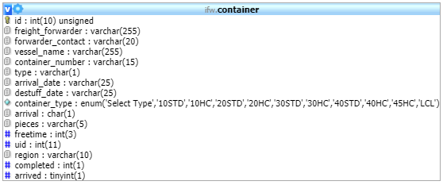

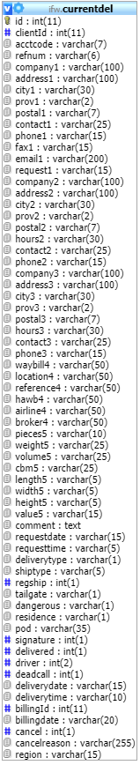**TABLE:** currentdel

**SIZE:** 79.6 KiB

**OLDEST RECORD:** N/A

**LAST UPDATED:** Jan 05, 2015 at 12:10 PM

**UPDATED FROM:** N/A

**PROGRAM:** N/A

**ACCESS FROM WHERE:** N/A

**NUMBER OF ROWS:** 598

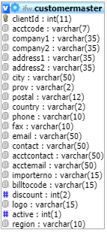**TABLE:** customermaster

**SIZE:** 137.1 KiB

**OLDEST RECORD:** N/A

**LAST UPDATED:** Apr 19, 2021 at 03:29 PM

**UPDATED FROM:** N/A

**PROGRAM:** N/A

**ACCESS FROM WHERE:** N/A

**NUMBER OF ROWS:** 584

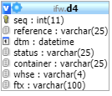**TABLE:** d4

**SIZE:** 325.3 MiB

**OLDEST RECORD:** N/A

**LAST UPDATED:** N/A

**UPDATED FROM:** N/A

**PROGRAM:** N/A

**ACCESS FROM WHERE:** N/A

**NUMBER OF ROWS:** 4,946,632

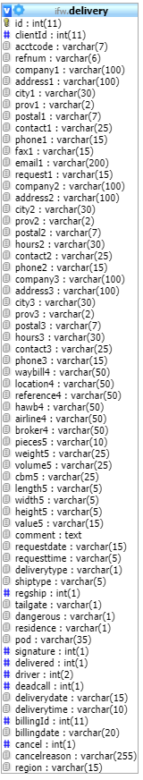**TABLE:** delivery

**SIZE:** 61.1 MiB

**OLDEST RECORD:** N/A

**LAST UPDATED:** N/A

**UPDATED FROM:** N/A

**PROGRAM:** N/A

**ACCESS FROM WHERE:** N/A

**NUMBER OF ROWS:** 102,889

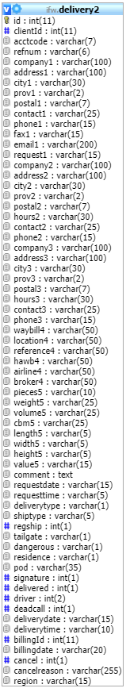**TABLE:** delivery2

**SIZE:** 49.8 KiB

**OLDEST RECORD:** N/A

**LAST UPDATED:** Jan 23, 2015 at 09:39 AM

**UPDATED FROM:** N/A

**PROGRAM:** N/A

**ACCESS FROM WHERE:** N/A

**NUMBER OF ROWS:** 83

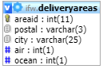**TABLE:** deliveryareas

**SIZE:** 28.2 KiB

**OLDEST RECORD:** N/A

**LAST UPDATED:** Sep 21, 2020 at 02:35 PM

**UPDATED FROM:** N/A

**PROGRAM:** N/A

**ACCESS FROM WHERE:** N/A

**NUMBER OF ROWS:** 520

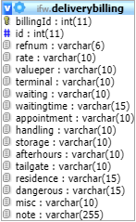**TABLE:** deliverybilling

**SIZE:** 8.6 MiB

**OLDEST RECORD:** N/A

**LAST UPDATED:** Apr 22, 2021 at 02:16 AM

**UPDATED FROM:** N/A

**PROGRAM:** N/A

**ACCESS FROM WHERE:** N/A

**NUMBER OF ROWS:** 100,183

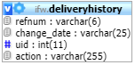**TABLE:** deliveryhistory

**SIZE:** 1.3 MiB

**OLDEST RECORD:** N/A

**LAST UPDATED:** Apr 22, 2021 at 11:38 PM

**UPDATED FROM:** N/A

**PROGRAM:** N/A

**ACCESS FROM WHERE:** N/A

**NUMBER OF ROWS:** 15,080

**TABLE:** deliveryno

**SIZE:** 2.0 KiB

**OLDEST RECORD:** N/A

**LAST UPDATED:** Apr 22, 2021 at 01:59 PM

**UPDATED FROM:** N/A

**PROGRAM:** N/A

**ACCESS FROM WHERE:** N/A

**NUMBER OF ROWS:** 1

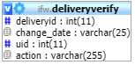**TABLE:** deliveryverify

**SIZE:** 10.9 MiB

**OLDEST RECORD:** N/A

**LAST UPDATED:** Apr 20, 2021 at02:16 AM

**UPDATED FROM:** N/A

**PROGRAM:** N/A

**ACCESS FROM WHERE:** N/A

**NUMBER OF ROWS:** 178,577

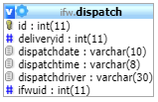**TABLE:** dispatch

**SIZE:** 655.9 KiB

**OLDEST RECORD:** N/A

**LAST UPDATED:** Apr 22, 2021 at 12:13 PM

**UPDATED FROM:** N/A

**PROGRAM:** N/A

**ACCESS FROM WHERE:** N/A

**NUMBER OF ROWS:** 8,399

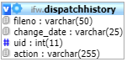**TABLE:** dispatchhistory

**SIZE:** 706.4 KiB

**OLDEST RECORD:** N/A

**LAST UPDATED:** Apr 22, 2021 at 12:13 PM

**UPDATED FROM:** N/A

**PROGRAM:** N/A

**ACCESS FROM WHERE:** N/A

**NUMBER OF ROWS:** 9,398

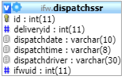**TABLE:** dispatchssr

**SIZE:** 32.0 KiB

**OLDEST RECORD:** N/A

**LAST UPDATED:** N/A

**UPDATED FROM:** N/A

**PROGRAM:** N/A

**ACCESS FROM WHERE:** N/A

**NUMBER OF ROWS:** 38

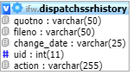**TABLE:** dispatchssrhistory

**SIZE:** 48.0 KiB

**OLDEST RECORD:** N/A

**LAST UPDATED:** N/A

**UPDATED FROM:** N/A

**PROGRAM:** N/A

**ACCESS FROM WHERE:** N/A

**NUMBER OF ROWS:** 48

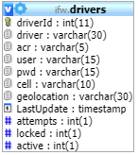**TABLE:** drivers

**SIZE:** 4.7 KiB

**OLDEST RECORD:** N/A

**LAST UPDATED:** Mar 03, 2021 at 01:15 PM

**UPDATED FROM:** N/A

**PROGRAM:** N/A

**ACCESS FROM WHERE:** N/A

**NUMBER OF ROWS:** 21

**TABLE:** expcoload

**SIZE:** 3.1 KiB

**OLDEST RECORD:** N/A

**LAST UPDATED:** Jan 22, 2018 at 11:40 AM

**UPDATED FROM:** N/A

**PROGRAM:** N/A

**ACCESS FROM WHERE:** N/A

**NUMBER OF ROWS:** 89

**TABLE:** expconsol

**SIZE:** 327.5 KiB

**OLDEST RECORD:** N/A

**LAST UPDATED:** Apr 22, 2021 at 01:52 AM

**UPDATED FROM:** N/A

**PROGRAM:** N/A

**ACCESS FROM WHERE:** N/A

**NUMBER OF ROWS:** 14,141

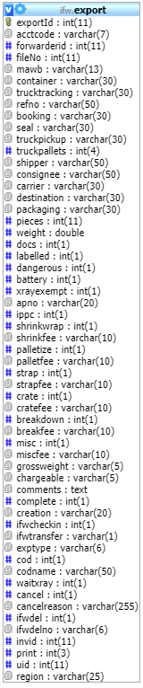**TABLE:** export

**SIZE:** 17.1 MiB

**OLDEST RECORD:** N/A

**LAST UPDATED:** Apr 22, 2021 at 01:52 PM

**UPDATED FROM:** N/A

**PROGRAM:** N/A

**ACCESS FROM WHERE:** N/A

**NUMBER OF ROWS:** 66,420

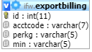**TABLE:** exportbilling

**SIZE:** 10.4 KiB

**OLDEST RECORD:** N/A

**LAST UPDATED:** Mar 15, 2021 at 01:55 PM

**UPDATED FROM:** N/A

**PROGRAM:** N/A

**ACCESS FROM WHERE:** N/A

**NUMBER OF ROWS:** 145

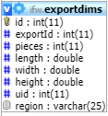**TABLE:** exportdims

**SIZE:** 5.9 MiB

**OLDEST RECORD:** N/A

**LAST UPDATED:** Apr 22, 2021 at 01:36 PM

**UPDATED FROM:** N/A

**PROGRAM:** N/A

**ACCESS FROM WHERE:** N/A

**NUMBER OF ROWS:** 100,113

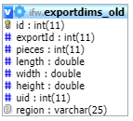**TABLE:** exportdims_old

**SIZE:** 1.9 MiB

**OLDEST RECORD:** N/A

**LAST UPDATED:** May 14, 2014 at 09:05 PM

**UPDATED FROM:** N/A

**PROGRAM:** N/A

**ACCESS FROM WHERE:** N/A

**NUMBER OF ROWS:** 32,689

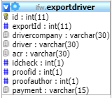**TABLE:** exportdriver

**SIZE:** 4.6 MiB

**OLDEST RECORD:** N/A

**LAST UPDATED:** Apr 22, 2021 at 01:36 PM

**UPDATED FROM:** N/A

**PROGRAM:** N/A

**ACCESS FROM WHERE:** N/A

**NUMBER OF ROWS:** 66,646

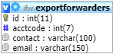**TABLE:** exportforwarders

**SIZE:** 14.5 KiB

**OLDEST RECORD:** N/A

**LAST UPDATED:** Apr 05, 2021 at 11:55 AM

**UPDATED FROM:** N/A

**PROGRAM:** N/A

**ACCESS FROM WHERE:** N/A

**NUMBER OF ROWS:** 140

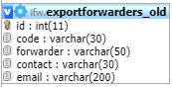**TABLE:** exportforwarders_old

**SIZE:** 4.8 KiB

**OLDEST RECORD:** N/A

**LAST UPDATED:** May 14, 2014 at 09:05 PM

**UPDATED FROM:** N/A

**PROGRAM:** N/A

**ACCESS FROM WHERE:** N/A

**NUMBER OF ROWS:** 45

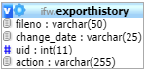**TABLE:** exporthistory

**SIZE:** 27.4 MiB

**OLDEST RECORD:** N/A

**LAST UPDATED:** Apr 22, 2021 at 01:36 PM

**UPDATED FROM:** N/A

**PROGRAM:** N/A

**ACCESS FROM WHERE:** N/A

**NUMBER OF ROWS:** 480,010

**TABLE:** exportno

**SIZE:** 1.0 KiB

**OLDEST RECORD:** N/A

**LAST UPDATED:** Apr 22, 2021 at 01:36 PM

**UPDATED FROM:** N/A

**PROGRAM:** N/A

**ACCESS FROM WHERE:** N/A

**NUMBER OF ROWS:** 1

**TABLE:** exportpics

**SIZE:** 3.3 KiB

**OLDEST RECORD:** N/A

**LAST UPDATED:** Oct 29, 2014 at 08:17 AM

**UPDATED FROM:** N/A

**PROGRAM:** N/A

**ACCESS FROM WHERE:** N/A

**NUMBER OF ROWS:** 8

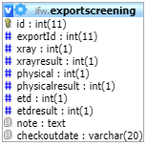**TABLE:** exportscreening

**SIZE:** 1.0 MiB

**OLDEST RECORD:** N/A

**LAST UPDATED:** Apr 21, 2021 at 04:33 PM

**UPDATED FROM:** N/A

**PROGRAM:** N/A

**ACCESS FROM WHERE:** N/A

**NUMBER OF ROWS:** 16,146

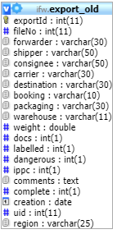**TABLE:** export_old

**SIZE:** 2.5 MiB

**OLDEST RECORD:** N/A

**LAST UPDATED:** May 14, 2014 at 09:05 PM

**UPDATED FROM:** N/A

**PROGRAM:** N/A

**ACCESS FROM WHERE:** N/A

**NUMBER OF ROWS:** 22,293

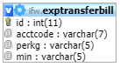**TABLE:** exptransferbill

**SIZE:** 8.4 KiB

**OLDEST RECORD:** N/A

**LAST UPDATED:** Mar 15, 2021 at 01:55 PM

**UPDATED FROM:** N/A

**PROGRAM:** N/A

**ACCESS FROM WHERE:** N/A

**NUMBER OF ROWS:** 92

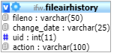**TABLE:** fileairhistory

**SIZE:** 10.9 MiB

**OLDEST RECORD:** N/A

**LAST UPDATED:** Apr 22, 2021 at 02:04 PM|

**UPDATED FROM:** N/A

**PROGRAM:** N/A

**ACCESS FROM WHERE:** N/A

**NUMBER OF ROWS:** 151,058

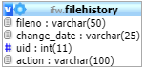**TABLE:** filehistory

**SIZE:** 49.2 MiB

**OLDEST RECORD:** N/A

**LAST UPDATED:** Apr 22, 2021 at 01:49 PM

**UPDATED FROM:** N/A

**PROGRAM:** N/A

**ACCESS FROM WHERE:** N/A

**NUMBER OF ROWS:** 797,610

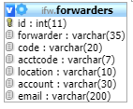**TABLE:** forwarders

**SIZE:** 6.9 KiB

**OLDEST RECORD:** N/A

**LAST UPDATED:** Apr 07, 2021 at 02:27 PM

**UPDATED FROM:** N/A

**PROGRAM:** N/A

**ACCESS FROM WHERE:** N/A

**NUMBER OF ROWS:** 78

**TABLE:** invbatch

**SIZE:** 1.0 KiB

**OLDEST RECORD:** N/A

**LAST UPDATED:** Apr 21, 2021 at 10:56 AM

**UPDATED FROM:** N/A

**PROGRAM:** N/A

**ACCESS FROM WHERE:** N/A

**NUMBER OF ROWS:** 1

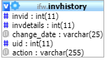**TABLE:** invhistory

**SIZE:** 220.4 KiB

**OLDEST RECORD:** N/A

**LAST UPDATED:** Nov 08, 2017 at 09:35 AM

**UPDATED FROM:** N/A

**PROGRAM:** N/A

**ACCESS FROM WHERE:** N/A

**NUMBER OF ROWS:** 3,050

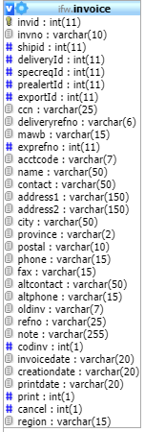**TABLE:** invoice

**SIZE:** 58.0 KiB

**OLDEST RECORD:** N/A

**LAST UPDATED:** Apr 20, 2021 at 12:49 PM

**UPDATED FROM:** N/A

**PROGRAM:** N/A

**ACCESS FROM WHERE:** N/A

**NUMBER OF ROWS:** 1,382

**TABLE:** invoicenumber

**SIZE:** 1.0 KiB

**OLDEST RECORD:** N/A

**LAST UPDATED:** Apr 22, 2021 at 02:16 AM

**UPDATED FROM:** N/A

**PROGRAM:** N/A

**ACCESS FROM WHERE:** N/A

**NUMBER OF ROWS:** 1

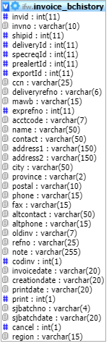**TABLE:** invoice_bchistory

**SIZE:** 750.7 KiB

**OLDEST RECORD:** N/A

**LAST UPDATED:** Sep 23, 2019 at 12:23 PM

**UPDATED FROM:** N/A

**PROGRAM:** N/A

**ACCESS FROM WHERE:** N/A

**NUMBER OF ROWS:** 3,374

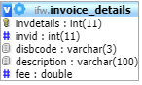**TABLE:** invoice_details

**SIZE:** 137.5 KiB

**OLDEST RECORD:** N/A

**LAST UPDATED:** Apr 22, 2021 at 02:16 PM

**UPDATED FROM:** N/A

**PROGRAM:** N/A

**ACCESS FROM WHERE:** N/A

**NUMBER OF ROWS:** 396

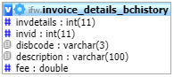**TABLE:** invoice_details_bchistory

**SIZE:** 289.1 KiB

**OLDEST RECORD:** N/A

**LAST UPDATED:** Feb 06, 2019 at 09:22 AM

**UPDATED FROM:** N/A

**PROGRAM:** N/A

**ACCESS FROM WHERE:** N/A

**NUMBER OF ROWS:** 6,454

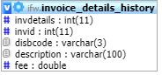**TABLE:** invoice_details_history

**SIZE:** 22.4 MiB

**OLDEST RECORD:** N/A

**LAST UPDATED:** Apr 21, 2021 at 10:56 AM

**UPDATED FROM:** N/A

**PROGRAM:** N/A

**ACCESS FROM WHERE:** N/A

**NUMBER OF ROWS:** 449,742

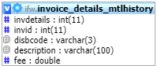**TABLE:** invoice_details_mtlhistory

**SIZE:** 1.3 MiB

**OLDEST RECORD:** N/A

**LAST UPDATED:** Apr 21, 2021 at 10:56 AM

**UPDATED FROM:** N/A

**PROGRAM:** N/A

**ACCESS FROM WHERE:** N/A

**NUMBER OF ROWS:** 24,450

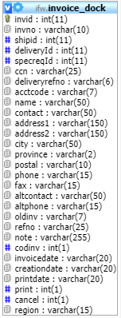**TABLE:** invoice_dock

**SIZE:** 236.1 KiB

**OLDEST RECORD:** N/A

**LAST UPDATED:** Apr 22, 2021 at 01:49 PM

**UPDATED FROM:** N/A

**PROGRAM:** N/A

**ACCESS FROM WHERE:** N/A

**NUMBER OF ROWS:** 911

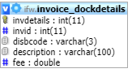**TABLE:** invoice_dockdetails

**SIZE:** 77.9 KiB

**OLDEST RECORD:** N/A

**LAST UPDATED:** Apr 22, 2021 at 01:47PM

**UPDATED FROM:** N/A

**PROGRAM:** N/A

**ACCESS FROM WHERE:** N/A

**NUMBER OF ROWS:** 957

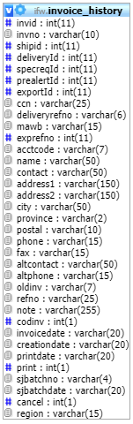**TABLE:** invoice_history

**SIZE:** 60.5 MiB

**OLDEST RECORD:** N/A

**LAST UPDATED:** Apr 22, 2021 at 01:36 AM

**UPDATED FROM:** N/A

**PROGRAM:** N/A

**ACCESS FROM WHERE:** N/A

**NUMBER OF ROWS:** 241,889

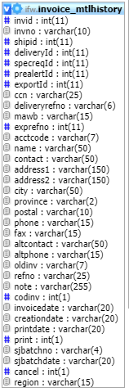**TABLE:** invoice_mtlhistory

**SIZE:** 2.5 MiB

**OLDEST RECORD:** N/A

**LAST UPDATED:** Apr 22, 2021 at 01:59 PM

**UPDATED FROM:** N/A

**PROGRAM:** N/A

**ACCESS FROM WHERE:** N/A

**NUMBER OF ROWS:** 9,261

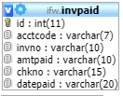**TABLE:** invpaid

**SIZE:** 1.0 KiB

**OLDEST RECORD:** N/A

**LAST UPDATED:** N/A

**UPDATED FROM:** N/A

**PROGRAM:** N/A

**ACCESS FROM WHERE:** N/A

**NUMBER OF ROWS:** 0

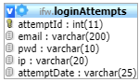**TABLE:** loginAttempts

**SIZE:** 14.5 MiB

**OLDEST RECORD:** N/A

**LAST UPDATED:** Apr 22, 2021 at 02:13 PM

**UPDATED FROM:** N/A

**PROGRAM:** N/A

**ACCESS FROM WHERE:** N/A

**NUMBER OF ROWS:** 174,830

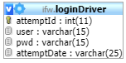**TABLE:** loginDriver

**SIZE:** 100.2 KiB

**OLDEST RECORD:** N/A

**LAST UPDATED:** Apr 22, 2021 at 11:26 AM

**UPDATED FROM:** N/A

**PROGRAM:** N/A

**ACCESS FROM WHERE:** N/A

**NUMBER OF ROWS:** 1,731

**TABLE:** newacctcode

**SIZE:** 2.0 KiB

**OLDEST RECORD:** N/A

**LAST UPDATED:** Mar 15, 2021 at 01:55 PM

**UPDATED FROM:** N/A

**PROGRAM:** N/A

**ACCESS FROM WHERE:** N/A

**NUMBER OF ROWS:** 1

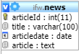**TABLE:** news

**SIZE:** 2.1 KiB

**OLDEST RECORD:** N/A

**LAST UPDATED:** May 14, 2014 at 09:06 PM

**UPDATED FROM:** N/A

**PROGRAM:** N/A

**ACCESS FROM WHERE:** N/A

**NUMBER OF ROWS:** 1

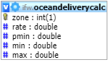**TABLE:** oceandeliverycalc

**SIZE:** 2.1 KiB

**OLDEST RECORD:** N/A

**LAST UPDATED:** Jul 15, 2020 at 08:18 AM

**UPDATED FROM:** N/A

**PROGRAM:** N/A

**ACCESS FROM WHERE:** N/A

**NUMBER OF ROWS:** 3

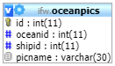**TABLE:** oceanpics

**SIZE:** 18.0 KiB

**OLDEST RECORD:** N/A

**LAST UPDATED:** Jul 29, 2014 at 11:15 AM

**UPDATED FROM:** N/A

**PROGRAM:** N/A

**ACCESS FROM WHERE:** N/A

**NUMBER OF ROWS:** 178

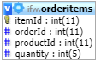**TABLE:** orderitems

**SIZE:** 3.1 KiB

**OLDEST RECORD:** N/A

**LAST UPDATED:** May 14, 2014 at 09:06 PM

**UPDATED FROM:** N/A

**PROGRAM:** N/A

**ACCESS FROM WHERE:** N/A

**NUMBER OF ROWS:** 5

**TABLE:** orderno

**SIZE:** 2.0 KiB

**OLDEST RECORD:** N/A

**LAST UPDATED:** May 14, 2014 at 09:06 PM

**UPDATED FROM:** N/A

**PROGRAM:** N/A

**ACCESS FROM WHERE:** N/A

**NUMBER OF ROWS:** 1

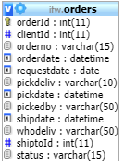**TABLE:** orders

**SIZE:** 2.1 KiB

**OLDEST RECORD:** N/A

**LAST UPDATED:** May 14, 2014 at 09:06 PM

**UPDATED FROM:** N/A

**PROGRAM:** N/A

**ACCESS FROM WHERE:** N/A

**NUMBER OF ROWS:** 2

**TABLE:** piggyback

**SIZE:** 715.2 KiB

**OLDEST RECORD:** N/A

**LAST UPDATED:** Apr 22, 2021 at 01:08 AM

**UPDATED FROM:** N/A

**PROGRAM:** N/A

**ACCESS FROM WHERE:** N/A

**NUMBER OF ROWS:** 28,812

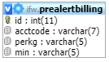**TABLE:** prealertbilling

**SIZE:** 8.4 KiB

**OLDEST RECORD:** N/A

**LAST UPDATED:** Mar 15, 2021 at 01:55 PM

**UPDATED FROM:** N/A

**PROGRAM:** N/A

**ACCESS FROM WHERE:** N/A

**NUMBER OF ROWS:** 92

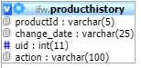**TABLE:** producthistory

**SIZE:** 1.2 KiB

**OLDEST RECORD:** N/A

**LAST UPDATED:** May 14, 2014 at 09:06 PM

**UPDATED FROM:** N/A

**PROGRAM:** N/A

**ACCESS FROM WHERE:** N/A

**NUMBER OF ROWS:** 5

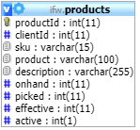**TABLE:** products

**SIZE:** 2.2 KiB

**OLDEST RECORD:** N/A

**LAST UPDATED:** May 14, 2014 at 09:06 PM

**UPDATED FROM:** N/A

**PROGRAM:** N/A

**ACCESS FROM WHERE:** N/A

**NUMBER OF ROWS:** 4

**TABLE:** quotenumber

**SIZE:** 1.0 KiB

**OLDEST RECORD:** N/A

**LAST UPDATED:** Apr 22, 2021 at 01:58 PM

**UPDATED FROM:** N/A

**PROGRAM:** N/A

**ACCESS FROM WHERE:** N/A

**NUMBER OF ROWS:** 1

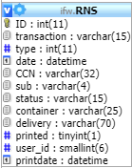**TABLE:** RNS

**SIZE:** 17.0 MiB

**OLDEST RECORD:** N/A

**LAST UPDATED:** N/A

**UPDATED FROM:** N/A

**PROGRAM:** N/A

**ACCESS FROM WHERE:** N/A

**NUMBER OF ROWS:** 101,565

**TABLE:** shipment

**SIZE:** 71.6 MiB

**OLDEST RECORD:** N/A

**LAST UPDATED:** N/A

**UPDATED FROM:** N/A

**PROGRAM:** N/A

**ACCESS FROM WHERE:** N/A

**NUMBER OF ROWS:** 71,687

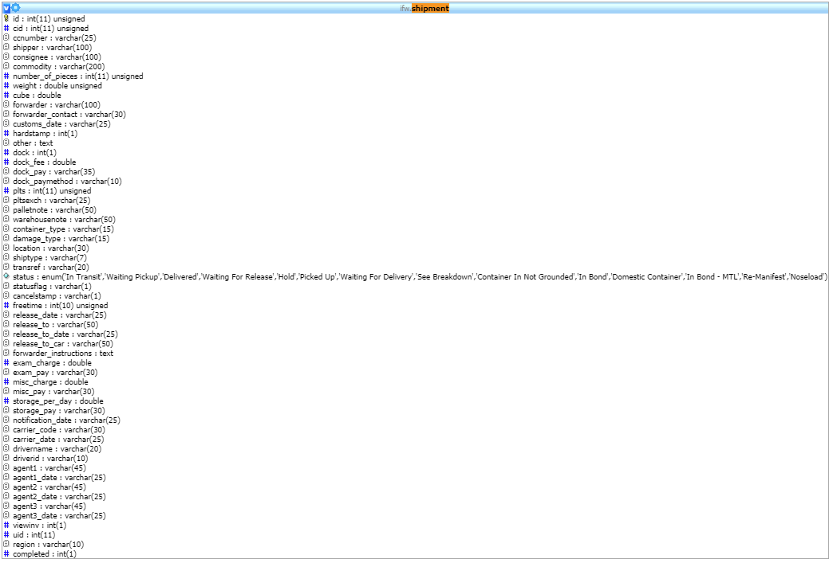

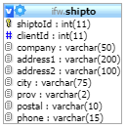**TABLE:** shipto

**SIZE:** 3.2 KiB

**OLDEST RECORD:** N/A

**LAST UPDATED:** May 14, 2014 at 09:06 PM

**UPDATED FROM:** N/A

**PROGRAM:** N/A

**ACCESS FROM WHERE:** N/A

**NUMBER OF ROWS:** 2

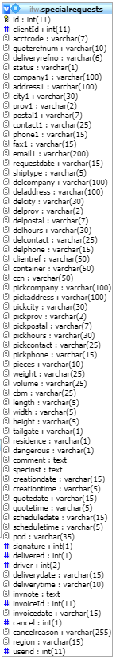**TABLE:** specialrequests

**SIZE:** 5.4 MiB

**OLDEST RECORD:** N/A

**LAST UPDATED:** Apr 22, 2021 at 01:56 AM

**UPDATED FROM:** N/A

**PROGRAM:** N/A

**ACCESS FROM WHERE:** N/A

**NUMBER OF ROWS:** 9,203

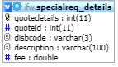**TABLE:** specialreq_details

**SIZE:** 747.8 KiB

**OLDEST RECORD:** N/A

**LAST UPDATED:** Apr 22, 2021 at 01:53 PM

**UPDATED FROM:** N/A

**PROGRAM:** N/A

**ACCESS FROM WHERE:** N/A

**NUMBER OF ROWS:** 10,684

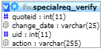**TABLE:** specialreq_verify

**SIZE:** 28.2 KiB

**OLDEST RECORD:** N/A

**LAST UPDATED:** Apr21, 2021 at 03:14 PM

**UPDATED FROM:** N/A

**PROGRAM:** N/A

**ACCESS FROM WHERE:** N/A

**NUMBER OF ROWS:** 408

**TABLE:** taxes

**SIZE:** 1.1 KiB

**OLDEST RECORD:** N/A

**LAST UPDATED:** Jan 31, 2017 at 10:25 AM

**UPDATED FROM:** N/A

**PROGRAM:** N/A

**ACCESS FROM WHERE:** N/A

**NUMBER OF ROWS:** 3

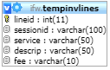**TABLE:** tempinvlines

**SIZE:** 23.5 KiB

**OLDEST RECORD:** N/A

**LAST UPDATED:** Apr 20, 2021 at 11:03 AM

**UPDATED FROM:** N/A

**PROGRAM:** N/A

**ACCESS FROM WHERE:** N/A

**NUMBER OF ROWS:** 125

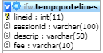**TABLE:** tempquotelines

**SIZE:** 4.7 KiB

**OLDEST RECORD:** N/A

**LAST UPDATED:** Apr 22, 2021 at 01:53 PM

**UPDATED FROM:** N/A

**PROGRAM:** N/A

**ACCESS FROM WHERE:** N/A

**NUMBER OF ROWS:** 15

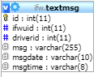**TABLE:** textmsg

**SIZE:** 1.0 KiB

**OLDEST RECORD:** N/A

**LAST UPDATED:** N/A

**UPDATED FROM:** N/A

**PROGRAM:** N/A

**ACCESS FROM WHERE:** N/A

**NUMBER OF ROWS:** 0

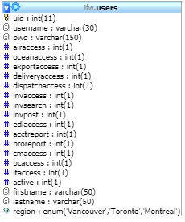**TABLE:** users

**SIZE:** 8.9 KiB

**OLDEST RECORD:** N/A

**LAST UPDATED:** Mar 11, 2021 at 02:45 PM

**UPDATED FROM:** N/A

**PROGRAM:** N/A

**ACCESS FROM WHERE:** N/A

**NUMBER OF ROWS:** 55

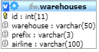**TABLE:** warehouses

**SIZE:** 6.8 KiB

**OLDEST RECORD:** N/A

**LAST UPDATED:** Aug 30, 2016 at 01:23 PM

**UPDATED FROM:** N/A

**PROGRAM:** N/A

**ACCESS FROM WHERE:** N/A

**NUMBER OF ROWS:** 102