**10.10.100.50**

**SQL Tables**

Database: ifwtest

Table of Contents

addressadmin………………………….…………………………..……… 7

addressbook………………...…………………………………………..… 8

airbreakdown…………………..………………………………………….. 9

aircontainer………………………………….……………………………….10

airdeliverycalc…………………………………….………………………. 11

airexit…………………………………………………..…………………….. 12

airlines………………………………………………………………………… 13

airsplit………………………………………………………………………... 14

airtranscalc…………………………………………………………………. 15

arrival…………………………………………………………………………. 16

arrivalerror…………………………………………………………………. 17

ar_receipts…………………………………………………………………. 18

bchistory…………………………………………………………………….. 19

billingcodes………………………………………………………………… 20

clienthistory………………………………………………………........... 21

clientinv………………………………………………………………………. 22

clientship…………………………………………………………………….. 23

cmactivate…………………………………………………………………… 24

cmchange……………………………………………………….…………… 25

cmhistory……………………………………………………….…………… 26

container……………………………………………………….…………… 27

currentdel……………………………………………….……….…………. 28

customermaster……………………………………………………….…. 29

customermasteraging…………………………………..……….…..… 30

dailynotice………………………………………………………………...… 31

delivery……………………………………………………….………………. 32

delivery2……………………………………………….……………………… 33

delivaryareas………………………………………………………………… 34

deliverybilling……………………………………………………………..… 35

deliveryhistory……………………………….……………………………… 36

deliveryno……………………………….…………………..……………….. 37

deliveryverify……………………………….…………………..…………… 38

dispatch……………………………….…………………..…………………… 39

dispatchhistory……………………………….…………………..………… 40

dispatchssr…………………………………………………………………….. 41

dispatchssrhistory…………………………………………………………. 42

drivers…………………………………………………………………………… 43

expcoload……………………………………………………………………… 44

expconsol………………………………………………………………………. 45

export……………………………………………………………………………. 46

exportbilling…………………………………………………………………… 47

exportdims…………………………………………………………………….. 48

exportdims_old……………………………………………………….…….. 49

exportdriver………………………….…………………………..…………… 50

exportforwarders………………...………………………………….…..… 51

exportforwarders_old…………………..…………………….………….. 52

exporthistory………………………………….……………………………….. 53

exportno…………………………………….……………………………..……. 54

exportpics…………………………………………………..………………….. 55

exportscreening…………………………………………………………….… 56

export_old…………………………………………………………………..….. 57

exptransferbill…………………………………………………………………. 58

fileairhistory……………………………………………………………………. 59

filehistory……………………………………………………………………….. 60

forwarders……………………………………………………………………… 61

invbatch…………………………………………………………………………. 62

invhistory……………………………………………………………………… 63

invoice………………………………………………………..................... 64

invoicenumber……………………………………………………….…….. 65

invoice_bchistory…………………………………………………….……. 66

invoice_details……………………………………………………….……… 67

invoice_details_bchistory…………………………………………….… 68

invoice_details_history……………………..………………….……….. 69

invoice_dock…………………………………………………………….……. 70

invoice_dockdetails…………………………………………….……….… 71

invoice_history……………………………………..…………………….…. 72

invoice_mtlhistory……………………………….………………….…..… 73

invpaid………………………………………………………………………...… 74

loginAttempts………………………………………………………..………. 75

loginDriver……………………………………………….…………………….. 76

newacctcode……………………………………………………………….…. 77

news………………………………………………………………...……………. 78

oceandeliverycalc……………………………….…………………..……… 79

oceanpics……………………………………………………………………….. 80

orderitems………………………………………………………………………. 81

orderno…………………………………………………………………………… 82

orders…………………………………………………………………………….. 83

piggybank……………………………………………………………………… 84

prealertbilling……………………………………………………………….. 85

producthistory………………………………………………………………. 86

products……………………………………………………………………….. 87

quotenumber……………………………………………………………….. 88

RNS………………………….…………………………..………………………. 89

shipment………………...…………………………………………..………. 90

shipto…………………..………………………………………………………. 92

specialrequests………………………………….……………..………….. 93

specialreq_details…………………………………………………………. 94

specialreq_verify ………………………….……………..………………. 95

taxes…………………………………………………………..………………… 96

tempinvlines……………………………………….……………………….. 97

tempquoteslines………………………………………………………….. 98

textmsg…………………………………………………….…………………. 99

users……………………………………………………………………….…… 100

warehouses………………………………………………………………… 101

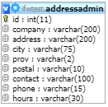**TABLE:** addressadmin

**SIZE:** 5.6 KiB

**OLDEST RECORD:** N/A

**LAST UPDATED:** Sep 11, 2015 at 01:38 PM

**UPDATED FROM:** N/A

**PROGRAM:** N/A

**ACCESS FROM WHERE:** N/A

**NUMBER OF ROWS:** 34

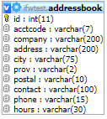**TABLE:** addressbook

**SIZE:** 432.8 KiB

**OLDEST RECORD:** N/A

**LAST UPDATED:** Sep 11, 2015 at 01:38 PM

**UPDATED FROM:** N/A

**PROGRAM:** N/A

**ACCESS FROM WHERE:** N/A

**NUMBER OF ROWS:** 2,959

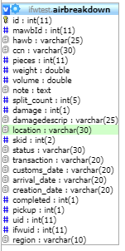**TABLE:** airbreakdown

**SIZE:** 1.8 MiB

**OLDEST RECORD:** N/A

**LAST UPDATED:** Jun 25, 2020 at 03:33 PM

**UPDATED FROM:** N/A

**PROGRAM:** N/A

**ACCESS FROM WHERE:** N/A

**NUMBER OF ROWS:** 10,166

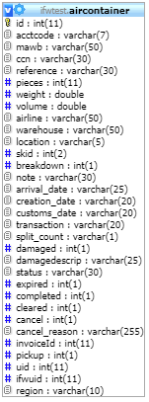**TABLE:** aircontainer

**SIZE:** 4.4 MiB

**OLDEST RECORD:** N/A

**LAST UPDATED:** Jun 25, 2020 at 03:34 PM

**UPDATED FROM:** N/A

**PROGRAM:** N/A

**ACCESS FROM WHERE:** N/A

**NUMBER OF ROWS:** 20,005

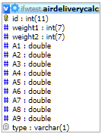**TABLE:** airdeliverycalc

**SIZE:** 3.6 KiB

**OLDEST RECORD:** N/A

**LAST UPDATED:** Jul 17, 2018 at 09:16 AM

**UPDATED FROM:** N/A

**PROGRAM:** N/A

**ACCESS FROM WHERE:** N/A

**NUMBER OF ROWS:** 27

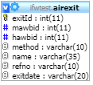**TABLE:** airexit

**SIZE:** 1.7 MiB

**OLDEST RECORD:** N/A

**LAST UPDATED:** Jul 06, 2016 at 02:29 PM

**UPDATED FROM:** N/A

**PROGRAM:** N/A

**ACCESS FROM WHERE:** N/A

**NUMBER OF ROWS:** 23,926

**TABLE:** airlines

**SIZE:** 3.2 KiB

**OLDEST RECORD:** N/A

**LAST UPDATED:** Sep 11, 2015 at 01:38 PM

**UPDATED FROM:** N/A

**PROGRAM:** N/A

**ACCESS FROM WHERE:** N/A

**NUMBER OF ROWS:** 60

**TABLE:** airsplit

**SIZE:** 32.5 KiB

**OLDEST RECORD:** N/A

**LAST UPDATED:** Nov 30, 2015 at 11:37 AM

**UPDATED FROM:** N/A

**PROGRAM:** N/A

**ACCESS FROM WHERE:** N/A

**NUMBER OF ROWS:** 903

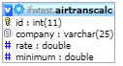**TABLE:** airtranscalc

**SIZE:** 2.4 KiB

**OLDEST RECORD:** N/A

**LAST UPDATED:** Sep 11, 2015 at 01:38 PM

**UPDATED FROM:** N/A

**PROGRAM:** N/A

**ACCESS FROM WHERE:** N/A

**NUMBER OF ROWS:** 14

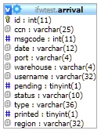**TABLE:** arrival

**SIZE:** 16.0 KiB

**OLDEST RECORD:** N/A

**LAST UPDATED:** N/A

**UPDATED FROM:** N/A

**PROGRAM:** N/A

**ACCESS FROM WHERE:** N/A

**NUMBER OF ROWS:** 165

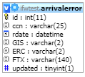**TABLE:** arrivalerror

**SIZE:** 16.0 KiB

**OLDEST RECORD:** N/A

**LAST UPDATED:** N/A

**UPDATED FROM:** N/A

**PROGRAM:** N/A

**ACCESS FROM WHERE:** N/A

**NUMBER OF ROWS:** 17

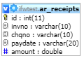**TABLE:** ar_receipts

**SIZE:** 32.0 KiB

**OLDEST RECORD:** N/A

**LAST UPDATED:** N/A

**UPDATED FROM:** N/A

**PROGRAM:** N/A

**ACCESS FROM WHERE:** N/A

**NUMBER OF ROWS:** 0

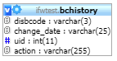**TABLE:** bchistory

**SIZE:** 1.2 KiB

**OLDEST RECORD:** N/A

**LAST UPDATED:** Sep 11, 2015 at 01:38 PM

**UPDATED FROM:** N/A

**PROGRAM:** N/A

**ACCESS FROM WHERE:** N/A

**NUMBER OF ROWS:** 4

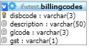**TABLE:** billingcodes

**SIZE:** 4.4 KiB

**OLDEST RECORD:** N/A

**LAST UPDATED:** Sep 11, 2015 at 01:38 PM

**UPDATED FROM:** N/A

**PROGRAM:** N/A

**ACCESS FROM WHERE:** N/A

**NUMBER OF ROWS:** 71

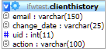**TABLE:** clienthistory

**SIZE:** 1.9 KiB

**OLDEST RECORD:** N/A

**LAST UPDATED:** Sep 11, 2015 at 01:38 PM

**UPDATED FROM:** N/A

**PROGRAM:** N/A

**ACCESS FROM WHERE:** N/A

**NUMBER OF ROWS:** 16

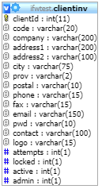**TABLE:** clientinv

**SIZE:** 2.3 KiB

**OLDEST RECORD:** N/A

**LAST UPDATED:** Sep 11, 2015 at 01:38 PM

**UPDATED FROM:** N/A

**PROGRAM:** N/A

**ACCESS FROM WHERE:** N/A

**NUMBER OF ROWS:** 2

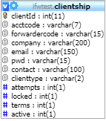**TABLE:** clientship

**SIZE:** 30.4 KiB

**OLDEST RECORD:** N/A

**LAST UPDATED:** Jul 23, 2018 at 01:31 PM

**UPDATED FROM:** N/A

**PROGRAM:** N/A

**ACCESS FROM WHERE:** N/A

**NUMBER OF ROWS:** 218

**TABLE:** cmactivate

**SIZE:** 1.0 KiB

**OLDEST RECORD:** N/A

**LAST UPDATED:** Sep 11, 2015 at 01:38 PM

**UPDATED FROM:** N/A

**PROGRAM:** N/A

**ACCESS FROM WHERE:** N/A

**NUMBER OF ROWS:** 1

**TABLE:** cmchange

**SIZE:** 1.0 KiB

**OLDEST RECORD:** N/A

**LAST UPDATED:** N/A

**UPDATED FROM:** N/A

**PROGRAM:** N/A

**ACCESS FROM WHERE:** N/A

**NUMBER OF ROWS:** 0

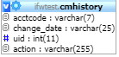**TABLE:** cmhistory

**SIZE:** 48.2 KiB

**OLDEST RECORD:** N/A

**LAST UPDATED:** Sep 11, 2015 at 01:38 PM

**UPDATED FROM:** N/A

**PROGRAM:** N/A

**ACCESS FROM WHERE:** N/A

**NUMBER OF ROWS:** 599

**TABLE:** container

**SIZE:** 1.8 MiB

**OLDEST RECORD:** N/A

**LAST UPDATED:** N/A

**UPDATED FROM:** N/A

**PROGRAM:** N/A

**ACCESS FROM WHERE:** N/A

**NUMBER OF ROWS:** 7,207

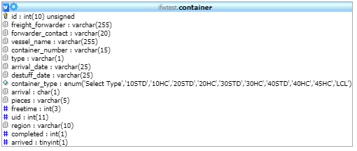

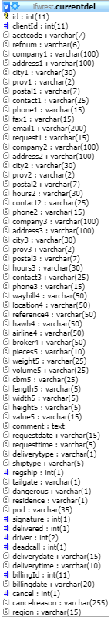**TABLE:** currentdel

**SIZE:** 79.6 KiB

**OLDEST RECORD:** N/A

**LAST UPDATED:** Sep 11, 2015 at 01:38 PM

**UPDATED FROM:** N/A

**PROGRAM:** N/A

**ACCESS FROM WHERE:** N/A

**NUMBER OF ROWS:** 598

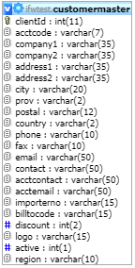**TABLE:** customermaster

**SIZE:** 77. KiB

**OLDEST RECORD:** N/A

**LAST UPDATED:** Oct 26, 2016 at 12:32 PM

**UPDATED FROM:** N/A

**PROGRAM:** N/A

**ACCESS FROM WHERE:** N/A

**NUMBER OF ROWS:** 268

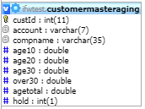**TABLE:** customermasteraging

**SIZE:** 51.5 KiB

**OLDEST RECORD:** N/A

**LAST UPDATED:** Apr 19, 2021 at 12:20 PM

**UPDATED FROM:** N/A

**PROGRAM:** N/A

**ACCESS FROM WHERE:** N/A

**NUMBER OF ROWS:** 593

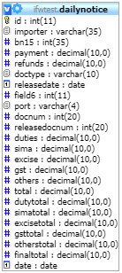**TABLE:** dailynotice

**SIZE:** 16.0 KiB

**OLDEST RECORD:** N/A

**LAST UPDATED:** N/A

**UPDATED FROM:** N/A

**PROGRAM:** N/A

**ACCESS FROM WHERE:** N/A

**NUMBER OF ROWS:** 0

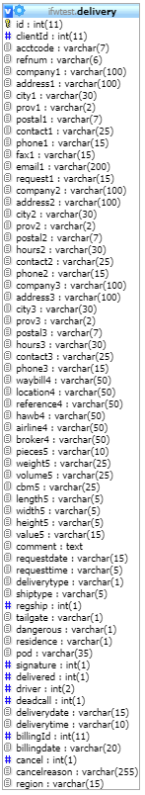**TABLE:** delivery

**SIZE:** 25.0 MiB

**OLDEST RECORD:** N/A

**LAST UPDATED:** Jul 24, 2018 at 02:42 PM

**UPDATED FROM:** N/A

**PROGRAM:** N/A

**ACCESS FROM WHERE:** N/A

**NUMBER OF ROWS:** 41,829

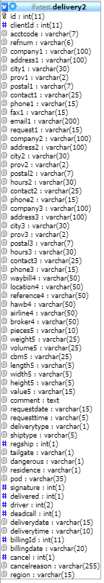**TABLE:** delivery2

**SIZE:** 49.8 KiB

**OLDEST RECORD:** N/A

**LAST UPDATED:** Sep 11, 2015 at 01:38 PM

**UPDATED FROM:** N/A

**PROGRAM:** N/A

**ACCESS FROM WHERE:** N/A

**NUMBER OF ROWS:** 83

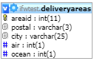**TABLE:** deliveryareas

**SIZE:** 28.1 MiB

**OLDEST RECORD:** N/A

**LAST UPDATED:** Sep 11, 2015 at 01:38 PM

**UPDATED FROM:** N/A

**PROGRAM:** N/A

**ACCESS FROM WHERE:** N/A

**NUMBER OF ROWS:** 520

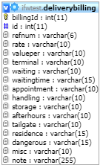**TABLE:** deliverybilling

**SIZE:** 3.2 MiB

**OLDEST RECORD:** N/A

**LAST UPDATED:** Jul 24, 2018 at 02:42 PM

**UPDATED FROM:** N/A

**PROGRAM:** N/A

**ACCESS FROM WHERE:** N/A

**NUMBER OF ROWS:** 40,863

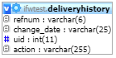**TABLE:** deliveryhistory

**SIZE:** 250.0 KiB

**OLDEST RECORD:** N/A

**LAST UPDATED:** Jul 18, 2017 at 10:40 AM

**UPDATED FROM:** N/A

**PROGRAM:** N/A

**ACCESS FROM WHERE:** N/A

**NUMBER OF ROWS:** 3,176

**TABLE:** deliveryno

**SIZE:** 2.0 KiB

**OLDEST RECORD:** N/A

**LAST UPDATED:** Jul 18, 2017 at 10:39 AM

**UPDATED FROM:** N/A

**PROGRAM:** N/A

**ACCESS FROM WHERE:** N/A

**NUMBER OF ROWS:** 1

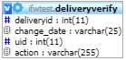**TABLE:** deliveryverify

**SIZE:** 3.4 MiB

**OLDEST RECORD:** N/A

**LAST UPDATED:** Jul 24, 2018 at 02:42 PM

**UPDATED FROM:** N/A

**PROGRAM:** N/A

**ACCESS FROM WHERE:** N/A

**NUMBER OF ROWS:** 55,263

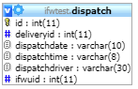**TABLE:** dispatch

**SIZE:** 188.0 KiB

**OLDEST RECORD:** N/A

**LAST UPDATED:** Sep 11, 2015 at 01:38 PM

**UPDATED FROM:** N/A

**PROGRAM:** N/A

**ACCESS FROM WHERE:** N/A

**NUMBER OF ROWS:** 2,603

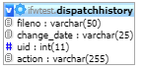**TABLE:** dispatchhistory

**SIZE:** 219.3 KiB

**OLDEST RECORD:** N/A

**LAST UPDATED:** Sep 11, 2015 at 01:38 PM

**UPDATED FROM:** N/A

**PROGRAM:** N/A

**ACCESS FROM WHERE:** N/A

**NUMBER OF ROWS:** 2,915

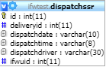**TABLE:** dispatchssr

**SIZE:** 32.0 KiB

**OLDEST RECORD:** N/A

**LAST UPDATED:** N/A

**UPDATED FROM:** N/A

**PROGRAM:** N/A

**ACCESS FROM WHERE:** N/A

**NUMBER OF ROWS:** 21

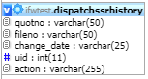**TABLE:** dispatchssrhistory

**SIZE:** 48.0 KiB

**OLDEST RECORD:** N/A

**LAST UPDATED:** N/A

**UPDATED FROM:** N/A

**PROGRAM:** N/A

**ACCESS FROM WHERE:** N/A

**NUMBER OF ROWS:** 31

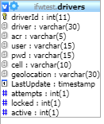**TABLE:** drivers

**SIZE:** 4.4 KiB

**OLDEST RECORD:** N/A

**LAST UPDATED:** Feb 27, 2018 at 10:43 AM

**UPDATED FROM:** N/A

**PROGRAM:** N/A

**ACCESS FROM WHERE:** N/A

**NUMBER OF ROWS:** 20

**TABLE:** expcoload

**SIZE:** 2.1 KiB

**OLDEST RECORD:** N/A

**LAST UPDATED:** Sep 11, 2015 at 01:38 PM

**UPDATED FROM:** N/A

**PROGRAM:** N/A

**ACCESS FROM WHERE:** N/A

**NUMBER OF ROWS:** 8

**TABLE:** expconsol

**SIZE:** 95.4 MiB

**OLDEST RECORD:** N/A

**LAST UPDATED:** Sep 11, 2015 at 01:38 PM

**UPDATED FROM:** N/A

**PROGRAM:** N/A

**ACCESS FROM WHERE:** N/A

**NUMBER OF ROWS:** 4,124

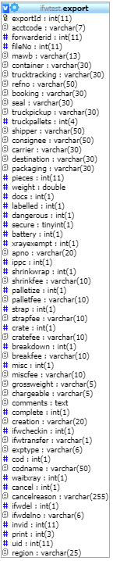**TABLE:** export

**SIZE:** 4.8 MiB

**OLDEST RECORD:** N/A

**LAST UPDATED:** May 11, 2018 at 10:54 AM

**UPDATED FROM:** N/A

**PROGRAM:** N/A

**ACCESS FROM WHERE:** N/A

**NUMBER OF ROWS:** 21,473

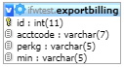**TABLE:** exportbilling

**SIZE:** 9.9 KiB

**OLDEST RECORD:** N/A

**LAST UPDATED:** Sep 11, 2015 at 01:38 PM

**UPDATED FROM:** N/A

**PROGRAM:** N/A

**ACCESS FROM WHERE:** N/A

**NUMBER OF ROWS:** 122

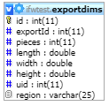**TABLE:** exportdims

**SIZE:** 1.8 MiB

**OLDEST RECORD:** N/A

**LAST UPDATED:** May 11, 2018 at 10:20 AM

**UPDATED FROM:** N/A

**PROGRAM:** N/A

**ACCESS FROM WHERE:** N/A

**NUMBER OF ROWS:** 31,163

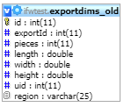**TABLE:** exportdims_old

**SIZE:** 1.9 MiB

**OLDEST RECORD:** N/A

**LAST UPDATED:** Sep 11, 2015 at 01:38 PM

**UPDATED FROM:** N/A

**PROGRAM:** N/A

**ACCESS FROM WHERE:** N/A

**NUMBER OF ROWS:** 32,689

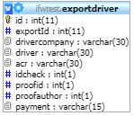**TABLE:** exportdriver

**SIZE:** 1.4 KiB

**OLDEST RECORD:** N/A

**LAST UPDATED:** May 11, 2018 at 10:20 AM

**UPDATED FROM:** N/A

**PROGRAM:** N/A

**ACCESS FROM WHERE:** N/A

**NUMBER OF ROWS:** 21,487

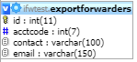**TABLE:** exportforwarders

**SIZE:** 7.3 KiB

**OLDEST RECORD:** N/A

**LAST UPDATED:** Oct 18, 2016 at 04:14 PM

**UPDATED FROM:** N/A

**PROGRAM:** N/A

**ACCESS FROM WHERE:** N/A

**NUMBER OF ROWS:** 86

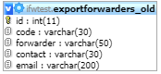**TABLE:** exportforwarders_old

**SIZE:** 4.8 KiB

**OLDEST RECORD:** N/A

**LAST UPDATED:** Sep 11, 2015 at 01:38 PM

**UPDATED FROM:** N/A

**PROGRAM:** N/A

**ACCESS FROM WHERE:** N/A

**NUMBER OF ROWS:** 45

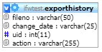**TABLE:** exporthistory

**SIZE:** 11.8 MiB

**OLDEST RECORD:** N/A

**LAST UPDATED:** May 11, 2018 at 10:54 AM

**UPDATED FROM:** N/A

**PROGRAM:** N/A

**ACCESS FROM WHERE:** N/A

**NUMBER OF ROWS:** 216,542

**TABLE:** exportno

**SIZE:** 1.0 KiB

**OLDEST RECORD:** N/A

**LAST UPDATED:** May 11, 2018 at 10:20 AM

**UPDATED FROM:** N/A

**PROGRAM:** N/A

**ACCESS FROM WHERE:** N/A

**NUMBER OF ROWS:** 1

**TABLE:** exportpics

**SIZE:** 3.3 KiB

**OLDEST RECORD:** N/A

**LAST UPDATED:** Sep 11, 2015 at 01:39 PM

**UPDATED FROM:** N/A

**PROGRAM:** N/A

**ACCESS FROM WHERE:** N/A

**NUMBER OF ROWS:** 8

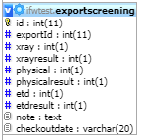**TABLE:** exportscreening

**SIZE:** 111.5 KiB

**OLDEST RECORD:** N/A

**LAST UPDATED:** May 11, 2018 at 10:54 AM

**UPDATED FROM:** N/A

**PROGRAM:** N/A

**ACCESS FROM WHERE:** N/A

**NUMBER OF ROWS:** 1,707

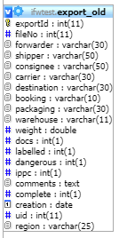**TABLE:** export_old

**SIZE:** 2.5 MiB

**OLDEST RECORD:** N/A

**LAST UPDATED:** Sep 11, 2015 at 01:39 PM

**UPDATED FROM:** N/A

**PROGRAM:** N/A

**ACCESS FROM WHERE:** N/A

**NUMBER OF ROWS:** 22,283

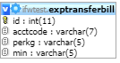**TABLE:** exptransferbill

**SIZE:** 4.6 KiB

**OLDEST RECORD:** N/A

**LAST UPDATED:** Sep 11, 2015 at 01:39 PM

**UPDATED FROM:** N/A

**PROGRAM:** N/A

**ACCESS FROM WHERE:** N/A

**NUMBER OF ROWS:** 61

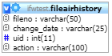**TABLE:** fileairhistory

**SIZE:** 4.4 MiB

**OLDEST RECORD:** N/A

**LAST UPDATED:** Jun 25, 2020 at 03:34 PM

**UPDATED FROM:** N/A

**PROGRAM:** N/A

**ACCESS FROM WHERE:** N/A

**NUMBER OF ROWS:** 64,840

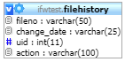**TABLE:** filehistory

**SIZE:** 27.5 MiB

**OLDEST RECORD:** N/A

**LAST UPDATED:** Jul 12, 2018 at 09:59 AM

**UPDATED FROM:** N/A

**PROGRAM:** N/A

**ACCESS FROM WHERE:** N/A

**NUMBER OF ROWS:** 459,673

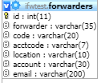**TABLE:** forwarders

**SIZE:** 5.5 KiB

**OLDEST RECORD:** N/A

**LAST UPDATED:** Sep 11, 2015 at 01:39 PM

**UPDATED FROM:** N/A

**PROGRAM:** N/A

**ACCESS FROM WHERE:** N/A

**NUMBER OF ROWS:** 55

**TABLE:** invbatch

**SIZE:** 1.0 KiB

**OLDEST RECORD:** N/A

**LAST UPDATED:** Sep 11, 2015 at 01:39 PM

**UPDATED FROM:** N/A

**PROGRAM:** N/A

**ACCESS FROM WHERE:** N/A

**NUMBER OF ROWS:** 1

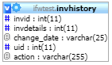**TABLE:** invhistory

**SIZE:** 100.3 KiB

**OLDEST RECORD:** N/A

**LAST UPDATED:** Jun 27, 2017 at 01:09 PM

**UPDATED FROM:** N/A

**PROGRAM:** N/A

**ACCESS FROM WHERE:** N/A

**NUMBER OF ROWS:** 1,382

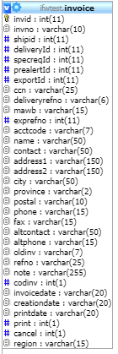**TABLE:** invoice

**SIZE:** 49.7 KiB

**OLDEST RECORD:** N/A

**LAST UPDATED:** Jun 25, 2020 at 03:48 PM

**UPDATED FROM:** N/A

**PROGRAM:** N/A

**ACCESS FROM WHERE:** N/A

**NUMBER OF ROWS:** 161

**TABLE:** invoicenumber

**SIZE:** 1.0 KiB

**OLDEST RECORD:** N/A

**LAST UPDATED:** Jun 25, 2020 at 03:48 PM

**UPDATED FROM:** N/A

**PROGRAM:** N/A

**ACCESS FROM WHERE:** N/A

**NUMBER OF ROWS:** 1

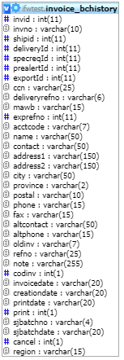**TABLE:** invoice_bchistory

**SIZE:** 296.3 KiB

**OLDEST RECORD:** N/A

**LAST UPDATED:** Sep 11, 2015 at 01:39 PM

**UPDATED FROM:** N/A

**PROGRAM:** N/A

**ACCESS FROM WHERE:** N/A

**NUMBER OF ROWS:** 1,272

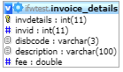**TABLE:** invoice_details

**SIZE:** 25.2 KiB

**OLDEST RECORD:** N/A

**LAST UPDATED:** Jun 25, 2020 at 03:48 PM

**UPDATED FROM:** N/A

**PROGRAM:** N/A

**ACCESS FROM WHERE:** N/A

**NUMBER OF ROWS:** 265

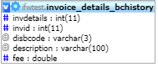**TABLE:** invoice_details_bchistory

**SIZE:** 96.0 KiB

**OLDEST RECORD:** N/A

**LAST UPDATED:** Sep 11, 2015 at 01:39 PM

**UPDATED FROM:** N/A

**PROGRAM:** N/A

**ACCESS FROM WHERE:** N/A

**NUMBER OF ROWS:** 1,861

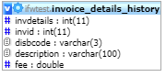**TABLE:** invoice_details_history

**SIZE:** 8.7 MiB

**OLDEST RECORD:** N/A

**LAST UPDATED:** Sep 11, 2015 at 01:39 PM

**UPDATED FROM:** N/A

**PROGRAM:** N/A

**ACCESS FROM WHERE:** N/A

**NUMBER OF ROWS:** 169,649

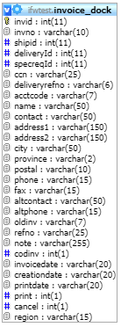**TABLE:** invoice_dock

**SIZE:** 127.3 KiB

**OLDEST RECORD:** N/A

**LAST UPDATED:** Jul 12, 2018 at 09:59 AM

**UPDATED FROM:** N/A

**PROGRAM:** N/A

**ACCESS FROM WHERE:** N/A

**NUMBER OF ROWS:** 576

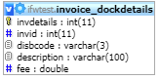**TABLE:** invoice_dockdetails

**SIZE:** 42.4 KiB

**OLDEST RECORD:** N/A

**LAST UPDATED:** Jul 12, 2018 at 09:59 AM

**UPDATED FROM:** N/A

**PROGRAM:** N/A

**ACCESS FROM WHERE:** N/A

**NUMBER OF ROWS:** 592

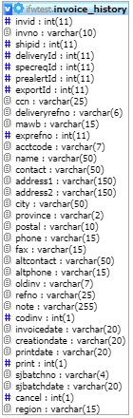**TABLE:** invoice_history

**SIZE:** 21.8 MiB

**OLDEST RECORD:** N/A

**LAST UPDATED:** Jan 02, 2018 at 02:14 PM

**UPDATED FROM:** N/A

**PROGRAM:** N/A

**ACCESS FROM WHERE:** N/A

**NUMBER OF ROWS:** 92,611

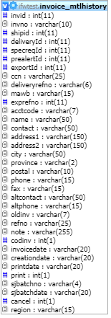**TABLE:** invoice_mtlhistory

**SIZE:** 1.0 KiB

**OLDEST RECORD:** N/A

**LAST UPDATED:** N/A

**UPDATED FROM:** N/A

**PROGRAM:** N/A

**ACCESS FROM WHERE:** N/A

**NUMBER OF ROWS:** 0

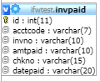**TABLE:** invpaid

**SIZE:** 1.0 KiB

**OLDEST RECORD:** N/A

**LAST UPDATED:** N/A

**UPDATED FROM:** N/A

**PROGRAM:** N/A

**ACCESS FROM WHERE:** N/A

**NUMBER OF ROWS:** 0

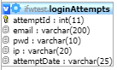**TABLE:** loginAttempts

**SIZE:** 5.0 MiB

**OLDEST RECORD:** N/A

**LAST UPDATED:** Aug 04, 2016 at 12:24 PM

**UPDATED FROM:** N/A

**PROGRAM:** N/A

**ACCESS FROM WHERE:** N/A

**NUMBER OF ROWS:** 60,216

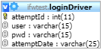**TABLE:** loginDriver

**SIZE:** 4.5 KiB

**OLDEST RECORD:** N/A

**LAST UPDATED:** Mar 01, 2018 at 09:13 AM

**UPDATED FROM:** N/A

**PROGRAM:** N/A

**ACCESS FROM WHERE:** N/A

**NUMBER OF ROWS:** 57

**TABLE:** newacctcode

**SIZE:** 2.0 KiB

**OLDEST RECORD:** N/A

**LAST UPDATED:** Sep 11, 2015 at 01:39 PM

**UPDATED FROM:** N/A

**PROGRAM:** N/A

**ACCESS FROM WHERE:** N/A

**NUMBER OF ROWS:** 1

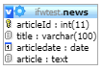**TABLE:** news

**SIZE:** 2.1 KiB

**OLDEST RECORD:** N/A

**LAST UPDATED:** Sep 11, 2015 at 01:39 PM

**UPDATED FROM:** N/A

**PROGRAM:** N/A

**ACCESS FROM WHERE:** N/A

**NUMBER OF ROWS:** 1

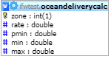**TABLE:** oceandeliverycalc

**SIZE:** 2.1 KiB

**OLDEST RECORD:** N/A

**LAST UPDATED:** Jul 18, 2017 at 10:05 AM

**UPDATED FROM:** N/A

**PROGRAM:** N/A

**ACCESS FROM WHERE:** N/A

**NUMBER OF ROWS:** 3

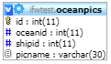**TABLE:** oceanpics

**SIZE:** 17.0 KiB

**OLDEST RECORD:** N/A

**LAST UPDATED:** Sep 11, 2015 at 01:39 PM

**UPDATED FROM:** N/A

**PROGRAM:** N/A

**ACCESS FROM WHERE:** N/A

**NUMBER OF ROWS:** 178

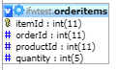**TABLE:** orderitems

**SIZE:** 3.1 KiB

**OLDEST RECORD:** N/A

**LAST UPDATED:** Sep 11, 2015 at 01:39 PM

**UPDATED FROM:** N/A

**PROGRAM:** N/A

**ACCESS FROM WHERE:** N/A

**NUMBER OF ROWS:** 5

**TABLE:** orderno

**SIZE:** 2.0 KiB

**OLDEST RECORD:** N/A

**LAST UPDATED:** Sep 11, 2015 at 01:39 PM

**UPDATED FROM:** N/A

**PROGRAM:** N/A

**ACCESS FROM WHERE:** N/A

**NUMBER OF ROWS:** 1

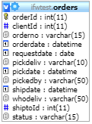**TABLE:** orders

**SIZE:** 2.1 KiB

**OLDEST RECORD:** N/A

**LAST UPDATED:** Sep 11, 2015 at 01:39 PM

**UPDATED FROM:** N/A

**PROGRAM:** N/A

**ACCESS FROM WHERE:** N/A

**NUMBER OF ROWS:** 2

**TABLE:** piggyback

**SIZE:** 378.9 KiB

**OLDEST RECORD:** N/A

**LAST UPDATED:** Nov 06, 2017 at 02:37 PM

**UPDATED FROM:** N/A

**PROGRAM:** N/A

**ACCESS FROM WHERE:** N/A

**NUMBER OF ROWS:** 16,488

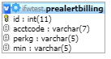**TABLE:** prealertbilling

**SIZE:** 4.6 KiB

**OLDEST RECORD:** N/A

**LAST UPDATED:** Sep 11, 2015 at 01:39 PM

**UPDATED FROM:** N/A

**PROGRAM:** N/A

**ACCESS FROM WHERE:** N/A

**NUMBER OF ROWS:** 61

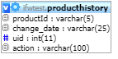**TABLE:** producthistory

**SIZE:** 1.2 KiB

**OLDEST RECORD:** N/A

**LAST UPDATED:** Sep 11, 2015 at 01:39 PM

**UPDATED FROM:** N/A

**PROGRAM:** N/A

**ACCESS FROM WHERE:** N/A

**NUMBER OF ROWS:** 5

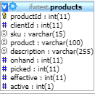**TABLE:** products

**SIZE:** 2.2 KiB

**OLDEST RECORD:** N/A

**LAST UPDATED:** Sep 11, 2015 at 01:39 PM

**UPDATED FROM:** N/A

**PROGRAM:** N/A

**ACCESS FROM WHERE:** N/A

**NUMBER OF ROWS:** 4

**TABLE:** quotenumber

**SIZE:** 1.0 KiB

**OLDEST RECORD:** N/A

**LAST UPDATED:** Dec 04, 2017 at 01:47 PM

**UPDATED FROM:** N/A

**PROGRAM:** N/A

**ACCESS FROM WHERE:** N/A

**NUMBER OF ROWS:** 1

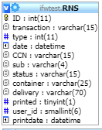**TABLE:** RNS

**SIZE:** 320.0 MiB

**OLDEST RECORD:** N/A

**LAST UPDATED:** N/A

**UPDATED FROM:** N/A

**PROGRAM:** N/A

**ACCESS FROM WHERE:** N/A

**NUMBER OF ROWS:** 2,017

**TABLE:** shipment

**SIZE:** 30.6 MiB

**OLDEST RECORD:** N/A

**LAST UPDATED:** N/A

**UPDATED FROM:** N/A

**PROGRAM:** N/A

**ACCESS FROM WHERE:** N/A

**NUMBER OF ROWS:** 75,183

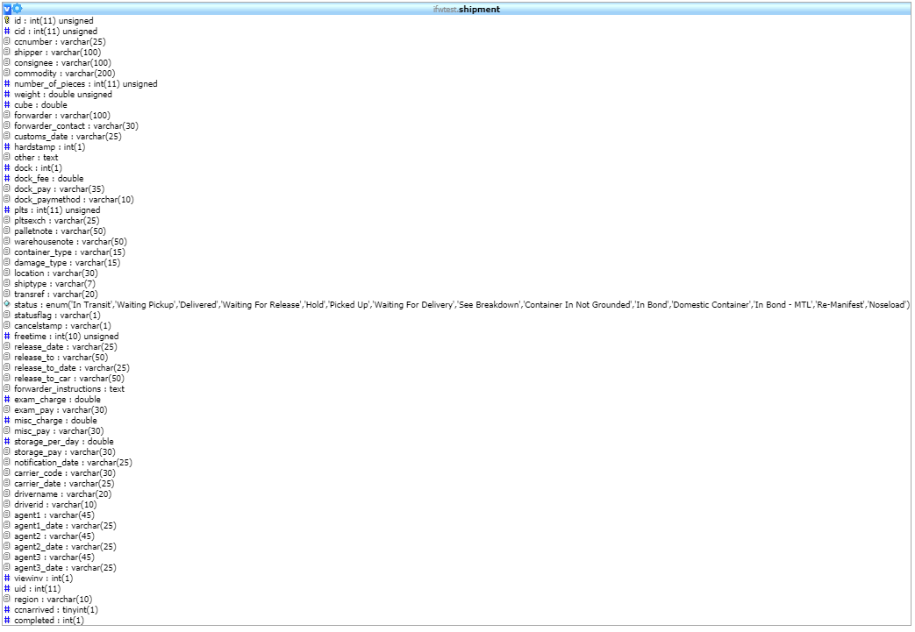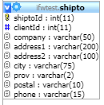**TABLE:** shipto

**SIZE:** 3.2 KiB

**OLDEST RECORD:** N/A

**LAST UPDATED:** Sep 11, 2015 at 01:39 PM

**UPDATED FROM:** N/A

**PROGRAM:** N/A

**ACCESS FROM WHERE:** N/A

**NUMBER OF ROWS:** 2

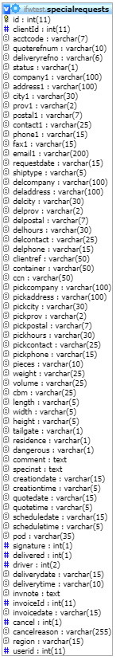**TABLE:** specialrequests

**SIZE:** 1.7 MiB

**OLDEST RECORD:** N/A

**LAST UPDATED:** Feb 15, 2018 at 11:33 AM

**UPDATED FROM:** N/A

**PROGRAM:** N/A

**ACCESS FROM WHERE:** N/A

**NUMBER OF ROWS:** 2,932

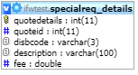**TABLE:** specialreq_details

**SIZE:** 226.3 KiB

**OLDEST RECORD:** N/A

**LAST UPDATED:** Dec 04, 2017 at 01:47 PM

**UPDATED FROM:** N/A

**PROGRAM:** N/A

**ACCESS FROM WHERE:** N/A

**NUMBER OF ROWS:** 3,212

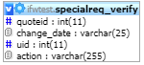**TABLE:** specialreq_verify

**SIZE:** 11.6 KiB

**OLDEST RECORD:** N/A

**LAST UPDATED:** Sep 11, 2015 at 01:39 PM

**UPDATED FROM:** N/A

**PROGRAM:** N/A

**ACCESS FROM WHERE:** N/A

**NUMBER OF ROWS:** 153

**TABLE:** taxes

**SIZE:** 1.0 KiB

**OLDEST RECORD:** N/A

**LAST UPDATED:** Jan 15, 2018 at 01:45 PM

**UPDATED FROM:** N/A

**PROGRAM:** N/A

**ACCESS FROM WHERE:** N/A

**NUMBER OF ROWS:** 2

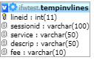**TABLE:** tempinvlines

**SIZE:** 3.8 KiB

**OLDEST RECORD:** N/A

**LAST UPDATED:** Jan 15, 2018 at 01:48 PM

**UPDATED FROM:** N/A

**PROGRAM:** N/A

**ACCESS FROM WHERE:** N/A

**NUMBER OF ROWS:** 9

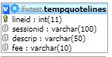**TABLE:** tempquotelines

**SIZE:** 3.1 KiB

**OLDEST RECORD:** N/A

**LAST UPDATED:** N/A

**UPDATED FROM:** N/A

**PROGRAM:** N/A

**ACCESS FROM WHERE:** N/A

**NUMBER OF ROWS:** 0

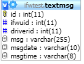**TABLE:** textmsg

**SIZE:** 1.0 KiB

**OLDEST RECORD:** N/A

**LAST UPDATED:** N/A

**UPDATED FROM:** N/A

**PROGRAM:** N/A

**ACCESS FROM WHERE:** N/A

**NUMBER OF ROWS:** 0

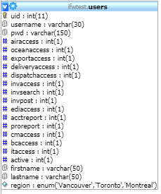**TABLE:** users

**SIZE:** 5.6 KiB

**OLDEST RECORD:** N/A

**LAST UPDATED:** Jun 25, 2020 at 12:18 PM

**UPDATED FROM:** N/A

**PROGRAM:** N/A

**ACCESS FROM WHERE:** N/A

**NUMBER OF ROWS:** 29

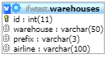**TABLE:** warehouses

**SIZE:** 6.7 KiB

**OLDEST RECORD:** N/A

**LAST UPDATED:** Aug 30, 2016 at 12:20 PM

**UPDATED FROM:** N/A

**PROGRAM:** N/A

**ACCESS FROM WHERE:** N/A

**NUMBER OF ROWS:** 99