**10.10.100.50**

**SQL Tables**

Database: testifw

Status: N/A

Used Where: N/A

Table of Contents

addressadmin………………………….…………………………..……… 6

addressbook………………...…………………………………………..… 7

airbreakdown…………………..………………………………………….. 8

aircontainer………………………………….……………………….…….. 9

airdeliverycalc…………………………………….………………………. 10

airexit…………………………………………………..……………………… 11

airlines………………………………………………………………………… 12

airsplit…………………………………………………………………………. 13

bchistory……………………………………………………………………… 14

billingcodes………………………………………………………………….. 14

clienthistory……………………………………………………………...... 16

clientinv……………………………………………………………………….. 17

clientship……………………………………………………………………… 18

cmactivate…………………………………………………………………… 19

cmchange……………………………………………………….…………… 20

cmhistory……………………………………………………….……………. 21

container……………………………………………………….……………. 22

customermaster……………………………………………………...…. 23

delivery……………………………………………………….……………… 24

deliveryareas……………………………………………….…….………. 25

deliverybilling……………………………………………………….....… 26

deliveryhistory……………………………….…………………………… 27

deliveryno……………………………….…………………..…………….. 28

drivers………………………………………………………………………… 29

expcoload…………………………………………………………………… 30

expconsol………………………………………………..…………………. 31

export………………………………………………………………………… 32

exportbilling………………………………………………………………. 33

exportdims………………………………………………………………… 34

exportdriver………………………….…………………………..……… 35

exportforwarders………………...………………………………...… 36

exporthistory…………………………………..……………………….. 37

exportno…………………………………….…….………………………. 38

exportpics……………………………………….………..………………. 39

exportscreening……………………….………………………………… 40

export_old…………………………..…………………………………….. 41

exptransferbill……………………..…………………………………….. 42

fileairhistory………………………………………………………………. 43

filehistory…………………………………………………………………… 44

forwarders…………………………………………………………………. 45

invbatch…………………………………………………………………….. 46

invhistory…………………………………………………………..………. 47

invoice……………………………………………………….................. 48

invoicenumber………………………………………………….……….. 49

invoice_bchistory…………………………………………….…………. 50

invoice_details…………………………………………….……………… 51

invoice_details_bchistory……………..………………………….… 52

invoice_details_history………….………………………….……….. 53

invoice_dock…………………………..…………………………….……. 54

invoice_dockdetails………………………………………….……….… 55

invoice_history…………………………..…………………………….…. 56

invpaid……………………………………………………..……………...… 57

loginAttempts…………………………………………………….………. 58

loginDriver……………………………………………….…………………. 59

newacctcode………………………………………………………………. 60

news………………………………………………………………...………… 61

oceandeliverycalc……………………………….…………………..…. 62

oceanpics…………………………………………………………………… 63

orderitems…………………………………………………………………. 64

orderno……………………………………………………………………… 65

orders………………………………………………………………………… 66

payment………………………………………………..………………….. 67

piggybank………………………………………………………………….. 68

prealertbilling……………………………………………………………. 69

producthistory………………………………………………………….. 70

products……………………………………………………………………. 71

quotenumber………………………………………………….…….….. 72

shipment………………...…………………………………….……..….. 73

shipto…………………..……………………………………….………….. 75

specialrequests………………………………….…………….……….. 76

specialreq_details……………………………..………………………. 77

specialreq_verify ……………………………………..………………. 78

taxes………………………………………………………….……………… 79

tempinvlines……………………………………………….…………….. 80

tempquoteslines……………………………………………………….. 81

users…………………………………………………………………………. 82

warehouses………………………………………………………………. 83

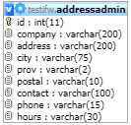**TABLE:** addressadmin

**SIZE:** 2.2 KiB

**OLDEST RECORD:** N/A

**LAST UPDATED:** May 14, 2014 at 10:04 AM

**UPDATED FROM:** N/A

**PROGRAM:** N/A

**ACCESS FROM WHERE:** N/A

**NUMBER OF ROWS:** 2

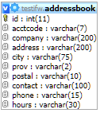**TABLE:** addressbook

**SIZE:** 1.0 KiB

**OLDEST RECORD:** N/A

**LAST UPDATED:** N/A

**UPDATED FROM:** N/A

**PROGRAM:** N/A

**ACCESS FROM WHERE:** N/A

**NUMBER OF ROWS:** 0

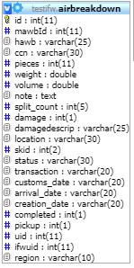**TABLE:** airbreakdown

**SIZE:** 5.7 KiB

**OLDEST RECORD:** N/A

**LAST UPDATED:** May 14, 2014 at 10:04 AM

**UPDATED FROM:** N/A

**PROGRAM:** N/A

**ACCESS FROM WHERE:** N/A

**NUMBER OF ROWS:** 19

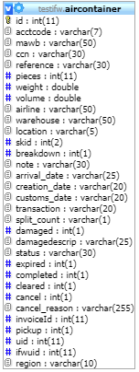**TABLE:** aircontainer

**SIZE:** 5.4 KiB

**OLDEST RECORD:** N/A

**LAST UPDATED:** Jul 30, 2020 at 09:51 AM

**UPDATED FROM:** N/A

**PROGRAM:** N/A

**ACCESS FROM WHERE:** N/A

**NUMBER OF ROWS:** 14

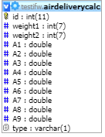**TABLE:** airdeliverycalc

**SIZE:** 5.8 KiB

**OLDEST RECORD:** N/A

**LAST UPDATED:** May 14, 2014 at 10:04 AM

**UPDATED FROM:** N/A

**PROGRAM:** N/A

**ACCESS FROM WHERE:** N/A

**NUMBER OF ROWS:** 42

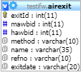**TABLE:** airexit

**SIZE:** 3.3 KiB

**OLDEST RECORD:** N/A

**LAST UPDATED:** May 14, 2014 at 10:04 AM

**UPDATED FROM:** N/A

**PROGRAM:** N/A

**ACCESS FROM WHERE:** N/A

**NUMBER OF ROWS:** 7

**TABLE:** airlines

**SIZE:** 3.2 KiB

**OLDEST RECORD:** N/A

**LAST UPDATED:** May 14, 2014 at 10:04 AM

**UPDATED FROM:** N/A

**PROGRAM:** N/A

**ACCESS FROM WHERE:** N/A

**NUMBER OF ROWS:** 60

**TABLE:** airsplit

**SIZE:** 3.0 KiB

**OLDEST RECORD:** N/A

**LAST UPDATED:** May 14, 2014 at 10:04 AM

**UPDATED FROM:** N/A

**PROGRAM:** N/A

**ACCESS FROM WHERE:** N/A

**NUMBER OF ROWS:** 2

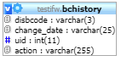**TABLE:** bchistory

**SIZE:** 1.1 KiB

**OLDEST RECORD:** N/A

**LAST UPDATED:** May 14, 2014 at 10:04 AM

**UPDATED FROM:** N/A

**PROGRAM:** N/A

**ACCESS FROM WHERE:** N/A

**NUMBER OF ROWS:** 2

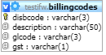**TABLE:** billingcodes

**SIZE:** 4.2 KiB

**OLDEST RECORD:** N/A

**LAST UPDATED:** May 14, 2014 at 10:04 AM

**UPDATED FROM:** N/A

**PROGRAM:** N/A

**ACCESS FROM WHERE:** N/A

**NUMBER OF ROWS:** 67

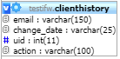**TABLE:** clienthistory

**SIZE:** 1.0 KiB

**OLDEST RECORD:** N/A

**LAST UPDATED:** N/A

**UPDATED FROM:** N/A

**PROGRAM:** N/A

**ACCESS FROM WHERE:** N/A

**NUMBER OF ROWS:** 0

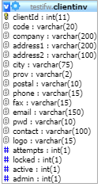**TABLE:** clientinv

**SIZE:** 1.0 KiB

**OLDEST RECORD:** N/A

**LAST UPDATED:** N/A

**UPDATED FROM:** N/A

**PROGRAM:** N/A

**ACCESS FROM WHERE:** N/A

**NUMBER OF ROWS:** 0

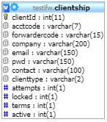 **TABLE:** clientship

**SIZE:** 2.2 KiB

**OLDEST RECORD:** N/A

**LAST UPDATED:** Sep 17, 2014 at 09:03 AM

**UPDATED FROM:** N/A

**PROGRAM:** N/A

**ACCESS FROM WHERE:** N/A

**NUMBER OF ROWS:** 2

**TABLE:** cmactivate

**SIZE:** 1.1 KiB

**OLDEST RECORD:** N/A

**LAST UPDATED:** May 14, 2014 at 10:04 AM

**UPDATED FROM:** N/A

**PROGRAM:** N/A

**ACCESS FROM WHERE:** N/A

**NUMBER OF ROWS:** 1

**TABLE:** cmchange

**SIZE:** 2.1 KiB

**OLDEST RECORD:** N/A

**LAST UPDATED:** Sep 16, 2014 at 10:04 AM

**UPDATED FROM:** N/A

**PROGRAM:** N/A

**ACCESS FROM WHERE:** N/A

**NUMBER OF ROWS:** 6

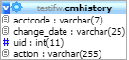**TABLE:** cmhistory

**SIZE:** 1.4 KiB

**OLDEST RECORD:** N/A

**LAST UPDATED:** Sep 16, 2014 at 10:04 AM

**UPDATED FROM:** N/A

**PROGRAM:** N/A

**ACCESS FROM WHERE:** N/A

**NUMBER OF ROWS:** 6

**TABLE:** container

**SIZE:** 32.0 KiB

**OLDEST RECORD:** N/A

**LAST UPDATED:** N/A

**UPDATED FROM:** N/A

**PROGRAM:** N/A

**ACCESS FROM WHERE:** N/A

**NUMBER OF ROWS:** 5

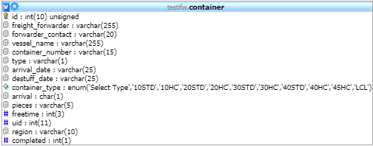

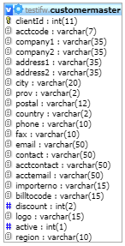**TABLE:** customermaster

**SIZE:** 34.4 KiB

**OLDEST RECORD:** N/A

**LAST UPDATED:** Sep 17, 2014 at 02:07 PM

**UPDATED FROM:** N/A

**PROGRAM:** N/A

**ACCESS FROM WHERE:** N/A

**NUMBER OF ROWS:** 132

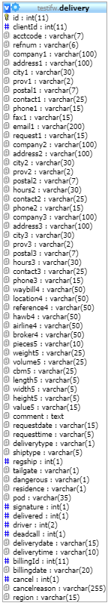**TABLE:** delivery

**SIZE:** 10.5 KiB

**OLDEST RECORD:** N/A

**LAST UPDATED:** Jul 30, 2020 at 11:42 AM

**UPDATED FROM:** N/A

**PROGRAM:** N/A

**ACCESS FROM WHERE:** N/A

**NUMBER OF ROWS:** 15

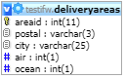**TABLE:** deliveryareas

**SIZE:** 28.2 KiB

**OLDEST RECORD:** N/A

**LAST UPDATED:** May 14, 2014 at 10:04 AM

**UPDATED FROM:** N/A

**PROGRAM:** N/A

**ACCESS FROM WHERE:** N/A

**NUMBER OF ROWS:** 520

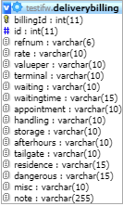**TABLE:** deliverybilling

**SIZE:** S1K B

**OLDEST RECORD:** N/A

**LAST UPDATED:** Jul 30, 2020 at 11:42 AM

**UPDATED FROM:** N/A

**PROGRAM:** N/A

**ACCESS FROM WHERE:** N/A

**NUMBER OF ROWS:** 23

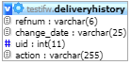**TABLE:** deliveryhistory

**SIZE:** 3.3 KiB

**OLDEST RECORD:** N/A

**LAST UPDATED:** Jul 30, 2020 at 11:17 AM

**UPDATED FROM:** N/A

**PROGRAM:** N/A

**ACCESS FROM WHERE:** N/A

**NUMBER OF ROWS:** 24

**TABLE:** deliveryno

**SIZE:** 2.0 KiB

**OLDEST RECORD:** N/A

**LAST UPDATED:** Jul 30, 2020 at 11:41 AM

**UPDATED FROM:** N/A

**PROGRAM:** N/A

**ACCESS FROM WHERE:** N/A

**NUMBER OF ROWS:** 1

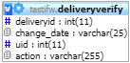**TABLE:** deliveryverify

**SIZE:** 5.7 KiB

**OLDEST RECORD:** N/A

**LAST UPDATED:** Jul 30, 2020 at 11:42 AM

**UPDATED FROM:** N/A

**PROGRAM:** N/A

**ACCESS FROM WHERE:** N/A

**NUMBER OF ROWS:** 73

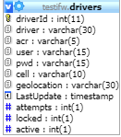**TABLE:** drivers

**SIZE:** 4.0 KiB

**OLDEST RECORD:** N/A

**LAST UPDATED:** Jun 05, 2014 at 10:38 AM

**UPDATED FROM:** N/A

**PROGRAM:** N/A

**ACCESS FROM WHERE:** N/A

**NUMBER OF ROWS:** 16

**TABLE:** expcoload

**SIZE:** 2.0 KiB

**OLDEST RECORD:** N/A

**LAST UPDATED:** May 14, 2014 at 10:04 AM

**UPDATED FROM:** N/A

**PROGRAM:** N/A

**ACCESS FROM WHERE:** N/A

**NUMBER OF ROWS:** 1

**TABLE:** expconsol

**SIZE:** 2.0 KiB

**OLDEST RECORD:** N/A

**LAST UPDATED:** Sep 02, 2014 at 02:59 PM

**UPDATED FROM:** N/A

**PROGRAM:** N/A

**ACCESS FROM WHERE:** N/A

**NUMBER OF ROWS:** 2

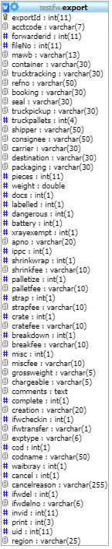**TABLE:** export

**SIZE:** 5.7 KiB

**OLDEST RECORD:** N/A

**LAST UPDATED:** Jul 17, 2020 at 01:53 PM

**UPDATED FROM:** N/A

**PROGRAM:** N/A

**ACCESS FROM WHERE:** N/A

**NUMBER OF ROWS:** 16

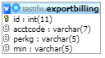**TABLE:** exportbilling

**SIZE:** 3.0 KiB

**OLDEST RECORD:** N/A

**LAST UPDATED:** May 14, 2014 at 10:04 AM

**UPDATED FROM:** N/A

**PROGRAM:** N/A

**ACCESS FROM WHERE:** N/A

**NUMBER OF ROWS:** 1

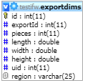**TABLE:** exportdims

**SIZE:** 2.8 KiB

**OLDEST RECORD:** N/A

**LAST UPDATED:** Sep 16, 2014 at 11:25 AM

**UPDATED FROM:** N/A

**PROGRAM:** N/A

**ACCESS FROM WHERE:** N/A

**NUMBER OF ROWS:** 16

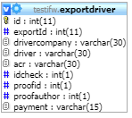**TABLE:** exportdriver

**SIZE:** 3.7 KiB

**OLDEST RECORD:** N/A

**LAST UPDATED:** Sep 16, 2014 at 11:25 AM

**UPDATED FROM:** N/A

**PROGRAM:** N/A

**ACCESS FROM WHERE:** N/A

**NUMBER OF ROWS:** 16

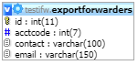**TABLE:** exportforwarders

**SIZE:** 6.2 KiB

**OLDEST RECORD:** N/A

**LAST UPDATED:** Sep 16, 2014 at 11:15 AM

**UPDATED FROM:** N/A

**PROGRAM:** N/A

**ACCESS FROM WHERE:** N/A

**NUMBER OF ROWS:** 65

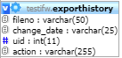**TABLE:** exporthistory

**SIZE:** 4.7 KiB

**OLDEST RECORD:** N/A

**LAST UPDATED:** Sep 16, 2014 at 11:25 AM

**UPDATED FROM:** N/A

**PROGRAM:** N/A

**ACCESS FROM WHERE:** N/A

**NUMBER OF ROWS:** 51

**TABLE:** exportno

**SIZE:** 1.0 KiB

**OLDEST RECORD:** N/A

**LAST UPDATED:** Sep 16, 2014 at 11:25 AM

**UPDATED FROM:** N/A

**PROGRAM:** N/A

**ACCESS FROM WHERE:** N/A

**NUMBER OF ROWS:** 1

**TABLE:** exportpics

**SIZE:** 3.0 KiB

**OLDEST RECORD:** N/A

**LAST UPDATED:** May 14, 2014 at 10:04 AM

**UPDATED FROM:** N/A

**PROGRAM:** N/A

**ACCESS FROM WHERE:** N/A

**NUMBER OF ROWS:** 1

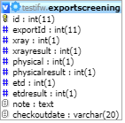**TABLE:** exportscreening

**SIZE:** 3.1 KiB

**OLDEST RECORD:** N/A

**LAST UPDATED:** May 14, 2014 at 10:04 AM

**UPDATED FROM:** N/A

**PROGRAM:** N/A

**ACCESS FROM WHERE:** N/A

**NUMBER OF ROWS:** 2

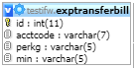**TABLE:** exptransferbill

**SIZE:** 3.0 KiB

**OLDEST RECORD:** N/A

**LAST UPDATED:** May 14, 2014 at 10:04 AM

**UPDATED FROM:** N/A

**PROGRAM:** N/A

**ACCESS FROM WHERE:** N/A

**NUMBER OF ROWS:** 1

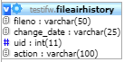**TABLE:** fileairhistory

**SIZE:** 4.8 KiB

**OLDEST RECORD:** N/A

**LAST UPDATED:** Jul 30, 2020 at 09:50 AM

**UPDATED FROM:** N/A

**PROGRAM:** N/A

**ACCESS FROM WHERE:** N/A

**NUMBER OF ROWS:** 48

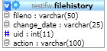**TABLE:** filehistory

**SIZE:** 8.8 KiB

**OLDEST RECORD:** N/A

**LAST UPDATED:** Jul 21, 2020 at 01:51 PM

**UPDATED FROM:** N/A

**PROGRAM:** N/A

**ACCESS FROM WHERE:** N/A

**NUMBER OF ROWS:** 128

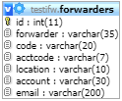**TABLE:** forwarders

**SIZE:** 2.2 KiB

**OLDEST RECORD:** N/A

**LAST UPDATED:** Sep 17, 2014 at 02:11 PM

**UPDATED FROM:** N/A

**PROGRAM:** N/A

**ACCESS FROM WHERE:** N/A

**NUMBER OF ROWS:** 3

**TABLE:** invbatch

**SIZE:** 1.0 KiB

**OLDEST RECORD:** N/A

**LAST UPDATED:** May 14, 2014 at 10:04 AM

**UPDATED FROM:** N/A

**PROGRAM:** N/A

**ACCESS FROM WHERE:** N/A

**NUMBER OF ROWS:** 1

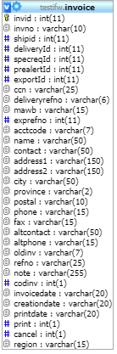**TABLE:** invhistory

**SIZE:** 2.9 KiB

**OLDEST RECORD:** N/A

**LAST UPDATED:** May 14, 2014 at 10:04 AM

**UPDATED FROM:** N/A

**PROGRAM:** N/A

**ACCESS FROM WHERE:** N/A

**NUMBER OF ROWS:** 31

**TABLE:** invoice

**SIZE:** 14.4 KiB

**OLDEST RECORD:** N/A

**LAST UPDATED:** Jul 30, 2020 at 11:42 AM

**UPDATED FROM:** N/A

**PROGRAM:** N/A

**ACCESS FROM WHERE:** N/A

**NUMBER OF ROWS:** 37

**TABLE:** invoicenumber

**SIZE:** 10.0 KiB

**OLDEST RECORD:** N/A

**LAST UPDATED:** Jul 30, 2020 at 11:42 AM

**UPDATED FROM:** N/A

**PROGRAM:** N/A

**ACCESS FROM WHERE:** N/A

**NUMBER OF ROWS:** 1

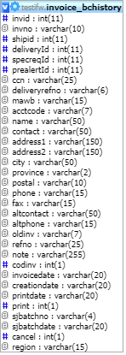**TABLE:** invoice_bchistory

**SIZE:** 1.0 KiB

**OLDEST RECORD:** N/A

**LAST UPDATED:** May 14, 2014 at 10:04 AM

**UPDATED FROM:** N/A

**PROGRAM:** N/A

**ACCESS FROM WHERE:** N/A

**NUMBER OF ROWS:** 0

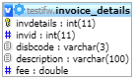**TABLE:** invoice_details

**SIZE:** 16.6 KiB

**OLDEST RECORD:** N/A

**LAST UPDATED:** N/A

**UPDATED FROM:** N/A

**PROGRAM:** N/A

**ACCESS FROM WHERE:** N/A

**NUMBER OF ROWS:** 166

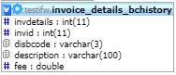**TABLE:** invoice_details_bchistory

**SIZE:** 1.0 KiB

**OLDEST RECORD:** N/A

**LAST UPDATED:** N/A

**UPDATED FROM:** N/A

**PROGRAM:** N/A

**ACCESS FROM WHERE:** N/A

**NUMBER OF ROWS:** 0

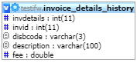**TABLE:** invoice_details_history

**SIZE:** 1.0 KiB

**OLDEST RECORD:** N/A

**LAST UPDATED:** N/A

**UPDATED FROM:** N/A

**PROGRAM:** N/A

**ACCESS FROM WHERE:** N/A

**NUMBER OF ROWS:** 0

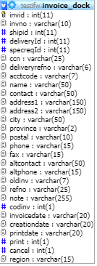**TABLE:** invoice_dock

**SIZE:** 8.0 KiB

**OLDEST RECORD:** N/A

**LAST UPDATED:** Nov 21, 2014 at 01:37 PM

**UPDATED FROM:** N/A

**PROGRAM:** N/A

**ACCESS FROM WHERE:** N/A

**NUMBER OF ROWS:** 7

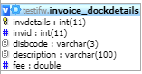**TABLE:** invoice_dockdetails

**SIZE:** 3.3 KiB

**OLDEST RECORD:** N/A

**LAST UPDATED:** Nov 21, 2014 at 01:37 PM

**UPDATED FROM:** N/A

**PROGRAM:** N/A

**ACCESS FROM WHERE:** N/A

**NUMBER OF ROWS:** 7

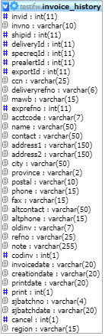**TABLE:** invoice_history

**SIZE:** 1.0 KiB

**OLDEST RECORD:** N/A

**LAST UPDATED:** May 14, 2014 at 10:04 PM

**UPDATED FROM:** N/A

**PROGRAM:** N/A

**ACCESS FROM WHERE:** N/A

**NUMBER OF ROWS:** 0

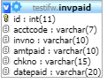**TABLE:** invpaid

**SIZE:** 1.0 KiB

**OLDEST RECORD:** N/A

**LAST UPDATED:** N/A

**UPDATED FROM:** N/A

**PROGRAM:** N/A

**ACCESS FROM WHERE:** N/A

**NUMBER OF ROWS:** 0

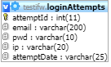**TABLE:** loginAttempts

**SIZE:** 4.1 KiB

**OLDEST RECORD:** N/A

**LAST UPDATED:** Feb 23, 2018 at 02:33 PM

**UPDATED FROM:** N/A

**PROGRAM:** N/A

**ACCESS FROM WHERE:** N/A

**NUMBER OF ROWS:** 26

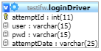**TABLE:** loginDriver

**SIZE:** 1.0 KiB

**OLDEST RECORD:** N/A

**LAST UPDATED:** N/A

**UPDATED FROM:** N/A

**PROGRAM:** N/A

**ACCESS FROM WHERE:** N/A

**NUMBER OF ROWS:** 0

**TABLE:** newacctcode

**SIZE:** 2.0 KiB

**OLDEST RECORD:** N/A

**LAST UPDATED:** Sep 16, 2014 at 10:04 AM

**UPDATED FROM:** N/A

**PROGRAM:** N/A

**ACCESS FROM WHERE:** N/A

**NUMBER OF ROWS:** 1

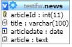**TABLE:** news

**SIZE:** 1.0 KiB

**OLDEST RECORD:** N/A

**LAST UPDATED:** N/A

**UPDATED FROM:** N/A

**PROGRAM:** N/A

**ACCESS FROM WHERE:** N/A

**NUMBER OF ROWS:** 0

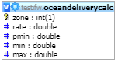**TABLE:** oceandeliverycalc

**SIZE:** 2.1 KiB

**OLDEST RECORD:** N/A

**LAST UPDATED:** Jun 26, 2020 at 01:39 PM

**UPDATED FROM:** N/A

**PROGRAM:** N/A

**ACCESS FROM WHERE:** N/A

**NUMBER OF ROWS:** 3

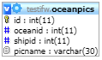**TABLE:** oceanpics

**SIZE:** 4.2 KiB

**OLDEST RECORD:** N/A

**LAST UPDATED:** May 14, 2014 at 10:04 AM

**UPDATED FROM:** N/A

**PROGRAM:** N/A

**ACCESS FROM WHERE:** N/A

**NUMBER OF ROWS:** 6

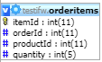**TABLE:** orderitems

**SIZE:** 1.0 KiB

**OLDEST RECORD:** N/A

**LAST UPDATED:** N/A

**UPDATED FROM:** N/A

**PROGRAM:** N/A

**ACCESS FROM WHERE:** N/A

**NUMBER OF ROWS:** 0

**TABLE:** orderno

**SIZE:** 2.0 KiB

**OLDEST RECORD:** N/A

**LAST UPDATED:** May 14, 2014 at 10:04 AM

**UPDATED FROM:** N/A

**PROGRAM:** N/A

**ACCESS FROM WHERE:** N/A

**NUMBER OF ROWS:** 1

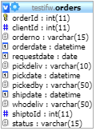**TABLE:** orders

**SIZE:** 1.0 KiB

**OLDEST RECORD:** N/A

**LAST UPDATED:** N/A

**UPDATED FROM:** N/A

**PROGRAM:** N/A

**ACCESS FROM WHERE:** N/A

**NUMBER OF ROWS:** 0

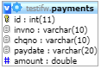**TABLE:** payments

**SIZE:** 32.0 KiB

**OLDEST RECORD:** N/A

**LAST UPDATED:** N/A

**UPDATED FROM:** N/A

**PROGRAM:** N/A

**ACCESS FROM WHERE:** N/A

**NUMBER OF ROWS:** 0

**TABLE:** piggyback

**SIZE:** 2.1 KiB

**OLDEST RECORD:** N/A

**LAST UPDATED:** May 14, 2014 at 10:04 AM

**UPDATED FROM:** N/A

**PROGRAM:** N/A

**ACCESS FROM WHERE:** N/A

**NUMBER OF ROWS:** 11

**TABLE:** prealertbilling 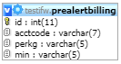

**SIZE:** 3.1 KiB

**OLDEST RECORD:** N/A

**LAST UPDATED:** May 14, 2014 at 10:04 AM

**UPDATED FROM:** N/A

**PROGRAM:** N/A

**ACCESS FROM WHERE:** N/A

**NUMBER OF ROWS:** 2

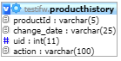**TABLE:** producthistory

**SIZE:** 1.0 KiB

**OLDEST RECORD:** N/A

**LAST UPDATED:** N/A

**UPDATED FROM:** N/A

**PROGRAM:** N/A

**ACCESS FROM WHERE:** N/A

**NUMBER OF ROWS:** 0

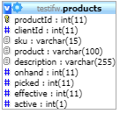**TABLE:** products

**SIZE:** 10KiB

**OLDEST RECORD:** N/A

**LAST UPDATED:** N/A

**UPDATED FROM:** N/A

**PROGRAM:** N/A

**ACCESS FROM WHERE:** N/A

**NUMBER OF ROWS:** 0

**TABLE:** quotenumber

**SIZE:** 1.0 KiB

**OLDEST RECORD:** N/A

**LAST UPDATED:** May 14, 2014 at 10:04 AM

**UPDATED FROM:** N/A

**PROGRAM:** N/A

**ACCESS FROM WHERE:** N/A

**NUMBER OF ROWS:** 1

**TABLE:** shipment

**SIZE:** 48.0 KiB

**OLDEST RECORD:** N/A

**LAST UPDATED:** N/A

**UPDATED FROM:** N/A

**PROGRAM:** N/A

**ACCESS FROM WHERE:** N/A

**NUMBER OF ROWS:** 33

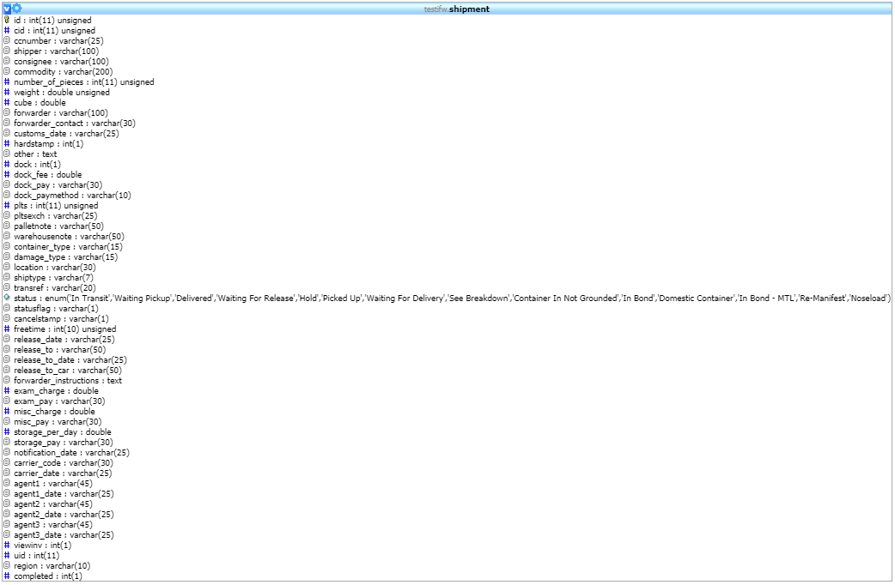

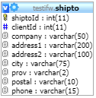**TABLE:** shipto

**SIZE:** 1.0 KiB

**OLDEST RECORD:** N/A

**LAST UPDATED:** N/A

**UPDATED FROM:** N/A

**PROGRAM:** N/A

**ACCESS FROM WHERE:** N/A

**NUMBER OF ROWS:** 0

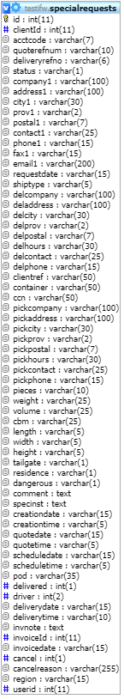 **TABLE:** specialrequests

**SIZE:** 3.5 KiB

**OLDEST RECORD:** N/A

**LAST UPDATED:** Jul 04, 2014 at 02:53 PM

**UPDATED FROM:** N/A

**PROGRAM:** N/A

**ACCESS FROM WHERE:** N/A

**NUMBER OF ROWS:** 1

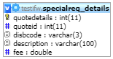**TABLE:** specialreq_details

**SIZE:** 3.1 KiB

**OLDEST RECORD:** N/A

**LAST UPDATED:** May 14, 2014 at 10:04 AM

**UPDATED FROM:** N/A

**PROGRAM:** N/A

**ACCESS FROM WHERE:** N/A

**NUMBER OF ROWS:** 1

**TABLE:** specialreq_verify 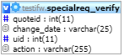

**SIZE:** 1.0 KiB

**OLDEST RECORD:** N/A

**LAST UPDATED:** N/A

**UPDATED FROM:** N/A

**PROGRAM:** N/A

**ACCESS FROM WHERE:** N/A

**NUMBER OF ROWS:** 0

**TABLE:** taxes

**SIZE:** 1.1 KiB

**OLDEST RECORD:** N/A

**LAST UPDATED:** May 14, 2014 at 10:04 AM

**UPDATED FROM:** N/A

**PROGRAM:** N/A

**ACCESS FROM WHERE:** N/A

**NUMBER OF ROWS:** 3

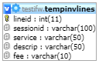**TABLE:** tempinvlines

**SIZE:** 3.1 KiB

**OLDEST RECORD:** N/A

**LAST UPDATED:** N/A

**UPDATED FROM:** N/A

**PROGRAM:** N/A

**ACCESS FROM WHERE:** N/A

**NUMBER OF ROWS:** 0

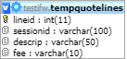**TABLE:** tempquotelines

**SIZE:** 1.0 KiB

**OLDEST RECORD:** N/A

**LAST UPDATED:** N/A

**UPDATED FROM:** N/A

**PROGRAM:** N/A

**ACCESS FROM WHERE:** N/A

**NUMBER OF ROWS:** 0

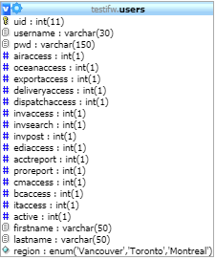**TABLE:** users

**SIZE:** 4.7 KiB

**OLDEST RECORD:** N/A

**LAST UPDATED:** Jun 26, 2020 at 01:28 PM

**UPDATED FROM:** N/A

**PROGRAM:** N/A

**ACCESS FROM WHERE:** N/A

**NUMBER OF ROWS:** 22

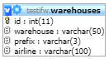**TABLE:** warehouses

**SIZE:** 6.7 KiB

**OLDEST RECORD:** N/A

**LAST UPDATED:** May 14, 2014 at 10:04 AM

**UPDATED FROM:** N/A

**PROGRAM:** N/A

**ACCESS FROM WHERE:** N/A

**NUMBER OF ROWS:** 99