**10.10.100.50**

**SQL Tables**

Database: testwlr

Status: N/A

Used Where: N/A

Last Updated: April 29, 2021

Table of Contents

2012Tariff………………………….…………………………..……… 4

accounts………………...…………………………………………..… 5

B3Footer…………………..………………………………………….. 6

B3HI………………………………….………………………………….. 7

B3Line…………………………………….……………………………. 8

B3Sub…………………………………………………..………………. 9

B3Temp………………………………………………………………… 10

ccn……………………………………………………………………….. 11

containers…………………………………………………………….. 12

dhlglobal………………………………………………………………. 13

download…………………………………………………………….. 14

downloadrecap……………………………………………………. 15

DutyTemp………………………………………………………...... 16

headerdesc…………………………………………………………. 17

imexlvs………………………………………………………………… 18

InvAddress……………………………………………………….… 19

invdetail……………………………………………………….……. 20

Invheader……………………………………………….……….… 21

invinfo…………………………………………………………….…. 22

invmattel………………………………………………………...… 23

invoice……………………………………………………….………. 24

loginAttempts……………………………………………….…… 25

office……………………………………………………………….… 26

ports………………………………………………………………..... 27

RECAPFooter……………………………….…………………..… 28

RECAPHI…………………………………………………………….. 29

RECAPLine………………………………………………………….. 30

RECAPSub…………………………………………………………… 31

RECAPTemp………………………………………………………… 32

rglfreight……………………………………………………………… 33

rglfreightclients…………………………………………………… 34

shipments……………………………………………………………. 35

test09………………………………………………………………….. 36

test1..………………………………………………………………….. 37

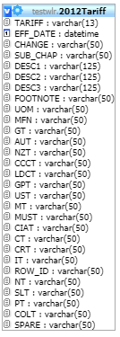**TABLE:** 2012Tarif

**SIZE:** 1.0 KiB

**OLDEST RECORD:** N/A

**LAST UPDATED:** N/A

**UPDATED FROM:** N/A

**PROGRAM:** N/A

**ACCESS FROM WHERE:** N/A

**NUMBER OF ROWS:** 0

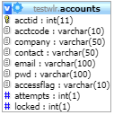**TABLE:** accounts

**SIZE:** 1.0 KiB

**OLDEST RECORD:** N/A

**LAST UPDATED:** N/A

**UPDATED FROM:** N/A

**PROGRAM:** N/A

**ACCESS FROM WHERE:** N/A

**NUMBER OF ROWS:** 0

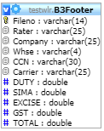**TABLE:** B3Footer

**SIZE:** 1.0 KiB

**OLDEST RECORD:** N/A

**LAST UPDATED:** N/A

**UPDATED FROM:** N/A

**PROGRAM:** N/A

**ACCESS FROM WHERE:** N/A

**NUMBER OF ROWS:** 0

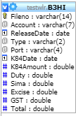**TABLE:** B3HI

**SIZE:** 1.0 KiB

**OLDEST RECORD:** N/A

**LAST UPDATED:** N/A

**UPDATED FROM:** N/A

**PROGRAM:** N/A

**ACCESS FROM WHERE:** N/A

**NUMBER OF ROWS:** 0

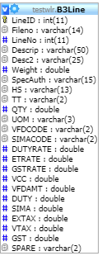**TABLE:** B3Line

**SIZE:** 1.0 KiB

**OLDEST RECORD:** N/A

**LAST UPDATED:** N/A

**UPDATED FROM:** N/A

**PROGRAM:** N/A

**ACCESS FROM WHERE:** N/A

**NUMBER OF ROWS:** 0

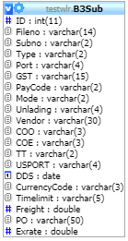**TABLE:** B3Sub

**SIZE:** 1.0 KiB

**OLDEST RECORD:** N/A

**LAST UPDATED:** N/A

**UPDATED FROM:** N/A

**PROGRAM:** N/A

**ACCESS FROM WHERE:** N/A

**NUMBER OF ROWS:** 0

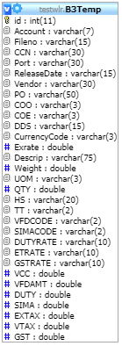**TABLE:** B3Temp

**SIZE:** 1.0 KiB

**OLDEST RECORD:** N/A

**LAST UPDATED:** N/A

**UPDATED FROM:** N/A

**PROGRAM:** N/A

**ACCESS FROM WHERE:** N/A

**NUMBER OF ROWS:** 0

**TABLE:** ccn

**SIZE:** 1.0 KiB

**OLDEST RECORD:** N/A

**LAST UPDATED:** N/A

**UPDATED FROM:** N/A

**PROGRAM:** N/A

**ACCESS FROM WHERE:** N/A

**NUMBER OF ROWS:** 0

**TABLE:** containers

**SIZE:** 1.0 KiB

**OLDEST RECORD:** N/A

**LAST UPDATED:** N/A

**UPDATED FROM:** N/A

**PROGRAM:** N/A

**ACCESS FROM WHERE:** N/A

**NUMBER OF ROWS:** 0

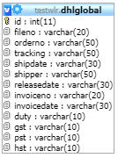**TABLE:** dhiglobal

**SIZE:** 1.0 KiB

**OLDEST RECORD:** N/A

**LAST UPDATED:** N/A

**UPDATED FROM:** N/A

**PROGRAM:** N/A

**ACCESS FROM WHERE:** N/A

**NUMBER OF ROWS:** 0

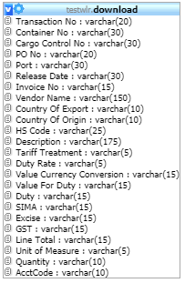**TABLE:** download

**SIZE:** 1.0 KiB

**OLDEST RECORD:** N/A

**LAST UPDATED:** N/A

**UPDATED FROM:** N/A

**PROGRAM:** N/A

**ACCESS FROM WHERE:** N/A

**NUMBER OF ROWS:** 0

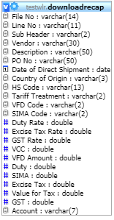**TABLE:** downloadrecap

**SIZE:** 1.0 KiB

**OLDEST RECORD:** N/A

**LAST UPDATED:** N/A

**UPDATED FROM:** N/A

**PROGRAM:** N/A

**ACCESS FROM WHERE:** N/A

**NUMBER OF ROWS:** 0

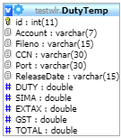**TABLE:** DutyTemp

**SIZE:** 1.0 KiB

**OLDEST RECORD:** N/A

**LAST UPDATED:** N/A

**UPDATED FROM:** N/A

**PROGRAM:** N/A

**ACCESS FROM WHERE:** N/A

**NUMBER OF ROWS:** 0

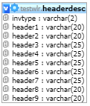**TABLE:** headerdesc

**SIZE:** 1.0 KiB

**OLDEST RECORD:** N/A

**LAST UPDATED:** N/A

**UPDATED FROM:** N/A

**PROGRAM:** N/A

**ACCESS FROM WHERE:** N/A

**NUMBER OF ROWS:** 0

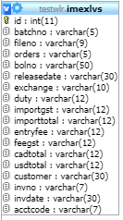**TABLE:** imexlvs

**SIZE:** 1.0 KiB

**OLDEST RECORD:** N/A

**LAST UPDATED:** N/A

**UPDATED FROM:** N/A

**PROGRAM:** N/A

**ACCESS FROM WHERE:** N/A

**NUMBER OF ROWS:** 0

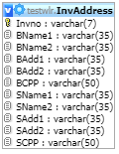**TABLE:** InvAddress

**SIZE:** 1.0 KiB

**OLDEST RECORD:** N/A

**LAST UPDATED:** N/A

**UPDATED FROM:** N/A

**PROGRAM:** N/A

**ACCESS FROM WHERE:** N/A

**NUMBER OF ROWS:** 0

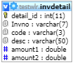**TABLE:** invdetail

**SIZE:** 1.0 KiB

**OLDEST RECORD:** N/A

**LAST UPDATED:** N/A

**UPDATED FROM:** N/A

**PROGRAM:** N/A

**ACCESS FROM WHERE:** N/A

**NUMBER OF ROWS:** 0

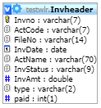**TABLE:** Invheader

**SIZE:** 1.0 KiB

**OLDEST RECORD:** N/A

**LAST UPDATED:** N/A

**UPDATED FROM:** N/A

**PROGRAM:** N/A

**ACCESS FROM WHERE:** N/A

**NUMBER OF ROWS:** 0

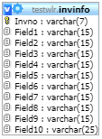**TABLE:** invinfo

**SIZE:** 1.0 KiB

**OLDEST RECORD:** N/A

**LAST UPDATED:** N/A

**UPDATED FROM:** N/A

**PROGRAM:** N/A

**ACCESS FROM WHERE:** N/A

**NUMBER OF ROWS:** 0

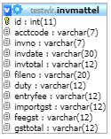**TABLE:** invmattel

**SIZE:** 1.0 KiB

**OLDEST RECORD:** N/A

**LAST UPDATED:** N/A

**UPDATED FROM:** N/A

**PROGRAM:** N/A

**ACCESS FROM WHERE:** N/A

**NUMBER OF ROWS:** 0

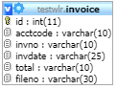**TABLE:** invoice

**SIZE:** 1.0 KiB

**OLDEST RECORD:** N/A

**LAST UPDATED:** N/A

**UPDATED FROM:** N/A

**PROGRAM:** N/A

**ACCESS FROM WHERE:** N/A

**NUMBER OF ROWS:** 0

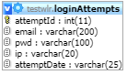**TABLE:** loginAttempts

**SIZE:** 1.0 KiB

**OLDEST RECORD:** N/A

**LAST UPDATED:** N/A

**UPDATED FROM:** N/A

**PROGRAM:** N/A

**ACCESS FROM WHERE:** N/A

**NUMBER OF ROWS:** 0

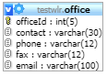**TABLE:** office

**SIZE:** 1.0 KiB

**OLDEST RECORD:** N/A

**LAST UPDATED:** N/A

**UPDATED FROM:** N/A

**PROGRAM:** N/A

**ACCESS FROM WHERE:** N/A

**NUMBER OF ROWS:** 0

**TABLE:** ports

**SIZE:** 1.0 KiB

**OLDEST RECORD:** N/A

**LAST UPDATED:** N/A

**UPDATED FROM:** N/A

**PROGRAM:** N/A

**ACCESS FROM WHERE:** N/A

**NUMBER OF ROWS:** 0

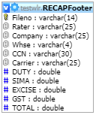**TABLE:** RECAPFooter

**SIZE:** 1.0 KiB

**OLDEST RECORD:** N/A

**LAST UPDATED:** N/A

**UPDATED FROM:** N/A

**PROGRAM:** N/A

**ACCESS FROM WHERE:** N/A

**NUMBER OF ROWS:** 0

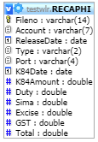**TABLE:** RECAPHI

**SIZE:** 1.0 KiB

**OLDEST RECORD:** N/A

**LAST UPDATED:** N/A

**UPDATED FROM:** N/A

**PROGRAM:** N/A

**ACCESS FROM WHERE:** N/A

**NUMBER OF ROWS:** 0

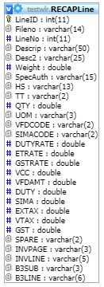**TABLE:** RECAPLine

**SIZE:** 1.0 KiB

**OLDEST RECORD:** N/A

**LAST UPDATED:** N/A

**UPDATED FROM:** N/A

**PROGRAM:** N/A

**ACCESS FROM WHERE:** N/A

**NUMBER OF ROWS:** 0

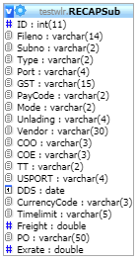**TABLE:** RECAPSub

**SIZE:** 1.0 KiB

**OLDEST RECORD:** N/A

**LAST UPDATED:** N/A

**UPDATED FROM:** N/A

**PROGRAM:** N/A

**ACCESS FROM WHERE:** N/A

**NUMBER OF ROWS:** 0

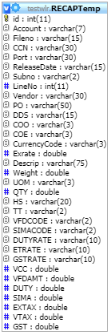**TABLE:** RECAPTemp

**SIZE:** 1.0 KiB

**OLDEST RECORD:** N/A

**LAST UPDATED:** N/A

**UPDATED FROM:** N/A

**PROGRAM:** N/A

**ACCESS FROM WHERE:** N/A

**NUMBER OF ROWS:** 0

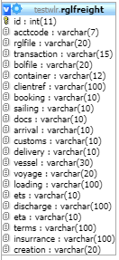**TABLE:** rglfreight

**SIZE:** 1.0 KiB

**OLDEST RECORD:** N/A

**LAST UPDATED:** N/A

**UPDATED FROM:** N/A

**PROGRAM:** N/A

**ACCESS FROM WHERE:** N/A

**NUMBER OF ROWS:** 0

**TABLE:** rglfreightclients

**SIZE:** 1.0 KiB

**OLDEST RECORD:** N/A

**LAST UPDATED:** N/A

**UPDATED FROM:** N/A

**PROGRAM:** N/A

**ACCESS FROM WHERE:** N/A

**NUMBER OF ROWS:** 0

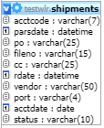**TABLE:** shipments

**SIZE:** 1.0 KiB

**OLDEST RECORD:** N/A

**LAST UPDATED:** N/A

**UPDATED FROM:** N/A

**PROGRAM:** N/A

**ACCESS FROM WHERE:** N/A

**NUMBER OF ROWS:** 0

**TABLE:** test09

**SIZE:** 1.0 KiB

**OLDEST RECORD:** N/A

**LAST UPDATED:** N/A

**UPDATED FROM:** N/A

**PROGRAM:** N/A

**ACCESS FROM WHERE:** N/A

**NUMBER OF ROWS:** 0

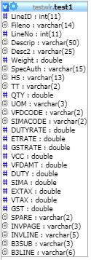**TABLE:** test1

**SIZE:** 1.0 KiB

**OLDEST RECORD:** N/A

**LAST UPDATED:** N/A

**UPDATED FROM:** N/A

**PROGRAM:** N/A

**ACCESS FROM WHERE:** N/A

**NUMBER OF ROWS:** 0