Course | Applied Cryptography and Blockchain
Instructor | Prof. Oumaima FADI
Programme / Level | Cybersecurity — 4th Year
Lab | Lab 1 — Introduction to Symmetric Cryptography
Submission | Moodle — one week after the session | Groups of up to 2 students
LAB 1
Introduction to Cryptography

1. Objectives
This lab introduces the foundations of information security and symmetric-key cryptography through real-life scenarios. You will first map everyday situations onto security goals, attacks, services and mechanisms, then apply and break the classical monoalphabetic ciphers (additive, multiplicative, affine), and finally implement the polyalphabetic Vigenère cipher in Python.
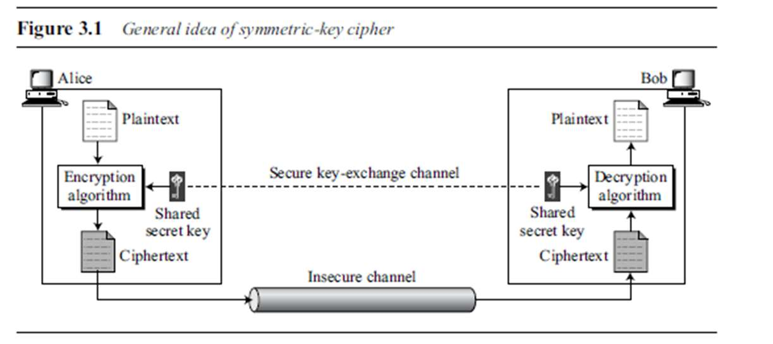
Figure 1 — General idea of a symmetric-key cipher (Forouzan, Fig. 3.1)
Encryption: C = Eₖ(P) Decryption: P = Dₖ(C) with Dₖ(Eₖ(x)) = x
Alice sends C = Eₖ(P) over the insecure channel; Bob recovers P₁ = Dₖ(C) = Dₖ(Eₖ(P)) = P. The same secret key k is used on both sides, which is why it must be distributed over a secure key-exchange channel.

Part A — Review Questions
Answer in your own words, in three to six sentences per question, and give at least one concrete example each time.
Q1. Define the three security goals. For each goal, give one example of a system or situation in which that goal is the primary concern, and one example of what its violation looks like in practice.
Security goal | Definition (your words) | Example of a violation
Confidentiality
Integrity
Availability
Q2. Distinguish between passive and active security attacks. Name and briefly describe at least two passive attacks and three active attacks. For each category, state which security goal is threatened and explain why passive attacks are harder to detect but easier to prevent, while active attacks are the opposite.
Q3. Distinguish between cryptography and steganography. Explain what each technique hides (the meaning of the message versus its existence), give one historical and one modern example of each, and explain how they can be combined.

Part B — Security Services and Mechanisms
Q4. Which security service(s) are guaranteed by each of the following methods of sending mail at the post office? Complete the table and justify each row.
Posting method | Security service(s) | Justification
a. Regular mail
b. Regular mail with delivery confirmation
c. Regular mail with delivery and recipient signature
d. Certified mail
e. Insured mail
f. Registered mail
Q5. Identify the type of security attack in each of the following cases, and state for each whether it is passive or active and which security goal it violates.
a. A student breaks into a professor's office to obtain a copy of the next day's test.
b. A student gives a cheque for $10 to buy a used book. Later she finds that the cheque was cashed for $100.
c. A student sends hundreds of e-mails per day to another student using a phony return e-mail address.
Q6. Which security mechanism(s) are provided in each of the following cases?
a. A school demands student identification and a password to let students log into the school server.
b. A school server disconnects a student if she has been logged into the system for more than two hours.
c. A professor refuses to send students their grades by e-mail unless they provide a student identifier preassigned by the professor.
d. A bank requires the customer's signature for a withdrawal.
Q7. Which technique — cryptography or steganography — is used for confidentiality in each of the following cases? Justify in one sentence.
a. A student writes the answers to a test on a small piece of paper, rolls up the paper, inserts it into a ball-point pen, and passes the pen to another student.
b. To send a message, a spy replaces each character in the message with a symbol agreed upon in advance as the character's replacement.
c. A company uses special ink on its cheques to prevent forgeries.
d. A graduate student uses watermarks to protect her thesis, which is posted on her website.
Q8. What type of security mechanism(s) are provided when a person signs a form he has filled out to apply for a credit card? Which security service(s) do these mechanisms deliver?

Part C — Additive, Multiplicative and Affine Ciphers

C.1 Background
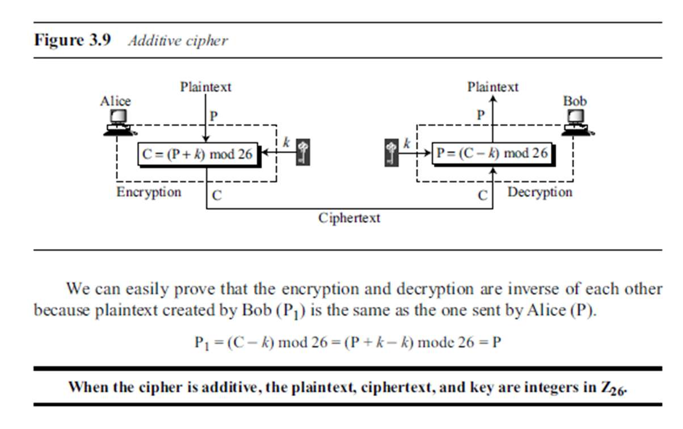
Additive: C = (P + k) mod 26 P = (C − k) mod 26
Correctness follows immediately: P₁ = (C − k) mod 26 = (P + k − k) mod 26 = P. The key space has only 26 keys, so the cipher falls to exhaustive search.
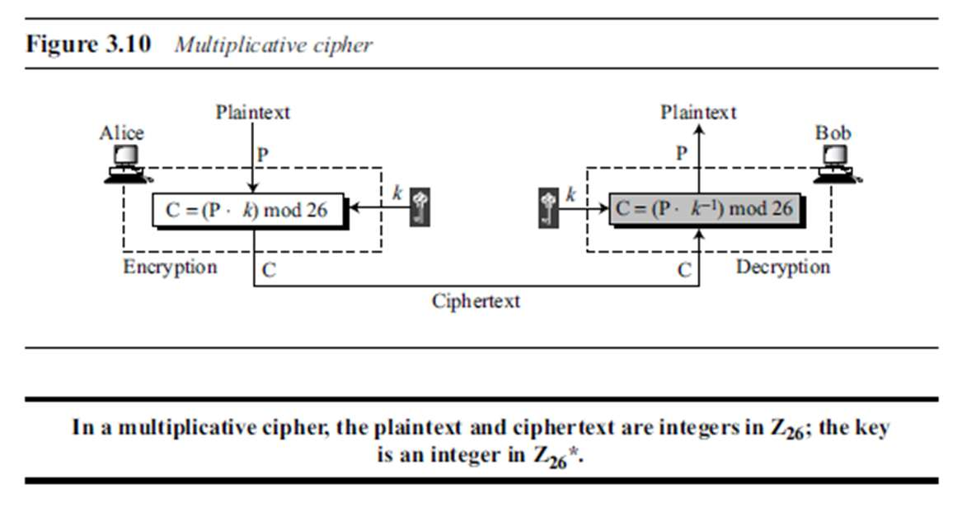
Multiplicative: C = (P × k) mod 26 P = (C × k⁻¹) mod 26
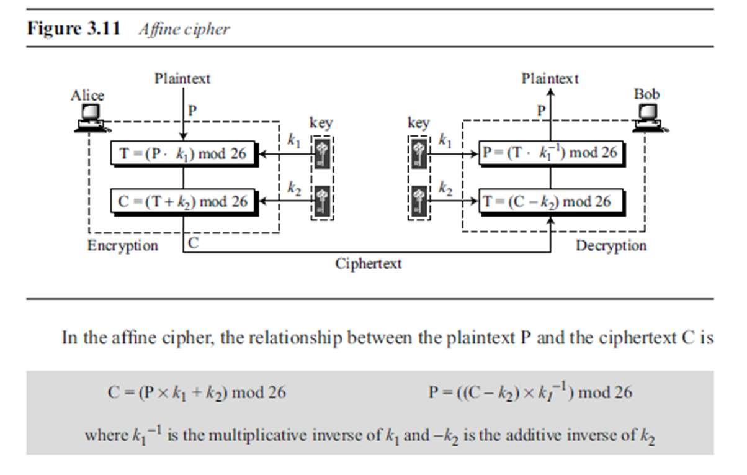
Affine: C = (P × k₁ + k₂) mod 26 P = ((C − k₂) × k₁⁻¹) mod 26
The affine cipher combines the two previous ones: k₁ must be invertible mod 26 and k₂ is any element of Z₂₆, giving 12 × 26 = 312 keys.

C.2 Exercises
C1. Use the additive cipher with key k = 15 to encrypt the message “Good Morning Starshine”. Present your work as a table with the columns: plaintext letter, P, (P + 15) mod 26, ciphertext letter.
C2. Decrypt the message “HVS AOB KVC GCZR HVS KCFZR” using the additive cipher with key k = 14. State the recovered plaintext and show the computation for at least the first word.
C3. Eve has intercepted the ciphertext below, produced with an additive cipher. Recover the key and the plaintext using a ciphertext-only statistical attack.
XLILSYWIMWRSAJSVWEPIJSVJSYVQMPPMSRHSPPEVWMXMWASVXLQSVILYVVCFIJSVIXLIWIPPIVVIGIMZIWQSVISJJIVW
Eve tabulates the letter frequencies of the ciphertext and obtains I = 14, V = 13, S = 12, and so on; the most frequent character is I, with 14 occurrences.
Table 1 — Frequency of occurrence of letters in English text (%)
Letter | Freq. | Letter | Freq. | Letter | Freq. | Letter | Freq.
E | 12.7 | H | 6.1 | W | 2.3 | K | 0.08
T | 9.1 | R | 6.0 | F | 2.2 | J | 0.02
A | 8.2 | D | 4.3 | G | 2.0 | Q | 0.01
O | 7.5 | L | 4.0 | Y | 2.0 | X | 0.01
I | 7.0 | C | 2.8 | P | 1.9 | Z | 0.01
N | 6.7 | U | 2.8 | B | 1.5
S | 6.3 | M | 2.4 | V | 1.0
Complete the following steps in your report:
- Assume the most frequent ciphertext letter corresponds to the most frequent English letter (Table 1) and derive a candidate key k = (C − P) mod 26.
- Decrypt with that candidate. If the result is not intelligible English, try the next most frequent pairing (V → E, then S → E) and repeat.
- Give the final key, the full plaintext (restore word spacing), and state how many candidate keys you had to test.
- Explain in two or three sentences why this attack works on a monoalphabetic cipher regardless of the key size.
C4. Encrypt the message “hello” with a multiplicative cipher of key k = 7 and verify that the ciphertext is “XCZZU”. Show the computation letter by letter. Then explain why k = 8 could not be used as a key, and what would go wrong if it were.
C5. Encrypt the message “hello” with an affine cipher using the key pair (k₁, k₂) = (7, 2). Show all steps and state the resulting ciphertext.
C6. Use the affine cipher with the key pair (7, 2) in modulus 26 to decrypt the message “rwquprwbb ymgqgxe”. Compute k₁⁻¹ explicitly (state the method you used) before decrypting, and give the recovered plaintext.

