Prediction of Refractory Mycoplasma Pneumoniae Pneumonia in Children Using Chest X-Rays Based Radiomics and Machine Learning
Bofan Wang¹, Maoxiang Zhang¹, Rufeng Ji², Deyu Zhao¹, Xia Huang¹
- Children’s Hospital of Nanjing Medical University, Nanjing, Jiangsu 211100, China.
- Department of Respiratory Medicine, Children’s Hospital of Nanjing Medical University, Jiangsu, and Department of Pediatric, Nanjing Lishui People’s Hospital, Zhongda Hospital Lishui Branch, Southeast University, Nanjing, China.
Corresponding Author
Deyu Zhao
E-mail: zhaodeyu988@126.com
Xia Huang
E-mail: huang_xia01@163.com

Declarations
Human Ethics and Consent to Participate declarations
This study has been approved by the Ethics Committee of Children’s Hospital of Nanjing Medical University [202601046-1] and informed consent was obtained from the parents/guardians of all participants.
Consent for publication
Not applicable.
Availability of data and materials
The image dataset analyzed during the current study is not publicly available for the privacy of individuals that participated but are available from the corresponding author on reasonable request.
Other datasets generated or analyzed during this study are included in this published article and its supplementary information files.
Competing interests
All authors declare no conflict of interest in this study.
Funding
This work was supported by National Natural Science Foundation of China [82500006].
Authors' contributions
All authors contributed to the study. And the specific roles of each author were listed following:
BW: conceptualization, data curation, formal analysis, investigation, methodology, project administration, resources, software, supervision, validation, visualization, writing – original draft, and writing– review & editing
MZ: data curation, formal analysis, investigation
RJ: data curation, formal analysis, investigation
DZ: conceptualization, data curation, formal analysis, investigation, methodology, project administration, resources, supervision, validation, writing – review & editing
XH: conceptualization, data curation, formal analysis, funding acquisition, investigation, methodology, project administration, resources, supervision, validation, writing – review & editing
Acknowledgements
Dr. Zhao and Dr. Huang are the guarantors of this manuscript, responsible for the integrity of the data, analysis accuracy, and content oversight. We are grateful to National Natural Science Foundation of China (82500006). The funding sources had no role in the study design, data collection, analysis, manuscript preparation, or decision to submit for publication.

Abstract
Background: Refractory Mycoplasma pneumoniae pneumonia (RMPP) is a severe form of community-acquired pneumonia in children that can cause significant intra- and extrapulmonary complications; thus, early identification is essential for improving prognosis. This study aimed to develop and evaluate prediction models based on radiomics features from pediatric chest X-rays (CXR) for the early diagnosis of RMPP.
Methods: This is a retrospective, single-center study. Chest X-rays of children with Mycoplasma pneumoniae pneumonia (MPP) were retrospectively collected, and radiomics features were extracted. We utilized k-fold cross-validation and grid search to evaluate the accurate predictive performance of nine machine learning (ML) models (Logistic Regression, Decision Tree, Random Forest, MLP, SVM, XGBoost, LightGBM, GaussianNB, and KNN) for RMPP. Feature selection was strictly performed within each cross-validation fold to prevent data leakage. After filtering low-quality radiomics features, nine features and clinical features were retained for model development. Model performance was comprehensively assessed using metrics including the Area Under the Receiver Operating Characteristic Curve (AUC), ROC curves, SHAP analysis, and confusion matrices.
Results: Data for this study were obtained from Children’s Hospital of Nanjing Medical University. A total of 931 children with MPP were included, comprising 557 in the RMPP group and 374 in the non-RMPP group. These cases were randomly divided into a training set and a validation set at an 80:20 ratio. A total of 102 radiomics features were extracted, and after screening, 9 radiomics features and 1 clinical feature (age) were retained for modeling. Among the nine ML models, the SVM model demonstrated superior robustness, achieving an AUC of 0.71, precision of 0.77, and accuracy of 0.66 in the validation set. SHAP analysis delineated the key radiomics features influencing model predictions and their respective contributions.
Conclusion: The SVM model built on CXR radiomics features exhibits moderate discriminative ability and clinical utility for predicting the occurrence of RMPP in children. DCA confirmed its clinical net benefit. External validation in multicenter cohorts is warranted to confirm generalizability.
Keywords: Mycoplasma pneumoniae pneumonia, Children, Radiomics, Machine learning, Prediction model.
List of Abbreviations
RMPP, refractory Mycoplasma pneumoniae pneumonia
CXR, Chest X-ray
CT, computed tomography
DICOM, Digital Imaging and Communications in Medicine
ROI, Regions of interest
GLCM, gray level co-occurrence matrix
GLRLM, gray level run length matrix
GLSZM, gray level size zone matrix
GLDM, gray level dependence matrix
NGTDM, neighboring gray tone difference matrix
CV, cross-validation
FDR, false discovery rate
mRMR, minimum redundancy maximum relevance
LR, Logistic Regression
RF, Random Forest
MLP, Multilayer Perceptron
SVM, Support Vector Machine
XGBoost, Extreme Gradient Boosting
GaussianNB, Gaussian Naive Bayes
KNN, K-Nearest Neighbors
AUC, Area Under Curve
ROC, Receiver operating characteristic curve
SHAP, Shapley Additive Explanations
Q-Q plot, Quantile-Quantile plot
CRP, C-reactive protein
WBC, white blood cell count
NEUT, neutrophil count
LYMPH, lymphocyte count
Hb, hemoglobin
PLT, platelet count
ALT, alanine aminotransferase
AST, aspartate aminotransferase
LDH, lactate dehydrogenase
CK, creatine kinase
CK-MB, creatine kinase-MB isoenzyme
PT, prothrombin time
APTT, activated partial thromboplastin time
PACS, picture archiving and communication system

Introduction
Mycoplasma pneumoniae pneumonia (MPP) is a common type of community-acquired pneumonia in children, particularly prevalent among school-aged children and young adults (1). In recent years, MPP has shown periodic outbreaks and a trend toward younger affected populations(2). Although most children experience mild and self-limiting disease with favorable outcomes following early identification and standardized treatment, a subset of patients progresses to refractory Mycoplasma pneumoniae pneumonia. The proportion of macrolide-resistant Mycoplasma pneumoniae in China is over 90% between 2023 and 2024, which directly led to an increase in hospitalizations and refractory cases.(3) Children with RMPP are typically characterized by persistent fever, worsening clinical symptoms, or progressive radiographic findings after standard macrolide antibiotic therapy, often accompanied by atelectasis, necrosis, or extrapulmonary complications (4).
At present, the diagnosis of RMPP mainly relies on clinical experience, inflammatory biomarkers, and imaging examinations, among which chest X-ray is a routine imaging modality for pediatric pneumonia. However, inflammatory biomarkers often exhibit a certain hysteresis in reflecting disease progression, and have limited predictive performance Furthermore, conventional imaging assessments lack quantitative indicators, with interpretations largely dependent on physicians’ subjective judgment, making it difficult to objectively quantify disease severity and progression.
>>> [创新性论证] 此处应强化三个创新点：(1)首次将CXR影像组学(非CT)用于儿童RMPP预测；(2)SAM2自动分割实现标准化ROI提取；(3)低辐射CXR在儿科反复评估中的独特临床价值。
Chest X-ray is the preferred imaging modality for the diagnosis and follow-up of MPP. It offers advantages such as low cost, convenience, and relatively low radiation exposure(5). Radiomics, as an emerging medical image analysis approach, enables high-throughput extraction of quantitative features from medical images, allowing in-depth quantification of lesion heterogeneity and other information that is difficult to assess visually, thereby providing more objective and reproducible evidence for disease diagnosis and prognosis prediction. Previous studies have successfully applied radiomics combined with CT images to various disease classification tasks, including RMPP prediction, demonstrating excellent performance (AUC > 0.85) (6,7).However, the high radiation exposure associated with CT poses significant barriers to its clinical application in pediatric RMPP prediction scenarios that require repeated assessments. Therefore, applying radiomics to CXR for the construction of early RMPP prediction models holds substantial scientific value and clinical translational potential.
The present study aimed to retrospectively analyze chest X-ray images of children with refractory Mycoplasma pneumoniae pneumonia, construct predictive models using multiple machine learning algorithms, and comprehensively evaluate model performance through k-fold cross-validation, with the goal of providing clinical practice with an objective and accurate early prediction tool that is non-invasive, low-radiation, and easily deployable.
Methods
Data Source
This study was a retrospective investigation that consecutively enrolled chest X-ray images (the first image obtained within 48 hours of hospital admission or in the outpatient visit, prior to macrolide antibiotic administration.) of hospitalized children diagnosed with Mycoplasma pneumoniae pneumonia between January 2023 and December 2023 at Children’s Hospital of Nanjing Medical University. This retrospective study was approved by the Ethics Committee of Children’s Hospital of Nanjing Medical University.
Inclusion criteria: (a) Positive etiological evidence for MPP (IgM or PCR positive); (b) Presence of clinical manifestations consistent with MPP; (c) Presence of imaging findings consistent with MPP.
Exclusion criteria: (a)Mixed pathogen infection; (b)Prolonged treatment prior to enrollment (≥2 weeks) or history of systemic glucocorticoid use; (c) Poor image quality or incomplete clinical data; (d) History of chronic respiratory diseases, congenital heart disease, autoimmune diseases, or central nervous system disorders.
Children were classified into the RMPP group and the non-RMPP group according to whether they developed RMPP.
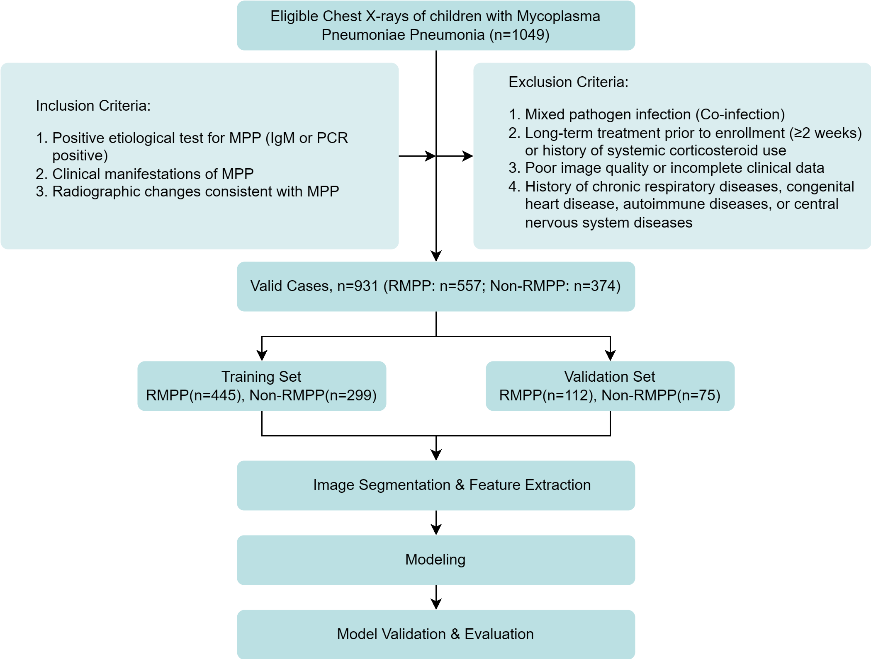
Image Acquisition and Preprocessing
Imaging data were obtained from the hospital imaging database, and all patients underwent posteroanterior chest radiography using a digital X-ray system. Images were exported in DICOM format and underwent standardized preprocessing, including grayscale normalization, spatial resampling (pixel spacing of 0.5 mm × 0.5 mm), maintenance of a 1:1 aspect ratio, and resizing to 1024 × 1024 pixels.
Image Segmentation
Regions of interest (ROIs) were delineated. All chest X-ray images were automatically and semi-automatically delineated and segmented using the isat-sam (v1.2.6) Python package, and the accuracy of the automated segmentation tool was preliminarily assessed by an experienced pediatric radiologist. Fig.1 shows the workflow(8) of the study.
>>> [必须补充 - R1+R3均要求] "preliminarily assessed"不满足审稿要求。需补充：(1)随机抽取50例，两位放射科医生独立标注ROI，计算ICC；(2)计算isat-sam自动分割与人工标注的Dice系数；(3)以表格报告结果。
Radiomics Feature Extraction
Radiomics features were extracted from each segmented image using PyRadiomics (version 3.1.1) (9) , including: (1) First-order statistical features; (2) Shape-based features (e.g., area, surface area, sphericity); (3) Texture features, including gray level co-occurrence matrix (GLCM), gray level run length matrix (GLRLM), gray level size zone matrix (GLSZM), gray level dependence matrix (GLDM), and neighboring gray tone difference matrix (NGTDM).
Model Construction
- Dataset Partitioning
The dataset was randomly divided at the subject level into a training set and a validation set at an 80:20 ratio. All features were standardized using Z-score normalization(10) based on the training set, and the same parameters were applied to the validation set. The training set was further divided into k folds, and subject-level random sampling was applied for cross-validation (CV).
- Feature Selection
Feature selection was performed strictly within each cross-validation fold to prevent information leakage from the validation data into the feature selection process. The following steps were encapsulated in a custom scikit-learn-compatible transformer (CVFeatureSelector) and executed de novo within each training fold: To eliminate redundant features, the following preliminary feature selection steps were performed on the training set: (1) Removal of features with a missing rate over 30%; (2) Removal of features with variance less than 0.05; (3) Standardization and normalization of the dataset; (4) Retention of features with statistical significance less than 0.05 using the Mann–Whitney U test; (5) Control of the false positive rate using false discovery rate (FDR) correction.
>>> [关键修改 - Reviewer 2拒稿主因！] 必须明确说明所有特征筛选步骤(Mann-Whitney U, FDR, mRMR)在每折CV内独立执行。建议补充："All feature selection steps were performed de novo within each cross-validation fold using only the training partition of that fold to prevent information leakage."
To further reduce feature redundancy and enhance model generalizability and clinical applicability, the minimum redundancy maximum relevance (mRMR) method(11) was applied to select the final features for model construction.
>>> [补充] 注明mRMR具体实现方式（skfeature库MID/MIM算法或自定义），以及最终特征数量的确定方法（累积互信息阈值或固定K值）。
- Machine Learning Model Development and Optimization
Nine machine learning algorithms were employed to construct RMPP prediction models, including Logistic Regression (LR), Decision Tree, Random Forest (RF), Multilayer Perceptron (MLP), Support Vector Machine (SVM), Extreme Gradient Boosting (XGBoost), LightGBM, Gaussian Naive Bayes (GaussianNB), and K-Nearest Neighbors (KNN). Model training was performed on the training set using 5-fold cross-validation, combined with grid search for hyperparameter optimization. To ensure the robustness of the findings and adhere to the TRIPOD+AI statement(12), model performance was evaluated through a multi-dimensional framework.
>>> [补充] 说明是否使用class_weight或SMOTE处理类别不平衡。如未使用需解释原因。确认训练/验证集采用stratified splitting。
- Comprehensive Model Evaluation
>>> [补充指标] 建议增补：(1)balanced accuracy和MCC；(2)所有指标95%CI(bootstrap 1000次)；(3)PR曲线AUC。
To identify the most robust and clinically applicable model, we implemented a comprehensive evaluation framework. Model performance was evaluated from the following aspects: (1) Discrimination ability: ROC curves were plotted, AUC, accuracy, precision, recall and F1 score were calculated; (2) Statistical significance: the DeLong test was employed to compare the AUC differences between models; (3)Calibration ability: calibration curves and brier scores were generated to assess the agreement between predicted probabilities and actual risk; (4) Model interpretability: SHAP (Shapley Additive Explanations) analysis (13) was used to quantify feature contributions and visualize the relationships between key features and model predictions. (5) Clinical applicability: Decision Curve Analysis (DCA) was used to calculate the net benefit of the model across a range of threshold probabilities, providing a direct measure of its potential clinical value.
Statistical Analysis
To analyze differences in clinical characteristics, normality was first assessed using Q-Q (Quantile-Quantile) plots and the Shapiro-Wilk test. For normally distributed characteristics, uniformity of variance was further evaluated. T-Tests were used to compare normally distributed characteristics with equal variances. Welch T-Tests were used to assess normally distributed characteristics with unequal variances. Non-normally distributed characteristics were analyzed using the Mann-Whitney U test. Categorical variables were compared between the two groups using the Chi-square tests. Multiple metrics were used to evaluate the performance of the classification model: AUC, accuracy, precision, recall and F1 score. Calibration curves were also used to further evaluate the clinical utility and reliability of the model. Statistical significance was determined using a 2-sided p < 0.05, which was considered indicative of a significant result. IBM SPSS Statistics (27.0.1.0) was used to conduct statistical analysis.
>>> [修改] 补充多重比较校正："For baseline characteristic comparisons, the Benjamini-Hochberg FDR correction was applied to control for multiple testing."
Results
Baseline Characteristics
Baseline characteristics of the study population are presented in Table 1. After screening, a total of 931 patients with MPP were included in this study, comprising 557 patients with RMPP and 374 patients without RMPP. Among these patients, 744 were allocated to the training set and 187 to the validation set. There was no significant difference in the occurrence of RMPP between hospitalized male and female patients. Patients with RMPP were more likely to present with fever, had longer fever duration, longer hospital stays, and a higher incidence of complications such as pleural effusion, pulmonary consolidation and bronchiolitis obliterans (BO) compared with non-RMPP patients. In addition, levels of CRP, WBC, NEUT, PLT, ALT, LDH, PT and D-dimer were all higher in the RMPP group than in the non-RMPP group.
Table 1 Descriptive statistics of patients with RMPP and non-RMPP included in this study.
Characteristics | RMPP (n=619) | Non-RMPP (n=369) | p-value*
Age (years)¹ | 7.26±2.69 | 6.08±3.06 | <0.001
Sex⁴
Male | 290(46.9%) | 187(53.0%)
Female | 328(53.1%) | 182(49.3%) | 0.254
Weight (Kg)³ | 23.00(19.00, 31.00) | 22.00(16.00, 29.00) | <0.001
Cough⁴ | 610(98.7%) | 365(98.9%) | 1.000
Fever⁴ | 609(98.5%) | 331(89.7%) | <0.001
Preadmission fever duration (days) ³ | 8(6, 10) | 6(4, 7) | <0.001
Length of stay (days) ³ | 6(5, 8) | 5(4, 6) | <0.001
Pleural Reaction⁴ | 3(0.5%) | 0 | 0.458
Pleural Effusion⁴ | 43(6.9%) | 3(0.8%) | <0.001
Pulmonary Consolidation⁴ | 79(12.8%) | 9(2.4%) | <0.001
Bronchiolitis Obliterans⁴ | 44(7.1%) | 0 | <0.001
CRP³ | 4.76(1.14, 12.90) | 3.90(0.70, 10.76) | 0.004
WBC² | 11.11±4.85 | 10.33±4.37 | 0.012
NEUT³ | 6.86(4.61, 9.53) | 5.39(3.58, 8.37) | <0.001
LYMPH³ | 2.29(1.55, 3.34) | 2.56(1.82, 3.48) | <0.001
Hb² | 126.16±10.46 | 126.19±10.23 | 0.978
PLT² | 361.73±116.69 | 345.43±125.99 | 0.041
ALT³ | 16.00(12.00, 25.00) | 14.00(11.00, 18.50) | <0.001
AST³ | 25.00(20.00, 32.00) | 26.00(21.00, 31.00) | 0.242
LDH³ | 328.00(278.00, 430.00) | 306.00(268.00, 368.50) | <0.001
CK³ | 55.00(35.00, 90.00) | 68.00(47.00, 100.50) | <0.001
CK-MB³ | 21.00(17.00, 27.00) | 21.00(17.00, 26.00) | 0.537
PT² | 12.15±1.19 | 11.97±1.09 | 0.026
APTT² | 31.15±6.06 | 32.05±5.03 | 0.025
D-Dimer³ | 259.00(169.00, 507.00) | 184.00(137.00, 267.00) | <0.001
Normally distributed continuous variables are expressed as mean ± standard deviation, non-normally distributed continuous variables are expressed as median (interquartile range), and categorical variables are presented as counts and proportions. Differences between groups were analyzed using the chi-square test, with p <0.05 considered statistically significant. 1. Welch T-Test. 2. T-Test. 3. Mann-Whitney U-Test. 4. Chi-Square Test. RMPP, refractory Mycoplasma pneumoniae pneumonia; Non-RMPP, non-refractory Mycoplasma pneumoniae pneumonia; CRP, C-reactive protein; WBC, white blood cell count; NEUT, neutrophil count; LYMPH, lymphocyte count; Hb, hemoglobin; PLT, platelet count; ALT, alanine aminotransferase; AST, aspartate aminotransferase; LDH, lactate dehydrogenase; CK, creatine kinase; CK-MB, creatine kinase-MB isoenzyme; PT, prothrombin time; APTT, activated partial thromboplastin time.* p value < 0.05 indicates statistical significance.
Radiomics Model Construction
A total of 102 radiomics features were initially extracted. An additional file shows this in more detail [see in Additional File 1]. After preliminary feature selection, the number of features was reduced to 34, and ultimately ten distinct features were selected using the mRMR method. These features were: firstorder_InterquartileRange, shape2D_MeshSurface, firstorder_MeanAbsoluteDeviation, gldm_SmallDependenceHighGrayLevelEmphasis, glcm_SumEntropy, firstorder_90Percentile, firstorder_Entropy, glcm_ClusterTendency, glcm_JointEntropy.
Table 2 Performance of each model in the training and validation sets.
 |  | Accuracy | F1 Scores | Precision | Recall | AUC | p-value
Logistic Regression | Train | 0.579 | 0.634 | 0.697 | 0.581 | 0.618
Logistic Regression | Validation | 0.631 | 0.673 | 0.758 | 0.605 | 0.675 | 0.582
Decision Tree | Train | 0.573 | 0.544 | 0.820 | 0.407 | 0.658
Decision Tree | Validation | 0.545 | 0.483 | 0.840 | 0.339 | 0.619 | 0.049
Random Forest | Train | 0.688 | 0.717 | 0.830 | 0.632 | 0.793
Random Forest | Validation | 0.636 | 0.657 | 0.802 | 0.556 | 0.672 | 0.384
MLP | Train | 0.627 | 0.749 | 0.647 | 0.889 | 0.674
MLP | Validation | 0.646 | 0.757 | 0.665 | 0.879 | 0.691 | 0.825
SVM | Train | 0.625 | 0.627 | 0.830 | 0.504 | 0.736
SVM | Validation | 0.606 | 0.606 | 0.811 | 0.484 | 0.697 | Reference
XGBoost | Train | 0.658 | 0.675 | 0.831 | 0.569 | 0.763
XGBoost | Validation | 0.616 | 0.616 | 0.824 | 0.492 | 0.684 | 0.632
LightGBM | Train | 0.759 | 0.788 | 0.878 | 0.715 | 0.852
LightGBM | Validation | 0.636 | 0.670 | 0.777 | 0.589 | 0.666 | 0.255
GaussianNB | Train | 0.564 | 0.589 | 0.719 | 0.498 | 0.605
GaussianNB | Validation | 0.571 | 0.573 | 0.760 | 0.460 | 0.655 | 0.300
KNN | Train | 0.691 | 0.773 | 0.715 | 0.842 | 0.733
KNN | Validation | 0.611 | 0.724 | 0.652 | 0.815 | 0.613 | 0.011
Five-fold cross-validation was performed for model training on the training set, combined with grid search for hyperparameter optimization. The performance metrics of the nine machine learning models in the training and validation sets are shown in Table 2.
Among the nine machine learning models, the XGBoost model achieved a validation AUC of 0.716 but exhibited substantial overfitting (training AUC = 0.832). In contrast, the SVM model demonstrated exceptional stability, with a validation AUC of 0.705 (training AUC = 0.708) and a higher precision of 0.769. The remaining models ranked by AUC were as follows: MLP (AUC = 0.691) > XGBoost (AUC = 0.684) > Logistic Regression (AUC = 0.675) > Random Forest (AUC = 0.672) > LightGBM (AUC = 0.666) > GaussianNB (AUC = 0.655) > Decision Tree (AUC = 0.619) > KNN (AUC = 0.613).
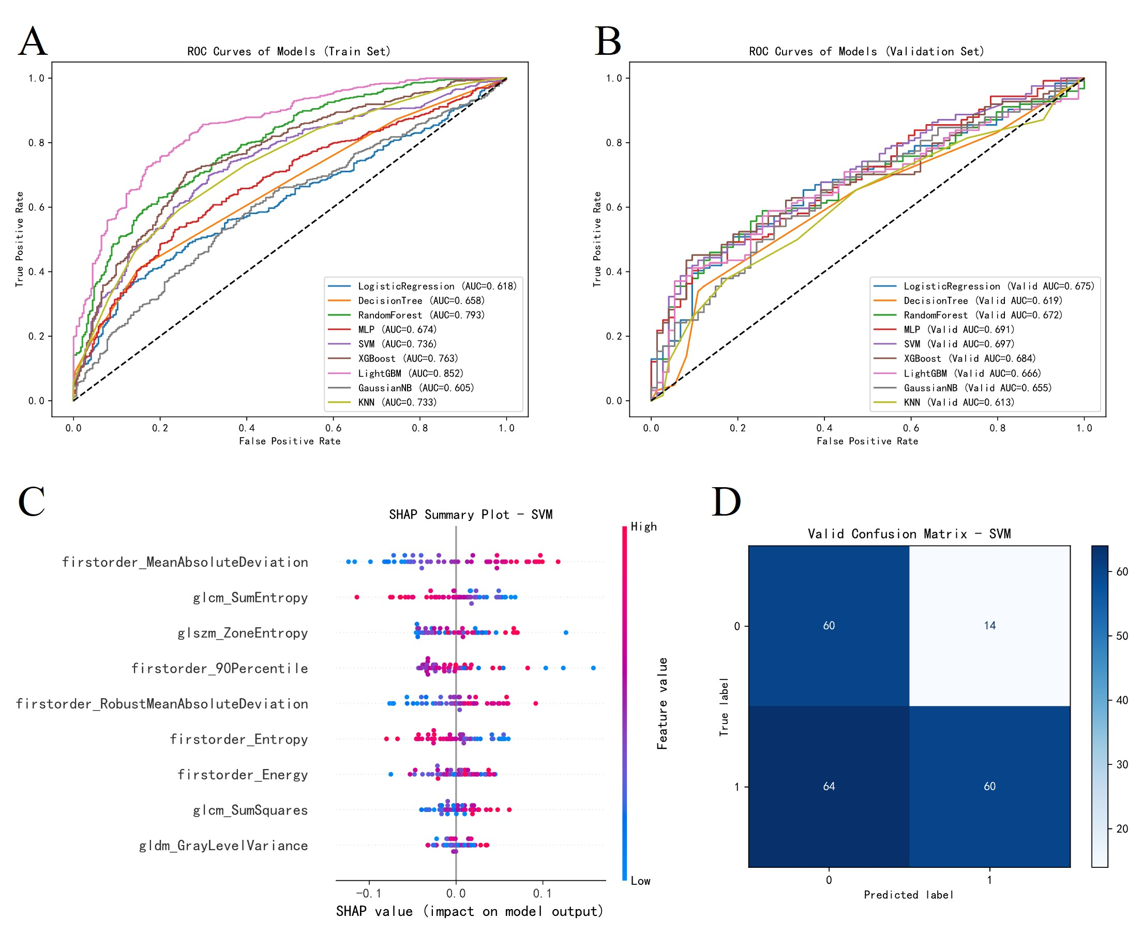
The ROC curves of all models are shown in Fig. 2A and 2B. The DeLong test revealed that while the SVM model achieved the highest AUC, its performance was not significantly different from several other models, such as MLP (p = 0.825) and XGBoost (p = 0.632), but it significantly outperformed the Decision Tree model (p = 0.049). The selection of SVM as the optimal model was supported by its calibration and robustness. The SVM model yielded a low Brier score (0.210, in Fig. 3A), indicating superior agreement between predicted probabilities and actual RMPP incidence compared to KNN (0.231), Random Forest (0.229), and Logistic Regression (0.234). Furthermore, models such as LightGBM, KNN and Random Forest exhibited substantial overfitting, while the SVM model maintained consistent performance across both datasets. Consequently, considering the combination of discriminative ability, statistical significance and calibration accuracy, the SVM model was identified as the most suitable tool for predicting RMPP.
>>> [修改] 建议在Table 2中增加DeLong检验p值矩阵（所有模型两两比较），而非仅选择性报告部分比较。
SHAP analysis revealed the ranking of key features influencing SVM model predictions, including four first-order features, four texture features, and one shape feature. Among these, features such as “firstorder_90Percentile” and “firstorder_RobustMeanAbsoluteDeviation” contributed most strongly to the model output.
>>> [补充临床验证 - R3要求] 建议：(1)top特征与RMPP影像学征象关联(90Percentile->高密度实变；RunEntropy->坏死致纹理异质性)；(2)引用影像学文献支撑病理学意义；(3)展示典型病例特征值对比图。
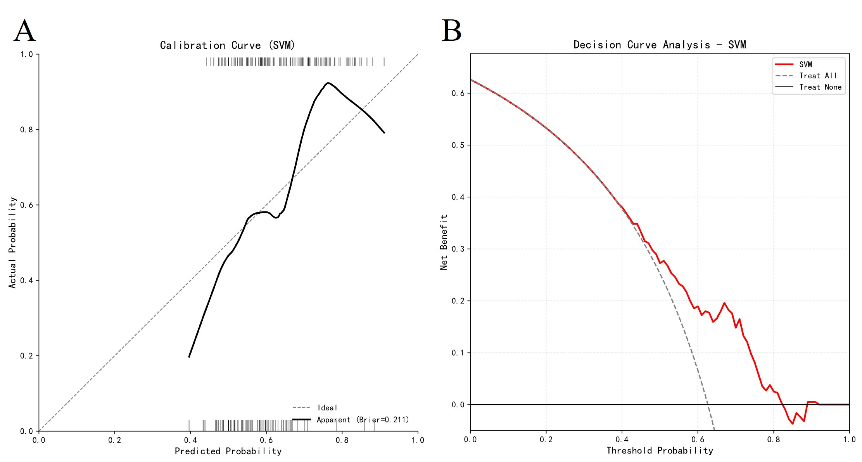
In addition, calibration curves (Fig. 3A) were used to further evaluate the agreement between predicted probabilities and actual RMPP incidence. An ideal calibration curve should closely follow the diagonal reference line. Among all models evaluated in this study, the SVM model demonstrated good calibration performance, with a Brier score of 0.211. These findings indicate that the predicted probabilities generated by the SVM model are highly reliable and accurately reflect the true risk of developing RMPP in pediatric patients.增加
>>> [补充] 在Results中增加DCA结果描述：报告模型在哪些阈值概率范围内提供正的净获益。
Discussion
Based on a large retrospective cohort, this study is the first to investigate the value of chest X-ray–based radiomics machine learning models for predicting RMPP in children. The results demonstrated that (1) among the nine constructed machine learning models, the SVM model exhibited a robust performance (AUC = 0.705), outperforming tree models that are prone to overfitting, such as LightGBM and XGBoost; (2) among radiomics features, texture features (Entropy) and first-order statistical features (90Percentile) were key determinants for distinguishing RMPP from non-RMPP; (3) as a low-radiation and low-cost screening tool, CXR-based machine learning models demonstrate substantial potential for clinical translation.
SHAP analysis showed that firstorder_90Percentile (distribution of high-intensity regions) and glrlm_RunEntropy (degree of textural heterogeneity) were the most important features for predicting RMPP. From a pathological perspective, children with RMPP are often accompanied by high-density pulmonary consolidation, necrotic debris deposition, and mucus plugging, which result in higher radiographic density and more complex internal textural heterogeneity on X-ray images. In contrast, inflammatory exudation in non-RMPP cases tends to be more homogeneous.
>>> [补充引用] 病理-影像关联论述需补充参考文献支持（RMPP影像学表现与病理对照研究文献）。
The model constructed in this study, based on chest X-ray images combined with radiomics, differs from previous studies that primarily focused on CT-based approaches. Although the SVM model achieved an AUC of 0.705 in the validation set—lower than some CT-based RMPP prediction models (14). But it remains suitable as a preliminary screening tool prior to further CT examinations when clinical benefits and risks are considered. Although CT provides more detailed anatomical information, its radiation dose is tens to hundreds of times higher than that of CXR and is therefore not recommended as a routine first-line examination or follow-up modality for pediatric pneumonia. The value of this study lies in extracting high-throughput quantitative information from X-ray images with relatively limited visual information, uncovering features that are imperceptible to the human eye. It provides a low-radiation auxiliary way for early warning of RMPP. Especially in primary care settings or outpatient screening scenarios, CXR-based models may offer superior practicality and accessibility compared with CT.
Although XGBoost and LightGBM demonstrated extremely high fitting performance in the training set, their performance declined markedly in the validation set, indicating substantial overfitting. This phenomenon may be attributed to the high-dimensional nature of radiomics features and the inherent noise in medical imaging data. In contrast, SVM demonstrated greater robustness when handling data with strong feature correlations. These findings suggest that in this and similar studies, complex ensemble models are not necessarily superior to classical linear or kernel-based models. In clinical practice for pediatric RMPP, a high-precision model is invaluable as it provides high-confidence alerts, helping clinicians minimize unnecessary invasive interventions for non-refractory patients while maintaining favorable overall discriminative ability and calibration (Brier score = 0.213).
The objective of this study was to develop a lightweight and easily deployable RMPP prediction model; therefore, age was the only clinical variable incorporated. Many laboratory test results require several hours to obtain, whereas chest X-ray imaging can typically be completed shortly after hospital admission. Moreover, the model can be directly integrated into hospital’s picture archiving and communication system (PACS) systems without requiring manual input of laboratory results, thereby enhancing clinical operability. In addition, the core value of radiomics models lies in extracting high-throughput features that provide complementary information beyond visual assessment.
>>> [新增讨论] 建议补充：(1)敏感性分析：加入CRP、LDH、发热持续时间后模型性能是否提升？(2)与纯临床基线模型对比，论证影像组学的增量价值。
The segmentation tool used in this study, isat-sam, is based on the Meta SAM2 model (15). Unlike traditional manual delineation, SAM2 is based on a vision Transformer architecture and offers high consistency and strong boundary adherence. This method, as a standardized process, can significantly reduce errors from manual delineating and ensure the robustness of feature extraction. To ensure segmentation reliability, all mask delineations were reviewed and corrected by experienced radiologists.
>>> [修改] "high consistency and strong boundary adherence"缺乏定量数据支撑，需补充ICC/Dice后才可保留此论断。
This study has several limitations: (1) This was a single-center retrospective study lacking an external independent validation cohort, and the generalizability of the model requires further verification through multicenter studies; (2) The proportion of RMPP cases in our study was higher than that of non-RMPP cases. This is primarily attributed to the hospital-based retrospective design. We predominantly admits children with severe or persistent symptoms who fail to respond to initial outpatient treatment. This inclusion bias reflects the clinical reality of inpatient populations but may not represent the general prevalence of RMPP among all children with MPP. (3) While age was incorporated as a clinical predictor, other laboratory biomarkers were excluded to prioritize the development of a lightweight and rapidly deployable screening tool. Future studies should explore the integration of radiomics using multicenter data, large-scale datasets and explore the potential of combined imaging–clinical models.
>>> [补充局限性] 建议增加：(4)mRMR实施细节需更明确；(5)ROI分割缺乏定量一致性评估；(6)未进行年龄亚组分析；(7)未提供代码和配置，限制可复现性。
In summary, this study successfully developed a chest X-ray–based prediction model for RMPP in children, demonstrating favorable discriminative ability and clinical applicability. Combined with SHAP analysis, the model exhibited high interpretability. This model provides pediatric clinicians with a noninvasive, low-radiation, and objective imaging-based tool for early identification of children at high risk of RMPP. It holds significant potential for application in hierarchical medical systems and early screening scenarios.

Preferences
1. Liu YN, Zhang YF, Xu Q, Qiu Y, Lu QB, Wang T, et al. Infection and co-infection patterns of community-acquired pneumonia in patients of different ages in China from 2009 to 2020: a national surveillance study. The Lancet Microbe. 2023 May 1;4(5):e330–9.
2. Diaz MH, Hersh AL, Olson J, Shah SS, Hall M, Edens C. Mycoplasma pneumoniae Infections in Hospitalized Children - United States, 2018-2024. MMWR Morb Mortal Wkly Rep. 2025 Jun 26;74(23):394–400.
3. Sun Y, Li P, Jin R, Liang Y, Yuan J, Lu Z, et al. Characterizing the epidemiology of Mycoplasma pneumoniae infections in China in 2022–2024: a nationwide cross-sectional study of over 1.6 million cases. Emerg Microbes Infect. 14(1):2482703.
4.Zhao SY, Qian SY, Chen ZM, Gao HM, Liu HM, Zhang HL, et al. Guidelines for the Diagnosis and Treatment of Mycoplasma pneumoniae Pneumonia in Children (2023 Edition). Infectious Disease Information.[in Chinese] 2023;36(4):291–7.
5.Willis CE, Slovis TL. The ALARA Concept in Pediatric CR and DR: Dose Reduction in Pediatric Radiographic Exams — A White Paper Conference. American Journal of Roentgenology. 2005 Feb;184(2):373–4.
6.Qian Y, Tao Y, Wu L, Zhou C, Liu F, Xu S, et al. Model based on the automated AI-driven CT quantification is effective for the diagnosis of refractory Mycoplasma pneumoniae pneumonia. Sci Rep. 2024 Jul 13;14(1):16172.
7.Zhuo LY, Hao JW, Song ZJ, Meng H, Wang TD, Yang LL, et al. Predicting the severity of mycoplasma pneumoniae pneumonia in pediatric and adult patients: a multicenter study. Sci Rep. 2024 Oct 3;14:22978.
8.Floca R, Bohn J, Haux C, Wiestler B, Zöllner FG, Reinke A, et al. Radiomics workflow definition & challenges - German priority program 2177 consensus statement on clinically applied radiomics. Insights Imaging. 2024 Jun 3;15:124.
9.van Griethuysen JJ, Fedorov A, Parmar C, Hosny A, Aucoin N, Narayan V, et al. Computational Radiomics System to Decode the Radiographic Phenotype. Cancer Res. 2017 Nov 1;77(21):e104–7.
10.Shalabi LA, Shaaban Z, Kasasbeh B. Data Mining: A Preprocessing Engine. JCS. 2006 Sep 30;2(9):735–9.
11.Ding C, Peng H. Minimum redundancy feature selection from microarray gene expression data. In: Computational Systems Bioinformatics CSB2003 Proceedings of the 2003 IEEE Bioinformatics Conference CSB2003 [Internet]. 2003 [cited 2026 Feb 9]. p. 523–8. Available from: https://ieeexplore.ieee.org/document/1227396
12.Collins GS, Moons KGM, Dhiman P, Riley RD, Beam AL, Van Calster B, et al. TRIPOD+AI statement: updated guidance for reporting clinical prediction models that use regression or machine learning methods. BMJ. 2024 Apr 16;385:e078378.
13.Lundberg S, Lee SI. A Unified Approach to Interpreting Model Predictions [Internet]. arXiv; 2017 [cited 2025 Dec 17]. Available from: http://arxiv.org/abs/1705.07874
14.Jiang Y, Wang X, Li L, Wang Y, Wang X, Zou Y. Predicting and interpreting key features of refractory Mycoplasma pneumoniae pneumonia using multiple machine learning methods. Sci Rep. 2025 May 23;15(1):18029.
15.Ravi N, Gabeur V, Hu YT, Hu R, Ryali C, Ma T, et al. SAM 2: Segment Anything in Images and Videos [Internet]. arXiv; 2024 [cited 2025 Dec 17]. Available from: http://arxiv.org/abs/2408.00714

Figure Titles and Legends
Fig. 1 Schematic workflow of the study. The data were divided into a training set and a validation set using group-based random sampling to ensure that all chest X-ray images from the same patient were assigned to the same dataset, thereby preventing data leakage. Radiomics features were extracted and subsequently filtered to remove low-quality and highly redundant features. K-fold cross-validation was performed to determine the optimal machine learning (ML) model and hyperparameter set. The final model was evaluated on an independent validation dataset to assess its predictive performance. Representative examples of image segmentation and a radiomics feature correlation heatmap are shown. Chest X-ray images were segmented using isat-sam and saved as mask files, and a radiomics feature correlation matrix was generated.
Fig. 2 ROC, AUC, SHAP, Confusion Matrix. 2A, 2B: Receiver operating characteristic (ROC) curves of the nine machine learning models. MLP Multilayer Perceptron, SVM Support Vector Machine, XGBoost Extreme Gradient Boosting, GaussianNB Gaussian Naive Bayes, KNN K-Nearest Neighbors. 2C: SHAP analysis illustrating the contribution of each feature to the SVM model. 2D: Confusion matrix of the SVM model in the validation set, where the x-axis represents predicted values and the y-axis represents actual values.
>>> [补充] Fig.3中DCA图需清晰标注阈值概率范围；Results正文需报告具体净获益数值。
Fig. 3 Calibration curve and Decision curve for SVM model. The Brier score is a scoring rule that measures the accuracy of probabilistic predictions. The lower the Brier score is for a set of predictions, the better the predictions are calibrated.

