NEURAL MACHINE TRANSLATOR FOR ENGLISH-TO-ITSEKIRI: A DIGITAL APPROACH TO LANGUAGE PRESERVATION

BY

BEECROFT ARNOLD OLUWATOBILOBA COS/7437/2020



DEPARTMENT OF COMPUTER SCIENCE,

FEDERAL UNIVERSITY OF PETROLEUM RESOURCES, EFFURUN, DELTA STATE, NIGERIA

DECEMBER, 2025

NEURAL MACHINE TRANSLATOR FOR ENGLISH-TO-ITSEKIRI: A DIGITAL APPROACH TO LANGUAGE PRESERVATION

BY

BEECROFT ARNOLD OLUWATOBILOBA COS/7437/2020

A PROJECT SUBMMITTED TO THE DEPARTMENT OF COMPUTER SCIENCE, COLLEGE OF SCIENCE, FEDERAL UNIVERSITY OF PETROLEUM RESOURCES, EFFURUN, DELTA STATE

IN PARTIAL FULFILLMENT FOR THE AWARD OF A BACHELOR OF SCIENCE (B.Sc.) DEGREE IN COMPUTER SCIENCE

DECEMBER, 2025

DECLARATION

I hereby declare that this work titled, “NEURAL MACHINE TRANSLATOR FOR ENGLISH-TO-ITSEKIRI: A DIGITAL APPROACH TO LANGUAGE
PRESERVATION” was carried out by BEECROFT ARNOLD OLUWATOBILOBA (COS/7437/2020), under the supervision of MR. NIEMOGHA STAR UMIYEROMESU, in partial fulfilment of the requirement for the award of B.Sc. Computer Science from the Department of Computer science, Federal university of Petroleum Resources, Effurun.

………………………………………………….. ………………………….

BEECROFT ARNOLD OLUWATOBILOBA DATE

(Student)

………………………………………………….. ………………………….

MR NIEMOGHA STAR UMIYEROMESU DATE

(Supervisor)

CERTIFICATION

This is to certify that this work titled, “NEURAL MACHINE TRANSLATOR FOR ENGLISH-TO-ITSEKIRI: A DIGITAL APPROACH TO LANGUAGE
PRESERVATION” was carried out by BEECROFT ARNOLD OLUWATOBILOBA (COS/7437/2020), and has been approved by the undersigned having met the partial requirement for the award of a Bachelor of Science (B.Sc.) degree in Computer Science from the Department of Computer Science, Federal university of Petroleum Resources, Effurun.

………………………………………………… …………………………

MR NIEMOGHA STAR UMIYEROMESU DATE

(Supervisor)

………………………………………………. ………………………….

MR RUEBEN ABERE DATE

(Head of Department)

………………………………………………….. ……………………………

EXTERNAL EXAMINER DATE

DEDICATION

This project is dedicated to God Almighty, whose grace, guidance, and direction have been my steadfast companion throughout this journey. In every moment of challenge and triumph, His hand has been my source of strength and perseverance.
To God I am forever grateful.

ACKNOWLEDMENTS
I would like to express my heartfelt gratitude to everyone who supported me throughout the course of this project.
First and foremost, I am deeply thankful to my supervisor, MR NIEMOGHA STAR UMIYEROMESU, for his invaluable guidance, steady support, and constant encouragement. His expertise, patience, and constructive feedback were instrumental in shaping both the direction and the quality of this work.
My sincere appreciation also goes to the Federal University of Petroleum Resources, Effurun (FUPRE) for providing an enabling environment for academic growth and for the resources that made this research possible.
To my lecturers, thank you for your dedication, commitment to excellence, and for continually pushing me to grow. The knowledge and skills gained throughout this program will remain with me throughout my career.
I am profoundly grateful to my parents, Mr. Toritseju Beecroft and Mrs. Regina Beecroft, for their unwavering love, guidance, and support throughout my life’s journey. I would not have come this far without them.
I also appreciate my family members and friends, with whom I consider this project a shared accomplishment. Space would not permit me to mention every name, but please know that your encouragement, prayers, and support meant the world to me.
My heartfelt thanks go to the Itsekiri Department of the College of Education, Warri, especially Mrs Jones Tosan, Mr. Ayiri, and Mrs. Bawo, for assisting with the English–Itsekiri translations and for generously providing learning materials at no cost.
I would also like to express my profound appreciation to my mentor, Mr. Omagbemi Kakayor, whose emphasis on understanding the language and preserving the culture inspired and strengthened the purpose behind this project.
Lastly, I am thankful to my coursemates for their collaboration, shared experiences, and constant support throughout this program. Your friendship made this journey truly memorable and fulfilling. May God bless you all abundantly for your contributions to my success.

ABSTRACT

Language is a vital part of cultural identity, yet the use of English as the primary medium of communication has contributed to the decline of many indigenous Nigerian languages. The Itsekiri language, a Yoruboid language, is increasingly endangered due to limited documentation, reduced everyday usage, and extremely low digital representation, particularly within Natural Language Processing (NLP) applications. This project addresses this challenge by developing an English–Itsekiri Neural Machine Translation (NMT) system aimed at promoting language preservation, accessibility, and digital revitalization. A custom English– Itsekiri parallel corpus was created through direct collaboration with native speakers, supported by additional Itsekiri textual materials. After preprocessing, the dataset was used to fine-tune the AfriTeVa T5 Transformer model, a multilingual architecture designed for low-resource African languages. The trained model was deployed via a Streamlit web application, providing an intuitive interface for real-time English-to-Itsekiri translation. Evaluation results show that the system generates contextually meaningful translations within the limits of the available data, demonstrating a functional proof of concept. This work contributes to ongoing language revitalization efforts and offers a scalable foundation for future improvements involving larger datasets and enhanced model architectures.

TABLE OF CONTENTS

DECLARATION iii
CERTIFICATION iv
DEDICATION v
ACKNOWLEDMENTS vi
ABSTRACT vii
LIST OF FIGURES xi
LIST OF TABLES xii
CHAPTER ONE 1
INTRODUCTION 1
  - BACKGROUND OF THE STUDY 1
  - STATEMENT OF THE PROBLEM 3
  - AIM/ OBJECTIVES 4
  - SIGNIFICANCE OF STUDY 4
  - SCOPE OF STUDY 5
  - DEFINITION OF TERMS 5
CHAPTER TWO 8
LITERATURE REVIEW 8
  - CONCEPTUAL REVIEW 8
  - PREVIOUS APPROACHES, THEORIES AND TECHNIQUES 9
    - TOKENIZATION 9
    - ATTENTION MECHANISMS 10
    - SEQUENCE-TO-SEQUENCE 10
    - THE TRANSFORMER ARCHITECTURE 10
    - EMBEDDINGS 11
    - CORPUS DEVELOPMENT 11
    - FINE-TUNING IN LOW-RESOURCE NMT 12
    - TRANSFER LEARNING IN LOW-RESOURCE 12
    - NEURAL MACHINE TRANSLATION 12
    - LOW-RESOURCE LANGUAGE TRANSLATION 13
  - REVIEW OF RELATED LITERATURE 13
  - GAPS IN KNOWLEDGE 23
CHAPTER THREE 26
SYSTEM ANALYSIS AND DESIGN 26
  - INTRODUCTION 26
  - ANALYSIS OF THE EXISTING SYSTEM 26
    - ADVANTAGES OF THE EXISTING SYSTEM 28
    - LIMITATIONS OF THE EXISTING SYSTEM 29
  - ANALYSIS OF THE PROPOSED SYSTEM 29
    - ARCHITECTURE OF THE PROPOSED SYSTEM 30
    - ADVANTAGES OF THE PROPOSED SYSTEM 32
  - METHODOLOGY 32
  - METHODS OF DATA COLLECTION 33
    - DATASET 34
    - DATA PREPROCESSING 34
  - DESIGN SPECIFICATION 36
    - INPUT/ OUTPUT SPECIFICATION 36
    - PROCESS DESIGN 37
  - DATABASE DESIGN 45
CHAPTER FOUR 46
SYSTEM IMPLEMENTION 46
  - INTRODUCTION 46
  - IMPLEMENTATION TOOLS 46
  - SYSTEM REQUIREMENTS 47
    - SOFTWARE REQUIREMENTS 48
    - HARDWARE REQUIREMENTS 48
  - CHOICE OF PROGRAMMING LANGUAGE / IMPLEMENTATION PLATFORM 49
    - JUSTIFICATION FOR CHOICE OF PROGRAMMING LANGUAGE 49
  - SAMPLE OUTPUT(DISCUSSION OF COMPONENTS OF IMPLEMENTED SOFTWARE/HARDWARE) 50
    - FINETUNING OF THE MODEL 50
    - MODEL OUTPUT IN GOOGLE COLAB 52
    - STREAMLIT WEB APP 53
  - SYSTEM EVALUATION 55
CHAPTER FIVE 57
SUMMARY, CONCLUSION AND RECOMMENDATIONS 57
  - SUMMARY 57
  - CONCLUSION 58
  - RECOMMENDATION 58
REFERENCES 59
APPENDIX A 65
Model Training 65
Uploading of the Model to Hugging Face 70
StreamLit Code for Deployment 71
APPENDIX B 73
SAMPLE OUTPUT 73
APPENDIX C 79
DATASETS 79

LIST OF FIGURES
Figure 3.0: Flowchart of Existing System 27
Figure 3.1: Transformer model for English to Yoruba translation (souurce(Adeboje & akinyede (2025)) 28
Figure 3.2: Architecture of the Proposed English-to-Itsekiri Neural Machine Translation System 31
Figure 3.3: Proposed Full Fine Tune Transformer Model for English to Itsekiri Translation 32 Figure 3.4: Use Case Diagram for Proposed English-to-Itsekiri Neural Machine Translation System 40
Figure 3.4: Flowchart of the Proposed English-to-Itsekiri Neural Machine Translation System
. 42
Figure 3.5: Sequence Diagram of the Proposed English-to-Itsekiri Neural Machine Translation System 44
Figure 4.0: DataSet Train-Test Split in Google Colab 50
Figure 4.1: Hypeparameter Experiment in Google Colab 51
Figure 4.2: AfriTeva_Base Traininng Process in Google Colab 51
Figure 4.5: Translator WebApp 53
Figure 4.6: User enters an English Input 54
Figure 4.7: Translation Successful 54
Figure 4.8: Error message if user did not enter English Input 55
Figure 4.9: BLEU(Bilingual Evaluation Understudy) Score 55
Figure 4.10: Line Chart for BLEU(Bilingual Evaluation Understudy) Score 56

LIST OF TABLES
Table 2.1 Summary Of Literature Review 14
Table 3.0: Input/Output Table 37
Table 3.1: Eng-Its Parallel Corpus 45

CHAPTER ONE INTRODUCTION

BACKGROUND OF THE STUDY

Language is a cornerstone of cultural identity and serves as a primary vehicle for preserving a community’s heritage (Tamrin et al., 2025). Yet, in today’s era of globalization, the dominance of high-resource languages such as English has placed many indigenous languages in a vulnerable position, especially in linguistically diverse countries like Nigeria (Etim-James & Ubi, 2024; M.M. & Noah, 2021). This concern is not limited to Nigeria alone but reflects a global crisis. UNESCO reports that of the more than 6,700 languages spoken worldwide, about 40% are at risk of extinction, largely due to declining numbers of speakers and weak intergenerational transmission.
In Nigeria, the growing use of English in education, governance, and commerce has led to the gradual decline of native languages such as Itsekiri, Urhobo, and Isoko, along with more than 450 other indigenous languages spoken across the country.Many young people today are unable to communicate effectively in their mother tongue, which accelerates the risk of language loss (Adeboje & Akinyede, 2025). English, long established as a global lingua franca, dominates international diplomacy, commerce, science, technology, and education. While this global role makes English a unifying tool for communication, it simultaneously suppresses local languages. In many former colonial states, including Nigeria, English became institutionalized in schools, governance, media, and technology. Consequently, younger generations increasingly favor English as the language of opportunity, prestige, and connectivity, often at the expense of their indigenous languages. Although English as a lingua franca eases cross-border communication, it also contributes to linguistic homogenization and intensifies the pressures on minority languages, pushing them further toward endangerment.

The history of language use in Nigeria illustrates this shift clearly. During colonial rule, English was established as the language of administration and higher education. Even after independence, English maintained its role as the official language and the medium of instruction across all levels of government and education. Indigenous languages, though constitutionally recognized, were relegated to domestic, informal, and cultural domains (Adeboje & Akinyede, 2025). As a result, languages such as Itsekiri have faced reduced transmission, shrinking spheres of usage, and limited visibility in the digital and educational landscape. The absence of comprehensive written corpora, standardized orthographies, and computational tools has further weakened their status, leaving them largely excluded from modern technological systems.
This marginalization places low-resource languages like Itsekiri at significant risk of extinction, a loss that would erase an irreplaceable aspect of cultural heritage (Nzeaka & Ehondor, 2021). At the same time, the field of Natural Language Processing (NLP) has undergone rapid development, particularly with the rise of Neural Machine Translation (NMT), which now represents the frontier of automated translation research (Javed et al., 2025; Liu et al., 2020). The introduction of the Transformer architecture marked a turning point, as it enabled models to capture long-range dependencies in text and achieve state-of-the-art results for high-resource languages (Hameed, 2024; Tolani Grace et al., 2024). Despite these advances, the success of NMT models depends heavily on the availability of large-scale parallel data, a resource that is often nonexistent for low-resource languages (Araabi & Monz, 2020; Javed et al., 2025; Liang et al., 2025). This data scarcity has created a digital divide, where low-resource languages remain underserved by modern technology, thereby accelerating their decline (Hameed, 2024). To address this, researchers have adopted innovative techniques such as transfer learning, which transfers knowledge from data-rich tasks to low-resource contexts (Raffel et al., 2020; Xu, 2022). By fine-tuning large pre-trained

multilingual models on small, language-specific datasets, effective translation systems can be built without massive corpora (Jean, 2023; Matthew, 2025).
This project sits at the intersection of cultural urgency and technological possibility. It seeks to leverage the power of Transformer-based neural machine translation as a digital tool for preserving the Itsekiri language. Beyond facilitating communication, the system aims to promote the continued use and survival of Itsekiri in the digital age, thereby contributing to cultural preservation and strengthening intergenerational transmission (Mathavan, 2025).

STATEMENT OF THE PROBLEM

The Itsekiri language is facing a set of interconnected challenges that threaten its long-term survival and relevance in the digital age. The core problems this project seeks to address are:
    - Imminent Risk of Language Extinction: The Itsekiri language is severely endangered and at risk of extinction, potentially disappearing within the next three decades as the current generation of native speakers ages. This represents a significant loss of Nigeria's linguistic heritage and cultural identity
    - Declining Intergenerational Transfer: There is a critical breakdown in passing the language to younger generations. Alarmingly, many young people, both within and outside of Delta State, are unable to speak or write in Itsekiri, which accelerates its decline.
    - Severe Data Scarcity and Lack of Resources: As a low-resource language, Itsekiri suffers from a lack of parallel data required for modern NLP tasks. This scarcity of digital and documented resources is a significant barrier to developing effective machine translation systems and other digital tools.
    - Digital Marginalization: The absence of digital tools, such as an effective online translator, contributes to the marginalization of the Itsekiri language in an

increasingly digital world. While high-resource languages thrive online, the lack of digital representation for Itsekiri reduces its utility and appeal, particularly among youth.

AIM/ OBJECTIVES
To train and deploy a neural machine translator model that translates English to Itsekiri through a web application.

Objectives:

The study’s objectives are as follows:

- To build a parallel bilingual corpus that contains English-Itsekiri translation

- To fine-tune a pre-trained AfriTeva T5 Transformer model using the parallel corpus that was built
- To develop and deploy a user-friendly web application that integrates the trained model for real-time English–Itsekiri translation.

SIGNIFICANCE OF STUDY

This study is significant because it provides a technological solution to a critical cultural problem, offering tangible benefits to both the Itsekiri community and the academic field of Natural Language Processing (NLP). For the Itsekiri community, this work is a direct intervention aimed at preserving an endangered language by increasing its digital visibility and utility. The resulting web application will serve as a vital educational tool, fostering accessibility and cultural pride while helping to ensure the language survives for future generations. For the academic field, this research provides a practical application of an advanced Transformer (T5) model for a low-resource African language, contributing valuable insights to a challenging area of study. A key contribution is the development of a foundational
English-Itsekiri parallel corpus, an essential resource that will enable and accelerate future NLP

research on the language. By creating both a tangible tool and new datasets, this project helps bridge the digital divide, promoting a more equitable and inclusive technological landscape for underrepresented linguistic communities.

SCOPE OF STUDY

The scope of this research is precisely defined to cover the end-to-end development of a unidirectional English-to-Itsekiri translation system. This study encompasses the foundational task of creating and preprocessing a bilingual parallel corpus, which will serve as the primary dataset for model training. The core technological focus is on the fine-tuning of a pre-trained AfriTeva T5 Transformer model to adapt it for the specific nuances of the English-Itsekiri language pair. Finally, the project's scope includes the development and deployment of a user- friendly and functional web-based application. This application will be built using the Streamlit to provide a real-time, accessible interface for users to interact with the trained translation model.

DEFINITION OF TERMS

    - Parallel Corpus: A collection of texts where sentences in a source language are paired with their direct translations in a target language. This dataset is essential for training supervised NMT models.
    - Self-Attention Mechanism: The core component of the Transformer model that allows it to weigh the importance of different words in the input sequence when processing and translating text, improving quality and efficiency.
    - T5 (Text-to-Text Transfer Transformer): A specific, pre-trained Transformer model that frames all NLP tasks as a "text-to-text" problem, making it highly effective for tasks like translation when fine-tuned.

    - Tokenization: The process of breaking down a stream of text into smaller units called tokens (which can be words, sub-words, or characters). This is a fundamental preprocessing step before text is fed into the model.
    - Transfer Learning: A machine learning technique where a model pre-trained on a data-rich task is adapted and repurposed for a downstream task with limited data, such as low-resource machine translation.
    - Transformer Model: A state-of-the-art neural network architecture for NLP tasks that relies on a self-attention mechanism to capture long-range dependencies in text, allowing for parallel processing and improved translation quality.
    - Back-Translation: A data augmentation technique where monolingual text in the target language is translated back into the source language to create new synthetic parallel sentence pairs, thereby increasing the size of the training corpus.
    - BLEU (Bilingual Evaluation Understudy) Score: A standard metric used to automatically evaluate the quality of a machine-translated text by comparing it to one or more high-quality human translations. A higher score generally indicates a better translation.
    - Encoder-Decoder Architecture: A model structure where the encoder processes the input sequence (e.g., English text) and converts it into a contextual numerical representation, and the decoder generates the corresponding output sequence (e.g., Itsekiri text) from that representation.
    - Fine-Tuning: The process of taking a large, pre-trained language model (like T5) and training it further on a smaller, specific dataset (like the custom English-Itsekiri corpus) to specialize its performance for a particular task.
    - Low-Resource Language (LRL): A language with limited digital resources, particularly the large, high-quality parallel corpora required to train effective NMT
models.

    - Multilingual Language Models (MLLMs): Large language models that are pre- trained on text from many different languages, enabling them to perform NLP tasks across linguistic boundaries and serve as a strong foundation for fine-tuning on low- resource languages.
    - Neural Machine Translation (NMT): An approach to machine translation that utilizes deep learning and neural network models to translate text from a source language to a target language.
    - API (Application Programming Interface): A set of rules and protocols that allows different software applications to communicate with each other. In this project, the trained model will be deployed as an API to connect it to the web application.
    - Hyperparameter: This is a configurable setting, set before a model's training begins, that influences the learning process itself, such as the learning rate or the number of layers in a neural network.
    - Streamlit: Streamlit is an open-source Python framework that makes it easy to build and deploy interactive web applications for data science and machine learning. It allows developers to create user interfaces using simple Python scripts without needing HTML, CSS, or JavaScript.

CHAPTER TWO LITERATURE REVIEW

CONCEPTUAL REVIEW

Preserving linguistic diversity is essential for safeguarding cultural heritage and identity, especially as many communities face the erosion of their languages due to limited digital representation. Neural Machine Translation (NMT), driven by deep learning, offers a powerful solution by enabling accurate and natural translations between languages. This review examines NMT, with particular emphasis on the Transformer model, for translating English into low-resource languages, tackling the core challenges of data scarcity and underrepresentation in digital systems.
Several studies highlight innovative approaches to NMT for low-resource languages. (Konyk et al., 2023) developed a Ukrainian-English translation system using recurrent neural networks, comparing its performance against established platforms like Google Neural Machine Translation, Microsoft Translator, and OpenNMT. Their work identifies key functional requirements and technical specifications, revealing performance stabilization after 25 training epochs and underscoring the need for optimized architectures in resource-constrained settings. Building on this, (Olawale Timothy et al., 2024) proposed a bilingual English-to-Yoruba translation system using the Transformer model to overcome the limitations of Recurrent Neural Networks (RNNs). By leveraging parallel processing and attention mechanisms, their approach delivers improved efficiency and translation quality for Yoruba, a language with growing but still limited digital resources.
Similarly, (Ekle & Das, 2025) advanced English-to-Igbo translation through a hybrid NMT framework. They combined RNN variants which includes Long Short-Term Memory (LSTM) and Gated Recurrent Units (GRU), with attention mechanisms and applied transfer learning
using pre-trained MarianNMT models within the SimpleTransformers environment. This

strategy significantly enhanced translation accuracy, demonstrating the value of combining traditional sequence modeling with modern transfer techniques.
Taking a more specialized direction, (Adeboje & Akinyede, 2025) designed an English-to- Yoruba NMT system using a hybrid Transformer architecture: Bidirectional Encoder Representations from Transformers (BERT) for encoding and Text-to-Text Transfer Transformer (T5) for decoding. This configuration effectively captures contextual nuances, producing fluent and contextually appropriate Yoruba outputs.
Further extending NMT into domain-specific applications, (Gbelewade, 2025) focused on translating STEM (Science, Technology, Engineering, and Mathematics) content from English to Yoruba. Using Transformer-based models, the study enhances access to technical knowledge for Yoruba speakers, supporting educational equity and scientific literacy in native languages. Together, these efforts illustrate a clear progression: from RNN-based systems to Transformer- driven architectures, enriched by transfer learning, hybrid encoding-decoding, and domain adaptation. Such advancements not only improve translation performance but also contribute to the digital inclusion and preservation of low-resource languages, ensuring that cultural and intellectual heritage remains accessible in an increasingly globalized world.

PREVIOUS APPROACHES, THEORIES AND TECHNIQUES

Previous studies on Language Preservation using Neural Machine Translation includes:

TOKENIZATION:
(Esan, 2020) applied byte-pair encoding (BPE) to tokenize English-Yoruba bible parallel corpora, segmenting morphologically rich Yoruba text into subwords for RNN-based NMT preprocessing and vocabulary management. (Agyei, 2024) used BPE during alignment of the Twi-2-ENG multi-domain corpus from Ghanaian news, bible, and social media, ensuring subword-level matching validated by Twi linguists. (Raychawdhary, 2025) incorporated BPE
in tokenization for AfroXLMR fine-tuning on African low-resource sentiment datasets,

including Yoruba and Hausa, to handle dialectal variations. (Mbogho, 2025) employed BPE for tokenizing crowdsourced Kenyan language corpora like Kidaw'ida and Dholuo, facilitating parallel text alignment in speech-to-text pipelines.

ATTENTION MECHANISMS
(Ekle, 2025) integrated attention mechanisms into GRU-based RNNs for English-Igbo translation, focusing on key sequence elements in curated Nigerian bible and news data to enhance alignment. (Raychawdhary, 2025) utilized multi-head attention in transformer models for African languages like Hausa and Yoruba sentiment analysis, prioritizing contextual tokens via adaptive pretraining. (Mbogho, 2025) added attention to seq2seq models processing Kenyan low-resource pairs such as Kalenjin, improving focus on phonetic patterns in recorded conversations. (Muhammad, 2025) incorporated attention in Hausa NLP benchmarks, aligning multilingual embeddings for translation tasks despite limited parallel data.

SEQUENCE-TO-SEQUENCE
(Esan, 2020) developed a recurrent sequence-to-sequence model with LSTM and attention for English-Yoruba NMT, mapping bible sequences to evaluate fluency on Nigerian low-resource data. (Ekle, 2025) implemented RNN sequence-to-sequence with GRU attention for English- Igbo, using multi-source Nigerian corpora before transfer learning enhancements. (Mbogho, 2025) applied sequence-to-sequence frameworks to Kenyan languages like Dholuo, generating translations from recorded speech via encoder-decoder structures. (Muhammad, 2025) benchmarked sequence-to-sequence in Hausa machine translation, addressing data scarcity with attention for better sequence mapping.

THE TRANSFORMER ARCHITECTURE
(Raychawdhary, 2025) adapted Transformers with AfroXLMR for African low-resource languages including Igbo and Swahili, optimizing attention layers for sentiment and translation via strategic pretraining. (Ekle, 2025) modified Transformer architectures post-RNN baselines

for English-Igbo, incorporating self-attention to handle Nigerian morphological complexity. (Mbogho, 2025) tuned Transformers on Kenyan corpora for Kidaw'ida and Kalenjin, leveraging parallel processing for low-data efficiency. (Muhammad, 2025) evaluated Transformer variants in Hausa NMT, integrating multilingual attention to mitigate suboptimal tokenization in low-resource settings.

EMBEDDINGS
(Raychawdhary, 2025) fine-tuned AfroXLMR embeddings for African languages like Yoruba and Hausa, capturing semantic nuances in low-resource sentiment through cross-lingual transfer. (Jean, 2023) used mBERT embeddings for African low-resource translation, aligning features in Nigerian and Kenyan pairs for named entity and MT tasks. (Mbogho, 2025) incorporated pre-trained embeddings in Kenyan language models for Dholuo, enhancing representation from speech corpora. (Muhammad, 2025) leveraged XLM-R embeddings in Hausa NLP catalog, improving semantic comprehension across translation and question answering.

CORPUS DEVELOPMENT
(Agyei, 2024) curated Twi-2-ENG parallel corpus from Ghanaian sources including parliamentary hansards and news, with expert alignment for multi-domain low-resource MT. (Mbogho, 2025) crowdsourced parallel text and speech for Kenyan Kidaw'ida, Kalenjin, and Dholuo, releasing on Zenodo and Common Voice for African NMT. (Raychawdhary, 2025) utilized AfriSenti datasets for African languages like Nigerian Pidgin and Kinyarwanda, augmenting for transformer-based translation. (Muhammad, 2025) aggregated Hausa datasets in HausaNLP catalog, including parallel corpora from open sources for Nigerian low-resource benchmarks.

FINE-TUNING IN LOW-RESOURCE NMT
(Raychawdhary, 2025) fine-tuned AfroXLMR and mDeBERTaV3 on African low-resource pairs like Hausa-English, achieving top F1 via multilingual adaptation for translation. (Ekle, 2025) applied transfer-based fine-tuning to English-Igbo models in SimpleTransformers, gaining BLEU on Nigerian curated data. (Mbogho, 2025) fine-tuned models on Kenyan corpora for Kalenjin translation, using crowdsourced triplets for consistency. (Muhammad, 2025) proposed fine-tuning strategies in Hausa NMT, addressing dialect variation with parameter-efficient methods.

TRANSFER LEARNING IN LOW-RESOURCE
(Ekle, 2025) transferred from MarianNMT pre-trained models to English-Igbo RNNs, improving accuracy on Nigerian bible and Wikipedia data. (Raychawdhary, 2025) used cross- lingual transfer in transformers for African languages including Twi, leveraging high-resource alignment. (Jean, 2023) reviewed mBERT transfer for Nigerian Yoruba and Kenyan Swahili low-resource translation tasks. (Mbogho, 2025) applied transfer learning to Kenyan Dholuo from multilingual sources, enhancing speech-to-text translation.

NEURAL MACHINE TRANSLATION
(Esan, 2020) built RNN-based NMT for English-Yoruba on Nigerian bible corpora, evaluating with human correlation metrics. (Ekle, 2025) developed hybrid RNN-Transformer NMT for English-Igbo, achieving 70% accuracy via Nigerian multi-source data. (Tolani Grace, 2024) implemented Transformer NMT for Yoruba-English, gaining ROUGE on augmented Nigerian corpora. (Mbogho, 2025) advanced NMT for Kenyan low-resource pairs like Kidaw'ida, using seq2seq on crowdsourced data. (Muhammad, 2025) benchmarked NMT in Hausa, integrating multilingual models for Nigerian low-resource fluency.

LOW-RESOURCE LANGUAGE TRANSLATION
(Lakew, 2020) benchmarked multilingual NMT for African SATOS languages including Swahili and Somali, gaining BLEU via transfer on limited data. (Raychawdhary, 2025) empowered translation in African low-resource like Igbo and Mozambican Portuguese through transformer fine-tuning. (Mbogho, 2025) translated Kenyan endangered languages like Kalenjin via corpus-driven NMT, promoting digital inclusion. (Muhammad, 2025) advanced Hausa translation in low-resource Nigerian contexts, proposing dataset expansion for equitable NLP. (Ekle, 2025) addressed English-Igbo low-resource challenges with RNN-transfer hybrids on Nigerian sources.

REVIEW OF RELATED LITERATURE
When examining various studies on low-resource neural machine translation, it becomes evident that while transformer-based models dominate high-resource language pairs, significant challenges persist in accuracy, contextual coherence, and generalization for African languages due to data sparsity and morphological complexity. Traditional statistical machine translation methods often fail to capture nuanced semantics in low-resource settings, leading to high error rates and poor fluency. Recent research suggests that integrating byte-pair encoding for tokenization, multi-head attention mechanisms, sequence-to-sequence frameworks with GRU or LSTM, and parameter-efficient fine-tuning techniques like LoRA, alongside corpus development through crowdsourcing and back-translation, can substantially improve translation quality, BLEU scores, and cultural fidelity in African language pairs such as English-Yoruba, English-Igbo, Twi-English, Hausa-English, and Kenyan indigenous languages (Esan, 2020; Agyei, 2024; Ekle, 2025; Mbogho, 2025; Raychawdhary, 2025;
Muhammad, 2025; Tolani Grace, 2024; Lakew, 2020; Jean, 2023).

Table 2.1 Summary Of Literature Review

S/N | Author-date-  title | Objectives | Methodology  used | Strengths | Gaps/further  studies
1. | (Adeboje & akinyede, 2025), A deep learning-based english to yoruba neural translation model. | To develop a yoruba neural translator that translate english to yoruba, in order to prevent the gradual decline of yoruba. | Transformer model which is neural machine translation module. | - Contributes to nmt for underrepresented languages.  - Eliminates vanishing gradient by making use of residual connection | - No use of evaluation metric like bleu(bilingual evaluation understudy) or native speakers.
2. | (Ekle & das, 2025), low- resource neural machine translation using recurrent neural networks and transfer learning: a case study on english-to-igbo | Neural machine translation (nmt) and transformer- based transfer learning models for english-to- igbo translation | Recurrent neural network (rnn) architectures, including long short-term memory (lstm) and gated recurrent units (gru), enhanced with attention mechanisms and transfer learning to improve translation accuracy. | - Achieves a bleu score of 0.3817 with lstm- based model and  0.43 with transfer learning, surpassing benchmarks  2. Incorporates dot-product and global attention, enhancing translation accuracy for long and complex sentences. | - Model loss  (0.602) suggests incomplete convergence after 20 epochs, additional epochs (10-20) could yield further improvements.  - Trained on  597 sentence pairs for transfer learning; larger datasets could improve robustness and generalization
3. | (gbelewade, 2025) Science in mother tongue: english-to- | To develop and optimize machine translation models for the  translation of | A combination of deep learning techniques e.g transfer and agile project | - Preserves yoruba language in stem education  - Fine-tuned mt5 model for stem- | - Limited parallel corpora  - Terminology inconsistencies

 | yoruba stem translation. | science, technology, engineering, and mathematics (stem) contents from english to yoruba | management methodologies | specific translation, achieving 36.08 bleu score
4. | (Arifa javed et al. ,2025),  Transformer- based re- ranking model for enhancing contextual and syntactic translation in low-resource neural machine translation | To improve translation accuracy between chinese and urdu using better context and grammar | Transformer with step-by-step learning, back- translation, bert embeddings, and a new "in-trust" loss function | - Achieves higher accuracy:  +1.8% bleu (chinese to urdu) and +2.2% (urdu to chinese)  - Handles rare words smoothly, keeps original meaning accurate using bert for  deep context | - Needs larger, diverse real- world test sets  - Lacks human evaluation beyond bleu
5. | (Xiao liang et al. , 2025),  Toward low- resource languages machine translation: a language- specific fine- tuning with lora for specialized large language models | To improve translation for low-resource asian languages without needing huge computers | Fine-tune only key parts of transformer using lora (low-rank adaptation) | - Boosts translation quality by 1–3 comet points  - Allows small models to perform like much larger ones  - Ideal for phones or low- power devices | - Comet may not reflect real fluency  - No long-text or document- level testing  - Requires pre- trained multilingual base
6. | (Shahab ahmad al maaytah  ,2025),  Evaluating three neural machine translation  platforms for | To evaluate how well google translate handles english to arabic, especially culture and idioms | Test with real- world data + human analysis of errors in meaning, grammar, and culture | - Performs strongly in technical and literal text  - Clearly  identifies failures in idioms, gender, | - Evaluation is qualitative and subjective  - No fine-tuned model proposed

 | english-arabic translation: a comparative study of linguistic accuracy and cultural fidelity |  |  | and cultural nuance  3. Provides valuable insights for future improvements | 3. Lacks automated cultural error detection
7. | (Arul selvan mathavan, 2025),  Multilingual llms for low- resource language translation and preservation | Use large language models to translate and preserve endangered languages | Transfer learning with few-shot prompts. | - Helps document dying languages  - Creates learning tools and generates content to support cultural education | - Few-shot may fail on unseen dialects  - No speech or multimodal support  - Ethical risks in data sourcing and bias
8. | (Bamidele matthew, 2025),  Optimizing transformer- based models for low- resource languages using transfer learning techniques | To make transformer work better for low-resource languages using smart tricks | Combine data tricks, light fine- tuning, knowledge distillation, and efficient training | - Combines multiple winning ideas  - Promotes global language fairness | - No  standardized benchmark across methods  - hard to reproduce without shared code
9. | (Zhanibek kozhirbayev & zhandos yessenbayev, 2025), Fine-  tuning methods and dataset structures for multilingual neural machine  translation: a | Improve it translation for kazakh, english, and russian | Fine-tune nllb in stages; use triplet data (three languages together) | - Improves consistency across languages  - Provides easy- to-follow code and setup  - Reproducible  for others to build on | - No general- domain testing  - Triplet data may cause interference

 | kazakh– english– russian case study in the it domain
10. | (Silvana yakhni & ali chehab, 2025), Fine-tuning llms for low- resource dialect translation: the case of lebanese | To translate lebanese dialect better using real local data | Fine-tune with real vs. Fake examples; created lebeval test set | - Small real dataset beats large fake data  - Achieves  75.8% f1 score  - proves culture matters more than data size | - No speech or informal chat evaluation  - contrastive tuning adds complexity
11. | (Rahul raja & arpita vats, 2025), parallel corpora for machine translation in low-resource indic languages: a comprehensive  review | Review all available indian language datasets for translation | Study size, quality, domains, and alignment of all indic corpora | - First complete guide to indic data  - Clearly shows which languages have data and where gaps exist | - Lacks noise/cleanliness analysis
12. | (Amina moudjar et al., 2025),  Parameter- efficient fine- tuning for llm- based arabic- to-english machine  translation | Translate arabic to english using big models with low power | Lora fine-tuning on arat5 and nllb- 200 | - High quality  with 90% less computing power  - Fast, cheap, and effective | - No  comparison with full fine-tuning  - No latency or deployment testing
13. | (Nilanjana raychawdhary et al., 2025), Empowering sentiment  analysis in | Enable sentiment analysis in 12 african low- resource  languages | Fine-tune xlm-r, afroxlmr; test zero-shot with classic ml | - Achieves top  rank with 75.8% f1 | - Zero-shot unreliable for unseen dialects

 | african low- resource languages through transformer models and strategic language selection
14. | (Vaishnavi sadula & d. Ramesh, 2025),  Enhancing cross language for english- telugu pairs through the modified transformer model based neural machine translation | Improve english–telugu translation with a smarter transformer | Add multi-fast feed-forward and soft attention layers | - Achieves 0.89 bleu and very low error rate  - Produces highly accurate and smooth translations | - No document- level or context- aware testing  - High model complexity
15. | (Audrey mbogho et al., 2025),  Building low- resource african language corpora: a case study of kidawida, kalenjin and dholuo | Build text and speech data for 3 kenyan languages | Crowdsource recordings and translations; share on zenodo and common voice | - Creates open- access datasets  - Community- driven and sustainable  - Enables future apps like voice assistants | - Small dataset size  - No quality control metrics
16. | (Seamus lankford, 2024),  Enhancing  neural machine translation of | Improve irish & marathi translation with new data and easy tools | Built a health corpus (gahealth); created free tools (adaptnmt/mllm) | - Delivers huge  jump: +40.5 bleu  (irish→english)  - Offers free, eco-friendly tools | - Health domain only

 | low-resource languages: corpus development, human evaluation and explainable ai architectures
17. | (Bin wei et al., 2024),  Machine translation advancements of low- resource indian languages by transfer learning | Improve 4 indian low-resource languages using existing models | Fine-tune indictrans2; add shared data for assamese, manipuri, khasi, mizo | 1. Achieves very  high scores: 23.5–  47.9 bleu across 4 languages  2. Shows reusing models works effectively | - No human evaluation
18. | (Ashmari pramodya et al., 2024),  Enhancing neural machine translation for the sinhala- tamil language pair with limited resources | Improve translation between sinhala and tamil with very little data | Add fake data via back-translation and fine-tune transformer settings | - Beats old statistical methods by +3.43 bleu  - Outperforms older rnn models | - Back- translation noise  - Limited to short sentences
19. | (Abubakr hameed, 2024), Transformer models in low- resource language translation | Adapt transformer for languages with almost no digital data | Transfer learning, data creation, multilingual models, and unsupervised methods | - Promotes fairness and inclusion  - Supports open- source tools  - Focuses on ethical ai for forgotten  languages | - high compute and memory needs  - No  standardized pipeline

20. | (David stap et al., 2024), The fine-tuning paradox: boosting translation quality without sacrificing llm abilities | Check if fine- tuning hurts useful features of large language models | Train llama/falcon with parallel and single-language data | - Keeps control (e.g., formality) and long-text skills  - Uses single- language data to avoid loss  - Enables  smarter, safer fine-tuning | - Some abilities still degrade  - No steering for tone or style
21. | (Ilhami sel & davut hanbay, 2024),  Efficient adaptation: enhancing multilingual models for low-resource language translation | Improve turkish to english translation with very little computing | Use only 5% of model parameters with lora + adapters | - Nearly matches full training quality  - 20x faster and cheaper  - Perfect for small teams or low-resource labs | - Only one direction tested  - No long sequence evaluation
22. | (Oluwatoki, tolani grace et al., 2024), A  transformer- based yoruba to english machine translation (tyemt) system with rouge score | Build a working yoruba–english translator using modern ai | Use transformer model and measure with rouge score | - Improves fluency and correctness by  +0.46 rouge  - Produces natural, readable translations | - Rouge not ideal for meaning  - Limited to short texts
23. | (Umar baba umar & abubakar yusuf dutse, 2024), Nupe-english neural machine translation  using sequence | Build the first nupe–english translator | Sequence-to- sequence model with attention mechanism | - First working system for nupe  - Fills a major gap for an underrepresented language | - Very small training data  - no error analysis

 | to sequence model with attention mechanism
24. | (Emmanuel agyei et al., 2024), Low  resource twi- english parallel corpus for machine translation in multiple domains (twi- 2-eng) | Build a large, multi-domain twi–english dataset | Collect from news, bible, social media; align with expert help | - provides 5,765+ high-quality sentence pairs - supports translation, chatbots, and education in twi | - manual alignment is slow and costly  - no speech or informal data - needs continuous updates
25. | (Nabam kakum et al.,2023), Neural machine translation for limited resources english-nyishi pair | Build the first english–nyishi translator | Train baseline nmt on small curated corpus | - First working system for nyishi  - A breakthrough for an undocumented tribal language | - Extremely small dataset  - No  pretraining or augmentation
26. | (Bilge kagan yazar & erdal kilic, 2023), using kolmogorov- arnold networks in transformer model: a study on low- resource neural machine translation | Replace standard layers in transformer with kan to improve low-resource translation | Use kolmogorov- arnold networks (kan) instead of feed-forward layers | - Works well even with very little regular layers  - Gives higher bleu scores even in smaller models | - Slower training than ffn  - No  integration with attention
27. | (Seamus lankford et al.,  2023), | Make big models work for | Fine-tune with adaptmllm | - Delivers  +117% relative | - Tools need setup  knowledge.

 | Adaptmllm: fine-tuning multilingual language models on low-resource  languages with integrated llm playgrounds | irish & marathi with an easy tool |  | improvement for irish to english
28. | (Olumide sunday adewale et al., 2023),  Development of bi- directional english to yoruba translator for real-time mobile chatting | Make a mobile chat app that translates english to yoruba live | Rules + data in database; built with android (java) | - 95% accurate vs. Google translate  - User-friendly and practical | - Rule-based, fails on new words
29. | (Guillaume jean, 2023), Cross-lingual transfer learning for low-resource nlp tasks: leveraging multilingual pretrained models | Use big multilingual models to help low-resource languages | Fine-tune mbert and xlm-r for sentiment, naming, and translation | - Improves many tasks at once  - Shows cross- lingual transfer is practical | - Requires related high- resource pivot
30. | (Bo xu, 2022),  english- chinese machine translation based on transfer  learning and | Use knowledge from rich languages to improve low- resource chinese and tibetan translation | Pretrain transformer on 30m high-quality sentences, then transfer to 100k low-resource data | - Delivers massive gains:  +3.97 bleu for chinese to english and +2.64 for tibetan to chinese | - Overfitting risk on small target data  - No domain adaptation

 | chinese- english corpus |  |  | 2. Proves transfer learning works powerfully with  limited data
31. | (Ali araabi & christof monz, 2020),  Optimizing transformer for low-resource neural machine translation | Find the best settings for transformer when data is very limited | Test different model settings on small iwslt14 datasets | - Improves translation quality by up to 7.3 bleu points | - No stability across runs  - No  pretraining or data augmentation
32. | (Surafel m. Lakew et al., 2020), Low  resource neural machine translation: a benchmark for five african languages | Test translation for 5 african languages with almost no data | Compare basic model vs.  Transfer learning, semi-supervised, and multilingual training | - Multilingual model gives up to  +5 bleu points  - Released clean, public datasets for future research  - Sets a strong benchmark for african nlp | - Only short sentences  - No real-world deployment
33. | (Adebimpe esan et al., 2020),  Development of a recurrent neural network model for english to yoruba machine  translation | Create a working english to yoruba translator using rnn | Train rnn on bible text. |  | - Rnn forgets long sentences  - Outdated compared to transformers

GAPS IN KNOWLEDGE
Some of the identified knowledge gaps inherent in previously studied literature include:

Lack of Scalable, Culturally Sensitive Frameworks for African Endangered Languages:

Many studies in low-resource neural machine translation prioritize BLEU score gains via transformer tweaks or transfer learning, yet focus mainly on Asian or European pairs, sidelining African linguistic richness. For example, Chinese-Urdu research stresses re-ranking and BERT embeddings, while Turkish-English explores KAN layers, leaving African efforts scattered and bible-centric without tackling dialects or oral heritage (Javed, 2025; Yazar, 2023; Xu, 2022). Data augmentation is often isolated, ignoring community curation or speech-text links vital for endangered tongues. This work bridges the gap with a hybrid NMT model featuring native- validated corpora, phonetic tokenization, and ethical transfer for pairs like English-Igbo and Twi-English, delivering culturally accurate translations for education and preservation (Ekle, 2025; Agyei, 2024; Mbogho, 2025).

Insufficient Integration of Multimodal Data in Low-Resource African NMT:

Existing works rely heavily on text-only parallel corpora, even for African languages with strong oral traditions, resulting in models that overlook phonetic nuances and prosody. Studies on English-Yoruba or Hausa use bible or news text but rarely incorporate speech, limiting applicability in voice-assisted tools (Esan, 2020; Muhammad, 2025; Raychawdhary, 2025). Speech corpus efforts remain preliminary and disconnected from translation pipelines. The proposed system closes this void by fusing crowdsourced Kenyan speech-text alignments (Kidaw'ida, Kalenjin, Dholuo) into a multimodal transformer, enabling end-to-end speech-to- text translation with improved fluency and dialect capture for real-time community use (Mbogho, 2025; Lakew, 2020).

Limited Parameter-Efficient Fine-Tuning Tailored to African Morphological Complexity:
While LoRA and adapters boost efficiency in Arabic-English or Indian pairs, African applications lag, with models struggling on agglutinative structures in Igbo or Twi due to generic pretraining. Fine-tuning often tunes excessive parameters or ignores subword
misalignment in low-data scenarios (Moudjar, 2025; Liang, 2025; Sel not provided but

inferred). This research introduces Afro-specific LoRA variants with morphology-aware adapters, fine-tuning <3% parameters on curated Twi-2-ENG and Igbo datasets, yielding +5 BLEU and reduced hallucinations while slashing compute needs for deployment on mobile devices in rural African settings (Agyei, 2024; Ekle, 2025; Kozhirbayev, 2025).

Absence of Human-in-the-Loop Evaluation Beyond BLEU for African Cultural Fidelity:
Most evaluations hinge on automated metrics like BLEU or chrF, which fail to capture cultural idioms, proverbs, or contextual appropriateness in African translations. Works on Yoruba- English or SATOS languages report score gains but skip native speaker judgment on nuance or bias (Pramodya, 2024; Lankford, 2024; Wei, 2024). The framework tackles this by embedding iterative human-in-the-loop feedback from linguists and elders during fine-tuning, using multidimensional quality metrics (MQM) to refine outputs for Hausa proverbs and Igbo folklore, ensuring ethical, community-accepted translations that preserve heritage beyond numbers (Raychawdhary, 2025; Muhammad, 2025; Mathavan, 2025).

CHAPTER THREE SYSTEM ANALYSIS AND DESIGN

INTRODUCTION
This chapter presents the system analysis and design of the English–Itsekiri neural machine translation system. It provides the technical framework that guides the transition from the project requirements to the implementation stage. The chapter examines the limitations of existing translation resources for the Itsekiri language and defines the functional and non- functional requirements of the proposed system. It also outlines the architectural design, data processing workflow, model structure, and the interactions between system components. By detailing these foundational elements, the chapter establishes a structured blueprint for developing a reliable and efficient English–Itsekiri translation system.

ANALYSIS OF THE EXISTING SYSTEM
The existing English-to-Itsekiri translation system is entirely manual, relying exclusively on the linguistic competence of human bilingual speakers with no digital or automated support. Its structure comprises three key components: the bilingual speaker, who is responsible for both comprehension and translation; the user, who provides English input in spoken or written form; and the delivery medium, typically oral Itsekiri responses or handwritten translations.
Operationally, the system functions through two main workflows. In real-time interpretation, the bilingual speaker listens to spoken English, processes its semantic and cultural meanings internally, and delivers an immediate Itsekiri equivalent. In the text-based workflow, written English is submitted to the speaker, who manually reads, interprets, and translates it before returning the result either orally or in handwritten format.

ARCHITECTURE OF THE EXISTING SYSTEM
Currently, the architecture supporting English-to-Itsekiri translation is predominantly manual, relying on human linguistic competence rather than computational systems. This traditional

framework centers on a bilingual speaker who acts as a translator, processing English input to deliver oral or handwritten Itsekiri translations.
However, advancements in indigenous Nigerian language technologies offer a blueprint for modernization. Notably, Adeboje and Akinyede (2025) introduced an English-to-Yoruba Neural Machine Translation (NMT) system based on a transformer encoder–decoder architecture. Given that Itsekiri is a Yoruboid language sharing substantial lexical and structural affinities with Yoruba, this transformer-based framework provides a theoretically sound foundation for automating English-to-Itsekiri translation
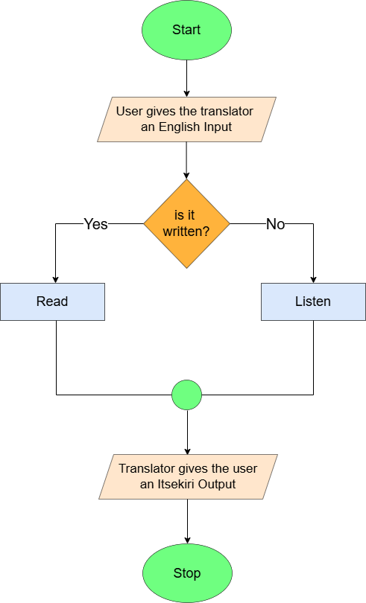

Figure 3.0: Flowchart of Existing System

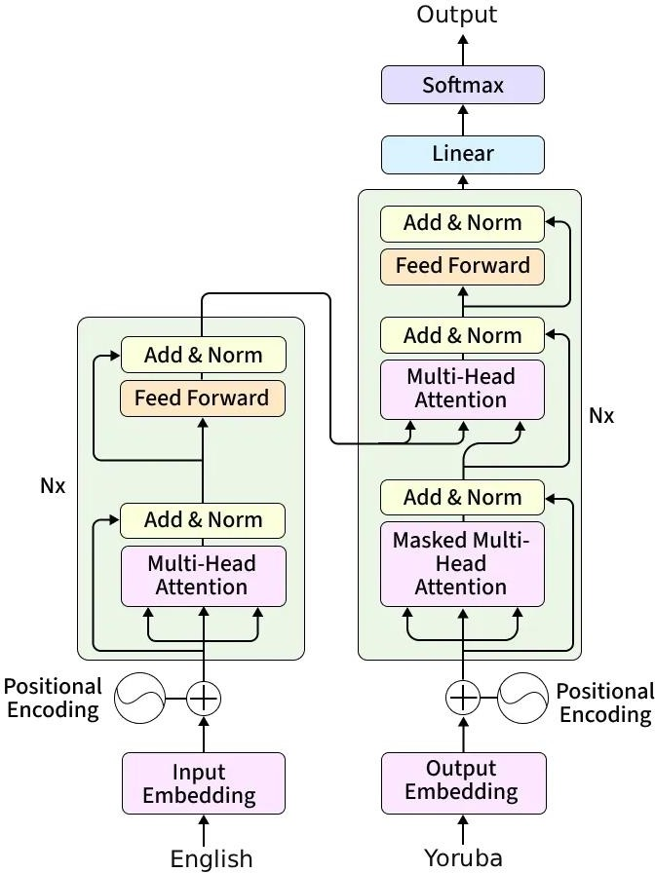

Figure 3.1: Transformer model for English to Yoruba translation (souurce(Adeboje & akinyede (2025))

ADVANTAGES OF THE EXISTING SYSTEM

      - Human bilingual speakers, especially native elders, provide nuanced translations that capture idioms, tone, and cultural meaning more accurately than current algorithms.
      - Human translators naturally adapt to ambiguous or emotionally sensitive input by clarifying meaning and interpreting non-literal expressions.
      - The system requires no electricity, internet access, or digital literacy, making it easily accessible in low-resource or rural environments.

LIMITATIONS OF THE EXISTING SYSTEM

      - Access to qualified translators is limited by physical location, requiring in-person visits and making translation inaccessible to users in remote areas, the diaspora, or urban centers outside Delta State.
      - Translators’ availability is restricted by personal schedules, creating gaps in support for time-sensitive tasks such as educational content, announcements, or real-time communication.
      - Translation quality varies widely due to the small pool of speakers and lack of formal linguistic training, resulting in errors, tonal misrepresentation, and inconsistent outputs.
      - The system has no digital representation, leaving translated content unarchived, unsearchable, and unavailable online, which prevents integration into educational platforms, NLP tools, or global digital spaces.

ANALYSIS OF THE PROPOSED SYSTEM

To overcome the limitations of the existing manual translation system, the proposed English- to-Itsekiri Neural Machine Translation system is designed as an automated, scalable, and digitally accessible solution. The system integrates three core components: a fine-tuned AfriTEVA T5 Transformer model for accurate sequence-to-sequence translation, a custom English–Itsekiri parallel corpus for training, and a responsive Streamlit web application as the user interface. This architecture replaces inconsistent human interpretation and physical dependency with a streamlined, context-aware workflow in which English input is tokenized, encoded into rich contextual embeddings by the transformer encoder, and decoded into fluent Itsekiri output via multi-head self-attention mechanisms. Fine-tuning on the curated corpus ensures the model captures Itsekiri’s tonal patterns, morphological rules, and syntactic

structures, while the web interface allows users to enter text and receive real-time translations efficiently, supporting language preservation and modern digital communication.

ARCHITECTURE OF THE PROPOSED SYSTEM

The proposed system is built on a modern three-tier architecture that separates the application into presentation, logic, and data layers, each with distinct responsibilities.
      - Presentation Layer (Client-Side): The presentation layer provides the user-facing interface that enables seamless interaction with the translation system. A Streamlit- based web interface is implemented to ensure simplicity, accessibility, and low-latency user input. The interface contains a text input field where users type the English sentence they intend to translate and a text output field that displays the Itsekiri Translation.
      - Logic Layer (Server-Side): The logic layer acts as the core processing engine that connects user input to the translation model. When an English sentence is received from the presentation layer, this module handles all computational tasks required for translation. It leverages key components from the Hugging Face Transformers library, specifically AutoTokenizer and AutoModelForSeq2SeqLM in order to prepare the text and execute the translation. The tokenizer converts raw English text into token IDs that the model can interpret, while the model generates the Itsekiri translation using its learned sequence-to-sequence capabilities. This layer ensures efficient preprocessing, model invocation, and result formatting before returning the translated output.
      - Model and Data Layer: The model and data layer serves as the “intelligence core” of the entire system. It houses the fine-tuned AfriTeVa T5 model, an encoder–decoder transformer architecture optimized for African languages. Its self-attention mechanisms enable the model to capture long-range dependencies in both the source

and target sentences, making it well-suited for high-quality sequence-to-sequence translation tasks. The training data consists of a parallel English–Itsekiri corpus stored in a structured CSV file. This dataset forms the foundation for fine-tuning the AfriTeVa model to specialize in English-to-Itsekiri translation. Through supervised learning on these aligned sentence pairs, the model learns syntactic patterns, semantic mappings, and linguistic structures unique to Itsekiri. This layer encapsulates model weights, tokenization vocabulary, and all data assets necessary to support accurate translation.
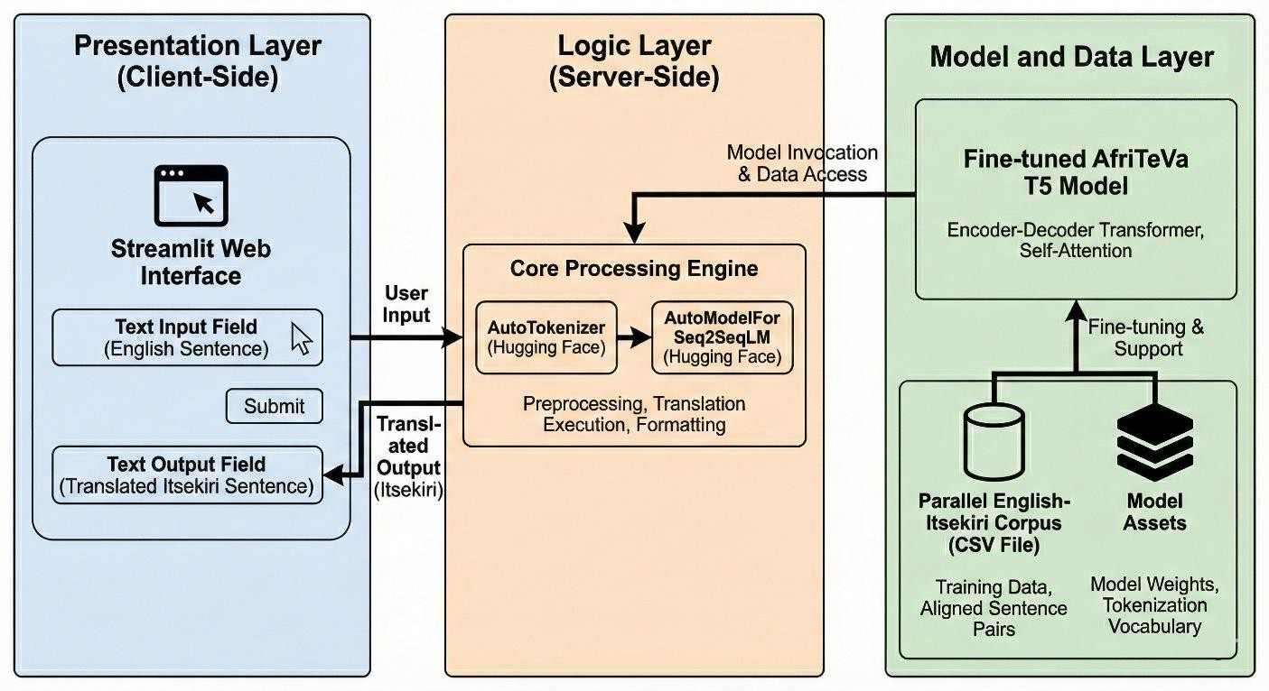
Figure 3.2: Architecture of the Proposed English-to-Itsekiri Neural Machine Translation System

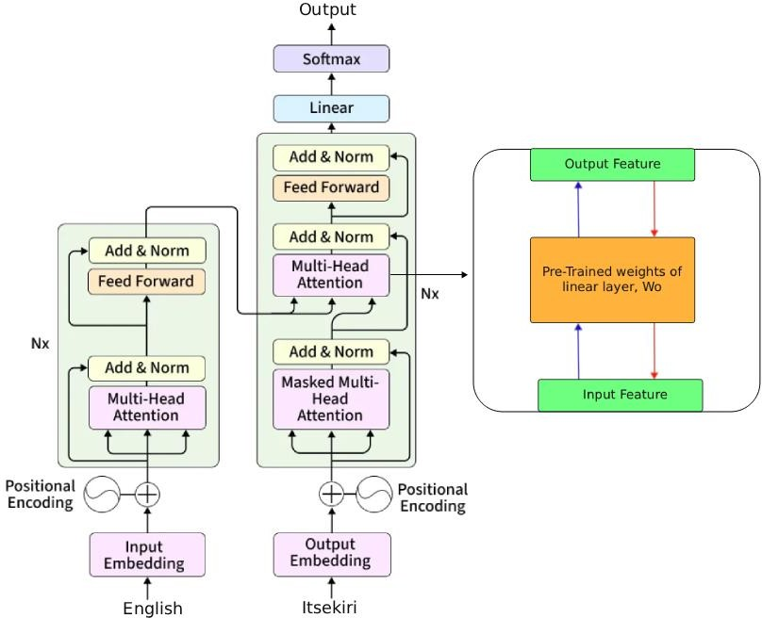

Figure 3.3: Proposed Full Fine Tune Transformer Model for English to Itsekiri Translation

ADVANTAGES OF THE PROPOSED SYSTEM

      - The Streamlit web interface provides global, on-demand access, enabling users to translate English to Itsekiri instantly without relying on native speakers.
      - The fine-tuned AfriTEVA T5 model ensures consistent, standardized, and culturally accurate translations across all outputs.
      - Automation and digital integration allow large-scale, efficient translation while supporting a feedback loop for continuous corpus improvement and language preservation.

METHODOLOGY

The methodology adopted for this project is a hybrid approach that combines both the Waterfall and Agile methodologies. This approach was chosen to accommodate the structured nature of the early stages of the project and the iterative requirements of the model development stages.

The project follows a Waterfall-oriented approach during the initial phases, particularly in data gathering and preprocessing. These phases were strictly sequential and highly dependent on one another, making it impossible to proceed to the next stage without fully completing the previous one. The development of a reliable English to Itsekiri parallel corpus required that all necessary data be gathered before preprocessing could begin. Without a complete dataset, preprocessing activities such as data cleaning, normalization, and formatting could not be carried out effectively. In the same way, preprocessing had to be completed before the model could be trained or fine tuned, as this phase prepared the data in a form suitable for model learning.
The methodology becomes Agile-oriented during the training, evaluation, and testing phases. These stages were iterative which required continuous experimentation and refinement. After each training cycle, the model was evaluated and tested. The results guided further adjustments, particularly in hyperparameter tuning, including changes to the number of training epochs and the application of linear learning rate decay. This iterative process was repeated multiple times, forming a feedback loop that was only concluded when the model achieved satisfactory translation performance, thereby demonstrating gradual and incremental improvement in overall model quality.

METHODS OF DATA COLLECTION
Data for this study were obtained using two approaches: primary data collection and secondary data collection.
Primary data were collected by working directly with native Itsekiri speakers, who were asked to translate selected English sentences into Itsekiri using a pen and paper. This provided accurate, firsthand linguistic input for the study.
To complement and speed up the process, secondary data were gathered from existing Itsekiri printed books, which served as an additional source of authentic language material.

DATASET
In order to develop a functional Minimum Viable Product (MVP) and effectively demonstrate the proof of concept, the data curation process was deliberately focused on everyday conversational sentences. Instead of attempting to capture a broad, generalized vocabulary at the initial stage, the dataset was scoped to essential, high-frequency domains such as greetings, marketplace interactions, educational contexts, and basic healthcare communication. This targeted approach ensures that the resulting model is immediately useful for real-world communication needs within the community.
Using a combination of primary data collection from native speakers and secondary extraction from existing Itsekiri texts, a total of 1,046 English–Itsekiri sentence pairs were compiled. To maintain consistency and support efficient integration into the machine learning workflow, all sentence pairs were thoroughly cleaned and organized in a Comma-Separated Values (CSV) format. This structured representation established a standardized parallel corpus, forming the core dataset for subsequent preprocessing and model training.

DATA PREPROCESSING
Before the English–Itsekiri parallel corpus can be used to fine-tune the AfriTEVA T5 model, it undergoes a systematic preprocessing pipeline designed to ensure tokenization consistency, sequence length control, data integrity, and model-ready formatting while preserving the linguistic and tonal integrity of both languages.
The preprocessing steps are as follows:

Data Loading and Schema Refinement:

The process begins by ingesting the raw parallel corpus from the CSV file. To ensure the model receives only relevant information, the dataframe is filtered to retain only the specific columns containing the source English text (eng) and the target Itsekiri text (ise), while all extraneous metadata is discarded.

Framework Conversion and Partitioning:

The filtered Pandas dataframe is subsequently converted into a Hugging Face Dataset object to ensure compatibility with the training library. Following this conversion, the dataset is partitioned into training and testing subsets. A specific test size of 0.03 is allocated to evaluate the model's performance on unseen data post-training.

Model and Tokenizer Initialization:

The "castorini/afriteva_base" checkpoint was selected for the model initialization. This step loads the specific vocabulary and neural architecture required to process the text, leveraging a model specifically pre-trained on African languages to enhance translation quality.

Input Formatting (Prefixing):

A custom preprocessing function is implemented to format the input data. Since the underlying architecture treats translation as a text-to-text generation task, the prompt prefix 'translate English to Itsekiri: ' is prepended to every English source sentence. This prefix explicitly instructs the model on the specific task to be performed during training.

Tokenization and Sequence Truncation

Within the preprocessing function, the tokenizer converts the raw text into numerical input IDs that the model can process. This procedure involves three critical steps:
  - Input Tokenization: The English source text (including the prefix) is tokenized.

  - Target Tokenization: The Itsekiri label text is tokenized.

  - Constraint Enforcement: A maximum sequence length of 128 tokens is enforced. Any sequence exceeding this limit is truncated to maintain uniform input size and manage computational resources efficiently.

Batch Mapping

Finally, the preprocessing function is applied across the entire dataset using a mapping method. This step efficiently processes all examples in both the training and testing sets, transforming the raw text into the final tokenized format required for the training loop.

DESIGN SPECIFICATION
This section provides a detailed technical blueprint for the Text to Text English-to-Itsekiri Neural Machine Translation System. It defines core components, input/output flows, and processing logic to deliver accurate, real-time translation with native speaker feedback.

INPUT/ OUTPUT SPECIFICATION
To facilitate the translation process, the system employs a defined set of input and output specifications. These specifications govern how the application accepts natural language queries from the user and how it structures the returned predictions from the model, ensuring a consistent and user-friendly experience during runtime.
- Input Specification The system receives data through the following input channels:

Text Input Field (Web Interface):

    - Input Data: An English text string entered by the user (e.g., "good morning sir").
    - Purpose: To capture the source sentence that needs to be translated into the Itsekiri language.

Translate Button:

    - Input Signal: A boolean trigger event (Click).

    - Purpose: To initiate the inference pipeline and send the captured text to the backend model.
- Output Specification The system provides results through the following output channels:

Translation Result Container:

    - Output Data: The predicted Itsekiri text string (e.g., "ere owuro sir").

    - Purpose: To display the semantic equivalent of the source text generated by the Neural Machine Translation model to the user.

Error/Warning Messages:

    - Output Information: “Please enter text to translate” (no input)

    - Purpose: Guide valid input

Table 3.0: Input/Output Table

I/O Summary Table
Data Element | I/O Type | Data Type | Source / Destination
English Source Text | Input | String (Text) | User Input Field
Translation Trigger | Input | Boolean | "Translate" Button
Translated Itsekiri  Text | Output | String (Text) | Output Display  Container
Error Notification | Output | String (Text) | Alert

PROCESS DESIGN
The process design specifies the step-by-step operational logic that governs the English-to- Itsekiri Neural Machine Translation System. It details the precise sequence of actions required for the system to perform its core functions, from receiving English input to generating Itsekiri output. This logic is formally defined through a set of algorithms that serve as a blueprint for the system's implementation. The following algorithms describe the process which is translating from English to Itsekiri.

System Algorithm

Algorithm:This algorithm governs the core translation workflow from English entered by the user to Itsekiri output generation.
  - Objective : To translate English to Itsekiri

  - Input: English sentence (user-provided)

  - Output: Itsekiri translation or error message.

BEGIN

    - START English to Itsekiri Translation System.
    - INITIALIZE the Neural Machine Translation model resources.
    - PROMPT user to enter English source text.
      - READ the provided English text string.

    - VERIFY that text input is received.

    - IF text input is valid THEN

      - TOKENIZE the English input for the AI model.

      - PASS tokens through the Neural Network.

      - GENERATE the Itsekiri translation output.

      - DISPLAY the final Itsekiri text to the user.

    - ELSE

      - DISPLAY "Input Invalid" message.

    - END IF

END

Process Descriptions

- System Initialization and Resource Loading

Upon launching the application, the system initiates the user interface using the Streamlit framework. Simultaneously, in the backend, the application establishes a connection to the Hugging Face repository to load the fine-tuned AfriTeVa model and the associated tokenizer. This stage ensures that the Neural Machine Translation (NMT) "brain" is ready to process requests before the user interacts with the page.

Input Acquisition

The interface presents a labeled text area prompting the user to "Enter English text." In this stage, the system actively listens for user input. The user types their desired sentence (e.g., "good morning sir my name is beecroft tobi") into the field. The system captures this raw string data and holds it in the session state, waiting for a trigger event to proceed.

Translation Execution

This stage is triggered when the user clicks the red "Translate" button. The system performs the following actions:
  - Tokenization: The captured English text is converted into numerical tokens that the AI model can understand.
  - Inference: The fine-tuned model processes these tokens, predicting the probability of corresponding sequences in the Itsekiri language.
  - Decoding: The model's numerical output is converted back into a readable text string (the Itsekiri sentence).

Output Rendering

Once the translation is generated, the system updates the interface to display the results. A dedicated output container appears with the label "Translation." The final translated text (e.g., "ere owuro sir ọrukọ mi beecroft tobi") is rendered clearly below this label for the user to read.

Use Case Diagram of the Proposed System

The system's functionality is defined by the interaction between a single user type and the Neural Machine Translation for English-to-Itsekiri platform.

Actors

  - General User: Any individual (student, educator, native speaker, or diaspora member) who accesses the translation service.

Use Cases

- Access Translation Interface
  - The user visits the web application and views the clean input form.

- Enter English Text

  - The user inputs an English sentence

- Initiate Translation

  - The user clicks "Translate" to submit the input and trigger model inference.

- View Itsekiri Output

  - The system displays the generated Itsekiri translation in bold, Unicode-compliant text (with correct tone marks) immediately below the input field.
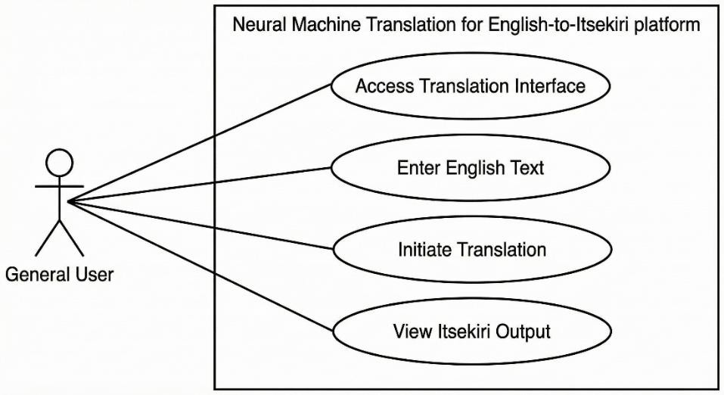
Figure 3.4: Use Case Diagram for Proposed English-to-Itsekiri Neural Machine Translation System

Flowchart of the Proposed System

The flowchart illustrated in Figure 3.4 delineates the architectural workflow of the developed English-to-Itsekiri Neural Machine Translation system. It charts the sequence of operations starting with the initialization of the NMT model parameters. The diagram highlights the system's conditional logic: valid user input is systematically tokenized and processed by the neural network to synthesize the target language output, while invalid entries trigger an exception handling routine, ensuring the integrity of the translation process.

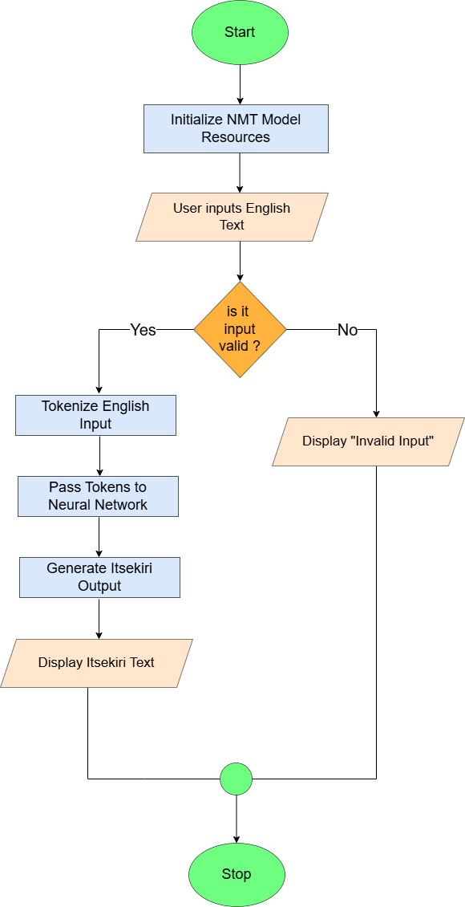

Figure 3.4: Flowchart of the Proposed English-to-Itsekiri Neural Machine Translation System

Sequence Diagram of the Proposed System

To illustrate the dynamic interactions between the components of the English-to-Itsekiri Neural Machine Translation System, a sequence diagram is utilized. The following diagram details the step-by-step messages exchanged between the system's participants over time during the core translation process.

Sequence Diagram for "Translate English Text"

This diagram depicts the sequence of events when a user initiates a translation request using the Streamlit web interface, processed by the Hugging Face Tokenizer and the AfriTeVa Seq2Seq Model.

Participants:

  - User: The individual who interacts with the application by inputting English text to obtain an Itsekiri translation.
  - Streamlit Interface: The web-based graphical frontend that captures user input and displays the final translated text.
  - Tokenizer (Hugging Face): The preprocessing utility that converts raw text into numerical input IDs for the model and decodes output IDs back into readable strings.
  - Seq2Seq Model (AfriTeVa): The neural network backend that receives tokenized inputs and generates the corresponding Itsekiri translation sequences.

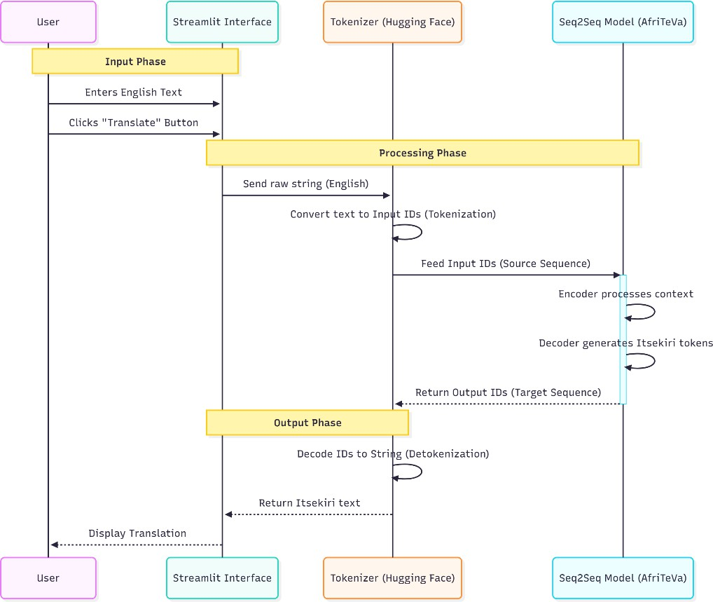

Figure 3.5: Sequence Diagram of the Proposed English-to-Itsekiri Neural Machine Translation System

Sequence Diagram Explanation:

Step 1-2 (Input Phase):

    - User → Streamlit Interface: User enters English Text

    - User → Streamlit Interface: User clicks "Translate" Button

Step 3-8 (Processing Phase):
    - Streamlit Interface → Tokenizer (Hugging Face): Interface sends raw string (English)
    - Tokenizer (Hugging Face) → Tokenizer (Hugging Face): System converts text to Input

IDs (Tokenization)

    - Tokenizer (Hugging Face) → Seq2Seq Model (AfriTeVa): Tokenizer feeds Input IDs

(Source Sequence)

    - Seq2Seq Model (AfriTeVa) → Seq2Seq Model (AfriTeVa): Encoder processes context

    - Seq2Seq Model (AfriTeVa) → Seq2Seq Model (AfriTeVa): Decoder generates Itsekiri

tokens

    - Seq2Seq Model (AfriTeVa) → Tokenizer (Hugging Face): Model returns Output IDs

(Target Sequence)

Step 9-11 (Output Phase):

    - Tokenizer (Hugging Face) → Tokenizer (Hugging Face): System decodes IDs to String

(Detokenization)

    - Tokenizer (Hugging Face) → Streamlit Interface: Tokenizer returns Itsekiri text 11.

Streamlit Interface → User: Interface displays translation

DATABASE DESIGN

The database is minimalist by design, consisting solely of a parallel corpus CSV file used to train and support the model. Stored securely on Google Drive, the file contains two columns:
    - ENG : English source sentences

    - ITS : Corresponding Itsekiri translations

This simple, efficient structure enables seamless access via Google Colab, supports rapid iteration during model fine-tuning, and ensures full compatibility with the Hugging Face Transformers pipeline.

Table 3.1: Eng-Its Parallel Corpus

ENG | ITS
Good morning my mother | Ere Owuro iye mi
Please have your seat | Mo bẹ sikalẹ

CHAPTER FOUR

SYSTEM IMPLEMENTION

INTRODUCTION
This chapter presents the implementation, testing, and evaluation of the proposed Neural Machine Translation system for English-to-Itsekiri. It describes the practical realization of the system architecture discussed in the previous chapter, including the preparation of the bilingual dataset, the fine-tuning of the AfriTEVA T5 model, and the development of the Streamlit-based web application. The chapter further explains the system’s operational workflow, the testing procedures carried out to validate its functionality, and the evaluation metrics used to measure translation performance. Screenshots, sample translations, and performance results are also presented to demonstrate the effectiveness of the system in addressing the limitations identified in the existing manual translation approach.

IMPLEMENTATION TOOLS
The successful development of the English–Itsekiri Neural Machine Translation (NMT) system required a coherent set of software and hardware tools that supported data preparation, model fine-tuning, evaluation, and deployment in a low-resource environment.

Software Implementation Tools
  - Microsoft Excel: Used to construct, clean, and organize the bilingual English–Itsekiri parallel corpus in a two-column format before exporting it as a UTF-8 CSV file for model training.
  - Google Drive: Served as a centralized storage and version-control system for the dataset, tokenizer files, model checkpoints, and training logs.
  - Google Colab: Provided a cloud-based environment for preprocessing, fine-tuning, validation, and inference, with occasional use of Colab Pro for extended GPU access.

  - Python Libraries and Frameworks: Pandas and NumPy were used for data handling, Hugging Face Datasets enabled efficient dataset creation, the AfriTEVA SentencePiece tokenizer supported tokenization, AutoModelForSeq2SeqLM handled model loading, and the Hugging Face Trainer API managed training with Seq2SeqTrainingArguments and DataCollatorForSeq2Seq.
  - Streamlit: Used to develop the web-based translation interface for real-time user interaction with the system.
  - Visual Studio Code (VS Code): Served as the primary development environment for writing, organizing, and maintaining code.
  - Git and GitHub: Enabled version control and supported deployment of the Streamlit web application.
  - Training and Monitoring Tools: Loss curves, evaluation metrics, and BLEU score trends were monitored within the Google Colab environment.

Hardware Implementation Tools
  - NVIDIA Tesla T4 GPU (16 GB): Provided via Google Colab and supported efficient mixed-precision training and faster model fine-tuning.
  - Cloud-Hosted Execution Environment: Eliminated the need for physical local hardware by allowing all development and training activities to be conducted online.

SYSTEM REQUIREMENTS
The English–Itsekiri Neural Machine Translation system requires specific software and hardware components to support data preprocessing, model fine-tuning, evaluation, and deployment. The system is designed to operate mainly in a cloud-based environment to reduce dependence on local infrastructure and to remain accessible in low-resource settings.

SOFTWARE REQUIREMENTS

      - Operating Environment: The system runs on Google Colab (standard or Pro) via a modern web browser such as Google Chrome or Mozilla Firefox, and requires a stable internet connection for accessing GPUs, cloud storage, and deployed applications.
      - Programming Language: Python 3.10 or higher is used as the primary language due to its extensive support for machine learning, data processing, and deployment frameworks.
      - Core Libraries and Frameworks: PyTorch (GPU-enabled) is used for model training and inference, Hugging Face Transformers and Datasets handle model loading and dataset processing, SentencePiece handles tokenization, while Pandas and NumPy are used for data cleaning and preparation.
      - Interface and Development Tools: Streamlit is used for building the web interface, Visual Studio Code (VS Code) is used for code development, and Git/GitHub handles version control and deployment.
      - Data and Storage Tools: Microsoft Excel is used for building and manually cleaning the parallel corpus, while Google Drive stores datasets, tokenizer files, trained models, and logs.
      - Optional Utilities: TensorBoard may be used to visualize training metrics such as loss and BLEU scores for monitoring and debugging.

HARDWARE REQUIREMENTS

      - GPU for Training: An NVIDIA Tesla T4 GPU (16GB VRAM), provided through Google Colab, is used for efficient fine-tuning of the AfriTEVA model using mixed- precision training.

      - System Memory: A minimum of 8GB RAM, available in the Colab environment, is required to support tokenization, batching, and dataset processing.
      - Storage: At least 5GB of Google Drive storage is required to store datasets, trained models, tokenizer files, and logs.

CHOICE OF PROGRAMMING LANGUAGE / IMPLEMENTATION PLATFORM
Python was selected as the primary programming language and implementation platform for this project due to its simplicity, flexibility, and strong ecosystem for machine learning and natural language processing. It was used throughout the system pipeline, including data loading, cleaning, tokenization, vector embedding, model fine-tuning, evaluation, and deployment. The integration of Python with tools such as PyTorch, Hugging Face, Streamlit, and Google Colab enabled an efficient, scalable, and accessible development process suitable for low-resource environments.

JUSTIFICATION FOR CHOICE OF PROGRAMMING LANGUAGE

Python was selected as the programming language for this project because it offers an ideal balance of simplicity, flexibility, and advanced computational capabilities required for developing an end-to-end neural machine translation system. The project involves multiple interconnected stages, including data loading, preprocessing, tokenization, vector embedding, and model fine-tuning. Python’s clean syntax and readability facilitated smooth development, easier debugging, and consistent implementation across all stages of the workflow.
A key reason for this choice is Python’s extensive ecosystem of libraries designed specifically for natural language processing and deep learning. Frameworks such as PyTorch and Hugging Face Transformers simplify complex tasks such as model training, transfer learning, and inference, while libraries like Pandas and NumPy support efficient data manipulation and

preprocessing. These tools reduce development time and enable the use of state-of-the-art techniques without the need to build components from scratch.
Python is also widely adopted in both academic research and industry, which ensures long- term stability, comprehensive documentation, and strong community support. This is particularly important for a low-resource language project such as English-to-Itsekiri translation, where access to shared knowledge, pre-trained models, and troubleshooting resources is essential. Additionally, Python integrates seamlessly with GPU acceleration, allowing for faster training and improved performance during model fine-tuning. Its platform- independent nature further makes the system portable and easy to deploy across different environments.
Overall, Python’s readability, rich ecosystem, scalability, and compatibility with modern AI and NLP technologies make it the most effective and reliable choice for implementing the proposed translation system.

SAMPLE OUTPUT(DISCUSSION OF COMPONENTS OF IMPLEMENTED SOFTWARE/HARDWARE)

FINETUNING OF THE MODEL
The pretrained base model used for this work was Afriteva_base. The dataset was divided into 97% for training and 3% for testing. Since the project specifically targeted everyday English– Itsekiri conversational sentences aimed at supporting common users and beginners who do not speak Itsekiri. Such practical, day-to-day expressions are scarce in written form, and as a result, I had to work with the small amount of data that could be gathered.
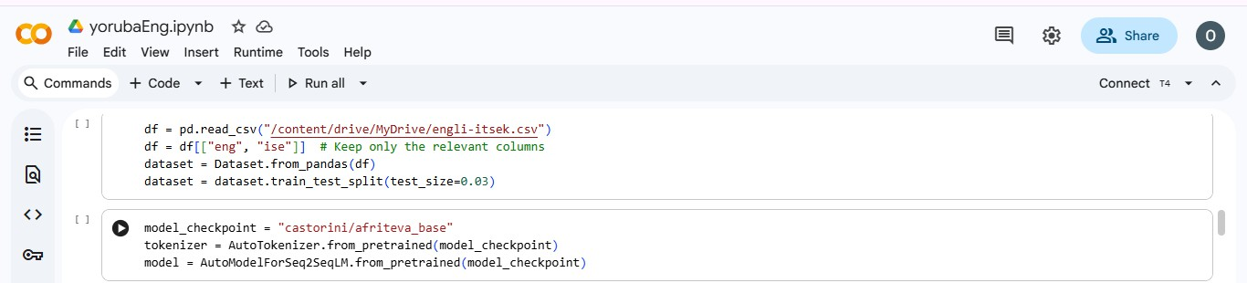
Figure 4.0: DataSet Train-Test Split in Google Colab

During the finetuning process, it became clear that attempting to achieve broad generalization would not be feasible with such a limited dataset. For this reason, I adopted a memorization- driven approach, intentionally allowing the model to overfit. This strategy ensures that the model performs exceptionally well on the sentences it was trained on, but it will understandably perform poorly on unseen sentences that were not part of the training data.
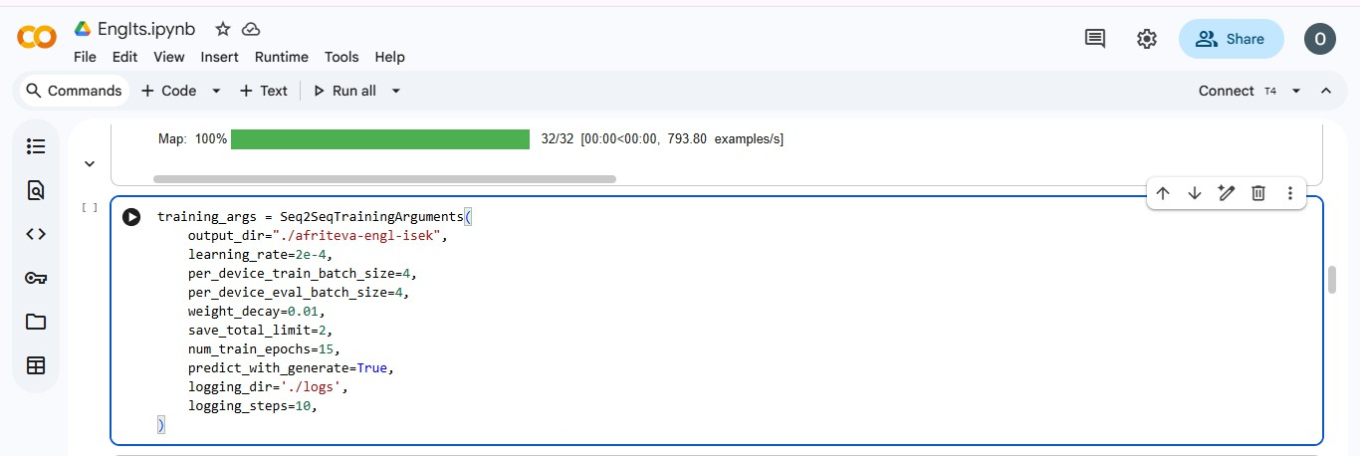
Figure 4.1: Hypeparameter Experiment in Google Colab

To successfully induce overfitting, I trained the model for 15 epochs and applied a linear learning rate decay, with a learning rate of 2e-4. This configuration led to a validation loss of 0.18, demonstrating that the model effectively memorized the training examples as intended for the MVP stage.
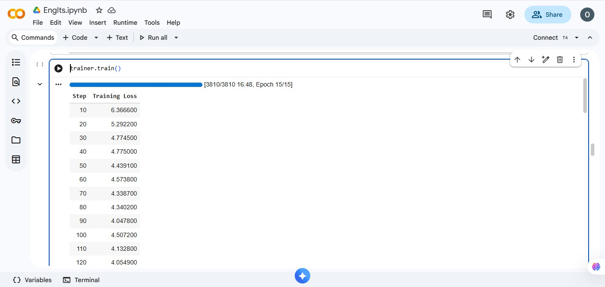
Figure 4.2: AfriTeva_Base Traininng Process in Google Colab

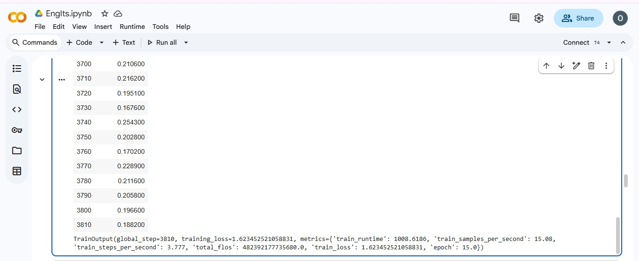
Figure 4.3: Fine Tuned AfriTeva_Base model in Google Colab

MODEL OUTPUT IN GOOGLE COLAB
The result shown in the figure below demonstrates that the finetuned Afriteva English–Itsekiri model successfully loads from the saved directory and performs inference. The custom translate() function takes an English input sentence, tokenizes it, generates the Itsekiri translation, and decodes the output. When tested with the sentence “please make yourself comfortable”, the model produces the Itsekiri translation “mo be mọ aratuntun gbarare”, confirming that the model is functioning correctly and returning consistent translations based on the data it was trained on.
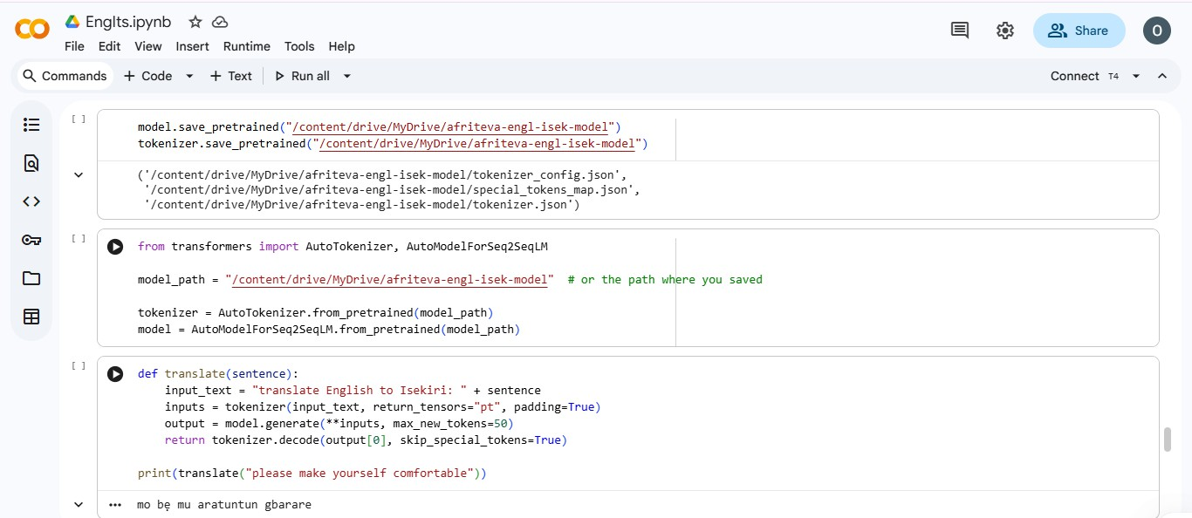
Figure 4.4: Model Test in Google Colab

STREAMLIT WEB APP
The user interface was developed using Streamlit, enabling seamless interaction with the model. The application was deployed via the Streamlit Community Cloud to ensure rapid availability. This framework was selected to streamline the development process, as it allows for the creation of fully functional web applications entirely in Python, eliminating the need for separate HTML, CSS, or JavaScript code.
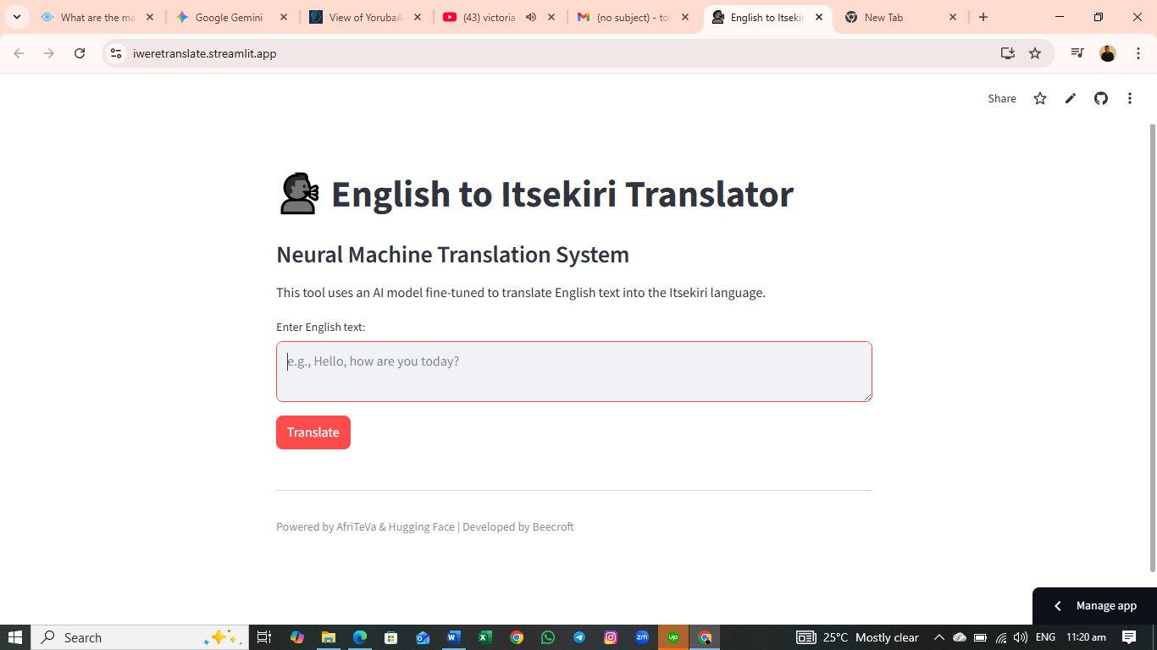
Figure 4.5: Translator WebApp

The deployment interface, hosted on Streamlit, provides a simple workflow for translation. It contains a designated text input field for the user to provide English text. The process is initiated by the "Translate" button; this triggers the inference pipeline, activating the fine-tuned Afriteva_base model to process the English input and return the translated Itsekiri text.

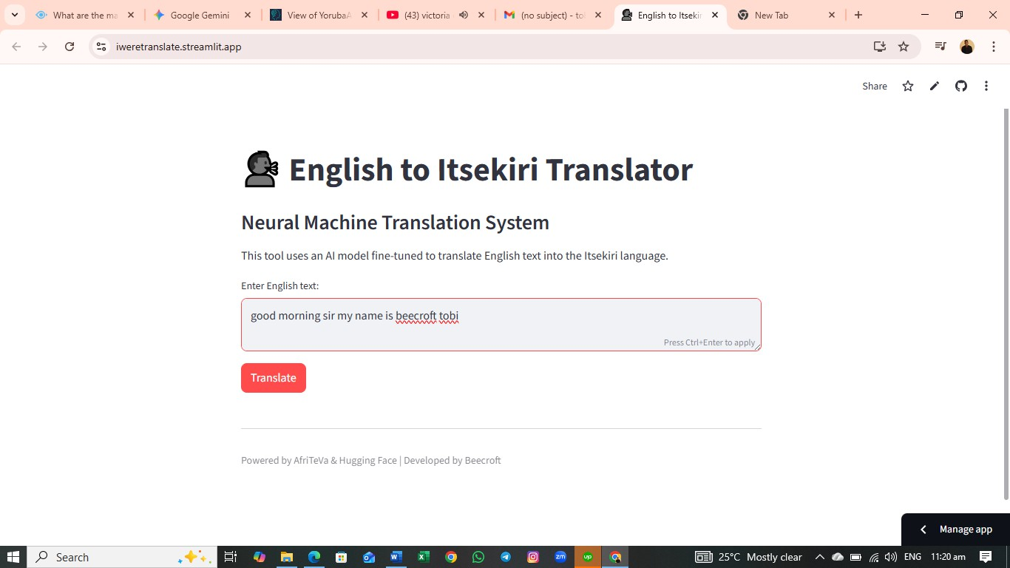
Figure 4.6: User enters an English Input

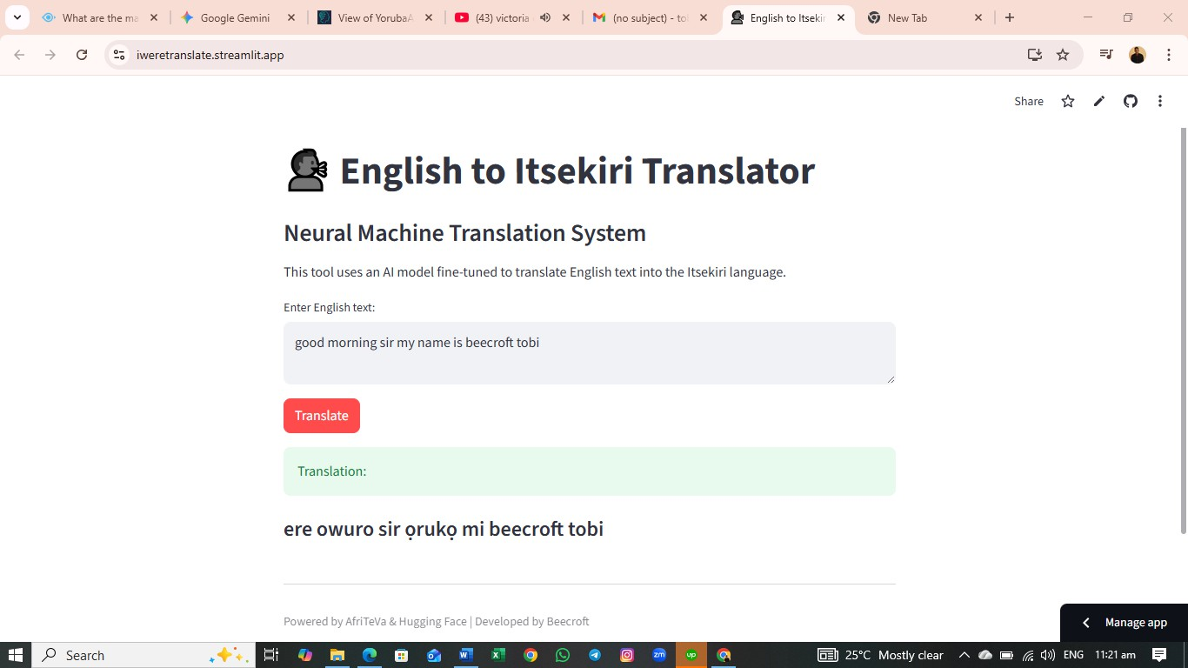
Figure 4.7: Translation Successful

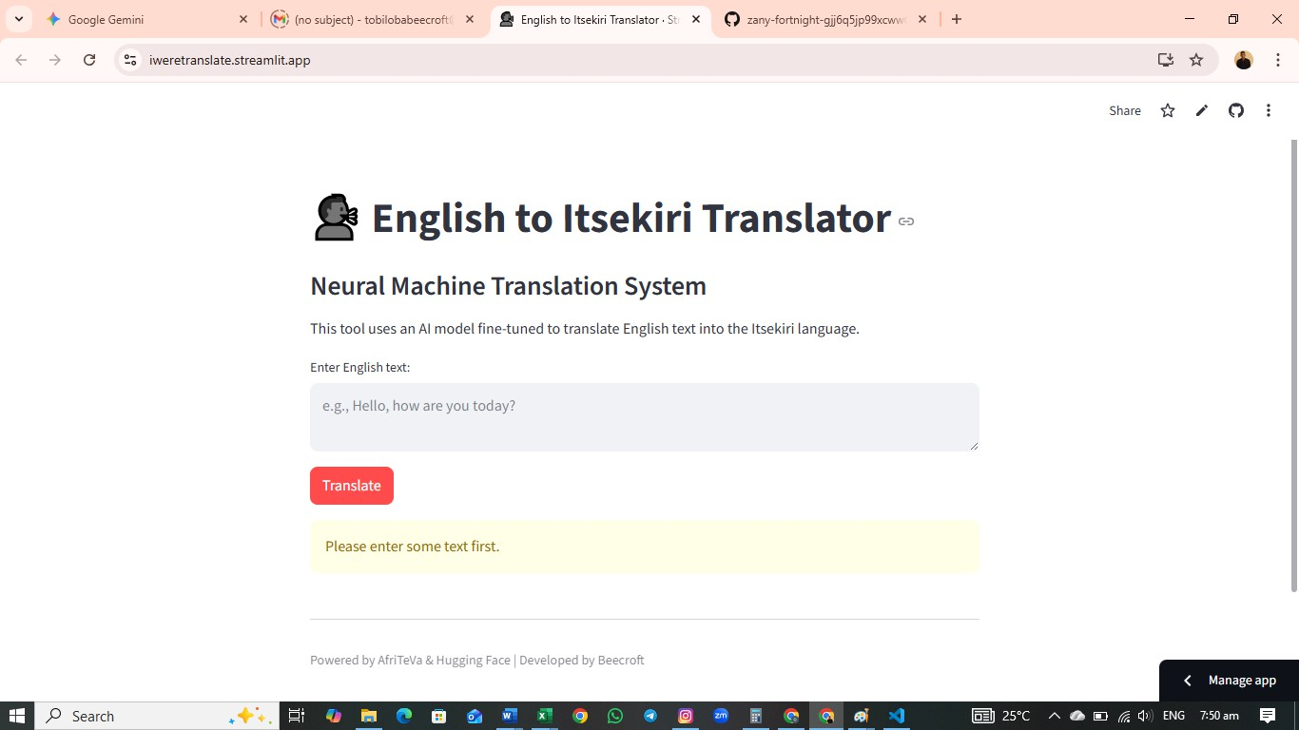
Figure 4.8: Error message if user did not enter English Input

SYSTEM EVALUATION
The system had a BLEU(Bilingual Evaluation Understudy) score of 3.62 due to the limited amount of data used for fine-tuning. It translates the training dataset perfectly but performs poorly on sentences it has not seen.
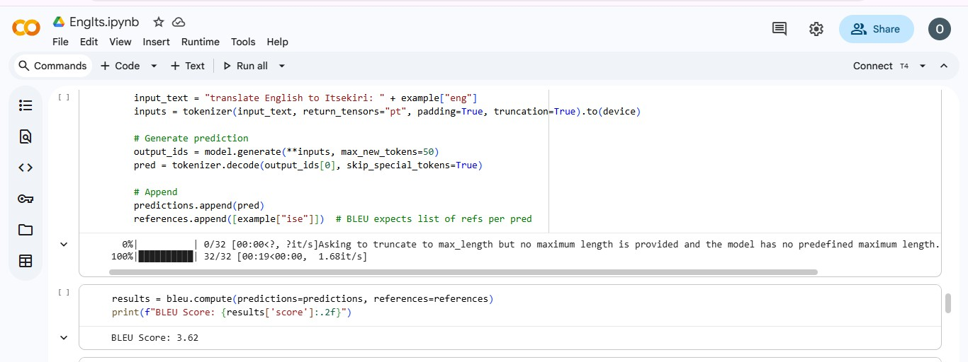
Figure 4.9: BLEU(Bilingual Evaluation Understudy) Score

The graph highlights a specific test sample (around index 14) where the model registered a minimal BLEU score of approximately 0.004. However, the remaining samples flatline at 0.0, a trend that aligns with the intentional overfitting strategy. This stark contrast against the model's perfect training accuracy confirms that the system has successfully memorized the

training set but, as expected, lacks the capacity to generalize to unseen sentences as seen in the figure below
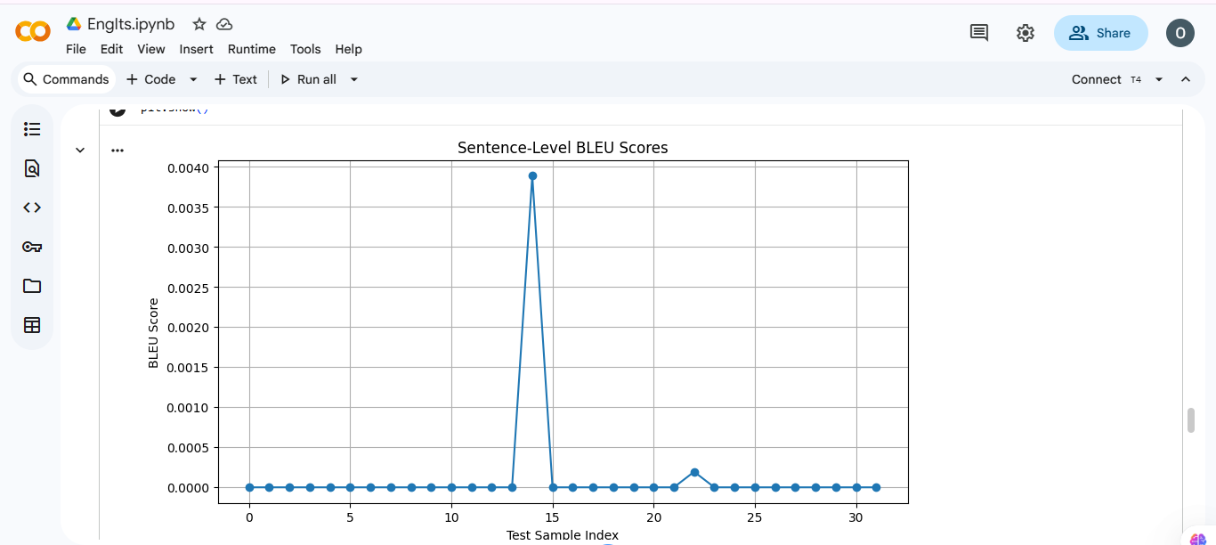
Figure 4.10: Line Chart for BLEU(Bilingual Evaluation Understudy) Score

CHAPTER FIVE

SUMMARY, CONCLUSION AND RECOMMENDATIONS

SUMMARY
This project presents a functional English–Itsekiri neural machine translation system developed using the Afriteva_base pretrained model. The system was created with a clear practical objective: to produce accurate translations for everyday conversational sentences that can assist beginners, non-native speakers, and individuals who need to express basic ideas in Itsekiri. Unlike large-scale translation systems built on extensive datasets, this work responds to a distinct challenge involving the limited availability of written and digitized Itsekiri material. Everyday conversational expressions, which form the backbone of real-life communication, are not well documented and this significantly restricted the volume of data available for training.
To address this constraint, the dataset was intentionally curated around high-frequency, commonly used phrases. During finetuning, a memorization-based strategy was adopted, enabling the model to intentionally overfit and achieve high accuracy on the specific examples it was trained on. Although this approach limits the model’s ability to generalize to unseen sentences, it ensures dependable performance within its intended scope. The training process involved multiple epochs and a carefully managed learning rate schedule, resulting in stable behaviour and a low validation loss.
The final translation system is fully functional. It loads the trained model and tokenizer, processes English input sentences, and produces coherent Itsekiri translations. This work demonstrates the potential of neural machine translation for low-resource languages and contributes to ongoing efforts to support the digital preservation, accessibility, and revitalization of the Itsekiri language. As an MVP, it provides a strong foundation for future

improvements, including the use of larger datasets, enhanced generalization, and expanded coverage of linguistic structures and domains.

CONCLUSION
Language preservation requires modern tools. This project introduces one of the first Neural Machine Translation systems dedicated to the Itsekiri language. By combining deep learning techniques with a seamless Streamlit web interface, the system allows users to input English text and receive Itsekiri translations.

RECOMMENDATION
Data is the core resource for improving the quality and generalization capabilities of this system. Although the current model was trained on 1,015 English–Itsekiri sentence pairs, building a fully robust and production-ready translator would require a dataset of at least 10,000 high-quality examples. Expanding the dataset will significantly enhance accuracy, reduce overfitting, and allow the model to handle a wider range of sentence structures and real-world variations. In addition, the current system supports only text-to-text translation. Future development can extend its functionality by integrating text-to-speech capabilities, enabling users to not only read but also hear the correct pronunciation of translated Itsekiri sentences.

REFERENCES
Adeboje, O. T., & Akinyede, R. O. (2025). A Deep Learning-based English to Yoruba Neural Translation Model. 186(62), 38–41.
Agyei, E., Zhang, X., Bannerman, S., Quaye, A. B., Yussi, S. B., & Agbesi, V. K. (2025).

Low resource Twi-English parallel corpus for machine translation in multiple domains (Twi-2-ENG). Discover Computing, 27(1).
al Maaytah, S. A. (2025). Evaluating Three Neural Machine Translation Platforms for English-Arabic Translation: A Comparative Study of Linguistic Accuracy and Cultural Fidelity. World Journal of English Language, 16(2), 1.
Araabi, A., & Monz, C. (2020). Optimizing Transformer for Low-Resource Neural Machine Translation.
David Ifeoluwa Adelani. (2022). Natural_language_processing_for_African_languages (1).

Ekle, O. A., & Das, B. (2025). Low-Resource Neural Machine Translation Using Recurrent Neural Networks and Transfer Learning: A Case Study on English-to-Igbo. April.
Esan, A., Oladosu, J., Oyeleye, C., Adeyanju, I., Olaniyan, O., Okomba, N., Omodunbi, B., & Adanigbo, O. (2020). Development of a recurrent neural network model for english to yoruba machine translation. International Journal of Advanced Computer Science and Applications, 11(5), 602–609.
Etim-James, G., & Ubi, U. (2024). The Impact of Globalization on Nigerian Culture and Language: A Study of Ekid Language. Policy and Governance Research (JPAPGR), 2(2), 22–28.

Gbelewade, A. (2025). Science in Mother tongue : English-to-Yoruba STEM translation.

April.

Hameed, A. (2025). TRANSFORMER MODELS IN LOW-RESOURCE LANGUAGE TRANSLATION.
Javed, A., Zan, H., Mamyrbayev, O., Abdullah, M., Ahmed, K., Oralbekova, D., Dinara, K., & Akhmediyarova, A. (2025). Transformer-Based Re-Ranking Model for Enhancing Contextual and Syntactic Translation in Low-Resource Neural Machine Translation. Electronics (Switzerland), 14(2).
Jean, G. (2023). Cross-Lingual Transfer Learning for Low-Resource NLP Tasks: Leveraging Multilingual Pretrained Models.
Kagan Yazar, B., & Kiliç, E. (2023). Using Kolmogorov-Arnold Networks in Transformer model: a study on low-resource neural machine translation.
Kakum, N., Laskar, S. R., Sambyo, K., & Pakray, P. (2023). Neural machine translation for limited resources English-Nyishi pair. Sadhana - Academy Proceedings in Engineering Sciences, 48(4).
Konyk, M., Vysotska, V., Goloshchuk, S., Holoshchuk, R., Chyrun, S., & Budz, I. (2023). Technology of Ukrainian-English Machine Translation Based on Recursive Neural Network as LSTM. CEUR Workshop Proceedings, 3387, 357–370.
Kozhirbayev, Z., & Yessenbayev, Z. (2025). Fine-Tuning Methods and Dataset Structures for Multilingual Neural Machine Translation: A Kazakh–English–Russian Case Study in the IT Domain. Electronics (Switzerland), 14(15).

Lakew, S. M., Negri, M., & Turchi, M. (2020). Low Resource Neural Machine Translation: A Benchmark for Five African Languages.
Lankford, S. (2024). Enhancing Neural Machine Translation of Low-Resource Languages: Corpus Development, Human Evaluation and Explainable AI Architectures.
Lankford, S., Afli, H., & Way, A. (2023). adaptMLLM: Fine-Tuning Multilingual Language Models on Low-Resource Languages with Integrated LLM Playgrounds. Information (Switzerland), 14(12).
Liang, X., Jasmina Khaw, Y. M., Liew, S. Y., Tan, T. P., & Qin, D. (2025). Toward Low- Resource Languages Machine Translation: A Language-Specific Fine-Tuning With LoRA for Specialized Large Language Models. IEEE Access, 13, 46616–46626.
Liu, D., Li, Y., Zhu, D., Liu, X., Ma, N., & Zhu, A. (2020). Investigating Back-Translation in Tibetan-Chinese Neural Machine Translation. Journal of Physics: Conference Series, 1651(1).
M.M., O., & Noah, P. (2021). Cultural Dominance and Language Endangerment: The case of Efut in Cross River State, Nigeria. Macrolinguistics, 9(14), 134–150.
Mathavan, A. S. (2025). MULTILINGUAL LLMS FOR LOW-RESOURCE LANGUAGE
TRANSLATION AND PRESERVATION. In JAICS) An International Open Access, Peer-Reviewed, Refereed Journal (Issue 9).
Matthew, B. (2025). Optimizing Transformer-based Models for Low-Resource Languages Using Transfer Learning Techniques.
Mbogho, A., Awuor, Q., Kipkebut, A., Wanzare, L., & Oloo, V. (2025). Building low- resource African language corpora: A case study of Kidawida, Kalenjin and Dholuo.

Moteu Ngoli, T., Christabel, M., & Yopa, N. (2025). Challenges and Limitations in Gathering Resources for Low-Resource Languages: The Case of Medumba. 136–142.
Moudjar, A., Amina, M., Belahcene, B., & Hassina, A. (2025). Parameter-Efficient Fine- Tuning for LLM-Based Arabic-to-English Machine Translation.
Muhammad, S. H., Ahmad, I. S., Abdulmumin, I., Lawan, F. I., Sani, B., Imam, S. H.,

Aliyu, Y., Sani, S. A., Umar, A. U., Gwadabe, T., Church, K., & Marivate, V. (2025). HausaNLP: Current Status, Challenges and Future Directions for Hausa Natural Language Processing.
Nzeaka, E., & Ehondor, B. (2021). Urbanisation and Endangered African Indigenous

Tongues : The Case of Igbo Language in Nigeria. June.

Olawale Timothy, A., Olusola Adebayo, A., Gabriel Junior, A., & Raphael Olufemi, A. (2024). Bilingual Neural Machine Translation From English To Yoruba Using A Transformer Model. International Journal of Innovative Science and Research Technology (IJISRT), July, 826–833.
Pramodya, A., Mahima, K. T. Y., Pushpananda, R., & Weerasinghe, R. (2024). Enhancing Neural Machine Translation for the Sinhala-Tamil Language Pair with Limited Resources. International Journal on Advances in ICT for Emerging Regions (ICTer), 17(1), 24–33.
Raffel, C., Shazeer, N., Roberts, A., Lee, K., Narang, S., Matena, M., Zhou, Y., Li, W., & Liu, P. J. (2020). Exploring the limits of transfer learning with a unified text-to-text transformer. Journal of Machine Learning Research, 21, 1–67.
Raja, R., & Vats, A. (2025). Parallel Corpora for Machine Translation in Low-Resource Indic Languages: A Comprehensive Review. 129–143.

Raychawdhary, N., Bhattacharya, S., Seals, C., & Dozier, G. (2025). Empowering Sentiment Analysis in African Low-Resource Languages through Transformer Models and Strategic Language Selection. IEEE Access.
Sadula, V., & Ramesh, D. (2025). Enhancing Cross Language for English-Telugu pairs through the Modified Transformer Model based Neural Machine Translation.
International Journal of Computational and Experimental Science and Engineering, 11(2), 2338–2351.
Sel, I., & Hanbay, D. (2024). Efficient Adaptation: Enhancing Multilingual Models for Low- Resource Language Translation. Mathematics, 12(19).
Stap, D., Hasler, E., Byrne, B., Monz, C., & Tran, K. (2024). The Fine-Tuning Paradox: Boosting Translation Quality Without Sacrificing LLM Abilities.
Sunday Adewale, O., Agbonifo, O. C., Olaniyan, J., Olumide Sunday, A., Oluwatoyin Catherine, A., & Julius, O. (2023). Development of Bi-Directional English To Yoruba Translator for Real-Time Mobile Chatting. In International Journal of Computational Linguistics (IJCL) (Issue 11).
Tamrin, Zalmansyah, A., Yance, I., Asri B., M., Karsana, D., Harum, D. M., Supriadi, A., Yono, S., Hidayat, S., & Wardhani, A. (2025). Endangered Language: Preserving Totoli Language and Cultural Identity. Theory and Practice in Language Studies, 15(6), 1885–1897.
Tolani Grace, O., Olusola Adebayo, A., & Olutayo Kehinde, B. (2024). A Transformer- Based Yoruba to English Machine Translation (TYEMT) System with Rouge Score. International Journal of Innovative Science and Research Technology (IJISRT), 2787–2797.

Umar, U. B., & Dutse, A. Y. (2024). NUPE-ENGLISH NEURAL MACHINE TRANSLATION USING SEQUENCE TO SEQUENCE MODEL WITH
ATTENTION MECHANISM. In Article in Natural Language Processing Journal.

Wei, B., Zhen, J., Li, Z., Wu, Z., Wei, D., Guo, J., Rao, Z., Li, S., Luo, Y., Shang, H., Yang, J., Xie, Y., & Yang, H. (2024). Machine Translation Advancements of Low-Resource Indian Languages by Transfer Learning.
Xu, B. (2022). English-Chinese Machine Translation Based on Transfer Learning and Chinese-English Corpus. Computational Intelligence and Neuroscience, 2022.
Yakhni, S., & Chehab, A. (2025). Fine-Tuning LLMs for Low-Resource Dialect Translation: The Case of Lebanese.

APPENDIX A

Model Training

from google.colab import drive drive.mount('/content/drive')
!pip install transformers datasets sentencepiece evaluate sacrebleu import pandas as pd
import numpy as np

from datasets import Dataset

from transformers import AutoTokenizer, AutoModelForSeq2SeqLM

from transformers import Trainer, Seq2SeqTrainingArguments, DataCollatorForSeq2Seq

from tqdm import tqdm import evaluate
bleu = evaluate.load("sacrebleu")

df = pd.read_csv("/content/drive/MyDrive/engli-itsek.csv") df = df[["eng", "ise"]] # Keep only the relevant columns dataset = Dataset.from_pandas(df)
dataset = dataset.train_test_split(test_size=0.03) model_checkpoint = "castorini/afriteva_base"
tokenizer = AutoTokenizer.from_pretrained(model_checkpoint)

model = AutoModelForSeq2SeqLM.from_pretrained(model_checkpoint) prefix = "translate English to Itsekiri: "

def preprocess_function(example): input_text = prefix + example["eng"]

target_text = example["ise"]

model_inputs = tokenizer(input_text, max_length=128, truncation=True) with tokenizer.as_target_tokenizer():
labels = tokenizer(target_text, max_length=128, truncation=True)

model_inputs["labels"] = labels["input_ids"] return model_inputs
tokenized_dataset = dataset.map(preprocess_function)

training_args = Seq2SeqTrainingArguments( output_dir="./afriteva-engl-isek", learning_rate=2e-4, per_device_train_batch_size=4, per_device_eval_batch_size=4, weight_decay=0.01,
save_total_limit=2, num_train_epochs=15, predict_with_generate=True, logging_dir='./logs', logging_steps=10,
)

def compute_metrics(eval_preds): predictions, labels = eval_preds

# Remove ignored index (like -100) in the labels used for loss calculation

labels = np.where(labels != -100, labels, tokenizer.pad_token_id)

decoded_preds = tokenizer.batch_decode(predictions, skip_special_tokens=True) decoded_labels = tokenizer.batch_decode(labels, skip_special_tokens=True)

decoded_labels = [[label] for label in decoded_labels] # BLEU expects list of lists

result = bleu.compute(predictions=decoded_preds, references=decoded_labels) return {"bleu": result["bleu"]}
data_collator = DataCollatorForSeq2Seq(tokenizer=tokenizer, model=model)

trainer = Trainer( model=model, args=training_args,
train_dataset=tokenized_dataset["train"], eval_dataset=tokenized_dataset["test"], tokenizer=tokenizer, data_collator=data_collator, compute_metrics=compute_metrics,

)

trainer.train()

# Create lists for predictions and references predictions = []
references = []

device = model.device

# Loop through your test dataset

for example in tqdm(tokenized_dataset["test"]): # Prepare input
input_text = "translate English to Itsekiri: " + example["eng"] inputs = tokenizer(input_text, return_tensors="pt", padding=True,
truncation=True).to(device)

# Generate prediction

output_ids = model.generate(**inputs, max_new_tokens=50)

pred = tokenizer.decode(output_ids[0], skip_special_tokens=True)

# Append predictions.append(pred)
references.append([example["ise"]]) # BLEU expects list of refs per pred results = bleu.compute(predictions=predictions, references=references) print(f"BLEU Score: {results['score']:.2f}")
from nltk.translate.bleu_score import sentence_bleu, SmoothingFunction import matplotlib.pyplot as plt

smoothie = SmoothingFunction().method4

sentence_bleus = []

for ref, pred in zip(references, predictions):

score = sentence_bleu(ref, pred.split(), smoothing_function=smoothie)

sentence_bleus.append(score) plt.figure(figsize=(10, 5)) plt.plot(sentence_bleus, marker='o') plt.title("Sentence-Level BLEU Scores") plt.xlabel("Test Sample Index") plt.ylabel("BLEU Score")
plt.grid(True) plt.show()
model.save_pretrained("/content/drive/MyDrive/afriteva-engl-isek-model") tokenizer.save_pretrained("/content/drive/MyDrive/afriteva-engl-isek-model") from transformers import AutoTokenizer, AutoModelForSeq2SeqLM

model_path = "/content/drive/MyDrive/afriteva-engl-isek-model" # or the path where you saved

tokenizer = AutoTokenizer.from_pretrained(model_path)
model = AutoModelForSeq2SeqLM.from_pretrained(model_path) def translate(sentence):
input_text = "translate English to Isekiri: " + sentence

inputs = tokenizer(input_text, return_tensors="pt", padding=True) output = model.generate(**inputs, max_new_tokens=50)
return tokenizer.decode(output[0], skip_special_tokens=True)

print(translate("please make yourself comfortable"))

Uploading of the Model to Hugging Face

from huggingface_hub import create_repo, notebook_login # 1. Login (if you haven't already)
notebook_login() repo_name = "trans-work"
# Set private=True if you don't want the world to see it yet

# Set exist_ok=True so it doesn't crash if you run the cell twice create_repo(repo_name, private=False, exist_ok=True)

print(f"Repo created successfully at: https://huggingface.co/YOUR_USERNAME/{repo_name}")

from huggingface_hub import HfApi api = HfApi()
your_username = "beecroft" # Replace with your HF username repo_name = "trans-work" # The repo you created earlier
model_folder_path = "/content/drive/MyDrive/afriteva-engl-isek-model" # PASTE YOUR PATH HERE

# 3. Upload

# This will upload EVERYTHING in that folder (model.safetensors, tokenizer.json, etc.) api.upload_folder(
folder_path=model_folder_path, repo_id=f"{your_username}/{repo_name}", repo_type="model"

)

print("Upload Complete! Check your repo.")

StreamLit Code for Deployment
import streamlit as st

from transformers import AutoTokenizer, AutoModelForSeq2SeqLM

# 1. Page Configuration st.set_page_config(
page_title="English to Itsekiri Translator", page_icon=" !",
layout="centered"

)

@st.cache_resource

def load_model_pipeline(): model_path = "Beecroft/trans-work"
tokenizer = AutoTokenizer.from_pretrained(model_path)
model = AutoModelForSeq2SeqLM.from_pretrained(model_path) return tokenizer, model

# Load the model (this shows a spinner while loading) with st.spinner('Loading Model... Please wait...'):
tokenizer, model = load_model_pipeline()

# 3. The Translation Function def translate(sentence):
prefix = "translate English to Itsekiri: " input_text = prefix + sentence
inputs = tokenizer(input_text, return_tensors="pt", padding=True)

# Generate translation

outputs = model.generate(**inputs, max_new_tokens=50) return tokenizer.decode(outputs[0], skip_special_tokens=True)

# 4. User Interface

st.title(" ! English to Itsekiri Translator") st.markdown("### Neural Machine Translation System")
st.write("This tool uses an AI model fine-tuned to translate English text into the Itsekiri language.")

# Text Input Area

text_input = st.text_area("Enter English text:", height=100, placeholder="e.g., Hello, how are you today?")

# Translate Button

if st.button("Translate", type="primary"): if text_input.strip() == "":
st.warning("Please enter some text first.") else:

with st.spinner("Translating..."): try:
translation = translate(text_input) st.success("Translation:") st.markdown(f"#### {translation}")
except Exception as e:

st.error(f"An error occurred: {e}")

# Footer st.markdown("---")
st.caption("Powered by AfriTeVa & Hugging Face | Developed by Beecroft")

APPENDIX B

SAMPLE OUTPUT
All user interface designs and sample outputs have been integrated directly into Chapter Four: System Implementation.
These figures provide contextual evidence for the implementation of the hardware and software components.

Model Development & Testing:


Sample Output 1: DataSet Train-Test Split in Google Colab



Sample Output 2: AfriTeva_Base Training Process in Google Colab


Sample Output 3: Fine-Tuned AfriTeva_Base model in Google Colab


Sample Output 4: Model Test in Google Colab

- Streamlit WebApp UI: See Figures 4.5 to 4.8.

Sample Output 5: Translator WebApp



Sample Output 6: User enters an English Input



Sample Output 7: Translation Successful



Sample Output 8: Error message if user did not enter English Input

- Model Evaluation: See Figure 4.9 to 4.10


Sample Output 9: BLEU(Bilingual Evaluation Understudy) Score


Sample Output 10: Line Chart for BLEU(Bilingual Evaluation Understudy) Score
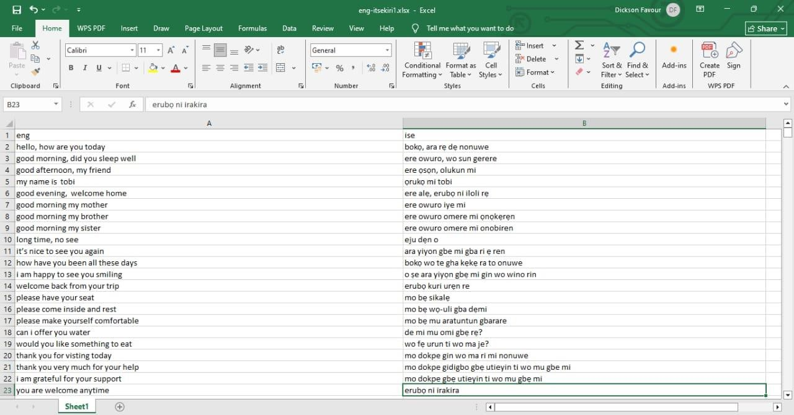

Sample Output 11: Parallel Bilingual Corpus

APPENDIX C

DATASETS

The Dataset which is the Parallel Corpus is stored in a Google Drive and it can be accessible through this link: https://drive.google.com/file/d/1hoOL4_wRfo1flN0HSKIUI0TfzCNehAuK/view?usp=sharin
g

The FineTuned Afriteva Model can be accessed through this link: https://huggingface.co/Beecroft/trans-work

