**Product Summary**

**LikeU’s Unique Features and Functions:**

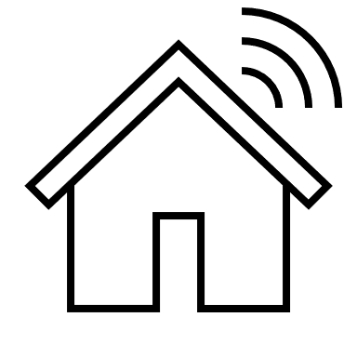

**Main Activity Hub** – Our breathtaking and easily navigable Main Activity Hub allows browsing one’s personal feed an enjoyable experience.

**About Us** – A page worth noting of great information about the creators of LikeU and the values this site stands for.

**Contact Us** – Giving the user the right to get in touch with us developers if need.



**3 Like System** – Exclusive to LikeU, that gives new meaning to responding to other users’ posts, through a tri-liking system formed to the user’s preference.

**Additional Functions:**

 **Account Creation** – A new guest signs up to create their own personal LikeU account.

**Sign In/ Sign Out** - Allows the user to sign in and sign out of their own personal profile.

**Profile Page/Editing** - A page where users can customize their bio to be displayed.

**Search for Users** – Permits oneself to search for another use through a search bar at the top of the Main Activity Hub Page.



**Upload posts and Captioning** – Authorizing the user to make post to the Main Activity Hub along with the option to add a caption if one pleases to.

**Commenting** – Offering users to add a comment under each post that will be displayed.