DA541A Laboratory report

Durim Miziraj
19851202-5092

Lab 1
This is the first lab assignment for the course “Data Communication and Networks” (DA541A HT26).
It consists of three subtasks, these are “Find your IP address, MAC address and DNS server address”, “Find mapping between domain name and IP address” and “Handle the DNS cache”.
No references are made to the subtasks, the questions are answered sequentially, starting from question one to question nine.
I am running Ubuntu 24.04.4, all commands assume this environment.

Answer to question 1 - What are the IP address and MAC address for the active Internet connection on your computer?
The IP-address for the active internet connection on my computer can be found with the following command.
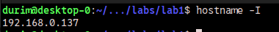

The MAC-address for the active internet connection on my computer can be found with the following command.
Note: “enp3s0” is the name for my specific network interface.

Answer to question 2 - What is the configured DNS server IP address?
‘resolvectl’ points to my router as the configured DNS server on my computer.
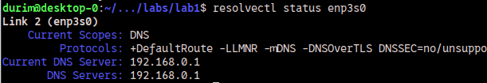

My router points to my ISP’s (Internet Service Provider) DNS server.
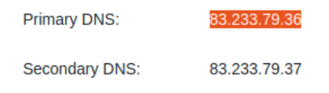

Verifying that my ISP is the owner of the DNS server.
Note: Bredband2 is my ISP.
The DNS server is used for mapping human-memorable addresses into IP-addresses.

Answer to question 3

What is the DNS server IP address used for this name resolution?
This points to my local name resolver, as verified by ’/etc/resolv.conf’.

What are the IP addresses for the host www.MIT.edu?
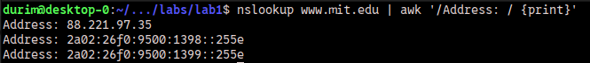
Note: Three addresses are given, one IPv4 address and two IPv6 addresses.

Is www.mit.edu an alias?
Yes, ‘www.mit.edu’ is an alias, and so is ‘www.mit.edu.edgekey.net’.

Answer to question 4.

What are the DNS servers responsible for domain names in mit.edu?
These are the DNS servers responsible for domain names in mit.edu.
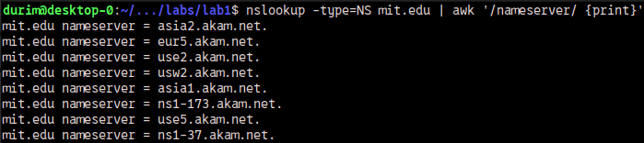

Find out these DNS server IP addresses (by using nslookup respectively on the name servers found in A).
These are the IP addresses of the DNS servers responsible for domain names in 'mit.edu’.
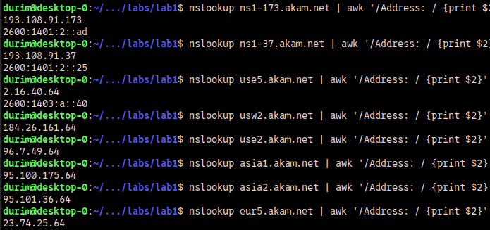

Answer to question 5.

Which DNS server is used for this name resolution?
The server with IP-address ‘8.8.8.8’ is used for this name resolution.
This server belongs to Google.
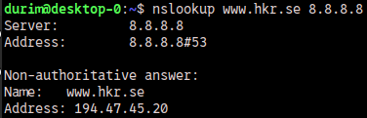

Do you find the IPv6 address for ’https://www.hkr.se/’?
No, I do not find the IPv6 address for ‘https://www.hkr.se/’.
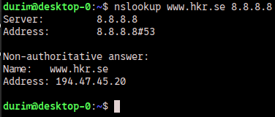

Answer to question 6 - Does the long name for 220.135.143.45 cause any inconvenient for its users? Why or why not?
Yes, it causes inconvenience. The reasons are that it is not human-memorable and that it takes time to type out.
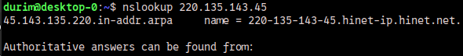

Answer to question 7 - where is the mail to sandra.roos@hkr.se sent?
Mails to ’sandra.roos@hkr.se’ are sent to ’hkr-se.mail.protection.outlook.com’.
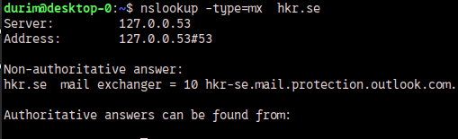

Answer to question 8

What IP addresses do you find for the web server www.google.com/ from the 3 queries above?
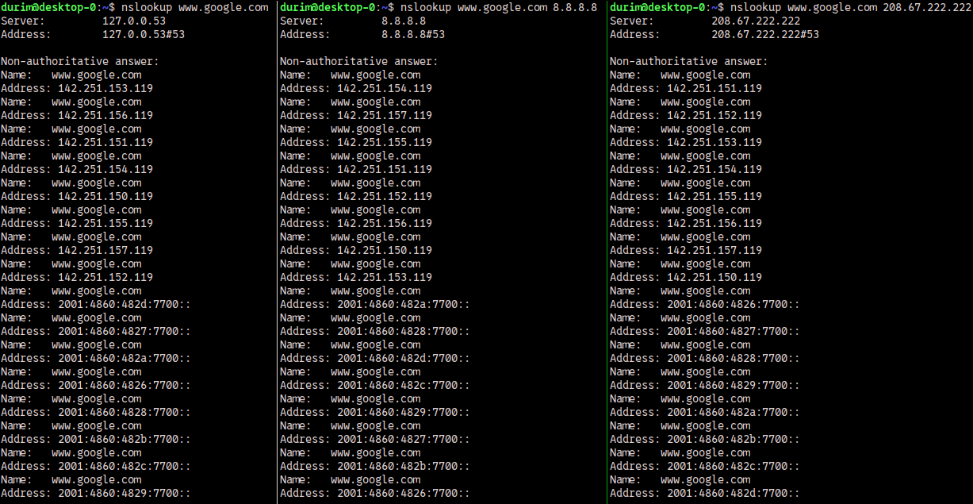

Explain your understanding on the load balancing technique based on DNS service.
DNS can support load balancing by having several IP-addresses for one hostname. The first adress to be returned is the one that is contacted. And as evidenced by the differing order of addresses, the first IP-address to be returned is not always the same. The first IP-address to be returned is assumed to be the one under the least amount of load, or the one that is closest to the requestee.

Answer to question 9 - How many domain names have been cached on your computer?
Twenty-seven domain names have been cached on my computer.
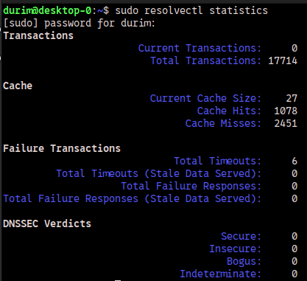

Lab 2

Answer to question 1

Answer to question 2

Answer to question 3

