DA541A Laboratory report

Durim Miziraj
851202-5092

Lab 1
This is the first lab assignment for the course “Data Communication and Networks” (DA541A HT26). Here I will answer a total of nine questions regarding the location my IP address, MAC address and DNS server address, mappings between domain names and IP addresses and the handling of the DNS cache.
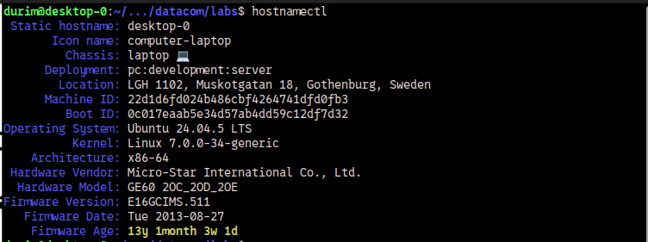
All answers come from tests, tasks and experiments done in this environment.

Answer to question 1
My computers local IP address is ”192.168.0.137”.

Answer to question 2
My local configured DNS server address is “192.168.0.1”.
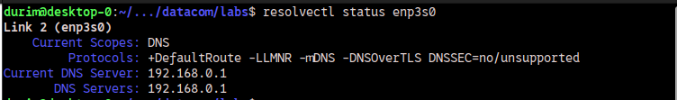
It is used for translating domain names into IP addresses.

Answer to question 3
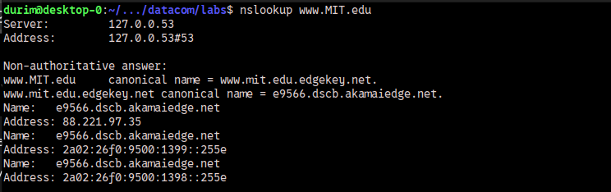
1. The DNS server IP address for this name resolution is “127.0.0.53”, which is my computers own name resolver.
2. The IP addresses for the host www.MIT.edu are “88.221.97.35”, “2a02:26f0:9500:1399::255e” and “2a02:26f0:9500:1398::255e”.
3. Yes, www.MIT.edu is an alias.

Answer to question 4
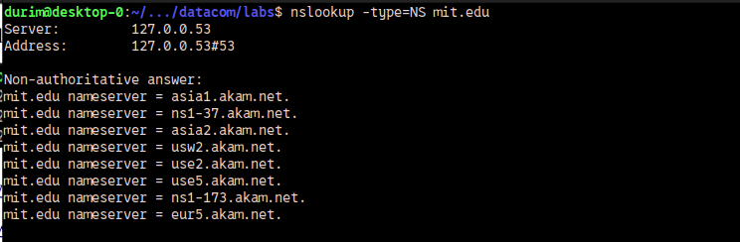
These are the DNS servers responsible for domain names in “mit.edu”.
Below are shown the IP addresses of the DNS servers above.
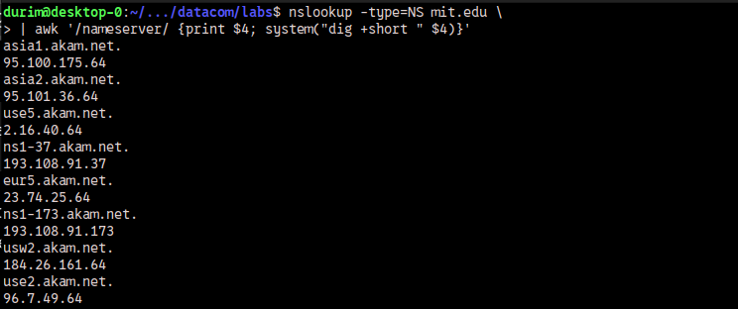

Answer to question 5
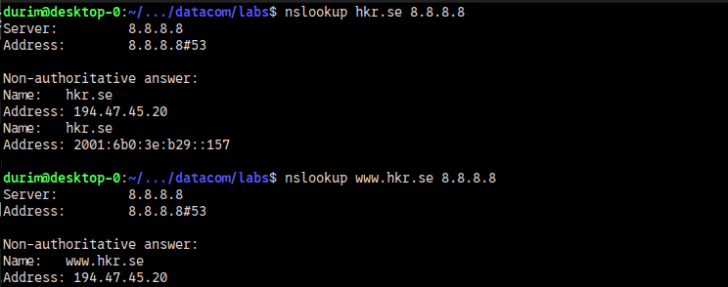
1. The DNS server used for the nameresolution of www.hkr.se is assigned by the IP address at the end of the command, namely “8.8.8.8”.
2. No, I do not find any IPv6 addresses on ‘www.hkr.se’, but I do find one on ‘hkr.se’.

Answer to question 6
Yes, the long name for 220.135.143.45 does cause inconvenience for users. Mainly because it is harder to remember, error prone and takes longer to type out.

Answer to question 7
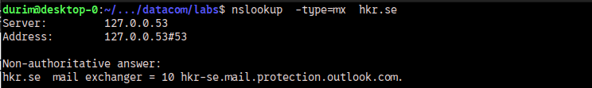
E-mail addressed to sandra.roos@hkr.se is sent to ‘hkr-se.mail.protection.outlook.com’.

Answer to question 8
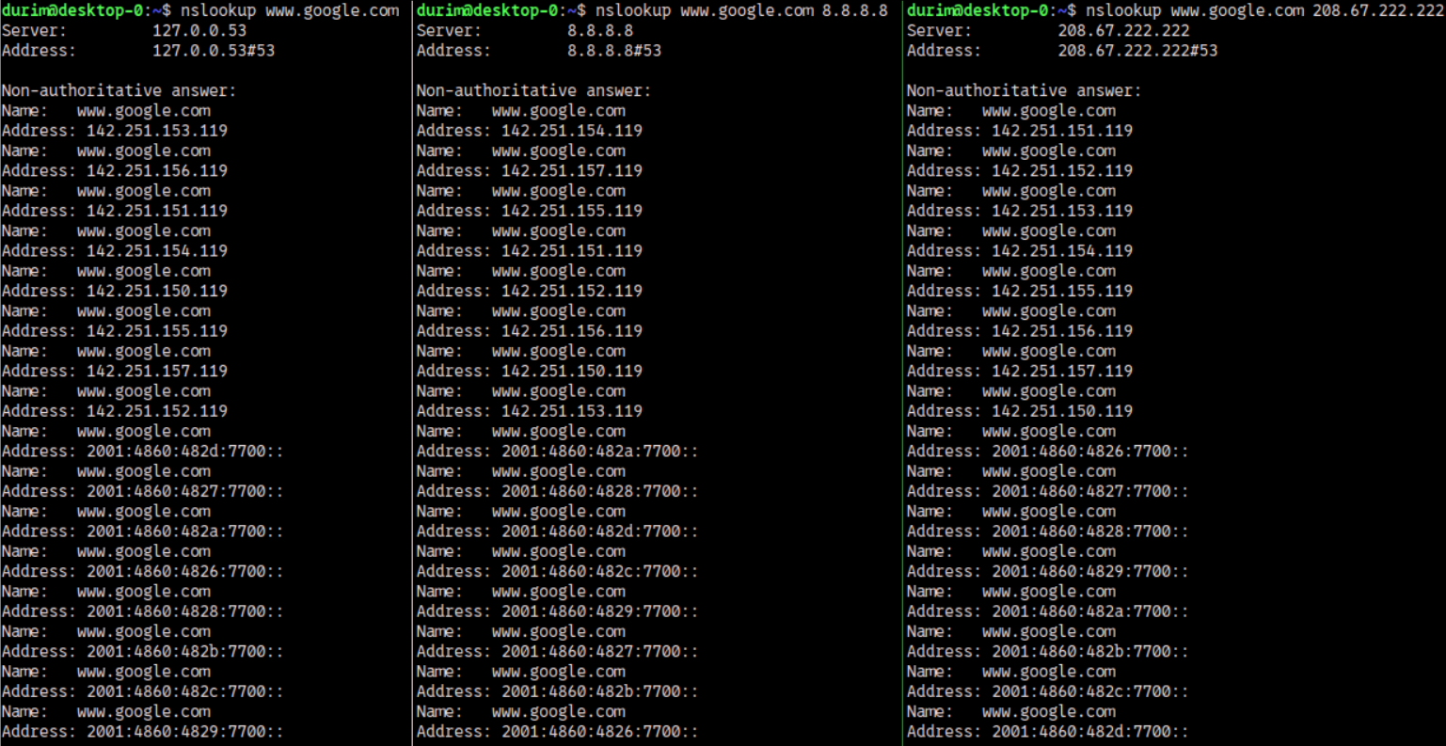
1. These are the IP addresses that I found for the queries in the assignment.
2. A DNS service can support load balancing by having several IP-addresses for one hostname. The first address to be returned is the one that is contacted. And as evidenced by the differing order of addresses, the first IP-address to be returned is not always the same. The first IP-address to be returned is assumed to be the one under the least amount of load, or the one that is closest to the requester.

Answer to question 9
Thirty-six domain names have been cached on my computer.

Lab 2
This is the second lab assignment for the course “Data Communication and Networks” (DA541A HT26). Here I will answer a total of nine question regarding the principles behind switch operations, including basic configurations, functions and purposes of static and dynamic routing.
All answers come from tests, tasks and experiments done in the environment referred to in the introduction to lab 1.
Task 1— The Basic HTTP GET command and response

Answer to question 1
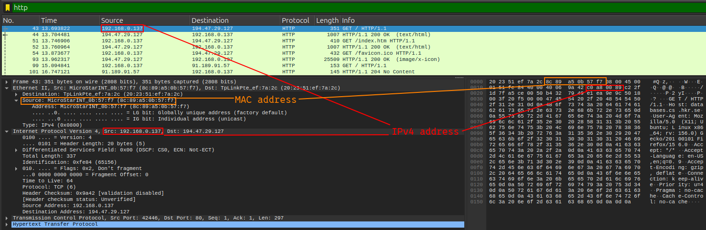
1. My IP address is “192.168.0.137”.
2. The MAC address corresponding to my computers only Ethernet port and therefore to my IP address is “8c:89:a5:0b:57:f7”.
3. They can be found in several ways. I retrieved the information from a HTTP packet captured by Wireshark. The source IP address is found at bytes 26 to 29 and the MAC address of my Ethernet interface is found at bytes 6 to 11.

Answer to question 2
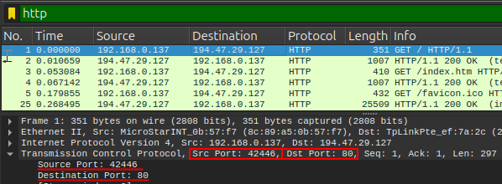

1. The port number for my browser is ‘42446’.
2. The remote http server’s port number is ‘80’.
3. These appear in the transport layer.
4. They are used by the the operating system for directing the information to the socket of the program that requested it.

Answer to question 3
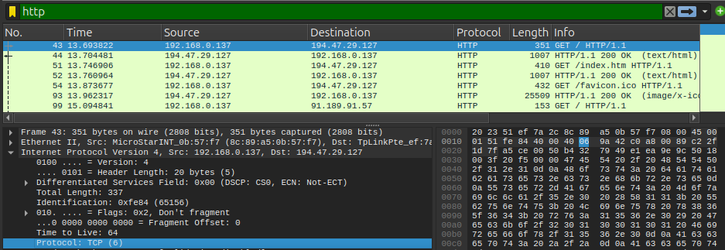
1. The transport layer protocol used for this GET message was the Transmission Control Protocol (TCP).
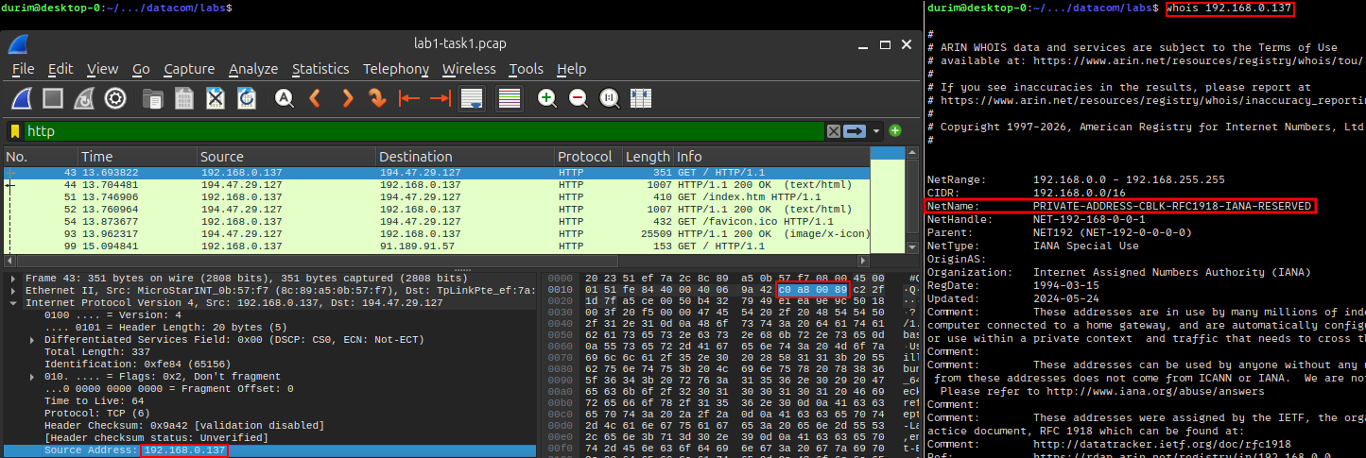
2. The source IP address is my computers local IP address.
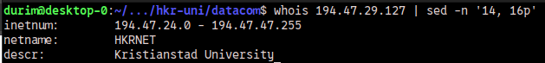
And the destination address is the remote web servers IP address.
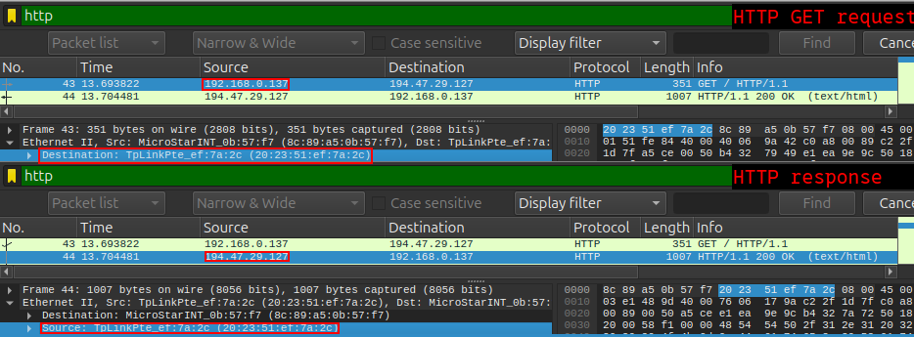
3. No. The destination MAC address at the top of the frame is the MAC address of my TP-link router. These MAC addresses only have relevance inside of their own local networks and never represent anything outside of the local network.

4. The calculations are specified in the table below, and the source for the numbers in the image below the table.
Note: Normally, I would not consider an initial HTTP GET request to have any HTTP payload, but since the assignment asks for a calculation of the HTTP payload, I have counted the header fields as the HTTP payload.
If this was a typo, please do not consider the calculation of the HTTP payload, consider it instead as the HTTP header.
_{HTTP header + payload} | _{16 + 281 = 297 B}
_{TCP header + payload} | _{20 + 297 = 317 B}
_{IP header + payload} | _{20 + 317 = 337 B}
_{Frameheader + payload} | _{14 + 337 = 351 B}
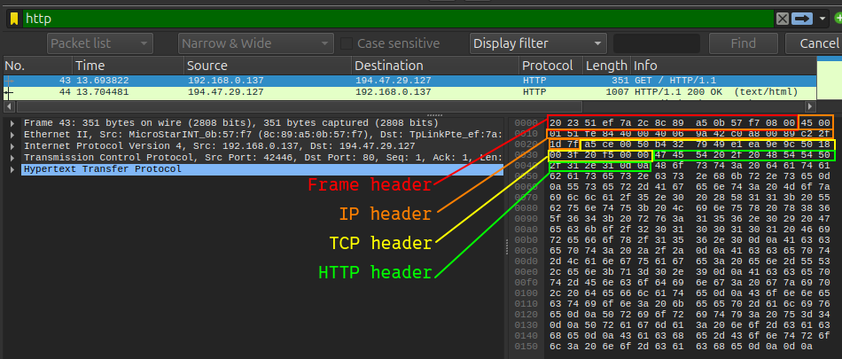

Answer to question 4
1. There are 9 header-lines / header-fields. The request line and the CRLF are not included.
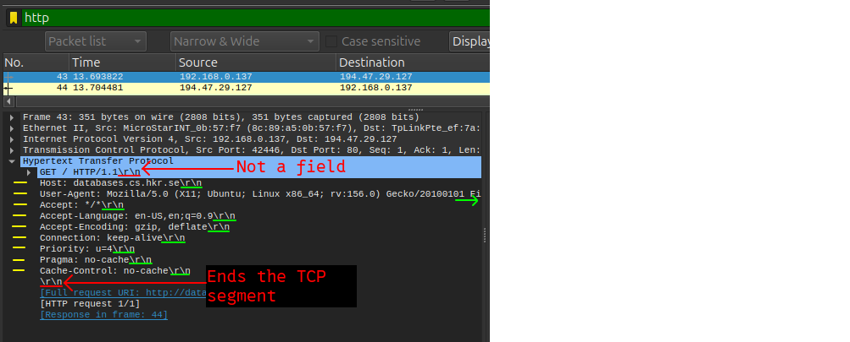
2. There is no http payload data, only headers.

Answer to question 5
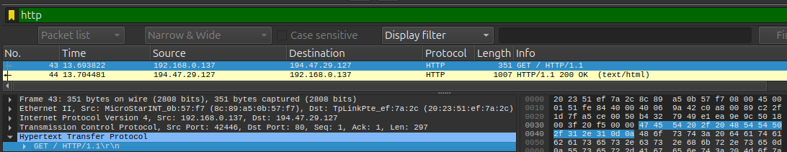
1. My browser is requesting and running ‘HTTP version 1.1’.
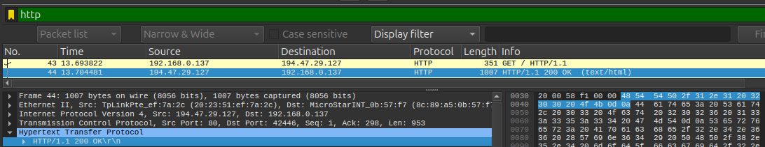
2. The server is running ‘HTTP version 1.1’. This is shown in the response to the first HTTP GET request.

Answer to question 6
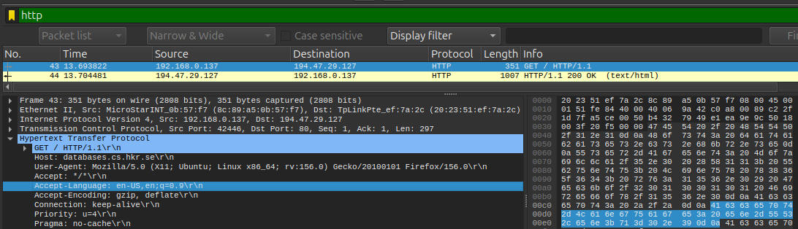
My browser has indicated that the language it can accept is “en-US” and “en” in the header field “Accept-Language”. This setup prefers US english, and then english generally if US english is not available.

Answer to question 7
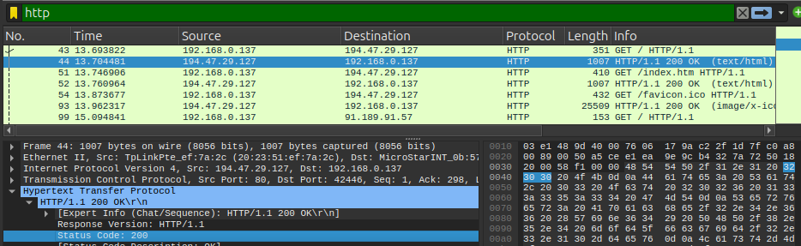
1. The server returned the value ‘200’. This is shown in Wiresharsk’s “Status code” field.
2. The meaning conveyed by the value ‘200’ is that the request was accepted and that the server is responding as should be expected.

Answer to question 8
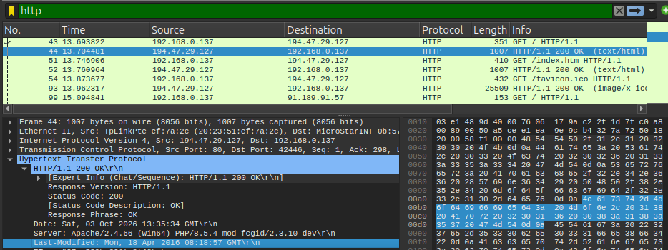
1. The HTML file was last modified at “Mon, 18 Apr 2016 08:18:57 GMT”
2. The server indicates the last modified timestamp so that the browser can use it to compare it with a cached version of the page. When the browser makes another request, it asks the server “Has the page changed since the last cached version?”. The server checks, and if the answer is no, then it doesn’t send a HTTP response body.

Answer to question 9
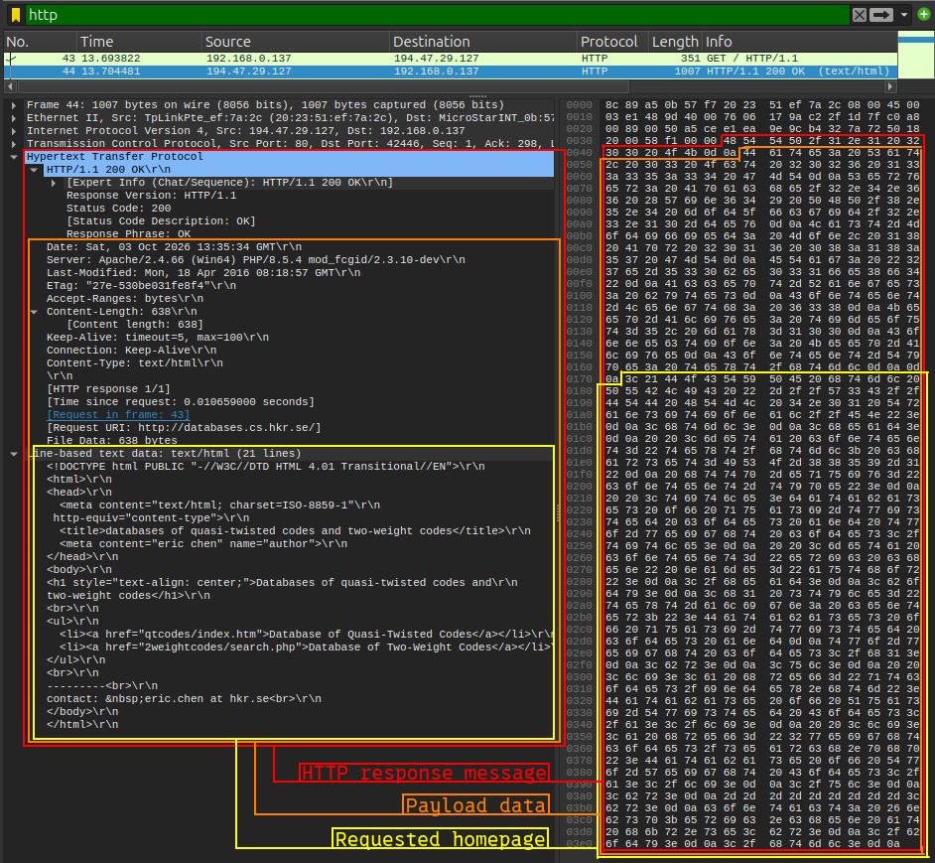
1. The length of the HTTP header and its payload is 953 B.
2. The length of HTTP message, excluding its header, is 936 B
3. The length of the requested homepage is 638 B.
4. No, I can not find ant field named “content-encoding”. But, based on the values of the field “Accept-encoding” in my first GET request, I can conclude that it refers to content that is encoded by a compression algorithm, or more specifically, by gzip.

Answer to question 10
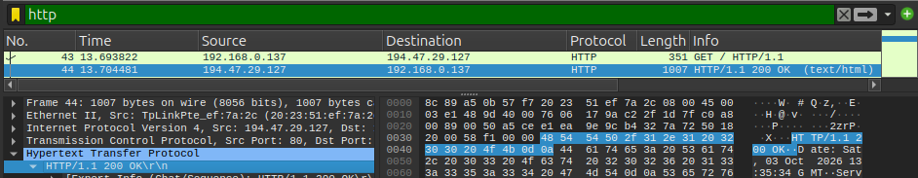
1. The hexadecimals represent ASCII characters. So the answer is that the HTTP message header is represented in text.

Answer to question 11
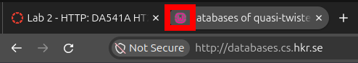

The file “favicon.ico” is a small icon image used by browsers to represent the webpage graphically.

Answer to question 12
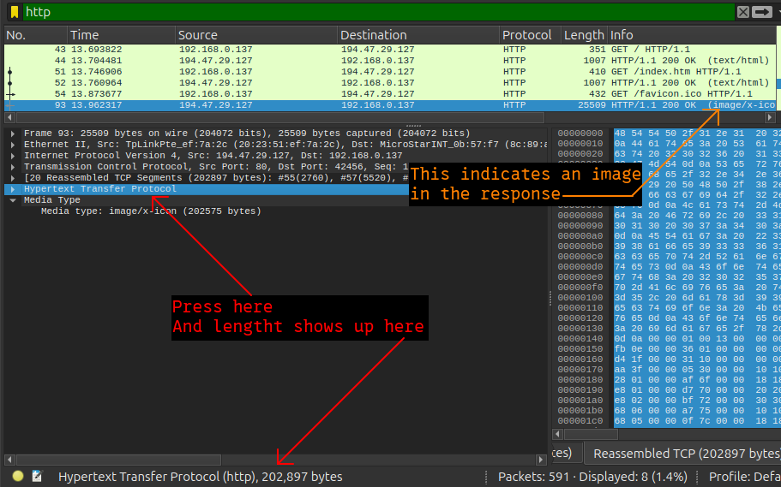
The HTTP response message containing the “favicon.ico” is ‘202’897 B’ long. And it can be found by clicking on the section “Hypertext Transfer Protocol” and then looking at the left side of the bottom status bar.
The response containing the image can be found by looking at the “info” column of the packet list. The row with the value “image/x-icon” on its “info” column represents the response containing the image binary.
Task 2 – The HTTP CONDITIONAL GET/response interaction.

Answer to question 13
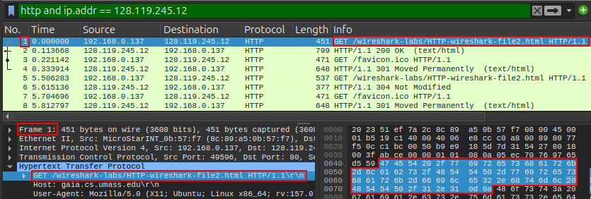
1. The frame number of the HTTP GET request to download the file “HTTP-wireshark-file2.html” is 1.
The reason for it being frame number 1 is that the frame numbering is Wireshark specific. Removing packets not included by the filter from the ‘.pcap’ file (as I have done) reorders the numbering according to that filter.
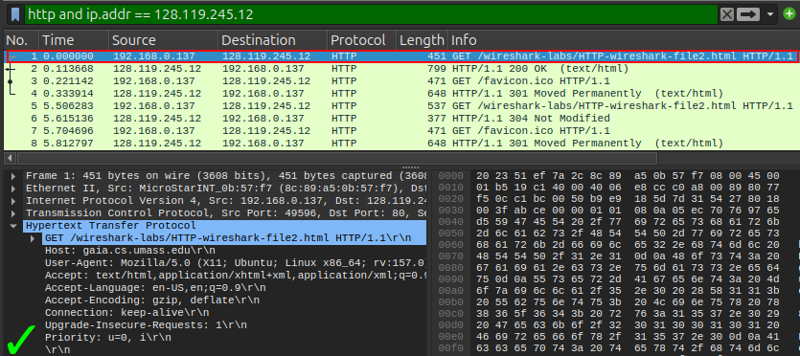
2. No, there is no “If-Modified-Since” field in that HTTP GET request.

Answer to question 14
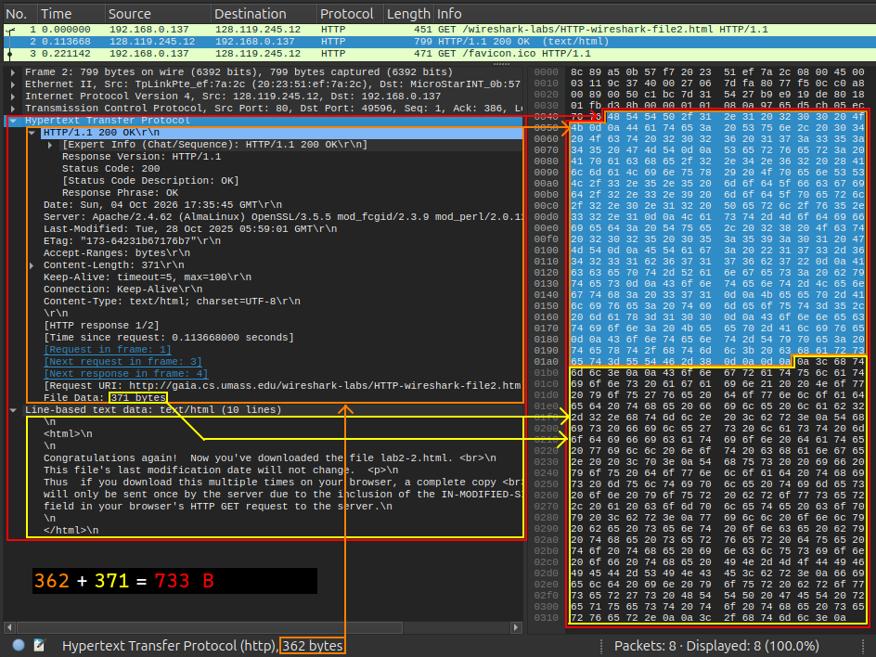
1. The length of the HTTP response is 733 B.
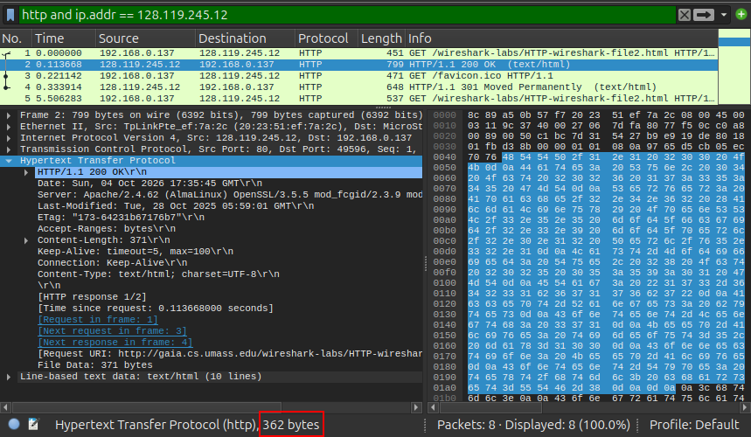
2. The length of the HTTP header in in the servers response to the GET request is 362 B.
Note: I have included the CRLF ending the header as part of the header. Some would exclude this delimiter from the count. I do not see how one could consider excluding it since it is a part of what defines the header.

Answer to question 15
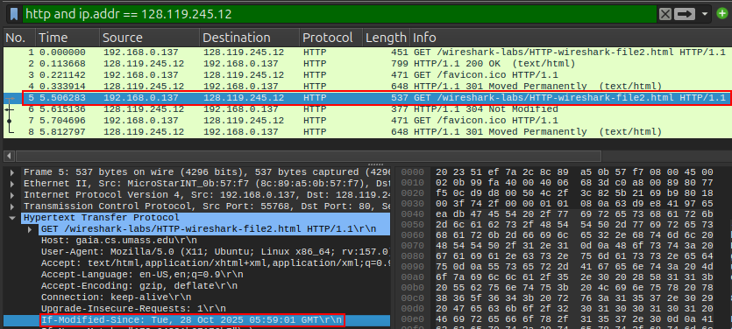
Yes, I see the ”If-Modified-Since” field.
The information that follows is the date-time value ”Tue, 28 Oct 2025 05:59:01 GMT”.

Answer to question 16
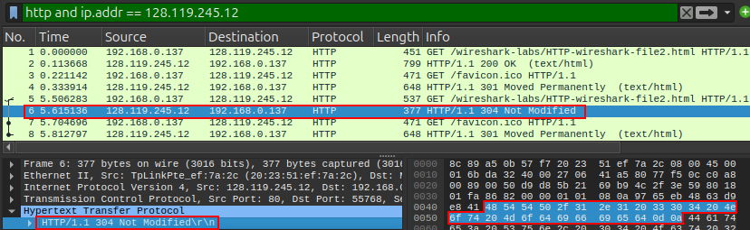
1. The HTTP status code and the phrase in the response is “HTTP/1.1 304 Not Modified”.
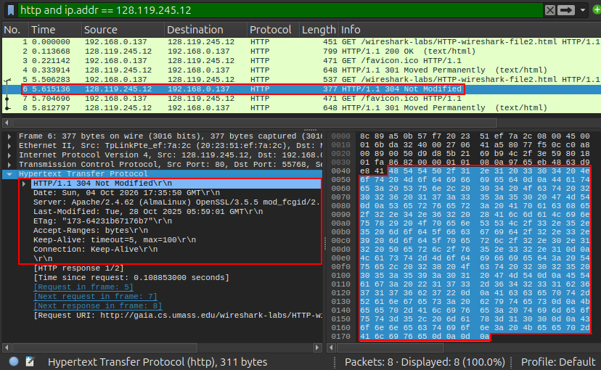
2. The length of this part of the response message is 311 B.
3. The response did not contain any file data.
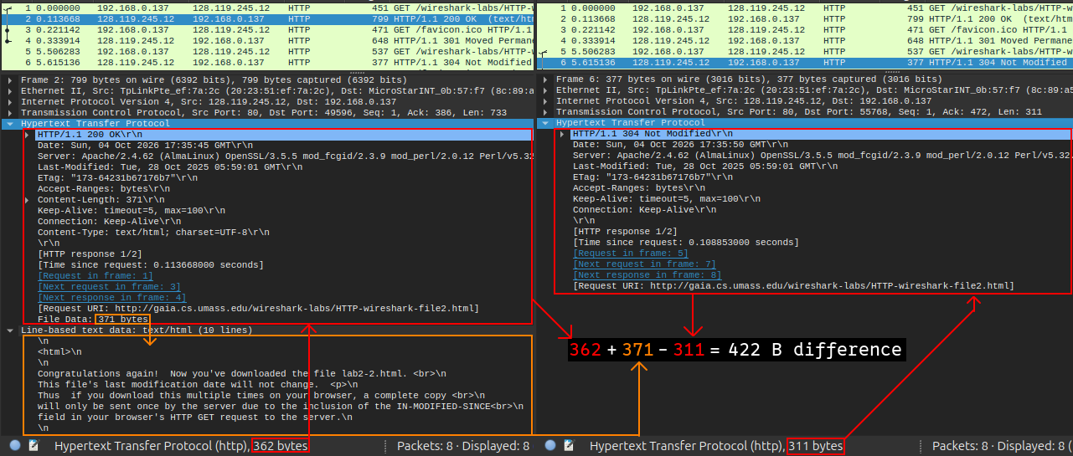
4. The length of the response to the first request was 733 B, and the length of the second response was 311 B, the difference was 422 B.

Answer to question 17
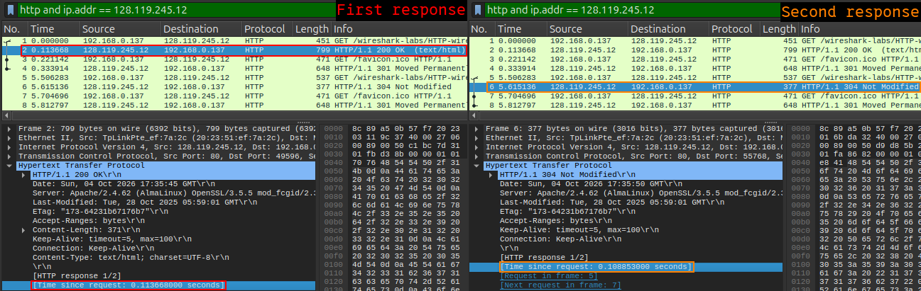
The time it took to receive a response to the first request was 0.113668 seconds, and the time it took to receive a response to the second request was 0.108853 seconds.
The response to the second request arrived about 5 milliseconds faster.

Answer to question 18
From what I have learned during my work with these exercises, I can confidently conclude that a web browser and a web server can communicate via “get” requests sent by the web browser and by responses to those “get” requests from the web server.
I have also established a confident view that web servers generally assume that data entering at port number 80 is expected follow the rules set by the HTTP communication protocol.
I have gained a fairly good grasp of how the messages are constructed according to the rules of the protocol, and I have also understood that there are fields in the HTTP document (sometimes called “header lines”) which can be included or excluded, depending on the context of the communication.
These HTTP-header-fields enable the web browser and the web server to have a conversation with a degree of dynamism. As we have seen in one of the exercises above, these fields can be used by a web server to instruct a web browser on where to get the data needed for displaying the requested page. In the case of our exercise, the web server instructed the web browser that the page should be loaded from its cache if it wasn’t older than a certain date and time.
https://en.wikipedia.org/wiki/List_of_HTTP_header_fields

Lab 3
This is the third and last lab assignment for the course “Data Communication and Networks” (DA541A HT26). Here I will answer a total of eighteen questions regarding MAC tables and switches.
All answers come from tests, tasks and experiments done in the environment referred to in the introduction to lab 1.
In addition to that, I have also used Cisco’s ‘Packet Tracer Version 9.0.1.0858’ which I got from the apt package manager on ‘Ubuntu 24.04.5’.
A file named ‘durim_miziraj_DA541A_HT26.pkt’ containing all the packet tracer laborations has been submitted through the lab assignment hand in page together with this lab report.

Switches

Answer to question 1
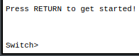
The switch enters ‘user EXEC’ mode on startup. I recognize it by the ‘greater than’ (>) symbol following the hostname.

Answer to question 2
The mode indicates that the host has the ability to change the configurations of the switch. It is reached by first entering “privileged EXEC” mode (as shown by the hash symbol) with the command “enable”, and afterwards by entering the command “configure terminal” which displays the substring “(config)”.

Answer to question 3
It is necessary because the configurations are not set in persistent memory when changed. If the configuration file is not saved, the changes will be lost when the switch restarts or its power supply is cut.

Answer to question 4
It shows the size of the current configuration, the software’s version number, log and debug info with timestamps, the password set by the “password” command, the hostname and the connection status of the switch’s interfaces.

Answer to question 5
Yes, the password can be viewed in plain text and it’s application can be confirmed by entering the command “show running-config”. It’s application can also be confirmed by exiting “privileged EXEC” mode and running the command “enable”. If the shell asks for a password, then the “enable password” command is confirmed to be successful.

Answer to question 6
The progression of time can not be measured without power, and the clock resets on startup. The same as with any computer that has its motherboard’s clock battery removed and the main power supply cut off.

Answer to question 7
I can verify that the configuration was erased by sending the command “show startup-config” and ensuring that the reply “startup-config is not present” is written to the terminal.

Answer to question 8
Unauthorized users can enter “privileged EXEC” mode and thus change security related configurations.

Answer to question 9
Turning off the power supply and then turning it on again has to be done manually on site, unlike using the “reload” command which enables the operator to do it remotely or even automatically by setting schedule for the reload to take place.

Answer to question 10
In “privileged EXEC“ mode, the user has access to all commands.
While “user EXEC” mode only gives access to a subset of commands.

MAC tables

Answer to question 1
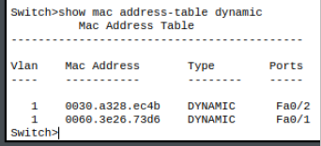

The switch’s MAC table provides the MAC addresses, the interfaces (ports), the VLAN and how the MAC addresses are learned (statically or dynamically) from the devices that have communicated through the switch.

Answer to question 2
The switch needs a MAC table so that it doesn’t need to rediscover the correct path every time an Ethernet frame comes to the switch.
Failing to have a MAC table causes a flood of unicast packages on the network.
A MAC table gives the ability to quickly reference the receiver and thus avoid flooding.

Answer to question 3
The switch learns of connected devices through the source MAC address of an incoming frame.

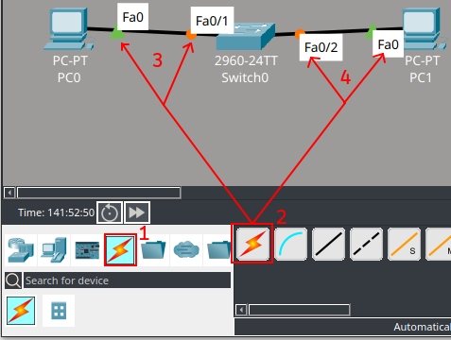
Answer to question 4
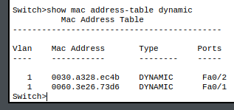
In Task 1, when the clients were connected to the same switch, the MAC table showed the MAC addresses of the Ethernet interfaces connected to the switch. I also observed that the printout of the MAC addresses were those of the interfaces on the device’s end, and not the interfaces on the switch’s end. I also observed their assigned VLAN, how the MAC addresses were learned and the ports on the switch that they were connected to.

Answer to question 5
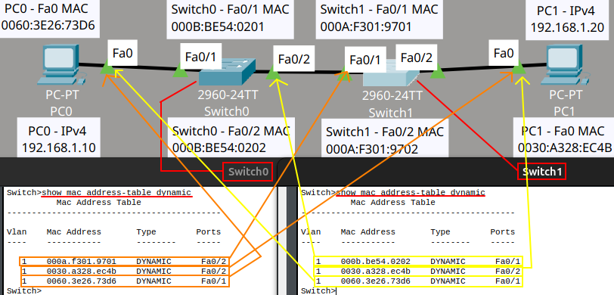
In Task 2, when the clients were connected to different switches, the command “show mac address-table dynamic” printed the MAC addresses of the Ethernet interfaces connected, both directly and transiently, to the switch. In addition to what was observed in Task 1, I also observed that the printout of the MAC addresses where those of the interfaces on the device’s end, and not those on the switch’s end.

Answer to question 6
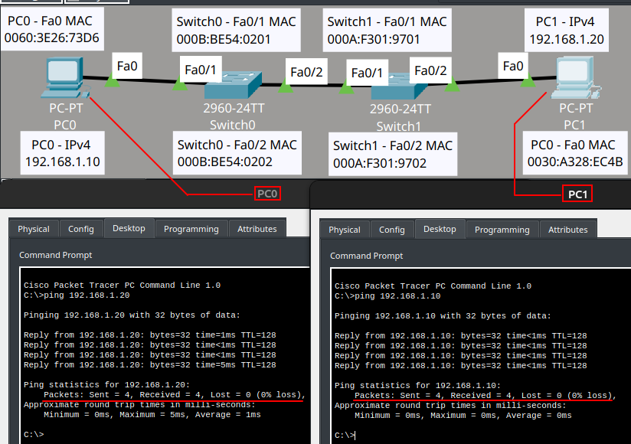
The tool “ping” can be useful for fault isolation on a computer network and for sending a frame through the network so that the network’s switches can learn the source MAC of that frame in a controlled environment.
It tells me if a device on a network can receive and respond to a signal from my device. It can also serve as a tool for finding switches that fail to learn the MAC address of my device’s Ethernet interface in a controllable and repeatable way.

Answer to question 7
There are several network issues on different layers of the OSI model that could cause a ping to fail.
On level 1: Defects on networking related hardware of different kinds. Examples are damaged Ethernet cables, and excessive electromagnetic noise.
On level 2: The Ethernet interfaces of the devices belonging to different VLAN’s.
A switch disables a port on the route due to having blocked the connecting interface’s MAC address.
On level 3: The IP addresses involved in the ping communication could be blocked by a firewall.
A device may be set to ignore all ICMP echo requests (the protocol that ‘ping’ uses).

Answer to question 8
The switch operates at ‘OSI level 2’ and needs a MAC table in order to deliver its promise to manage the information in respect to the Ethernet interfaces connected to it and their VLAN’s.
A hub operates at ‘OSI level 1’ where it does not have any use for a MAC table and instead redistributes incoming signals to all its connected interfaces irrespective of who the signal was meant for.

. https://www.cisco.com/en/US/docs/ios-xml/ios/sec_usr_cfg/configuration/15-1sg/sec-cfg-sec-4cli.html#GUID-1EEEC510-5B65-45D3-B827-5DD71F4F7218:~:text=access.-,Protecting,security.
. https://www.cisco.com/c/en/us/td/docs/switches/lan/catalyst2960x/software/15_2_6_e/configuration_guide/b_1526e_consolidated_2960x_cg/m_sm_setup_cg_c2k.html#con_1072139:~:text=gateway%2E-,Scheduled%20Reload
. https://www.cisco.com/c/en/us/td/docs/ios/sec_user_services/configuration/guide/12_4/sec_securing_user_services_12-4_book/sec_cfg_sec_4cli.html#:~:text=In%20order%20to%20have%20access%20to%20all%20commands
. https://www.cisco.com/c/en/us/support/docs/switches/catalyst-6000-series-switches/23563-143.html#:~:text=When%20there%20is%20no%20entry
. https://www.cisco.com/c/en/us/support/docs/switches/catalyst-9300-switch/222771-understand-unexpected-mac-learning-on-ca.html?#:~:text=Catalyst%20switches%20learn%20MAC%20addresses%20on%20switch%20ports%20based%20on%20the%20source%20
. https://www.cisco.com/en/US/docs/internetworking/troubleshooting/guide/tr1904.html#:~:text=Excessive%20noise
. https://www.cisco.com/c/en/us/support/docs/lan-switching/inter-vlan-routing/41260-189.html#:~:text=Layer%202%20%28L2%29%20switches%20need%20an%20L3%20routing%20device%20to%20facilitate%20communication%20between%20VLANs
. https://www.cisco.com/c/en/us/td/docs/switches/lan/catalyst9300/software/release/17-5/configuration_guide/sec/b_175_sec_9300_cg/port_security.html#:~:text=the%20port%20does%20not%20forward%20packets%20with%20source%20addresses%20outside%20the%20group
. https://docs.redhat.com/en/documentation/red_hat_enterprise_linux/7/html/security_guide/sec-managing_icmp_requests
. https://kernel.org/doc/html/latest/networking/ip-sysctl.html#:~:text=icmp%5Fecho%5Fignore%5Fall
. https://www.cisco.com/c/en/us/support/docs/lan-switching/ethernet/12006-chapter22.html#:~:text=switch%20is%20considered%20a%20layer%2Dtwo%20device
. https://www.cisco.com/c/en/us/support/docs/lan-switching/ethernet/12006-chapter22.html#:~:text=In%20order%20to%20know%20what%20to%20do%20with%20the%20frame%2C%20the%20switch%20learns%20the%20location%20of%20all%20devices%20on%20the%20segment
. https://www.cisco.com/c/en/us/support/docs/lan-switching/ethernet/12006-chapter22.html#:~:text=a%20hub%20is%20considered%20a%20layer%2Done%20%28physical%20layer%29%20device
. https://www.cisco.com/c/en/us/support/docs/lan-switching/ethernet/12006-chapter22.html#:~:text=It%20hears%20an%20electrical%20signal%20on%20the%20wire%20and%20passes%20it%20along%20to%20the%20other%20ports

