DA541A Laboratory report

Durim Miziraj
19851202-5092

Lab 1
This is the first lab assignment for the course “Data Communication and Networks” (DA541A HT26).
It consists of three subtasks, these are “Find your IP address, MAC address and DNS server address”, “Find mapping between domain name and IP address” and “Handle the DNS cache”.
I am running Ubuntu 24.04.4. All commands assume this environment.

Task 1
Q.1. What are the IP address and MAC address for the active Internet connection on your computer?
A.1. The IP-address for the active internet connection on my computer can be found with the following command.
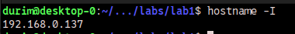

The MAC-address for the active internet connection on my computer can be found with the following command.
Note: “enp3s0” is the name for my specific network interface.

Q.2. What is the configured DNS server IP address?
A.2. ‘resolvectl’ points to my router as the configured DNS server on my computer.
Which is ‘192.168.0.1’.
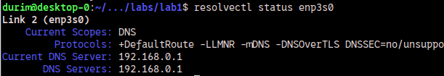

My router points to my ISP’s (Internet Service Provider) DNS server.
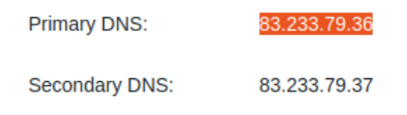

Verifying that my ISP is the owner of the DNS server.

Task 2
Q.3.1. What is the DNS server IP address used for this name resolution?
A.3.1.
This points to my local name resolver, as verified by ’/etc/resolv.conf’.
Q.3.2 What are the IP addresses for the host ‘www.MIT.edu’?
A.3.2 Three addresses are given, one IPv4 address and two IPv6 addresses.
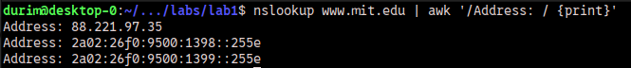
Q.3.3 Is the ‘www.MIT.edu’ alias?
A.3.3 Yes, ‘www.mit.edu’ is an alias, and so is ‘www.mit.edu.edgekey.net’.
Q.4.1 What are the DNS servers responsible for domain names in ‘www.mit.edu’?
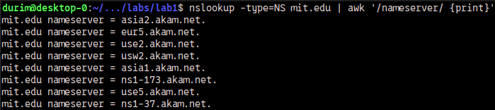
A.4.1 These are the DNS servers responsible for domain names in ‘mit.edu’.
Q.4.2. Find out these DNS server IP addresses (by using nslookup respectively on the name servers found in A).
A.4.2. These are the IP addresses of the DNS servers responsible for domain names at 'mit.edu’.
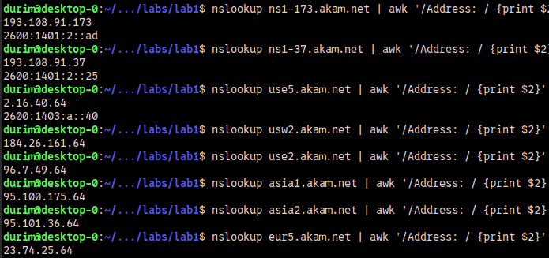
Q.5.1. Which DNS server is used for this name resolution (hkr.se)?
A.5.1. The server with IP-address ‘8.8.8.8’ is used for this name resolution.
The server belongs to Google.
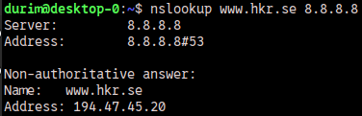

Q.5.2. Do you find the IPv6 address for ’https://www.hkr.se/’?
A.5.2. No, I do not find any IPv6 address for ‘https://www.hkr.se/’.
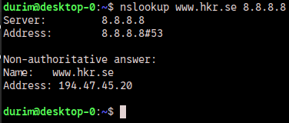

Q.6. Does the long name for 220.135.143.45 cause any inconvenience for its users?
Why or why not?
A.6. Yes, it causes inconvenience.
The reasons are that it is not human-memorable and that it takes time to type out.
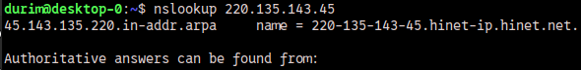
Q.7. Where is the mail to sandra.roos@hkr.se sent?
A.7. E-mails to ’sandra.roos@hkr.se’ are sent to ’hkr-se.mail.protection.outlook.com’.
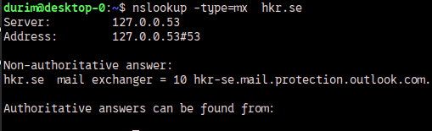

Q.8.1. What IP addresses do you find for the web server www.google.com/ from the
3 queries above?
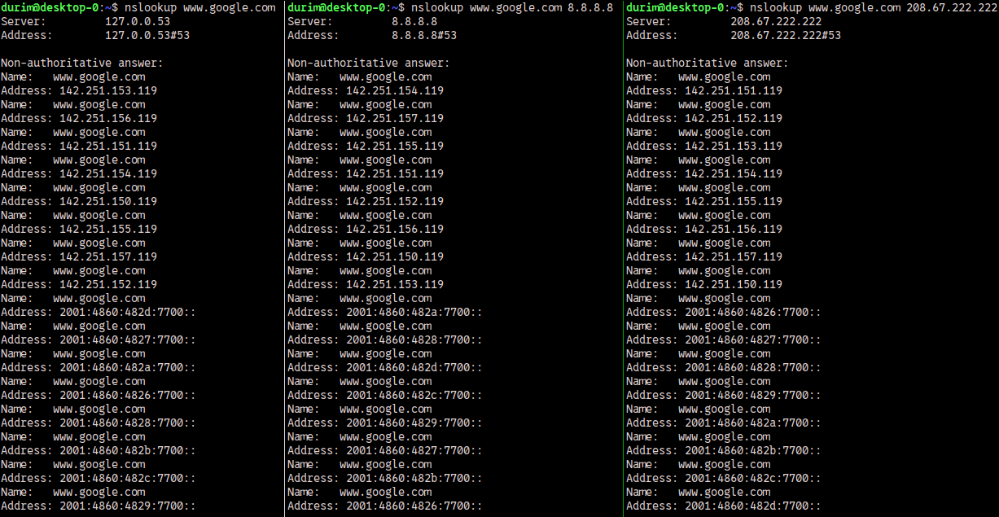
A.8.1. This is a screenshot of the the IP addresses I found.
Q.8.2. Explain your understanding on the load balancing technique based on DNS service.
A.8.2. DNS can support load balancing by having several IP-addresses for one hostname. The first adress to be returned is the one that is contacted. And as evidenced by the differing order of addresses, the first IP-address to be returned is not always the same. The first IP-address to be returned is assumed to be the one under the least amount of load, or the one that is closest to the requestor.

Task 3
Q.9. How many domain names have been cached on your computer?
A.9. Seventeen domain names have been cached on my computer.

Lab 2

Task 1 - The basic HTTP GET command and response interaction
Q.1.1. What is your IP address?
A.1.1. My IP address is ”192.168.0.137”.

Q.1.2. What is the corresponding MAC address?
A.1.2. The corresponding MAC address is “8c:89:a5:0b:57:f7”.

Q.1.3. How did you find them?
A.1.3. The source IP adress (my address) is found at bytes 26 to 29.
The MAC address Ethernet interface can be found at bytes 6 to 11.
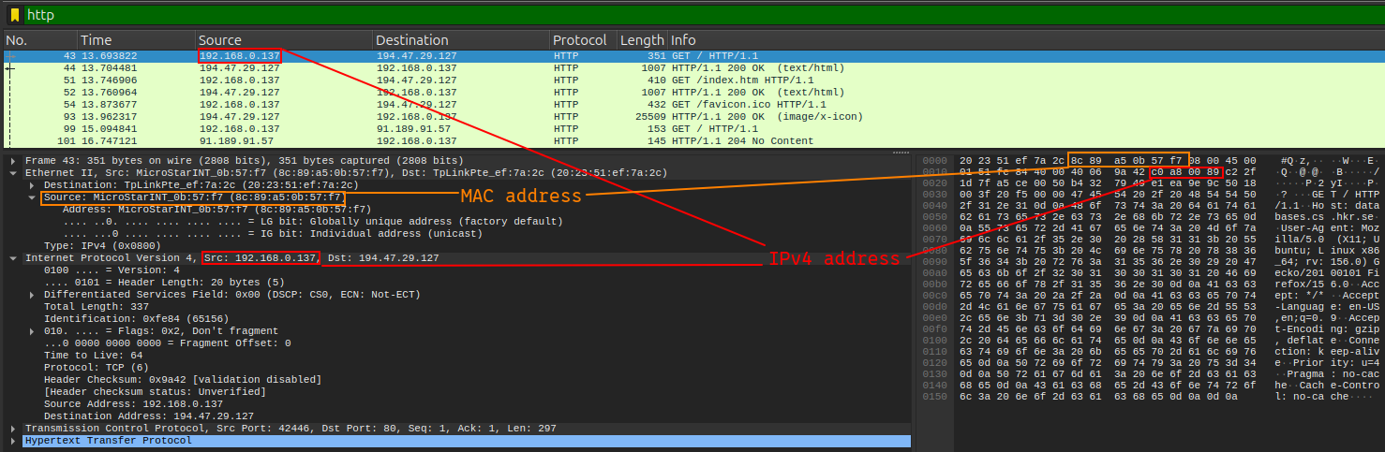

Q.2. Investigate the GET message?
Q.2.1. What is the port number for your browser to request the home page?
A.2.1. My browser’s port number is 42446.

Q.2.2. What is the remote HTTP server’s port number?
A.2.2. The remote HTTP server’s port number is 80.

Q.2.3. In which layer header do port numbers appear?
A.2.3. They can be found in the transport layer.

Q.2.4. What are these port numbers used for?
A.2.4. These port numbers come from applications who request them from the operations system that they are running on. They are bound to a socket managed by the OS.
They are used for identifying the socket that will receive the packet.
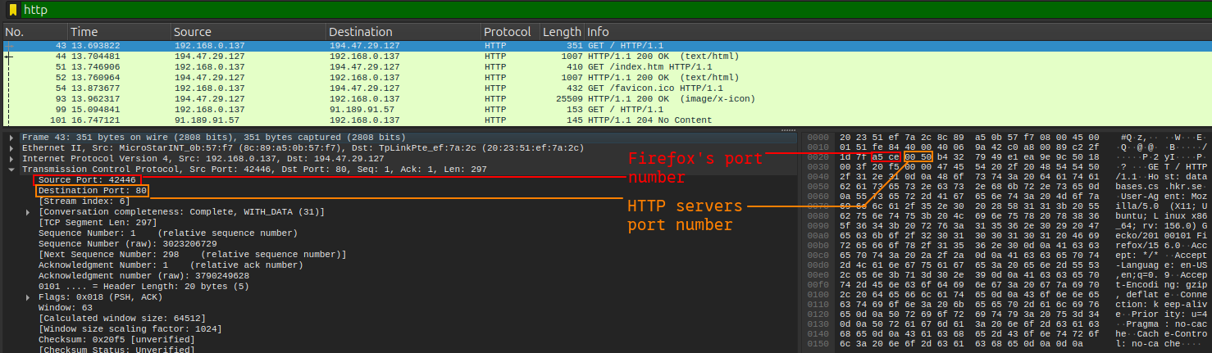
Q.3. Investigate the first GET message.
Q.3.1. Which transport layer protocol (UDP or TCP) was used to transport this GET message?
A.3.1. The Transmission Control Protocol (TCP).
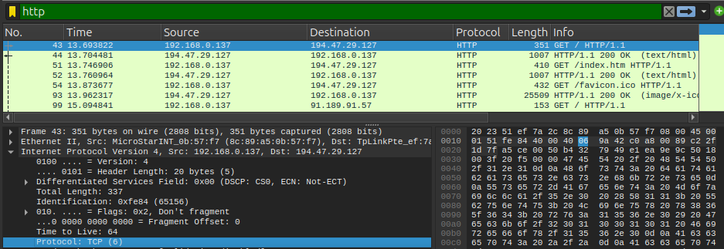
Q.3.2. The transport layer protocol data unit was encapsulated in an IP packet.
Check the source and destination addresses in the IP header.
- Is the source IP address your computer’s IP address?
- Is the destination IP address the remote web server’s IP address?
A.3.2. Yes, the source IP address is my computers private address within my own network.
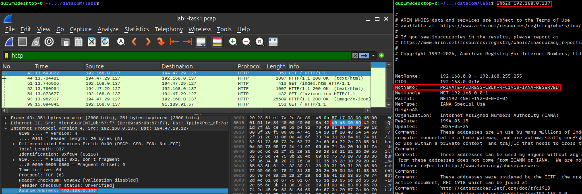
The destination IP address of the first GET request does not disclose with certainty if it belongs to the remote HTTP-server.
This can be verified in the first response from the HTTP server.
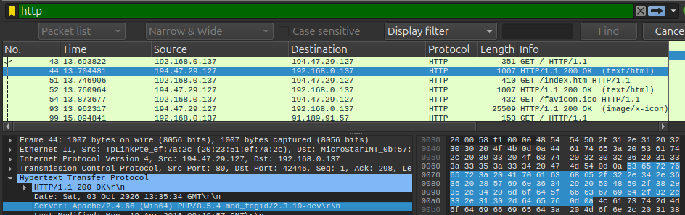
Q.3.3. The IP packet is encapsulated in a hardware frame. Check the frame header, you can find the source MAC address and destination MAC address. Is the destination MAC address corresponding to the MAC address of remote web server. Why and why not?
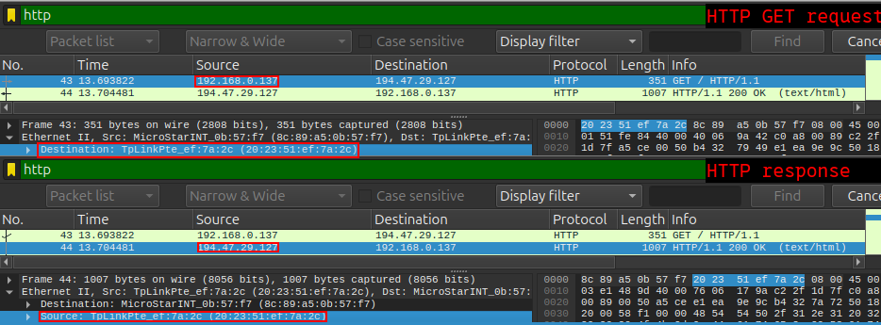
A.3.3 No. The destination MAC address at the top of the frame is the MAC address of my TP-link router. These MAC addresses only have relevance inside of their own local networks and never represent anything outside of the local network.

Q.3.4. For this packet, find or calculate the HTTP message size (both HTTP header plus the payload data), TCP PDU size (TCP header + TCP payload), IP packet size (IP header + IP payload), and frame size (frame header + frane oayload).
A.3.4. The calculations are specified in the table below, and the source for the numbers in the image below the table.
Message type calc | Byte size calc
_{HTTP header + payload} | _{16 + 281 = 297 B}
_{TCP header + payload} | _{20 + 297 = 317 B}
_{IP header + payload} | _{20 + 317 = 337 B}
_{Frameheader + payload} | _{14 + 337 = 351 B}
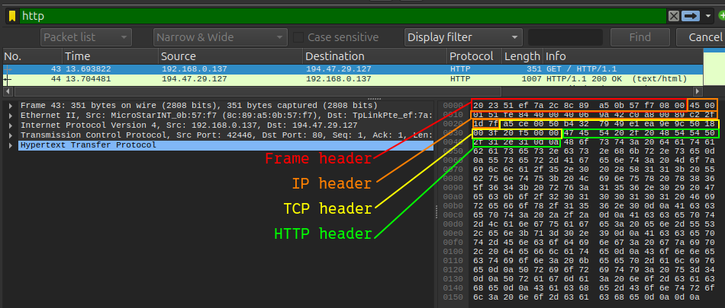
Q.4. Investigate the first GET message.
Q.4.1. How many header lines are there in this HTTP request?
A.4.1. There are 9 header-lines / header-fields.
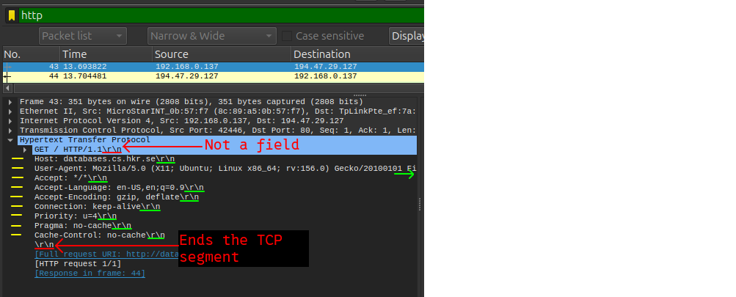
Q.4.2. Does this HTTP message contain any HTTP payload data?
A.4.2. I am unsure of what is meant by HTTP payload. The header fields contain data, but there is no HTTP data for a browser to construct a page.
I’ll go with the second definition of “HTTP payload data”. And in this case, no there is no HTTP payload data in the first GET request.
Q.5. Investigate the first GET message.
Q.5.1. Is your browser running HTTP version 1.0 or 1.1?
A.5.1. My browser is requesting and running HTTP version 1.1.
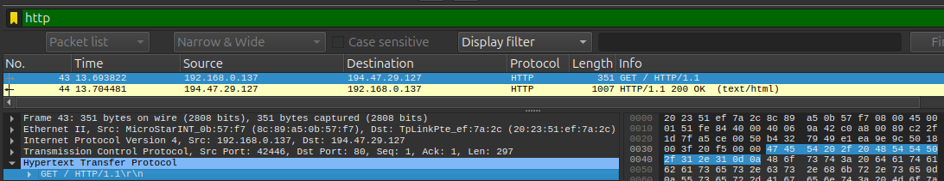
Q.5.2. What version of HTTP is the server running?
A.5.2. My first GET message does not disclose this.
This is shown in the servers response to the first GET message.
And yes, according to that response, the server is running HTTP version 1.1.
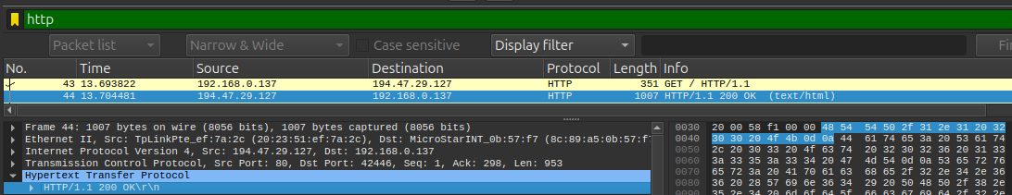
Q.6. What languages does your browser indicate that it can accept to the server?
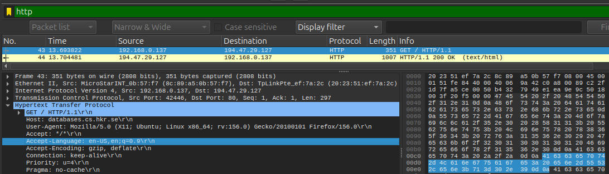
A.6. My browser has indicated that the language it can accept is “en-US” and “en” in the header field “Accept-Language”. Thi setup prefers US english, then english generally.
Q.7. Investigate the first HTTP response message.
Q.7.1. What is the status code returned from the server to your browser?
A.7.1. The server returned the value 200 in the “Status code” field.
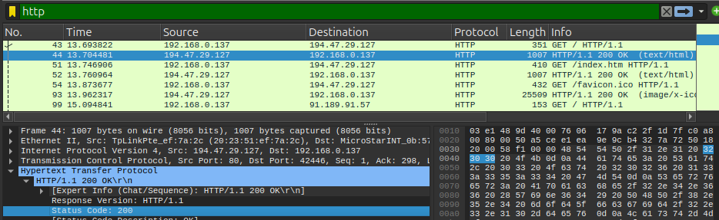
Q.7.2. What does the code mean?
A.7.2. It means that the request was accepted and that the server is responding normally.
Q.8. Investigate the first HTTP response message.
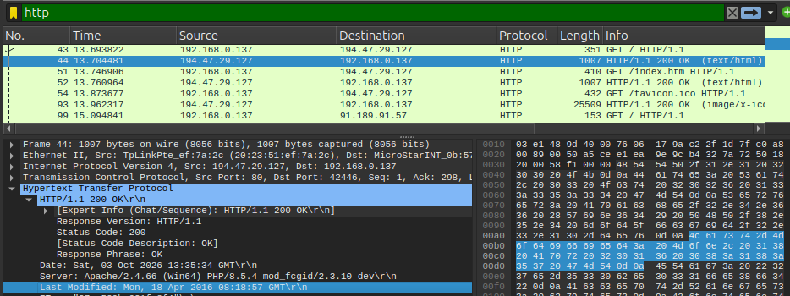
Q.8.1. When was the HTML file that you are retrieving last modified?
A.8.1. It was last modified at “Mon, 18 Apr 2016 08:18:57 GMT”.
Q.8.2. Why does the server indicate the last modified date stamp?
A.8.2. The browser can use it to compare it with a cached version of the page. When the browser makes another request, it asks the server “Has the page changed since the last cached version?”. The server checks, and if the answer is no, then it doesn’t send a HTTP response body.

Q.9. Investigate the first HTTP response message.
Q.9.1. How long in bytes is this HTTP response message?
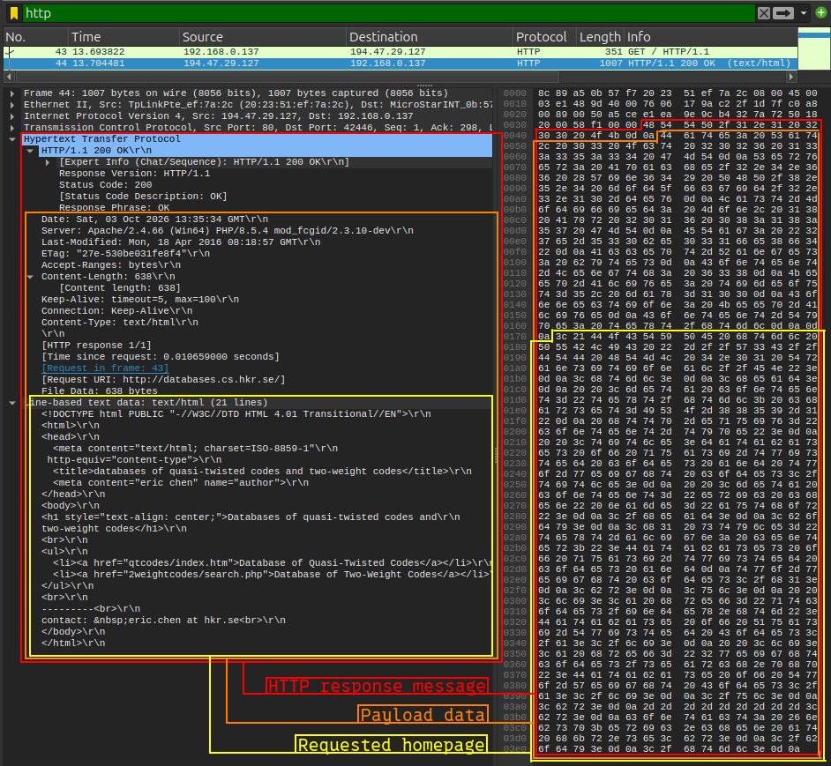
A.9.1. I define the HTTP header, the HTTP fields/lines and the actual HTML file data as part of the HTTP response. And with that definition, the total byte count is ‘953 B’.
Q.9.2. How long in bytes is the payload data in this HTTP message (excluding the HTTP header)?
A.9.2. I define “payload” in this context as the HTML fields/lines plus the HTML content/homepage. And in that case, the answer is ‘936 B’.
Q.9.3. How big in bytes is the requested home page?
A.9.3. The HTML file data is ‘638 B’ long.
Q.9.4. Do you find the “content-encoding:” header line? What is this line used for?
A.9.4. No, I can not find a field named “content-encoding”. But, I can find a field named “Accept-encoding“ in my initial HTTP GET request. The values in that field are “gzip, deflate”, which indicates that “content-encoding” refers to content that is compressed.
The line is used to indicate to the browser that the HTML content is encoded in a certain format.

Q.10. Packet listing window is on the top, while the packet content window is on the bottom. In the packet content window, the left shows the contents in hexa-decimal for each byte, and the right of the window shows the contents in ASCII characters.’
Q.10.1. Is the HTTP message header represented in binary or in text?
A.10.1. The hexadecimals represent ASCII characters. So the answer is that the HTTP message header is represented in text.
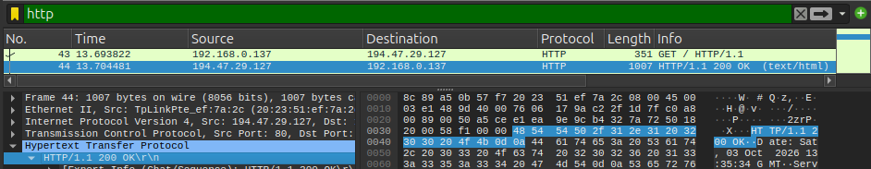
Q.11. What is the file “facicon.ico”?
A.11. The file “favicon.ico” is a small image file that is used as an icon for the webpage.
See the red-marked example in the image below.
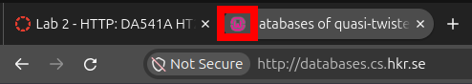

Q.12. How long in bytes for this HTTP response message and how do you find it out?
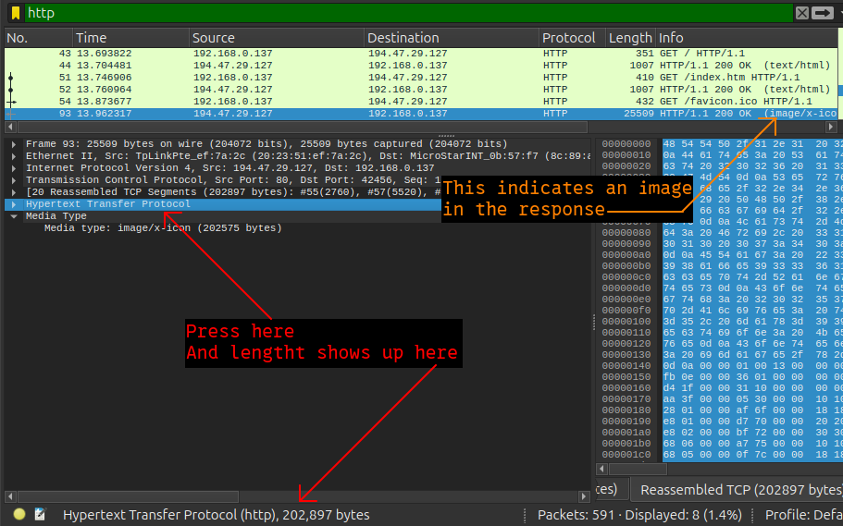
A.12. The HTTP response message containing the “favicon.ico” is ‘202’897 B’ long.
And it can be found by clicking on the section “Hypertext Transfer Protocol” and then looking at the left side of the bottom status bar.
The response containing the image can be found by looking at the “info” column of the packet list. The row with the value “image/x-icon” on its “info” column represents the response containing the image binary.

Task 2 – The HTTP CONDITIONAL GET/response interaction.
Q.13. Anwer the following questions.
Q.13.1. Which frame (packet) number contains the HTTP GET command to download the file “HTTP-wireshark-file2.html”?.
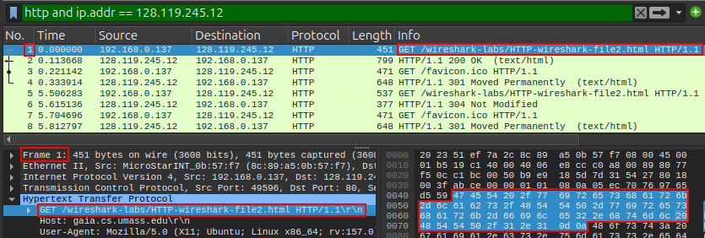
A.13.1. Frame number 1.
The reason for it being frame number 1 is that the frame numbering is wireshark specific. Removing packets not included by the filter from the ‘.pcap’ file (as I have done) reorders the numbering according to that filter. Frame numbering is not part of any network protocol, it is simply wireshark’s own index.

Q.13.2. Inspect the contents of this HTTP GET request.
Do you see an “IF-MODIFIED-SINCE” header line in this HTTP GET message?
A.13.2. No, there is no “If-Modified-Since” field in frame number 1.
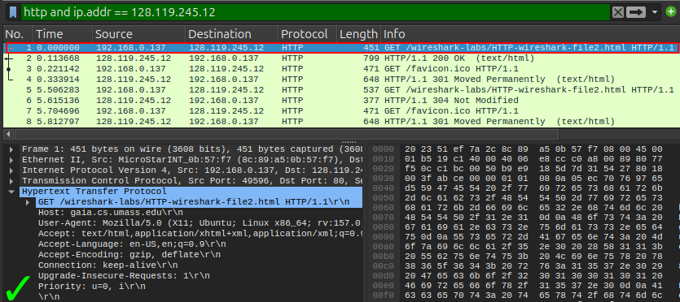
Q.14. Inspect the contents of the server response to this GET command.
Q.14.1. How big in bytes is this HTTP response message?
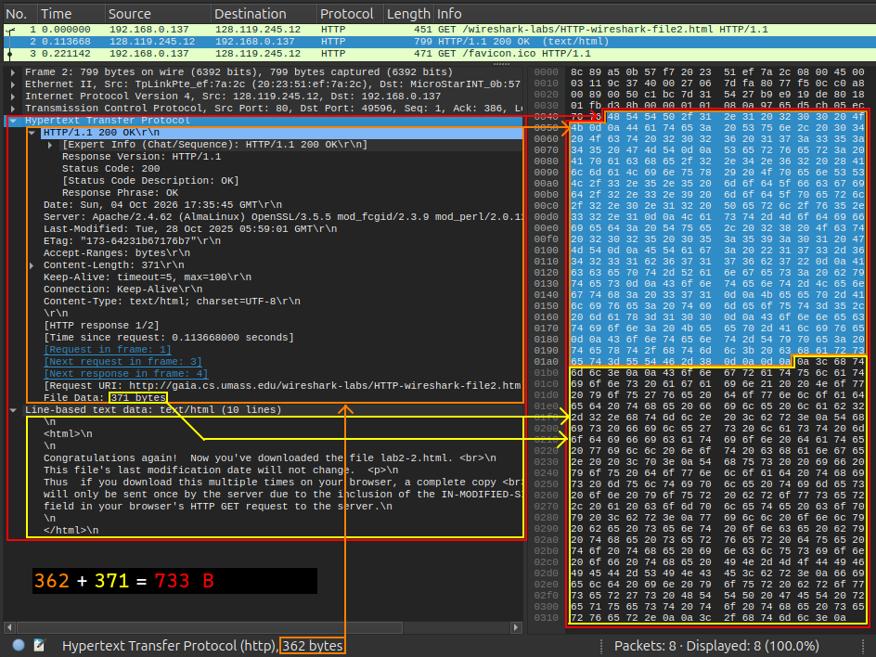
A.14.1. The size of the HTTP response is 733 B.

Q.14.2. How many bytes does this HTTP message header contain?
A.14.2. The amount of bytes in the HTTP header of frame number 1 is 56 B.
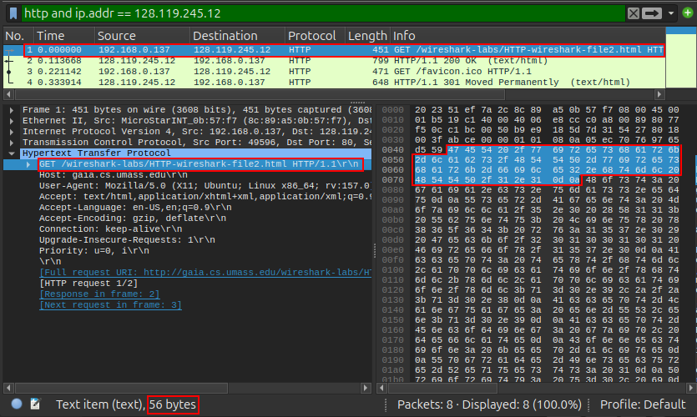
Q.15. Now inspect the contents of the last HTTP ”GET HTTP-wireshark-file2.html”
request from your browser to the server. Do you see an “IF-MODIFIED-SINCE:” header line in this HTTP message? If so, what information follows the “IF-MODIFIED-SINCE:” header?
A.15. Yes, I see the ”If-Modified-Since” field.
The information that follows is the date-time value ”Tue, 28 Oct 2025 05:59:01 GMT”.
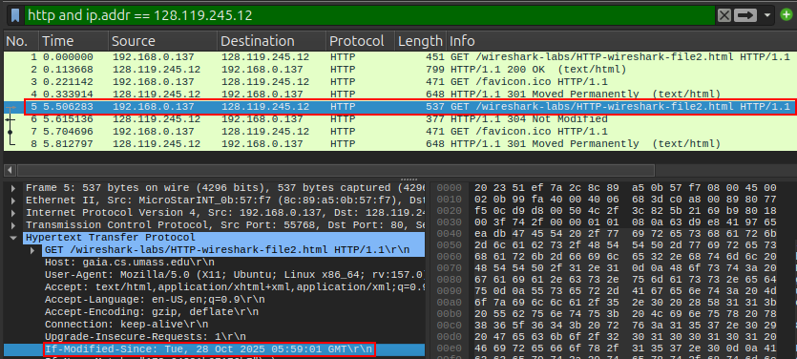
Q.16.
Q.16.1. What is the HTTP status code and phrase returned from the server in response to this HTTP GET request?
A.16.1. The HTTP status code and the phrase in the response is “HTTP/1.1 304 Not Modified”.
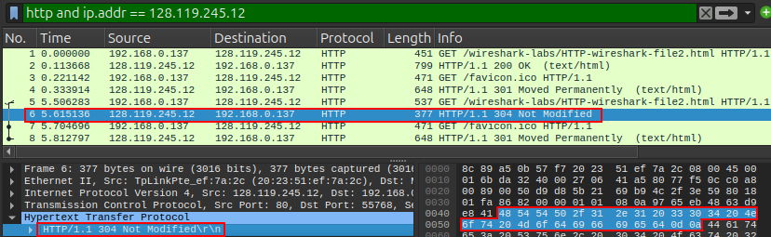
Q.16.2. How big in bytes is the HTTP response message?
A.16.2. The response message is 311 B long.
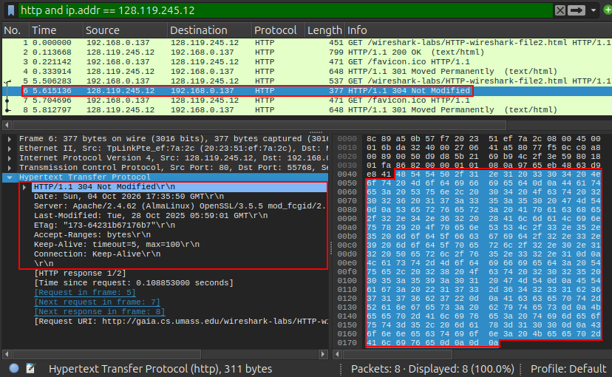
Q.16.3. Did the response contain the file data?
A.16.3. No, as can be seen in the image above.

Q.16.4. Compare the sizes of the HTTP responses to the first and second “GET HTTP-wireshrk-file2.html” requests.
The size of the response to the first request was 733 B, and the size of the second response was 311 B, the difference was 422 B.
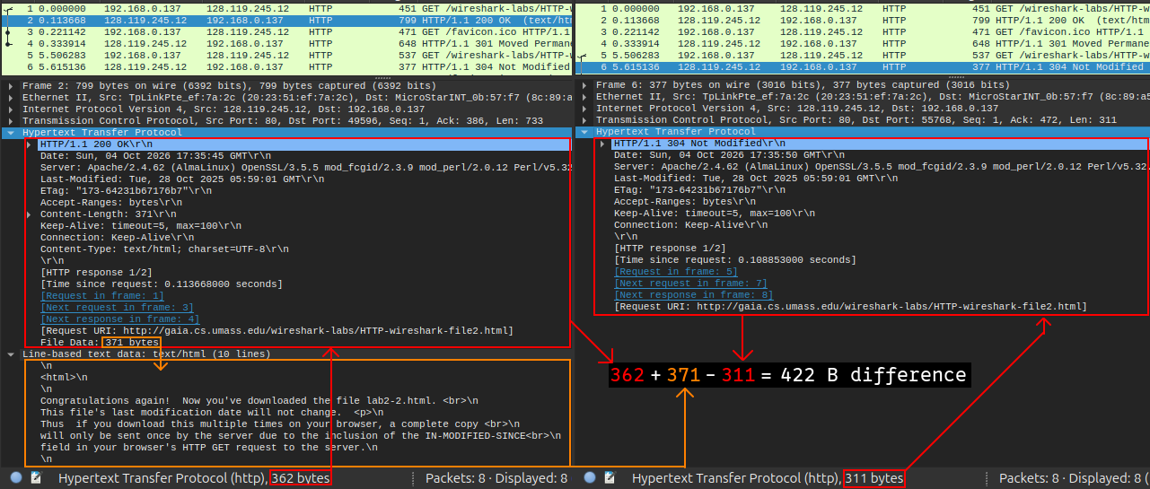
Q.17. The response time is the time duration from a request is sent and until a response to the request is received. What are response times for downloading the ”HTTP-wireshark-file2.html” file with first and second HTTP GET requests?
A.17. The time it took to receive a response to the first request was 0.113668 seconds, and the time it took to receive a response to the second request was 0.108853 seconds.
The response to the second request arrived about 5 milliseconds faster.
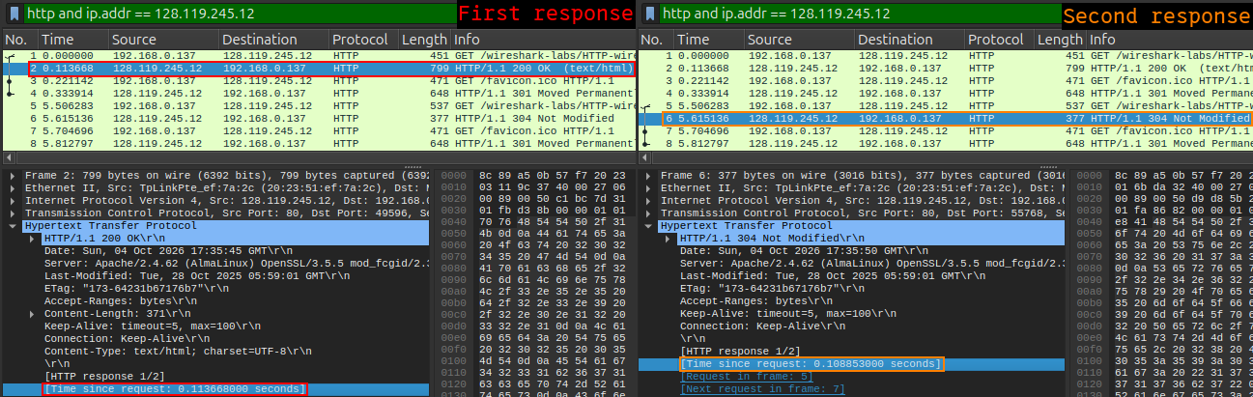
Q.18. Write a reflection on how HTTP client (browser) and HTTP server (web server) interact via HTTP messages, and how the header lines in HTTP messages are used to inform each other about the information carried in the messages. A good understanding about this would help to design your own application protocols in the future work.
A.18. From what I have learned during my work with these exercises, I can confidently conclude that a webbrowser and a webserver can communicate via “get” requests sent by the webbrowser and by responses to those “get” requests from the browser client.
I have also established a confident view that webservers generally assume that data entering at port number 80 is expected follow the rules set by the HTTP communication protocol.
I have gained a fairly good grasp of how the messages are constructed according to the rules of the protocol, and I have also understood that there are fields in the HTTP document (sometimes called “header lines”) which can be included or excluded, depending on the context of the communication.
These HTTP-header-fields enable the webbrowser and the webserver to have a conversation with a degree of dynamism. As we have seen in one of the exercises above, these fields can be used by a webserver to instruct a webbrowser on where to get the data needed for displaying the requested page. In the case of our exercise, the webserver instructed the webbrowser that the page should be loaded from its cache if it wasn’t older than a certain date and time.
https://en.wikipedia.org/wiki/List_of_HTTP_header_fields

Lab 3
2. Switch configuration.
Exercise 1. Entering and identifying command modes.
Exercise 1.1. Add a Cisco 2960 switch to the workspace in Packet Tracer.
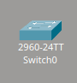

[Network Devices] > [Switches] > [2960]
Exercise 1.2. Click the switch and open the CLI tab.
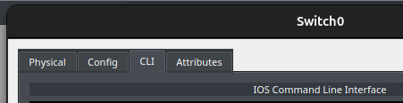

Exercise 1.3. Identify which command mode appears by default upon startup.
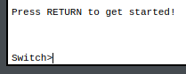

The default command mode is “user EXEC” mode.
Exercise 1.4. Enter Enable mode.
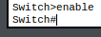

Exercise 1.5. Enter Global Configuration Mode.
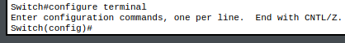

Exercise 1.6. Go back to Enable mode.
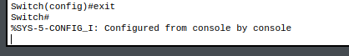

Exercise 2. Basic configuration.
Exercise 2.1. Assign a hostname to the switch.
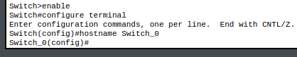

Exercise 2.2. Set an ‘enable’ password.

Exercise 2.3. Set the clock
Exercise 2.4. Save the configuration to the startup file.
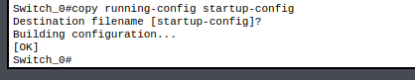

Exercise 2.5. Erase the current configuration.
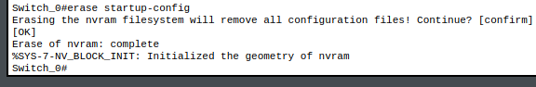
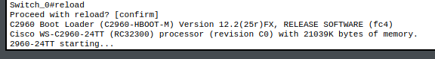
Exercise 2.6. Restart the switch again.
Exercise 2.7. Verify that the switch has erased the startup-config.

The first row shows us that the command line has entered the default ‘user EXEC’ mode with the default hostname “Switch”. This partially confirms that the switch has returned to default settings.
After entering the ‘enable’ mode, we can confirm the rest by asking it to show us if there is any ‘startup-config’ file. It clearly shows us that the file is not present.

Reflection and Review Questions and Answers
Q.1. Which command mode do you enter first when launching the CLI? How do you recognize it?
A.1. The switch enters ‘user EXEC’ mode on startup.
I recognize it by the ‘greater than’ (>) symbol following the hostname.
Q.2. What does the prompt “config#” indicate, and how do you reach this mode?
A.2. The mode indicates that the host has the ability to change the configurations of the switch. It is reached by first entering “privileged EXEC” mode (as shown by the hash symbol) with the command “enable”, and afterwards by entering the command “configure terminal” which displays the substring “(config)”.
Q.3. Why is it necessary to save the configuration to the startup file? What happens if you don’t?
A.3. It is necessary because the configurations are not set in persistent memory when changed. If the configuration file is not saved, the changes will be lost when the switch reloads or its power supply is cut.
Q.4. What information does the “show running-config” command display?
A.4. It shows the size of the current configuration, the software’s version number, log and debug info with timestamps. The password set by the “password” command. The hostname. The connection status of the switch’s interfaces.
Q.5. How can you confirm that a password has been applied? Can you view it in plain text?
A.5. Yes, it can be viewed in plain text and it’s application can be confirmed by entering the command “show running-config”. It’s application can also be confirmed by exiting “privileged EXEC” mode and running the command “enable”. If the shell asks for a password, then the “enable password …” command is confirmed to be successful.

Q.6. What happens to the clock settings after a reboot if the switch has no battery backup?
A.6. The same thing as with any computer when the motherboard’s clock battery is removed and the main power supply is cut off. The progression of time can not be measured without power, and the clock resets on startup.
Q.7. How can you verify that the configuration was erased after using write erase and reload.
A.7. By sending the command “show startup-config” and ensuring that the reply “startup-config is not present” is written to the terminal.
Q.8. What are the potential security riskts of not setting an “enable” password?
A.8. Unauthorized users can enter “privileged EXEC” mode and thus change security related configurations. (1)
Q.9. What are the differences between using the reload command and physically turning the switch off and on in Packet Tracer?
A.9. Turning off the power supply and then turning it on again will not prompt the user to save any configurations made in the current command line session, unlike using the “reload” command which will prompt the user for saving the recently made configurations. (2)
Q.10 What is the difference between “user EXEC” mode and “privileged EXEC” mode?
A.10 In “privileged EXEC“ mode, the user has access to all commands. (3)
While “user EXEC” mode only gives access to a subset of commands.

(1) https://www.cisco.com/en/US/docs/ios-xml/ios/sec_usr_cfg/configuration/15-1sg/...
(2) https://www.cisco.com/c/en/us/td/docs/ios-xml/ios/fundamentals/...
(3) https://www.cisco.com/c/en/us/td/docs/ios/sec_user_services/configuration/guide/...

3. MAC tables

Task 1
Instructions: Connect two clients to the same switch, as shown in figure 2. Make sure they can communicate with each other by using the “ping” command.
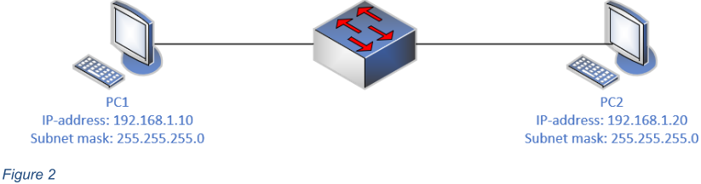
Execution:
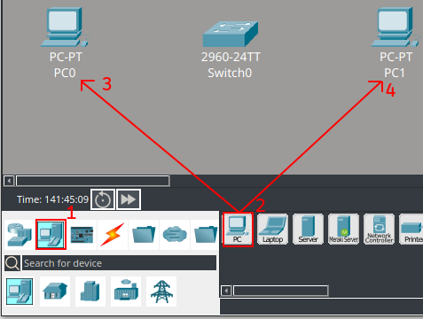
Adding two ‘end devices’.
Connecting the ‘end devices’ to the switch.
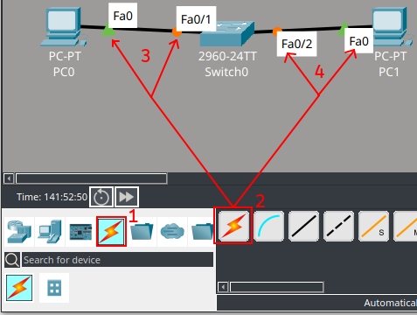
1. Choosing connections.
2. Letting the program decide the connection type.
3. Connecting the fast Ethernet port of PC0 and with fast Ethernet port ‘0/1’ of Switch0.
4. Connecting the fast Ethernet port of PC1 and with fast Ethernet port ‘0/2’ of Switch0.
Configuring the IPv4 addresses and Subnet Masks of the ‘end devices’
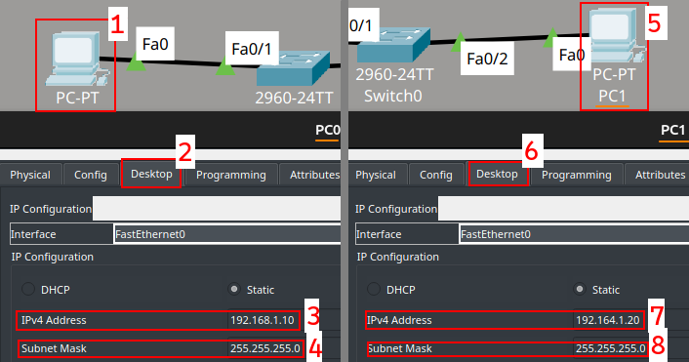
1. Clicking on PC0.
2. Clicking on the “Desktop” tab.
3. Setting a static IPv4 address to the value of PC1 specified by figure 2.
4. The Subnet Mask is set automatically once the IPv4 address is set.
5. Clicking on PC1.
6. Clicking on the “Desktop” tab.
7. Setting a static IPv4 address to the value of PC2 specified by figure 2.
The IP address in the image has since been changed to ‘192.168.1.20’.
8. The Subnet Mask is set automatically once the IPv4 address is set.
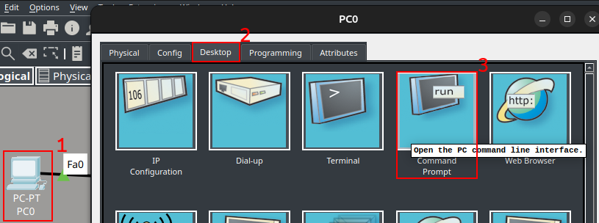
Sending a ‘ping’ command from each ‘end device’ to the other ‘end device’.
1. Clicking on an ‘end device’.
2. Clicking on the “Desktop” tab.
3. Clicking on the “Command Prompt” icon.
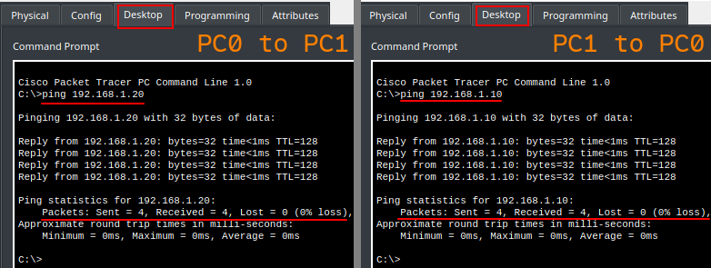
Sending a ‘ping’ and receiving a response from each end device to the other end device.
This assures us that the end devices are connected through “Switch0”.
Entering the command ‘show mac address-table dynamic’ on the switch.
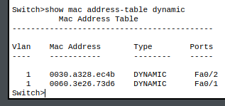
This shows the MAC addresses of the interfaces on the connected devices, and not the MAC addresses of the connected interfaces on the switch. This can be seen by the picture below where I show the that the switch’s internally assigned MAC addresses differ from the ones shown by the ‘show mac address-table dynamic’ command above.
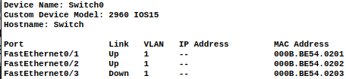

Task 2
Connecting the ‘end devices’ to separate switches and ensuring that the end devices can communicate.
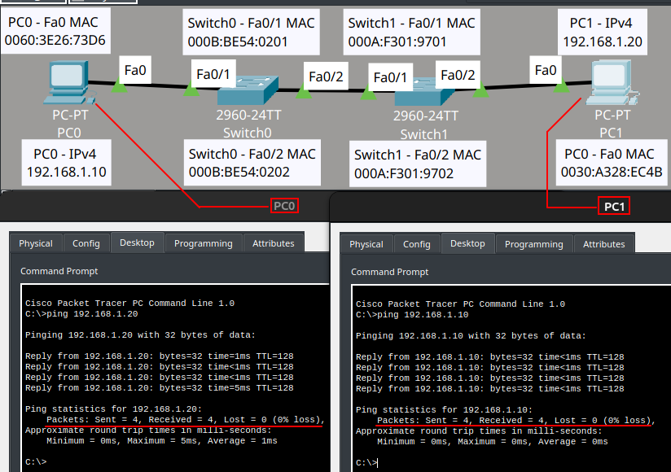
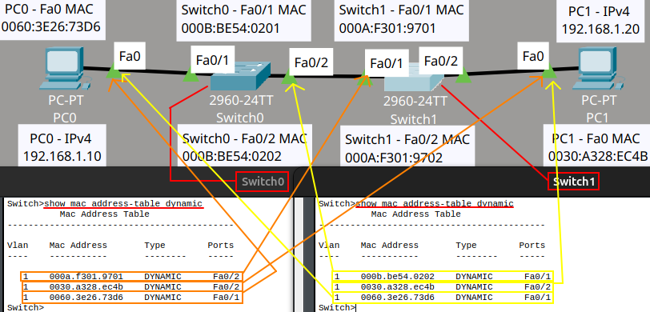
Examining the MAC tables, comparing the MAC addresses of the ‘end devices’ with the interfaces they are connected to.
The network topology from Task 1 had only one switch, and two ‘end devices’ connected directly to it. The network topology in the current task has two switches with only one ‘end device’ each, connected to them.
Switch0 has an added row representing the MAC address of one of the Ethernet interfaces on the added switch (Switch1). And Switch1 has a new mac table consisting of all the communicating devices on the network, except it’s own interfaces.

Reflection and Review Questions with Answers

Q.1. What information does the MAC table provide about the devices connected to the switch?
A.1. The switch’s MAC table provides the MAC addresses, the interfaces, the VLAN and how the MAC addresses are learned (statically or dynamically) from the devices that have communicated through the switch. (4)

Q.2. Why does the switch need a MAC table in order to forward Ethernet frames correctly?
A.2. The answer is that the switch needs a MAC table so that it does not need to rediscover the correct path every time an Ethernet frame comes to the switch, failing to have a MAC table causes a flood of unicast packages on the network (5).

Q.3. How does the switch learn the MAC addresses of connected devices.
A.3. The switch learns of connected devices through the source MAC address of an incoming frame (6).

Q.4. In Task 1, when both clients were connected to the same switch, what did you observe in the MAC table?
A.4. The command “show mac address-table dynamic” printed the MAC addresses of the Ethernet interfaces connected to the switch. I also observed that the printout of the interfaces were those on the device’s end, and not the interfaces on the switch’s end.
Q.5. In Task 2, when the clients were connected to different switches. How did the MAC tables differ compared to Task 1.
A.5. The MAC tables included the MAC address of the connected interface from the the other switch on the network.

Q.6. Why is the ping command useful in this lab, and what does it tell you about the network connection.
A.6. It can be useful for fault isolation on a computer network (8).
It tells me if a device on a network can receive and respond to a signal from another device on the same network, specifically the device that sent the signal.

Q.7. What kind of network issues could cause a ping to fail, even if the devices are physically connected.
A.7. There are several network issues on different layers of the OSI model that could cause a ping to fail.
On level 1: Defects on networking related hardware of different kinds. Examples are damaged Ethernet cables, and excessive electromagnetic noise (9).
On level 2: The Ethernet interfaces of the devices belonging to different VLAN’s (10).
A switch disables a port on the route due to having blocked the connecting interface’s MAC address (11).
On level 3: The IP addresses involved in the ping communication could be blocked by a firewall (12).
A device on the route may limit the number of ICMP messages that it can process, causing at least some of the ping packages to fail (13).
Q.8. How does the concept of MAC tables relate to the difference between a switch and a hub?
A.8. The switch operates at OSI level 2 (14) and needs a MAC table in order to deliver its promise to manage the information in respect to the Ethernet interfaces connected to it and their VLAN’s (15).
A hub operates at OSI level 1 (16) where it does not have any use for a MAC table and instead redistributes incoming signals to all its connected interfaces irrespective of who the signal was meant for (17).

(4) https://www.geeksforgeeks.org/computer-networks/mac-address-table…
(5) https://www.cisco.com/c/en/us/support/docs/switches/catalyst-6000-s…
(6) https://www.cisco.com/c/en/us/support/docs/switches/catalyst-9300…
(8) https://man.cx/ping(1)#:~:text=When%20using%20ping%20for%20fa…
(9) https://www.cisco.com/en/US/docs/internetworking/troubleshooting/gu…
(10) https://www.cisco.com/c/en/us/support/docs/lan-switching/inter-vlan-…
(11) https://www.cisco.com/c/en/us/td/docs/switches/lan/catalyst9300/soft…
(12) https://docs.redhat.com/en/documentation/red_hat_enterprise_linux/7…
(13) https://www.kernel.org/doc/html/latest/networking/ip …
(14) https://www.cisco.com/c/en/us/support/docs/lan-switching/ethernet/12…
(15) https://www.cisco.com/c/en/us/support/docs/lan-switching/ethernet/12…
(16) https://www.cisco.com/c/en/us/support/docs/lan-switching/ethernet/12…
(17) https://www.cisco.com/c/en/us/support/docs/lan-switching/ethernet/12…

4. Log in with Telnet
This part will follow the setup configuration suggested by the assignment.
It will be completed by doing both steps in one go, where the password setup for remote access is followed by setting up an IP-address to the switch’s internal management interface.

The initial setup.
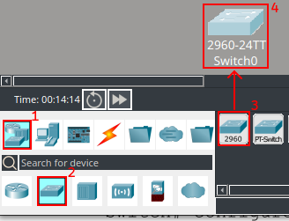

Password for remote access and Assigning an IP address to the switch.
1. Enter “privileged mode”.
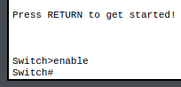
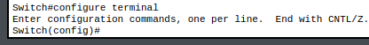
2. Enter global configuration mode.
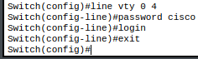
3. Set a password for remote (vty) access.
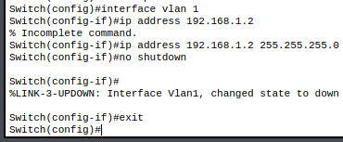
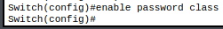
4. Set an enable password.
5. Assign an IP address to the management interface.
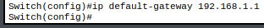
6. Configure a default gateway.

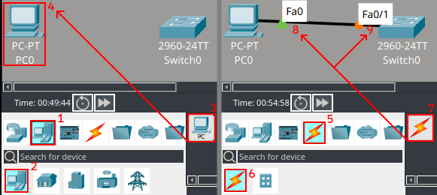
Expanding the initial setup in order to test the Telnet login.
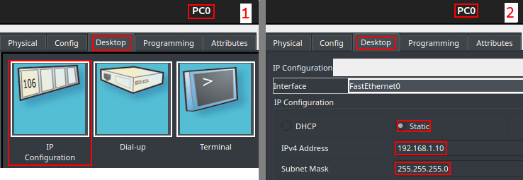
Configuring a static IP address for PC0.

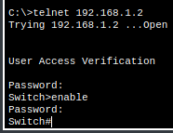
Attempting to login with Telnet.
Success!

5. Configure interface
This part is done on a fresh ‘.pkt’ file.
1. Select the interface.
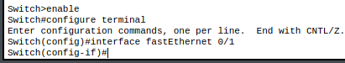
2. Enable port security.
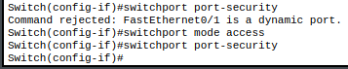
3. Set maximum number of MAC addresses.
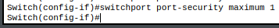
4. Enable sticky MAC learning.
5. Define violation mode.
6. Exit and save configuration.
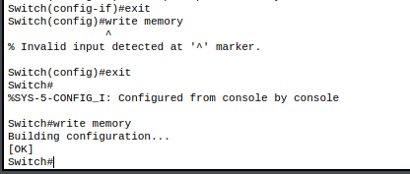

Verifying sticky MAC address.
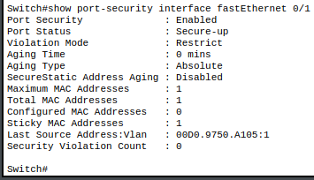

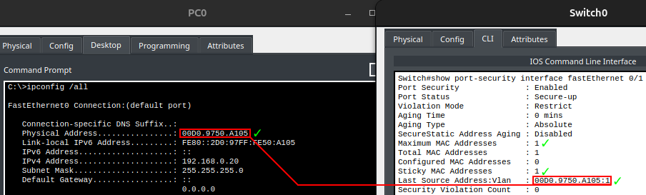
Verifying sticky MAC addresses specifically.

