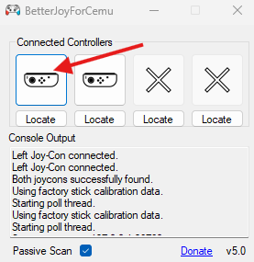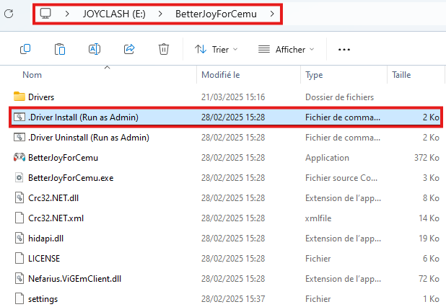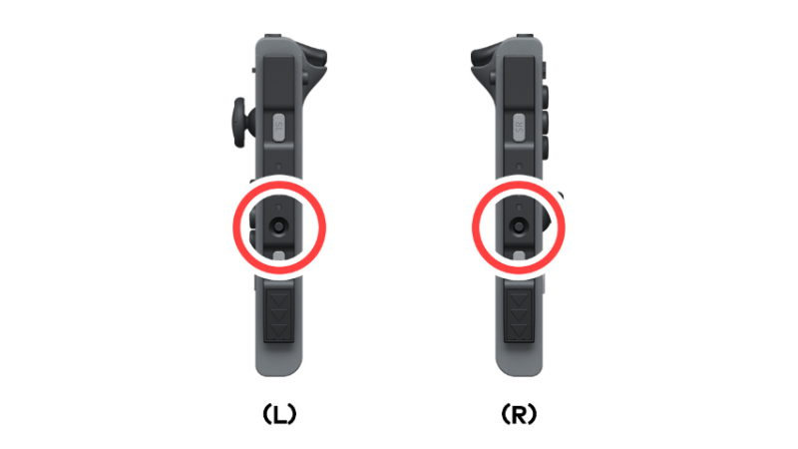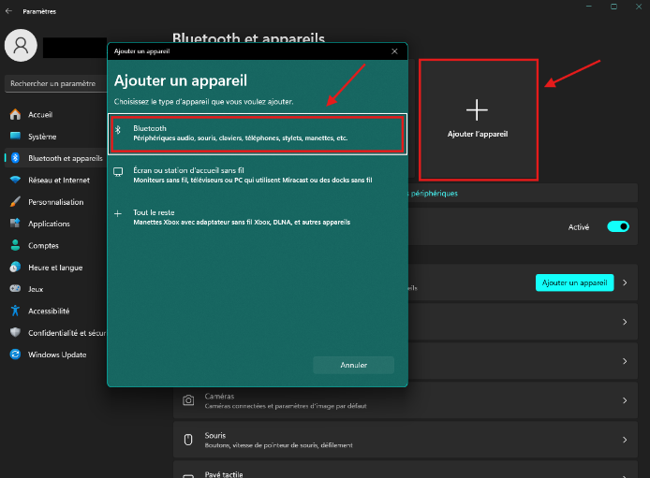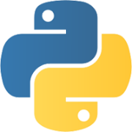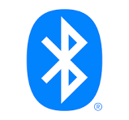

STEP 0

**HOW TO SETUP THE GAME**

Click on them to rotate on the side and you’re good to go

then connect them to the PC with Bluetooth in the settings

Press and hold the sync button on the side of both joy-con,

When both joy-con are paired, install drivers and execute BetterJoyForCemu

You need to have:

Latest version of python & pygame

Bluetooth

Execute drivers (Admin)

STEP 2

STEP 1

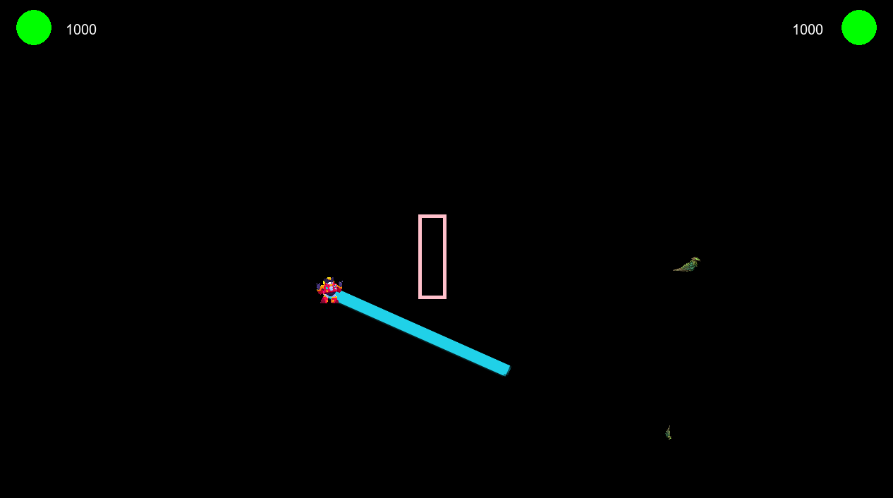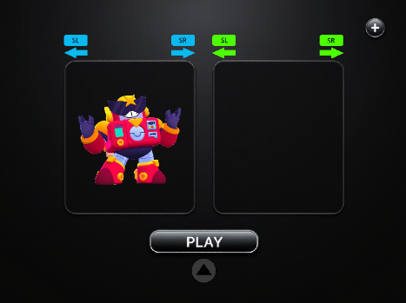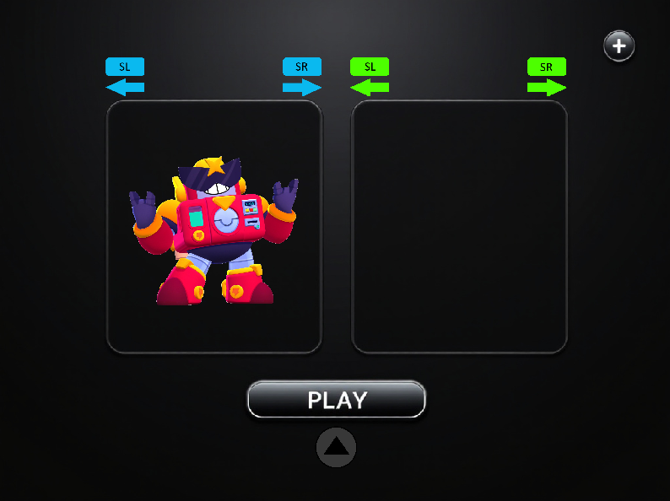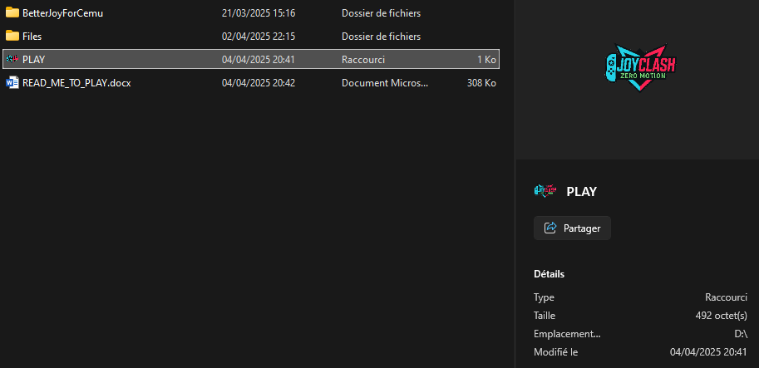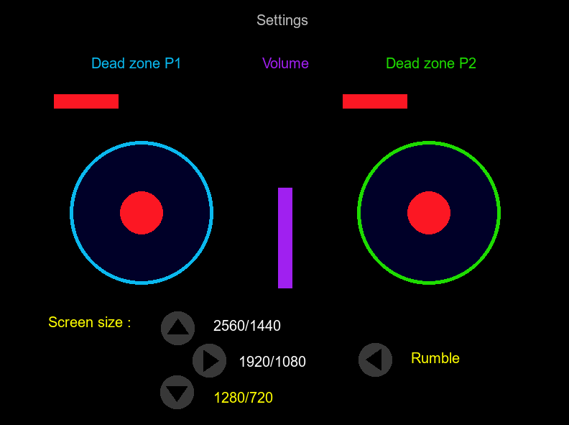

All feature is:

-stamina to go faster (↓)

-lock to aim shoot (SR)

-shoot to attack (→)

-joystick to move and aim also

-wall to block movement and projectiles

Here, you can change:

Dead zone

Volume

Screen size

Vibrations

STEP 2

When you’re both ready, press D-pad up ↑ together and the game will begin

Choose your fighter with SL/SR and if you want, go to the settings with -

STEP 1

STEP 0

Click on the PLAY shortcut and run the program

**HOW TO PLAY AT THE GAME**

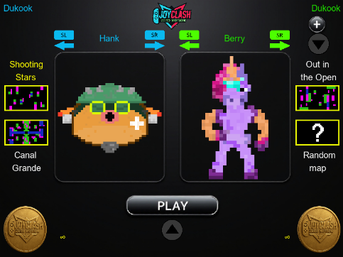

Don’t connect two same accounts, that could create some issues. (Patched in the version 3.0)

Crash 3

❗Don’t change any name’s file if you want to play

If you want to swap controller you can press space in setting’s menu but it will not swap account.

Path could be incorrect for you so change “chdir” line to your absolute path:

Crash 2

You need to have 2 or more controller connected on the PC

Crash 1

**HOW TO NOT CRASH**



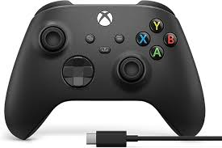

From

Audigé Louwig and Auguste Ouzoulias

❗You won’t play with all of the buttons of your controller, only the upper side can be use.

There is no step two, it’s so simple to play this game

STEP 2

STEP 1

You need to plug or connect your controller

**HOW TO PLAY WITHOUT JOY-CON**