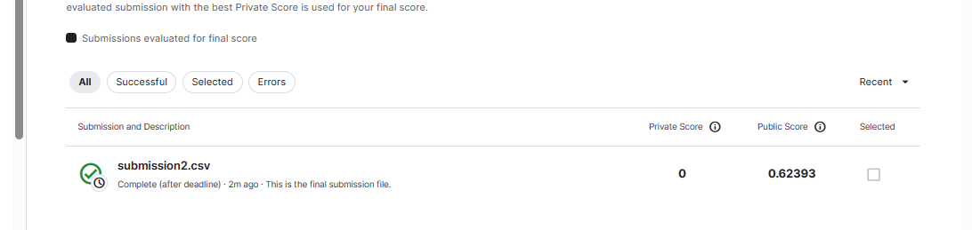

Score: 0.62393

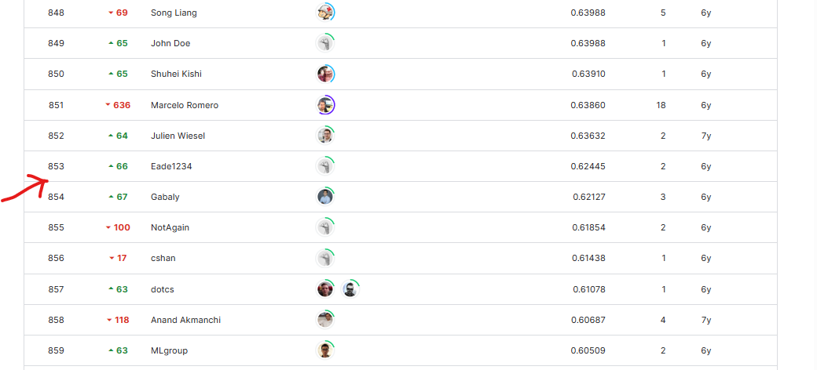

Supposed Position: 854