**PREPOSITIONS**

**PHASE 01:**

**Read carefully. Try and Identify the prepositions present in this passage. Check with the facilitator.**

1. Nazia is sitting in her study room in the evening. The semester final exam of EAP 101 is on Monday. She is trying to take a good preparation. Her EAP 101 Course Pack is on the table. She is taking notes in her Notebook.

**Now, read again and try to find out if there is any similarity or difference in the Prepositions used in these passages. Discuss with your Classmates and Facilitator.**

1. Nazia is a student of Green University of Bangladesh. It is situated at Shewrapara in Dhaka. She lives in Mirpur as well. During exams, she wakes up at 6 in the morning. She reviews the materials for exam. Then she has breakfast at 8:30am and gets ready. She leaves the house at 9:00 am and reaches at the University within 9:30am.
2. In the exam hall, the invigilator provides Nazia with an Answer Script and a Question paper. She writes her name at the Left Corner of the Front Page. She reads the instructions written on the Question paper very carefully. She submits the paper to the invigilator when the exam is finished.
3. After the exam, Nazia gets a seven days’ vacation. On 3rd November, her father takes all the family members for a tour in Bandarban. They check in a hotel on the hills. Nazia loves the natural beauty in Winter. She enjoys the view sitting on a chair in the balcony of her room.

**PHASE 02:**

**Try to place the appropriate Prepositions in the blanks; based on your observations from the earlier passages.**

**A.**

1. We always go on holiday ….. ……. summer.

2. My mother usually goes shopping …………….. Friday morning.

3. I always do my homework ……………… the evening.

4. The circus usually comes to our town ………………. spring.

5. Sophia’s birthday is …………… May 16th.

6. I usually get up ……………….. seven o’clock.

7. My favorite television program begins …………… 6:30 …………. the evening.

8. Sometimes it snows ……………….. winter.

9. My friend’s birthday is ……………… June.

10. Some birds and animals come out ……………… night.

**B.**

1. I looked at the bookcase and saw an interesting story book …………. the top shelf.

2. ……………. sunny days we usually go on a picnic.

3. I usually listen ……….. pop music, because I’m interested ………… it.

4. Mary was born ……… 20th March ………… 1982.

5. We had to work every day …………. last summer.

6. …………... Christmas I’d like to visit my relatives.

7. I last saw him ………… last March.

8. Section 5 is …………... the first floor of the Prep School.

9. You mustn’t smoke …………… a bus.

10. Ahmet’s grandmother died ………... 1990.

**PHASE 03:**

“Pre- “means “before”, and “position” means placement.

A **Preposition** is a word used to link nouns, pronouns, or phrases to other words within a sentence.

Preposition is a word which is placed before noun/noun equivalent, and makes a relationship between that noun and other words in sentence.

**Use of *in, on*, and *at:***

|  |  |
| --- | --- |
| **Use of IN** | |
| **Use** | **Example** |
| 1. **In** for **Place**: **in** for an *ENCLOSED SPACE* | in the garden, in my wallet, in a box,  in London |
| 2. **In** for **time**: **in** for MONTHS, YEARS, CENTURIES and LONG PERIODS | in May  in summer in 1990  in the next century |
| 3. **In**: **for Situation/Position**  In for a particular situation, relevant position etc. | He is not *in good health.* |
|  |  |
| **Use of ON** | |
| 1. **On** for **place** | The book is on the table. |
| 2. **On** for **“about”** | He wrote an essay on “Jute”. |
| 3. **On** for **“Reason”** | I congratulated on his success. |
| 4. **On** for **“Dependency”** | The cow lives on grass. |
| 5. **On** for **“following”** | I acted on my teacher’s advice. |
| 6. **On** for **time**: **on** for DAYS and DATES | On Sunday, On 6 March  on Christmas Day, On Easter Sunday |
| 7. **Situation** | She is on phone. He is on Television. |
| **Use of AT** | |
| 1. **At** for **place**: **at** for a POINT | At the bus stop, At the door,  At the top of the page, At the entrance |
| **2. At** for **time**: **at** for a PRECISE/TINY TIME | At 10.30am, At noon  At the moment, At night, At dawn, At Sunrise, At sunset |
| **3. At** for **“Dimension”** | The coach/horse runs at sixty miles an hour. |
| **4. At** for **“Direction”** | He came at me. |
| **5. At** for **“Price”** | Rice sells at Tk. 20 per Kg. |
| **6. At** for **“Result”** | He did it at his own risk. |
| **7. At** for **“Target/Aim”** | He aimed at the tiger. |
| **8. At** for **“Expression”** | He faced/frowned at me. |
| **9. At** for **“Insult/Criticize”** | We should not laugh at the poor. |
| * **“IN” and “AT”:** * “In” before larger place/time. * “At” before smaller place/time. | * He lives at Shyamoli in Dhaka. * She went there at 7 o’clock in evening. |
| * **ON, IN, AT** * “On” before day/date * “In” before month/year * “At” before particular period | * I will meet you at 5 o’clock on Sunday in January. |

Use **at** for the following:

Mobile number, Email address, FB ID, Home/residence address

1. Call me ------ this number if you need.
2. Green University is _ __ Rokeya Sarani _____ Mirpur__ __ Dhaka.
3. My home is ____ Shamim Sarani ____ Mirpur _____ Dhaka.
4. --on-- 2nd July in 2020, I went to BC located --—Pantha path ---- Karwan Bazar ---- Dhaka.

Street/road = same/different????

**Preposition of Location**

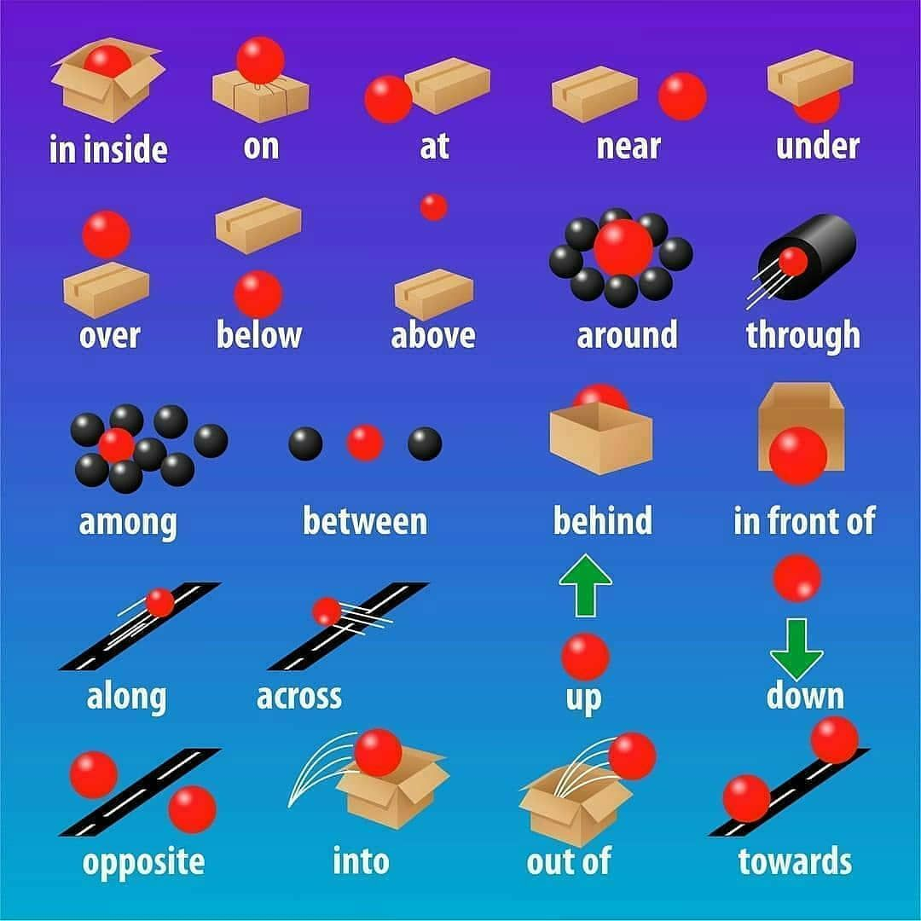**Image collected from internet**

**Exercises on location/place**

1. **Match the numbers with the prepositions.**

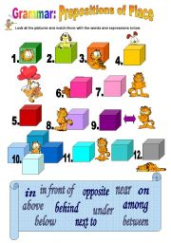

**Image collected from internet**

1. **Look at the image and fill in the gap with suitable preposition.**

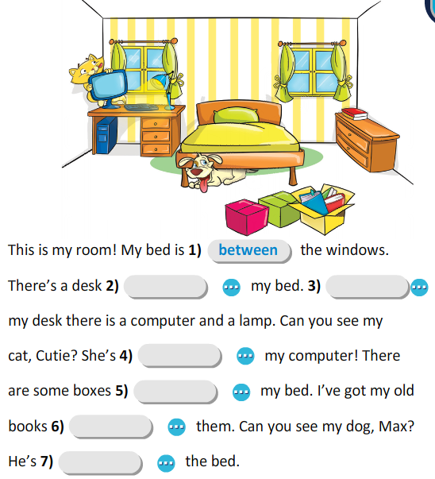

**Image collected from internet**

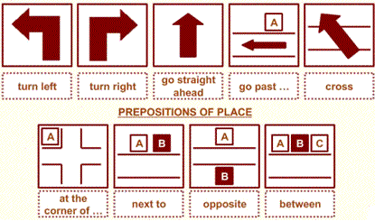**Preposition of Directions**

**Exercise on Direction**

1. 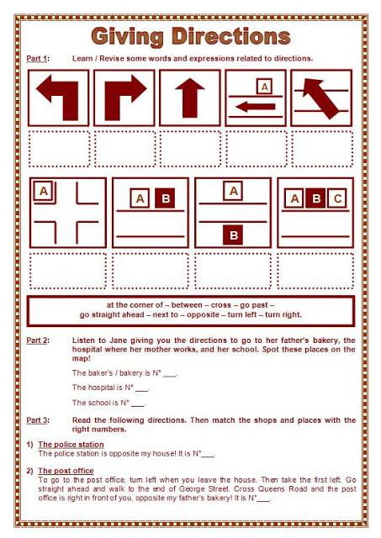**Write correct proposition for the symbols**
2. 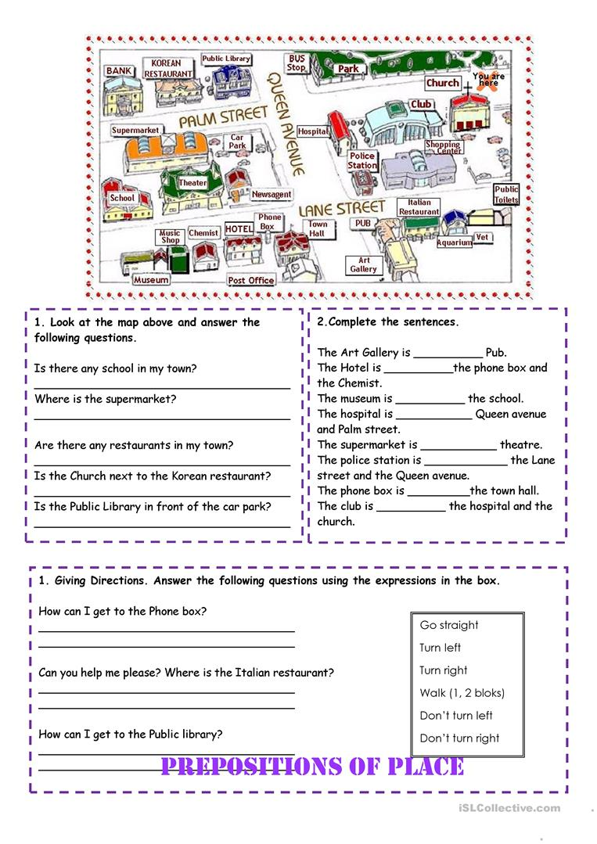**Fill in the gaps.**
3. 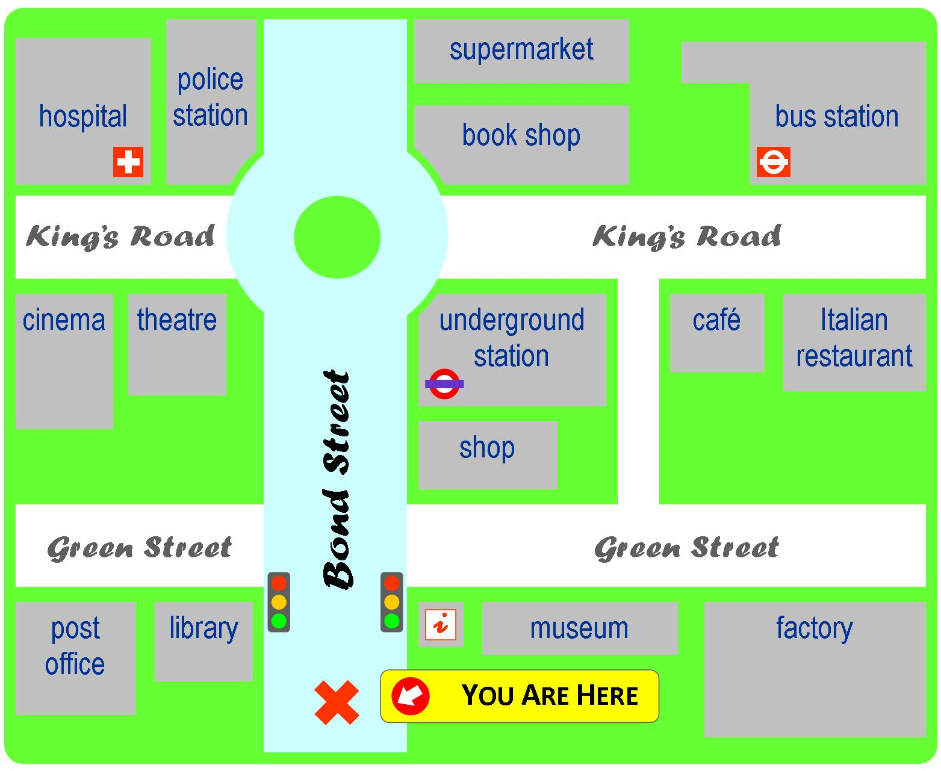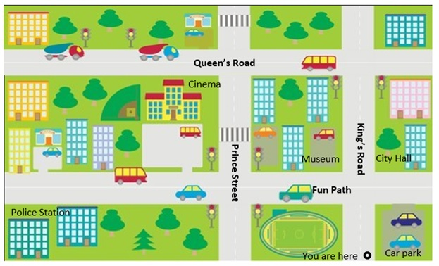**More practice!**