One important setup point first: vLLM runs on Linux, and the official docs say it does not support Windows natively.

On Windows, use WSL2 with Ubuntu and open that folder in VS Code using the Remote - WSL extension. The docs also show that vllm serve runs the OpenAI-compatible server, and vLLM exposes Prometheus metrics at http://localhost:8000/metrics. (vLLM)

0) What you need before starting
You need:
- a Linux environment, or Windows + WSL2 Ubuntu
- Python 3.10–3.13
- a GPU-supported setup for vLLM, or Docker if you prefer that route
- the demo folder
- The official GPU install page lists Linux as the supported OS for vLLM, recommends a fresh Python environment, and provides prebuilt wheels. (vLLM)

1) Extract and open the demo in VS Code
Extract the zip somewhere like:
~/projects/vllm_demo
Then in VS Code:
- File → Open Folder
- open vllm_demo
You should see:
- README.md
- scripts/
- examples/
- configs/
- requirements.txt

2) Open the integrated terminal in VS Code
In VS Code:
- Terminal → New Terminal
You’ll use multiple terminals:
- Terminal 1 → vLLM server
- Terminal 2 → benchmark client
- Terminal 3 → optional Prometheus/Grafana
- Terminal 4 → plots / metrics snapshots

3) Create and activate the Python environment
Run this inside the vllm_demo folder.
Linux / WSL

python3 -m venv .venv
source .venv/bin/activate
python -m pip install --upgrade pip
pip install -r requirements.txt

If you are using PowerShell inside WSL-less Windows
Do not use that for vLLM itself. Use WSL2 Ubuntu instead, because native Windows is not officially supported. (vLLM)

4) Install vLLM in the same environment
The official docs provide Python-based installation and prebuilt wheels for GPU installs. For a straightforward setup, install vllm into the same virtual environment you just created. (vLLM)

Run:

pip install vllm

If that fails because of your CUDA/PyTorch combination, use the official CUDA wheel index route from the docs. One documented example is:

pip install vllm --extra-index-url https://download.pytorch.org/whl/cu129

That exact pattern is documented in the GPU install page. (vLLM)

5) Pick a model for the demo
For the first run, use a small instruct model so the demo comes up quickly.

You can start with your own model name, for example:

export MODEL="your-model-name"

export MODEL="Qwen/Qwen2.5-3B-Instruct"

Or just replace the model directly in commands below.

6) Start the default vLLM server in Terminal 1
The vLLM quickstart/docs show vllm serve as the standard way to launch the OpenAI-compatible server, and the metrics docs use port 8000 and /metrics. (vLLM)

In Terminal 1:

source .venv/bin/activate
vllm serve <YOUR_MODEL> \
--host 0.0.0.0 \
--port 8000 \
--max-model-len 8192 \
--gpu-memory-utilization 0.90 \
--max-num-batched-tokens 4096

env -u PYTHONPATH -u PYTHONHOME PYTHONNOUSERSITE=1 \
/home/jovyan/.env-vllm/bin/vllm serve Qwen/Qwen2.5-3B-Instruct \
--host 0.0.0.0 \
--port 8000 \
--max-model-len 4096 \
--gpu-memory-utilization 0.20 \
--max-num-batched-tokens 2048

env -u PYTHONPATH -u PYTHONHOME PYTHONNOUSERSITE=1 \
/home/jovyan/.env-vllm/bin/vllm serve Qwen/Qwen2.5-1.5B-Instruct \
--host 0.0.0.0 \
--port 8000 \
--max-model-len 4096 \
--gpu-memory-utilization 0.20 \
--max-num-batched-tokens 1024

Qwen/Qwen2.5-0.5B-Instruct — lightest practical fallback
Qwen/Qwen2.5-1.5B-Instruct — best balance

env -u PYTHONPATH -u PYTHONHOME PYTHONNOUSERSITE=1 \
/home/jovyan/.env-vllm/bin/vllm serve Qwen/Qwen2.5-1.5B-Instruct \
--host 0.0.0.0 \
--port 8000 \
--max-model-len 4096 \
--gpu-memory-utilization 0.20 \
--max-num-batched-tokens 1024 \
--enforce-eager

export CC=/home/jovyan/cc-tools/bin/x86_64-conda-linux-gnu-cc
export CXX=/home/jovyan/cc-tools/bin/x86_64-conda-linux-gnu-c++

env -u PYTHONPATH -u PYTHONHOME PYTHONNOUSERSITE=1 \
CC=$CC CXX=$CXX \
/home/jovyan/.env-vllm/bin/vllm serve Qwen/Qwen2.5-1.5B-Instruct \
--host 0.0.0.0 \
--port 8000 \
--max-model-len 4096 \
--gpu-memory-utilization 0.20 \
--max-num-batched-tokens 1024 \
--enforce-eager
Example:
source .venv/bin/activate
vllm serve unsloth/Llama-3.2-1B-Instruct \
--host 0.0.0.0 \
--port 8000 \
--max-model-len 8192 \
--gpu-memory-utilization 0.90 \
--max-num-batched-tokens 4096

Wait until the server is fully ready.

7) Check that the server is alive
In Terminal 2:

source .venv/bin/activate

curl http://localhost:8000/metrics | head

The vLLM metrics docs show this exact pattern for checking the /metrics endpoint. (vLLM)

You can also test model discovery:

curl http://localhost:8000/v1/models

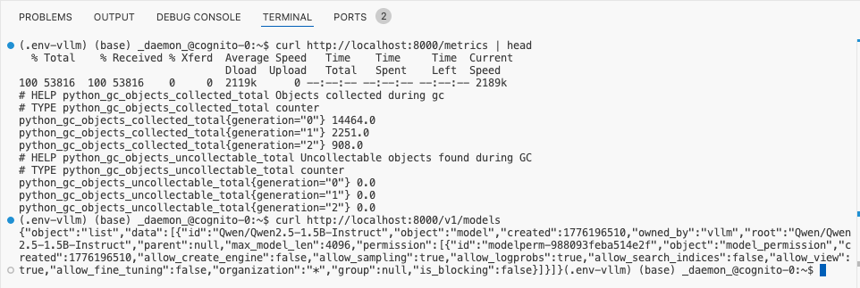

8) Run the smoke test
In Terminal 2:

source .venv/bin/activate

python scripts/client_benchmark.py \
--base-url http://localhost:8000/v1 \
--model Qwen/Qwen2.5-1.5B-Instruct \
--scenario mixed_batching \
--label smoke \
--output-root results

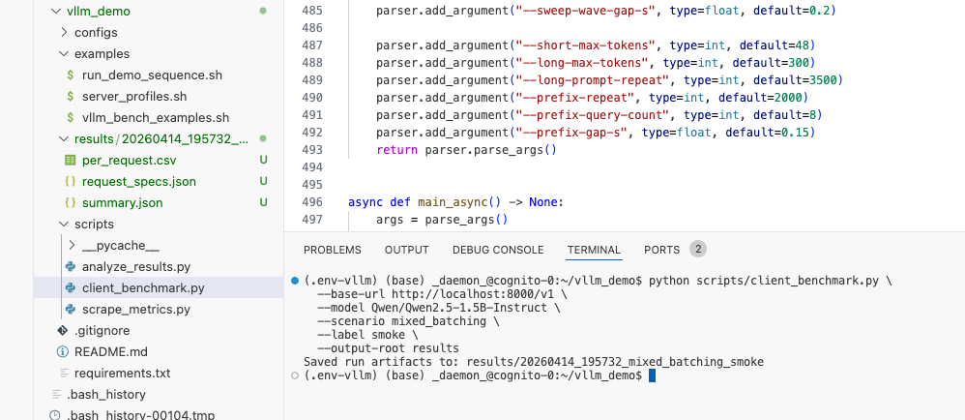

After it finishes, open the new run folder under:
results/

You should see files like:

- summary.json
- per_request.csv

9) Run Demo 1: Continuous batching

9A) Serialized baseline

In Terminal 2:

source .venv/bin/activate

python scripts/client_benchmark.py \
--base-url http://localhost:8000/v1 \
--model Qwen/Qwen2.5-1.5B-Instruct \
--scenario mixed_batching \
--serialized \
--label serialized \
--output-root results

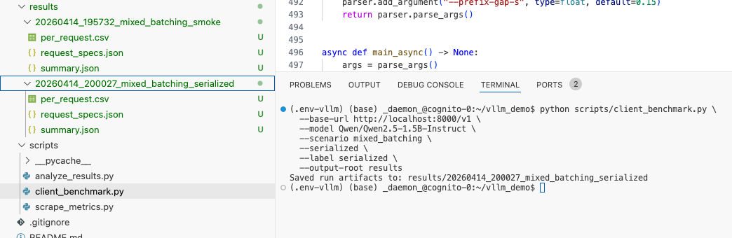
9B) Concurrent arrivals on vLLM

Still in Terminal 2:

source .venv/bin/activate

python scripts/client_benchmark.py \
--base-url http://localhost:8000/v1 \
--model Qwen/Qwen2.5-1.5B-Instruct \
--scenario mixed_batching \
--request-rate 2.5 \
--label vllm_concurrent \
--output-root results

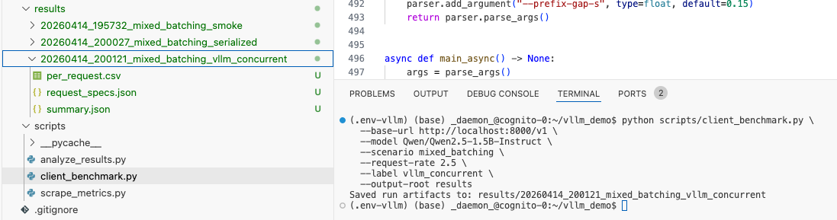

This gives you the two runs needed for the batching comparison.

10) Run Demo 2: Chunked prefill A/B
Stop the server in Terminal 1 with:

Ctrl + C

10A) Start server with chunked prefill disabled

In Terminal 1:

source .venv/bin/activate

vllm serve Qwen/Qwen2.5-1.5B-Instruct \
--host 0.0.0.0 \
--port 8000 \
--max-model-len 8192 \
--gpu-memory-utilization 0.90 \
--no-enable-chunked-prefill \
--max-num-batched-tokens 12288

If you really want chunked prefill off: Then you must make max_num_batched_tokens >= max_model_len

env -u PYTHONPATH -u PYTHONHOME PYTHONNOUSERSITE=1 \
CC=$CC CXX=$CXX \
/home/jovyan/.env-vllm/bin/vllm serve Qwen/Qwen2.5-1.5B-Instruct \
--host 0.0.0.0 \
--port 8000 \
--max-model-len 2048 \
--gpu-memory-utilization 0.20 \
--no-enable-chunked-prefill \
--max-num-batched-tokens 2048 \
--enforce-eager

Now in Terminal 2 run:

source .venv/bin/activate

python scripts/client_benchmark.py \
--base-url http://localhost:8000/v1 \
--model Qwen/Qwen2.5-1.5B-Instruct \
--scenario chunked_prefill \
--short-request-count 20 \
--request-rate 1.5 \
--long-prompt-repeat 5000 \
--label no_chunked \
--output-root results

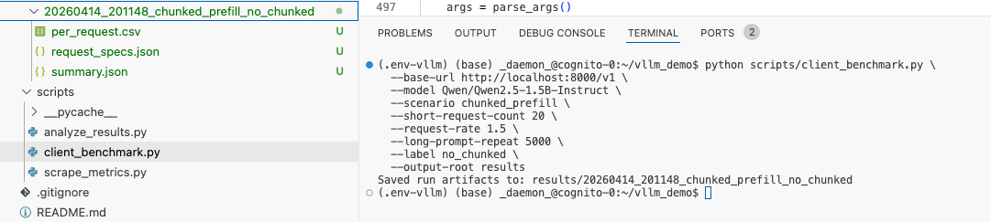

10B) Start server with default / chunked prefill on

Stop the server again with Ctrl + C.

Then in Terminal 1:

source .venv/bin/activate

env -u PYTHONPATH -u PYTHONHOME PYTHONNOUSERSITE=1 \
CC=$CC CXX=$CXX \
/home/jovyan/.env-vllm/bin/vllm serve Qwen/Qwen2.5-1.5B-Instruct \
--host 0.0.0.0 \
--port 8000 \
--max-model-len 4096 \
--gpu-memory-utilization 0.20 \
--enable-chunked-prefill \
--max-num-batched-tokens 2048 \
--enforce-eager

Then in Terminal 2:

source .venv/bin/activate

python scripts/client_benchmark.py \
--base-url http://localhost:8000/v1 \
--model Qwen/Qwen2.5-1.5B-Instruct \
--scenario chunked_prefill \
--short-request-count 20 \
--request-rate 1.5 \
--long-prompt-repeat 5000 \
--label chunked_on \
--output-root results

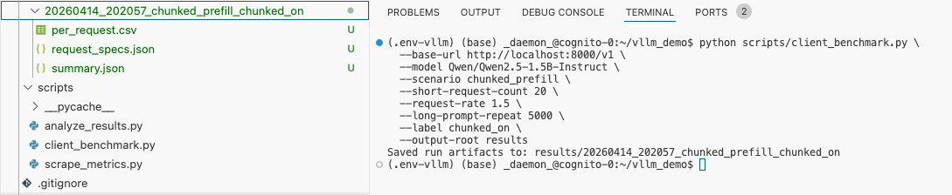

Your plot script will compare these runs.

11) Run Demo 3: Prefix caching A/B

Stop the server again.

11A) Prefix caching OFF

In Terminal 1:

source .venv/bin/activate

env -u PYTHONPATH -u PYTHONHOME PYTHONNOUSERSITE=1 \
CC=$CC CXX=$CXX \
/home/jovyan/.env-vllm/bin/vllm serve Qwen/Qwen2.5-1.5B-Instruct \
--host 0.0.0.0 \
--port 8000 \
--max-model-len 4096 \
--gpu-memory-utilization 0.20 \
--no-enable-prefix-caching
--enforce-eager

In Terminal 2:
source .venv/bin/activate
python scripts/client_benchmark.py \
--base-url http://localhost:8000/v1 \
--model Qwen/Qwen2.5-1.5B-Instruct \
--scenario prefix_cache \
--prefix-repeat 2500 \
--prefix-query-count 8 \
--label prefix_off \
--output-root results

python scripts/client_benchmark.py \
--base-url http://localhost:8000/v1 \
--model Qwen/Qwen2.5-1.5B-Instruct \
--scenario prefix_cache \
--prefix-repeat 50 \
--prefix-query-count 5 \
--label prefix_off_small \
--output-root results

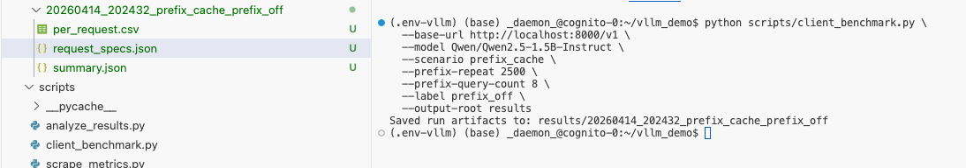

11B) Prefix caching ON

Stop the server again.

In Terminal 1:

source .venv/bin/activate

env -u PYTHONPATH -u PYTHONHOME PYTHONNOUSERSITE=1 \
CC=$CC CXX=$CXX \
/home/jovyan/.env-vllm/bin/vllm serve Qwen/Qwen2.5-1.5B-Instruct \
--host 0.0.0.0 \
--port 8000 \
--max-model-len 4096 \
--gpu-memory-utilization 0.20 \
--enable-prefix-caching
--enforce-eager

In Terminal 2:

source .venv/bin/activate

python scripts/client_benchmark.py \
--base-url http://localhost:8000/v1 \
--model Qwen/Qwen2.5-1.5B-Instruct \
--scenario prefix_cache \
--prefix-repeat 2500 \
--prefix-query-count 8 \
--label prefix_on \
--output-root results

python scripts/client_benchmark.py \
--base-url http://localhost:8000/v1 \
--model Qwen/Qwen2.5-1.5B-Instruct \
--scenario prefix_cache \
--prefix-repeat 50 \
--prefix-query-count 5 \
--label prefix_off_small \
--output-root results

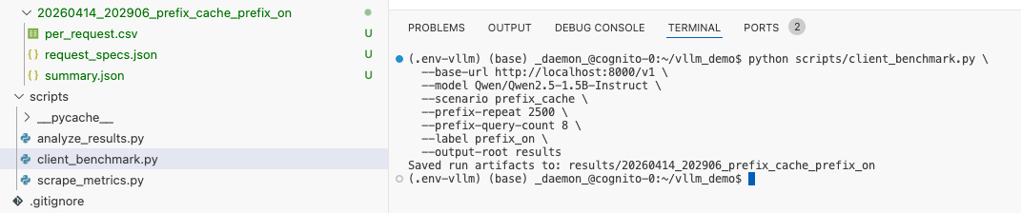

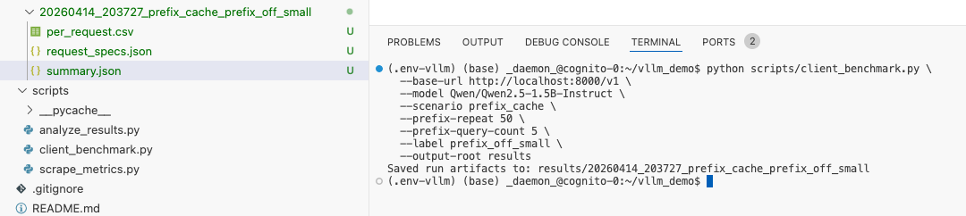

The vLLM metrics documentation also exposes prefix-cache-related counters such as vllm:prefix_cache_hits and vllm:prefix_cache_queries, so you can verify caching behavior from /metrics too. (vLLM)

12) Run Demo 4: Concurrency sweep

Restart the default server in Terminal 1:

source .venv/bin/activate

env -u PYTHONPATH -u PYTHONHOME PYTHONNOUSERSITE=1 \
CC=$CC CXX=$CXX \
/home/jovyan/.env-vllm/bin/vllm serve Qwen/Qwen2.5-1.5B-Instruct \
--host 0.0.0.0 \
--port 8000 \
--max-model-len 4096 \
--gpu-memory-utilization 0.20 \
--max-num-batched-tokens 2048 \
--enforce-eager

Now in Terminal 2:

source .venv/bin/activate

python scripts/client_benchmark.py \
--base-url http://localhost:8000/v1 \
--model Qwen/Qwen2.5-1.5B-Instruct \
--scenario sweep \
--sweep-values 1,2,4,8,12,16 \
--requests-per-sweep 12 \
--label sweep \
--output-root results

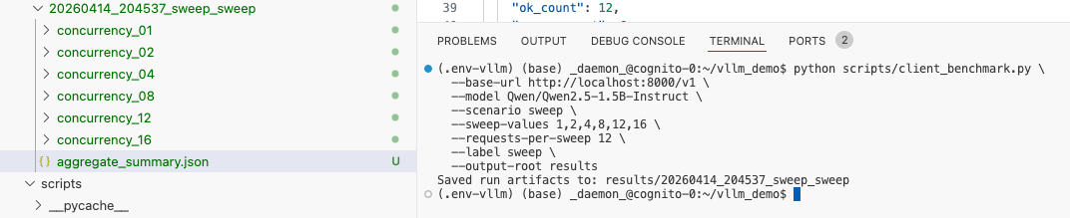

13) Save a raw metrics snapshot

In Terminal 3:

source .venv/bin/activate

python scripts/scrape_metrics.py \
--metrics-url http://localhost:8000/metrics \
--output results/metrics_snapshot.prom

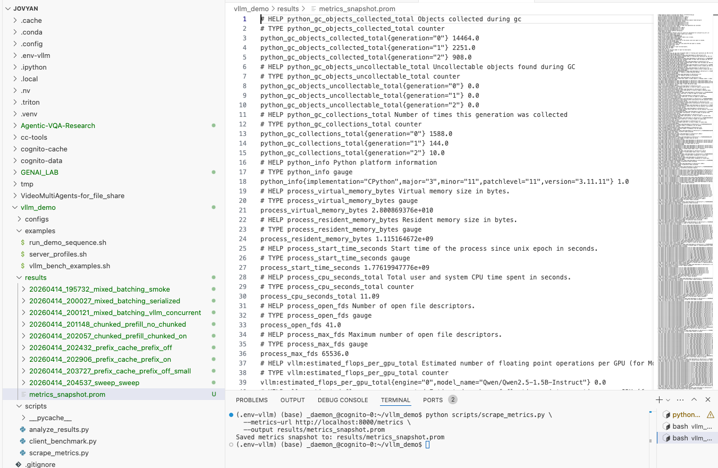

That gives you a raw Prometheus-format file for later inspection.

14) Generate the plots
In Terminal 3:

source .venv/bin/activate

python scripts/analyze_results.py \
--results-root results \
--output-dir results/plots

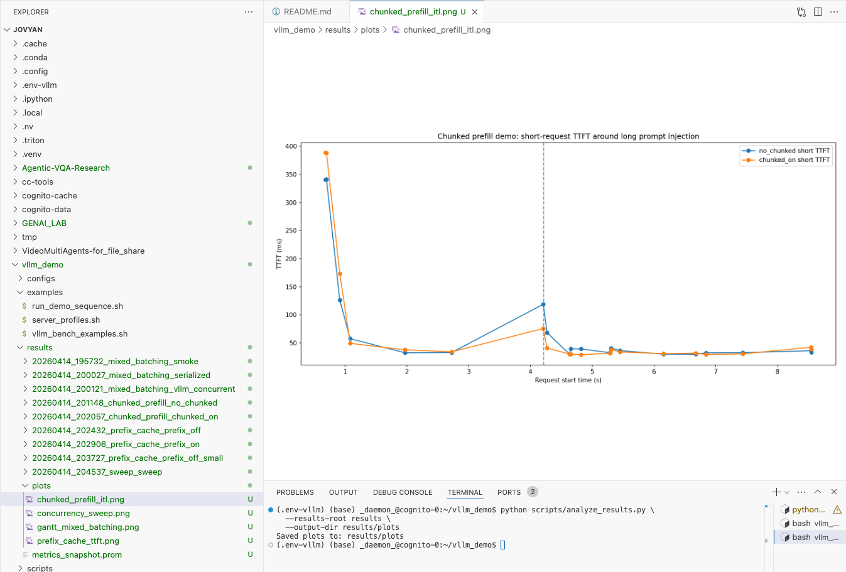

This will generate:

- gantt_mixed_batching.png
- chunked_prefill_itl.png
- prefix_cache_ttft.png
- concurrency_sweep.png

Open results/plots/ directly from the VS Code explorer.

