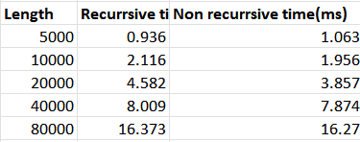

According to the results we can see that time taken to both are almost same.

