**CSC 110 2.0 Object Oriented Programming**

**Tutorial 10**

----------------------------------------------------------------------------------------------------------------

**Instructions:**

* All questions must be attempted and answers submitted in a handwritten document, **on or before 4.00pm on Monday, 28th October 2019, to the Department Office**.
* You must indicate your **Index Number and the Tutorial Class** to which you belong to **(LCS1/ LCS2/ NFC3.1)** clearly on the front page of your submission.
* Recommended Time Duration: **1 hour and 10 minutes**

----------------------------------------------------------------------------------------------------------------

**Examination Practice**

01.

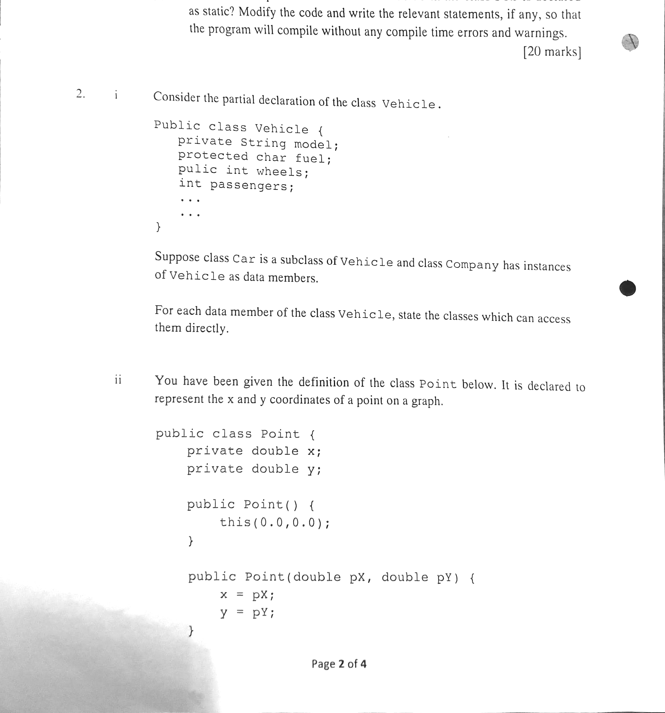

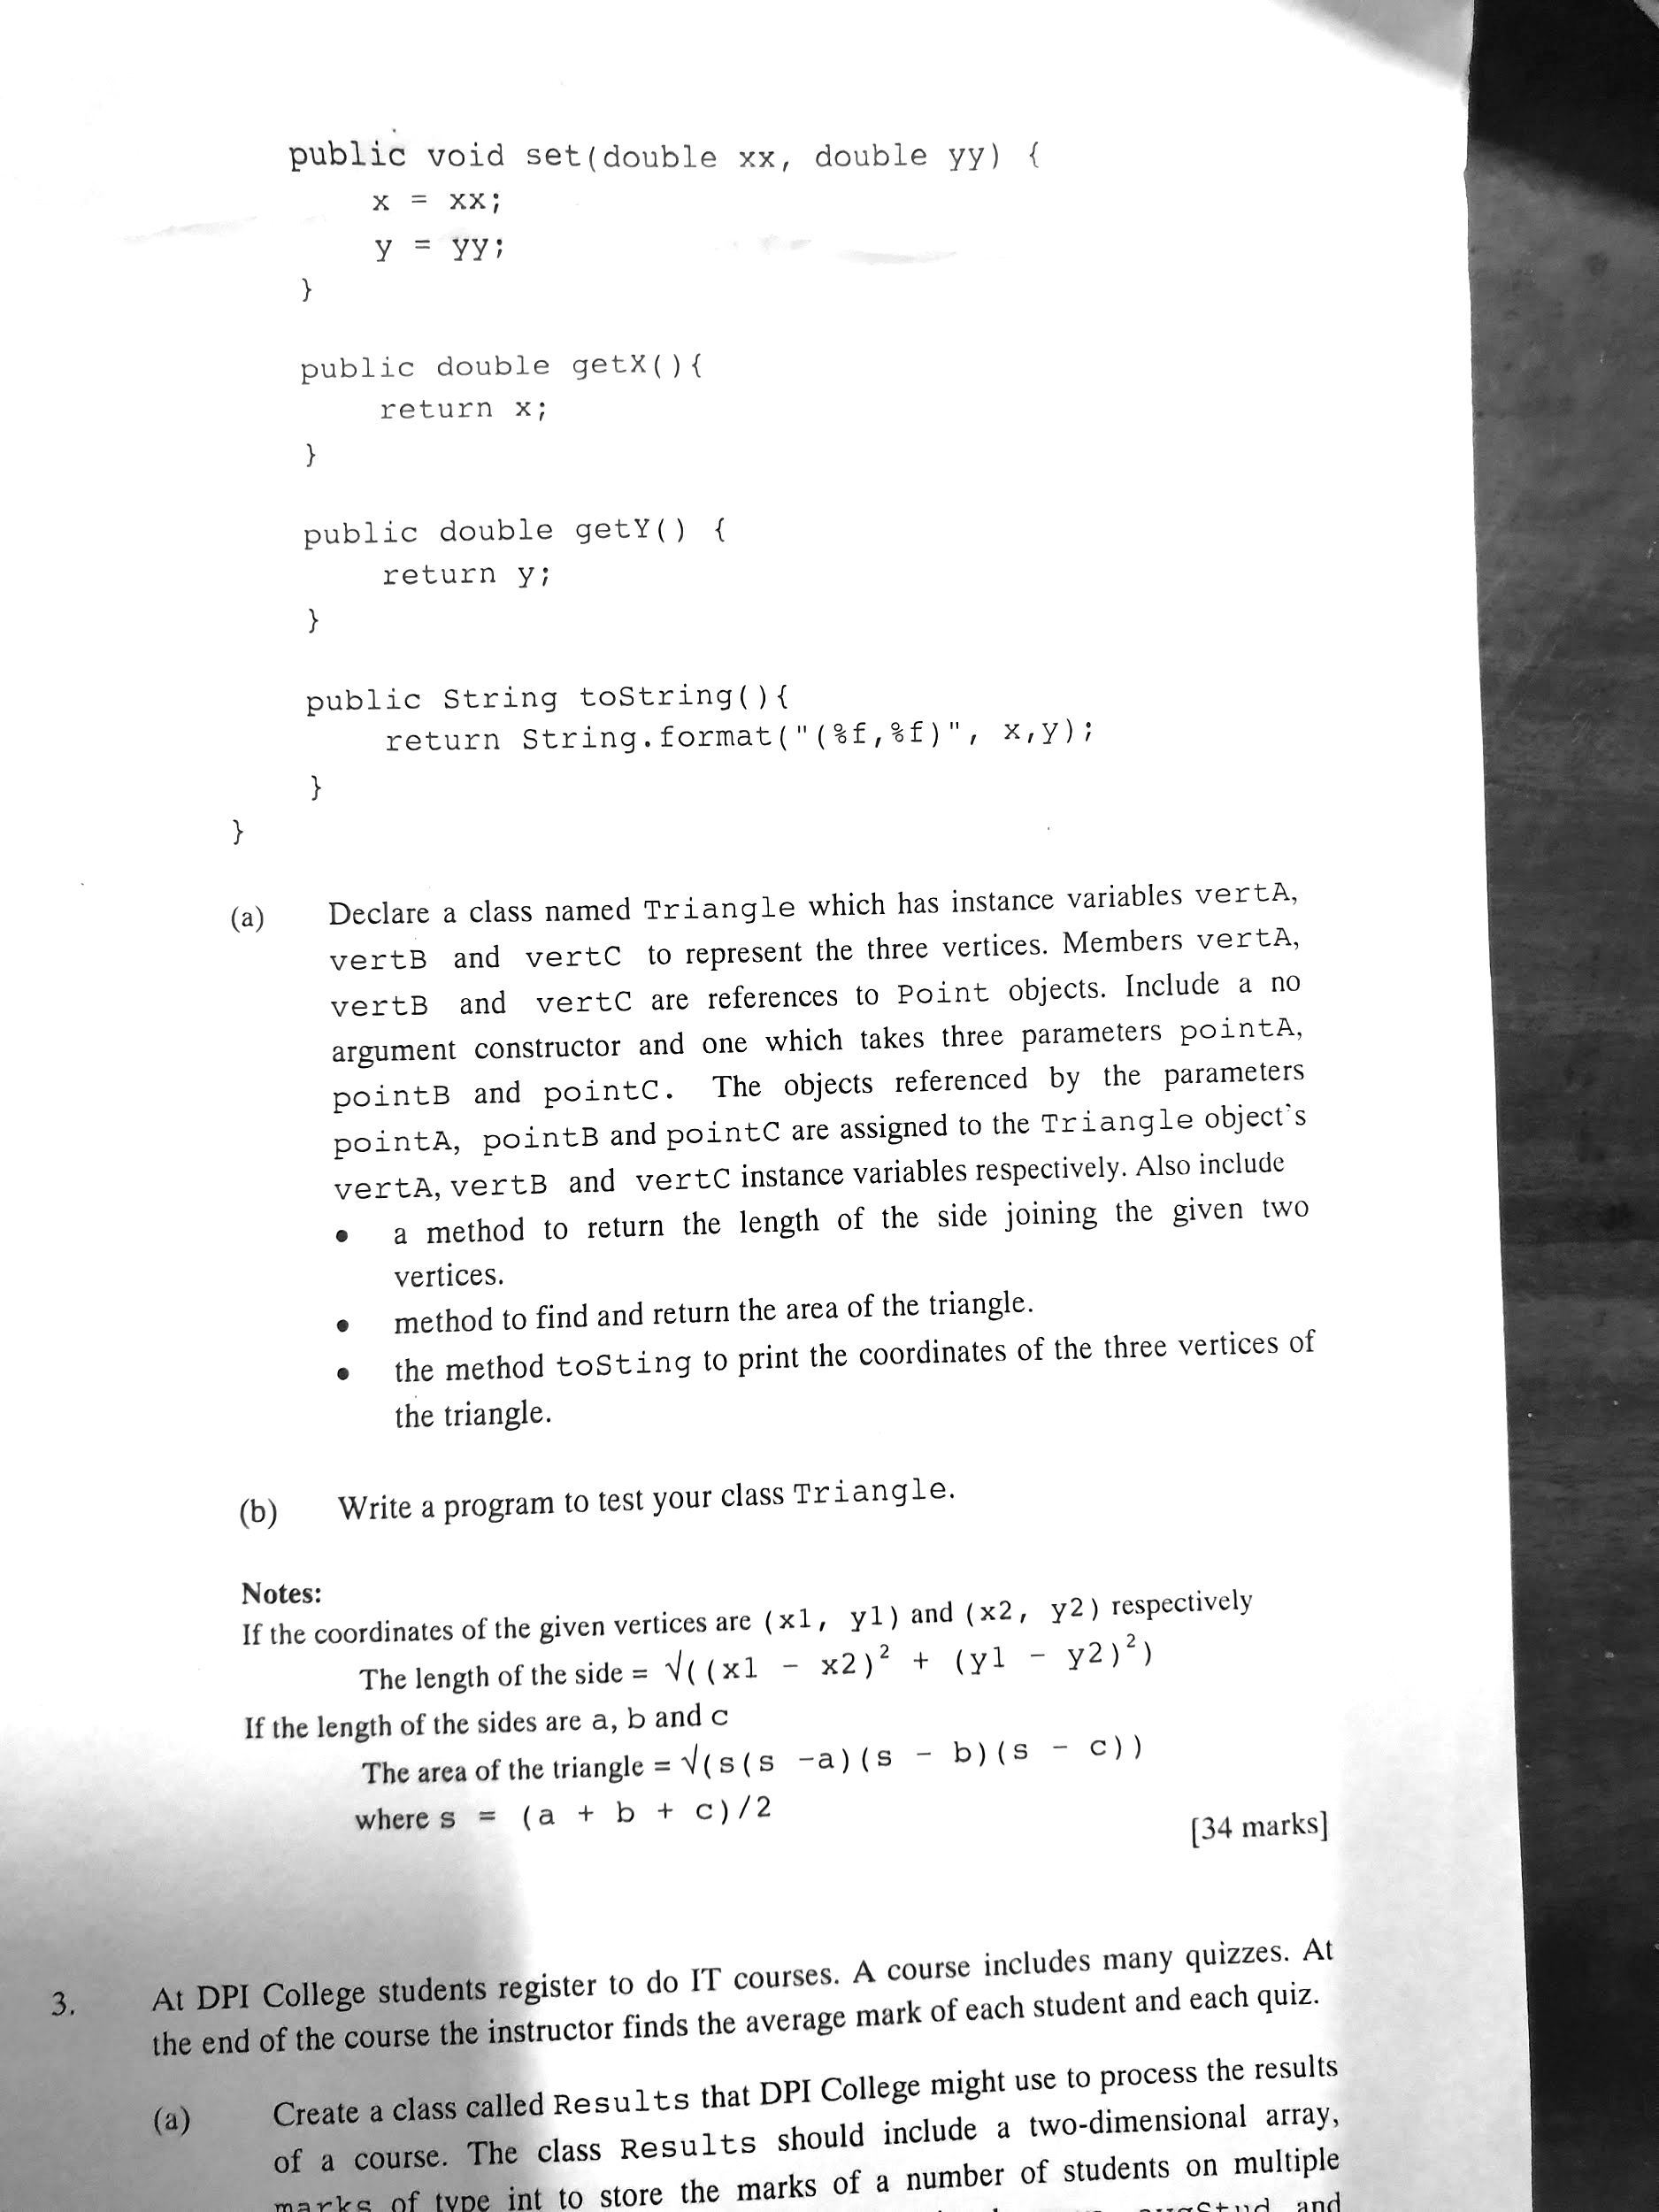

02.



       