**IT21193804**

**SE4050-Lab 4**

7. The number of boxes is related to how the YOLO algorithm works. YOLO divides the input image into a grid, and for each cell in the grid, it predicts a certain number of bounding boxes along with their class probabilities and confidence scores.

* Grid Size: The image is divided into a 19x19 grid, which means there are 361 grid cells (19 * 19 = 361).
* Bounding Boxes per Grid Cell: For each grid cell, YOLO predicts 5 bounding boxes.
* Final Shape: Given that each grid cell predicts 5 bounding boxes, the total number of potential boxes is 19 * 19 * 5 = 1783.

The output of boxes.eval() has a shape of (1783, 4), where 1783 is the total number of bounding boxes, and 4 corresponds to the four values representing the bounding box coordinates (e.g., x, y, width, height).

Maximum and Minimum Number of Boxes

* Maximum Number of Boxes: The maximum number of boxes is 1783, as calculated by multiplying the number of grid cells (361) by the number of bounding boxes per grid cell (5).
* Minimum Number of Boxes: The minimum number of boxes could be 0, which would occur if none of the bounding boxes meet the confidence threshold criteria and are filtered out.

8. Advantage of Using Anchor Boxes:

* Anchor boxes help detect multiple objects of different sizes in the same grid cell, allowing YOLO to handle overlapping objects and varying object sizes more effectively.

Method to Determine Anchor Box Sizes:

* The sizes of the anchor boxes are chosen using k-means clustering on the dataset's bounding boxes, which groups similar box sizes together and finds the most common shapes to use as anchor boxes.

10.

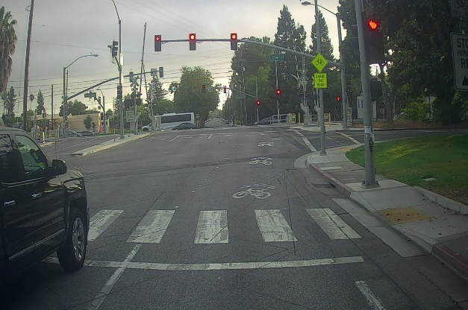 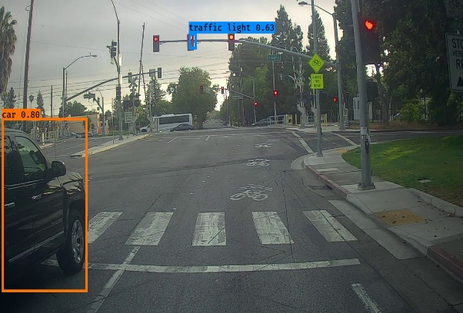

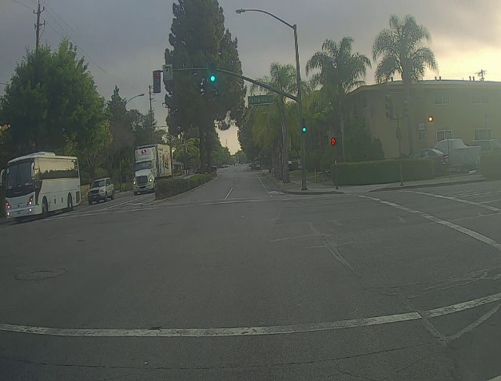 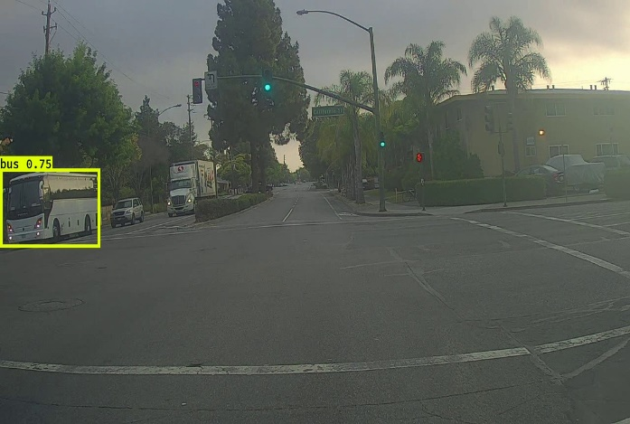

Incorrectly Detected Objects:

* Image Pair 1 (0116.jpg): No obvious false positives were detected in the image.
* Image Pair 2 (0103.jpg): Again, no clear false positives were detected.

Undetected Objects:

* Image Pair 1 (0116.jpg): Other cars in the background or on the street not have been detected.
* Image Pair 2 (0103.jpg): Potentially missed objects And other vehicles like the truck on the right side of the image.

Incorrect Bounding Boxes:

* Image Pair 1 (0116.jpg): The bounding boxes around the detected objects seem reasonably accurate based on visual observation.
* Image Pair 2 (0103.jpg): The bounding box around the bus looks accurate as well.

11. **max_boxes 10 to 15**

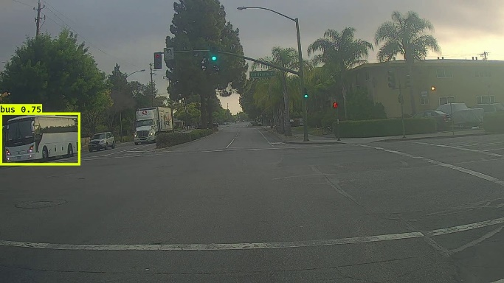 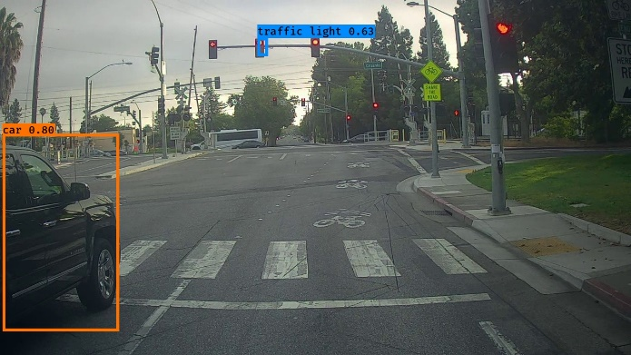

No major difference to identified

Incorrectly Detected Objects:

* Image Pair 1 (0116.jpg): No obvious false positives were detected in the image.
* Image Pair 2 (0103.jpg): Again, no clear false positives were detected.

Undetected Objects:

* Image Pair 1 (0116.jpg): Other cars in the background or on the street not have been detected.
* Image Pair 2 (0103.jpg): Potentially missed objects And other vehicles like the truck on the right side of the image.

Incorrect Bounding Boxes:

* Image Pair 1 (0116.jpg): The bounding boxes around the detected objects seem reasonably accurate based on visual observation.

Image Pair 2 (0103.jpg): The bounding box around the bus looks accurate as well.

**score_threshold 0.6 to 0.2**

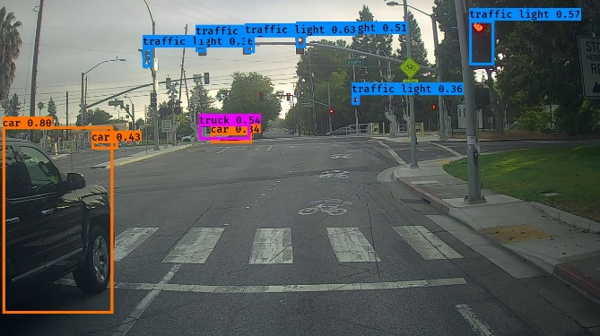 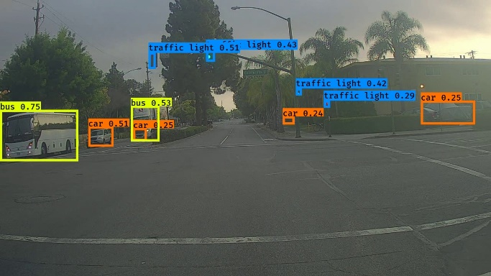

Lot of objects have been detected.

Incorrectly Detected Objects:

* Image 1 (0116.jpg): No obvious false positives were detected.
* Image 2 (0103.jpg): No obvious false positives were detected.

Undetected Objects:

* Image 1 (0116.jpg): Almost all the object and vehicals have been detected.
* Image 2 (0103.jpg): Almost all the object and vehicals have been detected.

Incorrect Bounding Boxes:

* Image 1 (0116.jpg): The bounding boxes around the detected objects seem reasonably accurate.
* Image 2 (0103.jpg): The bounding box Seems accurate.

**iou_threshold 0.5 to 0.9**

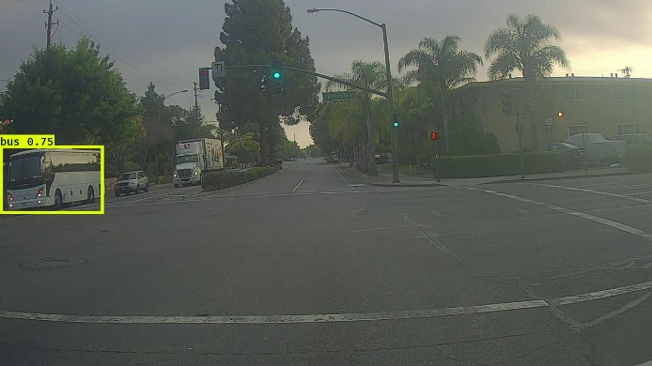 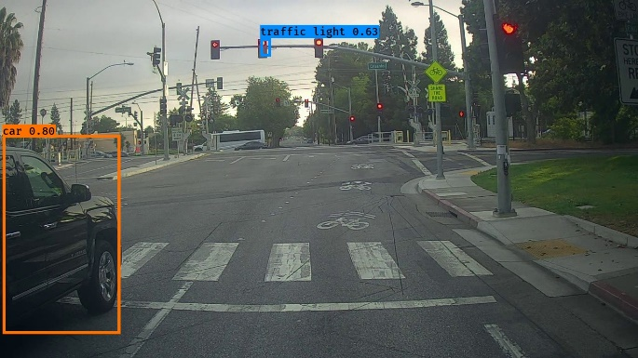

No major difference to identified

Incorrectly Detected Objects:

* Image Pair 1 (0116.jpg): No obvious false positives were detected in the image.
* Image Pair 2 (0103.jpg): Again, no clear false positives were detected.

Undetected Objects:

* Image Pair 1 (0116.jpg): Other cars in the background or on the street not have been detected.
* Image Pair 2 (0103.jpg): Potentially missed objects And other vehicles like the truck on the right side of the image.

Incorrect Bounding Boxes:

* Image Pair 1 (0116.jpg): The bounding boxes around the detected objects seem reasonably accurate based on visual observation.

Image Pair 2 (0103.jpg): The bounding box around the bus looks accurate as well.