**Diabetes Prediction Web App - Project Report**

# Dataset Description and Selection Rationale

Dataset: Pima Indians Diabetes Dataset

Features: Pregnancies, Glucose, Blood Pressure, Skin Thickness, Insulin, BMI, Diabetes

Pedigree Function, Age

Target: Outcome (0 = Non-Diabetic, 1 = Diabetic)

Rationale: Widely used benchmark dataset for binary classification in medical diagnosis, small enough for quick model training yet representative of real-world diabetes screening.

# Data Preprocessing Steps Taken

* Handled missing values: Zero values in physiological measurements considered missing.
* Feature Scaling: Applied StandardScaler to numerical features.
* Train/Test Split: 80/20 ratio.
* Encoding: Not required as all features are numerical.

# Model Selection and Evaluation Process

Final Model: Logistic Regression

Rationale: Interpretable, efficient, performs well on small datasets.

Evaluation Metrics: Accuracy, Confusion Matrix, Precision, Recall, F1-score. Accuracy: ~0.78 on the test set.

# Streamlit App Design Decisions

* Sidebar navigation with sections: Home, Data Exploration, Visualisation, Model Prediction, Model Performance.
* Visualisations: Outcome histogram, correlation heatmap, BMI vs Glucose scatter plot.
* Prediction Interface: Numeric inputs for all features, prediction label, and probability.
* Performance Page: Displays accuracy, confusion matrix, classification report.

# Deployment Process and Challenges Faced

* Hosting: Streamlit Cloud.
* Challenges:
* Managing pickle model loading.
* Ensuring consistent scaling in prediction and training.
* Handling dependency issues in deployment.

# Screenshots of the Application

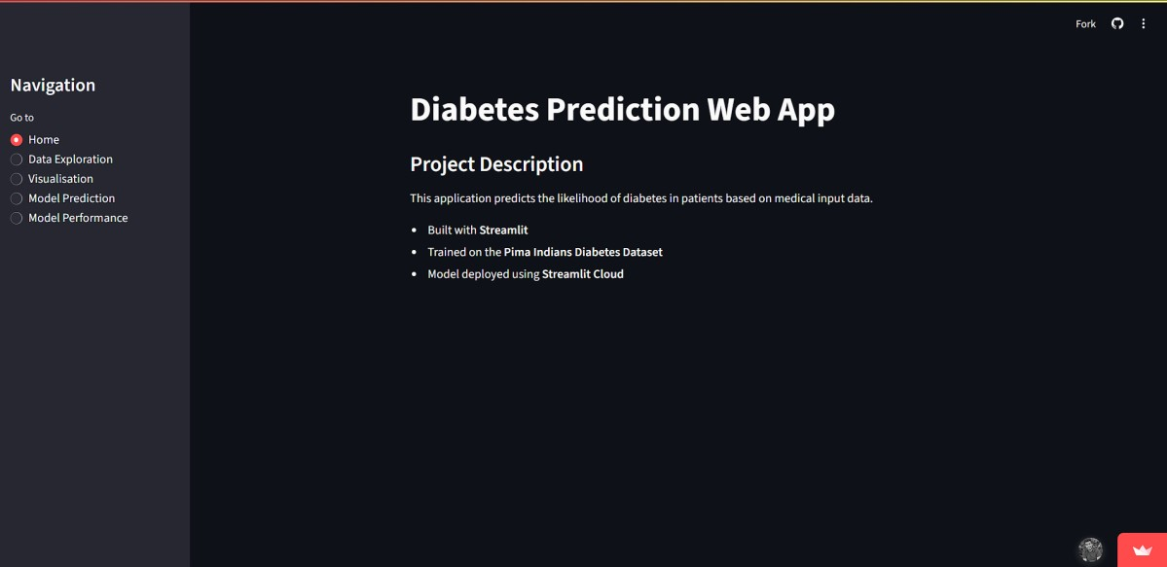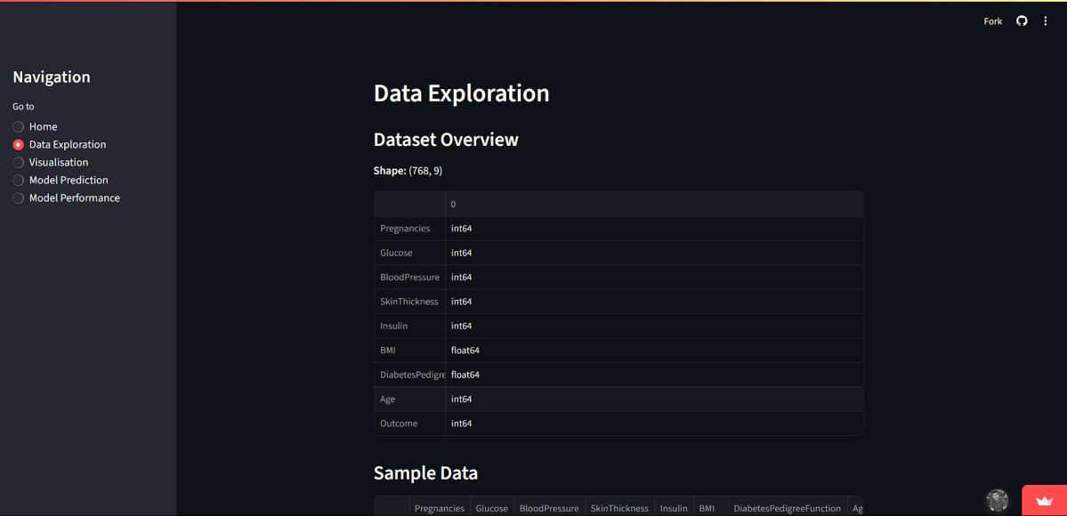

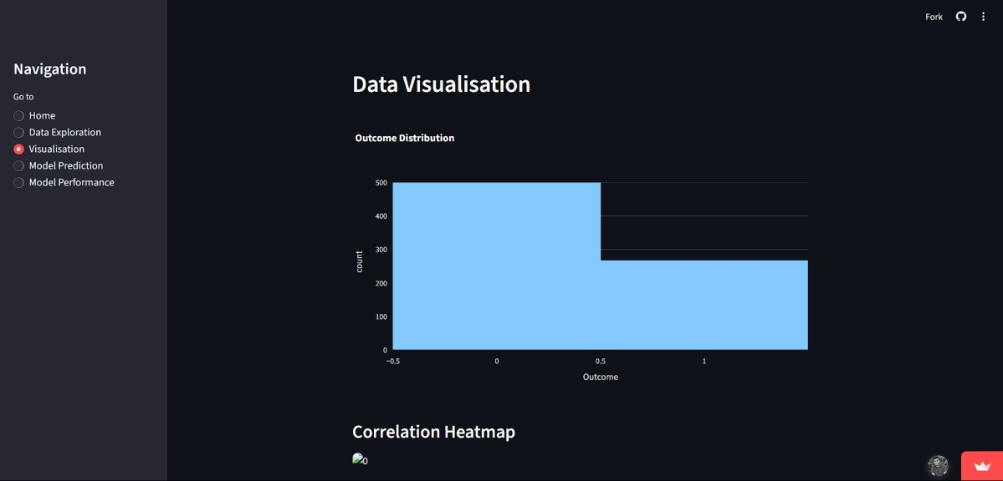

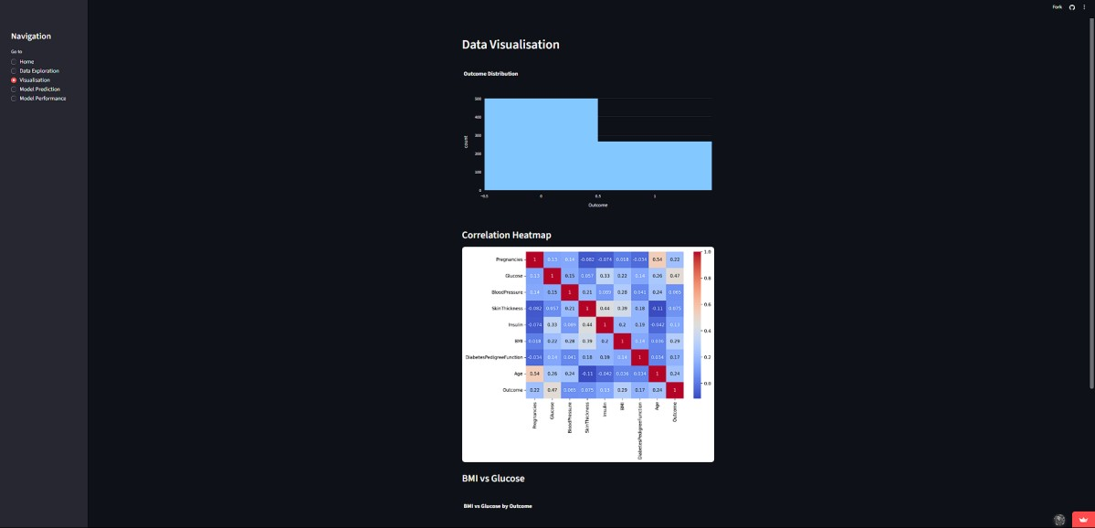

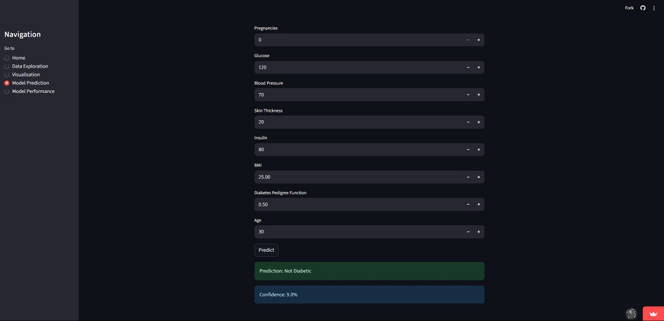

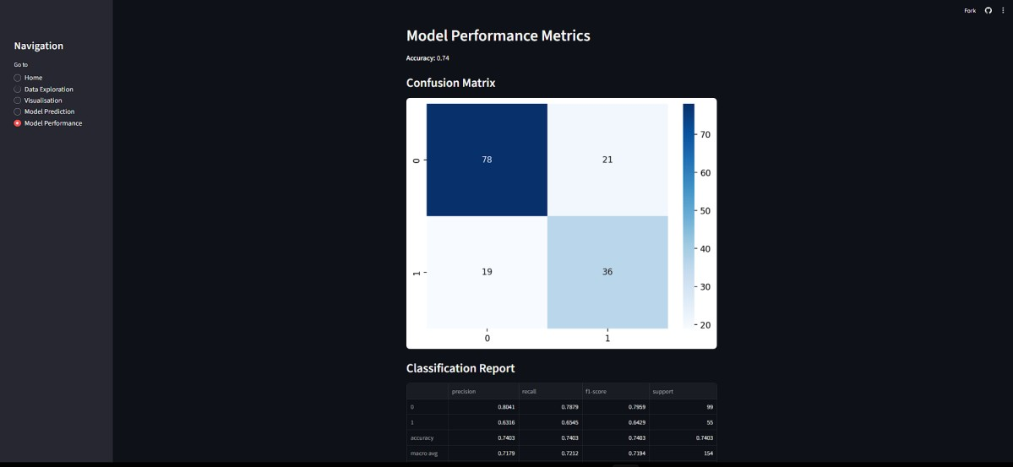

# Reflection on Learning Outcomes

* Learned the end-to-end ML pipeline: data loading, preprocessing, model training, evaluation, and deployment.
* Gained experience with Streamlit for interactive apps.
* Understood importance of feature scaling and model interpretability.
* Improved UI design for medical decision support tools.

# Links

Streamlet App: <https://diabetesprediction2.streamlit.app/>

GitHub Repository: <https://github.com/Dulanga917/House>