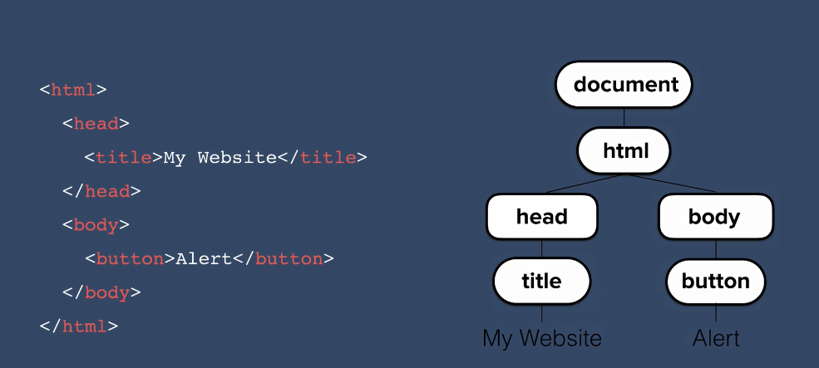

Have properties and methods

Method: thing that an object can do

Function: