DIETAS.R

Usuario

2023-05-18

#Dulce maria samaniego   
#Experimento ganancia en pesos (GP) BASADO EN DIFERENTES DIETAS   
#N iveles de factor: 4 (die12, die2, die3, die4)  
  
  
die1 <- c(2.4, 2.2, 3.4, 1.6)  
die2 <- c(2.2, 1.9, 1.7, 2.1)  
die3 <- c(3.3, 1.3, 2.8, 2.1)  
die4 <- c(1.6, 2.5, 1.4, 2.4)  
  
  
GP <- c(2.4, 2.2, 3.4, 1.6, 2.2, 1.9, 1.7, 2.1,  
 3.3, 1.3, 2.8, 2.1, 1.6, 2.5, 1.4, 2.4)   
Trat <- gl(4,4,16, labels = c("die1", "die2","die3", "die4"))  
bloque <- gl (4,4,16, labels = c("bajo", "normal", "SP", "OB"))  
dietas <- data.frame(Trat, GP, bloque)  
  
boxplot( dietas$GP ~ dietas$Trat,  
 "col" = "salmon",   
 "xlab" = "dietas",   
 "ylab" = "ganancia en peso (Kg)")

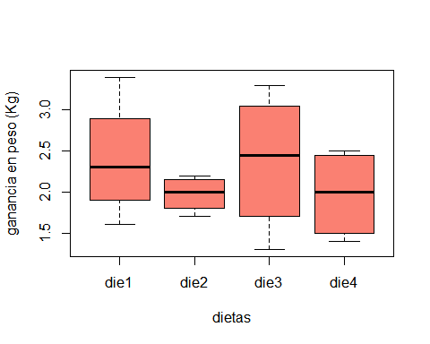

tapply(dietas$GP, dietas$Trat, var)

## die1 die2 die3 die4   
## 0.56000000 0.04916667 0.75583333 0.30916667

fligner.test(dietas$GP, dietas$Trat)

##   
## Fligner-Killeen test of homogeneity of variances  
##   
## data: dietas$GP and dietas$Trat  
## Fligner-Killeen:med chi-squared = 4.6369, df = 3, p-value = 0.2004

bartlett.test(dietas$GP, dietas$Trat)

##   
## Bartlett test of homogeneity of variances  
##   
## data: dietas$GP and dietas$Trat  
## Bartlett's K-squared = 4.1152, df = 3, p-value = 0.2493

diet.aov <- aov(dietas$GP ~ dietas$Trat)  
summary(diet.aov)

## Df Sum Sq Mean Sq F value Pr(>F)  
## dietas$Trat 3 0.682 0.2273 0.543 0.662  
## Residuals 12 5.022 0.4185