TRATAMIENTOGERMI.R

Usuario

2023-05-26

#DULCE MARIA SAMANIEGO MENDOZA   
#25/05/23   
  
#IMPORTAR DATOS   
  
setwd("C:/Users/Usuario.PC14/Documents")  
germi <- read.csv("DulceMaria/germi1.csv" , header = TRUE)  
germi$TRAT <- as.factor(germi$TRAT)  
  
  
#grafica   
  
boxplot(germi$PG ~ germi$TRAT,   
 col= "pink",   
 xlab = "TRATAMIENTO GERMINATIVO" ,   
 ylab = "% GERMINACION")

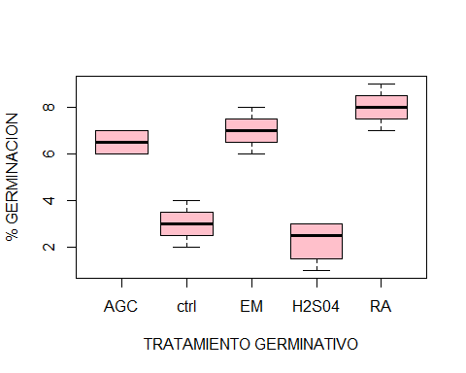

#ordenar tramientos   
levels(germi$TRAT)

## [1] "AGC" "ctrl" "EM" "H2S04" "RA"

germi$TRAT <- factor(germi$TRAT, levels = c("ctrl", "EM", "RA", "AGC", "H2S04"))  
levels(germi$TRAT)

## [1] "ctrl" "EM" "RA" "AGC" "H2S04"

tapply(germi$PG, germi$TRAT, mean)

## ctrl EM RA AGC H2S04   
## 3.00 7.00 8.00 6.50 2.25

tapply(germi$PG, germi$TRAT, var)

## ctrl EM RA AGC H2S04   
## 0.6666667 0.6666667 0.6666667 0.3333333 0.9166667

# ANOVA   
germi.aov <- aov(germi$PG ~germi$TRAT)  
summary(germi.aov)

## Df Sum Sq Mean Sq F value Pr(>F)   
## germi$TRAT 4 104.80 26.20 40.31 7.42e-08 ***  
## Residuals 15 9.75 0.65   
## ---  
## Signif. codes: 0 '***' 0.001 '**' 0.01 '*' 0.05 '.' 0.1 ' ' 1

#PRUEBA DE TUCKEY   
TukeyHSD(germi.aov, conf.level = 0.95)

## Tukey multiple comparisons of means  
## 95% family-wise confidence level  
##   
## Fit: aov(formula = germi$PG ~ germi$TRAT)  
##   
## $`germi$TRAT`  
## diff lwr upr p adj  
## EM-ctrl 4.00 2.2396122 5.7603878 0.0000356  
## RA-ctrl 5.00 3.2396122 6.7603878 0.0000024  
## AGC-ctrl 3.50 1.7396122 5.2603878 0.0001587  
## H2S04-ctrl -0.75 -2.5103878 1.0103878 0.6862491  
## RA-EM 1.00 -0.7603878 2.7603878 0.4332120  
## AGC-EM -0.50 -2.2603878 1.2603878 0.9009428  
## H2S04-EM -4.75 -6.5103878 -2.9896122 0.0000045  
## AGC-RA -1.50 -3.2603878 0.2603878 0.1140897  
## H2S04-RA -5.75 -7.5103878 -3.9896122 0.0000004  
## H2S04-AGC -4.25 -6.0103878 -2.4896122 0.0000175

##entre EM- ctrl diferencia de 4% y SI hay dif   
##entre RA- ctrl diferencia de 5% y SI hay dif  
##entre AGC- ctrl diferencia de 3.5% y SI hay dif   
  
plot(TukeyHSD(germi.aov), las =1, col="red")

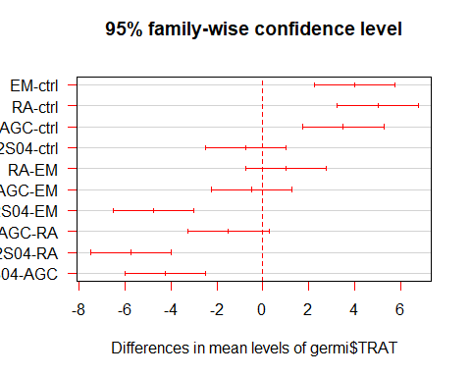

#agregar letras de diferencia   
  
boxplot(germi$PG ~ germi$TRAT,   
 col="pink",   
 xlab = "TRATAMIENTO GERMINATIVO",   
 ylab = "% GERMINACION",   
 ylim = c(0,10))  
text(1,4.2, "A", col="red")  
text(2,8.3, "B", col="blue")  
text(3,9.4, "B", col="blue")  
text(4,7.4, "B", col="blue")  
text(5,3.3, "A", col="red")

