**Kreative Perspektives AS**

Semsmoveien 50

3302 Hokksund

+47 918 66 725

ORG 923749845

Eiker 3D Digitizing Services

# About Kreative Perspektives AS

Kreative Perspektives works to digitize your assets using the high resolution, 3D camera from Matterport. We offer fast and accurate 3D captures through our scanning services and provide our customers with additional architectural and 3D printing services.

Kreative Perspektives was established by California Professional Registered Engineer, photographer and inventor Miguel Valeznuela. Miguel’s experience in engineering, 3D Modeling and design allows him to create great visuals for a variety of projects.

# Service Overview

*By digitizing your home, property, or building you are able to capture high resolution data that will allow you to showcase it, manipulate it or have an archive of your assets for future reference.*

## *Scanning Services*

*1.1 Museums and Galleries*

Nowadays, reaching a wider audience can easily be done through online 3D walkthroughs. Once captured, exhibitions can be archived, making them more accessible without any time or space restrictions. With the knowledge and many years of experience in photography, we make sure that the virtual tours are in high degree lifelike, always having in mind the visitors or users of the space. 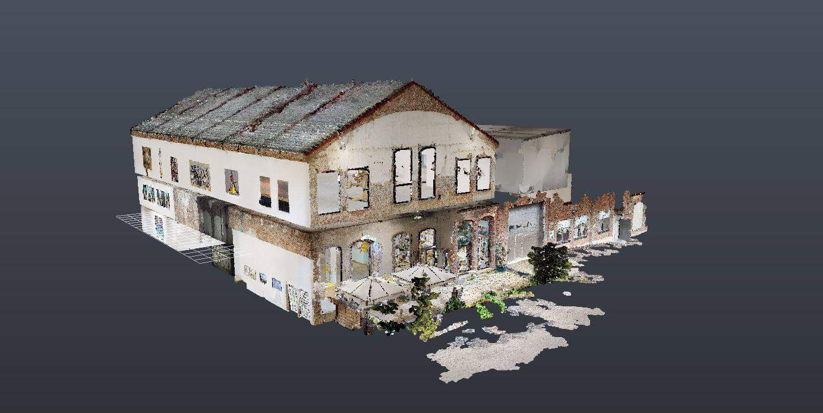

*1.2 Real Estate*

Whether you're a property owner wanting to sell, real estate agent or a property manager having your space digitized makes it easily accessible and convenient to visit. 3D walkthroughs in real estate are gaining more and more in popularity simply because of the fact that they provide the customers with the possibility to immerse themselves in the space they are viewing.

*1.3 Renovation*

*1.4 Construction Data Collection*

While you may not be experiencing construction at your home or facility, others near you might. Different soil conditions will affect how your building reacts while construction is happening. With the use of proper scanning and digitizing techniques, before and after construction, you’ll have quality data allowing you to see if your facility was damaged during construction. The evaluation of the data will allow you to file claims with the insurance company or support your case if your property is damaged due to neglect from the contractors.

## *Architectural Services*

Once digitized, the data can be transferred over to Revit or ArchiCAD. Our team of architects and engineers delivers accurate as-builds, 3D models and renderings, giving you the complete documentation of the building.

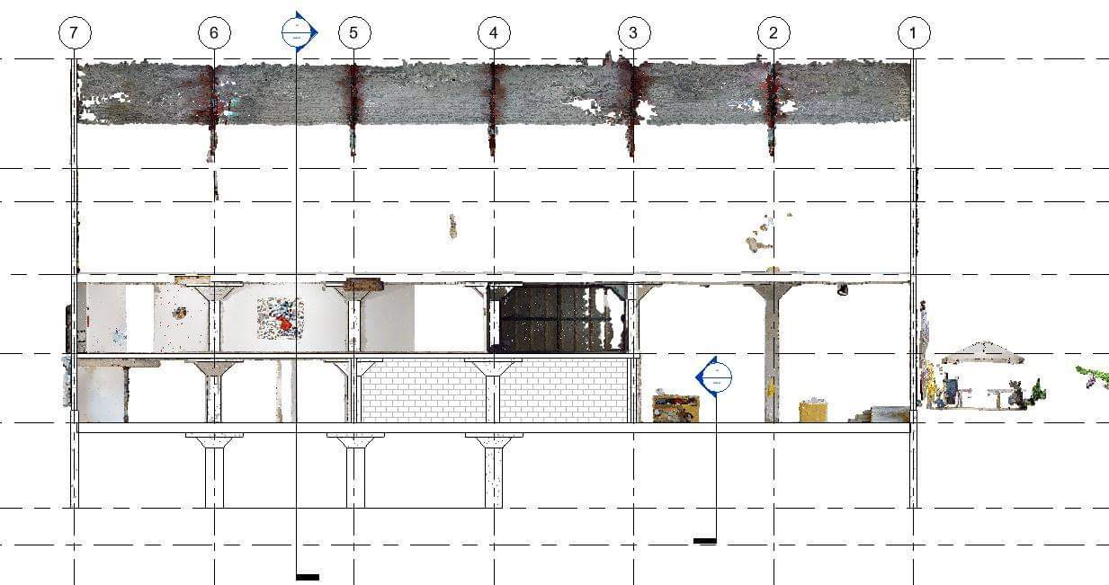

## *3D Printing Services*

Making scans printable requires a special skill set to optimize the information making it easy for printing. With over ten years of experience our staff works to print out your house, facility, or property from the scans it generates.