

**Green-O-Meter**

***Index***

*Introduction 3*

*Green-O-Meter 3*

*Logo 3*

*Impacts / Applications / Significance 4*

*Goal 5*

*Theoretical Framework 5*

* *Tropospheric Ozone 6*
  + *Impact on Plant 7*
    - * *Necrosis 7*
      * *Chlorosis 11*
  + *Impact on Human Beings 13*

*Procedure 14*

*Observations and Results 14*

*Recommendations 16*

*Conclusions 17*

*Bibliography 17*

**Introduction**

The plants show a special sensitivity to most air pollutants, and suffer significant damage at much lower than that necessary to cause harmful effects on human and animal health and concentrations.

**Green-O-Meter**

We decided to give this name to the application because it refers to what it intends to do with the application, which is to measure the amount of green leaf posing as between greener this plant, it has a better plant health.

And what we want to accomplish with this application is to identify the parts that are not green leaf (damaged parts) and get an estimate of how much is the damage caused by ozone.

**Logo**

* *Green:*

We decided to use the green color because it is closely related to everything natural, also symbolizing life, fertility and good health.

Besides the color green is the color of nature. All natural and healthy is associated with it and it is precisely why it is used as a symbol of nature from the perspective of civilization.

* *Initial below:*

Are the initials of the "Green-O-Meter" application, in which the Earth takes the place of our "O".

* *Planet:*

We decided to use the form on the planet because it is ours, Paneta Earth. And it is this that we want to help through this application.

**Impacts / Applications / Significance**

*The above diagram organizes the areas in which the project could have an impact, if used correctly.*

* *Social:*

It will help the farming community and other stakeholders in botany to form a collective consciousness responsible in taking preventive measures against pollution damage caused to plants. To counteract the emission of pollutants that may be harmful to flora and fauna.

Green-O-Meter is a useful and interesting tool that will allow anyone to use it and understand. This means that it is easy to use even though no knowledge can not have on the subject.

However, people who you could take greater advantage of this useful and interesting tool would be involved with the theme. Ie environmental authorities in the area, agronomists, botanists, etc.

This way, you can promote responsible culture and at the same time closer to learn more about the environment and the damage that humanity has caused.

* *Environmental:*

Identify environmental areas that are at risk or are actually damaged due to over exposure of plants to tropospheric ozone.

Assist the rapid identification of necrosis and chlorosis diseased plants suffering due to overexposure to tropospheric ozone. To counteract the emission of pollutants that may be harmful to flora and fauna.

Help taking preventive for future cultivation of plants in the area measures.

* *Biological:*

It will help detect health problems in plants, such as necrosis and chlorosis.

It will help prevent health problems in people, such as infections, Poisonings and Toxi-infections.

**Goal**

Develop an application with the ability to analyze the color of some leaves and compared with healthy leaves and thus get an amount representing ozone pollution in the area.

**Theoretical Framework**

*The above diagram organizes information investigated.*

* *Tropospheric Ozone*

In the news published by the American Geophysical Union in the year 2014 states that in India ozone pollution kills enough crops to feed 94 million people. It also states:

"The researchers calculated the total amount of crop damage from ozone pollution by comparing emission estimates from 2005 with data on the amount of ozone each of the four crops could bear.

The plants begin to show damage when exposed to ozone levels reach 40 parts per million or higher, according to previous research.

A computer model used by researchers ozone levels calculated during the growing seasons of crops that were more than 40-50 ppb for most of the country. The team ran the model with different emissions estimated to reach an average amount of each crop was lost due to ozone pollution. "(Agu, 2014)

1. What is it?

Tropospheric ozone is a secondary pollutant (occurs from other pollutants emitted by cars or industry, several kilometers from where they are produced).

It is a colorless gas that is created through chemical reactions between picture nitrogen oxides (NOx) and volatile organic compounds (VOCs) derived from sources such as burning fuel. Part of the so-called photochemical smog.

1. How is it produced?

Ozone is formed in the troposphere and in the polluted boundary layer, which extends from the ground to a height of between 100 and 3,000 meters. The pollutant is formed by oxidation of VOC and CO and NOx in the presence of sunlight. In contaminated boundary layer, the more reactive VOC main act as "fuel" in this process, while in remote areas is the predominant oxidation process of CO and CH4. Ozone formation is often limited by the availability of the catalyst NO.

1. What are their effects on plants?

Acute episodes of exposure to ozone, high concentrations (greater than 65 mg / m3) for a few hours, can cause visible damage to the leaves. These symptoms are manifested in chlorosis, mottled (silver staining) and necrosis. Although different species, and within these varieties have different resistances to ozone, it is generally considered that from 33ppb (65 mg / m3) on average in 24 hours, begin to appear significant damage to vegetation.

1. What are the most susceptible to contamination of ground level ozone plants?

There are four types of plants are more sensitive to the negative effects of ozone:

* + Green shoots milkweed (eg, Asclepias syriaca).
  + Beans (Phaseolus vulgaris).
  + potato.
  + cutleaf coneflower (Rudbeckia lacinata).

These ozone-sensitive plants may show signs of damage caused by exposure to 40 parts per billion.

1. Does it affect humans?

Causes damage to human health (from about 150 micrograms per cubic meter).

Its health effects depend on your level of concentration. From 180 micrograms per cubic meter (the level of information), some people (especially asthmatics and those with respiratory problems) could see augmented their ailments.

In the case of 240 micrograms per cubic meter (alert level to the population) are exceeded, there is a risk to human health. This happens rarely, but these pollutants levels could cause respiratory problems in anyone.

* *Impacts on Plants*
  1. *Necrosis*

Necrosis of plants is to defend against pathogens to attack by a pathogen, either bacteria, virus or fungus, most plants defends causing necrosis, cell death, around the points of infection, so that the pathogen isolated stops. The reaction is called hypersensitive response.

1. What is it?

Necrosis (Greek: νεκρóς Pronunciation. / Nekros / Meaning:. 'Body') is the pathological death of a whole cell or any tissue.

1. How does it occur and what causes it?

It is caused by an external or internal harmful agent that alters its physiognomy largely surpassing the limits of this adaptability, causing such a serious injury that can not be repaired or cure.

1. What types of necrosis exist?

* *Coagulative necrosis:*

Occurs due to tissue ischemia generating coagulation of intracellular proteins, making feasible (that is what occurs for instance in acute myocardial infarction). Necrosis area is replaced with fibrous tissue

* *Liquefaction necrosis with:*

In this case makes rapid autolysis the necrotic zone is liquefied, bacterial or fungal etiology occurs. It is typical of the central nervous system, but in this case it can also be caused by hypoxic processes.

* *Fat necrosis:*
  1. *Traumatic:*

It is unusual, it is caused by trauma that exceeds the capabilities of cellular adaptation

* 1. A series of physiological or pathological events generate a biochemical changes in the cell and this "decide" his own death, in an orderly fashion, disintegrating into small vesicles that are phagocytosed by macrophages and without major repercussions for the tissue in question ( We could call suicide).
* *Gangrenous necrosis:*

This is not a type of necrosis, is a term used by pathologists and clinicians, to describe limb necrosis, can be wet or dry.

* *Necrosis cheesy:*

The term derives from the cheesy white macroscopic appearance, cheese in appearance, is observed in known diseases such as tuberculosis or pseudoparatuberculosis.

What are the "symptoms"?

The damage is manifested as foliar necrosis in localized areas with a white-reddish-brown color, chlorosis, acquiring tissue pale or yellow, or the occurrence of necrotic spot stains green coloring. If the action of the contaminant is very strong it can cripple the growth of the plant.

Typically, many of the lesions known as necrosis begin as small chlorotic spots. The necrosis may also be localized or systemic. There are several types of lesions in which no death of plant tissues. Among these we have:

* *General or systemic necrosis:*

It is the death of all tissues of a plant. One example is fire blight of fire blight caused by the bacterium Erwinia milovora, which also affects other Rosaceae.

* *Necrosis located:*

They are injuries or dead areas of plant, small or large tissue in any organ of diseased plants. The fungus Enthomosporium spp., In quince leaves, the bacteria Pseudomonas phaseolicola in bean leaves and fungus Phoma ligam cauliflower leaves are examples of pathogens that cause localized lesions.

* *Angular spots:*

Are areas of dead plant tissue, delimited by leaf veins, which have geometric shapes, such as square, rectangular, among others. An example is the disease known as "angular leaf spot" bean by the fungus Isariopsis griseola.

* *Pustules:*

Are formed by the growth subepidermal injury, for example, a fungus that mechanically presses the epidermis until it breaks to expose the spores into the environment. The aecidiales phases urediales and telial of fungi known as rusts or chahuixtles form this type of injury. Examples: Stem rust that causes stem rust or black rust of wheat, P. striformis causing or orange stripe rust of wheat hidden P. and P. sorghi that causes rust of maize and sorghum.

* *Blight:*

This name applies to all tissue or plant organ that dies partially or fully acquiring a dark or black.

* *Dieback:*

It is a type of necrosis or death of plant tissue that starts from the apex of twigs or stems and moves towards the base thereof. An example of this symptom is caused by the fungus Valsa leucostoma (= Cytospora) in fruit trees, shade and ornamental.

* *Shooting ammunition:*

It is called the holes left in the leaves of peach, apricot, plum, etc., caused by the fungus Wilsonomyces carpophilus (= Coyneum berjerinekii). The fungus causes a necrotic leaf spot on leaves and as a defense reaction of the plant, this injury is rodeanda with layers of cork and abscission tissue, whereby the diseased tissue is separated from healthy until it falls leaving a hole . The same also causes blight fungus and stems die back injury and also buried in the same stem canker or canker call.

* *Canker:*

Necrotic lesions are destructive action by the phytopathogenic sunken observed in tissues (fruits, stems, trunks) of plants. These are oval, circular or amorphous. Fungi V. leucostoma, W. carpophilus and bacteria Pseudomonas phaseolicola cause this type of injury.

* *White root rot*

This necrosis is so called because the plant pathogenic fungus forms an abundant white mycelium on the affected tissues. An example is the fungus Sclerotium rolfsii in beans. It is further noted that the fungus is also small, white spherical bodies when they are immature and are dark when mature sclerotia.

* *Soft rot:*

This symptom of necrosis occurs when the tissues that are being destroyed are exosmosis water. For this reason, the dead tissue is soft and watery consistency. The bacteria Erwinia carotovora causes soft rot of vegetables.

* *Stem Wire:*

Type of stem rot or necrosis makes this are thin and look like a wire. The fungus Rhizotonia solani when applied to cauliflower and broccoli seedlings causes this type of symptom.

* *Drowning (English damping off) or death of seedlings:*

In phytopathogenic seedling stage can cause constriction of the stem, at ground level, due to necrosis engaged. This symptom is caused by the fungus Rhizoctonia solani and Pytium oomycete spp. These and many other fungi can also destroy the seed or seedling fresh out of the seed. The destruction of the seedling can be when the seedling still not come to the soil surface (pre emergent rot) or when it comes to the surface of the soil (rot after emerging).

* *Walk or blackleg:*

This type of symptom occurs when a pathogen affects the stem of plants causing necrosis or rot has a dark or black color. The bacterium Erwinia caratovora pv. Carotovora cause this symptom in potato fungus Leptosphaeria maculans and (= Phoma lingam) is caused in cultivated crucifers.

* *Rona:*

In the fungus Venturia inaequalis Apple develops subcuticularly in fruits, causing deposition of layers of cork and causing scabs on the surface of the fruit. There are also cracking by the difference in the growth of healthy and diseased tissue, which are gateways of opportunistic fungi as Trichotecium roseum that even cause greater harm than the self V. inaequalis. The Shaceloma persea fungus causes symptoms similar to earlier in avocado.

* *Override Mancha:*

Is a type of injury which is circular necrosis (as a ring) at the center of the lesion is undamaged or normal tissue. An example of this type are ringspot necrosis caused by papaya ringspot virus.

1. What types of plants are affected?

All plants show a special sensitivity to most contaminants therefore all plants are exposed to necrosis.

1. How necrosis measured?

In this application the percentage of necrosis that is affecting plant / leaf captured by the camera is calculated. All this based on the plant size and the spot size of necrosis.

1. How to prevent it?

Who has determined that we are all susceptible to diseases caused by contaminated food, anyone of any layer can be in a position to get an ETA.

1. How to fight it?

Once that has been produced and developed, is irreversible necrosis. It is one of the two recognized morphological expressions of cell death within a living tissue.

* *Chlorosis*

1. What is the chlorosis?

Chlorosis is an abnormal physiological condition in which the foliage produces insufficient chlorophyll. When this occurs, the leaves do not have normal green coloration; the color is pale green, yellow, whitish yellow. Affected plants have reduced their ability to form carbohydrates and may die if the cause of their chlorophyll failure is not treated.

Chlorosis is a characteristic symptom of iron-deficient plants.

1. How is it produced?

Because of specific nutrient deficiencies (often aggravated by high pH) produce chlorosis, which could be corrected by supplementing with iron, magnesium and nitrogen in various combinations. It can also be due to excess calcium. Certain pesticides, particularly herbicides, can cause chlorosis, as both weed occasionally treated cultures. It can also be due to an excess or deficiency of irrigation, several parasites, infectious diseases (such as citrus tristeza) or to be planted on firm ground or plant too deep

1. What are the symptoms?

Symptoms vary depending on several factors. Commonly, mild chlorosis starts as discoloration (light lime green) of internerval tissue while yellow indicates a more serious problem. In some cases, it becomes chlorotic one part of the plant.

The affected (or the whole plant) areas may atrophy and stop producing flowers and fruits. In addition, chlorotic leaves are sick and scalding. Causes severe chlorosis of leaf yellowing nerves, then the leaf necrosis after the branch and finally the plant.

Nitrogen deficiency in plants decreased growth (the leaves are small and you can not synthesize chlorophyll); thus chlorosis (yellow leaves). Chlorosis begins in older leaves or lower, which may eventually fall; If the deficiency is severe, can appear chlorosis in young leaves. Also decreases the size of the fruits and fruit set, as is the case of avocados. This lack is seen initially in the older leaves that are in the bottom of the plant.

Lighter pale green leaves that are turning yellow, including nerves, although chlorosis plant reaches all the symptoms are more evident in older leaves are. If the deficiency continues the lower leaves fall to the ground, in addition, the plant will not grow and create leaves, and future generations will be born weaker.

Chlorosis is a characteristic symptom of iron-deficient plants.

In submerged conditions, iron deficiency occurs in soils with high pH (> 7.5). Iron deficiency occurs in neutral to alkaline soils.

1. What types of plants affected?

It affects all kinds of plants without distinction.

1. How Chlorosis measured?

The higher the pH, the plant will be chlorotic. In general, the longer lasts chlorosis in the plant becomes more serious.

1. How to fight it?

Treatment begins with eliminating some factors such as damage the root system or the presence of parasitic plants rectified these problems can begin treatment.

One alternative is the application of a foliar fertilizer, it is applied by spray and can be found in nurseries, it is important that is manufactured from water.

Moreover we can make the so-called inoculation is to drill the trunk of the plant to enter the same nutrients directly, is quite risky but highly effective if applied correctly.

The last alternative will find direct reference to the ground, using fertilizer with micronutrients which corrects the variation of PH.

* *Impact on Human Health*

1. Does your consumption affects humans?

Yes, children, the elderly and pregnant women are especially vulnerable and need extra care. For healthy people, most are temporary ETA diseases, which only last a couple of days without any complications, but for people more susceptible such as children, the elderly, pregnant women or those who are patients may be more severe sequelae or even cause death. It is estimated that each year die from diarrhea 1 million children under 5 in developing countries, involving 2,700 deaths per day.

1. How?

ETA called to diseases that are caused by the ingestion of food infected with pollutants enough to affect the health of consumers quantities. They are solid, natural, preparation or beverages such as water, food can cause diseases caused by pathogens, such as bacteria, viruses, fungi, parasites or chemical components found in its composition.

They can occur through:

* *Infections:*

Resulting from ingestion of foods containing live microorganisms harmful. Eg .: Salmonella, Hepatitis A virus, toxoplasmosis.

* *Poisoning:*

Is given by eating foods with toxins formed in tissues of plants or animals, or metabolic products of microorganisms in foods or chemicals added to those of accidental, incidental or intentional from production to consumption mode. Eg .: Botulism, Staphylococcal or fungal toxins.

* *Toxi-infections:*

Resulting from ingestion of food with a number of disease causing microorganisms, which are able to produce or release toxins once ingested. Eg .: Cholera.

They can last several days, include vomiting, diarrhea, abdominal pain and fever. There may also be neurological symptoms, swollen eyes, kidney problems, double vision. The duration and intensity vary according to the food, the amount consumed and the health of people. There have been about 250 foodborne diseases.

**Procedure**

* Investigate everything needed for the theoretical framework (Tropospheric Ozone, necrosis, chlorosis, etc.).
* Creating a relationship between the percentage of the damaged blade and the amount of ozone which could be in the environment.

|  |  |  |  |  |
| --- | --- | --- | --- | --- |
| ***“Percentage of damaged leaf relationship with the amount of ozone in the atmosphere”*** | | | | |
| From 0 to 0.0275 ppm  10% | From 0.0276 to 0.055 ppm  20% | From 0.056 to 0.0835 ppm  30% | From 0.0835 to 0.11 ppm  40% | From 0.12 to o.138 ppm  50% |
| From 0.139 to 0.166 ppm  60% | From 0.167 to 0. 193 ppm  70% | From 0.194 to 0.221 ppm  80% | From 0.23 to 0.276 ppm  90% | From 0.277 to 0.33 ppm  100% |

This relationship was established based on the data recorded by the Metropolitan Index Air Pollution and the amount of ppm of ozone that a plant needs to show visible damage.

For this it was necessary to convert the points IMECA to parts per million with the formula

*ppm = (IMECA) 100 / 0.11*

And find the amount of ozone with which you start to see symptoms of chlorosis and necrosis in plants and the amounts in which the damage turned out to be more serious.

* *Development of simulation Green-O-Meter.*

Manual.

The app Green-O-Meter is an algorithm that is formally physically and mathematically simplified, so that users understand what the objective and how this project works. Our app uses a didactic way to interact with the user, now describe briefly how our application.

* Green-O-Meter is an executable application for Android devices.
* The algorithm implementation is to have greater interactivity with the user, and somehow generates an environmental learning.
* It involves taking a photograph of a sheet of a plant considering an average level of contamination in it. The user will select the outline of the sheet to permit calculation of a measure (area). Will then select the damaged area including the two kinds of contamination (chlorosis and necrosis), then output the result to an operation in which display the damaged and healthy percentage leaf is performed. With these data the app will throw the environmental state of location and compared with a database to get the average tropospheric pollution.

*Direct*

The app will be for the general public and primarily for environmental authorities and civil protection, which will be alerted in real time on the statistics presented by the current environment.

**Observations and results**

In the simulation of the Green-O-Meter application we find that we can use two different algorithms to perform its operation:

* *Manual*

Within this type of application the user after taking the picture of the leaf, you must select the beam area of ​​the leaf, then need to select the damaged leaf area, and you must select the option that will scan results showing the percentage of damaged leaf and the approximate amount of tropospheric ozone that may have in the area.



*In the picture above the "start" simulation Green-O-Meter is shown.*

* *Direct*

This mode is more complex than the previous one, because it uses advanced features (OpenCV) that are responsible for all operations to calculate the percentage of the damaged area of the leaf showing the contrast of colors that have damaged areas it , which allows us to identify the percentage of chlorosis and necrosis which presents the current leaf.

The following is a table that organizes the way the colors are detected in the damaged area using the OpenCV function:

|  |  |
| --- | --- |
| **Color** | **Represents** |
| Negro | Percentage of the non-damaged leaf |
| Amarillo, Café y Blanco | Percentage of the damaged leaf |

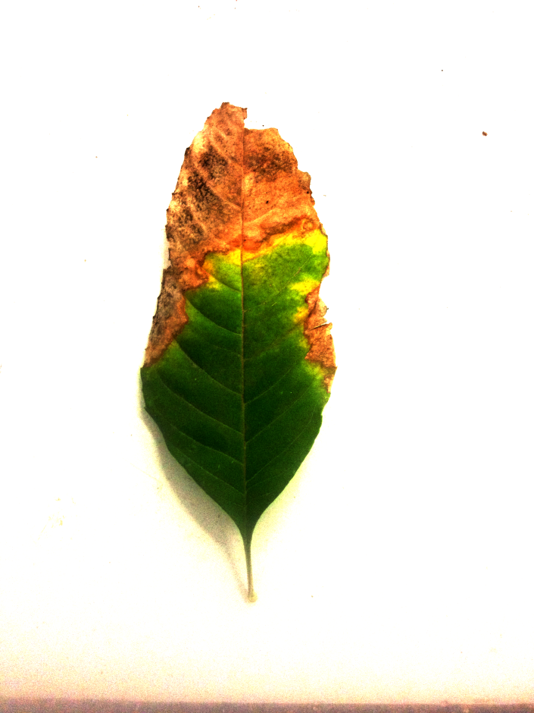

*An example of what the OpenCV function is shown in the picture above.*

**Recommendations**

* *Using NASA Project*

NASA has a project in which a largely composed sensitive to pollution by ozone plants, garden within which also explain the symptoms caused by ozone is created, as well as those symptoms that are caused by the Ozone us.

We recommend doing this wonderful experiment that could exploit this handy tool to have a reality approached about Ozone levels vision.

* *Reported Selection Process Leaf*

We recommend the average plant leaf, this means that instead of choosing the "ugliest" plant leaf is best to choose 3 different leaves of the same plant:

* + 1 that is most damaged.
  + 1 that are in the best conditions.
  + 1 which is in the middle of the previous two (Leaf to be Selected for use).

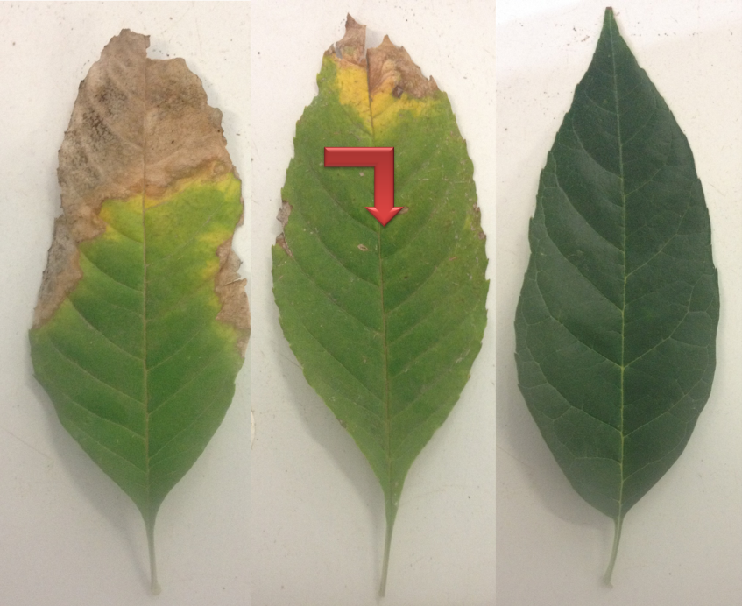

*In the picture above the Choice Process Leaves Recommended shown.*

In this way one could identify an "average" plant leaf, avoiding what could be a too high estimate of Ozone given case or too low.

**Conclusions**

Given the objectives and the results obtained during the proyect, we conclude thas we managed to créate an app that is able to evaluate the damage caused by the Tropospheric Ozone in the plants, quantify and catalog the damage produced in the leaf through a process of reconocing and detecting with a Smartphone camera comparing it in the data base of the app, wich is supported with a detailed investigation about the subject. This durign the simulation of the apps’ performance.

We hope Gree-O-Meter could make an ambiental concence in each one of the habitant in the planet and at the same time help to authorities responsable for the environmental potection, so we can counteract the emissions of pollutants what could be dangerous for the plants and animals in the zone. Wich would help in the taking of preventive measures for the future crop of plants in anywhere.

In the same way it will help the agricultural comunity and other interested in the botany making a colective concence in the taking of preventive measures against to the damage what contamination cause to the plants.

We also wish it helps to detect health problems in the plants, as the Necrosis and the Chlorosis. Wich would contribuite to previse health problems in the people, as the infections, the intoxications and the toxi-infections.

**Bibliography**

* Necrosis:

# Bibliografía

1. (6 de 5 de 4). *2*. Recuperado el 9 de 8 de 7, de 3: 10

Anónimo. (? de ? de ?). *Efectos de los contaminantes atmosféricos*. Recuperado el 11 de Abril de 2015, de Efectos de los contaminantes atmosféricos: http://www.jmarcano.com/recursos/contamin/catmosf6b.html

Anónimo. (? de ? de ?). *SÍNTOMAS QUE PRESENTAN LAS PLANTAS ENFERMAS*. Recuperado el 11 de Abril de 2015, de SÍNTOMAS QUE PRESENTAN LAS PLANTAS ENFERMAS: http://es.fitopatologiauaa.wikia.com/wiki/S%C3%8DNTOMAS_QUE_PRESENTAN_LAS_PLANTAS_ENFERMAS

Anónimo. (14 de Febrero de 2014). *Contaminantes criterio*. Recuperado el 11 de Abril de 2015, de Contaminantes criterio: http://es.wikipedia.org/wiki/Contaminantes_criterio

Chew, J. (27 de Febrero de 2013). *CLOROSIS Y NECROSIS*. Recuperado el 11 de Abril de 2015, de CLOROSIS Y NECROSIS: http://juliochewurlescuintla.blogspot.mx/2013/02/clorosis-y-necrosis.html

EPA. (1 de Noviembre de 2012). *Ground-level Ozone*. Recuperado el 11 de Abril de 2015, de Ground-level Ozone: http://www.epa.gov/groundlevelozone/ecosystem.html

Marcela Alejandro Rega. (? de ? de ?). *www.monografias.com*. Recuperado el 11 de 04 de 2015, de www.monografias.com: http://www.monografias.com/trabajos94/eta-enfermedades-transmitidas-alimentos/eta-enfermedades-transmitidas-alimentos.shtml

Rivera, A. (23 de Junio de 1999). *Necrosis de las plantas para defenderse de los patógenos*. Recuperado el 11 de Abril de 2015, de Necrosis de las plantas para defenderse de los patógenos: http://elpais.com/diario/1999/06/23/sociedad/930088829_850215.html

* Tropospheric Ozone

# Bibliografía

1. (6 de 5 de 4). *2*. Recuperado el 9 de 8 de 7, de 3: 10

Anónimo. (? de ? de ?). *Efectos de los contaminantes atmosféricos*. Recuperado el 11 de Abril de 2015, de Efectos de los contaminantes atmosféricos: http://www.jmarcano.com/recursos/contamin/catmosf6b.html

Anónimo. (? de ? de ?). *SÍNTOMAS QUE PRESENTAN LAS PLANTAS ENFERMAS*. Recuperado el 11 de Abril de 2015, de SÍNTOMAS QUE PRESENTAN LAS PLANTAS ENFERMAS: http://es.fitopatologiauaa.wikia.com/wiki/S%C3%8DNTOMAS_QUE_PRESENTAN_LAS_PLANTAS_ENFERMAS

Anónimo. (14 de Febrero de 2014). *Contaminantes criterio*. Recuperado el 11 de Abril de 2015, de Contaminantes criterio: http://es.wikipedia.org/wiki/Contaminantes_criterio

Anónimo. (15 de Marzo de 2015). *Ozono*. Recuperado el 11 de Abril de 2015, de Ozono: http://es.m.wikipedia.org/wiki/Ozono

Casado., D. (8 de Agosto de 2005). *¿Qué es el ozono troposférico?* Recuperado el 11 de Abril de 2015, de ¿Qué es el ozono troposférico?: http://www.20minutos.es/noticia/42251/0/ozono/troposferico/contaminacion/#xtor=AD-15&xts=467263

Chew, J. (27 de Febrero de 2013). *CLOROSIS Y NECROSIS*. Recuperado el 11 de Abril de 2015, de CLOROSIS Y NECROSIS: http://juliochewurlescuintla.blogspot.mx/2013/02/clorosis-y-necrosis.html

EPA. (1 de Noviembre de 2012). *Ground-level Ozone*. Recuperado el 11 de Abril de 2015, de Ground-level Ozone: http://www.epa.gov/groundlevelozone/ecosystem.html

Ghude, S. D. (4 de Septiembre de 2014). *OOZONE POLLUTION IN INDIA KILLS ENOUGH CROPS TO FEED 94 MILLION IN POVERTY.* Recuperado el 11 de Abril de 2015, de OOZONE POLLUTION IN INDIA KILLS ENOUGH CROPS TO FEED 94 MILLION IN POVERTY: http://news.agu.org/press-release/ozone-pollution-in-india-kills-enough-crops-to-feed-94-million-in-poverty/

Marcela Alejandro Rega. (? de ? de ?). *www.monografias.com*. Recuperado el 11 de 04 de 2015, de www.monografias.com: http://www.monografias.com/trabajos94/eta-enfermedades-transmitidas-alimentos/eta-enfermedades-transmitidas-alimentos.shtml

Revista. (? de Diciembre de 2013). *Ozono troposférico*. Recuperado el 11 de Abril de 2015, de Ozono troposférico: http://www.ecologistasenaccion.org/article27108.html

Rivera, A. (23 de Junio de 1999). *Necrosis de las plantas para defenderse de los patógenos*. Recuperado el 11 de Abril de 2015, de Necrosis de las plantas para defenderse de los patógenos: http://elpais.com/diario/1999/06/23/sociedad/930088829_850215.html

S. Del Valle, E. B. (? de ? de ?). *Estudio sobre el impacto del ozono en la agricultura.* Recuperado el 11 de Abril de 2015, de Estudio sobre el impacto del ozono en la agricultura: http://www.ivia.es/sdta/pdf/revista/proteccion_vegetal/22tema41.pdf

Salmerón, M. (16 de Julio de 2014). *Plantas que indican la concentración de ozono en el aire.* Recuperado el 11 de Abril de 2015, de Plantas que indican la concentración de ozono en el aire: http://www.ecologiablog.com/post/21533/plantas-que-indican-la-concentracion-de-ozono-en-el-aire

* Chlorosis:

# Bibliografía

1. (6 de 5 de 4). *2*. Recuperado el 9 de 8 de 7, de 3: 10

Anónimo. (? de ? de ?). *Efectos de los contaminantes atmosféricos*. Recuperado el 11 de Abril de 2015, de Efectos de los contaminantes atmosféricos: http://www.jmarcano.com/recursos/contamin/catmosf6b.html

Anónimo. (? de ? de ?). *SÍNTOMAS QUE PRESENTAN LAS PLANTAS ENFERMAS*. Recuperado el 11 de Abril de 2015, de SÍNTOMAS QUE PRESENTAN LAS PLANTAS ENFERMAS: http://es.fitopatologiauaa.wikia.com/wiki/S%C3%8DNTOMAS_QUE_PRESENTAN_LAS_PLANTAS_ENFERMAS

Anónimo. (2013). *Clorosis.* Recuperado el 11 de Abril de 2015, de Clorosis: http://es.m.wikipedia.org/wiki/Clorosis

Anónimo. (14 de Febrero de 2014). *Contaminantes criterio*. Recuperado el 11 de Abril de 2015, de Contaminantes criterio: http://es.wikipedia.org/wiki/Contaminantes_criterio

Anónimo. (15 de Marzo de 2015). *Ozono*. Recuperado el 11 de Abril de 2015, de Ozono: http://es.m.wikipedia.org/wiki/Ozono

Casado., D. (8 de Agosto de 2005). *¿Qué es el ozono troposférico?* Recuperado el 11 de Abril de 2015, de ¿Qué es el ozono troposférico?: http://www.20minutos.es/noticia/42251/0/ozono/troposferico/contaminacion/#xtor=AD-15&xts=467263

Chew, J. (27 de Febrero de 2013). *CLOROSIS Y NECROSIS*. Recuperado el 11 de Abril de 2015, de CLOROSIS Y NECROSIS: http://juliochewurlescuintla.blogspot.mx/2013/02/clorosis-y-necrosis.html

Coto, G. R. (? de ? de ?). *clorosis ozono.* Recuperado el 11 de Abril de 2015, de clorosis ozono: https://books.google.com.mx/books?id=xpTHXEWG_t8C&pg=PA142&lpg=PA142&dq=clorosis+ozono&source=bl&ots=OQKP_bgy_e&sig=r0q_hqu5nVAlrGW5gJ-lk1iTw3I&hl=es419&sa=X&ei=MnQpVc_KIISrsAXz5oAY&ved=0CB0Q6AEwAA

EPA. (1 de Noviembre de 2012). *Ground-level Ozone*. Recuperado el 11 de Abril de 2015, de Ground-level Ozone: http://www.epa.gov/groundlevelozone/ecosystem.html

Ghude, S. D. (4 de Septiembre de 2014). *OOZONE POLLUTION IN INDIA KILLS ENOUGH CROPS TO FEED 94 MILLION IN POVERTY.* Recuperado el 11 de Abril de 2015, de OOZONE POLLUTION IN INDIA KILLS ENOUGH CROPS TO FEED 94 MILLION IN POVERTY: http://news.agu.org/press-release/ozone-pollution-in-india-kills-enough-crops-to-feed-94-million-in-poverty/

KLBot2. (2013). *Clorosis (medicina).* Recuperado el 11 de Abril de 2015, de Clorosis (medicina): http://es.m.wikipedia.org/wiki/Clorosis_(medicina)

Librita. (? de Diciembre de 2014). *Nutrición de nitrógeno en plantas.* Recuperado el 11 de Abril de 2015, de Nutrición de nitrógeno en plantas: http://es.m.wikipedia.org/wiki/Nutrici%C3%B3n_de_nitr%C3%B3geno_en_plantas

Marcela Alejandro Rega. (? de ? de ?). *www.monografias.com*. Recuperado el 11 de 04 de 2015, de www.monografias.com: http://www.monografias.com/trabajos94/eta-enfermedades-transmitidas-alimentos/eta-enfermedades-transmitidas-alimentos.shtml

Morales, P. (22 de Junio de 2010). *Clorosis, problema latente, solución eficaz.* Recuperado el 11 de Abril de 2015, de Clorosis, problema latente, solución eficaz: http://www.gardencenterejea.com/entrada.php/clorosis,-problema-latente,-soluci%C3%B3n-eficaz/753

Revista. (? de Diciembre de 2013). *Ozono troposférico*. Recuperado el 11 de Abril de 2015, de Ozono troposférico: http://www.ecologistasenaccion.org/article27108.html

Rivera, A. (23 de Junio de 1999). *Necrosis de las plantas para defenderse de los patógenos*. Recuperado el 11 de Abril de 2015, de Necrosis de las plantas para defenderse de los patógenos: http://elpais.com/diario/1999/06/23/sociedad/930088829_850215.html

S. Del Valle, E. B. (? de ? de ?). *Estudio sobre el impacto del ozono en la agricultura.* Recuperado el 11 de Abril de 2015, de Estudio sobre el impacto del ozono en la agricultura: http://www.ivia.es/sdta/pdf/revista/proteccion_vegetal/22tema41.pdf

Salmerón, M. (16 de Julio de 2014). *Plantas que indican la concentración de ozono en el aire.* Recuperado el 11 de Abril de 2015, de Plantas que indican la concentración de ozono en el aire: http://www.ecologiablog.com/post/21533/plantas-que-indican-la-concentracion-de-ozono-en-el-aire

University, I. (2015). *Clorosis.* Recuperado el 11 de Abril de 2015, de Clorosis: http://urbanext.illinois.edu/focus_sp/chlorosis.cfm

* *Recomendations*

# Bibliografía

NASA. (27 de Enero de 2014). *Ozone Bioindicator Garden Project.* Recuperado el 12 de Abril de 2015, de Ozone Bioindicator Garden Project: http://science-edu.larc.nasa.gov/ozonegarden/