Database Systems
B.Sc. (Hons) in IT
Laboratory Worksheet 07
1.Running SampleDB.sql
2. Creating PLAN_TABLE
3. Configuring the Session
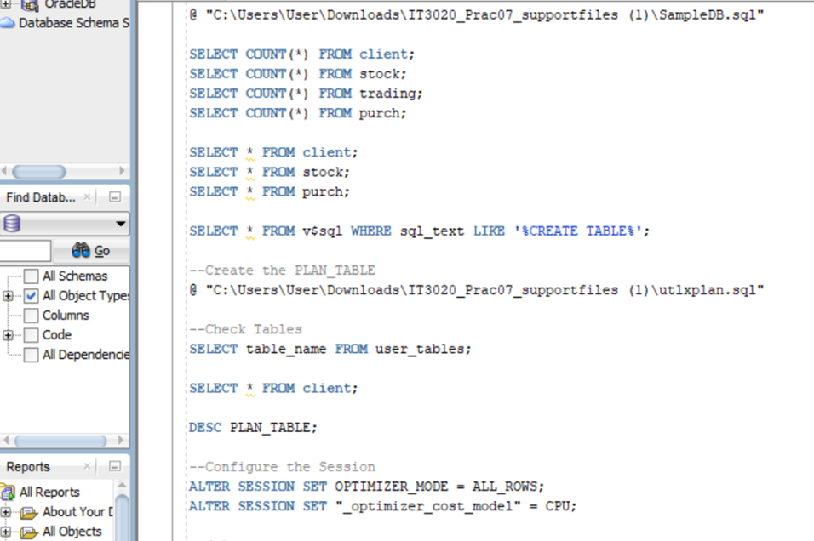

- Use EXPLAIN PLAN to find Oracle’s generated query plan for the above query by executing the following statement:

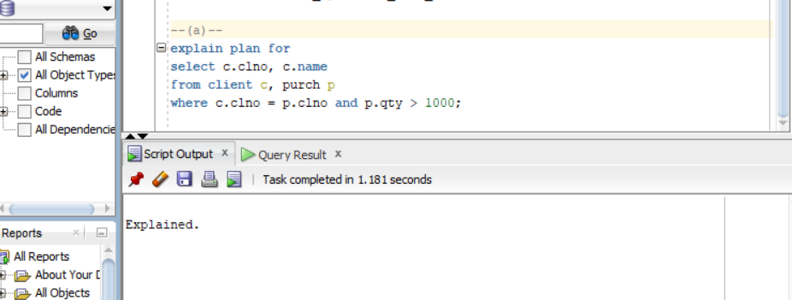

(b.) 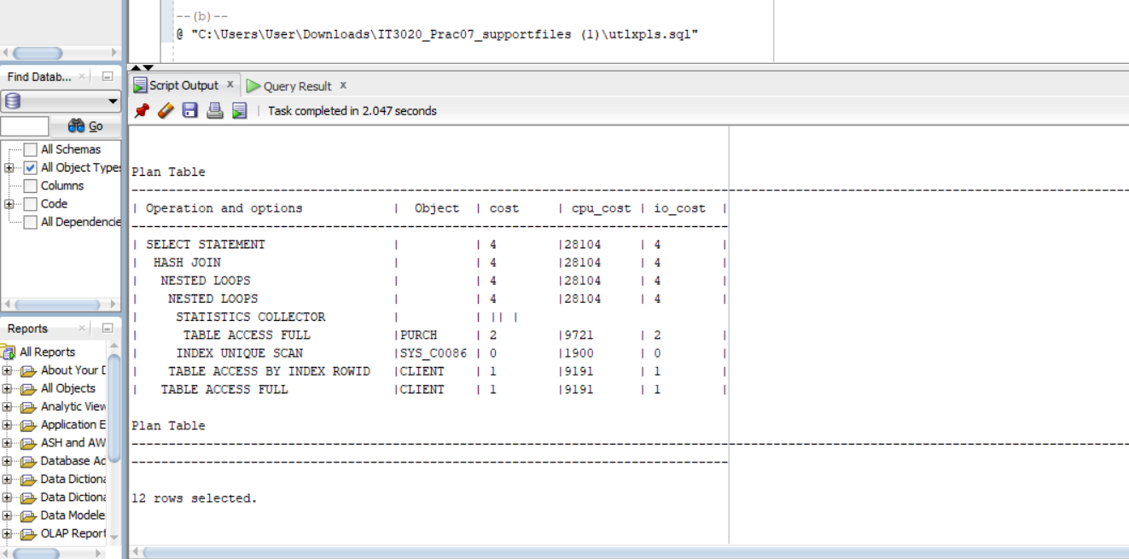
Describe each step of the query plan.
1. INDEX UNIQUE SCAN (most inner step)
  - Oracle uses the primary key index on client table
  - Finds the specific client using clno
  - Cost = 0 (very fast, like looking up a word in dictionary index)
- TABLE ACCESS BY INDEX ROWID
  - Once Oracle finds the client in the index, it gets the actual name
  - Uses the ROWID (like a page number) to find the data
  - Cost = 1
- TABLE ACCESS FULL on PURCH
  - Oracle reads the ENTIRE purch table row by row
  - Checks each row to see if qty > 1000
  - Cost = 2 (more expensive because reading everything)
- NESTED LOOPS
  - For EACH row found in purch (step 3), Oracle does steps 1-2 to find client name
  - Like a nested loop in programming
- SELECT STATEMENT
  - Final output

(c.)
Create indexes for client and purchase tables 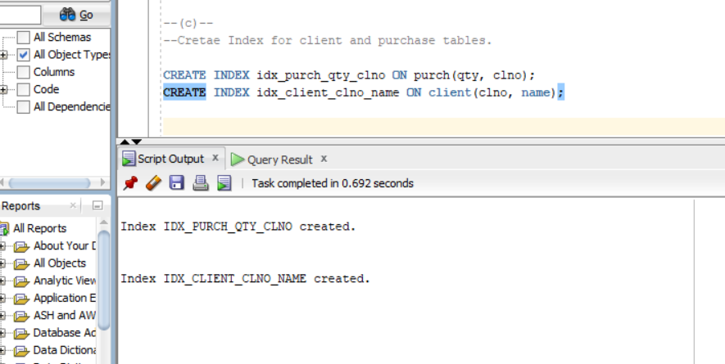
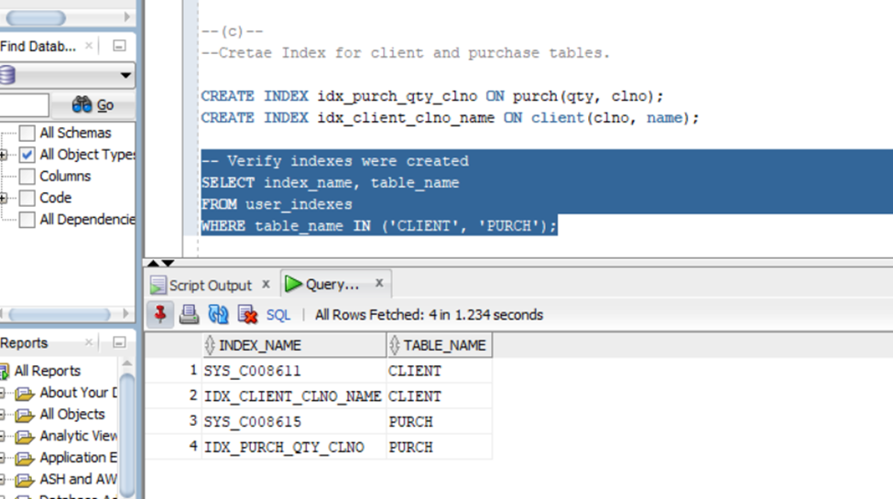

(d.)
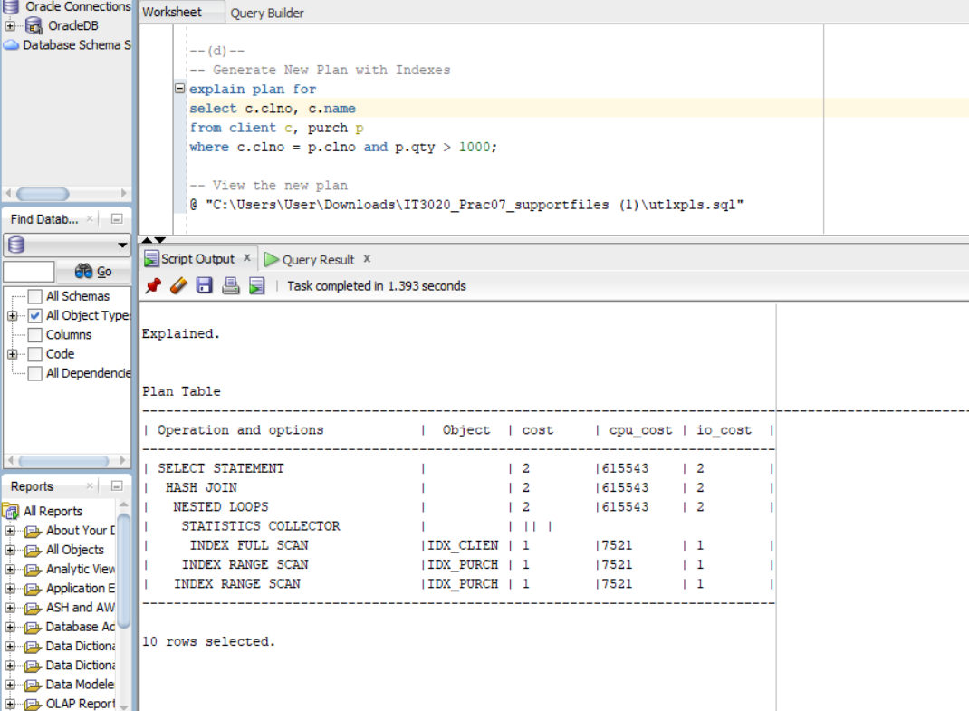

Explain the query plan and compare it with the query plan in part (b.)
1. INDEX RANGE SCAN (instead of FULL TABLE SCAN on PURCH)
  - BEFORE: Read entire purch table (all 10 rows)
  - AFTER: Index quickly finds only rows with qty > 1000
  - Only 3 rows have qty > 1000 (c01-BHP-2000, c01-IBM-1200, c01-INFOSYS-1000)
- INDEX UNIQUE SCAN on new index (instead of accessing table)
  - BEFORE: Had to go to client table to get name
  - AFTER: Name is RIGHT IN THE INDEX! (clno, name index)
  - This is a "COVERING INDEX" - index has all data needed
- Cost Comparison:
  - Before: Total cost = 2
  - After: Total cost = 3 (Wait - it went UP? Let me explain...)
Important Note: The costs might actually be similar or slightly different because:
- The sample data is very small (only 10 purch records)
- Full table scan on 10 rows is trivial
- Indexes add overhead for small tables
- In REAL databases with millions of rows, indexes make HUGE differences

