University of Moratuwa
Department of Electronic and Telecommunication Engineering
  - Digital IC Design

Laboratory Experiment 1
  - RTL Synthesis of a UART Transceiver
Name Ranaweera R.P.D.D.H.
Index number 220511N
Semester 7 | Experiment date 5 October 2026

Abstract
A two-transceiver UART design was synthesized using Cadence Genus 18.10 and the educational 45 nm standard-cell libraries. The experiment examined the mapped hierarchy, clocks and resets, area, timing, power estimates and constraint completeness. The transmitter and receiver word lengths were increased from 8 to 32 bits, followed by a constraint-only experiment with 50 MHz clocks and an increased output load.
Increasing the word lengths raised the mapped cell count from 772 to 1130 and the cell area by 80.57%. The worst reported setup slack decreased from +2.539 ns to +2.031 ns. After changing the constraints, the worst reported late output-path slack was +8.864 ns. Electrical transition problems remained: the heavily loaded final output driver had a reported transition of 7.077 ns. Positive setup slack therefore did not establish that the design met every electrical and functional requirement.

Objectives
The objectives were to understand the RTL-to-netlist synthesis flow, identify the design clocks and reset behavior, interpret synthesis reports, and compare the effects of parameter and interface-constraint changes.
Experiment | Word length | Clock | Output load | Worst late slack
Baseline | 8 bits | 100 MHz | 0.2 pF | +2.539 ns
Wider design | 32 bits | 100 MHz | 0.2 pF | +2.031 ns
Exercise 9 | 32 bits | 50 MHz | 5.2 pF | +8.864 ns

All three timing reports identify the operating condition as PVT_0P9V_125C. The comparison uses the recorded late/setup paths; a separate hold analysis is required for a complete timing assessment.

1 UART design and hierarchy
The top module, uart_top, contains two instances of uart_transceiver. Transceiver A is clocked by clk_a and reset by reset_a; transceiver B is clocked by clk_b and reset by reset_b. The serial transmitter output of each transceiver connects to the serial receiver input of the other. Parallel ports provide the user interface for writing transmit data and reading received data.
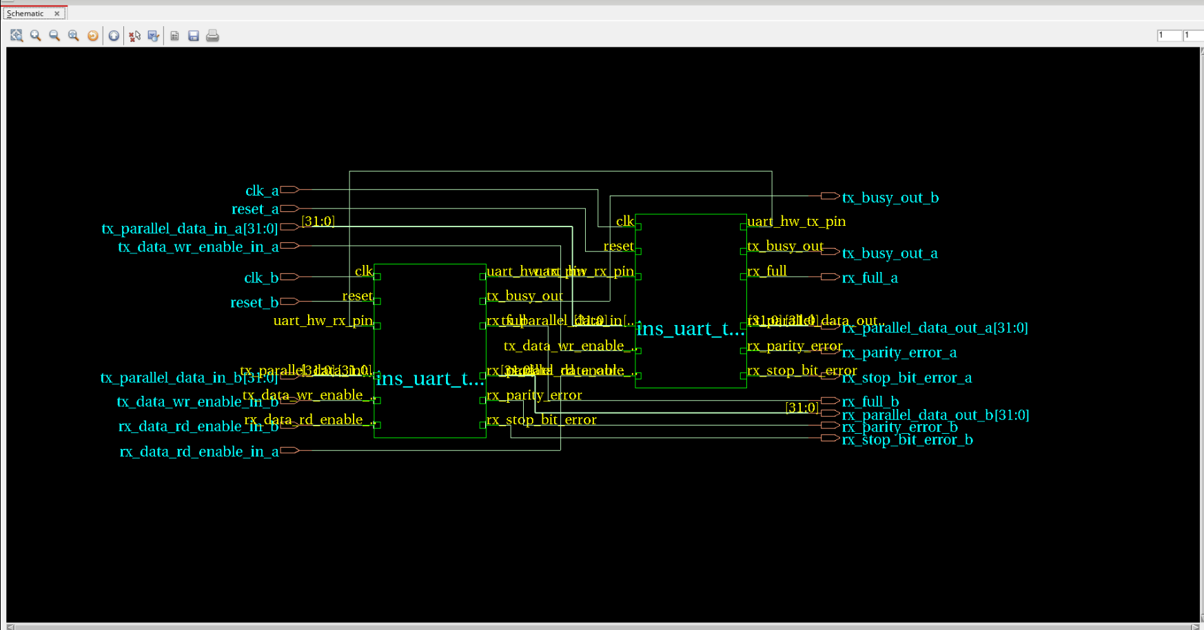
Figure 1. Top-level hierarchy showing both transceivers and the 32-bit parallel interfaces Source: Screenshot 2026-10-05 144957.png.
Each transceiver contains a transmit wrapper and a receive wrapper. The wrappers combine a buffer, a finite-state machine and a sampling tick generator. Buffer logic stores and selects data, while the state machines sequence transmission and reception. The GUI shows hierarchy connectivity; it is not a placed-and-routed layout.
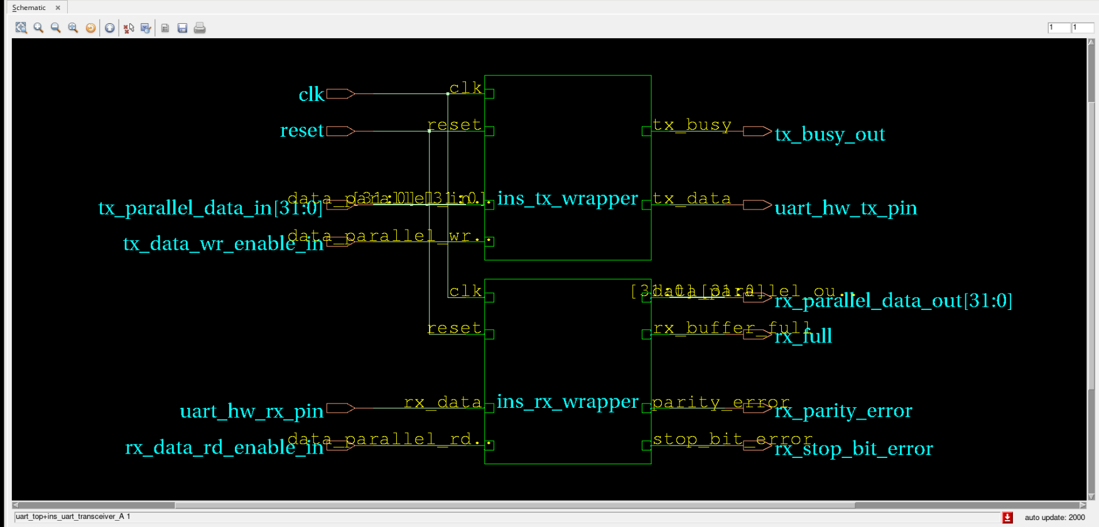
Figure 2. Transmit and receive wrappers inside transceiver A Source: Screenshot 2026-10-05 145236.png.

2 Synthesis procedure and technology libraries
The project separates input RTL and libraries from log, report and output directories. Genus was launched from the work directory. The synthesis sequence read the source, elaborated the hierarchy using the top-level parameters, checked its structure, applied constraints, and mapped the design to library cells.
Operation | Command or input | Purpose
Read RTL | read_hdl [glob ../input/rtl/*.v] | Read the Verilog source
Elaborate | elaborate uart_top | Resolve parameters and hierarchy
Check and uniquify | check_design; uniquify uart_top | Check structure and separate shared subdesigns
Apply constraints | source ../input/constraints.tcl | Specify clocks and interface timing
Synthesize | synthesize -to_mapped -effort m | Optimize and map with medium effort
Export | write -mapped; write_sdc | Save the mapped netlist and constraints
Inspect reports | Area, timing, ports, power and lint | Evaluate the resulting implementation

The .lib files supply cell functions, delay, setup/hold, slew and power data. LEF files supply physical cell and routing information. The QRC .tch file supplies interconnect extraction technology. The reports use physical-library area and global interconnect estimates, so these results precede physical placement and routing.
The loading log records both slow and fast libraries, nominal-condition warnings and duplicate cell names, with colliding fast entries deleted. The reported operating condition is 0.9 V and 125 °C. Loading two libraries in this way does not demonstrate separate setup and hold checks at two independently configured corners.
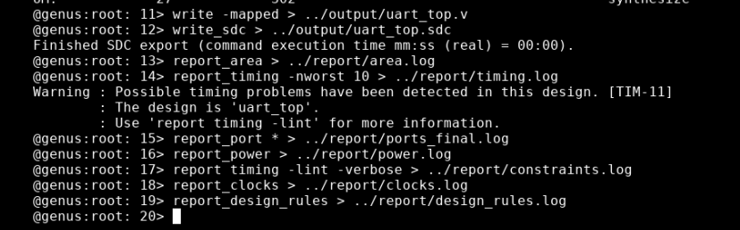
Figure 3. Netlist and SDC export followed by generation of synthesis reports Source: Screenshot 2026-10-05 141555.png.
The synthesis log also reports constant propagation and removal of constant register bits. Such optimizations can reduce the mapped design without changing the represented RTL behavior. A completed check_design operation is a structural check, not proof of UART functional correctness.

3 System clocks resets and sampling ticks
Property | clk_a | clk_b
Initial period | 10 ns | 10 ns
Initial frequency | 100 MHz | 100 MHz
Rising and falling edges | 0 ns and 5 ns | 0 ns and 5 ns
Duty cycle | 50% | 50%
Setup uncertainty | 0.5 ns | 0.5 ns
Registers in the 8-bit run | 83 | 83
Registers in the 32-bit run | 153 | 153

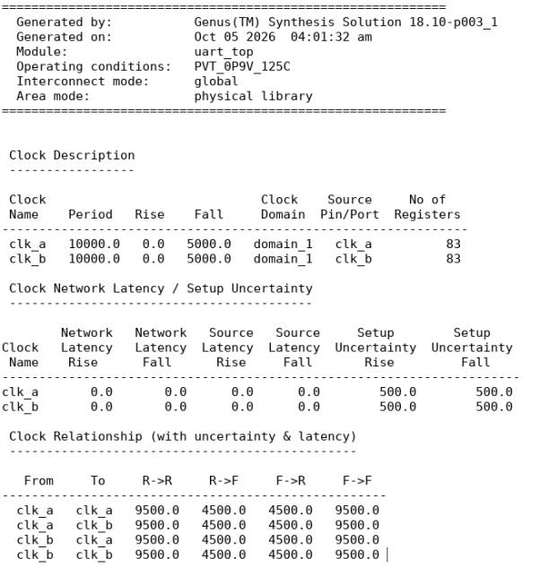
Figure 4. Baseline clock report in picoseconds Source: clock.png.
Both resets are active high and synchronous. The RTL tests if (reset) inside always @(posedge clk), so reset actions occur on the corresponding rising clock edge. They are not asynchronous reset events in the sensitivity list.
There are no derived clocks used to clock registers in this design. The sampling_tick_middle and sampling_tick_end signals are conditions inside blocks triggered by the system clock. They act as enables. Their lower repetition rate alone does not make them generated clocks.
Clock source and network latency are modeled as zero at this stage. The shared domain_1 label does not prove physical synchronization of the input clocks. The reciprocal false-path constraints exclude ordinary timing checks between clk_a and clk_b; they do not implement a clock-domain crossing circuit.

4 Baseline area ports and power
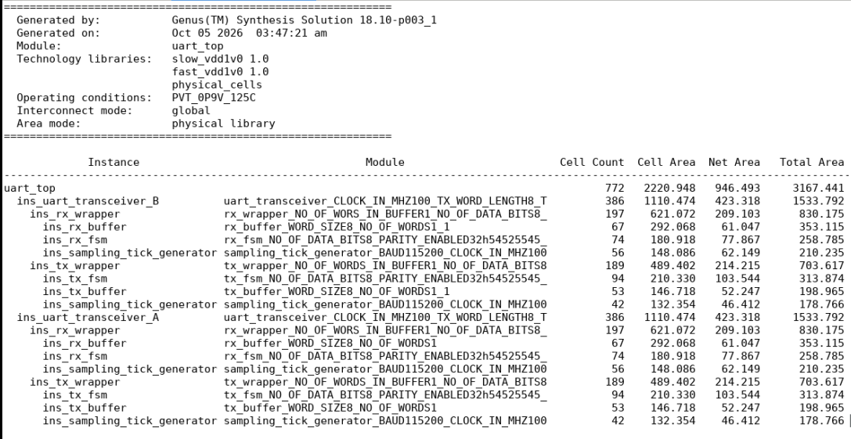
Figure 5. Area report for the corrected 8-bit baseline Source: area.png.
Measurement | 8-bit result
Mapped cells | 772
Cell area | 2220.948
Estimated net area | 946.493
Total reported area | 3167.441
Cells per transceiver | 386
Total area per transceiver | 1533.792

Cell area is the sum of mapped cell areas. Net area is an interconnect estimate, and the total combines these contributions. Hierarchy rows already include their children and must not be added together. The top-level net area also includes interconnections between subblocks. The reported total is not final die area.
Area values are retained in the numerical units of the physical-library report because its header does not explicitly state the unit. The relative comparisons do not depend on the absolute unit. The 45 nm educational library is the technology actually loaded in this experiment.
The corrected port report assigns rx_full_a to clk_a and rx_full_b to clk_b, each with a 6 ns output delay. Output pin loads are 200 fF, corresponding to the 0.2 pF set_load value. The input and output delays describe the external timing budget; they are distinct from the internal path delay.

Power estimate
An earlier 8-bit power report records leakage power of 60.819 nW, dynamic power of 172490.052 nW, and total power of 172550.870 nW, or approximately 172.551 µW. Its generation stamp precedes the corrected baseline reports, so it is treated as an earlier estimate rather than a matched power comparison for the later runs. The saved synthesis sequence does not establish a transaction-specific switching-activity input.

5 Baseline constraint and electrical checks
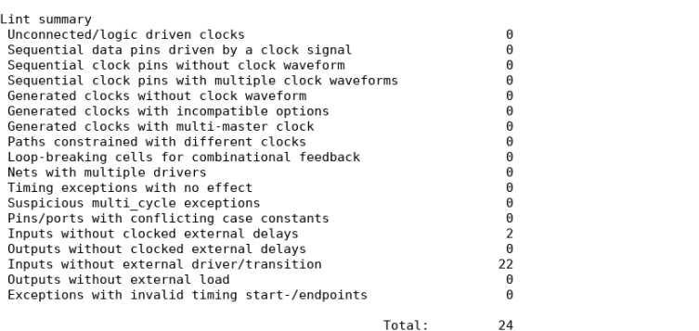
Figure 6. Baseline timing-lint summary Source: Constraint-lint2.png.
Timing lint identifies two inputs without clocked external delays (reset_a and reset_b) and 22 without driver or transition definitions. Genus assumes zero transition for the latter. Input arrival delay and edge speed are separate constraints. The total of 24 counts warning entries, including overlapping categories for the resets.
All outputs have external delays and loads after correction of rx_full_b. Reset timing and realistic driver values still require external interface definitions.
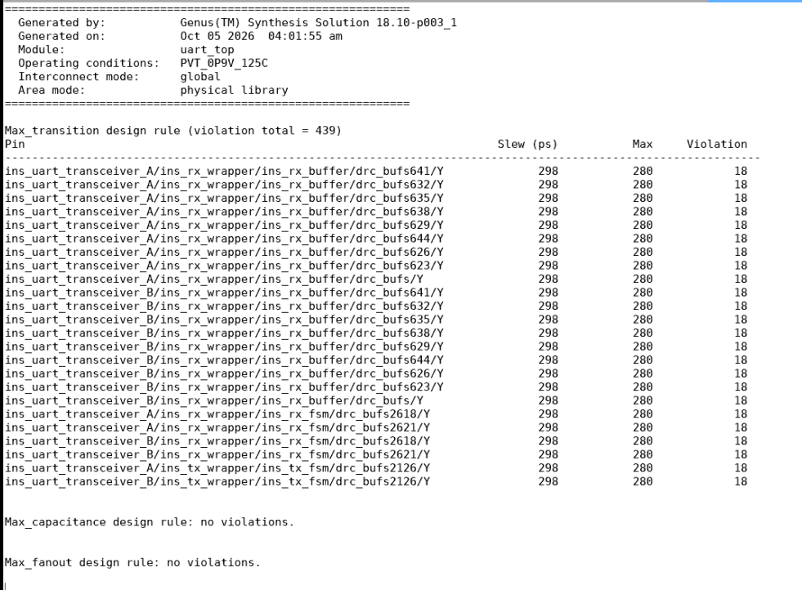
Figure 7. Baseline transition violations with capacitance and fanout results Source: design_rules.png.
There are 24 listed violating driver pins, with transition approximately 298 ps against a 280 ps limit. The aggregate violation cost is 439, not a pin count. Maximum capacitance and fanout checks pass. An allowed load can still result in an excessively slow driver transition.

6 Word length change and area comparison
For exercises 5 and 6, TX_WORD_LENGTH and RX_WORD_LENGTH were changed from 8 to 32 while both word-count parameters remained 1. The design was read and elaborated again, then synthesized under the same 100 MHz clock and 0.2 pF output-load constraints. The new hierarchy identifies TX_WORD_LENGTH32 and receive blocks with 32 data bits.
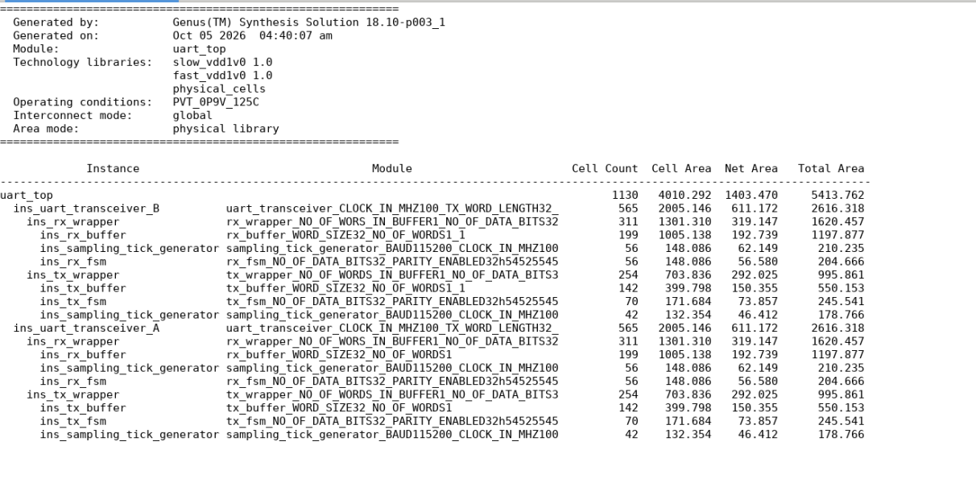
Figure 8. Area report after increasing both word lengths to 32 bits Source: area32.png.
Measurement | 8 bits | 32 bits | Change
Mapped cell count | 772 | 1130 | +46.37%
Cell area | 2220.948 | 4010.292 | +80.57%
Estimated net area | 946.493 | 1403.470 | +48.28%
Total reported area | 3167.441 | 5413.762 | +70.92%
Registers per clock | 83 | 153 | +70

$$Cell area increase = \frac{4010.292 - 2220.948}{2220.948} × 100\% = 80.57\%$$
Most of the increase occurs in buffer logic. Per transceiver, receive-buffer cell area rises from 292.068 to 1005.138 and transmit-buffer cell area rises from 146.718 to 399.798. Wider storage and selection logic increase both cell usage and estimated interconnect area.
The whole design does not grow fourfold. The receive and transmit tick-generator cell areas remain 148.086 and 132.354 respectively. Receive-FSM cell area decreases from 180.918 to 148.086, and transmit-FSM cell area decreases from 210.330 to 171.684. These results show that parameter changes can also expose constant or unreachable control behavior to optimization.

7 Timing comparison for the two word lengths
The worst listed baseline path starts at rx_data_rd_enable_in_b and ends at the D pin of the receive buffer full-counter register, bit 2. For 32 bits, the worst listed path still begins at this input but ends at bit 4. The endpoint name indicates a wider buffer-counter implementation.
Timing component | 8 bits | 32 bits
Capture clock edge | 10.000 ns | 10.000 ns
Setup requirement | 0.168 ns | 0.091 ns
Setup uncertainty | 0.500 ns | 0.500 ns
Input delay | 6.000 ns | 6.000 ns
Internal data-path delay | 0.793 ns | 1.378 ns
Data arrival time | 6.793 ns | 7.378 ns
Required time | 9.332 ns | 9.409 ns
Setup slack | +2.539 ns | +2.031 ns

$$Slack = Required time - Data arrival time$$
$$32-bit slack = 10 - 0.091 - 0.500 - 6 - 1.378 = 2.031 ns$$
The slack decreases by 0.508 ns. The internal data path becomes 0.585 ns longer, partly offset by a 0.077 ns smaller setup requirement for the reported endpoint transition. The 32-bit path includes an input buffer driving 33 loads followed by additional control logic.
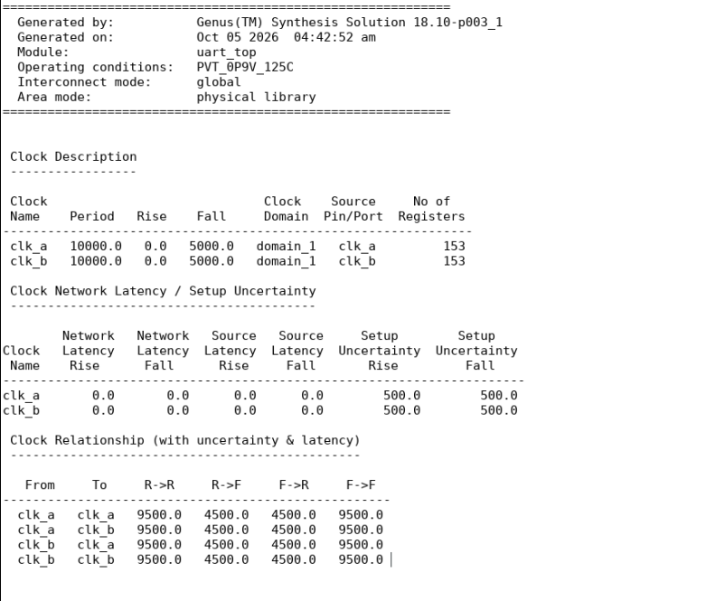
Figure 9. Clock report confirming the unchanged 100 MHz timing model and 153 registers per clock Source: clock_32.png.
All ten listed late/setup paths in timing.txt and timing_32.txt have positive slack. Thus, no negative slack is present in these saved reports. This conclusion is limited to the modeled and constrained checks; hold timing and excluded paths are not established by this result.

8 Constraint and electrical results for 32 bits
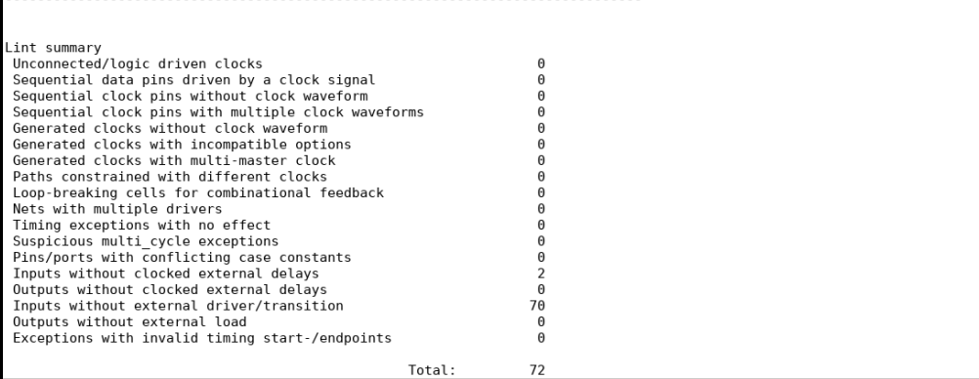
Figure 10. Timing-lint summary for the 32-bit run Source: Constraint-lint_2_32.png.
The number of inputs without driver or transition definitions increases from 22 to 70: 64 parallel data bits, four read/write enable inputs, and two resets. The two reset inputs remain without clocked external delays. The total warning count is therefore 72. Outputs remain fully covered by external delays and loads.
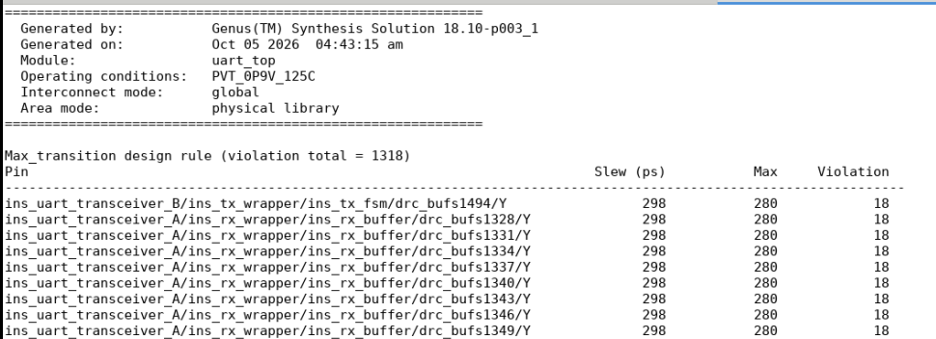
Figure 11. Top portion of the provided 32-bit maximum-transition report Source: design_rules_32.png.
The excerpt reports a maximum-transition violation cost of 1318, compared with 439 for the baseline. Its listed pins still show approximately 298 ps transition against a 280 ps limit. The cost increase is consistent with loading more output bits; 1318 is not a pin count. The excerpt is cropped before the end of the full report, so it does not establish the complete capacitance or fanout results for this run.

Functional limitation of the parameter experiment
Both transmit and receive FSMs declare data_bit_counter as reg [2:0]. This counter can represent only 0 through 7, whereas a 32-bit transfer requires reaching bit 31. The parameter-only synthesis experiment therefore demonstrates area and timing changes, but not correct 32-bit UART operation. The reduced FSM areas should not be interpreted as proof of a better functional implementation. Functional simulation and parameter-consistent counter widths would be required before using the design as a working 32-bit UART.

9 Clock waveform and output load changes
Exercise 9 retains the 32-bit HDL and changes the timing constraints. Both clocks are specified at 50 MHz with 40% duty cycle, and clock B is shifted by 180 degrees relative to A. The output load increases by 5 pF from its previous value of 0.2 pF.
$$T = \frac{1}{50 × 10⁶} s = 20 ns$$
$$High time = 0.40 × 20 = 8 ns$$
$$Phase offset = \frac{180}{360} × 20 = 10 ns$$
Property | clk_a | clk_b
Specified period | 20 ns | 20 ns
Specified rising edge | 0 ns | 10 ns
Specified falling edge | 8 ns | 18 ns
High and low times | 8 ns and 12 ns | 8 ns and 12 ns
Specified duty cycle | 40% | 40%

The resulting constraint definitions are:
create_clock -name clk_a -period 20 -waveform {0 8} [get_ports clk_a]
create_clock -name clk_b -period 20 -waveform {10 18} [get_ports clk_b]
set_load 5.2 $design_outputs
A phase shift moves both edges by the same amount. Inverting a 40% duty-cycle clock would instead produce 60% high time. The load command assigns 5.2 pF per constrained output, which is 26 times the original 0.2 pF. It is a final assigned value, not an instruction to add 5.2 pF each time the script is sourced.
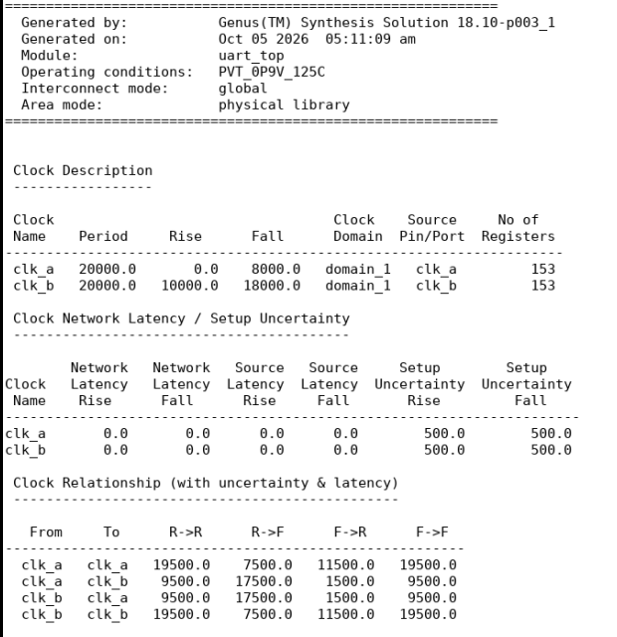
Figure 12. Final clock report confirming both 20 ns periods and the specified rising and falling edges Source: Screenshot 2026-10-05 144246.png.

10 Timing after the constraint changes
The final worst listed path ends at rx_full_b. It starts at the clock pin of receive-buffer counter bit 3 and includes the register clock-to-Q delay, output logic, and the output driver. All ten listed late output paths in timing_step9.txt have positive slack, ranging from +8.864 ns to +8.897 ns.
Timing component | rx_full_b path | rx_full_a path
Launch rising edge | 10.000 ns | 0.000 ns
Capture rising edge | 30.000 ns | 20.000 ns
Output delay allowance | 6.000 ns | 6.000 ns
Setup uncertainty | 0.500 ns | 0.500 ns
Required absolute time | 23.500 ns | 13.500 ns
Data-path delay from launch | 4.636 ns | 4.636 ns
Data arrival absolute time | 14.636 ns | 4.636 ns
Late output-path slack | +8.864 ns | +8.864 ns

$$B path slack = 23.500 - (10.000 + 4.636) = 8.864 ns$$
The larger cycle time increases the available timing budget. Clock B shifts both launch and capture edges by 10 ns, so this same-clock path still receives a full 20 ns cycle. The worst path has changed from an input-to-register path to a register-to-output path; the new slack should not be treated as a direct speed improvement of the original critical path.

Effect of the increased output load
The final CLKBUFX20 output-driver row reports a load of 5201.6 fF, transition of 7077 ps, and cell delay of 4070 ps. The driver contributes most of the 4636 ps path delay. Although the output arrives before its required time, its transition of 7.077 ns is much larger than the 0.280 ns maximum reported for the earlier runs. Relative to that limit, the excess is approximately 6.797 ns.
Thus, the final result satisfies the reported late output timing checks but still fails the maximum-transition requirement. The final design-rule excerpt confirms this distinction explicitly. Positive slack means that the signal arrives in time; it does not imply that its voltage edge meets the electrical transition limit.

Interpretation of warnings
TIM-11 directs the user to timing lint and does not by itself indicate negative setup slack. Constraint gaps, negative timing slack, and electrical-limit violations describe different issues and must be recorded separately. A larger clock period can improve setup slack while leaving output slew outside the permitted range.
The final clock report confirms 20000 ps periods, A rising/falling edges of 0/8000 ps, and B edges of 10000/18000 ps. Each clock still drives 153 registers, with 500 ps setup uncertainty. Both 40% duty cycles and the 180 degree shift are therefore verified by the measured report.
The 6 ns interface delays and reciprocal inter-clock false paths are retained. These exceptions exclude ordinary inter-clock path checks. Also, CLOCK_IN_MHZ remains 100 in the unchanged RTL: physically operating that sampling logic at 50 MHz would halve its counter-based baud timing rate.

11 Final area and electrical results
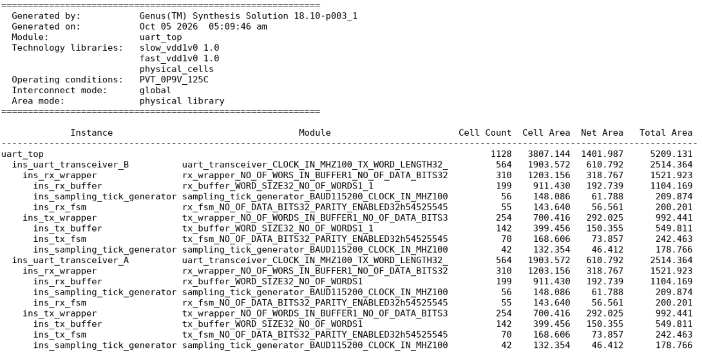
Figure 13. Final area report after the constraint-only synthesis run Source: Screenshot 2026-10-05 144236.png.
Measurement | 32 bits at 100 MHz | Exercise 9
Mapped cell count | 1130 | 1128
Cell area | 4010.292 | 3807.144
Estimated net area | 1403.470 | 1401.987
Total reported area | 5413.762 | 5209.131

With the same 32-bit HDL, the constraint-only run reduces cell area by 5.07% and total reported area by 3.78%. The changed targets produce a different optimized mapping. Receive-buffer cell area falls from 1005.138 to 911.430 per transceiver, while output transition limits remain unmet.
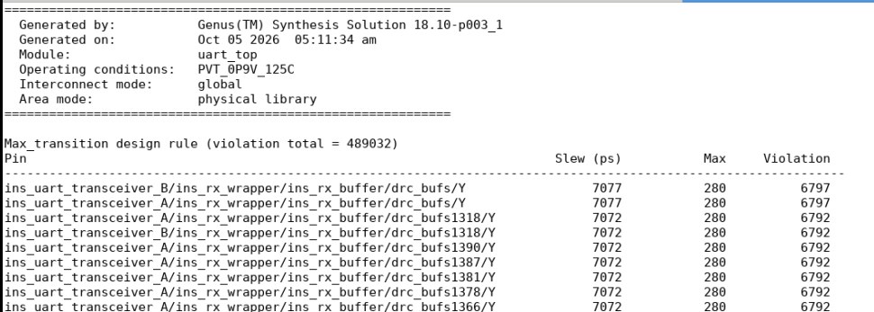
Figure 14. Top portion of the final maximum-transition violation list Source: Screenshot 2026-10-05 144325.png.
The final transition violation cost is 489032. Listed outputs have transitions around 7072 to 7077 ps against a 280 ps limit, exceeding it by approximately 6792 to 6797 ps. This confirms severe slew violations. The cost is not a pin count. The screenshot does not establish final capacitance or fanout status because the report ending is not visible.
The final lint screenshot still identifies resets without external arrival delays and data/control inputs without driver or transition definitions. The clock and load changes therefore do not resolve those interface-model gaps.

12 Conclusions and further verification
The experiment demonstrated the main synthesis stages from parameterized Verilog to a technology-mapped netlist and exported SDC. The mapped hierarchy and reports show how synthesis resolves parameters, propagates constants and selects library cells under the stated timing and load assumptions.
Increasing the UART word lengths from 8 to 32 raised cell count by 46.37%, cell area by 80.57%, and total reported area by 70.92%. Buffer growth was the principal area contribution. The worst listed setup slack decreased from +2.539 ns to +2.031 ns as the input-to-counter path became longer, while sampling tick-generator areas remained unchanged.
With verified 50 MHz clocks, 40% duty cycles, a 180 degree B phase shift and the increased 5.2 pF output load, the worst listed late output-path slack was +8.864 ns. Cell area fell by 5.07% relative to the 32-bit 100 MHz run. However, the final maximum-transition violation cost reached 489032 and the worst listed output-driver transition was 7.077 ns against a 0.280 ns limit. The experiment therefore illustrates that meeting setup timing is only one part of evaluating an ASIC implementation.
Further verification should include the complete final electrical report, early/hold timing analysis, realistic input driver models, and an explicit timing model for the synchronous reset inputs. The fixed 3-bit UART data counters require review before functional use at 32 bits. Inter-clock false paths require a separate clock-domain crossing assessment; timing exceptions alone do not prevent metastability.
Large positive slack does not justify deleting functional registers. Registers encode storage and sequencing. Any change to them would require a separate architectural justification and functional verification.

References and experimental records
1. Department of Electronic and Telecommunication Engineering, University of Moratuwa. Laboratory Experiment 1 RTL Synthesis, EN4603-Lab1.pdf, pages 1 to 5. The handout identifies the experiment and exercise sequence.
2. Cadence Genus 18.10-p003_1 experimental logs and reports: step1-2.txt, step3.txt, area.txt, timing.txt, timing_32.txt, timing_step9.txt, clocks.txt, port_final.txt, design_rules.txt, constraints.txt and power.txt. Report values and timestamps were used to distinguish the runs.
3. UART RTL in code.txt and the exported baseline netlist uart_top.txt. The source was used to identify synchronous reset behavior, sampling enables and the fixed-width data counters.
4. Experimental screenshots: area.png, area32.png, clock.png, clock_32.png, Constraint-lint2.png, Constraint-lint_2_32.png, design_rules.png, design_rules_32.png, and the hierarchy and report-generation screenshots identified in figure captions. Final results are recorded in Screenshot 2026-10-05 144236.png, 144246.png, 144309.png and 144325.png. Figure excerpts remove unused margins and repeated rows without changing report values.
5. Previous cohort report 170287A_DICD_Lab1.pdf, consulted as an example of report organization. Numerical results and conclusions in this report are drawn from the current experimental records.

