**In-class Assignment 4**

1. **D. B. Perera - 210465P**

**Exercise:**

Link to the github repository:

<https://github.com/DulinaPerera/Lab-Work/blob/main/Lab-7/main.cpp>

* I inputted 100 line input & here is the result.

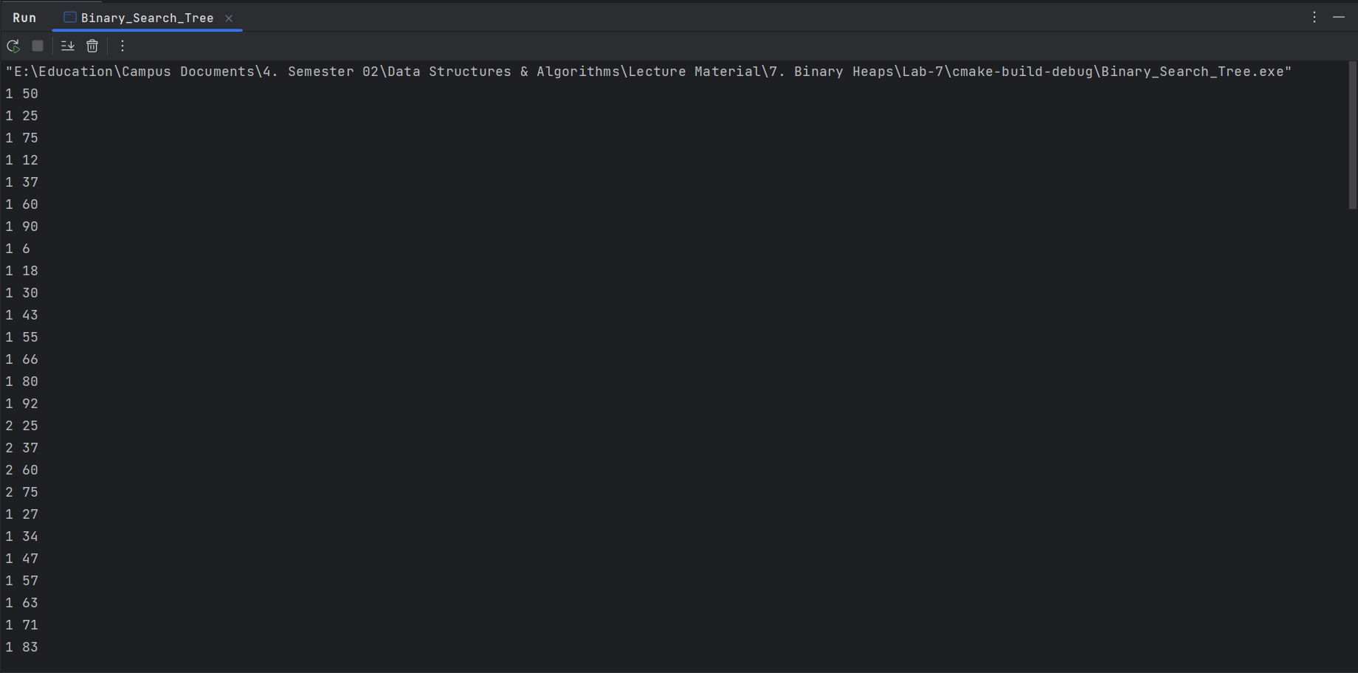

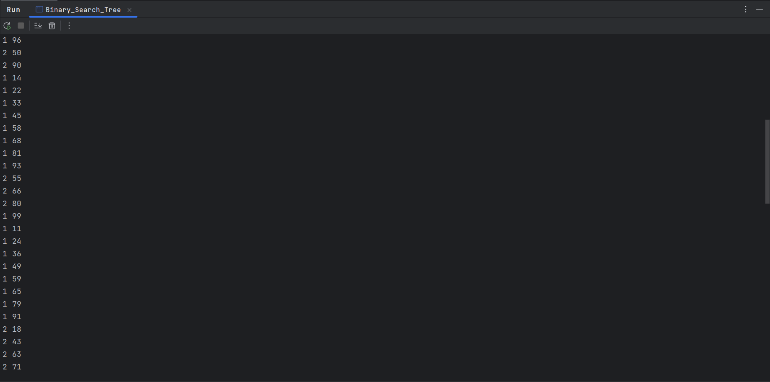

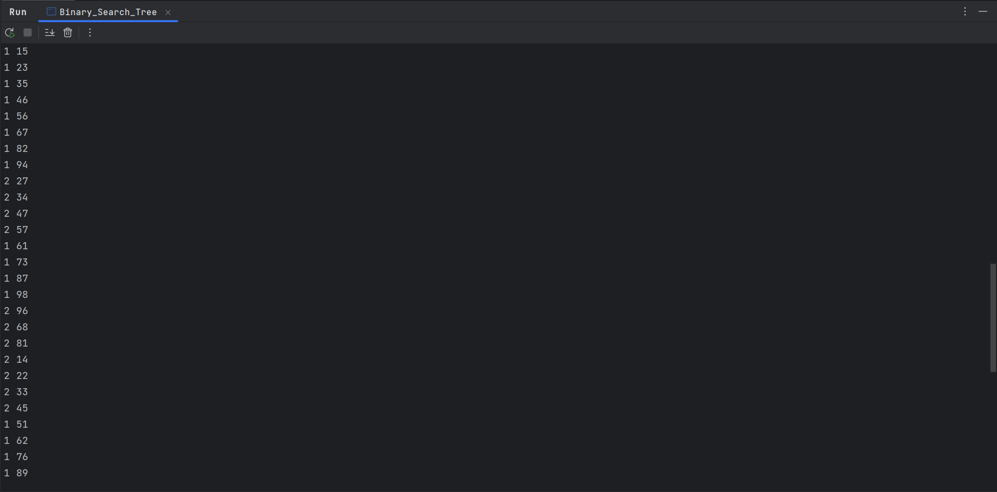

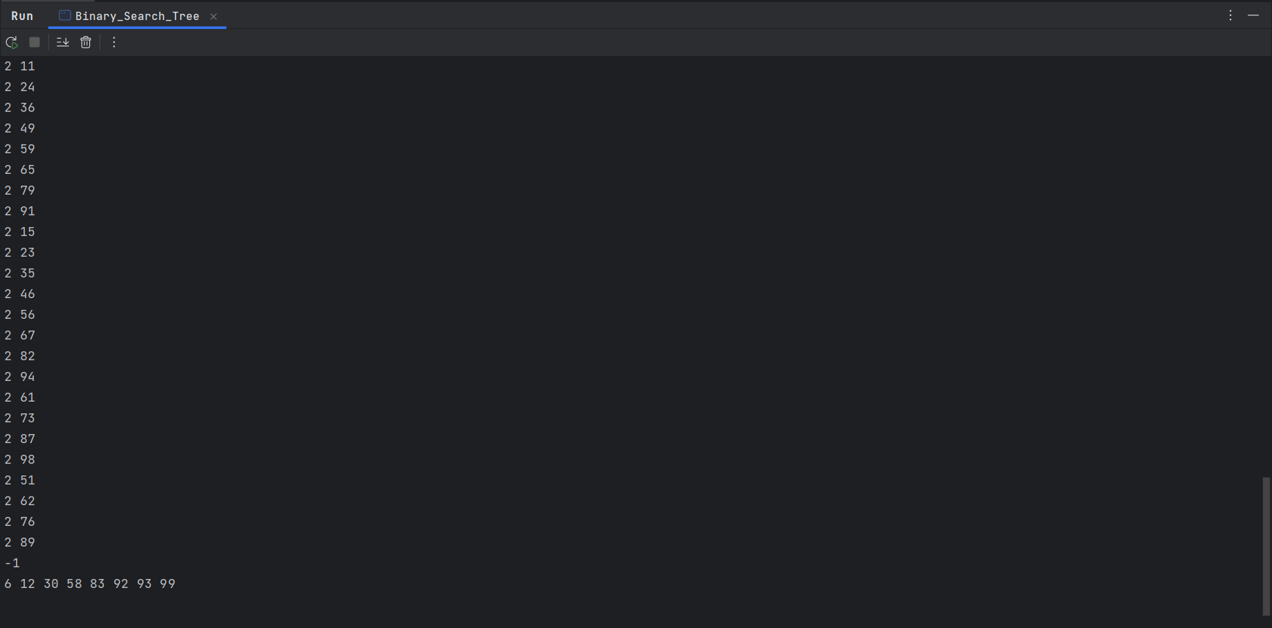

* I also received the desired output for the input in the lab sheet.

