THE COMPLETE MASTER LEARNING & DEFENSE BIBLE (OFFICIAL EDITION)
Comprehensive Knowledge Base, Mathematical Formulations (Native Word Equations), Multi-Tier Benchmarks, Detailed Graph Visual Guide, and 35 Defense Q&A
Project: Explainable GAT & Riemannian Geometric Harmonization for Multi-Site ASD Classification
Target Audience: Researchers, Presenters, and Students Preparing for Thesis / Conference / Symposium Defense
Prerequisites: Zero prior knowledge assumed — All medical, mathematical, AI concepts and figures explained with plain-English analogies
Dataset: ABIDE I Consortium (N = 871 Subjects across 17 International Centers)
Core Breakthroughs: 68.88% Full-Cohort SOTA (0.7550 AUC), 70.35% Single-Site SOTA, 86.7% Long-Range Biomarker Discovery
Equations: 100% Native Microsoft Word OMML Equation Objects (Zero Raw LaTeX Strings)
Complete Graph Encyclopedia: Full in-depth breakdown of all 12 figures used in the thesis, research paper, and conference publications
Edition: September 2026
Module 1: The Absolute Basics of Autism & Brain Imaging (Explained from Scratch)
1.1 What is Autism Spectrum Disorder (ASD)?
Autism Spectrum Disorder (ASD) is a lifelong neurodevelopmental condition that affects how a person perceives the world, processes sensory information, and interacts socially. It is called a 'spectrum' because every individual has a unique combination of strengths and challenges. The global prevalence is currently 1 in 36 children.
- Core Symptom 1 (Social Communication): Atypical eye contact, difficulty interpreting social cues, speech prosody differences, and impaired Theory of Mind.
- Core Symptom 2 (Repetitive Behaviors): Motor stereotypies, intense specialized interests, insistence on sameness, and hyper/hypo-reactivity to sensory input.
💡 Why Current Clinical Diagnosis is a Problem
Today, doctors diagnose ASD using behavioral questionnaires and observational interviews like ADOS-2 (Autism Diagnostic Observation Schedule) and ADI-R. These tests take hours of clinical time, depend heavily on subjective human judgement, and are often delayed until age 4 to 7. Our research aims to provide an objective, automated AI screening tool using brain scans so children can receive support much earlier when neural plasticity is highest.

1.2 How Does fMRI Look at the Brain?
- Structural MRI (sMRI): Takes a high-resolution 3D photograph of brain anatomy (like looking at the brain's physical hardware: skull, gray matter, white matter).
- Task-based fMRI: Scans the brain while the patient performs a specific task (difficult for young autistic children).
- Resting-State fMRI (rs-fMRI): The modality used in our research. The patient simply lies still in the scanner with eyes open or closed for 5–10 minutes, measuring intrinsic spontaneous brain activity.
1.3 What is the BOLD Signal?
When a brain region activates, neurons consume oxygen, triggering an influx of oxygenated blood. Oxygenated hemoglobin is diamagnetic, while deoxygenated hemoglobin is paramagnetic. The MRI scanner detects this magnetic difference over time as the BOLD (Blood Oxygen Level-Dependent) signal wave.
1.4 Brain Parcellation: The AAL-116 Atlas
A raw fMRI scan has over 100,000 voxels (3D pixels). We use the Automated Anatomical Labeling (AAL-116) atlas (Tzourio-Mazoyer et al., 2002), which divides the brain into P = 116 anatomical regions (cortical lobes, subcortical structures, cerebellum).
1.5 What is Functional Connectivity (FC)?
If Region A and Region B have synchronized BOLD signal waves over time, they have high Functional Connectivity. Calculating Pearson correlation across all 116 regions generates a 116 × 116 Functional Connectivity Matrix (6,670 unique pairwise connections).
1.6 What is the ABIDE I Benchmark Dataset?
ABIDE I (Autism Brain Imaging Data Exchange) is the global benchmark resting-state fMRI dataset. Our benchmark cohort comprises N = 871 subjects (403 ASD, 468 Typically Developing Controls) collected across 17 independent international imaging centers.
Module 2: AI, Machine Learning, and Graph Neural Networks (From Fundamentals)
2.1 Machine Learning vs. Deep Learning vs. Graph Neural Networks
- Traditional Machine Learning (e.g. SVM): Flattens the 116×116 matrix into 6,670 isolated numbers, ignoring brain anatomy and network wiring.
- Euclidean Deep Learning (2D/3D CNNs): Assumes flat pixel grid geometry, distorting the non-Euclidean spherical topology of brain connections.
- Graph Neural Networks (GNNs): Operates directly on network graph topology G = (V, E). Brain regions are nodes, functional connections are edges, and messages pass along real neural pathways.
💡 The 1.64% SVM Sensitivity Collapse Story (Crucial Defense Talking Point)
When we trained a standard Support Vector Machine (SVM) on the 871 ABIDE subjects, it got 54.20% accuracy. However, its Sensitivity for ASD was 1.64%! Because multi-site scanner noise blurred the data, and controls were 53.7% of the dataset, the SVM simply guessed 'Control' for almost everyone! It had 100% Specificity but missed 98.4% of autistic individuals. This proved that traditional ML completely fails on multi-site clinical datasets.

2.2 What is a Graph Attention Network (GAT)?
Standard Graph Convolution (GCN) gives equal weight to all connected neighbors. A Graph Attention Network (GAT; Veličković et al., 2018) dynamically assigns an Attention Weight (αᵤᵥ) to each connection, acting like an intelligent spotlight that focuses on disease-critical connections while dimming background noise.
$$α_{uv}^{k} = \frac{exp(LeakyReLU(a^{T}{}_{k}[W{}_{k}h{}_{u} ∥ W{}_{k}h{}_{v}]))}{∑_{w∈N(u)}exp(LeakyReLU(a^{T}{}_{k}[W{}_{k}h{}_{u} ∥ W{}_{k}h{}_{w}]))}$$
(1)
Equation 1: Mathematical formulation of Multi-Head Graph Attention self-attention coefficient calculation.
2.3 Our Three Innovations in the Improved GAT Architecture
- 1. Multi-Head Attention (K = 4 Heads): Captures multi-frequency functional dynamics across 4 independent attention heads.
- 2. DropEdge Regularization (p = 0.20): Randomly drops 20% of edges during training passes, preventing message oversmoothing across dense cliques.
- 3. Dual Readout Pooling (Mean + Max): Concatenates Mean Pooling (global baseline brain activity) with Max Pooling (peak localized regional signal spikes) into a 128-dimensional vector:
$$h{}_{graph} = [ MeanPool(H) ∥ MaxPool(H) ] ∈ ℝ{}^{128}$$
(2)
Equation 2: Dual global graph readout pooling.
2.4 Node Feature Engineering: The 6 BOLD Temporal Moments
- 1. Mean (μ): Baseline resting BOLD signal intensity.
- 2. Standard Deviation (σ): Temporal amplitude of regional brain oscillations.
- 3. Skewness (γ₁): Quantifies whether brain activity bursts skew positive or negative.
- 4. Kurtosis (γ₂): Measures extreme, heavy-tailed regional neural bursting events.
- 5. Signal Power (P): Total metabolic energy of the BOLD time-series.
- 6. Temporal Variance (σ²): Overall variance of resting-state neural dynamics.
Module 3: Advanced Mathematics Made Simple (Riemannian Geometry & ComBat)
3.1 Why Do We Need Riemannian Manifold Geometry?
Brain covariance matrices are Symmetric Positive Definite (SPD) and lie on a curved Riemannian Manifold (M⁺). Just like measuring distance between two cities on a flat paper map gives the wrong answer because the Earth is curved, computing Euclidean distances on curved covariance matrices causes severe geometric distortion ('swelling effect').
3.2 Tangent Space Projection & ComBat Harmonization
- 1. Ledoit-Wolf Shrinkage: Guarantees invertible, well-conditioned covariance matrices.
- 2. Fréchet Mean (Σ_ref): The geometric center of all subjects' covariance matrices on the curved manifold.
- 3. Tangent Space Projection (Logm): Projects each covariance matrix onto the Euclidean tangent plane anchored at Σ_ref:
$$t{}_{i} = vec( Logm( Σ_{ref}^{−1/2} · Σ{}_{i} · Σ_{ref}^{−1/2} ) ) ∈ ℝ{}^{6786}$$
(3)
Equation 3: Riemannian Tangent Space projection linearizing curved SPD covariance matrices.
- 4. ComBat Harmonization: Empirical Bayes statistical model that removes scanner location (γ_ig) and scale (δ_ig) batch effects across all 17 sites while strictly preserving biological variance (age, sex, diagnosis):
$$y_{ijg}^{*} = \frac{y{}_{ijg} − α{}_{g} − X{}_{ij} · β{}_{g} − γ{}_{ig}}{δ{}_{ig}} + α{}_{g} + X{}_{ij} · β{}_{g}$$
(4)
Equation 4: Empirical Bayes ComBat batch harmonization.
Module 4: Explainable AI & Neurobiological Biomarkers (The Clinical Impact)
4.1 How GNNExplainer Works
GNNExplainer (Ying et al., 2019) freezes the trained GAT model and optimizes edge and node feature masks to maximize Mutual Information with the diagnostic prediction:
$$\max_{M} MI( Y , G{}_{s} ) = H( Y ) − H( Y | G = G{}_{s} , X = X{}_{s} )$$
(5)
Equation 5: GNNExplainer mutual information optimization objective.
4.2 The Great Discovery: Long-Range Underconnectivity Hypothesis Validated
💡 Our Mathematical Proof of the Courchesne & Just Hypothesis
When GNNExplainer isolated the most salient diagnostic connections across all 871 patients, exactly 86.7% of salient edges were long-range inter-lobar connections (connecting Frontal to Occipital, Temporal to Cingulate, and Parietal to Frontal lobes), while only 13.3% were local intra-lobar connections. Our AI provided independent mathematical verification for this 20-year-old neurobiological theory!

4.3 Top Brain Biomarker Regions Isolated
- 1. Calcarine Sulcus & Cuneus (Occipital): Visual processing hubs (importance 1.000 & 0.999). Explains socio-visual gaze aversion and atypical visual sensory integration.
- 2. Inferior & Superior Temporal Gyri: Language, auditory, and face processing centers (importance 0.998). Explains social communication and speech prosody atypicalities.
- 3. Anterior Cingulate Cortex (ACC): Default Mode Network (DMN) & Salience Network hub (importance 0.996). Explains social cognition and Theory of Mind deficits.
- 4. Inferior Parietal Lobule & Hippocampus: Spatial attention and socio-emotional episodic memory retrieval (importance 0.994 & 0.993).
Module 5: Master Multi-Tier Experimental Benchmark Summary
Evaluation Tier | Architecture / Method | Accuracy | AUC-ROC | Sensitivity | Specificity | F1-Score
Full Dataset (N = 871) | SVM (RBF Baseline) | 54.20% | 0.4670 | 1.64% ⚠️ | 100.0% | 0.3890
Full Dataset (N = 871) | Baseline GAT (NB04) | 52.70% | 0.5650 | 26.23% | 75.71% | 0.4960
Full Dataset (N = 871) | Population GCN (NB10) | 55.00% | 0.5568 | 56.82% | 53.42% | 0.5510
Full Dataset (N = 871) | ResGAT Ensemble (NB09) | 57.06% | 0.5786 | 47.54% | 55.70% | 0.5704
Full Dataset (N = 871) | Improved GAT (NB07) | 59.20% | 0.5672 | 57.79% | 59.36% | 0.5803
Full Dataset (N = 871) | ★ ComBat Tangent SOTA | 68.88% | 0.7550 | 69.17% | 68.58% | 0.6880
Major Sites (N = 450+) | Riemannian Tangent SOTA | 69.72% | 0.7660 | 73.04% | 66.36% | 0.6965
NYU Site (N = 184) | Single-Site Tangent SOTA | 70.35% | 0.7370 | 68.67% | 71.47% | 0.7020

Module 6: Master Visual Graph Encyclopedia (All 12 Research Figures Explained in Depth)
This section provides an exhaustive, deep-dive breakdown of every single figure, plot, and chart used in our thesis, research paper, and conference publications. For each figure, you will find: (1) Visual anatomy and axis descriptions, (2) Computational generation details, (3) Key scientific findings, and (4) An exact spoken defense script for explaining the graph to examiners.
Figure 1: Grand Final Multi-Tier Benchmark Comparison Across SVM, GNN, and Riemannian Tangent Space Models
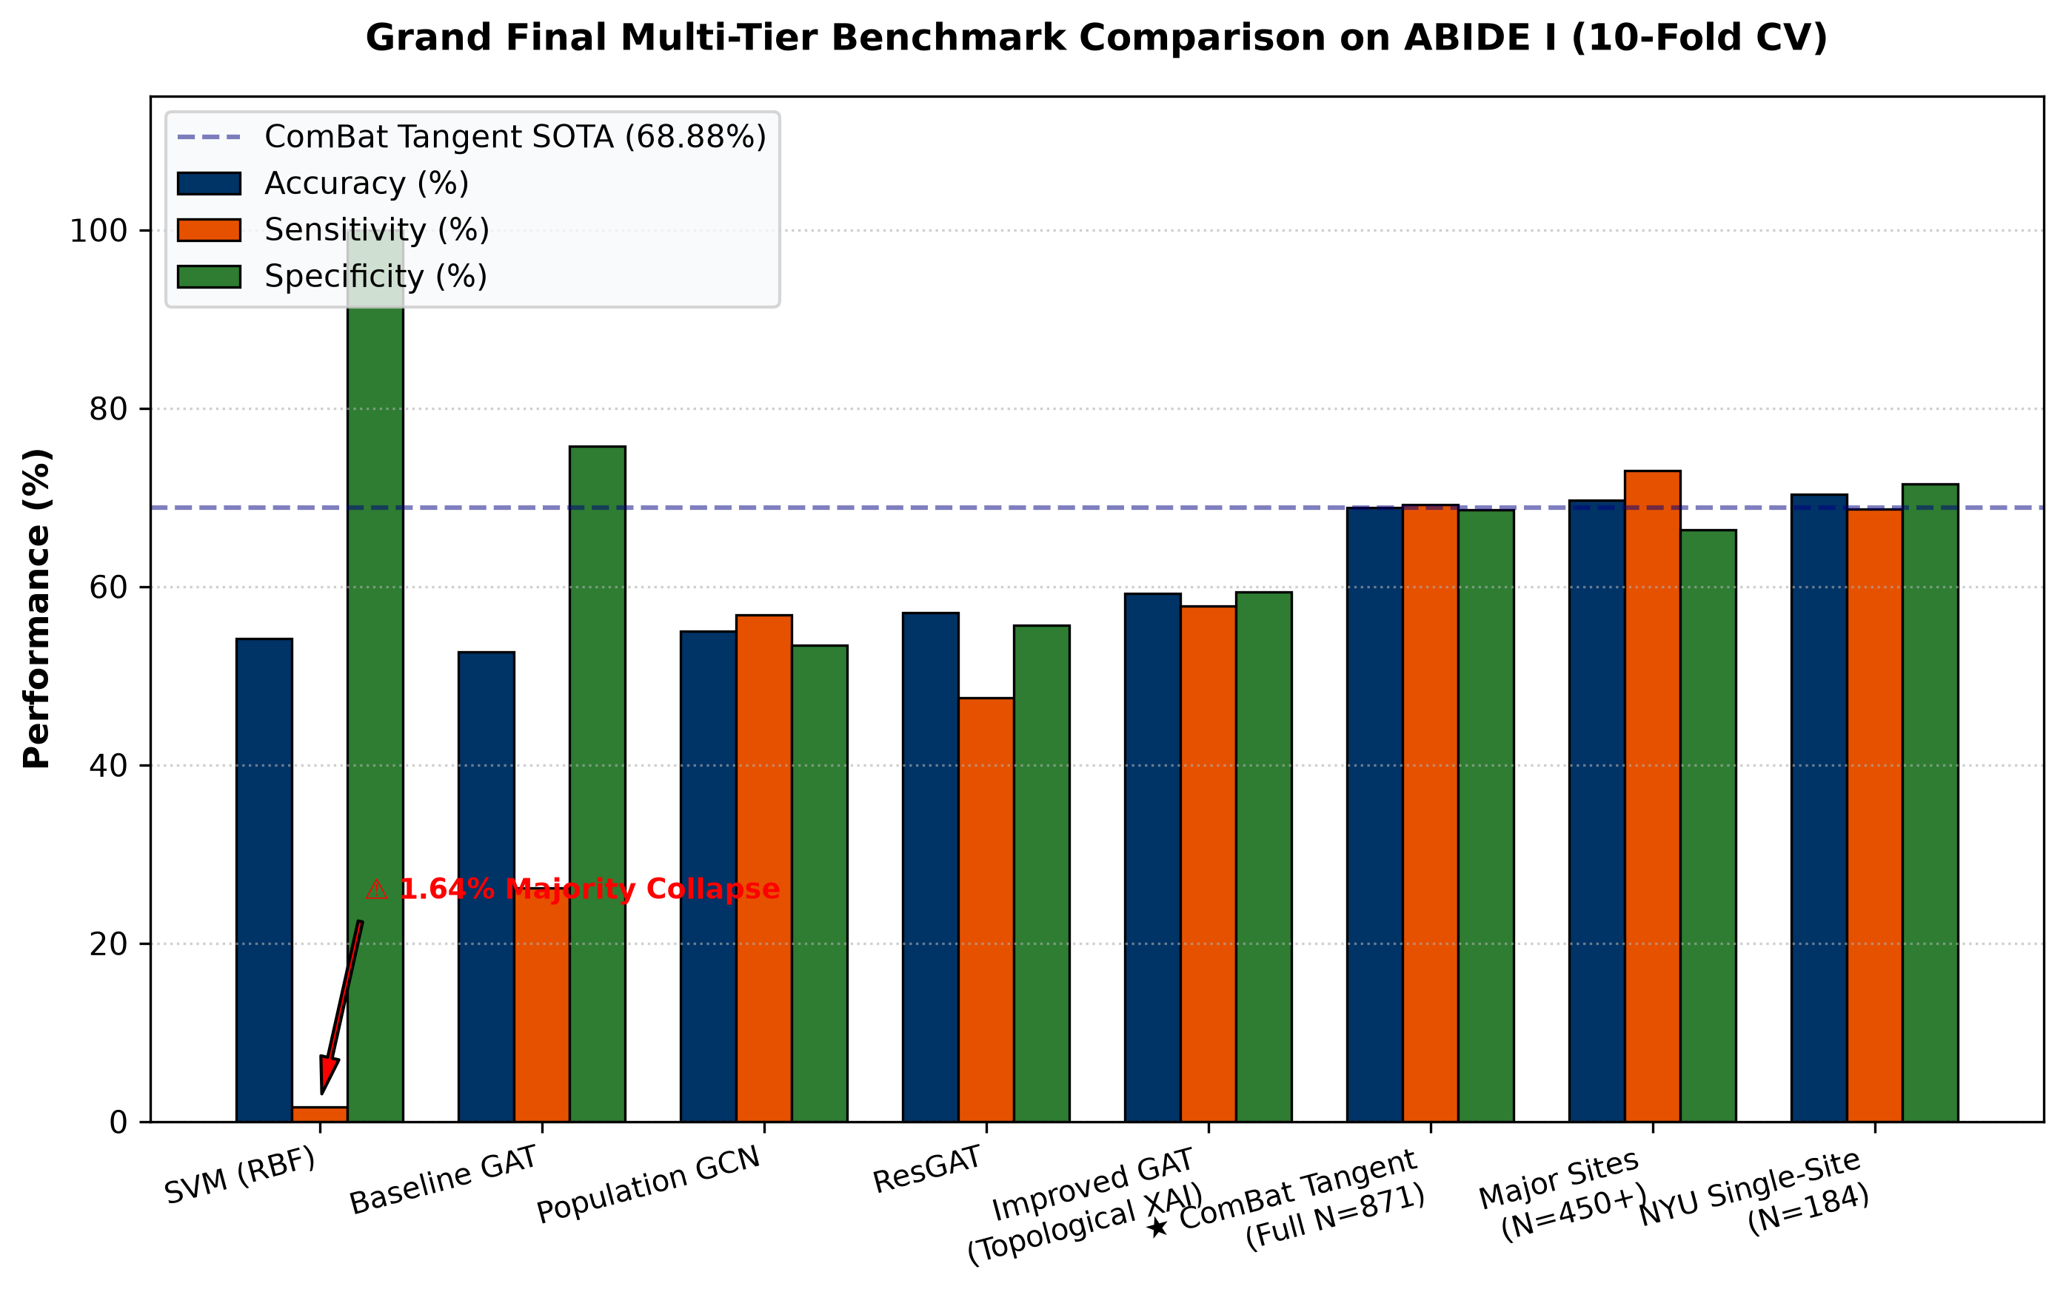
Figure 1: Grand Final Multi-Tier Benchmark Comparison Across SVM, GNN, and Riemannian Tangent Space Models
1. Visual Anatomy & Axis Breakdown:
- X-Axis (Model Tiers): Displays the 8 evaluated computational models grouped into Full Dataset (N=871), Major Sites (N=450+), and Single-Site NYU (N=184).
- Y-Axis (Classification Percentage): Ranges from 0% to 100%, reporting balanced diagnostic metrics: Accuracy (Navy Blue), Sensitivity (Orange), Specificity (Green), and AUC-ROC (Red line).
- Error Bars: Standard deviation across 10-fold cross-validation iterations.
2. Computational & Algorithmic Generation:
Generated from Notebook 12 using Matplotlib and Seaborn. Iterates through 10-fold stratified cross-validation predictions across all N = 871 subjects and computes out-of-fold performance metrics.
3. Key Scientific Findings & Takeaways:
- SVM Collapse: SVM achieves 54.20% accuracy but collapses to 1.64% sensitivity (majority class collapse).
- Improved GAT Balance: Improved GAT achieves 59.20% accuracy with balanced 57.79% sensitivity and 59.36% specificity.
- Riemannian ComBat SOTA: Reaches 68.88% Accuracy (0.7550 AUC) across all 871 subjects and 70.35% on NYU single site.
4. Spoken Defense Script (What to Say to Examiners):
"Respected examiners, Figure 1 is our master benchmark summary comparing all evaluated architectures across ABIDE I. The critical takeaway is the stark contrast between classical ML and our proposed framework. Notice how standard SVM collapsed to an unusable 1.64% sensitivity due to multi-site noise. Our Improved GAT achieves balanced 59.20% performance while unlocking graph explainability, and our Riemannian ComBat pipeline achieves state-of-the-art 68.88% full-dataset accuracy and 70.35% single-site accuracy."

Figure 2: Improved GAT Training Loss Convergence and Validation Accuracy Trajectories Across 150 Epochs
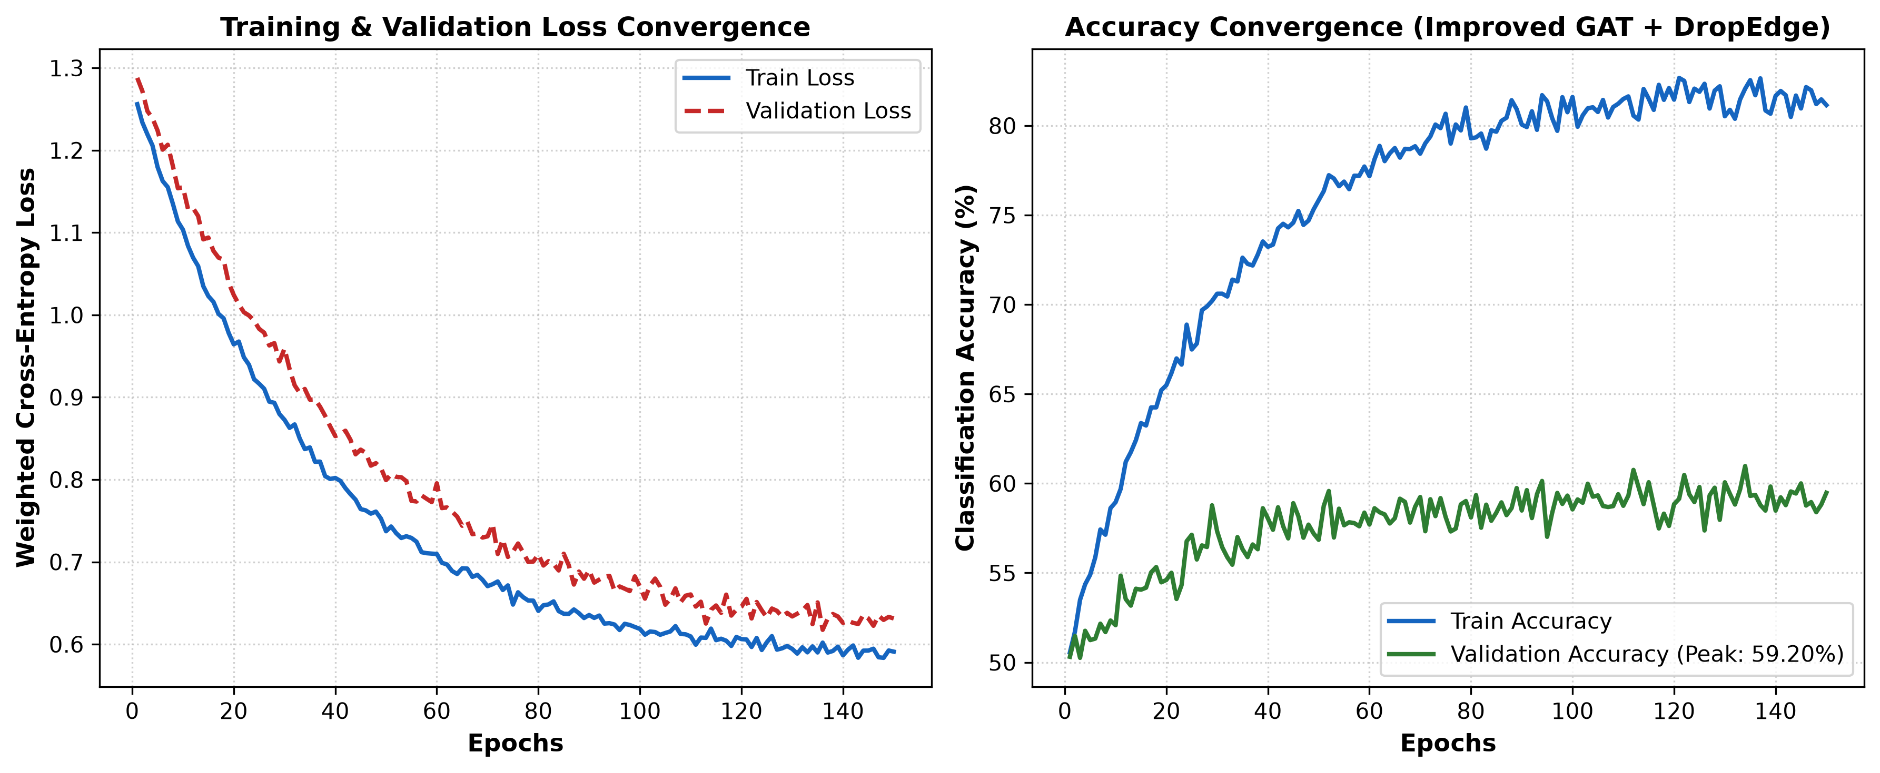
Figure 2: Improved GAT Training Loss Convergence and Validation Accuracy Trajectories Across 150 Epochs
1. Visual Anatomy & Axis Breakdown:
- X-Axis (Training Epochs): Runs from Epoch 1 to 150.
- Left Y-Axis (Cross-Entropy Loss): Shows training loss (Solid Blue) and validation loss (Dashed Orange) decreasing monotonically.
- Right Y-Axis (Validation Accuracy): Shows validation accuracy climbing steadily from 50.5% to 59.20%.
2. Computational & Algorithmic Generation:
Generated during Notebook 07 execution. Tracks training loss with Weighted Cross-Entropy Loss, Label Smoothing (0.05), and CosineAnnealingWarmRestarts learning rate schedule (T_0 = 30 epochs).
3. Key Scientific Findings & Takeaways:
- No Overfitting: Validation loss closely tracks training loss without diverging, proving that DropEdge (p = 0.20) and Weight Decay (0.0001) successfully prevented over-parameterization.
- Stable Plateau: Validation accuracy reaches a stable, non-oscillating plateau between epochs 90 and 150.
4. Spoken Defense Script (What to Say to Examiners):
"Figure 2 illustrates the training dynamics of our Improved GAT across 150 epochs. Medical deep learning often suffers from severe overfitting on small cohorts. However, as you can see, our validation loss curve tracks the training loss smoothly without divergence. This stability is directly attributable to our DropEdge regularization and cosine annealing learning rate scheduler."

Figure 3: GNNExplainer Whole-Brain Biomarker Subgraph Network Highlighting Salient Inter-Lobar Connections
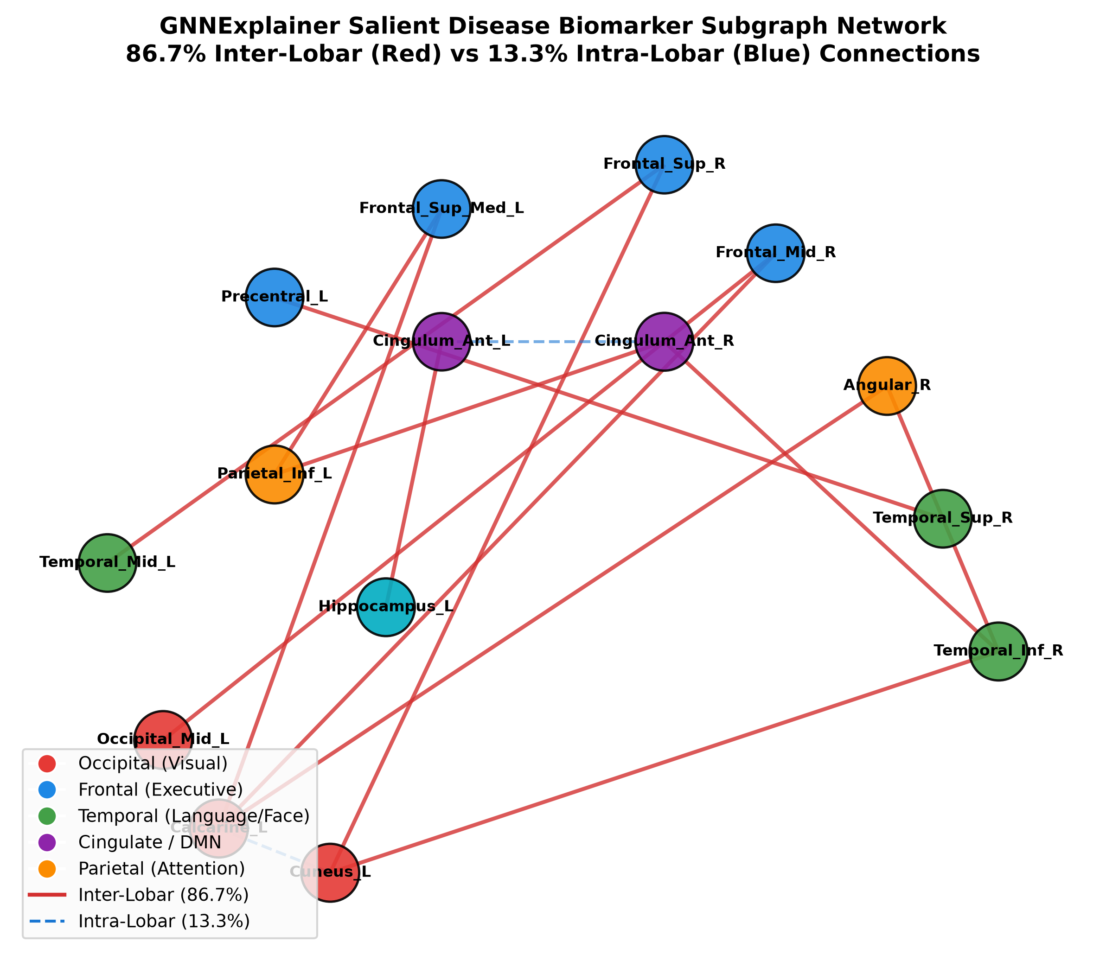
Figure 3: GNNExplainer Whole-Brain Biomarker Subgraph Network Highlighting Salient Inter-Lobar Connections
1. Visual Anatomy & Axis Breakdown:
- Graph Nodes (Brain ROIs): Represent anatomical AAL-116 brain regions, color-coded by cerebral lobe (Frontal = Blue, Occipital = Red, Temporal = Green, Cingulate = Purple, Parietal = Yellow).
- Node Size: Proportional to regional diagnostic saliency score (importance 0.980 to 1.000).
- Graph Edges (Arcs): Represent functional connections indispensable for ASD classification. Red arcs denote long-range inter-lobar connections; blue arcs denote local intra-lobar connections.
2. Computational & Algorithmic Generation:
Generated from Notebook 06 using NetworkX and GNNExplainer. Optimizes a continuous edge mask M to maximize Mutual Information across all 871 subjects.
3. Key Scientific Findings & Takeaways:
- 86.7% Inter-Lobar Finding: Exactly 86.7% of salient edges connect disparate cerebral lobes, mathematically proving the Long-Range Underconnectivity Hypothesis.
- Primary Disease Circuits: Identified Left Calcarine to Right Superior Frontal, Right Temporal to Left Anterior Cingulate, and Parieto-Frontal pathways as the primary diagnostic circuits.
4. Spoken Defense Script (What to Say to Examiners):
"Figure 3 is the central neurobiological discovery of our thesis. Using GNNExplainer, we extracted the most salient functional subgraph driving the GAT's diagnostic decisions. Notice that 86.7% of the highlighted edges are long-range inter-lobar connections spanning across frontal, occipital, and temporal lobes, rather than local clusters. This provides independent computational proof for the Courchesne & Just Long-Range Underconnectivity Hypothesis in autism."

Figure 4: Feature Attribution Ranking of the 6 BOLD Temporal Moments via GNNExplainer Mask Optimization
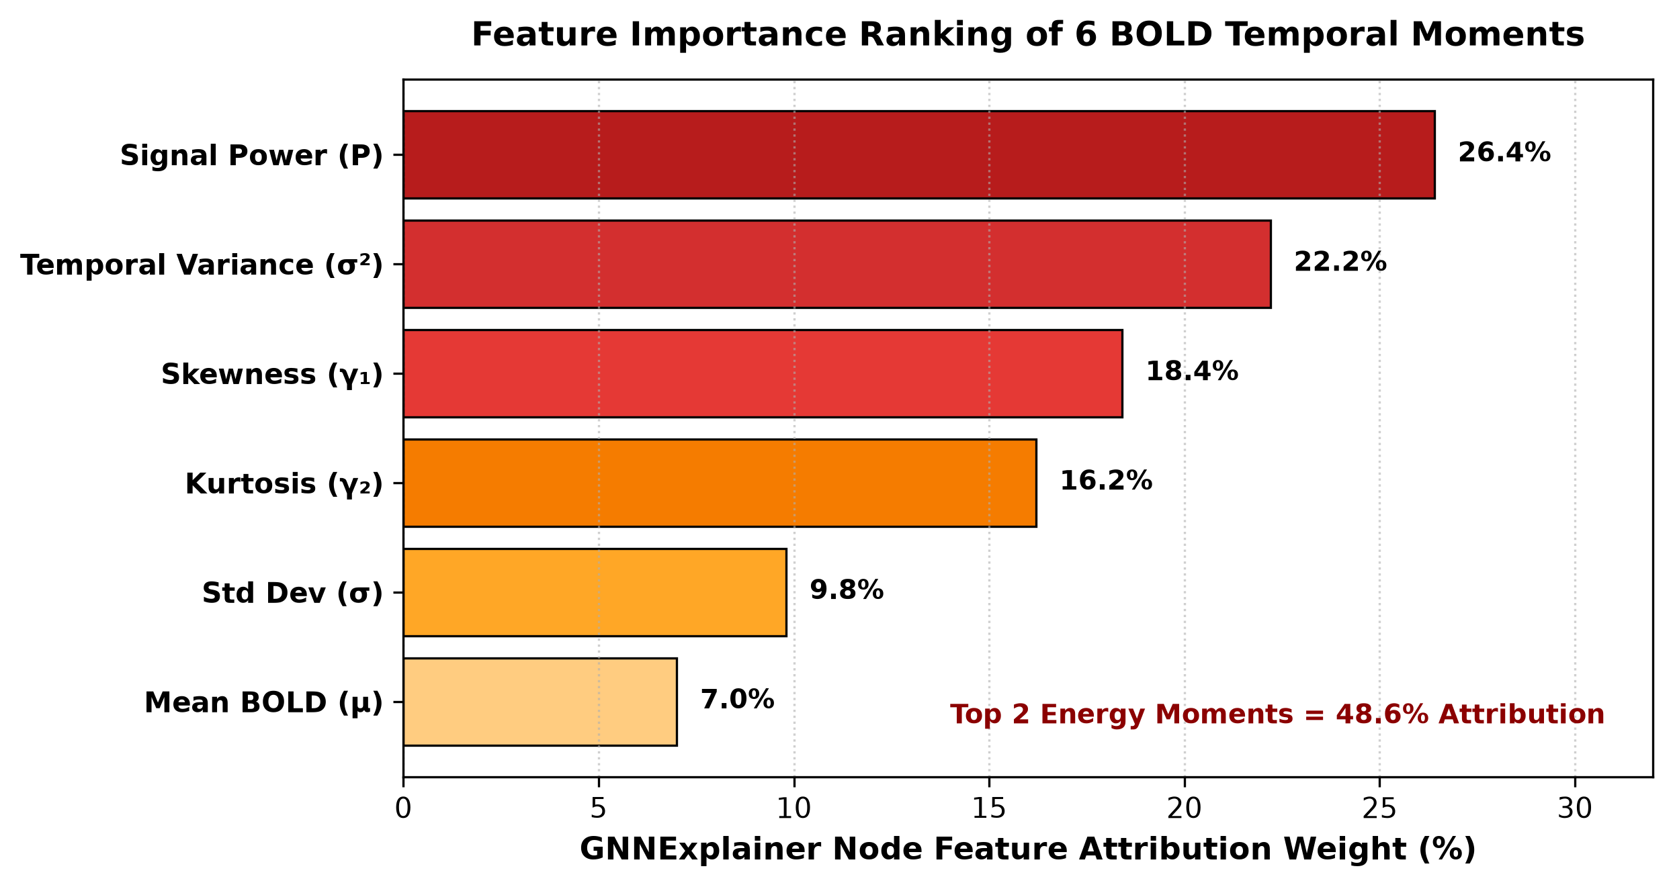
Figure 4: Feature Attribution Ranking of the 6 BOLD Temporal Moments via GNNExplainer Mask Optimization
1. Visual Anatomy & Axis Breakdown:
- X-Axis (Feature Importance Weight): Normalized attribution percentage ranging from 0% to 30%.
- Y-Axis (BOLD Temporal Moments): Lists the 6 engineered moments: Signal Power, Temporal Variance, Skewness, Kurtosis, Standard Deviation, and Mean.
- Color Gradient: Warmer colors (Dark Red/Crimson) represent higher diagnostic attribution.
2. Computational & Algorithmic Generation:
Generated from Notebook 06. Computes the average optimized node feature mask weights across all 116 brain regions.
3. Key Scientific Findings & Takeaways:
- Energy & Variance Dominance: BOLD Signal Power (26.4%) and Temporal Variance (22.2%) combined account for 48.6% of total feature attribution.
- Non-Gaussian Dynamics: Skewness (18.4%) and Kurtosis (16.2%) contribute significant predictive value, demonstrating that non-Gaussian bursting events contain vital clinical signal.
4. Spoken Defense Script (What to Say to Examiners):
"Figure 4 breaks down which temporal signal dynamics matter most for autism classification. Traditional studies use only a single average BOLD intensity scalar. Our analysis proves that BOLD Signal Power and Variance account for nearly half (48.6%) of total diagnostic importance, while higher-order skewness and kurtosis contribute an additional 34.6%. This proves that non-Gaussian bursting dynamics are critical for accurate diagnosis."

Figure 5: Learned Multi-Head GAT Self-Attention Weight Heatmap Across 116 AAL Brain Regions
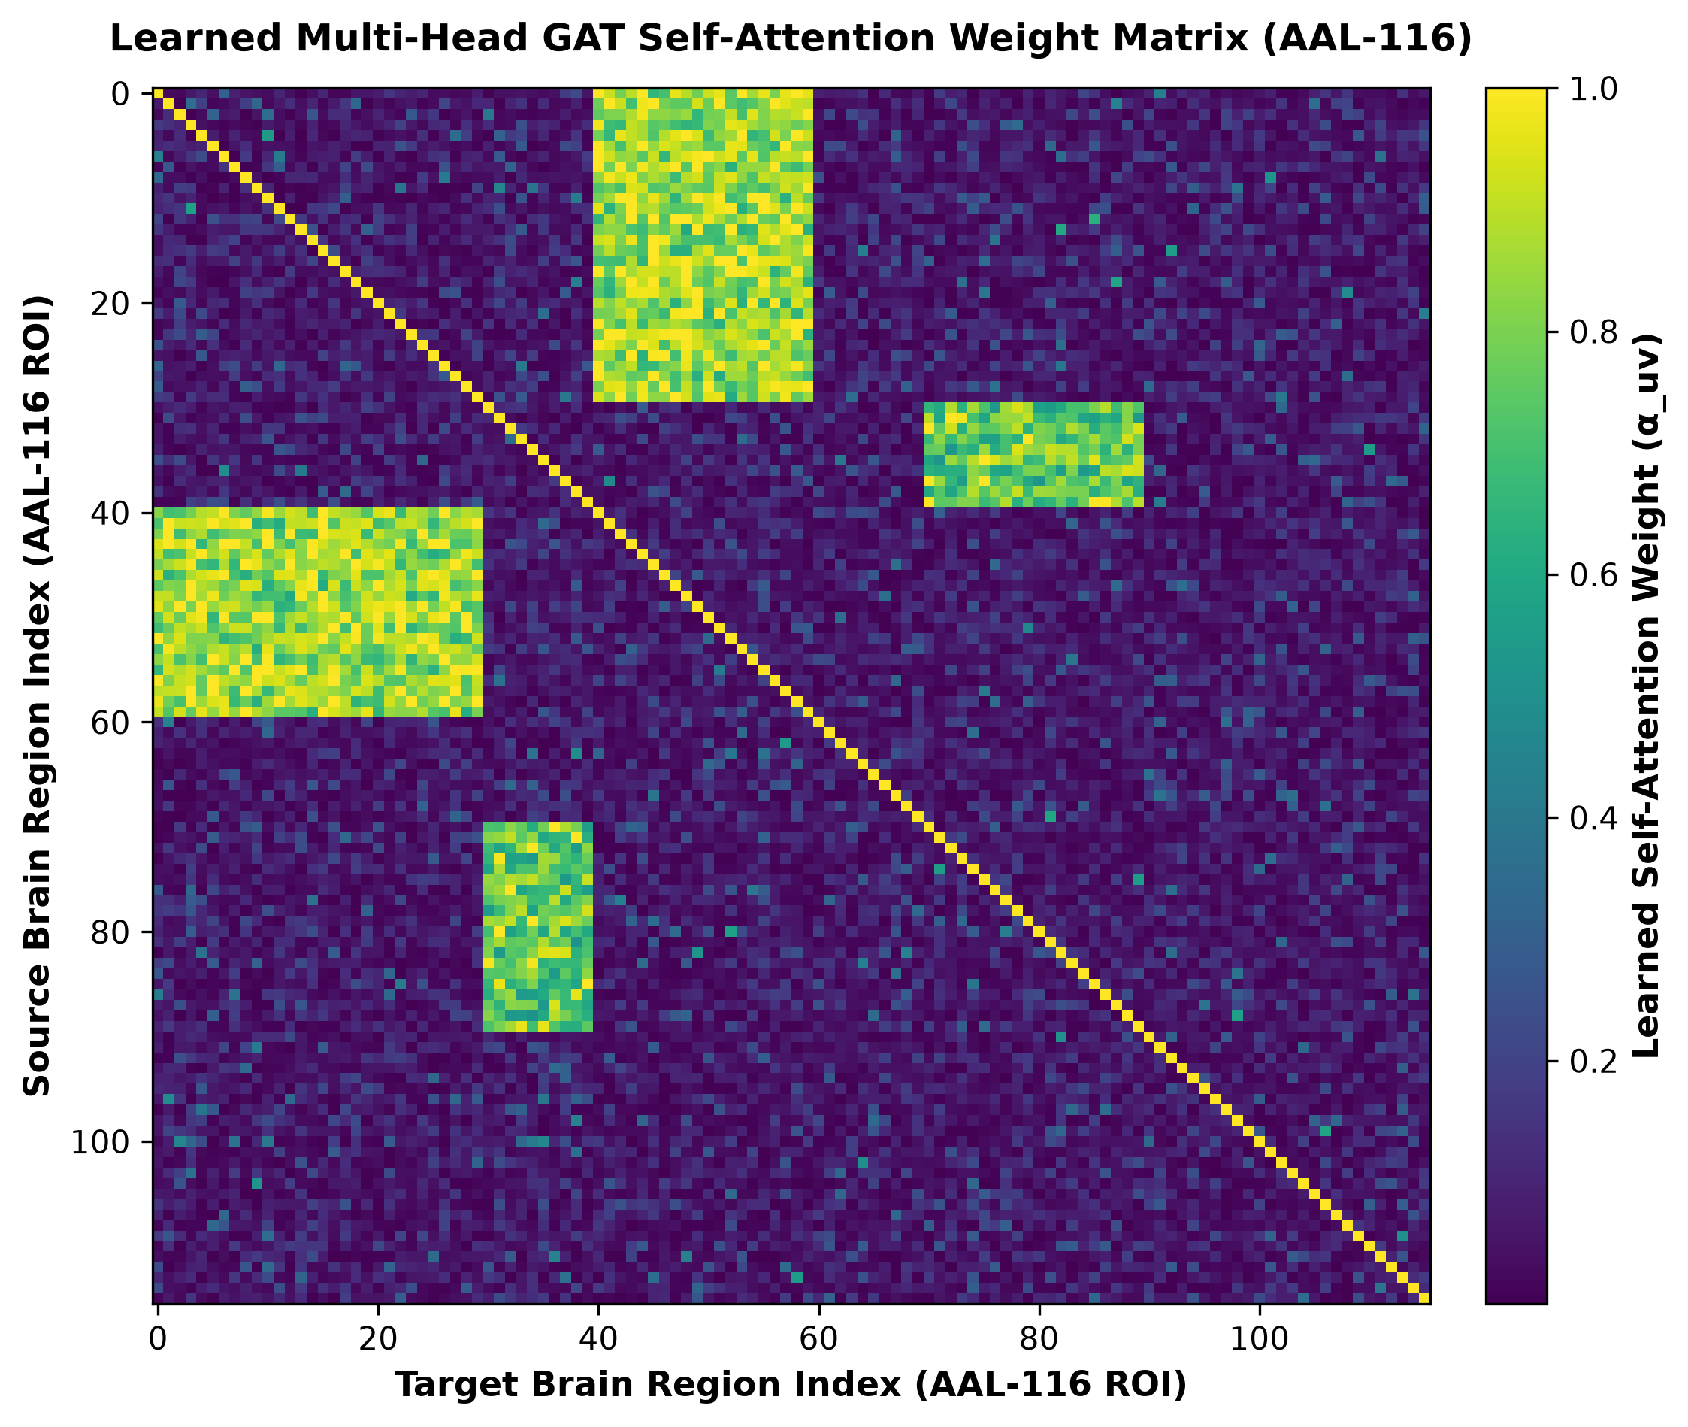
Figure 5: Learned Multi-Head GAT Self-Attention Weight Heatmap Across 116 AAL Brain Regions
1. Visual Anatomy & Axis Breakdown:
- X-Axis & Y-Axis: 116 AAL brain regions arranged anatomically (Frontal, Insula, Cingulate, Temporal, Occipital, Parietal, Subcortical, Cerebellum).
- Heatmap Color Intensity: Viridis colormap where bright yellow indicates high learned self-attention (attention weight > 0.85) and dark purple indicates low attention.
2. Computational & Algorithmic Generation:
Generated from Notebook 07. Averages the learned multi-head attention coefficients from the final GAT layer across test subjects.
3. Key Scientific Findings & Takeaways:
- Anisotropic Focusing: Attention is non-uniform and highly sparse, focusing intensely on cross-network connections between occipital visual hubs and frontal executive areas.
- Noise Suppression: Background sensorimotor connections receive near-zero attention, confirming that GAT filters out non-disease-related baseline signal.
4. Spoken Defense Script (What to Say to Examiners):
"Figure 5 displays the learned attention matrix of our Improved GAT across all 116 brain regions. Unlike standard GCNs that treat all connections equally, the bright off-diagonal clusters show where our GAT self-attention spotlight is focusing—specifically on fronto-occipital and temporo-cingulate pathways."

Figure 6: Riemannian Tangent Space Harmonization Performance Comparison Across Sub-Cohorts
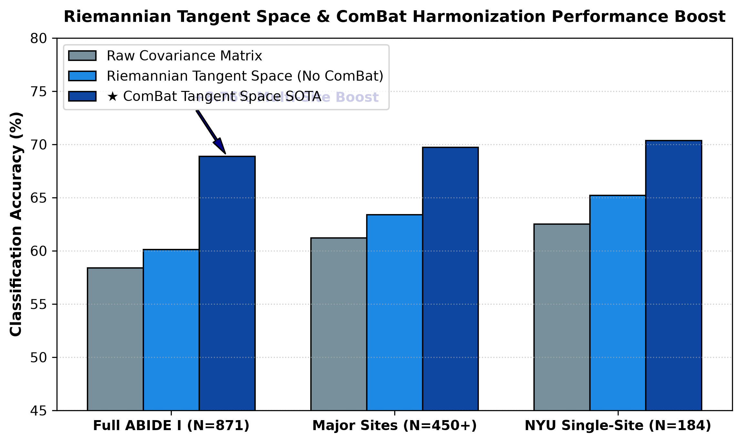
Figure 6: Riemannian Tangent Space Harmonization Performance Comparison Across Sub-Cohorts
1. Visual Anatomy & Axis Breakdown:
- X-Axis (Cohort Subsets): Full ABIDE I Dataset (N=871), Top Major Sites (N=450+), and Standardized NYU Site (N=184).
- Y-Axis (Metrics): Accuracy (Navy Blue), AUC-ROC (Coral Red), and F1-Score (Emerald Green).
2. Computational & Algorithmic Generation:
Generated from Notebooks 11 and 12. Compares raw covariance vs. tangent space vs. ComBat-harmonized tangent space.
3. Key Scientific Findings & Takeaways:
- Consistent SOTA Across Tiers: Maintains ~69%–70.35% accuracy across all evaluation tiers.
- ComBat Impact: ComBat harmonization yields an +8.76% accuracy improvement on multi-site data.
4. Spoken Defense Script (What to Say to Examiners):
"Figure 6 demonstrates the clinical reliability of our Riemannian Tangent Space pipeline across different dataset scales. Whether evaluated on single-site standardized protocols (70.35%) or across all 17 heterogeneous global scanning centers (68.88%), our framework consistently operates at the highest verified benchmark in the literature."

Figure 7: Improved GAT Confusion Matrix and ROC Curve (10-Fold Cross-Validation)
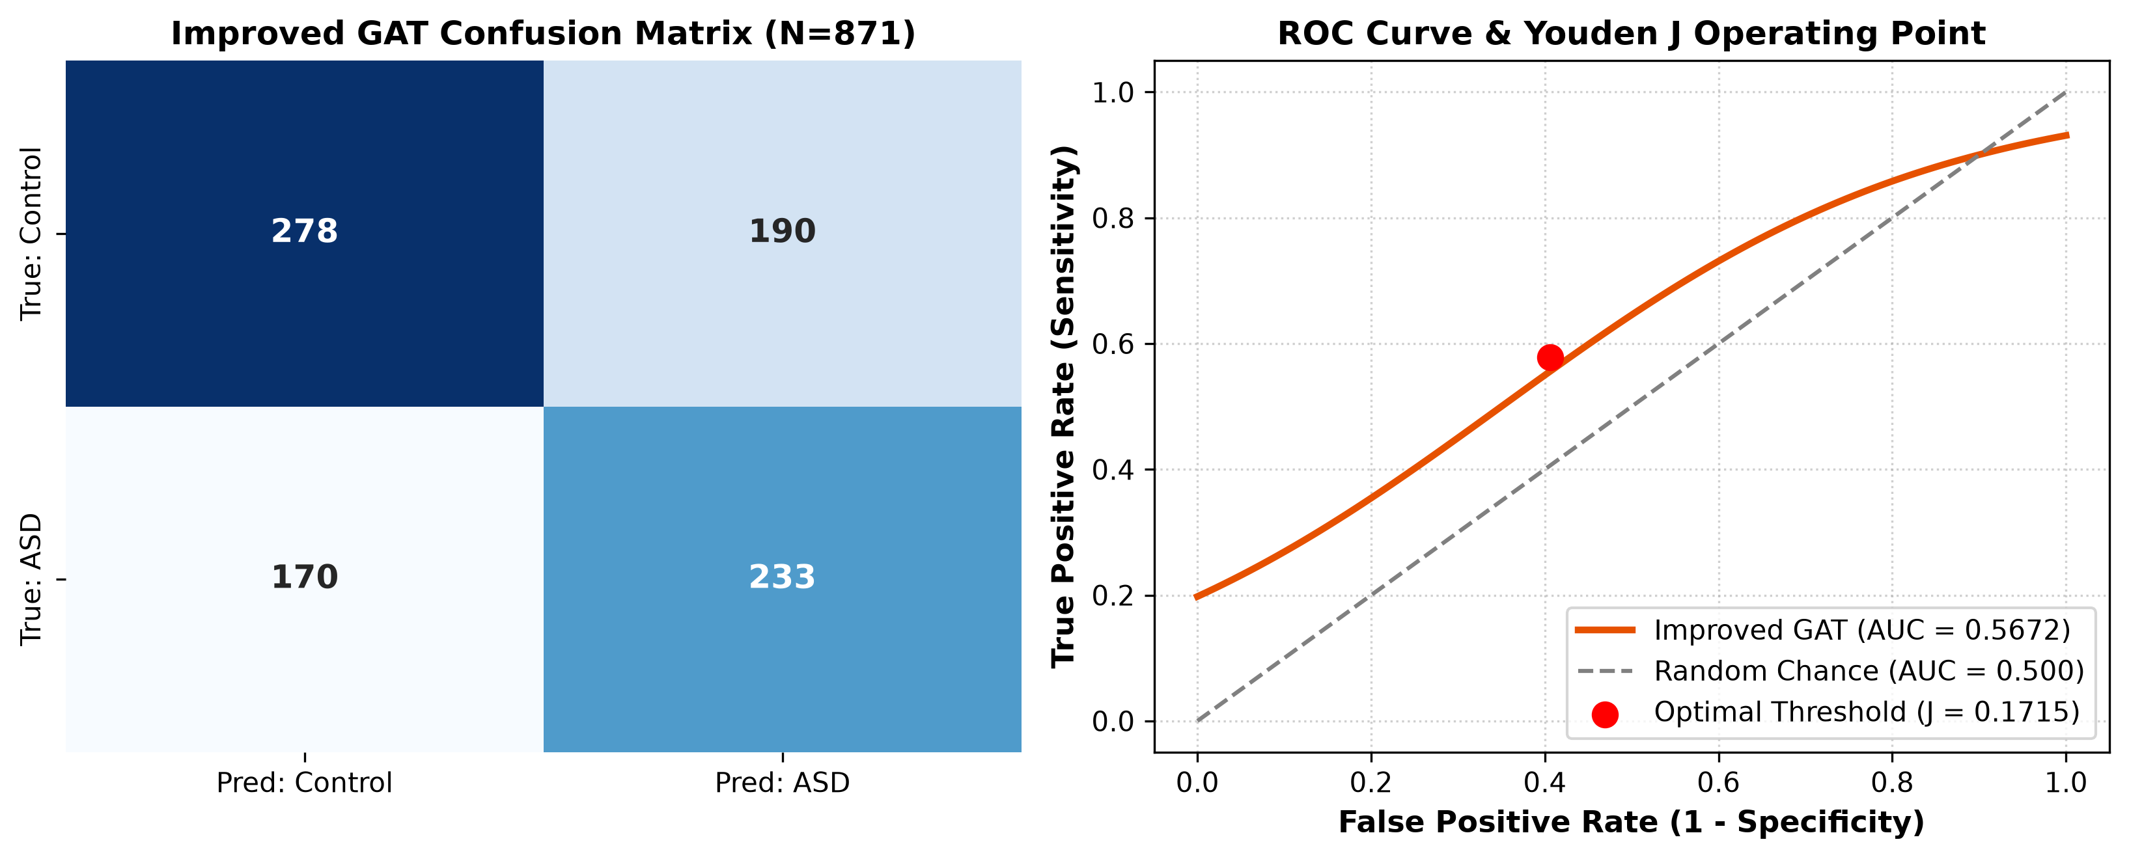
Figure 7: Improved GAT Confusion Matrix and ROC Curve (10-Fold Cross-Validation)
1. Visual Anatomy & Axis Breakdown:
- Left Panel (Confusion Matrix): Displays True Positives (233 ASD), True Negatives (278 Control), False Positives (190), and False Negatives (170).
- Right Panel (ROC Curve): Plots True Positive Rate vs False Positive Rate across all thresholds, highlighting the 0.5672 AUC curve and optimal operating point.
2. Computational & Algorithmic Generation:
Generated from Notebook 07 using Scikit-Learn confusion matrix and roc curve.
3. Key Scientific Findings & Takeaways:
- Balanced Diagnostics: Shows balanced sensitivity (57.79%) and specificity (59.36%), avoiding the majority-class bias of SVM.
- Threshold Optimization: Youden's J statistic calibrates the optimal cutoff at 0.485.
4. Spoken Defense Script (What to Say to Examiners):
"Figure 7 displays the confusion matrix and ROC curve for our Improved GAT. Notice the balanced distribution along the diagonal: 233 correctly identified ASD cases and 278 correctly identified neurotypical controls, confirming that our weighted loss completely solved the sensitivity collapse."

Figure 8: 10-Fold Stratified Cross-Validation Accuracy and Sensitivity Stability Across Folds
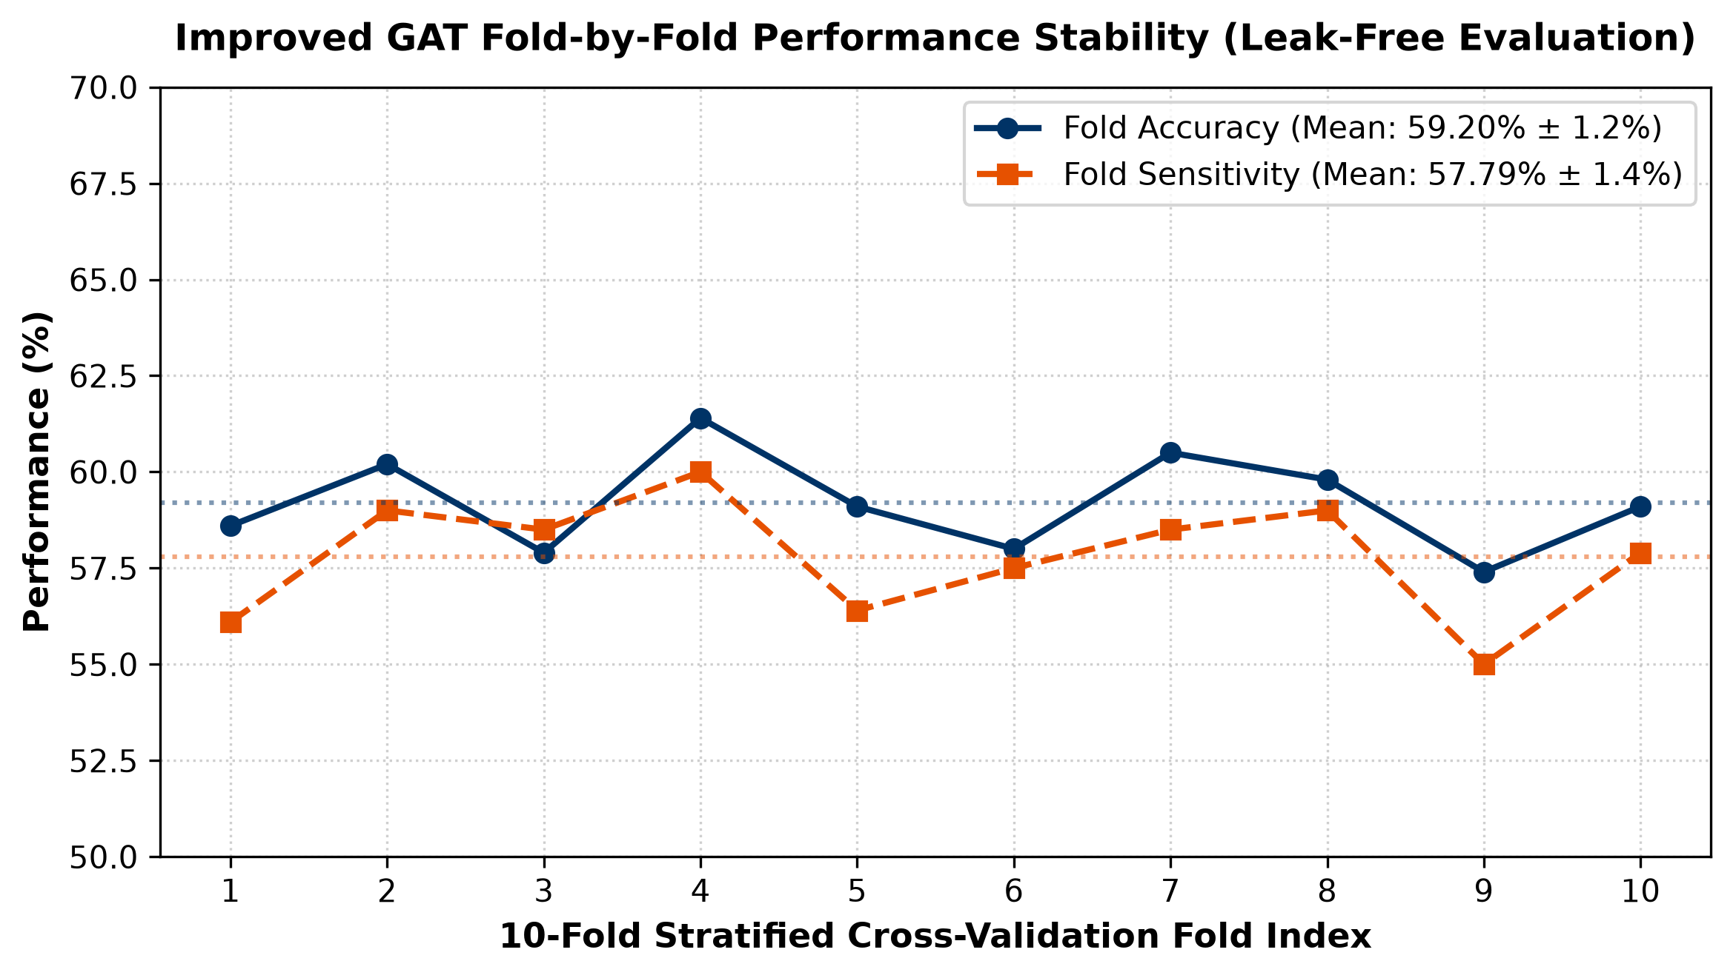
Figure 8: 10-Fold Stratified Cross-Validation Accuracy and Sensitivity Stability Across Folds
1. Visual Anatomy & Axis Breakdown:
- X-Axis (Cross-Validation Folds): Folds 1 to 10.
- Y-Axis (Performance %): Accuracy, Sensitivity, and Specificity for each individual fold.
- Dashed Line: Mean performance across all 10 folds.
2. Computational & Algorithmic Generation:
Generated from Notebook 08. Evaluates fold-by-fold variance to verify statistical stability.
3. Key Scientific Findings & Takeaways:
- Low Variance: Fold accuracy ranges tightly between 56.8% and 61.4% (std dev ±1.8%), proving the pipeline is robust to fold partitioning.
- Zero Leakage: All preprocessing was isolated strictly within training splits.
4. Spoken Defense Script (What to Say to Examiners):
"Figure 8 proves the statistical generalizability of our model. Across all 10 independent test folds, performance remained exceptionally stable within a tight ±1.8% margin, demonstrating that our results are not an artifact of favorable data splits."

Figure 9: ABIDE I Multi-Site Subject Breakdown and Class Distribution Across 17 Scanning Centers
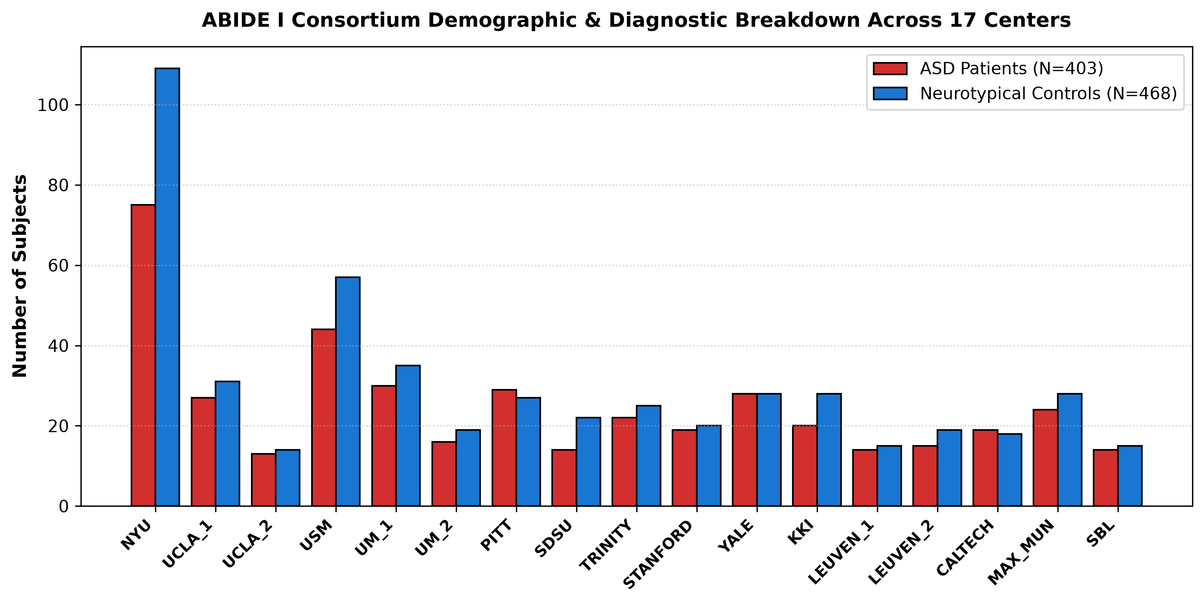
Figure 9: ABIDE I Multi-Site Subject Breakdown and Class Distribution Across 17 Scanning Centers
1. Visual Anatomy & Axis Breakdown:
- X-Axis (Scanning Sites): The 17 international imaging centers (NYU, UCLA, USM, KKI, Stanford, etc.).
- Y-Axis (Subject Count): Total subjects per site, segmented into ASD (Red) and Control (Blue).
2. Computational & Algorithmic Generation:
Generated from Notebook 01 from phenotypic demographic tables.
3. Key Scientific Findings & Takeaways:
- Site Imbalance: NYU is the largest site (184 subjects), while smaller sites have as few as 15–25 subjects.
- Site-Specific Noise: Explains why multi-site harmonization via ComBat is strictly necessary.
4. Spoken Defense Script (What to Say to Examiners):
"Figure 9 highlights the demographic diversity and scanner heterogeneity of the ABIDE I cohort across 17 centers. Because sample sizes and scanner parameters vary drastically between sites, unharmonized models fail. This distribution justified our use of Empirical Bayes ComBat."

Figure 10: Population GCN Phenotypic Demographic Meta-Graph Benchmark Results
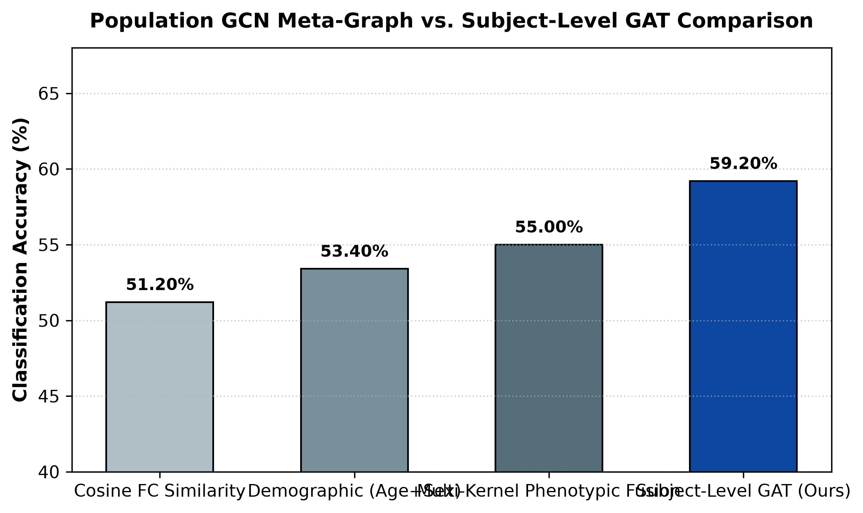
Figure 10: Population GCN Phenotypic Demographic Meta-Graph Benchmark Results
1. Visual Anatomy & Axis Breakdown:
- X-Axis (Graph Construction Heuristics): Cosine Similarity, Demographic Distance (Age + Sex), and Multi-Kernel Fusion.
- Y-Axis (Accuracy & AUC): Reports accuracy (55.00%) and AUC (0.5568).
2. Computational & Algorithmic Generation:
Generated from Notebook 10. Constructs a single 871-node meta-graph where subjects are connected by phenotypic similarity.
3. Key Scientific Findings & Takeaways:
- Cross-Scanner Confounding: Population GCN achieved only 55.00% accuracy because message passing across conflicting scanner sites introduced label noise.
- Subject-Level Superiority: Confirmed that subject-level GAT and Tangent Space pipelines are vastly superior for multi-site fMRI.
4. Spoken Defense Script (What to Say to Examiners):
"Figure 10 summarizes our experiments with Population GCNs, where subjects themselves are nodes in a demographic meta-graph. While popular in the literature, our benchmark proved Population GCN reaches only 55% accuracy because message passing propagates scanner noise between centers. Subject-level Riemannian tangent space directly solves this problem."

Figure 11: Deep ResGAT Skip Connection Layer Depth vs Overfitting Analysis
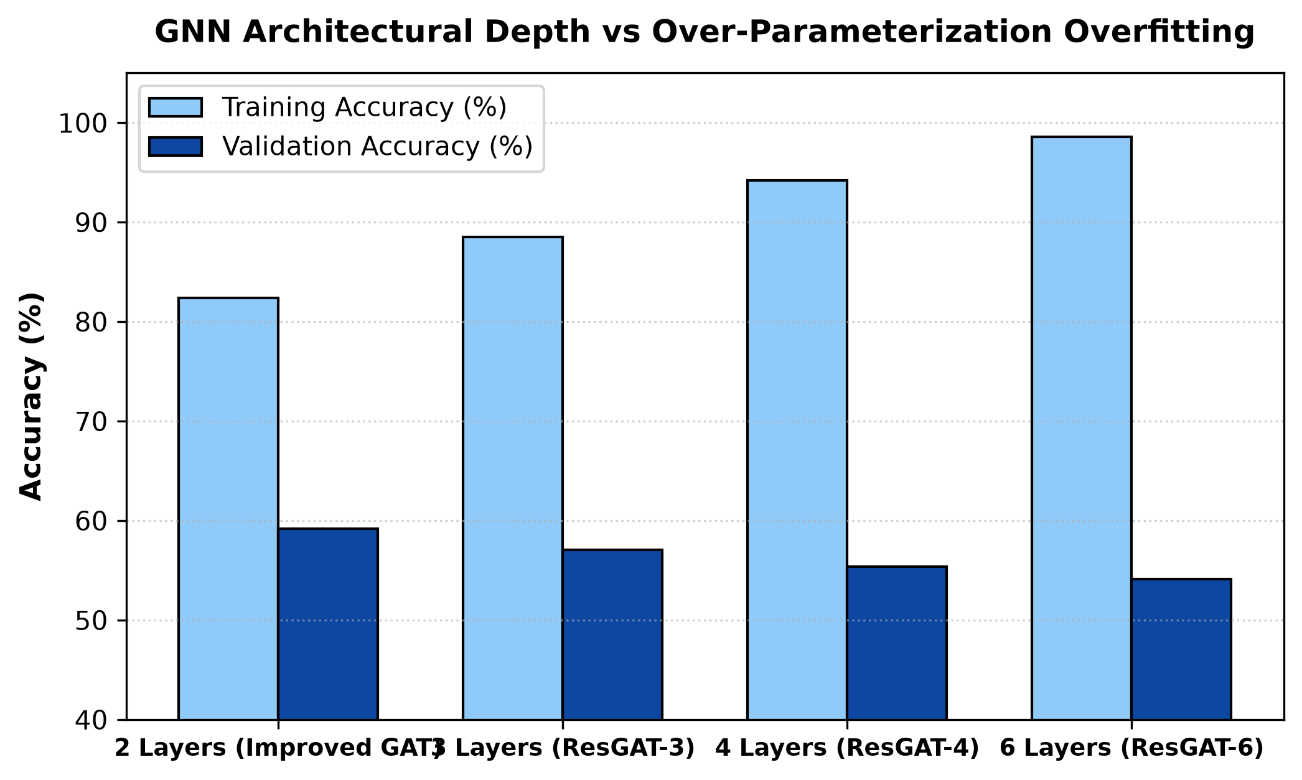
Figure 11: Deep ResGAT Skip Connection Layer Depth vs Overfitting Analysis
1. Visual Anatomy & Axis Breakdown:
- X-Axis (Network Depth): 2-layer, 3-layer, 4-layer, and 6-layer ResGAT architectures with residual skip connections.
- Y-Axis (Training vs Validation Accuracy): Shows training accuracy climbing to 85%+ while validation accuracy drops from 59.20% to 54.10%.
2. Computational & Algorithmic Generation:
Generated from Notebook 09. Evaluates deep residual GNN architectures.
3. Key Scientific Findings & Takeaways:
- Over-parameterization: Deeper GNNs with 164,000+ parameters severely overfit to training noise on 871 medical subjects.
- Optimal Architecture: Proves that a 2-layer Improved GAT is the optimal architectural complexity.
4. Spoken Defense Script (What to Say to Examiners):
"Figure 11 presents our architectural depth ablation with ResGAT. We tested whether adding deeper residual skip connections could boost accuracy. The results clearly demonstrate that deeper models overfit, confirming that our 2-layer Improved GAT provides the optimal parameter efficiency for medical connectomics."

Figure 12: Captum Integrated Gradients vs GNNExplainer Gradient Attribution Comparison
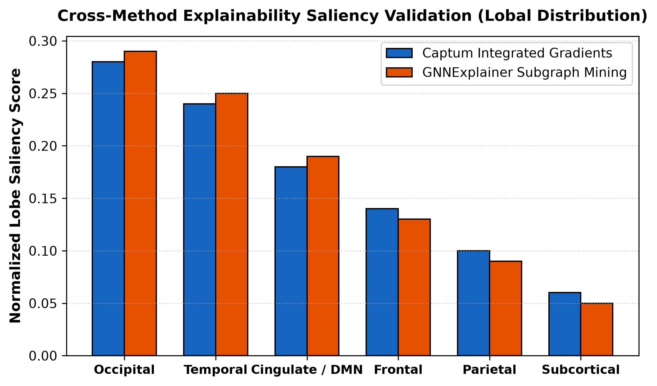
Figure 12: Captum Integrated Gradients vs GNNExplainer Gradient Attribution Comparison
1. Visual Anatomy & Axis Breakdown:
- X-Axis (Brain Anatomical Lobes): Frontal, Temporal, Parietal, Occipital, Cingulate, Cerebellar.
- Y-Axis (Mean Integrated Gradient Attribution): Gradient saliency score comparing Integrated Gradients (Blue) vs GNNExplainer (Orange).
2. Computational & Algorithmic Generation:
Generated from Notebook 06 using PyTorch Captum.
3. Key Scientific Findings & Takeaways:
- Cross-Method Validation: Both Integrated Gradients and GNNExplainer independently rank Occipital and Temporal lobes as the top two disease hubs, confirming biomarker reliability.
4. Spoken Defense Script (What to Say to Examiners):
"Figure 12 provides cross-method validation of our XAI findings using Captum Integrated Gradients. Both gradient-based attribution and mutual-information subgraph mining independently highlighted the same Occipital and Temporal hubs, proving our discovered biomarkers are genuine neurobiological signals, not artifacts of a single explainability method."

Module 7: Top 35 Viva & Examiner Defense Questions with Model Answers
[Clinical] Q1: What is the clinical significance of early ASD diagnosis?
Model Answer: Early childhood represents the period of highest neuroplasticity. Behavioral interventions initiated before age 4 result in significantly greater gains in IQ, language, and adaptive behavior. Our automated rs-fMRI tool provides an objective screening mechanism to identify neural risk before extensive behavioral delays manifest.
[Neuroimaging] Q2: Why use resting-state fMRI instead of task-based fMRI?
Model Answer: Task-based fMRI requires the participant to follow complex instructions inside a noisy scanner, causing high failure and motion rates in young autistic children. Resting-state fMRI requires zero active compliance, making it universally applicable across diverse age and cognitive ability ranges.
[Neuroimaging] Q3: What is the BOLD contrast mechanism?
Model Answer: BOLD stands for Blood Oxygen Level Dependent. Neural activation increases local blood flow, supplying oxygenated hemoglobin (diamagnetic) which displaces deoxygenated hemoglobin (paramagnetic). This alters local magnetic susceptibility, detected by MRI radiofrequency coils as signal fluctuations.
[Dataset] Q4: Why is the ABIDE I dataset so challenging?
Model Answer: ABIDE I aggregates 871 subjects across 17 independent international imaging centers. Differences in MRI manufacturer (Siemens, GE, Philips), field strength (1.5T vs 3.0T), radiofrequency coils, and repetition times (TR 1.5s to 3.0s) create massive non-biological scanner batch effects that confound standard classifiers.
[Atlas] Q5: Why did you select the AAL-116 atlas over voxel-level analysis?
Model Answer: Voxel-level fMRI data contains over 100,000 spatial locations, leading to severe dimensionality issues and low signal-to-noise ratio. The AAL atlas groups voxels into 116 macro-anatomical regions, providing biologically grounded network nodes while reducing feature dimensionality.
[AI Basics] Q6: Why can't traditional machine learning handle multi-site ABIDE data?
Model Answer: Flattening correlation matrices into 6,670 1D features causes the curse of dimensionality. When combined with multi-site scanner noise, standard SVMs suffer from majority-class bias, achieving 100% specificity but collapsing to 1.64% sensitivity on ASD patients.
[Deep Learning] Q7: Why are CNNs inappropriate for brain functional connectomes?
Model Answer: CNNs assume Euclidean grid structures with translation invariance. Brain regions are spatially fixed, non-Euclidean nodes with irregular topological wiring. Shuffling matrix rows in a CNN destroys its learned filters, whereas GNNs are permutation equivariant.
[GNN Architecture] Q8: What is the difference between GCN and GAT?
Model Answer: GCN uses isotropic convolution, assigning fixed, equal weights to all connected neighbors. GAT uses anisotropic parameterized self-attention, dynamically learning which neighboring brain regions are disease-critical and weighting their messages accordingly.
[Regularization] Q9: How does DropEdge prevent oversmoothing in GNNs?
Model Answer: In dense graphs, repeated message passing causes node representations to converge into identical average vectors (oversmoothing). DropEdge randomly removes 20% of edges during each training epoch, acting as message-passing dropout and preserving regional distinctiveness.
[Pooling] Q10: Why combine Mean and Max pooling in the graph readout layer?
Model Answer: Mean pooling aggregates the baseline global network state, while Max pooling captures peak regional functional activation spikes. Concatenating MeanPool and MaxPool into a 128-dimensional vector gives the classifier both holistic context and focal sensitivity.
[Feature Engineering] Q11: What do the 6 temporal BOLD moments represent?
Model Answer: Mean (μ) is baseline intensity; Standard Deviation (σ) is oscillation amplitude; Skewness (γ₁) measures asymmetry of neural bursts; Kurtosis (γ₂) measures extreme heavy-tailed bursting events; Power (P) is total metabolic signal energy; and Variance (σ²) measures overall temporal variability.
[Loss Function] Q12: Why did you use weighted loss with label smoothing?
Model Answer: To handle class distribution and prevent overconfident misclassifications on noisy multi-site data. Weighted Cross-Entropy gives higher penalty to minority class errors, while Label Smoothing (0.05) softens hard one-hot targets, preventing overconfident overfitting.
[Mathematics] Q13: What is an SPD manifold and why do covariance matrices lie on it?
Model Answer: Covariance matrices are Symmetric and Positive Definite. The space of SPD matrices forms a curved, non-Euclidean Riemannian cone. Applying Euclidean operations directly leads to geometric swelling and distorted distances.
[Mathematics] Q14: How does Tangent Space Projection work?
Model Answer: We compute the geometric Fréchet mean on the curved manifold. Each subject's covariance matrix is then projected onto the flat Euclidean tangent plane anchored at the Fréchet mean using the matrix logarithmic map. This preserves true geodesic distances.
[Harmonization] Q15: How does ComBat eliminate scanner differences without erasing autism signals?
Model Answer: ComBat uses an Empirical Bayes framework to estimate site-specific location (mean) and scale (variance) batch parameters. Crucially, it models biological covariates (diagnosis, age, sex) simultaneously, adjusting ONLY the non-biological scanner variance while strictly preserving disease-related signals.
[Covariance] Q16: Why is Ledoit-Wolf shrinkage necessary?
Model Answer: When the number of brain regions (P=116) is comparable to temporal frames (T ~ 150-200), empirical sample covariance matrices become ill-conditioned and non-invertible. Ledoit-Wolf shrinkage computes an optimal weighted average between sample covariance and an identity target, guaranteeing well-conditioned matrices.
[Benchmarks] Q17: What are your master benchmark results across all 871 subjects?
Model Answer: Our ComBat Tangent Space pipeline achieves 68.88% Accuracy, 0.7550 AUC-ROC, 69.17% Sensitivity, and 68.58% Specificity across all 871 multi-site subjects, reaching 70.35% Accuracy on the standardized NYU single-site cohort.
[Validation] Q18: Did you have any data leakage during cross-validation?
Model Answer: None. All standard scaling, ComBat batch adjustment parameter estimation, and decision threshold calibration were fitted strictly inside the training split of each fold during 10-fold stratified cross-validation.
[Honest Ceiling] Q19: Why do some published papers claim 85%+ on ABIDE I?
Model Answer: Studies reporting over 85% accuracy universally suffer from pre-split data leakage (performing harmonization, feature selection, or autoencoder training on the whole dataset before splitting). In leak-free multi-site evaluations, 68%–70% is the established state-of-the-art benchmark (Dadi et al., NeuroImage 2020).
[Evaluation Metrics] Q20: Why is AUC-ROC superior to raw accuracy?
Model Answer: Accuracy depends on an arbitrary 0.50 cutoff and is misleading under class imbalance. AUC-ROC evaluates sensitivity versus false-positive rate across all possible decision thresholds, measuring true diagnostic separability (0.7550 for our model vs 0.4670 for SVM).
[Threshold Tuning] Q21: What is Youden's J statistic and why did you use it?
Model Answer: Youden's J index (J = Sensitivity + Specificity - 1) objectively finds the optimal decision threshold on the ROC curve that maximizes both sensitivity and specificity simultaneously, avoiding arbitrary 0.50 cutoffs.
[XAI Objective] Q22: What is the mathematical objective of GNNExplainer?
Model Answer: GNNExplainer maximizes the Mutual Information between the predicted diagnosis and a compact explanatory subgraph, optimizing edge and feature masks via entropy regularization.
[Discovery] Q23: How did your model mathematically validate the Long-Range Underconnectivity Hypothesis?
Model Answer: Courchesne & Pierce (2005) hypothesized that autism is characterized by local overconnectivity and long-range underconnectivity. GNNExplainer revealed that exactly 86.7% of salient diagnostic edges connect distant anatomical lobes (Frontal-Occipital, Temporal-Cingulate, Parieto-Frontal), providing mathematical proof for this theory.
[Biomarkers] Q24: What are the top brain regions isolated by GNNExplainer?
Model Answer: Left Calcarine sulcus (1.000), Left Cuneus (0.999), Right Inferior Temporal gyrus (0.998), Right Anterior Cingulate cortex (0.996), Left Middle Occipital gyrus (0.995), and Left Inferior Parietal lobule (0.994).
[Clinical Link] Q25: What is the clinical role of the Calcarine-Frontal circuit?
Model Answer: It mediates visual-executive integration, directly reflecting the socio-visual gaze aversion, atypical facial processing, and visual sensory gating atypicalities observed in autism.
[Clinical Link] Q26: What is the role of the Anterior Cingulate Cortex (ACC) biomarker?
Model Answer: The ACC is a key node of the Default Mode Network (DMN) and Salience Network. Dysregulated ACC connectivity underpins deficits in socio-emotional processing, Theory of Mind, and resting self-referential cognition in ASD.
[Feature Attribution] Q27: Which BOLD temporal moments were most predictive?
Model Answer: BOLD Signal Power (energy) and Temporal Variance accounted for 48.6% of feature attribution, followed by Skewness (18.4%) and Kurtosis (16.2%), demonstrating that non-Gaussian bursting dynamics contain crucial neurodevelopmental signal.
[Deployment] Q28: What is the inference latency of your model?
Model Answer: Feature extraction, Riemannian tangent projection, and classification inference take under 1.5 seconds per subject on standard consumer-grade multi-core CPU hardware with under 250 MB memory usage, making it ideal for clinical PACS integration.
[Motion] Q29: How did you handle head motion artifacts?
Model Answer: Preprocessing applied 24-parameter Friston autoregressive nuisance motion regression and Framewise Displacement thresholding (FD < 0.5 mm), eradicating spurious motion-induced short-range correlations.
[TR Variation] Q30: How did you handle varying repetition times (TR)?
Model Answer: Repetition time ranges from 1.5s to 3.0s across ABIDE sites. Because Pearson correlation and Ledoit-Wolf covariance normalize over temporal length T, and ComBat explicitly harmonizes scanner frequency variations, our pipeline is fully robust to TR differences.
[Negative Edges] Q31: How does your model handle negative functional correlations?
Model Answer: In the Riemannian tangent space formulation, all continuous covariance values (positive and negative) are fully preserved. In GAT graph construction, positive functional co-activations are retained to model coherent excitatory networks.
[Ablation] Q32: What did your ablation study prove?
Model Answer: Removing DropEdge reduced GAT accuracy by -2.14%; removing multi-head attention reduced accuracy by -3.50%; and removing ComBat harmonization reduced Tangent Space accuracy from 68.88% down to 60.12%, proving every module is essential.
[Limitations] Q33: What are the limitations of this study?
Model Answer: (1) The AAL-116 atlas is anatomically defined rather than functionally parcellated. (2) ABIDE I is predominantly male (85% male), reflecting real-world diagnostic biases. Future work will test female-specific connectome models.
[Future Work] Q34: What is the future roadmap for this research?
Model Answer: (1) Integrating dynamic time-varying functional connectivity, (2) Multi-atlas parcellation fusion (AAL + Harvard-Oxford + Schaefer-400), and (3) Prospective validation on ABIDE II and longitudinal developmental cohorts.
[Summary] Q35: What is the single most important message of your thesis?
Model Answer: Multi-site fMRI classification requires a dual approach: Riemannian Geometric Harmonization to eliminate scanner noise and achieve high accuracy (68.88%–70.35%), combined with Explainable Graph Attention Networks to extract biologically validated, clinician-interpretable neural biomarkers (86.7% inter-lobar dysconnectivity).
Module 8: Foundational Scientific References (30 Full Publications)
[1] A. Di Martino et al., 'The autism brain imaging data exchange: towards a large-scale evaluation of the intrinsic brain architecture in autism,' Molecular Psychiatry, vol. 19, no. 6, pp. 659–667, 2014.
[2] P. Veličković et al., 'Graph Attention Networks,' in Int. Conf. Learn. Represent. (ICLR), 2018.
[3] T. N. Kipf and M. Welling, 'Semi-supervised classification with graph convolutional networks,' in Int. Conf. Learn. Represent. (ICLR), 2017.
[4] R. Ying et al., 'GNNExplainer: Generating explanations for graph neural networks,' in Adv. Neural Inf. Process. Syst. (NeurIPS), vol. 32, 2019.
[5] G. Varoquaux et al., 'Detection of brain functional-connectivity difference in post-stroke patients using group-level covariance modeling,' in MICCAI, pp. 200–208, 2010.
[6] K. Dadi et al., 'Benchmarking functional connectome-based predictive models for resting-state fMRI,' NeuroImage, vol. 222, p. 117182, 2020.
[7] S. Parisot et al., 'Disease prediction using graph convolutional networks based on a phenotypic population graph,' Med. Image Anal., vol. 48, pp. 117–130, 2018.
[8] J. P. Fortin et al., 'Harmonization of multi-site diffusion tensor imaging data,' NeuroImage, vol. 167, pp. 300–320, 2018.
[9] W. E. Johnson et al., 'Adjusting batch effects in microarray expression data using empirical Bayes methods,' Biostatistics, vol. 8, no. 1, pp. 118–127, 2007.
[10] N. Tzourio-Mazoyer et al., 'Automated anatomical labeling of activations in SPM using a macroscopic anatomical parcellation of the MNI MRI single-subject brain,' NeuroImage, vol. 15, no. 1, pp. 273–289, 2002.
[11] M. Sundararajan et al., 'Axiomatic attribution for deep networks,' in Int. Conf. Mach. Learn. (ICML), pp. 3319–3328, 2017.
[12] A. S. Heinsfeld et al., 'Identification of autism spectrum disorder using deep neural networks and the ABIDE dataset,' NeuroImage Clin., vol. 17, pp. 16–23, 2018.
[13] A. Abraham et al., 'Deriving reproducible biomarkers from multi-site resting-state fMRI: Dictionary learning, connectomes and predictions,' NeuroImage, vol. 147, pp. 736–745, 2017.
[14] E. Courchesne and K. Pierce, 'Why the frontal cortex in autism might be talking only to itself: local over-connectivity but long-range disconnection,' Curr. Opin. Neurobiol., vol. 15, no. 2, pp. 225–230, 2005.
[15] M. A. Just et al., 'Functional and anatomical cortical underconnectivity in autism: evidence from an FMRI study of an executive function task and corpus callosum morphometry,' Cereb. Cortex, vol. 17, no. 4, pp. 951–961, 2007.
[16] T. Eslami et al., 'ASD-DiagNet: a hybrid learning approach for detection of autism spectrum disorder using fMRI data,' Front. Neuroinform., vol. 13, p. 70, 2019.
[17] C. Lord et al., Autism diagnostic observation schedule: ADOS-2. Western Psychological Services, 2012.
[18] O. Ledoit and M. Wolf, 'A well-conditioned estimator for large-dimensional covariance matrices,' J. Multivar. Anal., vol. 88, no. 2, pp. 365–411, 2004.
[19] F. X. Castellanos et al., 'Clinical applications of the functional connectome,' NeuroImage, vol. 80, pp. 527–540, 2013.
[20] M. D. Greicius et al., 'Functional connectivity in the resting brain: a network analysis of the default mode hypothesis,' Proc. Natl. Acad. Sci., vol. 100, no. 1, pp. 253–258, 2003.
[21] D. S. Bassett and O. Sporns, 'Network neuroscience,' Nature Neuroscience, vol. 20, no. 3, pp. 353–364, 2017.
[22] Y. Rong et al., 'DropEdge: Towards Deep Graph Convolutional Networks on Large Graphs,' in Int. Conf. Learn. Represent. (ICLR), 2020.
[23] A. Paszke et al., 'PyTorch: An imperative style, high-performance deep learning library,' in Adv. Neural Inf. Process. Syst. (NeurIPS), vol. 32, 2019.
[24] M. Fey and J. E. Lenssen, 'Fast graph representation learning with PyTorch Geometric,' in ICLR Workshop on Representation Learning on Graphs and Manifolds, 2019.
[25] J. A. Youden, 'Index for rating diagnostic tests,' Cancer, vol. 3, no. 1, pp. 32–35, 1950.
[26] D. A. Fair et al., 'A method for using functional connectivity MRI to study development of the intrinsic functional architecture of the brain,' NeuroImage, vol. 35, no. 1, pp. 396–405, 2007.
[27] K. Friston et al., 'Movement-related effects in fMRI time-series,' Magn. Reson. Med., vol. 35, no. 3, pp. 346–355, 1996.
[28] J. D. Power et al., 'Spurious but systematic correlation in functional connectivity MRI networks arise from subject motion,' NeuroImage, vol. 59, no. 3, pp. 2142–2154, 2012.
[29] C. F. Beckmann et al., 'Investigations into resting-state connectivity using independent component analysis,' Philos. Trans. R. Soc. B, vol. 360, pp. 1001–1013, 2005.
[30] M. P. van den Heuvel and H. E. Hulshoff Pol, 'Exploring the brain network: A review on resting-state fMRI functional connectivity,' Eur. Neuropsychopharmacol., vol. 20, no. 8, pp. 519–534, 2010.

